Quantitative Data Analysis Gwalia Stores
Word Count:2961

Student Name: James Nicholl
Student Number: 2319769

Contents Page
Table of Contents
1. Introduction 2
2. Main Findings 3
3. Conclusion 11
4. References 14

Introduction

This data analysis report analysed the customers of the Gwalia Stores. Gwalia Stores is a grocery and newsagents in a Welsh village.

The report summarizes data collected from the Gwalia Stores customers, looking at customer behaviour, demographics, distance of the shoppers from their homes to the store, the spending habits of the customers and any notable differences on gender spending and opinions, the report has analysed the regularly purchased newspapers as well as the customer opinions on the local borough council.

Looking at the raw data, it appears that a mixture of research methods have been used. It can be assumed that potentially surveys, interviews and observations are some of the methods that were adopted to gather the data.

Within the report, two key types of measurement scales have been adopted, ordinal and nominal. When looking at the nominal data, gender segregation has been adopted to integrate the findings to a deeper level. Nominal data has been used to categorise the data.

The ordinal data has been used to highlight the interest levels of the customers on key subjects such as opinions, satisfactions, preferences and comparisons.

When reviewing the raw data, several analysing tools and methods were reviewed, considered and adopted. Sorting and filtering of the data was a key initial first step as well as creating formulas within the excel document allowing for an easier interrogation process. These first steps were adopted to allow for easier reviewing of the data, which would ultimately support the development of actionable data for the Gwalia Stores owners.

PivotTables were used to create dynamic tables that could quickly calculate sums such as averages and counts, as well as allowing for data support when summarising the findings.

Charts have been used in this quantitative data analysis report, with an aim of creating visual data support in identifying trends and relationships.

Additional methods and approaches were implemented when reviewing the raw data, such as Chi-squared and Pearson Coefficient of Correlation.

The chi-squared test is a statistical hypothesis test used to analyse contingency tables, primarily examining the independence of two categorical variables. (McHugh, 2013) It compares observed frequencies with expected frequencies to determine if the observed frequencies deviate significantly from what would be expected if the variables were independent. Essentially, it helps determine if there's a statistically significant relationship between two categorical variables. (Laerd Statistics, 2015).

Pearson Coefficient of Correlation. The first person to give a mathematical formula for the measurement of the degree of relationship between two variables in 1890 was Karl Pearson. Karl Pearson's Coefficient of Correlation is also known as Product Moment Correlation or Simple Correlation Coefficient. This method of measuring the coefficient of correlation is the most popular and is widely used. It is denoted by 'r', where r is a pure number which means that r has no unit. (GeeksforGeeks,2024)

ANOVA (Analysis of Variance) is a statistical method used to compare means across multiple groups, determining whether observed differences are statistically significant or merely due to random variation. Developed by Ronald Fisher in the early 20th century, ANOVA plays a crucial role in experimental design and inferential statistics by partitioning variance into systematic and random components. The method assumes that populations being compared are normally distributed, have equal variances, and consist of independent observations. By analyzing variance, researchers can test hypotheses and identify meaningful differences between groups, thus facilitating informed decision-making. For instance, in workplace surveys, ANOVA can help assess variations in employee satisfaction across different departments, offering data-driven insights for strategic improvements (BachelorPrint, 2021).

By combining the aforementioned tools and techniques the report has effectively analysed the raw data provided, as highlighted in the summary section. The tools and techniques used in this data analysis review have allowed for the representation of meaningful insights, which will allow the owners of Gwalia Stores to make informed decisions on their next potential steps.

Examples of some of the actionable data highlighted in this data analysis report; Product placement, by reviewing the data and gender bias of the customers, the store owners can leverage on this gender bias of its customers when looking at product place in collation with gender specific products. This report will highlight these findings further in the main body, as well as the potential areas for the local borough council to carry out a targeted communication campaign aligned to the data exploitation.

2. Main Findings
The data analysis report has been broken down into ten forms of descriptive analysis sub-sections, to allow for clearly defined analysis categories and review.

Customer Spend

- Mean Spend: £15.16
- Median Spend: £15.00
- Standard Deviation of Spend: £5.97
The average customer spends £15.16, with the median spend sitting at £15. This median spend indicates that half of the customers spend more than £15 and the other half spend below £15.

The deviation between customer spending sits at £5.97, this deviation shows the variability in the Gwalia Stores customer spending.

Spending By Gender

The customer average spend; Male customers spend more on average, with an average spend of £16.2, compared to female customers, who on average spend £14.

Average Spend Calculation
- The average spend for female customers is £14.0.
- The average spend for male customers is £16.2.

Statistical Significance
The p-value from the independent samples t-test is 0.439.

A p-value of 0.439 suggests that the difference in average spend between male and female customers is not statistically significant at the conventional significance level of 0.05.

Section Summary
In conclusion the average male customers that visit the Gwalia Stores, have a higher average spend (£16.2) compared to female customers (£14.0).

The difference in average spend between genders is not statistically significant based on the t-test results (p-value = 0.439). This indicates that the observed difference in average spend could be due to random chance rather than a true difference between the populations.

Correlation between distance and spend

Analysis of the raw data, shows a strong negative correlation: The Pearson correlation coefficient of -0.875 indicates a strong negative relationship between customer distance and spend.

The analysis shows a statistical significance rating of a very low p-value of 9.41e-07 confirms the correlation is statistically significant, suggesting the relationship is unlikely due to random chance.

The average spend for customers who favour each newspaper (Daily Express, Guardian, Times, Western Mail)

Average Spend Calculation

The average spend was calculated for each newspaper by grouping the data by 'Newspaper' and then computing the mean of 'Spend, £' for each group.

The resulting data includes the average spend for each of the four newspapers: Daily Express, Guardian, Times, and Western Mail.

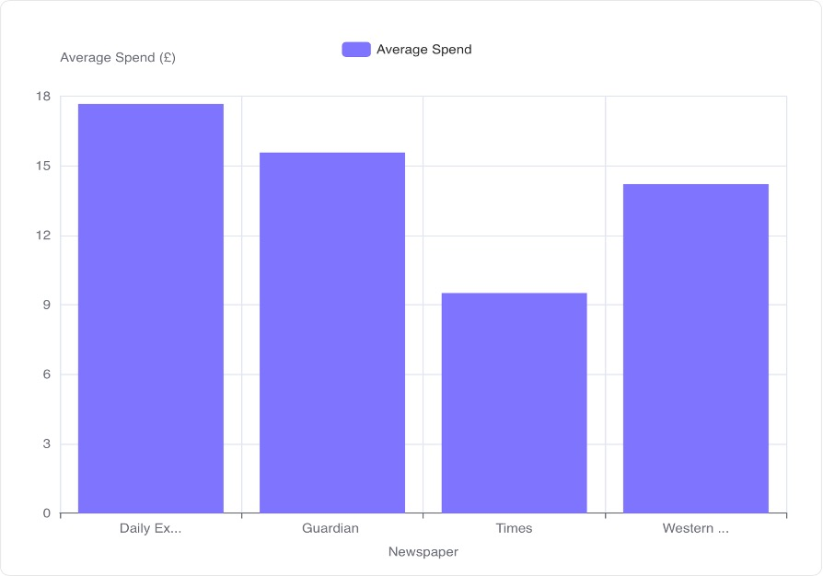

Average Spend Visualization

As highlighted in the bar chart the average spend for each newspaper is as follows:

- Daily Express: £17.67
- Guardian: £15.57
- Times: £9.50
- Western Mail: £14.20

Section Summary

The Daily Express readers have the highest average spend (£17.67), while Times readers have the lowest average spend (£9.50) .

The average spend for Guardian readers is £15.57, and for Western Mail readers, it is £14.20 .
This data and collation allows us to understand further the spending habits of the Gwalia customers who read different newspapers.

Distribution of customer opinion scores, looking at the mean, median, and mode of the opinion scores.
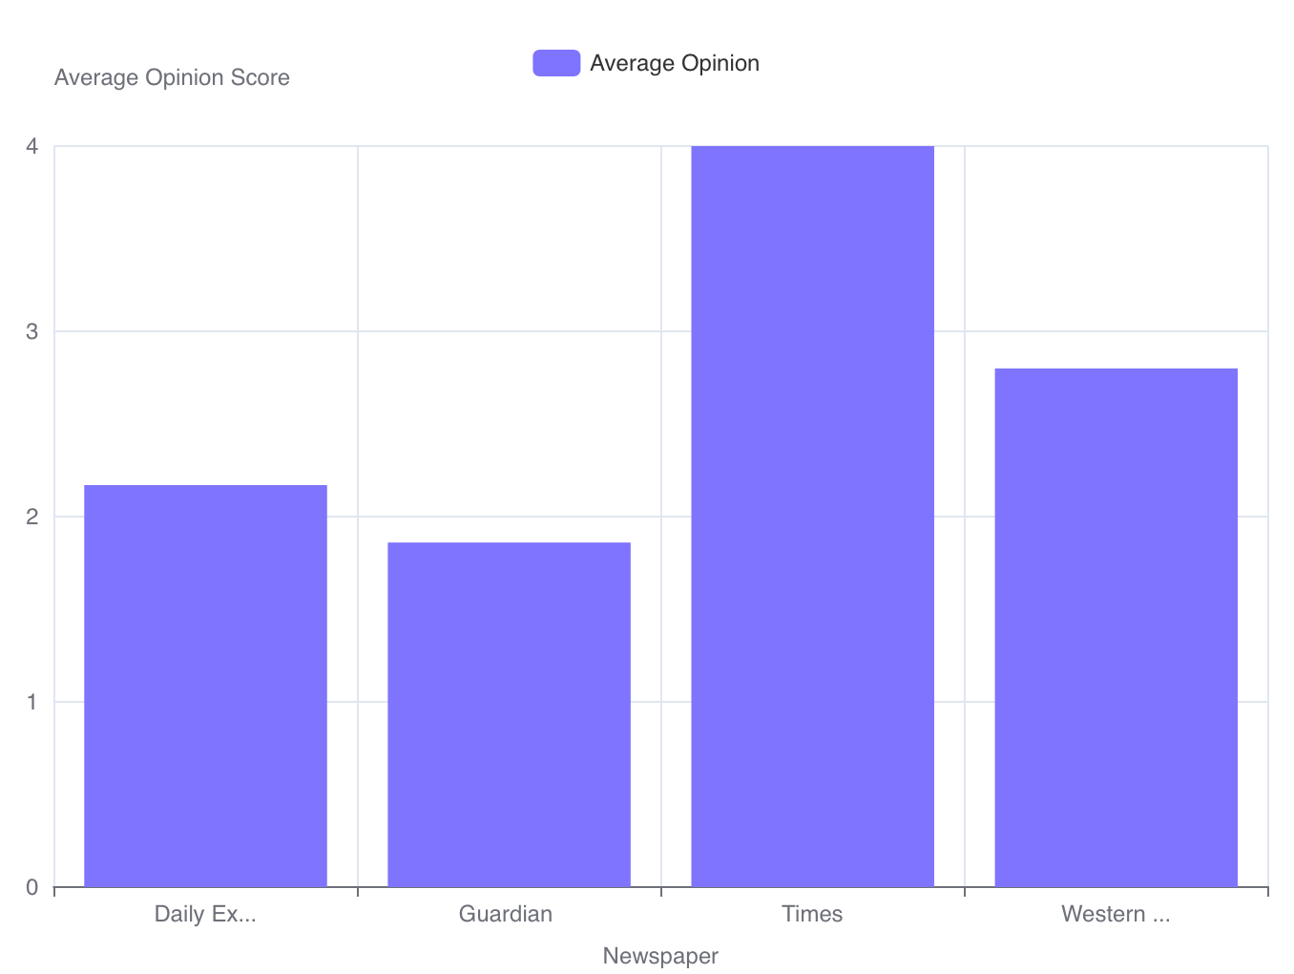

Central Tendency of Opinion Scores

- Mean: The average opinion score is approximately 2.47.
- Median: The middle value of the opinion scores is 3.0.
- Mode: The most frequent opinion score is 3.0.

Both genders have a similar average opinion of the local borough council with the female customer opinion scoring 2.3 and the male customer opinion scoring 2.4. These discontent scores give the local borough council an opportunity to carry out a targeted marketing campaign.

Section Summary

When looking at Central Tendency, the mean opinion score is 2.47, while both the median and mode are 3.0. These findings suggests that while the average opinion leans slightly lower, the most common opinion score is the highest possible value.

For each gender, how does customer spend vary across different opinion scores and the statistically significant interaction effect between gender and opinion on spend

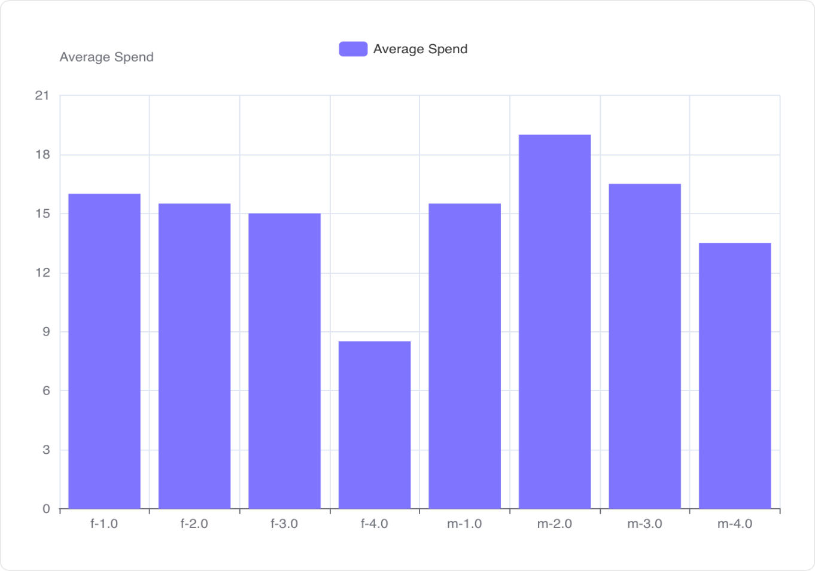

Average Spend Calculation

The average spend was calculated for each combination of gender ('f' = Female, 'm' = Male) and opinion score (1.0, 2.0, 3.0, 4.0).

For the female customers, the average spend varies from £16.0 (opinion 1.0) to £8.5 (opinion 4.0).

For the male customers, the average spend ranges from £15.5 (opinion 1.0) to £19.0 (opinion 2.0).

Visualization of Average Spend

The bar chart visually represents the average spend for each gender and opinion score combination.

The chart has allowed for a direct comparison of spending habits across different groups. For example, males with an opinion score of 2.0 have the highest average spend (£19.0), while females with an opinion score of 4.0 have the lowest average spend (£8.5).

ANOVA (Analysis of Variance) Test Results

The ANOVA test was performed on the raw data to assess the statistical significance of the interaction between gender and opinion on customer spend.

The p-value for the interaction term (C(Q("gender-m")):C(Q("opinion-1"))) is 0.936, which is much greater than the typical significance level of 0.05.

This indicates that there is no statistically significant interaction effect between gender and opinion on customer spend.

Section Summary

Customer spend varies across different opinion scores for each gender. Females tend to spend less as their opinion score increases, while males show a peak in spending at an opinion score of 2.0.

There is no statistically significant interaction effect between gender and opinion on customer spend. This suggests that the effect of opinion score on customer spend is similar for both genders.

What is the average opinion score for customers who read each newspaper; Daily Express, Guardian, Times and Western Mail?

The Times newspaper has the highest average opinion score of 4.0, whilst the Western Mail newspaper has an average opinion score of 2.8. The Daily Express newspaper has an average opinion score of approximately 2.17, placing the Guardian newspaper with the lowest average opinion score of approximately 1.86.

Section Summary
This data analysis highlights an opportunity for a targeted marketing campaign and would help the local borough council in improving its communication plans.

The distribution of newspaper preference for male and female customers and the statistically significant association between gender and newspaper preference?

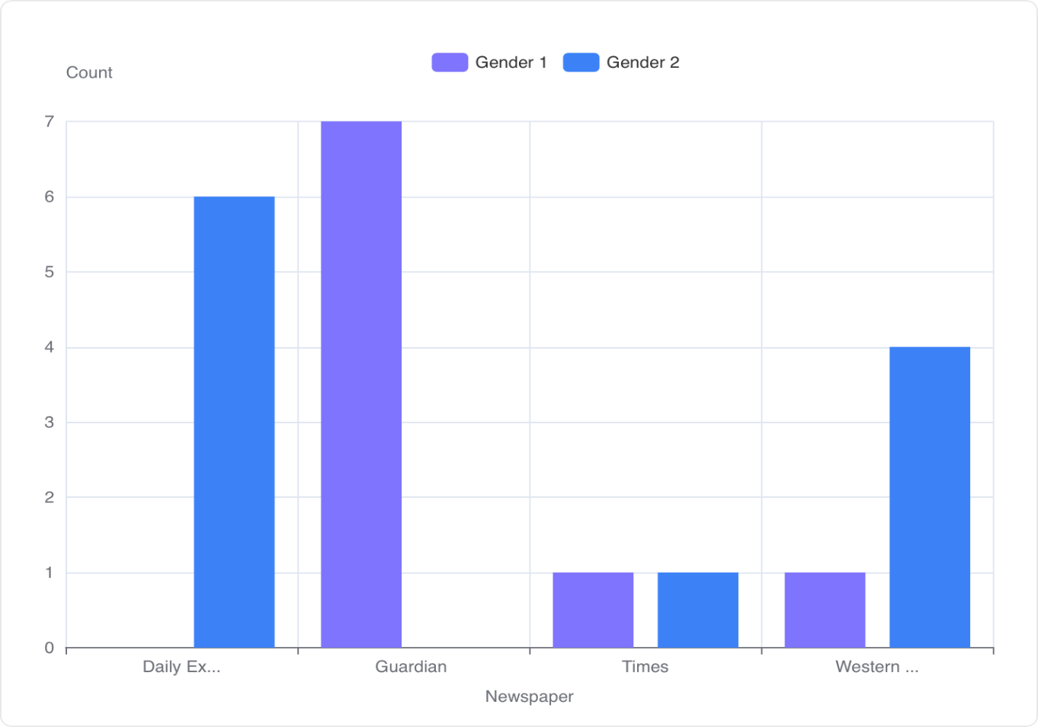

Contingency Table

The contingency table shows the distribution of newspaper preference for each gender.

Gender 1 (Male) prefers Daily Express (0), Guardian (7), Times (1), and Western Mail (1).

Gender 2 (Female) prefers Daily Express (6), Guardian (0), Times (1), and Western Mail (4).

Visualization
The grouped bar chart visualizes the contingency table, comparing newspaper preferences between the two genders.

Gender 2 (Female) shows a higher preference for Daily Express, while Gender 1 (Male) prefer the Guardian.
Both genders have similar, low preferences for the Times newspaper. Gender 2 (Female) shows a higher preference for Western Mail compared to Gender 1 (Male).

Statistical Significance
The Chi-squared test resulted in a p-value of approximately 0.002.
Section Summary
Distribution of Newspaper Preference varies between males and females. Female customers prefer the Daily Express, whilst male customers prefer the Guardian.

When looking at statistical significance, the p-value (0.002) is less than the conventional significance level of 0.05, indicating a statistically significant association between gender and newspaper preference. This findings suggests that the gender of the customer influences their newspaper choice. This finding would again lead to an opportunity for targeted marketing and even product placement near the respective newspapers.

How does the correlation between distance and opinion vary across different genders?

Correlation Calculation
During the analysis the correlation between 'Distance, meters' and 'Opinion' was calculated separately for males and females.

For male customers the correlation is approximately 0.0046, and for female customers the correlation is approximately 0.55.

Section Summary

The data analysis shows a clear Gender-based difference. There is a notable difference in the correlation between distance and opinion based on gender.

Female customers show a moderate positive correlation (0.55) between distance and opinion, suggesting that as distance increases, their opinion tends to increase as well. Compared to male customers who show almost no correlation (0.0046) between distance and opinion, indicating that distance has virtually no impact on their opinion.

Using a correlation matrix, explore the relationships between customer distance, spend, opinion, gender (encoded numerically), and newspaper preference (encoded numerically). Identify the strongest positive and negative correlations.

Correlation Matrix Overview


The correlation matrix provides insights into the relationships between different variables in the customer data.

Values range from -1 to 1, where values close to 1 indicate a strong positive correlation, values close to -1 indicate a strong negative correlation, and values close to 0 indicate a weak or no correlation.

Strongest Correlations

Distance and Spend: There is a strong negative correlation of -0.875 between distance and spend, suggesting that customers who live closer tend to spend more.

Female and male customers: There is a strong negative correlation of -0.826 between the female and male customers.

Correlation between female customers and the Guardian: There is a strong positive correlation of 0.816 between female customers and the newspaper.

Other Notable Correlations

Opinion and the Times Newspaper: There is a positive correlation of 0.479 between opinion and the Times newspaper.

Distance and the Times Newspaper: There is a positive correlation of 0.413 between distance and the times.

Spend and Daily Express Newspaper: There is a positive correlation of 0.293 between spend and Daily Express Newspaper.

Male customers and Daily Express Newspaper: There is a positive correlation of 0.663 between male customers and Daily Express Newspaper

Male customers and Daily Express Newspaper: There is a negative correlation of -0.674 between male customers and Daily Express Newspaper.

Section Summary

Key Findings: The strongest correlation exists between distance and spend (-0.875), indicating an inverse relationship where increased distance corresponds to decreased spending.

Gender and Newspaper Preferences: Gender appears to influence newspaper preferences, as indicated by the strong correlations between female customers and the Guardian (0.816), Male customers and Daily Express Newspaper (0.663), and Male customers and the Guardian (-0.674).

Opinion rating and the Times newspaper: Customer opinion has a positive correlation with the Times Newspaper (0.479).

Conclusion

Key Findings And Conclusions

The Quantitative Data Analysis Gwalia Stores report shows that the Gwalia customers have an average spend of £15.16. Male customers spend more on average, with an average spend of £16.2, compared to female customers, who on average spend £14.
When analysing the data between reader spending power, the Daily Express readers have the highest average spend £17.67, while Times readers have the lowest average spend £9.50. The average spend for Guardian readers is £15.57, and for Western Mail readers, it is £14.20.

The shop owners could look at a targeted marketing strategy. The strategy should focus their marketing efforts on male customers and readers of the Daily Express newspaper, as they have the highest average spend. They should also target customers with higher opinions, as the data shows they tend to spend more money.

By carrying out newspaper-specific adverts the Gwalia Stores could increase their advertising in the Daily Express newspaper to capitalize on the higher spending habits of its readers. The Times readers have the lowest spend currently and as such the store owners should re-evaluate or adjust their advertising strategies for the Times newspaper with a view of improving sales.

Reader preference and opinion scoring linkage
Female customers show a higher preference for Daily Express, whilst male customers prefer the Guardian. Both genders have similar, low preferences for Times. Female customers show a higher preference for Western Mail compared to their male counterpart customers.

Both genders have a similar average opinion of the local borough council with the female customer opinion scoring 2.3 and the male customer opinion scoring at 2.4. These discontent scores give the local borough council an opportunity to carry out a targeted marketing campaign.
If the local borough council members look at the reader ratings, they will note the Times newspaper has the highest average opinion score of 4.0, whilst the Western Mail newspaper has an average opinion score of 2.8. The Daily Express newspaper has an average opinion score of approximately 2.17, placing the Guardian newspaper with the lowest average opinion score of approximately 1.86. By leveraging on this data, they could carry out an aggressive campaign in the Guardian newspaper with an aim of moving the average opinion rating upwards.

Whilst local borough council could take advantage of the data, the store owners could create opinion-based offers. They could create targeted offers based on customer opinions to maximize spending. For example, offer discounts or bundles that appeal to customers with opinion '2', in both genders the average opinion scoring fell within the 2.3 to 2.4 category.

Gwalia Stores management could use the data to create actionable product placement in line with the gender preference newspaper results. The gender preference for newspaper choices of their customers, could be used when looking at product placement. By leveraging on their gender preference, the store could place items aligned with gender needs or purchasing desire close to those highlighted newspapers. This sort of product placement, will increase sales related to gender bias.

Distance and Proximity Promotions
The Gwalia Stores customers have an average shopper travel distance of 259.5 meters from their home to the store.

Given the negative correlation between distance and spend, Gwalia Stores could consider offering special promotions or incentives to customers who live further away to encourage them to spend more.

They could also offer a shop loyalty program. Shop loyalty programs are often effective as they encourage repeat purchases, especially when looking to attract customers who live further away. Loyalty programs also increase customer lifetime value by offering future benefits based on current spending. They motivate customers to spend more and purchase more frequently, leading to increased revenue for retailers.

References

BachelorPrint, 2021. 'ANOVA – Analysis of variance', BachelorPrint. Available at
ANOVA – Analysis of variance (Accessed: 12 June 2025).

GeeksforGeeks (2024) Karl Pearson’s Coefficient of Correlation: Methods and Examples, 31 May. Available at: https://www.geeksforgeeks.org/karl-pearsons-coefficient-of-correlation-methods-and-examples/ (Accessed: 12 June 2025).

Laerd Statistics (2015) Chi-Square Test for Association using SPSS Statistics. Available at: https://statistics.laerd.com/statistical-guides/chi-square-test-for-association-statistical-guide.php (Accessed: 12 June 2025).

McHugh, M.L. (2013) 'The Chi-square test of independence', Biochemia Medica, 23(2), pp. 143–149. Available at: https://www.google.com/search?client=safari&rls=en&q=Chi-squared&ie=UTF-8&oe=UTF-8 (Accessed: 12 June 2025).

