
Name: Abeer Al Qadhi
Student Number: 2410956
Course Name: Digital Transformation in the Health and Care Professions
Class Group: G2
Course Code: (BMHP6026_BIRM)
Lecturer Name: Tomy Adattu Chacko

Critical Evaluation of Technology-Enabled Remote Patient Monitoring within NHS Virtual Wards in England

Contents
Introduction 2
Workforce 3
Service Delivery 4
Patients and Service Users 5
Community 6
Conclusion and Recommendations 7
Reference list 8

Introduction
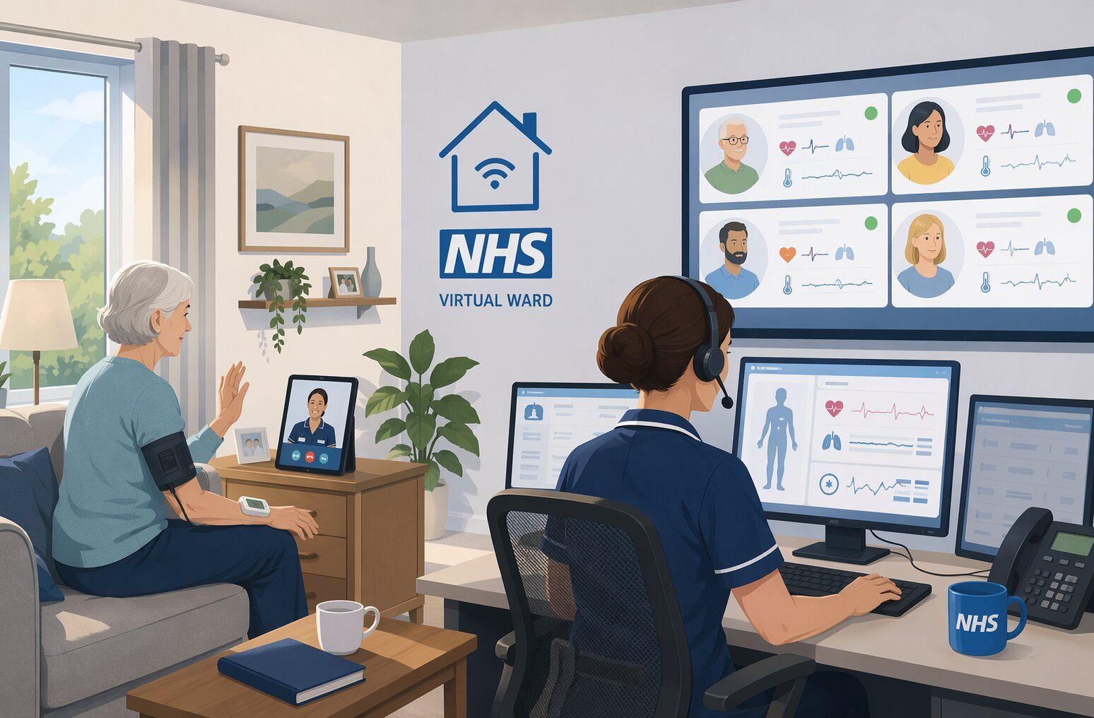
(The University of Manchester, 2026)
Digital transformation has become increasingly important in health and social care as services strive to address growing demand, workforce pressures, and limited hospital capacity (Ćwiklicki, Duplaga and Klich, 2022). A significant innovation introduced and expanded within the NHS over the last decade is technology-enabled remote patient monitoring (RPM) within virtual wards. Virtual wards, also known as hospital-at-home services, enable selected patients to receive hospital-level care in their usual place of residence (NHS England, 2023). This model uses devices such as pulse oximeters, blood-pressure monitors, and wearable sensors to transmit physiological observations to healthcare professionals via an application or digital platform. RPM, therefore, facilitates regular home monitoring, earlier identification of deterioration, and timely clinical intervention, while supporting admission avoidance or earlier discharge where appropriate (NHS England, 2023).
The development of virtual wards reflects a broader national policy to shift healthcare from hospitals to communities and to replace analogue processes with digitally enabled care. England's national virtual ward programme, launched in 2022, has since been implemented across integrated care systems (Chappell et al., 2024). This initiative aligns with the ambitions of A Plan for Digital Health and Social Care, which advocates for digitally enabled, connected, and person-centred services (Department of Health and Social Care, 2022), and the more recent commitment within the 10-Year Health Plan for England to move care from hospital to community settings (Department of Health and Social Care, 2025).
However, successful implementation should not be solely measured by the adoption of new technology. Its impact on professionals, service organisation, individual patients, and wider communities must also be taken into account. This report, therefore, critically evaluates technology-enabled remote patient monitoring within virtual wards, examining its implications for the workforce, service delivery, patients/service users, and communities.

Workforce
Remote patient monitoring transforms both the location and the nature of healthcare delivery. Rather than solely depending on in-person observations at the bedside, clinicians can review remotely transmitted physiological data, communicate with patients via telephone or video, and determine whether treatment should continue at home or necessitate hospital admission. This shift increases the demand for multidisciplinary collaboration among doctors, nurses, allied health professionals, community services, and, in some instances, social care. NHS England (2024a) highlights clinical leadership, appropriate staffing, multidisciplinary collaboration, and workforce competency as critical elements for the safe operation of virtual wards.
A potential benefit is that remote monitoring can allow staff to supervise several suitable patients simultaneously, without them occupying acute hospital beds. Professional acceptance is also positive. For instance, Thornton, Horton and Hardie (2023), in a UK survey of 1,251 NHS staff, found that 63% supported virtual wards. Nevertheless, staff particularly emphasised that patients must be able to access professional help and return rapidly to hospital if their condition deteriorates. This suggests that staff support is conditional on adequate clinical safeguards rather than solely on enthusiasm for technology.
Digitalisation introduces new competency requirements. Staff need to be confident in remote assessment, the use of digital platforms, the interpretation of transmitted observations, and escalation procedures. Research by Sidhu et al. (2023) on remote home-monitoring services in England found that successful implementation necessitated staff adapting to new work methods, underscoring the importance of appropriate training and organisational support.
More recent research indicates that digital technology does not automatically reduce workload. Lindsay, Cunnington, and Dixon-Woods (2025) observed that remote monitoring of individuals with frailty could increase the workload for professionals, patients, and carers, especially when responsibilities and processes lacked clarity. Similarly, Bradley et al. (2026), in their study of adult virtual wards across eleven hospital sites in North West England, identified multiple organisational factors that influenced implementation.
Consequently, describing RPM simply as a workforce-efficiency tool would be misleading. While it may release capacity within physical hospital wards, it can simultaneously generate additional work through reviewing dashboards, responding to alerts, troubleshooting equipment, and coordinating care across organisational boundaries. This aligns with the NHS What Good Looks Like framework, which identifies supporting a digitally capable workforce and maintaining safe digital practice as central to successful digital transformation (NHS England, 2026). The benefits of RPM, therefore, depend on technology being integrated into realistic staffing models rather than being added to existing workloads. Competency-based training, protected development time, digital champions, and clearly defined responsibility for responding to alerts could reduce implementation risks. However, these measures themselves require time and resources, meaning workforce investment should be regarded as an integral part of digital transformation rather than an optional additional cost.

Service Delivery
Remote monitoring fundamentally alters the traditional relationship between hospital and community care. Virtual wards can function in two ways: as a "step-up" pathway, preventing hospital admission by treating suitable patients at home, or as a "step-down" pathway, facilitating earlier discharge from hospital. Physiological data are transmitted to a digital platform for review by a clinical team, with escalation triggered if readings or symptoms indicate a patient's deterioration (NHS England, 2023). Consequently, acute-level monitoring is no longer confined to hospital settings.
Evidence increasingly suggests benefits to service delivery. An independent NHS England evaluation of 29 virtual ward pathways in South East England analysed over 22,000 admission-avoidance episodes. This evaluation estimated approximately 9,165 non-elective admissions were avoided annually, leading to an annual net financial benefit of approximately £10.4 million across the pathways studied (NHS England, 2024b). These findings offer relatively strong real-world evidence that virtual wards can assist in managing hospital demand. However, these results should not be automatically generalised across all NHS services, as effectiveness varied between pathways and service maturity was a significant factor.
Economic research illustrates this uncertainty. For instance, Jalilian et al. (2024), in their study of a virtual ward within Wrightington, Wigan and Leigh Teaching Hospitals NHS Foundation Trust, concluded that the service was not economically sustainable at its observed level of activity, highlighting the importance of sufficient patient throughput. Conversely, Rasoul et al. (2025) identified economic benefits associated with a heart-failure virtual ward in Liverpool. Similarly, Tomini et al. (2024), who analysed remote monitoring across 26 English sites, found lower average costs at sites employing technology-enabled approaches alongside analogue methods compared to those relying solely on analogue monitoring. However, as this study focused on pandemic-era services, its findings cannot be assumed to apply directly to all contemporary virtual wards.
These seemingly conflicting results are significant. They suggest that virtual wards should not be regarded as a standardised intervention that yields identical outcomes across all settings. Financial and operational success appears to hinge on factors such as patient selection, pathway design, utilisation, staffing, and local infrastructure. Norman, Bennett and Vardy (2023) also concluded that while the evidence for hospital-at-home models is promising, uncertainties persist regarding rapidly developing virtual ward models specifically. Therefore, local evaluation of implementation is crucial, rather than assuming that benefits demonstrated in one NHS trust will automatically transfer to another.

Patients and Service Users
Remote patient monitoring (RPM) offers patients the benefit of receiving acute care in familiar surroundings. Avoiding or shortening hospital stays can enable individuals to remain close to family, maintain independence and experience less disruption to their daily lives. However, Westby et al. (2024) emphasise that positive outcomes depend on the design of virtual wards and individual circumstances, rather than simply the location of care. Therefore, location alone should not be considered proof of an improved patient experience.
Research by Thornton, Horton and Hardie (2023) indicates considerable, though not universal, acceptance of virtual wards. Their study found that 71% of UK respondents were willing to consider virtual ward treatment if appropriate conditions were met, while 27% were unwilling. Furthermore, 78% were comfortable monitoring their health at home using technology. Despite this, some patients may prefer face-to-face assessment, especially when their condition is unstable or they lack confidence in recognising deterioration.
Walton et al. (2022) observed that while remote home monitoring can offer reassurance and support recovery, it can also shift responsibility towards patients and their families. This is particularly pertinent for older individuals and those with frailty, cognitive impairment, sensory difficulties or limited digital literacy. Consequently, technology may enhance independence for some, while increasing anxiety or dependency for others. A service cannot be truly patient-centred if an individual is unable or unwilling to use it safely.
Patient choice is therefore paramount. Shared decision-making should take into account a person's health condition, home environment, digital confidence and available support. This aligns with the What Good Looks Like framework (NHS England, 2026), which advocates empowering people through digital transformation rather than expecting them to simply adapt to technology.
Data privacy is another significant concern due to the sensitive nature of health information involved in RPM. Health data is classified as special-category personal data, requiring additional safeguards (Information Commissioner's Office, 2024). Services must therefore comply with the UK GDPR and Data Protection Act 2018, ensuring information is processed lawfully, securely and transparently. Appropriate access controls and clear communication about data use are also crucial for maintaining patient trust.
In summary, patient-centred implementation of RPM involves more than just supplying equipment. Patients require informed choice, appropriate training, technical support and a reliable pathway back to face-to-face or hospital care when needed. Maintaining non-digital alternatives may therefore be more equitable than assuming digital delivery is suitable for everyone.

Community
The community dimension is significant because virtual wards intentionally relocate care from institutional settings. Patients may receive treatment in their own homes or residential care facilities, which alters not only the location of healthcare delivery but also the individuals involved in providing it. This aligns with current policy objectives to transition care from hospitals to community settings (Department of Health and Social Care, 2022).
For families, home-based care can be beneficial, as relatives can stay close to the patient and avoid prolonged hospital visits. However, the apparent transfer of care into the community may also shift practical responsibilities to unpaid carers. Family members might assist patients with measuring observations, operating devices, communicating with clinicians, or identifying deterioration. Lindsay, Cunnington and Dixon-Woods (2025) observed that remote monitoring could generate additional work for both patients and carers, demonstrating that a reduction in formal hospital care does not necessarily equate to a reduction in the overall care required. Consequently, co-production is crucial: services ought to be designed in collaboration with patients and carers, rather than assuming that families are willing or able to undertake additional responsibilities.
Digital inequality represents another major concern. The South East evaluation found consistent under-representation of Black and minority ethnic populations in the virtual ward cohorts analysed alongside significant gaps in recorded ethnicity data (NHS England, 2024b). Similarly, Pahirden, Stefler and Jayatunga's (2026) systematic review concludes that questions persist regarding the equity of virtual ward models across UK sociodemographic groups. This issue extends beyond technical skill. Factors such as reliable internet access, housing conditions, language barriers, disability, deprivation, and the availability of family support can all influence the practicality of home monitoring.
This creates a potential contradiction within digital transformation. While remote monitoring can reduce geographical barriers by delivering specialist care into the patient's home, potentially benefiting those living far from hospitals, it can simultaneously create new barriers for individuals whose homes, connectivity, or support networks are unsuitable. Consequently, community implementation should incorporate digital-inclusion assessments, provide equipment and connectivity support, ensure accessible communication, and offer an alternative pathway for patients unable to safely utilise the technology. Furthermore, population-level evaluation should monitor uptake and outcomes disaggregated by deprivation, ethnicity, disability, and other relevant characteristics, rather than solely reporting overall figures.

Conclusion and Recommendations
Technology-enabled remote patient monitoring, facilitated by virtual wards, represents an important recent change in NHS care. Its adoption has redefined professional roles, modified clinical workflows, allowed for the provision of hospital-level care in patients' homes, and enhanced opportunities for individuals to actively manage their health. Evidence from England suggests potential reductions in hospital activity and, in certain services, financial advantages. However, it is also clear that successful outcomes are not guaranteed. Factors such as workforce requirements, patient selection, service maturity, technology reliability, and local context significantly impact effectiveness.
From a workforce standpoint, remote monitoring necessitates new digital proficiencies and clearly defined responsibilities for clinical escalation. Regarding service delivery, while virtual wards may enhance hospital flow, the economic benefits vary across different services. Patients may value the independence and opportunity for recovery at home, but their digital literacy, privacy concerns, safety, and personal preferences must be respected. At a community level, virtual wards can broaden access to home-based care; however, they may also increase the burden on unpaid carers and perpetuate existing inequalities.
Future implementation should therefore prioritise quality over merely increasing the number of virtual beds. NHS organisations ought to provide competency-based workforce training, establish clear escalation pathways, involve patients and carers in service design, actively monitor inequalities, offer alternatives for digitally excluded patients, and routinely evaluate clinical, financial, and patient-ported outcomes. These actions would help ensure that remote monitoring genuinely supports person-centred digital transformation, rather than simply replicating hospital processes within the home environment.

Reference list
Bradley, F., Howells, K., Gasteiger, N., Sanders, C., Blakeman, T. and Dowding, D. (2026) ‘Factors affecting implementation of hospital inpatient-level care at home: a qualitative study of virtual wards in North West England’, BMJ open, 16(4), p. e111868. Available at: https://doi.org/10.1136/bmjopen-2025-111868.
Chappell, P., Co, M., Hardie, T., Lloyd, T., Tallack, C., Gerhold, M. and Mayers, C. (2024) ‘What do virtual wards look like in England? (Working Paper)’, The Health Foundation. Available at: https://www.health.org.uk/sites/default/files/upload/publications/2024/What%20do%20virtual%20wards%20look%20like%20in%20England_0.pdf (Accessed: 24 September 2026).
Ćwiklicki, M., Duplaga, M. and Klich, J. (eds.) (2022) The digital transformation of healthcare : health 4.0. Abingdon, Oxon ; Routledge.
Department of Health and Social Care (2022) A plan for digital health and social care. Available at: https://www.gov.uk/government/publications/a-plan-for-digital-health-and-social-care/a-plan-for-digital-health-and-social-care (Accessed: 25 September 2026).
Department of Health and Social Care (2025) Fit for the future: 10 Year Health Plan for England (accessible version). Available at: https://www.gov.uk/government/publications/10-year-health-plan-for-england-fit-for-the-future/fit-for-the-future-10-year-health-plan-for-england-accessible-version (Accessed: 24 September 2026).
Information Commissioner's Office (2024) Special category data. Available at: https://ico.org.uk/for-organisations/uk-gdpr-guidance-and-resources/lawful-basis/a-guide-to-lawful-basis/special-category-data/ (Accessed: 24 September 2026).
Jalilian, A., Sedda, L., Unsworth, A. and Farrier, M. (2024) ‘Length of stay and economic sustainability of virtual ward care in a medium-sized hospital of the UK: a retrospective longitudinal study’, BMJ open, 14(1), p. e081378. Available at: https://doi.org/10.1136/bmjopen-2023-081378.
Lindsay, R.K., Cunnington, P. and Dixon-Woods, M. (2025) ‘Why is implementing remote monitoring in virtual wards (Hospital at Home) for people living with frailty so hard? Qualitative interview study’, Age and ageing, 54(1). Available at: https://doi.org/10.1093/ageing/afaf003.
NHS England (2023) Virtual wards enabled by technology: Guidance on selecting and procuring a technology platform. Available at: https://www.england.nhs.uk/long-read/virtual-wards-enabled-by-technology-guidance-on-selecting-and-procuring-a-technology-platform/ (Accessed: 23 September 2026).
NHS England (2024a) Virtual wards operational framework. Available at: https://www.england.nhs.uk/long-read/virtual-wards-operational-framework/ (Accessed: 25 September 2026).
NHS England (2024b) Summary of South East region virtual wards evaluation. Available at: https://www.england.nhs.uk/long-read/summary-of-south-east-region-virtual-wards-evaluation/ (Accessed: 26 September 2026).
NHS England (2026) Digital Maturity Assessment report 2024 and 2025 results. Available at: https://digital.nhs.uk/data-and-information/digital-maturity-assessment-report-2024-and-2025-results (Accessed: 27 September 2026).
Norman, G., Bennett, P. and Vardy, E.R.L.C. (2023) ‘Virtual wards: a rapid evidence synthesis and implications for the care of older people,’ Age and ageing, 52(1). Available at: https://doi.org/10.1093/ageing/afac319.
Pahirden, G.R., Stefler, D. and Jayatunga, W. (2026) ‘The equity of virtual ward models of care across sociodemographic groups in the United Kingdom – a systematic review’, Journal of Integrated Care, 34 (1), pp. 58–74. Available at: https://doi.org/10.1108/JICA-03-2025-0018
Rasoul, D., Chattopadhyay, I., Mayer, T., West, J., Stollar, H., Black, C., Oguguo, E., Kaur, R., MacDonald, R., Pocock, J., Uzdzinska, B., Umpleby, B., Hex, N., Lip, G. Y. H. and Sankaranarayanan, R. (2025) ‘Economic evaluation of the Liverpool heart failure virtual ward model’. European heart journal. Quality of care & clinical outcomes, 11(2), pp. 197–205. Available at: https://doi.org/10.1093/ehjqcco/qcae095.
Sidhu, M., Walton, H., Crellin, N., Ellins, J., Herlitz, L., Litchfield, I., Massou, E., Tomini, S. M., Vindrola-Padros, C. and Fulop, N. J. (2023) ‘Staff experiences of training and delivery of remote home monitoring services for patients diagnosed with COVID-19 in England: A mixed-methods study’, Journal of health services research & policy, 28(3), pp. 171–180. Available at: https://doi.org/10.1177/13558196231172586.
The University of Manchester (2026) New study examines how safety is delivered in NHS virtual wards. Available at: https://www.manchester.ac.uk/about/news/new-study-examines-how-safety-is-delivered-in-nhs-virtual-wards/ ( Accessed: 29 September 2026)
Thornton, N., Horton, T. and Hardie, T. (2023) How do the public and NHS staff feel about virtual wards?. The Health Foundation. Available at https://www.health.org.uk/reports-and-analysis/analysis/how-do-the-public-and-nhs-staff-feel-about-virtual-wards (Accessed: 24 September 2026).
Tomini, S. M., Massou, E., Crellin, N. E., Fulop, N. J., Georghiou, T., Herlitz, L., Litchfield, I., Ng, P. L., Sherlaw-Johnson, C., Sidhu, M. S., Walton, H. and Morris, S. (2024) ‘A Cost Evaluation of COVID-19 Remote Home Monitoring Services in England’, PharmacoEconomics - Open, 8(5), pp. 739–753. Available at: https://doi.org/10.1007/s41669-024-00498-3.
Walton, H., Vindrola‐Padros, C., Crellin, N. E., Sidhu, M. S., Herlitz, L., Litchfield, I., Ellins, J., Ng, P. L., Massou, E., Tomini, S. M. and Fulop, N. J. (2022) ‘Patients’ experiences of, and engagement with, remote home monitoring services for COVID‐19 patients: A rapid mixed‐methods study’, Health Expectations : An International Journal of Public Participation in Health Care and Health Policy, 25(5), pp. 2386–2404. Available at: https://doi.org/10.1111/hex.13548.
Westby, M., Ijaz, S., Savović, J., McLeod, H., Dawson, S., Welsh, T., Le Roux, H., Walsh, N. and Bradley, N. (2024) ‘Virtual wards for people with frailty: what works, for whom, how and why—a rapid realist review’, Age and ageing, 53(3). Available at: https://doi.org/10.1093/ageing/afae039.

