researching ANd analysing DATA

Table of Contents
Introduction 2
Articulating the question 3
The core question 3
The sub questions 3
Gathering the information 4
SOURCES 4
Method of the research 4
Statistical Analysis 5
Consumers 5
Retailers 7
Findings 10
Findings from the primary data: 10
Findings from the secondary data 10
Combining both primary and secondary data to answer the core question 11
Further research questions 11
Appendix 12
1. References 12
2. Questioner 13
Retailers 13
Consumers 13
3. Snap shots of the data set 13
Consumers 13
Retailers 14

Introduction

I have based my short research on ONLINE SHOPPING AND HIGH END STORES for our understanding some basics of how to collect gather and visualise and show data in an effective statistical way. I have surveyed two types of people 1. Retail shop owners 2. Consumers. The main question for my research was how the retail high end shops are changing by the effect of internet? It was a hard task for me as the information was not easily available. The shop owners were reluctant to give away the information but I have tried as much as we can to gather to the information and done the statistical analysis on the topic then found some things that might really help us to go forward

Articulating the question
To design the project my objective was to answer a question which is too descriptive .So I have put that question as the core question and divided them into some sub questions.

The core question
How the retail high end shops are changing by the effect of internet? (Butler, 2017)

The sub questions
- The effects of digital disruption (O'Hanley and Tiller, n.d.) in the high end retail shops business model
- Effects of digital retail shops in the tax structure (O&#x27;Carroll, 2017)
- What are the key things in a company that measures (Levy, 2013)the Business digitalisation
To do our research we have prepared a 2 questioners Appendix 2, 3, for different samples .Our samples were the High end retail shoppers and consumers of high end retail shops. Then I have gathered the information and tried to show them with a more comprehensive view by doing some statistical analysis and lastly interpreted (Levy, 2013) the data and shared my findings based on the core question.

Gathering the information

SOURCES
I have gathered the information by two sources
- Primary: I have tried to make the research as comprehensive as possible but the primary data was hard to collect and it was filled with biases of the respondents. Keeping all aside I have asked 43 consumers with a google doc and 37 retail shoppers personally to collect the data that I presented.
- Secondary: I have also tried to gather some information from the web and various books that our course teacher suggested then tried to make the most of the conclusion they had made to measure our data .The used internet links, books and eBooks are given in the reference appendix

Method of the research
I have followed this method to do this assignment
- Gathering information from 2 sources with 3 different questioners
- Doing some statistical analysis on the found data
- Interpreting the information
- Gathering the key information from the web
- Drawing some findings and answering the core question in the lights of the sub questions
So as we have chalked out our assignment we have put the data on the excel sheets and the results of the statistical information is given on the next Chapter

Statistical Analysis

Consumers
Q1Mean of the people’s ratings of choosing online High end retail shopping on a scale of 1 – 10.
Ans. 6.78
Interpretation: This means that the data set we have used to has told us that they give internet shopping a rate of 6.78 on an average
Q2 Mode of the people’s ratings of choosing online High end retail shopping on a scale of 1 – 10.
Ans. 8
Interpretation: This most of them has given a rating of 8
Standard deviation on the data is 2.08 which proves that there is spread of 2.08 in the data set so as the highest range Is 10 it is a huge spread . (Schmuller, n.d.)
Q3 Then we will see how many people has given their consent in online shopping with a help of a bar chart

So most of them thinks it is easy to buy from online rather going to the high end shops and buying the products (Schmuller, n.d.)

Q4 the next thing I have worked with is do they think it is cost effective to buy from an online retailer rather the high end shops?

Interpretation: Most of them thinks it is cost effective as I did not talk with them by person I cannot say that why they think of this in that manner (Schmuller, n.d.) but retailers gave us some valuable information about this which will be explained later
The next question I asked them was do they feel they are okay sharing information this gave to the internet?

This gave us surprising results
Most of them replied negatively. Although they are happy with what (Schmuller, n.d.) they are having they are a bit worried about the security information.
As we have judged it from the customer point of view now we judge it from the retailer point of view

Retailers
We have asked them some relevant question these are the answers we got from them
Q1. On a scale of 1-10 how much would you rate online selling?
We have calculated the mean median mode from the collected ratings
Mean 7.342105
Median 8
Mode 9
Standard deviation 1.475499
Interpretation this proves that most of the retailers love online selling and as it is larger than the online experience of the consumers as I talked with them they told their tax has been decreasing as the online selling does not hold account to the tax system
Q2) How many of the people uses online selling?
We have found that the high end shops selling online are plenty which shows the significance of the current online development and the huge impact of the online in the high end retail shops (Schmuller, n.d.)

As we can see from this chart that most of (Berk and Carey, 2010) the high end sellers are selling online to cope with the online bubble.
Q3) Is it cost effective?
As per the most high end shops the online selling is more cost effective for certain tax mitigation and the fact that they don’t need any physical stores to display their products .This gives them a huge cost advantage The people we have surveyed (Berk and Carey, 2010) gave us the following result

As we see most of the respondent said it saves cost and as we talked more they told their cost gets exceedingly low as they don’t have to waste time to make the displays they could just show it online a and sell it easily and tax is another huge factor they get an advantage on .

Q4. Which part of online selling give you a competitive advantage

We have organised the data with a bar chart which is given below

Interpretation: As we can see Most of the people use the internet for the tax advantage and not applicable people does not use online selling (Berk and Carey, 2010) this proves that the government is lenient in the lights of selling online and want this industry to grow as fast as possible.

Q5 Do you use the data that are found from your online selling?

As you can see although they use the online selling tool often they still have not gotten used the data culture so we can say finally that although are starting to get in the habit of online and it is disrupting the very nature of the industry

Here you can see most of the people says they don’t use the large set of data they get from the users .So this is also significant when we try to give a shape of the digitalisation of the high-street shops.

Findings

Findings from the primary data:
As the usage of internet is increasing the business model of the high end as the government is giving tax exemption this is one of the reason this industry is blooming rapidly. So the key finding I found from the primary data are given below
- Online is more cost effective to both consumers and retailers
- Although the structure of the online is selling is on the rise it needs huge development on the data sector
- Customers thinks it is easier to buy online rather offline
- Most of the cost effectiveness comes from the tax deduction from the online selling

Findings from the secondary data
I have not just surveyed the regular people I did a lot of research on the topic and found out the following things
- Although the tax advantage on online selling the government is trying to increase the online selling as the growth is rapid
- As the online disruption is increasing the online security concern is (Levy, 2013) also increasing.
- The consumers are opting for more convenience (O'Hanley and Tiller, n.d.) for the online shopping
- The future of online selling lies in the cost structure and one (Deloitte United Kingdom, 2017) of the most important thing our respondent failed to answer are the delivery system of the high end online shops
- Almost 65% of the sell are online for the high end shops

Combining both primary and secondary data to answer the core question
As we have analysed the whole data set and collected information (Deloitte United Kingdom, 2017) from the web we have found 3 core things the internet is changing
- Cost
- Reach
- Efficiency
Although it is proving to be more effective it is raising serious security concern the buyers and also the online sellers are evading tax so it is helping the country in a least friendly manner.

Further research questions
- Doing a survey on the government (Harvey, 2017) employees to get a comprehensive view on the taxation of the online and offline retail tax structure. Evaluate the difference.
- Getting more sample to conduct the analysis (Harvey, 2017).
- Further research on data security

Conclusion

So from my primary and secondary data we got to understand that our research on the how the high end retail shops are changing rapidly with the usage of internet (Harvey, 2017) .The people are getting more used to the internet and the retailers are also comfortable with its cost structure as it has to provide less tax. As more than 66% (Harvey, 2017) of the total retail sellers tend to sell online this provides the picture of the growing nature of online selling and finally the consumers are also getting used to this trend .But The data security is a concern for the consumers which must be coped with very cautious steps by the government and the people involved

Appendix

References
Berk, K. and Carey, P. (2010). Data analysis with Microsoft Excel. Boston, Mass.: Brooks/Cole.
Butler, S. (2017). John Lewis to extend online shopping empire via thousands of corner stores. [online] the Guardian. Available at: https://www.theguardian.com/business/2013/feb/21/john-lewis-online-shopping-collect?INTCMP=ILCNETTXT3487 [Accessed 28 Dec. 2017].
Deloitte United Kingdom. (2017). Drivers of digital disruption | Deloitte UK. [online] Available at: https://www2.deloitte.com/uk/en/pages/energy-and-resources/articles/digital-disruption-in-the-utilities-sector.html [Accessed 28 Dec. 2017].
Harvey, F. (2017). Kingfisher chief warns of store closure over online firms' tax advantage. [online] the Guardian. Available at: https://www.theguardian.com/business/2013/mar/04/kingfisher-warns-of-store-closures [Accessed 28 Dec. 2017].
Levy, H. (2013). The Shops of Britain. Hoboken: Taylor and Francis.
O&#x27;Carroll, L. (2017). City must wake up to digital growth, says tech investor. [online] the Guardian. Available at: https://www.theguardian.com/business/2013/mar/01/city-wake-up-digital-investor [Accessed 28 Dec. 2017].
O'Hanley, R. and Tiller, J. (n.d.). Information security management handbook.
Schmuller, J. (n.d.). Statistical analysis with Excel for dummies.
Susilo, W. and Mu, Y. (2014). Information Security and Privacy. Cham: Springer International Publishing.

2. Questioner

Retailers
- Which part of the internet changed your whole business?
- How much do you prefer to sell online on a scale of 1 -10?
- Do you use the data to enhance the user experience?
- Do you think it is cost effective?

Consumers
- Do you find it easy to shop online?
- On a scale of 1-10 How much would you rate your experience.
- Do you think it is cost effective?
- Do you think you are okay to share the information you are sharing?

3. Snap shots of the data set

Consumers

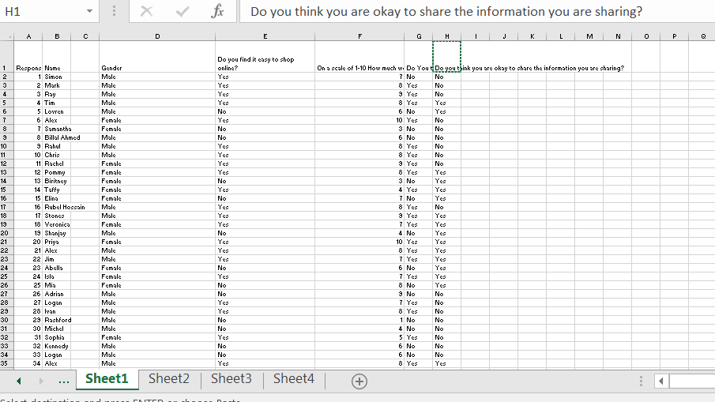

Retailers



