Painting from Botanical still life

Working from the provided studio setup, you are tasked to look, observe and identify emerging shape, forms and patterns.

Working on two or three compositions simultaneously, exploring stripes, background and foreground with media onto coloured ground. You will explore the variety of brushes that you have in your kit and use them as a tool, working across the 3 pieces using brushwork techniques, while adding in texture from other media such as paint sticks and oil pastel. You are tasked to work loosely, directly (no drawing out shapes first to explore painterly textured detail. You will work with colours from the botanical beauty palette, to explore motif and gather information.

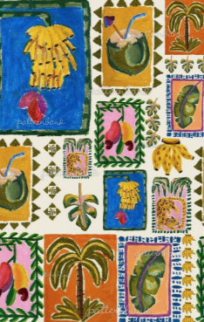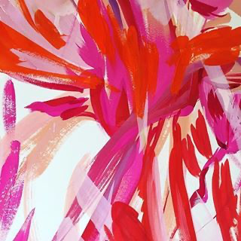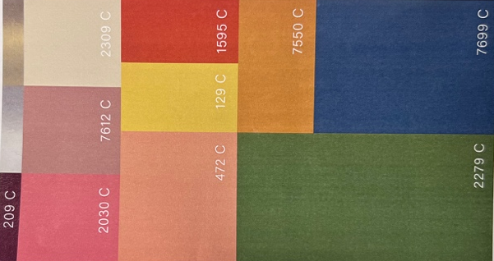

Malungo Art Alexandra Farmer

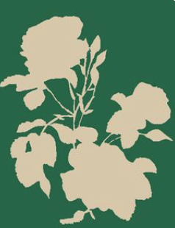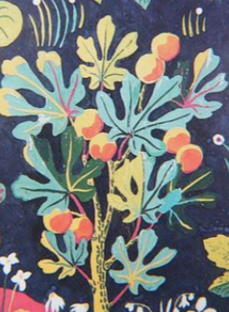

Unknown Josef Frank
Additional Tasks: Research (this should be informing your learning, relating to the session, of interest to you and connected to your outcomes).

- Identify and look up at least 5 artists/ designers, use the list of names provided and ensure that you look at the work of:
  - V&A botanical painting and drawing in the collections archive
  - Alexandra Farmer
  - Studio Coverdale
  - Hebe Studio
  - Kitty Mccall
  - Paul Gauguin

- Record your findings and print 3 different images from the 5 artists that you are inspired by, add to your sketchbook. This is suggested, you may have more or less.

- Expand on your findings, note key points about the images, colour, process, technique, media used (small notes, no large chunks of text needed). You should be questioning the relevance of the imagery and how it relates to the learning so far.

To extend the session; consider creating additional themed paintings taking them beyond, by adding techniques and media from the session that you have explored previously. How could your stamp motifs work to create frames and decorative borders. Continue to work on your drawing and painting, to extend the body of work and find newness, difference and individuality in your imagery.

