Module Title: Marketing Essentials

Module Code: BMIH4005

Re-Sit

Component A: Marketing Plan

Name: Basem Issam Elhersh
ID: 2234245
Lecturer Name: Scott James

Table of Contents
Introduction 3
Situation Analysis 4
5Cs 4
Objectives 7
Strategy 8
Tactics 9
Action 11
Control 12
Conclusion 13
References 14
Appendices 16
SWOT Analysis 16
PESTLE Analysis 16
Similarweb 16
Component B: Presentation 17

Introduction
Brand visibility and brand awareness is the marketing issue which Ibis is facing. The Ibis Chesterfield North-Barlborough brand is brought to more people's attention because of this marketing strategy. This is for the benefit of stakeholders who want to increase the hotel's presence in the market. The strategy for the plan will make use of SOSTAC, the 4'Ps, and Ansoff's grid. In the current economic climate, the strategy proposes to implement these strategies to enhance the hotel's brand recognition as well as its position in the market.

Situation Analysis

5Cs
Company: The Ibis Chesterfield North - Barlborough's SWOT analysis highlights its prominent location and well-established brand. Nevertheless, it has flaws such as outdated furnishings and limited facilities (Calles, 2023). Opportunities exist in service expansion, digital marketing, and sustainability. But the hotel is under threat from intense competition, evolving regulations, and economic shifts. In a cutthroat market, this micro study establishes the foundation for brand awareness.
Customers: SimilarWeb data is used for Ibis Chesterfield North - Barlborough's customer segmentation and targeting to yield insightful information. The hotel's primary clientele consists of budget-conscious leisure tourists, business travellers looking for accessible locations, and tech-savvy consumers using online booking services (Gill, 2023). The hotel can modify its marketing to reach and interact with a wider range of customers by identifying these segments.
Competitors
Perceptual positioning map
High Price
Low Price
Low Quality
High Quality

Radisson Hotel
Hilton Hotel
Marriott Hotel

Sheraton Hotel
Holiday Inn
Ibis

Ibis Chesterfield North receives a rating from Bowman's Strategy Clock "Low Price/Low Value." Accommodations that are friendly to those on a budget and place an emphasis on cost efficiency may provide fewer features than their competitors do while charging higher fees (Moro et al., 2020).
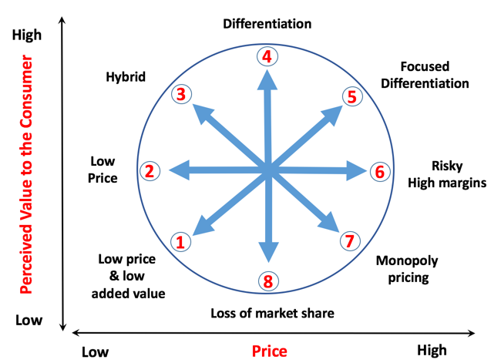
Ibis
Collaborators: The Ibis Chesterfield North - Barlborough collaborates with internet booking platforms, travel brokers, and local event organisers (London Filemed.com and The Event Book.UK) to provide accommodations for guests. Partnerships between local attractions and transport providers enhance visitors' experiences (Kozhukhіvska et al., 2022). The hotel is also thinking about getting into the franchising business to expand its network and boost its brand recognition in other areas.
Climate
The success of the Ibis Chesterfield North is impacted by a variety of PESTLE factors. Its operations are influenced by local rules and taxes, while its revenue is influenced by economic stability and trends in tourism (Kim, Lee and Han, 2019). Customers are impacted by demographics and digital trends, and the company's long-term performance in the business is ensured by its compliance with sustainability and safety standards.

Marketing Mix
Ibis Chesterfield North - Barlborough is a reasonably priced option with comfortable rooms that come with basic conveniences. Affordable due to competitive prices and sporadic decreases (Zarei, 2014). Hotel visibility is increased by partnerships, web marketing, and loyalty schemes. Its excellent location makes it easy to visit nearby attractions.
Element | Description
Product | Comfortable rooms, basic amenities
Price | Competitive rates, and occasional discounts (Hay, 2017).
Promotion | Online marketing, partnerships, loyalty programs
Place | Prime location, accessibility to attractions

Objectives
The SMART objective of the marketing strategy is to raise Ibis Chesterfield North-Barlborough brand awareness by 25% in a single year. This will be accomplished through targeted marketing strategies that build on the hotel's advantages and placement in the market. Goals that are time-bound, relevant, quantifiable, practical, and specific maintain an eye on market presence and brand recognition (Hassanien and Dale, 2019). The goal of solving the marketing problem is the foundation for all of the concepts, strategies, and actions in the marketing plan.

Strategy
To raise awareness of the Ibis brand, the Ibis Chesterfield North - Barlborough will emphasize providing exceptional service and one-of-a-kind experiences for its guests. This strategy, which uses Ansoff's grid as its foundation, aims to increase market penetration within current categories (Kapoor, Singh and Manchanda, 2023). As a result, modifications to the marketing mix are required. These modifications, which focus mostly on promotion and product offerings, bring attention to the enhancements made to services to change the attitudes of customers and attract a more diverse audience. It may be possible to highlight these developments, improve the company's reputation, and increase its market share by enhancing the online presence of the brand and applying targeted advertising (Rachmawati, Handayani and Kuswanto, 2020). The marketing problem may now be resolved, and market reach and reputation are both enhanced as a result of these adjustments to the plan.

Tactics
The RACE framework is an essential component of communication strategies. It all begins with "Reach," which expands Ibis Chesterfield North-Barlborough's online presence and reach through the distribution of content and the use of social media. To "act" means to attract the attention of the audience through the use of compelling content, posts that encourage participation, and online advertising to elicit responses (Sadraei et al., 2022). "Convert" can transform interested audiences into customers thanks to the convincing messaging and calls to action that it designs. "Engage" builds consumer relationships through the use of post-stay feedback and individualised content to sustain brand awareness.
Restoring communication at the hotel is essential to address the difficulties raised by the situational analysis. Increased social media engagement can be achieved through the use of frequent updates that are interesting, interactive campaigns, and active customer feedback. Online readers can be engaged through the use of informative blog posts, alluring graphics, and compelling narratives (Mamahit, Worang and Rumokoy, 2019). Through the use of collaborative marketing, a brand's visibility will be increased if it enters into strategic partnerships with local businesses, event organisers, and travel influencers.
The hotel's communication environment is characterised by inconsistencies in branding as well as the absence of a content calendar. These concerns contribute to a decrease in brand visibility. A unified branding approach will ensure that both the brand messaging and the visual identity are consistent, which will allow this problem to be fixed (Giglio et al., 2019). Having a content calendar will guarantee that relevant content is distributed regularly, which will engage audiences. Positive customer sentiment can be boosted by the use of visitor testimonials and by encouraging guests to share their experiences (Similarweb.com, 2023). The legitimacy of user-generated content such as reviews, photos, and posts on social networks will be enhanced through promotion.
Data analytics will be used to determine how effectively these modifications have been implemented. The success of your website traffic, activity on social media platforms, and email campaign will tell what works and what needs to be adjusted (Bacari, Séraphin and Gowreesunkar, 2021). Adjustments to the communication plan that are driven by these measurements will result in an increase in both the visibility and the awareness of the Ibis Chesterfield North-Barlborough brand.

Action
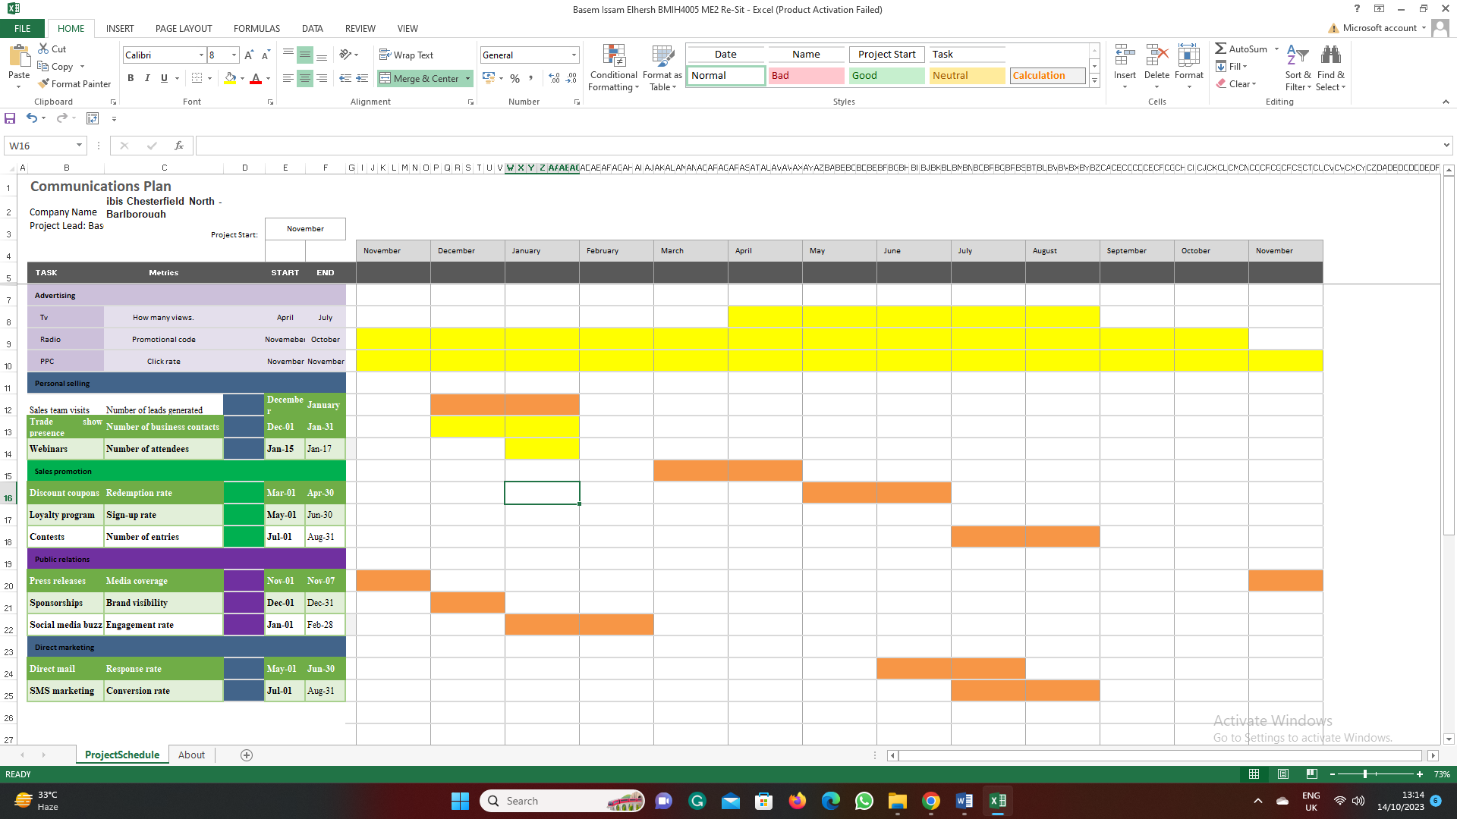
Figure: Gantt chart
Source: Author
This marketing channel schedule is based on peaks in user engagement and competitor activity. This allows us to coordinate our communication efforts with the times of day when our target audience is the most active and receptive. By pre-emptively scheduling social media posts, email campaigns, and content releases during times of high engagement, we can optimise our ability to reach consumers and encourage their participation (Hussain et al., 2020). Keeping an eye on the activities of our competitors helps us remain nimble and flexible in a market that is constantly shifting, which contributes to our success in gaining brand visibility and awareness.

Control
KPI monitoring is essential to achieving success. This includes increased website traffic, activity across social media, and feedback from customers, all of which point to improved brand visibility. Success in marketing can also be determined by additional metrics, such as increased revenue and the number of new customers acquired (Hay, 2017). Brand happiness can be measured through surveys and sentiment analysis, whilst financial impact can be measured through profitability analysis. These metrics give a comprehensive picture of how successfully the marketing strategy boosted consumers' recognition of the brand.

Conclusion
Marketing issues that have been particularly important for Ibis Chesterfield North-Barlborough include increasing brand recognition and awareness. Modifications will be made to customer engagement, brand positioning, and strategic communication as part of the plan. Maintain data-driven optimisation, adjust to ever-shifting market conditions, and listen to and act on input from customers. To generate a positive reputation for the brand while also establishing it as a top choice in the highly competitive hotel industry.

References
Bacari, C., Séraphin, H. and Gowreesunkar, V. (2021). Sustainable development goals and the hotel sector: case examples and implications. Worldwide Hospitality and Tourism Themes, ahead-of-print(ahead-of-print). doi:https://doi.org/10.1108/whatt-08-2020-0085.
Bourke, J.G., Izadi, J. and Olya, H.GT. (2020). Failure of play on asset disposals and share buybacks: Application of game theory in the international hotel market. Tourism Management, 77, p.103984. doi:https://doi.org/10.1016/j.tourman.2019.103984.
Calles, A.R. (2023). Exploring The 10 Best Ibis Hotels In London For An Affordable Yet Amazing Stay. [online] TheTravel. Available at: https://www.thetravel.com/ibis-hotels-london/ [Accessed 4 Oct. 2023].
Giglio, S., Pantano, E., Bilotta, E. and Melewar, T.C. (2019). Branding luxury hotels: Evidence from the analysis of consumers’ ‘big’ visual data on TripAdvisor. Journal of Business Research, 119. doi:https://doi.org/10.1016/j.jbusres.2019.10.053.
Gill, R. (2023). Ibis boosts presence in UK with new properties. [online] www.businesstravelnewseurope.com. Available at: https://www.businesstravelnewseurope.com/Accommodation/Ibis-boosts-presence-in-UK-with-new-properties [Accessed 4 Oct. 2023].
Hassanien, A. and Dale, C. (2019). Hospitality business development. London: Routledge.
Hay, C. (2017). How to grow your hospitality business : a guide for owners and managers. Auckland, New Zealand: Hay Publishing.
Hussain, I., Mu, S., Mohiuddin, M., Danish, R.Q. and Sair, S.A. (2020). Effects of Sustainable Brand Equity and Marketing Innovation on Market Performance in Hospitality Industry: Mediating Effects of Sustainable Competitive Advantage. Sustainability, 12(7), p.2939. doi:https://doi.org/10.3390/su12072939.
Kapoor, R., Singh, A. and Manchanda, G. (2023). Hospitality internships and green leaders: analysing the engagement of interns with hotel sustainable development practices. Worldwide Hospitality and Tourism Themes. doi:https://doi.org/10.1108/whatt-02-2023-0023.
Kim, J.J., Lee, Y. and Han, H. (2019). Exploring competitive hotel selection attributes among guests: An importance-performance analysis. Journal of Travel & Tourism Marketing, 36(9), pp.998–1011. doi:https://doi.org/10.1080/10548408.2019.1683484.
Kozhukhіvska, R., Sakovska, О., Maslovata, S., Dluhoborskа, L. and Chuchmii, I. (2022). Managing innovation in tourism and hospitality industry: International experience. INTERNATIONAL CONFERENCE ON SUSTAINABLE INNOVATION IN MECHANICAL ENGINEERING. doi:https://doi.org/10.1063/5.0089854.
Mamahit, N.I., Worang, F.G. and Rumokoy, F.S. (2019). FACTOR ANALYSIS ON EMPLOYEE RETENTION AT IBIS HOTEL MANADO. Jurnal EMBA : Jurnal Riset Ekonomi, Manajemen, Bisnis dan Akuntansi, [online] 7(1). doi:https://doi.org/10.35794/emba.v7i1.22283.
Moro, S., Lopes, R.J., Esmerado, J. and Botelho, M. (2020). Service quality in airport hotel chains through the lens of online reviewers. Journal of Retailing and Consumer Services, 56, p.102193. doi:https://doi.org/10.1016/j.jretconser.2020.102193.
Rachmawati, M., Handayani, E. and Kuswanto, Y. (2020). THE EFFECT OF SERVICE QUALITY, CONSUMER RELATIONS MANAGEMENT ON CUSTOMER SATISFACTION AND IMPLICATIONS FOR CUSTOMER LOYALTY AT IBIS PASTEUR BANDUNG HOTEL. repository.widyatama.ac.id. [online] Available at: https://repository.widyatama.ac.id/xmlui/handle/123456789/12126 [Accessed 10 Oct. 2023].
Sadraei, R., Biancone, P., Lanzalonga, F., Jafari‐Sadeghi, V. and Chmet, F. (2022). How to increase sustainable production in the food sector? Mapping industrial and business strategies and providing future research agenda. Business Strategy and the Environment. doi:https://doi.org/10.1002/bse.3244.
Similarweb.com (2023). Ibis Hotel. [online] Similarweb.com. Available at: https://www.similarweb.com/website/ibis.com/#overview.
Zarei, E. (2014). Hotel marketing. Lulu Com.

Appendices

SWOT Analysis
Strengths | Weaknesses | Opportunities | Threats
Convenient location | Limited amenities | Expansion into new markets | Competition from rivals
Modern facilities | Small room size | Collaboration with local | Economic fluctuations
Excellent service | Dependence on tourism | attractions | Changing consumer trends

PESTLE Analysis
PESTLE Factor | Impact on Ibis Chesterfield North
Political | Local regulations, and taxation.
Economic | Tourism trends, economic stability
Social | Demographics, lifestyle changes
Technological | Digital trends, booking platforms
Environmental | Sustainability initiatives (Bourke, Izadi and Olya, 2020).
Legal | Licensing, safety regulations

Similarweb
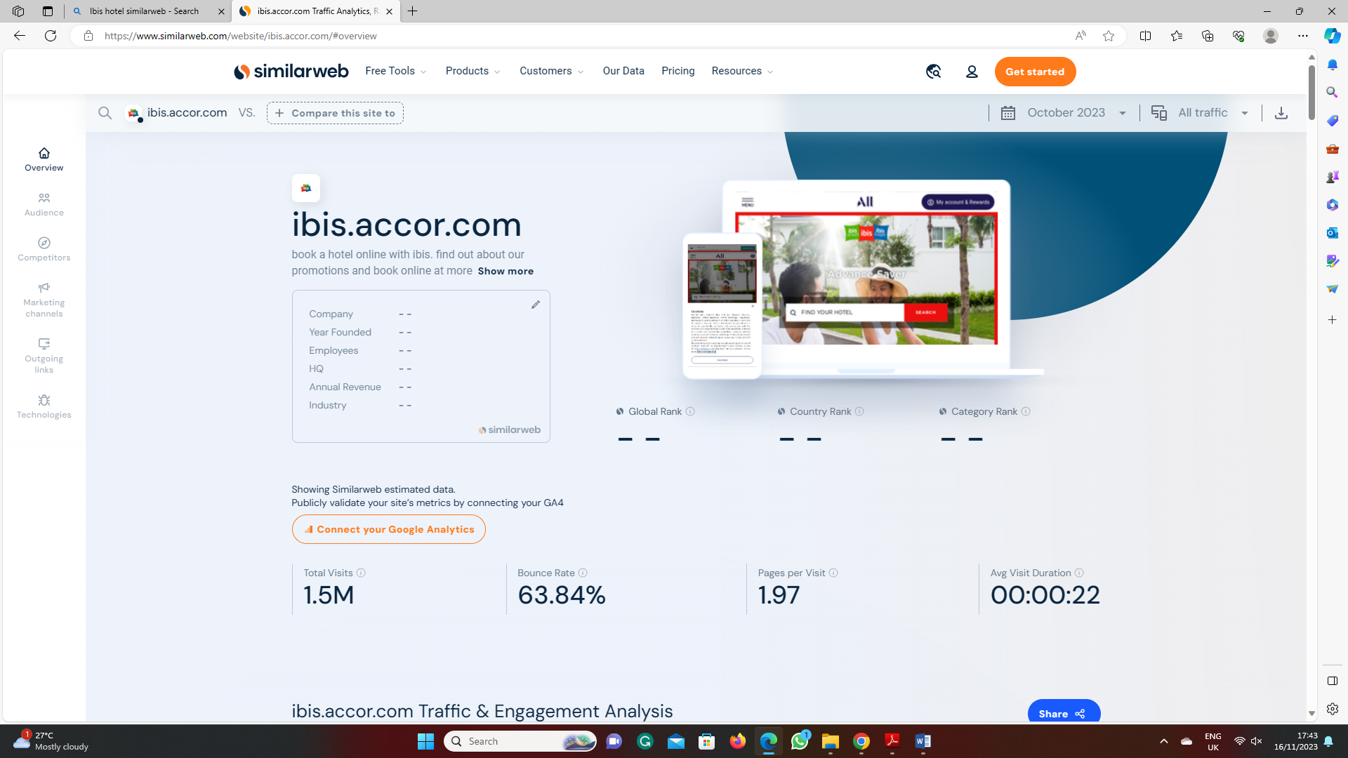
Figure: Data
Source: (Similarweb.com, 2023)

Component B: Presentation
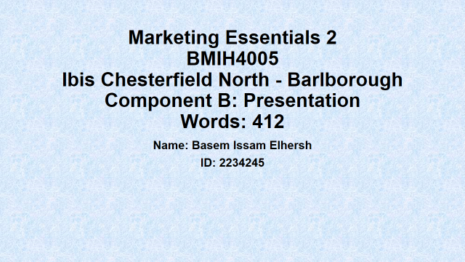
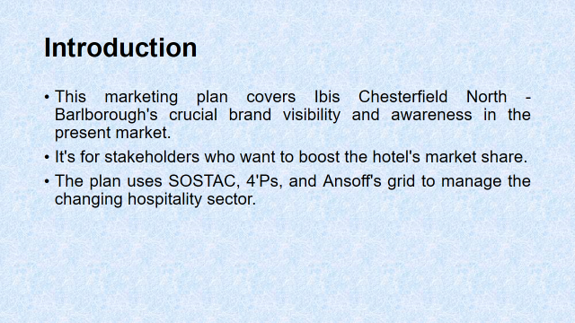
The critical brand visibility and awareness of Ibis Chesterfield North - Barlborough in the current market is covered by this marketing plan. It is intended for those involved who wish to increase the hotel's market share. The strategy makes use of Ansoff's grid, SOSTAC, and the four Ps to manage the evolving hospitality industry.

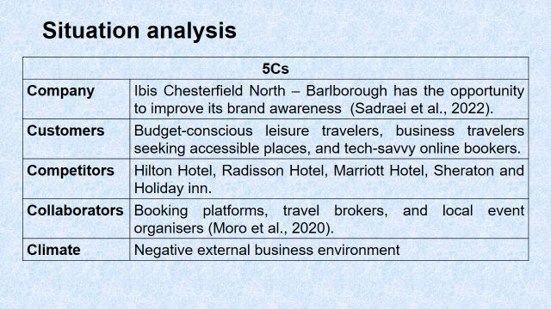
The 5'C's are revealed in Ibis Chesterfield North-Barlborough's situation study. SWOT analyses reveal internal strengths and weaknesses, whereas SimilarWeb data guides client segmentation and targeting. Competitor analysis uses Bowman's strategy clock and perceptual positioning maps (Moro et al., 2020). PESTLE analyses, collaborations, and partnerships are essential. Finally, the marketing mix identifies crucial aspects that boost brand awareness.
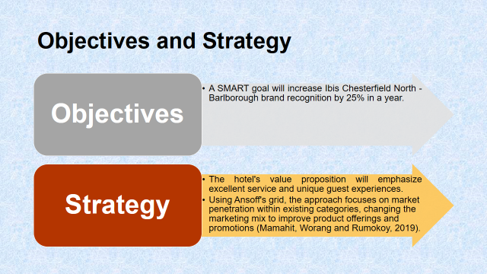
In a year, a SMART target will raise brand recognition for Ibis Chesterfield North - Barlborough by 25%. The hotel's value proposition will highlight exceptional guest experiences and first-rate service. The strategy, which makes use of Ansoff's grid, concentrates on market penetration inside already-existing categories and modifies the marketing mix to enhance product offerings and promotions (Mamahit, Worang and Rumokoy, 2019).
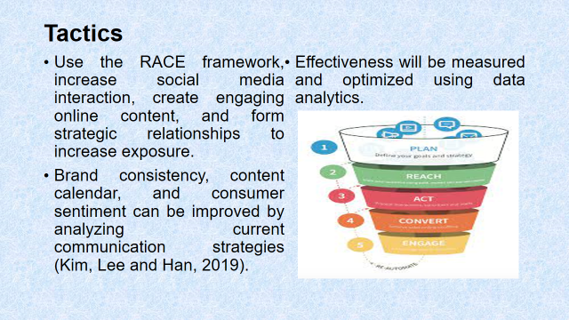
To gain more visibility, apply the RACE framework, engage in more social media activity, provide interesting online material, and establish business partnerships. An analysis of current communication tactics can lead to improvements in consumer sentiment, content schedule, and brand consistency (Kim, Lee and Han, 2019). Data analytics will be used to measure and optimize effectiveness.
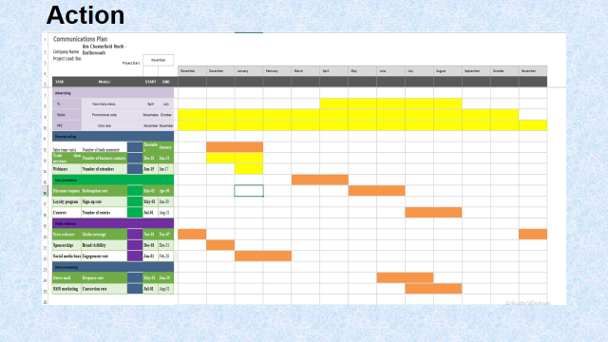
The marketing schedule based on rival activity and peak user engagement is displayed in a Gantt chart. Plan your messaging to be seen by the target audience during periods of high interaction.
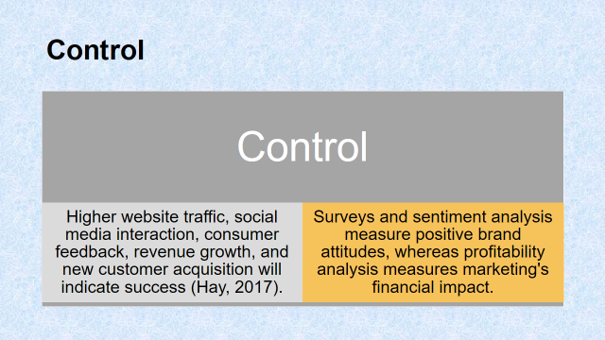
Success will be measured by increased website traffic, social media engagement, customer feedback, revenue growth, and acquisition of new clients (Hay, 2017). Positive brand perceptions are measured through surveys and sentiment analysis, while the financial impact of marketing is measured through profitability analysis.
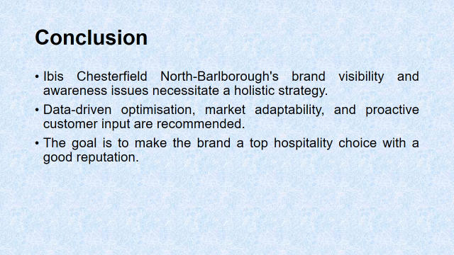
The problems with Ibis Chesterfield North-Barlborough's brand awareness and visibility demand a comprehensive approach. Proactive customer input, market adaptation, and data-driven optimization are advised. The objective is to establish the brand as a premier, well-regarded option for hospitality.


