ECAD6008 – WHAT, HOW AND WHY AM I TEACHING?

Hannah Louise Warrilow – 1801583

Critically reflect on your pedagogical process demonstrated through required elements of the Professional Learning Passport, identifying a specific area for professional development, and justifying next steps for improvement.
Word Count: Part 1 – Equivalent to 3000 words.
Word Count: Part 2 – 2,092 words

Contents Page

Reflection on Subject Knowledge Development……………………………… Page 3
Reflection on Planning for Progression………………………………………... Page 5
Reflection on Planning for the Four Purposes………………………………… Page 7
Assignment Part 2……………………………………………………………….. Page 9
Reference List…………………………… ……………………………………… Page 13
Appendices……………………………………………………………………….. Page 15

Part 1
Reflection on Subject Knowledge Development

Languages, Literacy and Communication – Phonics:
During the final placement of my teaching degree, I was placed within a Reception class. Due to the global pandemic, I was only able to teach face to face for two weeks. During these weeks I had the opportunity to develop and deliver phonics sessions to the children; as it had been some time since being in a Reception class, I knew that revisiting common practices when teaching phonics, aligning with the school policy would only be beneficial to myself and the learners. Upon observing two sessions of the class teacher delivering phonics, I felt it necessary to undertake my own research into different practices in order to develop the learners further. Through undertaking this research, I found that according to the National Literacy Trust (2017) the most common and recognised way to teach learners to read is through ‘synthetic phonics’; this encourages the association of phonemes with graphemes that are initially pronounced in isolation and then blended together. Within the classroom I witnessed the learners having the opportunity to practice letter formation with the LSA and the opportunity to develop the segmenting and blending of Consonant, Vowel, Consonant (CVC) words through online, interactive games.
Upon the chance to deliver phonics I was entrusted with the delivery of the CVC segmenting and blending activities. Through ensuring my planning was differentiated I was able to effectively deliver the sessions to pre-decided ability groups. The Education Endowment Foundation (2018) suggests that through encouraging young readers to master the basics of reading through the use of phonics approaches, there is an ‘average impact of an additional four-month progress’. This, and subsequent research has encouraged me to understand and value the importance of using phonics to teach not only young but any person to read effectively.
Please see Appendix 1.
Mathematics and Numeracy – Measurement:
During my third professional teaching experience (PTE3) I had the opportunity to plan and deliver the topic of measurement within the Mathematics and Numeracy Area of Learning and Experience. As I had no prior experience of teaching this topic, I felt it necessary to converse with my class mentor along with undertaking professional research into the teaching of measurement to Reception learners. Through witnessing different methods used within a Foundation Phase classroom I knew that to deliver this successfully I would have to adopt the Experiential Learning Cycle developed by Kolb. From subsequent research I found that it was important that the learners have concrete, reflective, abstract, and active experiences in order to progress their learning (McLeod, 2017). As a result of the research and aligning this with practice witnessed within the classroom, I was able to begin delivering the concept of measurement by initially using non-standard units such as multi-link and progressing the learners to begin to use standard units of measurement in the form of centimetres on a ruler. From this I was able to observe that the learners who had a fundamental understanding of number were able to progress more quickly compared to their peers who required further assistance.
Please see Appendix 2.
Digital Competency – The use of digital applications during online teaching:
My final teaching placement took place during a global pandemic and national lockdown, thus meaning all school buildings were closed and the children were unable to access their usual learning environment. As this was the third national lockdown the school were prepared to move learning experiences to an online format for the children to access. It was decided as a school that the Foundation Phase would access their learning asynchronously, meaning the sessions and tasks were pre-recorded and accessible as and when the pupils were able. During this period, I had to adapt my teaching style in order for the children to engage and complete tasks given. I was able to develop my digital competence through developing my knowledge of recording applications such as Loom. I was able to deliver a variety of sessions this way and the videos were uploaded to Just 2 Easy (J2E) for the children to access. Prior to this placement I had not encountered Loom or Flipgrid so took it upon myself to record simple weekly story videos for the children to engage with. I gained insight through experimenting with and using the application along with conversing with my class mentor about Loom's potential. Through engaging with the differing functions available on J2E I had the opportunity to provide written and oral feedback to the children through the comment section and microphone option along with using the message function to communicate with parents/carers.
Further to this, due to the sessions I delivered being pre-recorded, this not only gave the learners opportunity to revisit what had been taught but also gave myself the opportunity to re-watch and critically reflect on my own practices. In 2020, Estyn noted an area of good practice whereby staff were recording their live, face to face sessions in order to evaluate and develop their professional practice. From this it was found that teaching staff were able to make ‘worthwhile adjustments to their practice, giving them confidence in their planning and delivery’ (Estyn, 2020). I feel that through the period of delivering sessions asynchronously I was able to gain ample insight into my own teaching styles and adjust or enhance them accordingly.
During this period of online learning the three Reception class teachers worked collaboratively to plan and prepare sessions for the children. Each teacher was responsible for specific areas of learning and experience that would be delivered to and accessible by the whole cohort. Whilst on teaching online I was responsible for delivering the Mathematics and Numeracy sessions along with Expressive Arts and Welsh Language.
Please see Appendix 3.

Reflection on Planning for Progression

Mathematics and Numeracy – 2 Digit Numbers:
During PTE3, both online and in class I was able to take the lead with planning and delivering Mathematics and Numeracy to the students. For the first six weeks I planned and asynchronously delivered a range of mathematical topics including Shape, Direction and Symmetry to the whole of the year group. Further to this I was able to deliver sessions on Doubling and Halving via pre-recorded Loom videos and utilising online games for the children to access. In order to successfully plan the sessions, I knew that I needed to revise the specific skills linked to these topics along with ensuring the activities were age appropriate. Following a discussion with the class mentor I was able to understand that the cohort used the Area of Learning and Experience (AOLE) What Matter's statements, aligning them with Progression Step 1 and the Literacy and Numeracy Framework (LNF). The LNF and Progression Step statements were used to construct the 'Lego Challenges' for the children. I felt that I was successful throughout my planning through using the Curriculum for Wales 2022 as this aligned with the school's policies. A specific example of when I was able to utilise the documents well was through the planning and delivery of the Doubling and Halving sessions. I was able to choose relevant and age-appropriate skills from the LNF along with the What Matters statement that linked best. These lesson plans for these sessions can be found below within the assets.
As I was able to take the lead of Mathematics and Numeracy from the beginning of my placement, this gave me the invaluable opportunity to witness the children's progression through the chosen topics. Whilst teaching online I was able to track the children's progression as and when they uploaded the completed work to their files. This was difficult at times as not all children uploaded work when it was completed; therefore, this gave me a limited insight into the children's mathematical development. From the children who did upload completed work I was able to provide written feedback via the comment section on JTE and verbal feedback via the microphone function. This allowed me to converse with the children and parents about how the children completed the given tasks along with providing additional resources if any child needed further practice. The comment function also allowed me to converse with the children and parents who felt they needed further challenge during the topics. As the sessions were asynchronous, I felt it was difficult to fully assess the children's progress as I was unable to witness them completing the work given and the level of support they required.
Despite this, upon the return to the classroom I was able to fully engage in delivering the sessions along with assessing the children through written and verbal feedback. Whilst giving whole class introductions I was able to gauge how the children were progressing as a whole. Through group work during teacher-led tasks I was able to deliver the sessions to smaller numbers of children. From this I was able to assess if and how the children were progressing through observation and conversing with the children and was able to make a professional decision as whether or not to revisit the topic further. According to Welsh Government (2020) the role of assessment is fundamental in ‘enabling each individual learner makes progress at an appropriate pace’. This is further ensured through pertinent support and challenge.
Within the classroom I intend to repeat and build upon my actions carried out within my final professional teaching experience. I felt that I was able to judge whether or not the children were appropriately challenged or needed further support with certain aspects of a topic. Although this was not needed on this placement, I understand that if the class or a large proportion of the class did not understand fully the skills required, I would revisit this an appropriate number of times until a consensus of understanding was reached. I would also adjust the way I approached the lesson and would perhaps change the language and resources used. I believe that through undertaking further online and in-person research I could adopt further strategies for recording progression as other than taking informal notes to aid my planning, I had limited opportunity to witness how the children's progression were formally recorded.
Please see Appendix 4.

Languages, Literacy and Communication – Welsh Language Development:
During the return to the classroom from a period of online learning I had the opportunity to engage with incidental and focused welsh language sessions. As the class teacher disclosed that they were not as confident with their personal welsh language skills, I jumped at the chance to lead the welsh language sessions in class. Following this conversation, they explained that prior to online learning the children were going to be introduced to the story of 'Harri Llwyd'. Through my planning and delivery of the lesson I was able to use incidental welsh such as 'eisteddwch' and 'gwrandewch' along with questions such as 'pwy sy'n barod?'. I ensured that I used actions in time with the commands to ensure the children had a visual representation of what was being asked of them. Whilst in class I was able to teach two welsh language sessions as the children had these once per week. The first session consisted of reading through the story of 'Harri Llwyd' followed by a chosen sentence structure. Prior to the reading of the short story, I was encouraged to read two sentences in welsh followed by translating them for the children; I followed this structure throughout. By using actions throughout the story, the children were able to associate the actions with certain words and from those actions were able to make a sensible prediction about what the word translated to.
As this was the children's first week back in school I decided to revisit 'Pwy wyt ti?'. I was able to model this with the LSA as we took it in turns to ask each other 'Pwy wyt ti?' and replying with '....... ydw i. I then asked three children to solidify understanding and encouraged the children to turn to their partner and practice asking and answering the question. I was able to assess the children's understanding through listening to each pair.
The links to the appropriate four purpose skills can be seen within my planning. During the introductions in the welsh language sessions, I asked the children what skills they felt they needed in order to get the most from the session. I encouraged them to link these skills to an individual from the four purpose characters incorporated throughout the school. The children were able to recognise that they needed to speak welsh along with speaking and listening. The children chose Ambitious, Capable Anwen as she can speak different languages and uses prior knowledge to help her learning.
As mentioned above I was able to deliver two welsh language sessions. The second session included revisiting the story of Harri Llwyd to access prior knowledge. I was able to witness the children become more confident in recognising the structure of the story along with key welsh words. The children were able to increase their independence with demonstrating the actions and pronouncing the simpler welsh words. For the sentence structure during the second session, I focussed on 'Ga i ...'. I was able to encourage the children to recognise and understand what this meant through actions and modelling. I asked the children to form a circle on the carpet and placed different classroom items in the middle of the circle. The children were able to take turns asking and answering their peers 'Ga i...' and giving the item to their peer.
​​​​​​​Throughout these opportunities to teach Welsh language to the children I recognised the importance to have a professional and expansive knowledge of the Welsh language in order to teach it effectively. From a personal learning stance, I was able to gain confidence in using Welsh and reading a welsh story. I was able to use effective incidental welsh to ask the children to sit, listen and ask who was ready. The children were able to understand through the use of actions and the repetition of key words to understand different points within the story. Through teaching a series of lessons, I was able to witness the progression of the children and the increased confidence with speaking and understanding welsh. Alongside the national aim to reach one million welsh speakers by the year twenty-fifty, the government has along proposed an action plan that aims to ‘increase the number of primary teachers who can teach in Welsh from 2,900 to 3,900 by 2031 and 5,200 by 2050’ (Welsh Government, 2017).
Please see Appendix 5.

Reflection on Planning for the Four Purposes
Ambitious, Capable Learners – Incorporation of Four Purpose Characters
The school in which I was placed for my third and final teaching practice was not only the lead school for the network but also a pioneer school assisting with the incorporation of Curriculum for Wales 2022 in line with the recommendations by Donaldson in 2015. Upon a visit to the school prior to my placement starting, it was evident through displays within the corridors and classrooms that the Four Purposes were the starting point for all learning that took place, and they were beginning to be embedded within everyday life in the school. Upon having a conversation with my class mentor, I learned that pupils from the school had taken part in a competition to create Four Purposes characters that would be used across the school. I learned that the school was keen to incorporate these characters to make the purposes more recognisable and relatable for the children. Further to this, it was clear that within both existing and upcoming planning, the Four Purposes played a key role. I then understood that in order for my planning to align with that of the schools this is something that I would need to incorporate.
During lectures with university, I had become aware of the Four Purposes and the role they would play in schools when the Curriculum for Wales was fully integrated, I felt however that further personal research into the descriptors for the purposes and the links with the different Areas of Learning and Experience (AOLEs) would allow me to have a more comprehensive understanding when approaching my final placement. As the country is working towards the implementation of the new Curriculum for Wales being utilised in schools from 2022, I understand the importance of having in-depth knowledge of the basis of a school's personalised curriculum. Welsh Government (2020) state that the four purposes should be ‘the starting point and aspiration for every child and young person in Wales.
Through personal research and lectures within my three years of university I feel that I am in a confident position to assist in the delivery of the new curriculum in Wales. From this experience during my final placement, I have recognised the importance of the children having a firm understanding of these purposes as drivers of the learning they are undertaking. I was enthusiastic about seeing that the school had encouraged their own pupils to design and name the characters in order to make them more relatable and this is certainly something I plan to bring to schools within my career if they are not already doing so. I believe that through sharing the good practice I have witnessed during my final placement, future schools I am a part of can only benefit from having the children involved within the Four Purpose planning and implementation through their lessons. I feel it is important for the children, no matter their age, to feel a part of such an important part of the curriculum and to have those relatable, visual prompts to work towards and achieve.
Please see Appendix 6.

Enterprising, Creative Contributors – Expressive Arts:
Throughout my time on placement in my final year I was given the opportunity to plan and deliver a range of AOLEs including Numeracy, Languages, Literacy and Communication and Expressive Arts. Through the incorporation of the Four Purposes within my planning and lessons, it has allowed me to merge AOLEs in a cross-curricular fashion. An example of this would be during the asynchronous Expressive Arts sessions where the children were learning about the rainforests. It allowed me to place focus on them being Healthy, Confident Individuals through using their bodies to mimic rainforest animals whilst conveying tempo in music. The children also had to embody Enterprising, Creative Contributors who could connect and apply their knowledge of different rainforest animals in order to demonstrate their understanding of tempo.
Through recognising the school's emphasis on the incorporation and recognition of the Four Purposes I felt that I needed to incorporate them into the asynchronous sessions. This is not something the class teachers were currently doing so I suggested adding the characters to the slides or tasks in order to maintain some continuity between the home and school environments. This was encouraged by my class mentor and therefore I was able to incorporate these within the sessions I had planned for the children.
This experience is undoubtedly just one encounter throughout my early career as we are in the middle of the curriculum change and implementation process. I believe it will be interesting to see how different settings incorporate the Four Purposes with their school community and how involved the children will be in implementing these changes. I plan to undertake further online research around the Curriculum for Wales 2022 along with conversing with individuals more knowledgeable on the subject than myself. I plan to attend different seminars and workshops available to ensure I am as ready and confident as possible to contribute to the schools I am a part of within my career as a primary school teacher.
Please see Appendix 7.

Part 2
From the areas identified above, the chosen aspect of professional progression is that of digital competence. I feel that through a broader understanding and a suitable allocation of time to develop the relevant skills needed to successfully plan and incorporate the use of technology, it would undoubtably support and enhance not only personal but learner progression throughout my career.
Despite an ongoing commitment to enhance personal and professional knowledge of the Curriculum for Wales 2022, containing aspects such as the differing Areas of Learning and Experience (AOLE) alongside an in-depth knowledge of the Four Purposes, I feel that through gaining a deeper extensive knowledge and understanding not only of the Digital Competence Framework (DCF) required across Wales but innovative ways in which to incorporate these skills both in and out of the classroom, the learners in my care would have the opportunity to progress successfully within the increasingly digital world in which we live.
The choice to identify and critically evaluate my personal digital competence arose as a result of experiencing my final teaching placement during a global pandemic. Due to this pandemic, schools across the United Kingdom were unable to provide face-to-face, in class teaching and learning opportunities. Despite this, many schools had developed a contingency plan that consisted mainly of delivering teaching and learning online through the use of differing software applications. During this period of online learning, I was placed within a Reception class formed of twenty-five learners. Due to the age of the learners, a professional decision was made by the school that they would receive their learning asynchronously, meaning that sessions were pre-recorded and available for the learners to visit and revisit as and when they felt necessary. The opportunity arose each day to be involved with a live, thirty-minute session using Microsoft Teams. This ensured the establishment of positive relationships not only with the learners but their primary care givers also. Further to this, the live sessions allowed an understanding to be gained of whether they required assistance or further challenge with the learning opportunities being provided for them whilst at home. I was able to confidently use and navigate the Microsoft Teams software as has been used throughout the final year of university lectures. From my understanding of the application, I was able to manipulate different features such as incorporating a background with the intention of engaging the learners further and as a hook for the short games played within the introduction of the session. An example of this would be during a live session where the learners were challenged, as a cohort, to sound and blend letters in order to successfully rebuild a rocket and in turn further develop their knowledge and understanding of different phonic strategies. From this I felt it necessary to incorporate a picture of space as the background on my stream as it enabled the learners to envision that I was stuck in space and required their help to return to Earth.
As mentioned above, the learners were provided with pre-recorded sessions to access and interact with. As a result of conversing with professionals within the cohort I was placed in, I initially discovered that these sessions would be recorded using Loom and uploaded to Just 2 Easy (J2E). Prior to this placement I had limited knowledge of J2E and had not previously encountered Loom. From this I recognised the importance of maintaining knowledge and understanding of current applications the learners are using and the age-appropriate digital skills that align with relevant progression steps.

In line with the curriculum reform that was established following the recommendations of Donaldson in 2015, Curriculum for Wales 2022 has continued to deem digital competency one of three cross-curricular responsibilities, suggesting that it is to be incorporated across and throughout everyday teaching and learning. Along with Literacy and Numeracy, Digital Competence is a requirement to be considered within any school’s personalised curriculum design (Welsh Government, 2019). The Welsh Government have noted that the responsibility to successfully incorporate and deliver the skills is placed on all teaching professionals to develop and ensure progression in learners (Welsh Government, 2019). In order for learners to develop a competent and in-depth understanding of the range of skills required for them to progress, it may be seen as crucial to have access to appropriate technology both within the school setting in the first instance and at home to supplement the development of skills and knowledge. Subsequent personal research and observations undertaken during the period of online learning carried out whilst on teaching practice raised differing points of view regarding the ease of access and benefits to having technology so readily available for learners. In guidance published by the Education Endowment Foundation into the use of digital technology to improve learning it states that ‘we live in a digital age’ and that ‘the pupils we teach do not know a life without it’ (Education Endowment Foundation 2019). It is abundantly clear that as a result of the world in which we live, with technology so readily accessible and utilised throughout education and differing careers, opportunities for learners delivered by teaching professionals should be equal to all.
A concern that arose during the final professional teaching placement and though research into the differing levels of poverty in Wales for prior assignments within university, was the lack of accessibility to different technology within the home in order to access the learning experiences provided. Welsh Government data highlights that ‘almost one in three children, approximately twenty-eight percent, are currently living in relative income poverty.’ Due to the global pandemic, initial analysis of these statistics predicts that ‘two hundred thousand more children across the United Kingdom could be living below the poverty line by the end of two thousand and twenty’ (Welsh Government, 2020). It is a personal belief that no matter a learner’s circumstances, they should have the same opportunities as their peers throughout their education and beyond; thus, meaning that organisations should use their allocated funds to ensure the learners are able to access the relevant technology both in school and at home. Despite the above statistics, with access to aids such as the Pupil Deprivation Grant, most qualifying primary schools have access to either computers, laptops, or iPads, or in fact all three (Picton, 2019). Miller (2021) argues that the emphasis put on technology within the classroom automatically puts those at the lower end of the wage scale at ‘significant disadvantage’. In a press release published by the Welsh Government, it was stated that there will be a further investment of fifteen million pounds into educational technology along with the Hwb EdTech programme providing ‘over 128,000 devices since the start of the pandemic’ and has ‘provided 10,848 MiFi devices for learners without internet access at home’ (Welsh Government, 2021). This should inevitably benefit learners throughout their education and beyond.
Estyn (2016) found that a school in Wales realised that enhanced teaching and learning of digital technology can only occur if staff are confident in using it. Martin (2020) argues that the impact of learning spaces is dependent on the teachers’ expertise to use and apply digital skills. As a result of Estyn’s findings, the school staff have the opportunity to receive half-termly training on each strand of the DCF. The enables the opportunity to build upon existing knowledge and gain increasing confidence in delivering each strand. Furthermore, Estyn found that teaching staff were given specified additional time out of the classroom in order to coordinate and liaise with the Staff Digital Lead within the school. It is clear from the report of effective practice that the pupils within the school are a key asset to assisting the Digital Lead with training and support offered to staff.
It can be seen through the research into the use of technology within schools that there are many clear benefits. In addition to the points made above, through instant messaging functions available on applications such as J2E and Class Dojo, it was found that there was a large improvement of parental engagement and communication from home to school. Along with this, the Department for Education concluded that through the incorporation of technology in classwork, homework and assignments, there was a significant reduction of time that teaching professionals spent planning, marking and analysing work. Furthermore, in regard to continued professional development (CPD), the competent use of technology within education claims to support schools and teachers to diagnose their personal development needs and supports a more flexible and personal CPD (Department for Education, 2019).
Despite the seemingly obvious benefits to the accessibility to technology both within school and the home environment, it must be noted that there are notable disadvantages to increasing a learner’s digital exposure. According to Sigman (2012), it is commonly feared that a learner’s creativity, language, and imagination are restricted by such exposure. In addition to this, it was noted that through levels of isolation and exploitation, learners have the opportunity to suffer social and emotional long-term damage. In agreeance with this, Grigg (2015, p.211) stated that most children have the opportunity to freely ‘grow up with technologies at home’ and are able to understand their uses through ‘imitation and trial and error’. This may be seen as harmful to a child if their primary care giver, siblings, or family members are using the available technology inappropriately due to a lack of education around the software.
As a result of the digital competency framework being an integral resource within the Curriculum for Wales 2022, I believe that it is crucial as a practitioner to be confident and competent when planning and delivering these skills to my learners. Through analysis of the above information, I have deduced that frequent but necessary hands-on use of differing types of technology within the classroom will better equip learners for the world in which we live. From this I understand the importance of having a solid understanding of the framework along with a wide repertoire of delivery methods. As a result of this, my learners will use the invaluable skills to progress throughout their education and beyond. With the incorporation of technologies such as Artificial Intelligence (AI), robotics along with virtual and augmented reality being used more commonly within the workplace and within schools, I feel that my personal knowledge on the use of age-appropriate applications such as ‘Perino Pop-Up Book’ and ‘Fantastic Contraption’ needs to be developed further (Immersive Learning News, 2020). I plan to develop this knowledge by revisiting and revising the skills that encompass the digital competence framework and use my professional judgement on how best to discover and then demonstrate different resources available.
The DCF, being developed as an inclusive, accessible framework of skills incorporates the approach of holistic learning that comprises of ‘several pathways of possible development’ (Welsh Government, 2018). Throughout my career I plan to involve myself within the holistic planning and incorporation of the different elements of the DCF through staff meetings along with putting forward the idea of introducing a specific club that would take place during lunch breaks or after school, aligning with the school’s timetable. As mentioned previously, digital competence is a cross-curricular responsibility and will therefore be incorporated throughout teaching and learning. In order to ensure learner progression, I intend to plan, with the assistance of the learners, how they feel certain skills will be best developed during the topics or sessions they receive. I plan to ensure that pupil voice is utilised throughout my career but more specifically within digital competence in order to encourage the learners to suggest ideas and think creatively about how to incorporate age-appropriate skills. An example of this could be during topics where learning experiences incorporating the different countries within the world and how communication could occur. The learners may know and recognised the existence of e-mailing but may not understand how to correctly formulate one; this is something that can be introduced if teaching in a Year 2 classroom or beyond.
Prior to beginning my first teaching job as a qualified teacher I plan to develop a portfolio encompassing each skill within the DCF along with different applications and available technologies as a starting point of my future planning. This is something that would be shared with professional colleagues along with the learners for them to adapt and enhance to suit the age and progression step of their learners. Further to this, with Hwb as the ‘organisational centre of the new digital learning system for Wales’ utilising this platform would be the focus of both professional and learner progression (Welsh Government, 2012).

Reference List:
Department of Education (2019) Realising the potential of technology in education: A summary report. Available at: https://assets.publishing.service.gov.uk/government/uploads/system/uploads/attachment_data/file/929036/Realising_the_potential_of_technology_in_education_summary_report.pdf (Accessed: 15 April 2021).
Education Endowment Foundation (2018) Phonics. Available at: https://educationendowmentfoundation.org.uk/evidence-summaries/teaching-learning-toolkit/phonics/ (Accessed: 14th April 2021).
Education Endowment Foundation (2019) Using Digital Technology to Improve Learning. Available at: https://educationendowmentfoundation.org.uk/public/files/Publications/digitalTech/EEF_Digital_Technology_Guidance_Report.pdf (Accessed: 15 April 2021).
Estyn (2016) Digital technology in primary school life. Available at: https://www.estyn.gov.wales/effective-practice/digital-technology-primary-school-life (Accessed: 15 April 2021).
Estyn (2020) Using video technology for professional development. Available at: https://www.estyn.gov.wales/effective-practice/using-video-technology-professional-development (Accessed: 14 April 2021).
Grigg, R. (2015) Becoming an outstanding primary school teacher. 2nd edn. Oxon: Routledge.
Immersive Learning News (2020) The Best Virtual Reality Apps for Children. Available at: https://www.immersivelearning.news/2020/01/01/the-best-virtual-reality-apps-for-children/ (Accessed: 15 April 2021).
Martin, S. (2020) Digital competence of early childhood education teachers: attitude, knowledge and use of ICT. Available at: https://www.tandfonline.com/doi/full/10.1080/02619768.2019.1681393?casa_token=sZmHytuGskkAAAAA%3AjQq-JIJGiEDdXTTFfLGczeAVVxlx2I8urSGj6fhKjbIGvqBZxvi_Rt-nc2GlR2drMphH0iR-Ncw (Accessed: 29 April 2021).
McLeod, S. A (2017) ‘Kolb’s Learning Styles and Experiential Learning Cycle’, ‘Simply Psychology’ [Blog]. 24 October. Available at: https://www.simplypsychology.org/learning-kolb.html (Accessed: 14 April 2021).
Miller, K. (2021) ‘22 Advantages and Disadvantages of Technology in Education’, ‘Future of Working’ [Blog] Available at: https://futureofworking.com/10-advantages-and-disadvantages-of-technology-in-education/ (Accessed: 29 April 2021).
National Literacy Trust (2017) What is Phonics? Available at: https://literacytrust.org.uk/information/what-is-literacy/what-phonics/ (Accessed: 14th April 2021).
Picton, I. (2019) Teachers’ use of technology to support literacy in 2018. Available at: https://cdn.literacytrust.org.uk/media/documents/Teachers_Use_of_Technology_report.pdf (Accessed: 15 April 2021).
Sigman, A. (2012) The impact of screen media on children: A Eurovision for Parliament. In Clouder, C. et al. Improving the Quality of Childhood in Europe 2012. Volume 3. Brighton: ECSWE.
Welsh Government (2012) Find it, Make it, Use it, Share it: Learning in Digital Wales. Available at: https://gov.wales/sites/default/files/publications/2018-03/find-it-make-it-use-it-share-it-learning-in-digital-wales.pdf (Accessed: 15 April 2021).
Welsh Government (2017) Welsh in Education – Action Plan 2017-2021. Available at: https://gov.wales/sites/default/files/publications/2018-02/welsh-in-education-action-plan-2017%E2%80%9321.pdf (Accessed: 14 April 2021).
Welsh Government (2018) Digital Competence Framework Guidance. Available at: https://hwb.gov.wales/storage/337437b8-cfe3-4305-ae32-f47ad82f3e76/digital-competence-framework-guidance-2018.pdf (Accessed: 15 April 2021).
Welsh Government (2020) Child Poverty: Income maximisation action plan 2020 to 2021. Available at: https://gov.wales/sites/default/files/pdf-versions/2021/1/3/1610565260/child-poverty-income-maximisation-action-plan-2020-2021.pdf (Accessed: 15 April 2021).
Welsh Government (2020) Introduction to Curriculum for Wales guidance. Available at: https://hwb.gov.wales/curriculum-for-wales/introduction#:~:text=The%20Curriculum%20for%20Wales%20guidance%20is%20a%20clear,and%20misinformation%2C%20and%20encourage%20critical%20and%20civic%20engagement (Accessed: 14 April 2021).
Welsh Government (2020) Supporting learner progression: assessment guidance. Available at: https://hwb.gov.wales/curriculum-for-wales/supporting-learner-progression-assessment-guidance/ (Accessed: 14 April 2021).
Welsh Government (2021) £15 million for education technology in schools next year. Available at: https://gov.wales/15-million-education-technology-schools-next-year (Accessed: 15 April 2021).

Appendices:
Appendix 1:
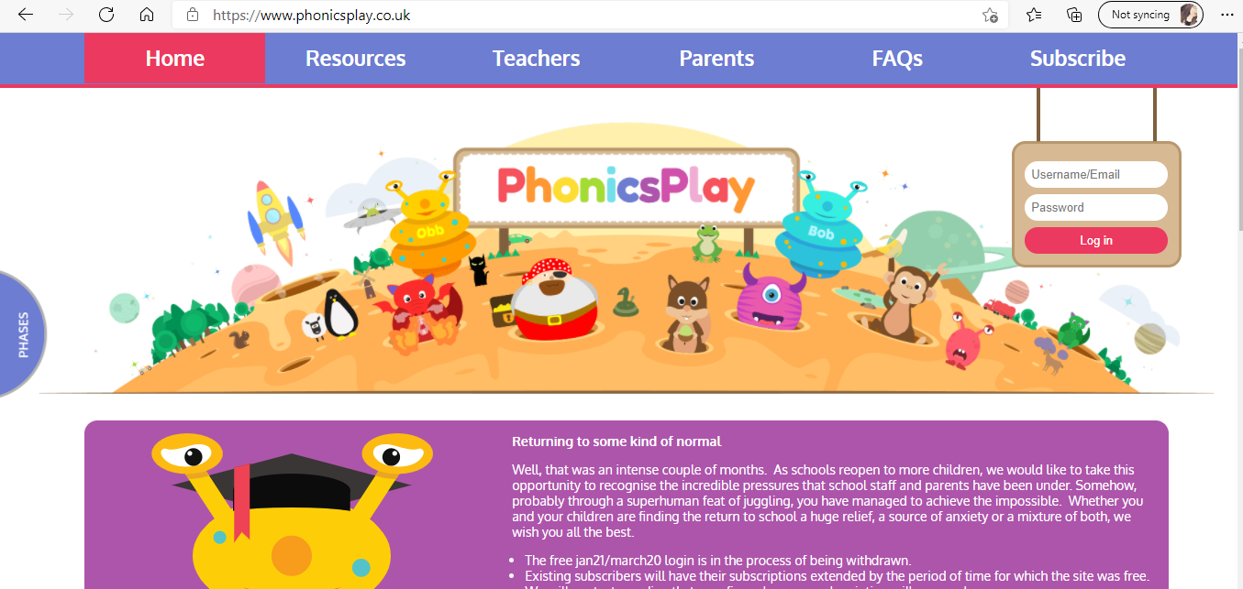
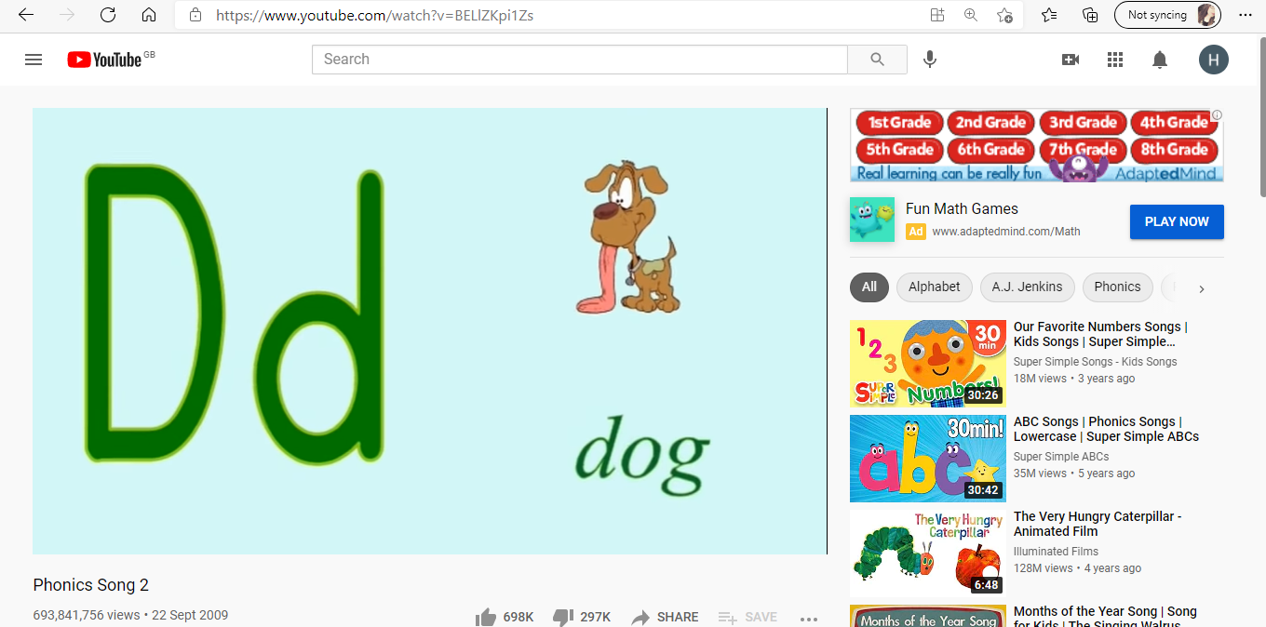

Appendix 2:
Lesson Plan – BA3

Student-teacher | Hannah Warrilow | Class: | Reception
AoLE/Subject | Mathematics and Numeracy | Date: | W/C 15th March
Lesson Focus: | Measuring
Relevant/meaningful links to:  Curriculum  &  Cross-curricular responsibilities | What Matters:  - WM - Measurement focuses on quantifying phenomena in the physical world.  Progression Step 1:  - PS1 - I can make estimates and comparisons with measures, such as ‘shorter than’, ‘heavier than’.  - PS1 - I have used a variety of objects to measure. I am beginning to understand the need to repeat the same physical unit without any gaps when measuring.  Four Purposes:  - Ambitious, capable learners who can explain the ideas and concepts they are learning about.
Personal Targets  (Linked to QTS and identfied in weekly review) | Exercising corporate responsibility ​​​​​​ - Contractual, pastoral, legal and professional responsibilities are known and understood by the student teacher.  Supporting formal leadership roles - The teacher demonstrates an understanding of the nature of responsibilities within and across teams and of the contribution’s individuals make towards the successful fulfilment of the school’s vision.

Learning Objectives (Focus on Learning) | - I can estimate measurements  - I can use both standard and non standard units of measurement.
Success Criteria  (process/product) | - I can use non standard units of measurement (red), NSU and am beginning to use SU (yellow). I can use standard units to measure objects (green).  - I can measure the width and length of an object.

Key Resources Health & Safety | - Interactive whiteboard  - Easter Egg cut outs  - Rulers

Time | Content, Pedagogy & Assessment Opportunities (key teaching points and questions)
Links to Previous Learning | - The children have previously encountered measuring with both standard and non standard units.
Opening Phase | Monday –  - Action counting to 30 clap & tap. Counting backwards from 20.  - What do we mean when we say we want to measure something? TPS  - Talk about measuring height / length - Go through the measuring sunflowers powerpoint (in planning folder)  Tuesday –  - Counting in 2s to 20. Counting in 10s to 100.  - Recap on measure – what does it mean? Show children a ruler – what is it? TPS  - How do we use it to measure? Talk about how we measure in centimetres when using a ruler - play Topmarks measuring game (see weblink) https://www.topmarks.co.uk/maths-games/measuring-in-cm  Wednesday –  - Counting in 5s to 50. Can we go to 100?  - Ask a selection of children of various heights to come to the front of class. Can they work together to put themselves in size order from shortest to tallest?  - Compare different heights – add a staff member for extra comparison.
Teaching & Core Learning | Monday –  Gwyrdd – Amser Dewis – Enhanced provision  Oren – Amser Dewis – Enhanced provision  Melyn – Teacher – Have a selection of laminated easter eggs. Can the children put them in size order from smallest to the biggest. Can the children use NSU (unifix cubes) to measure the length of the eggs? Can they also measure the width? Can they estimate how many unifix cubes they think it will be and compare the actual to their estimate? MAT – Can they go on to use a ruler and measure in SU (cm)?  Porffor – LSA Outdoor – Children to go on an Easter egg hunt and collect as many eggs as they can find. Can they count how many eggs they have altogether? Children have to throw their eggs into a 'nest' (eg tyre/bucket/crate). Practise underarm throwing / opposite leg. Start close to the nests and then move further away each time. Who can throw the egg the furthest? Measure how far they are from the nest using steps to how far they can throw their egg. How many steps away did they manage to get the egg into the nest? (Use eggs from egg and spoon race or similar or a beanbag)  Tuesday –  Gwyrdd LSA Outdoor – Children to go on an Easter egg hunt and collect as many eggs as they can find. Can they count how many eggs they have altogether? Children have to throw their eggs into a 'nest' (eg tyre/bucket/crate). Practise underarm throwing / opposite leg. Start close to the nests and then move further away each time. Who can throw the egg the furthest? Measure how far they are from the nest using steps to how far they can throw their egg. How many steps away did they manage to get the egg into the nest? (Use eggs from egg and spoon race or similar or a beanbag)  Oren - Amser Dewis – Enhanced provision  Melyn Amser Dewis – Enhanced provision.  Porffor Teacher – Have a selection of laminated easter eggs. Can the children put them in size order from smallest to the biggest. Can the children use NSU (unifix cubes) to measure the length of the eggs? Can they also measure the width? Can they estimate how many unifix cubes they think it will be and compare the actual to their estimate? MAT – Can they go on to use a ruler and measure in SU (cm)?  Wednesday –  Gwyrdd - Teacher – Have a selection of laminated easter eggs. Can the children put them in size order from smallest to the biggest. Can the children use NSU (unifix cubes) to measure the length of the eggs? Can they also measure the width? Can they estimate how many unifix cubes they think it will be and compare the actual to their estimate? MAT – Can they go on to use a ruler and measure in SU (cm)?  Oren - LSA Outdoor – Children to go on an Easter egg hunt and collect as many eggs as they can find. Can they count how many eggs they have altogether? Children have to throw their eggs into a 'nest' (eg tyre/bucket/crate). Practise underarm throwing / opposite leg. Start close to the nests and then move further away each time. Who can throw the egg the furthest? Measure how far they are from the nest using steps to how far they can throw their egg. How many steps away did they manage to get the egg into the nest? (Use eggs from egg and spoon race or similar or a beanbag)  Melyn - Amser Dewis – Enhanced provision  Porffor – Amser Dewis – Enhanced provision.  Lego Challenges:  Red Lego: I can make direct comparisons of length, height & distance e.g. longer / shorter than.  Yellow Lego: I can use non-standards units to measure length, height & distance e.g. blocks, straws, hand-spans.  Green Lego: I can use standard units to measure length, height & distance (cm).
Plenary | • At the end of the session each group will take part in a pupil led session review.  • This gives the children an opportunity to show what they have learned either verbally or by showing what they have completed during the session.  • Ask the children to verbalise what they liked about their peers’ work.  • The children will also have an opportunity to gather feedforward and their next steps for progress.

Lesson Plan – Phase 2
Evaluation of the Learning Experience
(include references to QTS)

Evaluation of Pupil Learning

Evidence of Learning (including attitude to learning over time) | - The children were able to use the visual lego challenge prompts to understand what they needed to achieve to progress.  - The children were able to understand that we were measuring length and width, how long and wide our eggs were.  - All children were able to use the multilink (NSM) to measure their eggs. The children were then able to write the number of blocks on a whiteboard – practising their number formation.  - The children were able to predict how many blocks long or wide their eggs would be.  - Some children were able to use a ruler to measure their eggs (SM). They understood that they needed to measure from the end of the ruler and recognised that the ruler measured in CMs.
Next Steps for Progress | - Encourage the use of rulers to every child to challenge themselves further.  - Ensure all children understood how to use a ruler correctly.

Reflective Analysis of Teaching and Strategies for Development – including justification/rationale for pedagogical choices

Evidence of my Effective Practice | - I felt that the children understood what was being asked of them through clear instruction and demonstrations.  - I was able to appropriately challenge the children based on their progress within the sessions.  - I was able to keep the children engaged with the task through effective questioning.  - The children were abel to understand the lego challenges and knew how to progress.  - They were able to recognise when they had achieved a lego challenge and fed back what they were happy with and what they felt their next steps were.
Areas for my Development  Personal Targets for Progress | - I would increase the number of eggs for the children who progressed more quickly.  - I would revisit this, targeting pupils who needed more support.

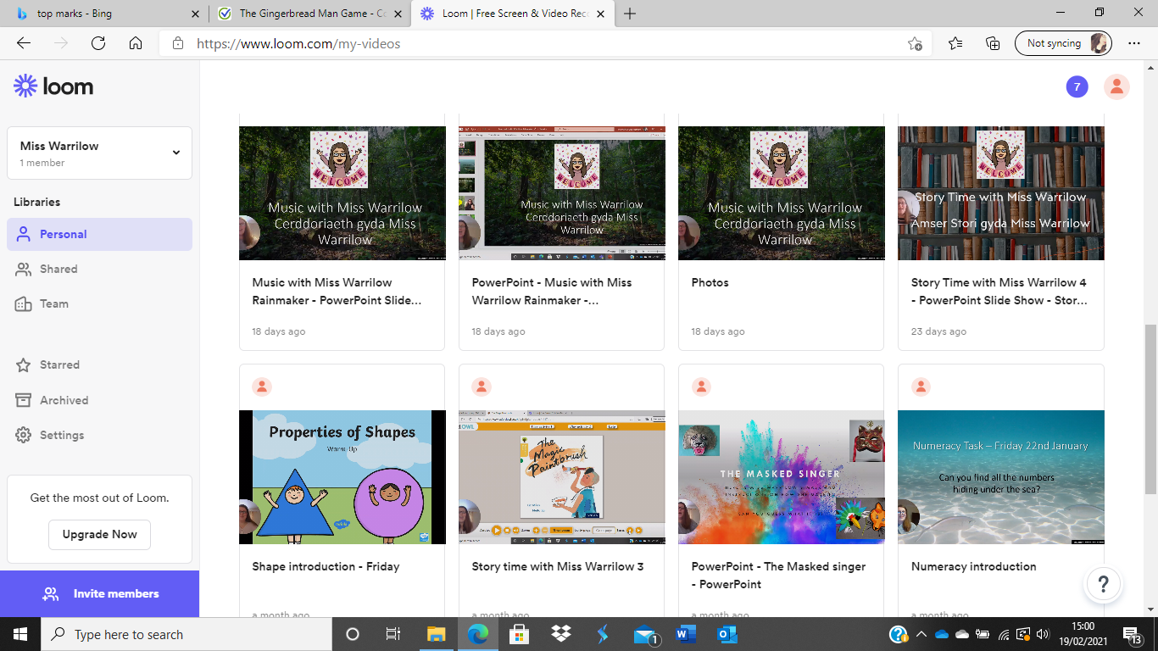
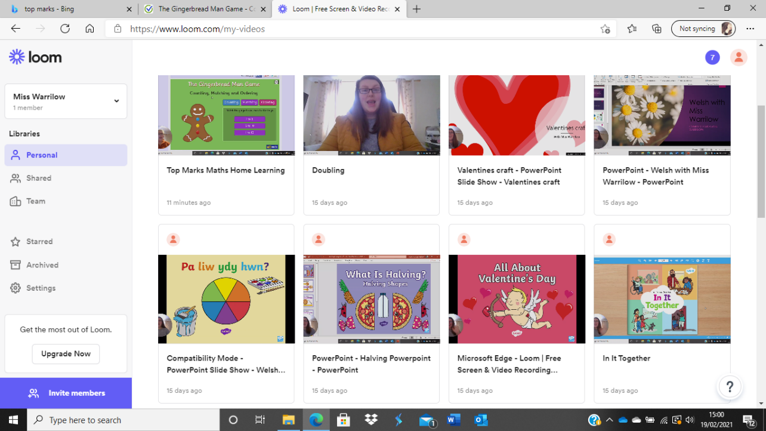
Appendix 3:
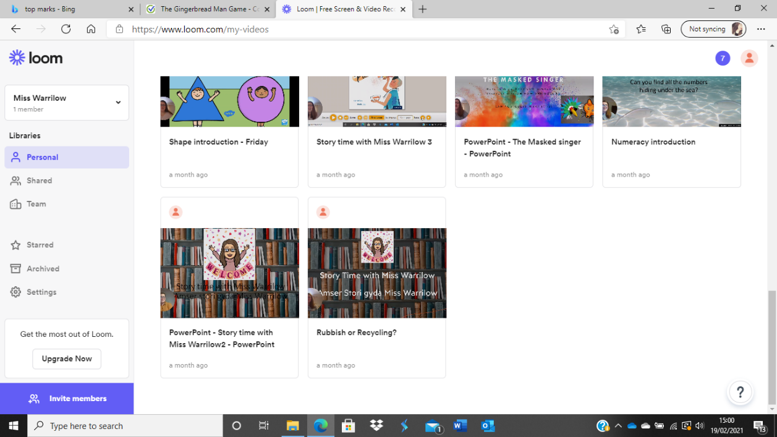

Appendix 4:

Student-teacher | Hannah Warrilow | Class: | Reception
AoLE/Subject | Numeracy | Date: | W/C 1st March
Lesson Focus: | 2 Digit Numbers
Relevant/meaningful links to:  Curriculum  &  Cross-curricular responsibilities | What Matters –  - The number system is used to represent and compare relationships between both numbers and quantities.  Progression Steps –  - PS1 – I can use my experience of the counting sequence of numbers  - PS1 - I am beginning to recognise patterns and sequences around me  - PS1 – I can use language to describe 'more than' & 'less than'  - PS2 - I understand that the value of a number can be determined by the position of digits  Four Purposes – Ambitious Anwen  - Ambitious, capable learners can use number effectively in different context
Personal Targets  (Linked to QTS and identfied in weekly review) | Assessment - The range of purposes and practices for assessment is confidently understood and articulated.  Working with in school colleagues - Organised and constructive work with a wide range of colleagues to enhance learners’ experience is a permanent feature of the student-teacher’s practice. Reflection on developing expertise is effectively structured as a personal or a collaborative process, as appropriate. ​​​​​​​

Learning Objectives (Focus on Learning) | - To count reliably up to 20 objects (petals)  - To use everyday and mathematical language to talk about their own ideas and choices
Success Criteria  (process/product) | - I can use some (red), more (yellow) or many (green) petals to demonstrate two-digit place value up to 20.  - I can demonstrate and describe adding one more and one less to numbers up to 10 (red), 15 (yellow) or 20 (green).

Key Resources Health & Safety | - Numicon  - Number lines to 20  - Daffodil stems and petals (Laminated resources)  - Whiteboards  - Whiteboard pens

Time | Content, Pedagogy & Assessment Opportunities (key teaching points and questions)
Links to Previous Learning | This plan will take place in a rotation with four groups over four days. This gives each child an opportunity to engage with all the proposed tasks.  The children will have come across numbers to 20 previously along with one more and one less. However, with a long period of online learning they will need to be assessed on their ability when returning to school.
Opening Phase | - Display the mental maths powerpoint, work through this with the children.  - Explain to the children that they will be looking at 2 digit numbers, these are numbers after 9.
Teaching & Core Learning | Monday:  Gwyrdd, – Amser Dewis – Enhanced provision  Oren – Amser Dewis – Enhanced Provision  Melyn – Teacher –  - Using number flash cards assess children's recognition of numbers from 1-10 & then 11-20.  - Using a number line to 20, count along the number line from 1-20.  - Give each child a daffodil stem and a selection of petals. Ask the children to add a certain number of petals to the daffodil. Once the children have done this, ask them to add one more – How many petals does the daffodil have now?  - Continue this approximately 5 times. (Ensure the children are counting the petals correctly)  - To extend, children could write the numbers 1-20 on white board in order, using a number line to support if required.  Porffor – LSA –  - Using number flash cards assess children's recognition of numbers from 1-10 & then 11-20.  - Show a number flash card to the children and ask them to count out that number of unifix cubes (starting with numbers to 10 & then increasing to 20). When counting out number of cubes 11-20, demonstrate how to set them out with 10 cubes in a row and then the remaining cubes in a row next to it, discussing the 10s and units in the number.  - To extend, children could write the numbers 1-20 on white board in order, using a number line to support if required.  Lego Challenges -  Red Lego: I can recite a range of numbers. I can count reliably up to 5 objects. I am beginning to understand place value with support.  Yellow Lego: I can count in 2s to 20 & 5s and 10s to 100. I can count reliably up to 10 objects. I can understand place value.  Green Lego: I can compare and order numbers to at least 20. I can count reliably up to 20 objects. I can understand place value up to 100.
  Day: | Teacher led | LSA led | Enhanced Prov | Enhanced Prov
  Tuesday | PORFFOR | GWYRDD | OREN | MELYN
  Wednesday | GWYRDD | OREN | MELYN | PORFFOR
  Thursday | OREN | MELYN | PORFFOR | GWYRDD
Plenary | - At the end of the session each group will take part in a pupil led session review.  - This gives the children an opportunity to show what they have learned either verbally or by showing what they have completed during the session.  - Ask the children to verbalise what they liked about their peers’ work.  - The children will also have an opportunity to gather feedforward and their next steps for progress.

Lesson Plan – Phase 2
Evaluation of the Learning Experience
(include references to QTS)

Evaluation of Pupil Learning

Evidence of Learning (including attitude to learning over time) | - All children engaged well with the teacher led task (daffodils).  - The children used increased levels of independence whilst completing the task.  - All children were able to achieve the yellow lego challenge with some progressing to green.  - The children were thoughtful when placing their petals on their daffodil, counting aloud to help them.  - From observing the LSA led task it was evident to see that they children were engaged and many children reached the green lego challenge.  - They were able to use the numicon to demonstate their number awareness. Further to this the children were able to practice their number formation on whiteboards.
Next Steps for Progress | - The children were given feedforward during the reflection and the general next steps were to push the children to reach the green lego challenge by counting objects up to 20.

Reflective Analysis of Teaching and Strategies for Development – including justification/rationale for pedagogical choices

Evidence of my Effective Practice | - I feel that through the rapport I have built with the children they were able to demonstrate a respect towards me and as a result understood the expectations I had of them.  - I feel that I delivered the mental maths warm ups with enthusiasm and ensured pupil involvement.  - Whilst completing the daffodil task I quickly understood which pupils would benefit from writing the given number on the center of the daffodil, this is something that I hadn’t originally planned however rolled out with each group to ensure consistency and to not draw attention to the children who needed further support.  - The children benefited from a visual demonstration prior to beginning the task and I welcomed any questions.  - Throughout the task I was able to give the children feedback and feedforward which they would then share during the review.
Areas for my Development  Personal Targets for Progress | - I feel that going forward I plan to develop the review (plenary). I feel that by developing a structure for the reviewing period the children would benefit more.  - After speaking to the class teacher I understand that under different circumstances (COVID) the children could be sat in a circle making the interaction between pupils easier and more freeflowing.

Appendix 5:

Student-teacher | Hannah Warrilow | Class: | Reception
AoLE/Subject | Welsh Language | Date: | 4/3/21
Lesson Focus: | Pwy wyt ti? a stori Harri Llwyd
Relevant/meaningful links to:  Curriculum  &  Cross-curricular responsibilities | What Matters:  - Languages connect us.  Progression Step 1:  - I am beginning to talk with my peers in the language of the setting/school.  Four Purposes:  - Ambitious, capable learners who can communicate effectively in different forms and settings, using both Welsh and English  LNF:  - use words, phrases and simple sentences.  - speak audibly  - ask questions about something that has been said.  - follow texts read to them and respond appropriately.
Personal Targets  (Linked to QTS and identfied in weekly review) | Assessment – The range of purposes and practices for assessment is confidently understood and articulated.  Working with in school colleagues – Organised and constructive work with a wide range of colleagues to enhance learners’ experience is a permanent feature of the student-teacher’s practice. Reflection on developing expertise is effectively structured as a personal or a collaborative process, as appropriate. ​​​​​​​

Learning Objectives (Focus on Learning) | - Follow along with the story ‘Harry Llwyd’.  - Repeat simple sentences to peers.
Success Criteria  (process/product) | - I can follow along with some (red), most (yellow) or all (green) of the story.  - I can understand what ‘Pwy wyt ti?’ means.  - I can ask my peers ‘pwy wyt ti?’.  - I can reply to ‘pwy wyt ti’ with my name and ‘ydw i’.

Key Resources Health & Safety | - Interactive whiteboard  - Harri Llwyd story

Time | Content, Pedagogy & Assessment Opportunities (key teaching points and questions)
Links to Previous Learning | The children have previously visited the structure of ‘Pwy wyt ti’ followed by ‘…. Ydw I’ in the autumn term.
Opening Phase | - Ask the children to ‘eisteddwch’ and ‘dim siarad’ (Sit and no talking)  - Ask ‘Beth syn bod?’ (Who is ready?)  - Explain to the children that they will be looking at the story of Harry Llwyd and will be asked some questions about the story.
Teaching & Core Learning | - Read the story, sentence by sentence, translating after 2 sentences.  - Give actions to repeated words such as ‘rhedeg’ (running).  - Ask questions about the story – ‘Who is Harri Llwyd? ‘What does Harri Llwyd want to eat?  - ‘Today we are going to practice the question Pwy wy ti? This means ‘Who are you?  - Ask 2 or 3 children ‘Pwy wy ti? to ensure they are aware of the correct response.  - Get a child to ask the teacher who they are, model the correct was of replying.  - Allow the children time to work in pairs to practice their sentence patterns.  - Visit each pair to ensure they are on task and are pronouncing the sentence pattern correctly.
Plenary | - To conclude, ask 2 or 3 pairs to come to the front and demonstrate what they have learned to their peers.

Appendix 6:
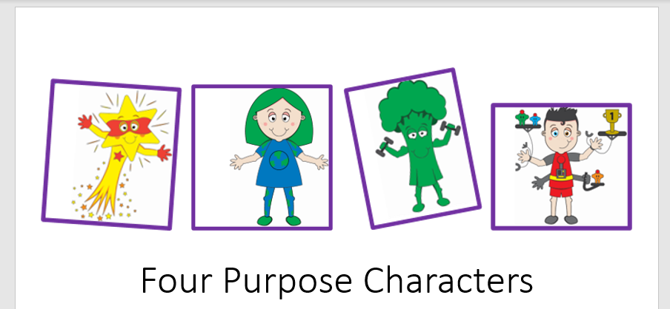
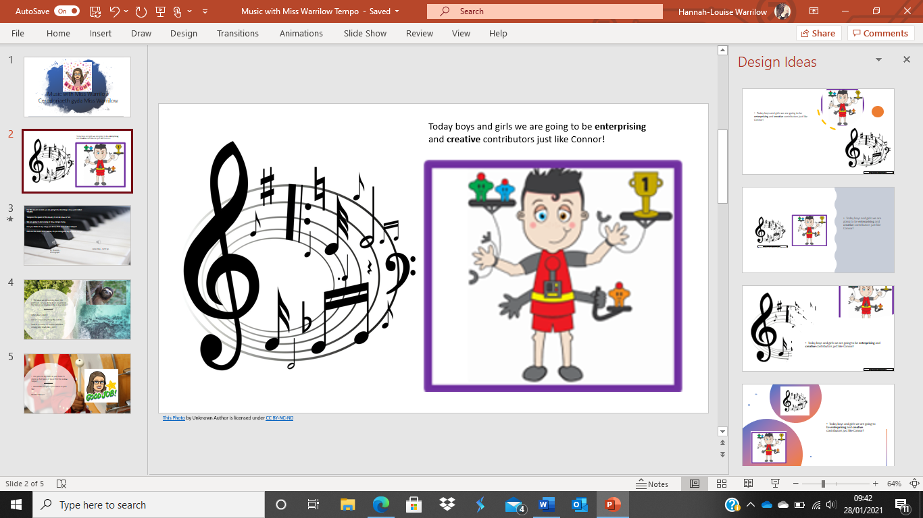
Appendix 7:

