

Databases and Application Development

Module Code: | ACCA5026
Assignment Title: | Database Design & Implementation
Student Name: | Ioana Catalina Sava
Student number: | 2329918
Submission Deadline: | Thursday 2nd April 2026  14:00
Table 1: Course and Student informations.


Figure 2: database picture
Table of Contents

Introduction 3
Database Design 4
Implementation Documentation 7
Sample data insertion 12
Trigger and stored procedure execution 16
Stored Procedure and Transactional Scenario 18
Performance Tuning Enhancement 24
Conclusion and Reflection 26
References 27

Introduction
The GreenLeaf Organics case study focuses on the development of a relational database system designed to support the operations of an online platform that sells organic food, natural skincare products, and eco-friendly household items. The business model involves several interconnected activities including supplier registration, product listing, customer registration, order processing, and product feedback. Because these activities rely on accurate data storage and efficient information retrieval, a well-structured database system is essential to ensure the reliability and scalability of the platform. Database design plays a critical role in organizing this information so that the business can manage suppliers, products, customers, and transactions efficiently while maintaining data integrity and consistency [1].
The database must support several key relationships between entities. Each supplier can provide multiple products, while every product is associated with only one supplier. Products can also belong to multiple categories, such as organic vegetables, natural skincare, or eco household products, which requires a many-to-many relationship between products and categories. Customers can place multiple orders, and each order may include several products, forming another set of relationships that must be properly modeled. In addition, customers can provide feedback and reviews for purchased products, allowing the platform to monitor product quality and supplier performance. These relationships highlight the need for a structured relational model that accurately represents business operations and supports efficient data management.
From a technical perspective, the database design must follow recognized principles such as normalization and data integrity constraints to avoid redundancy and ensure reliable data storage. The design is normalized to the Third Normal Form (3NF), ensuring that each table stores only relevant attributes and that dependencies between data elements are minimized. This approach improves consistency, reduces duplication, and simplifies future maintenance of the system [2]. Furthermore, the database implementation includes features such as stored procedures, transaction management using COMMIT and ROLLBACK, triggers for auditing changes, and indexing for performance optimization. Together, these components create a robust database environment that supports both operational efficiency and data accuracy.
Overall, the GreenLeaf Organics database system demonstrates how structured database design and implementation can support complex e-commerce processes. By carefully modeling entities, relationships, and transactions, the system ensures reliable order processing, inventory management, and customer interactions. This project highlights the importance of integrating database design principles with practical implementation techniques to support real-world business operations.

Database Design
The ERD for GreenLeaf Organics is designed around the key entities required to support the platform’s business operations. The main entities identified in the model include Customers, Orders, Products, Suppliers, Categories, Reviews, and Inventory. Each entity contains a primary key used to uniquely identify records, while foreign keys are used to establish relationships between entities. For instance, each order is associated with a specific customer, and each product is supplied by a particular supplier. Customers can also write reviews for products, which are stored in the Review entity together with attributes such as rating, review text, and date. These relationships allow the system to capture interactions between customers, products, and suppliers while maintaining data consistency and integrity [3].
The ERD also represents how products are classified and stored. Products can be grouped into categories through the “classifies” relationship, allowing the system to organize items such as organic vegetables, natural skincare, or eco-friendly household products. The Inventory entity is used to track product quantities and the last update date, enabling effective stock management. Additionally, orders contain products through the “contains” relationship, which reflects how multiple products can be included in a single purchase. Suppliers are connected to products through the “supply” relationship, indicating that one supplier may provide multiple products to the platform.
To ensure a well-structured database, the design follows the principles of Third Normal Form (3NF). Each entity represents a distinct concept, and attributes depend only on their respective primary keys. This eliminates redundant data and prevents anomalies during insertion, updating, or deletion of records. Separating entities such as reviews, suppliers, and inventory also improves scalability and maintainability of the system. By applying normalization and clearly defining relationships between entities, the ERD provides a strong foundation for implementing a reliable relational database system that supports the operational needs of the GreenLeaf Organics platform [4].
Third Normal Form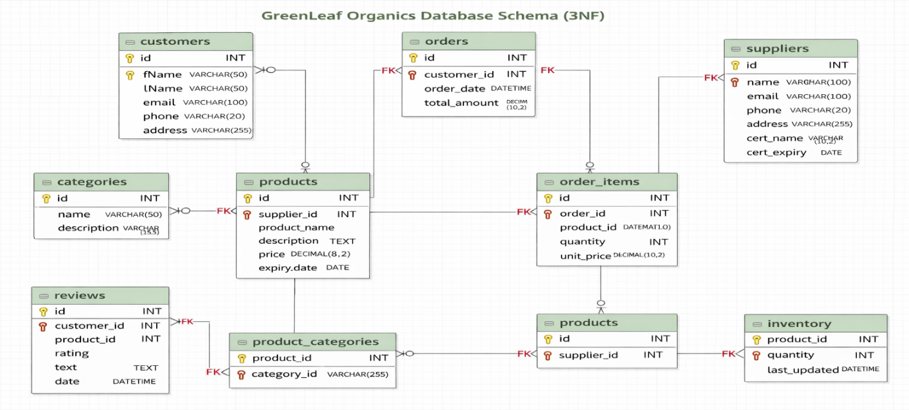
Figure 2: 3NF schema

Entity Relationship Diagram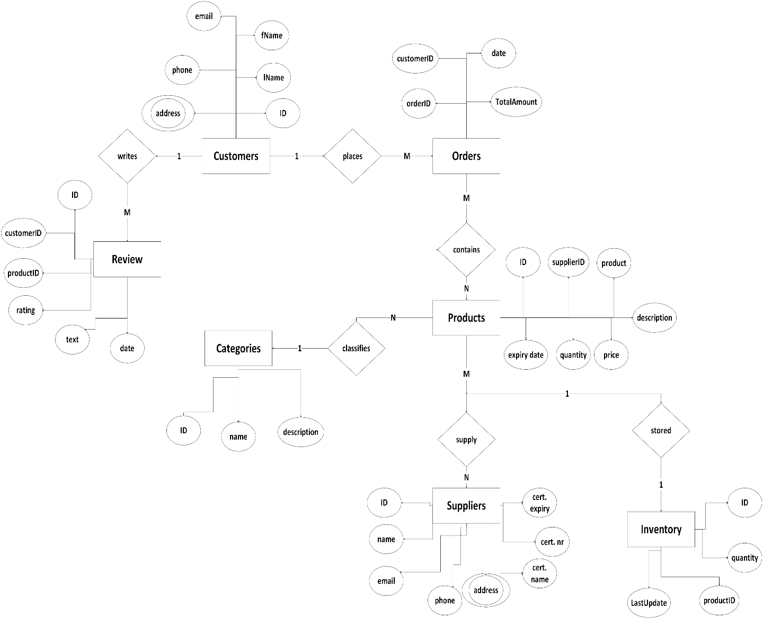
Figure 3: ER Diagram
Cardinality
- Suppliers → Products
One supplier can supply many products, but each product is supplied by only one supplier.
Relationship: 1-to-many
- Customers → Orders
One customer can place many orders, but each order belongs to only one customer.
Relationship: 1-to-many
- Orders → Order_Items
One order can contain many order items, but each order item belongs to only one order.
Relationship: 1-to-many
- Products → Order_Items
One product can appear in many order items, but each order item refers to only one product.
Relationship: 1-to-many
- Products → Inventory
One product has one inventory record, and each inventory record belongs to one product.
Relationship: 1-to-1
- Customers → Reviews
One customer can write many reviews, but each review is written by only one customer.
Relationship: 1-to-many
- Products → Reviews
One product can receive many reviews, but each review is linked to only one product.
Relationship: 1-to-many
- Orders → Payments
One order can have one payment record, and each payment belongs to one order.
Relationship: 1-to-1
If your design allows multiple payment attempts, then this can also be treated as 1-to-many, but in your current sample it is usually written as 1-to-1.
- Products ↔ Categories
A product can belong to many categories, and a category can contain many products.
This is implemented through the junction table product_categories.
Relationship: many-to-many
So the junction-table breakdown is:
- Products → Product_Categories = 1-to-many
- Categories → Product_Categories = 1-to-many

Implementation Documentation
The GreenLeaf Organics database was implemented in MySQL using phpMyAdmin. Tables such as suppliers, customers, products, orders, and inventory were created using SQL CREATE TABLE statements, with primary keys and foreign key constraints to maintain relationships and data integrity. Sample data was inserted to simulate real operations, including adding products and creating customer orders. Triggers were also implemented to record changes in an audit log and track updates to inventory. These tests confirmed that the database structure, constraints, and automated processes function correctly and support the business processes required by the system [5].
Table creation
Table creation was performed in MySQL using phpMyAdmin by executing SQL CREATE TABLE statements for each entity identified in the database design. Tables such as suppliers, customers, categories, products, orders, and inventory were created with clearly defined attributes and primary keys using the AUTO_INCREMENT property. The screenshots show the successful execution of these queries and the structure of each table within the database. Creating the tables first establishes the foundation of the system and ensures that all entities required for the GreenLeaf Organics platform are properly structured and ready for further relationships and constraints to be implemented[6].
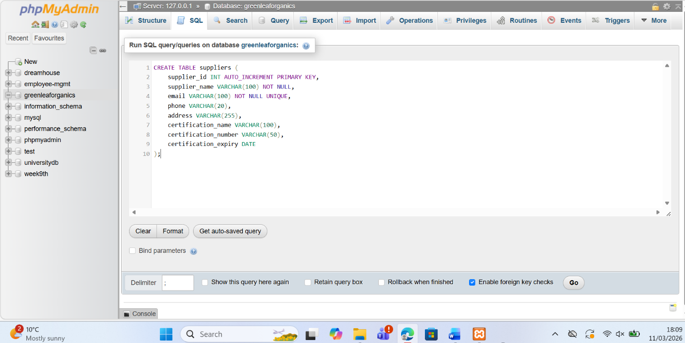
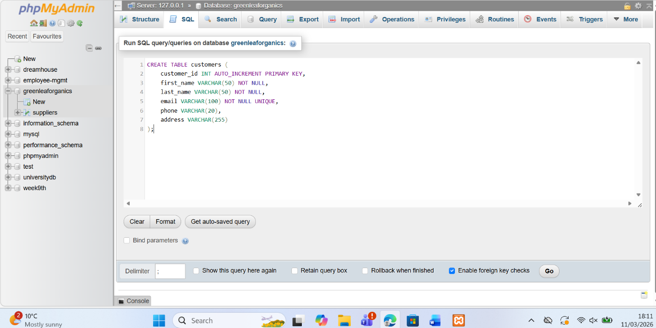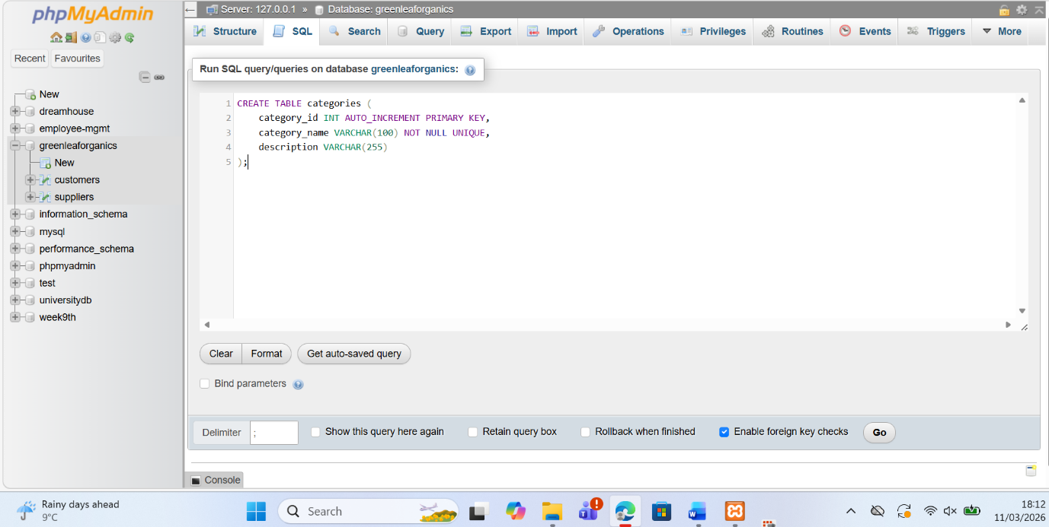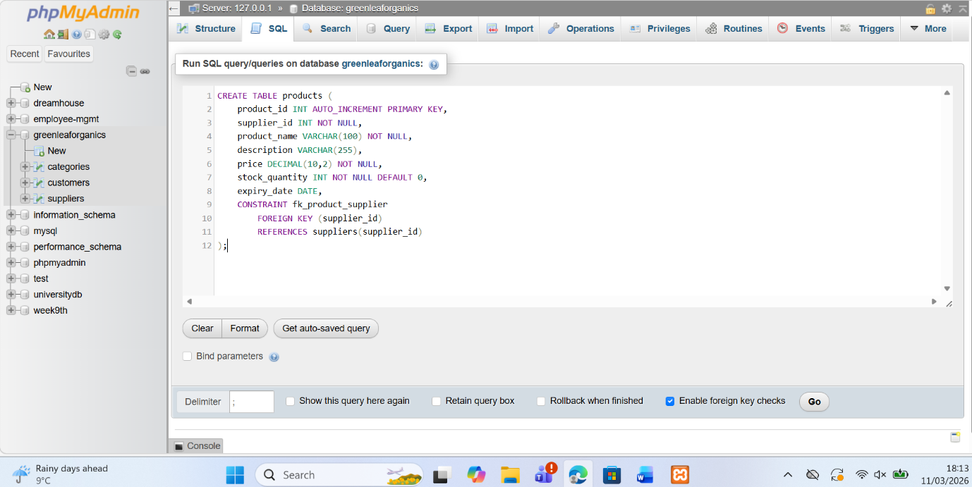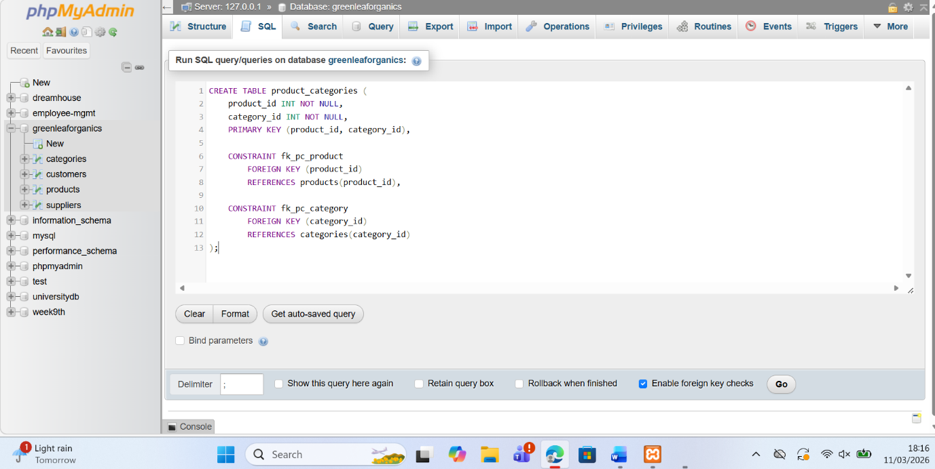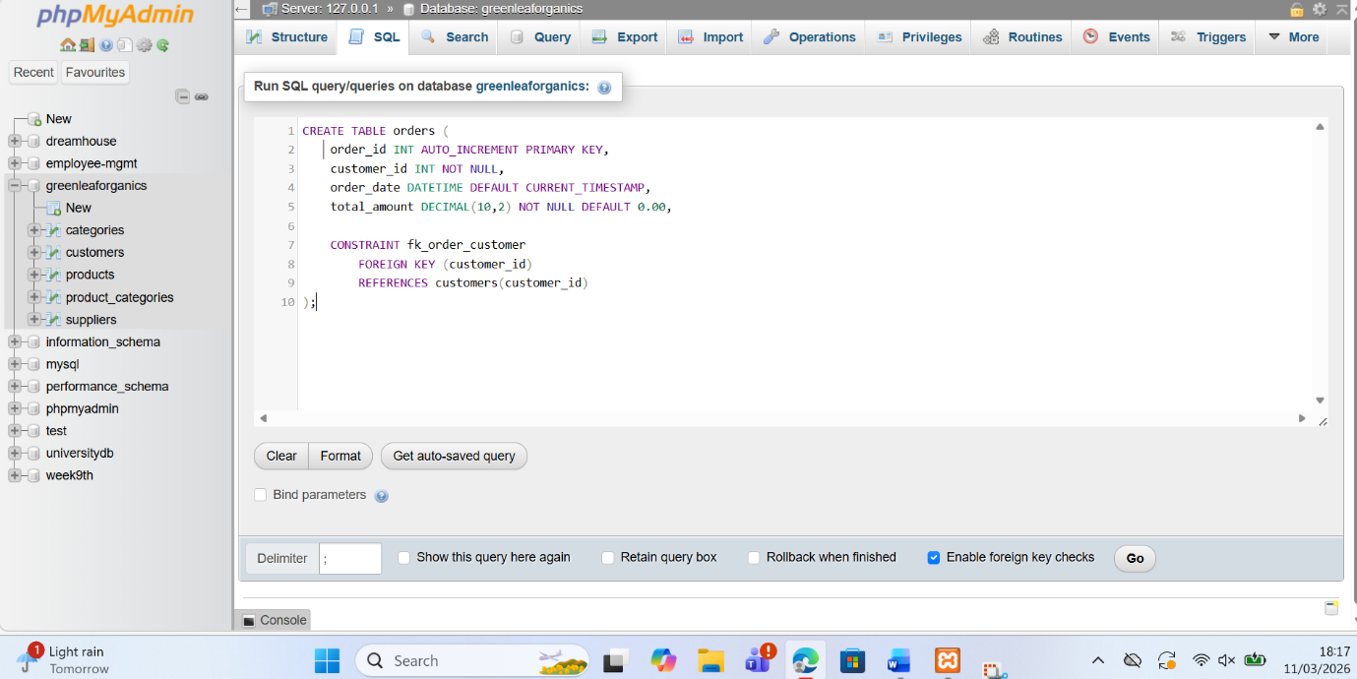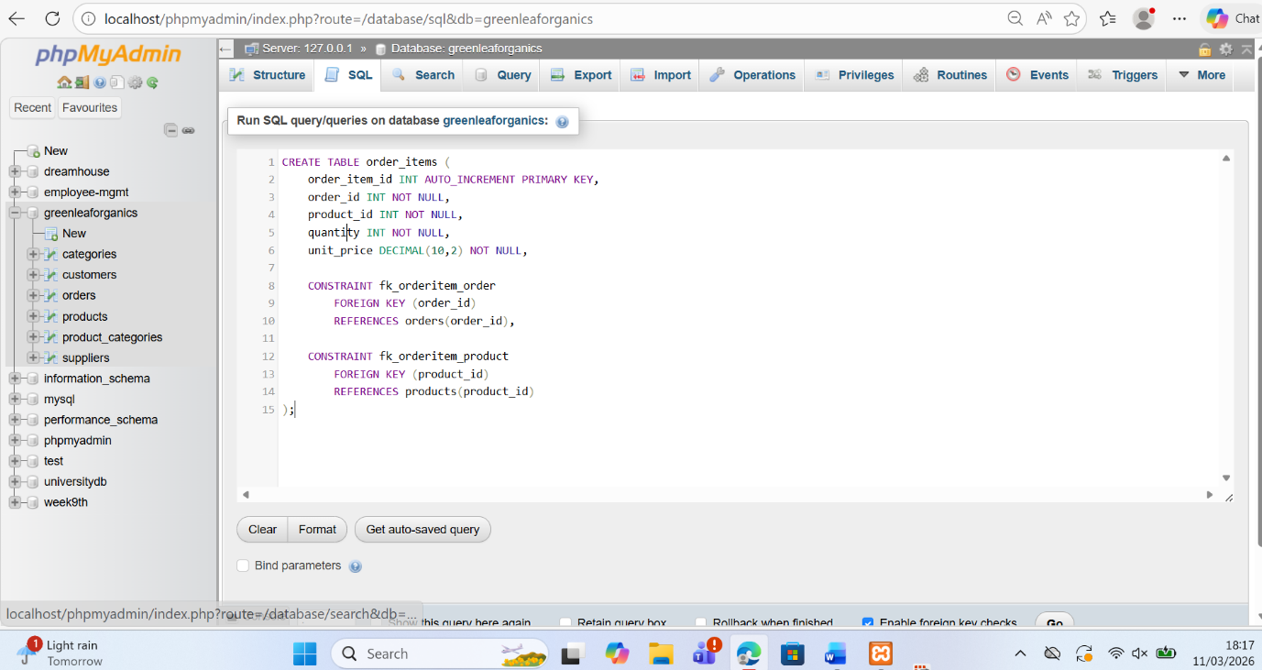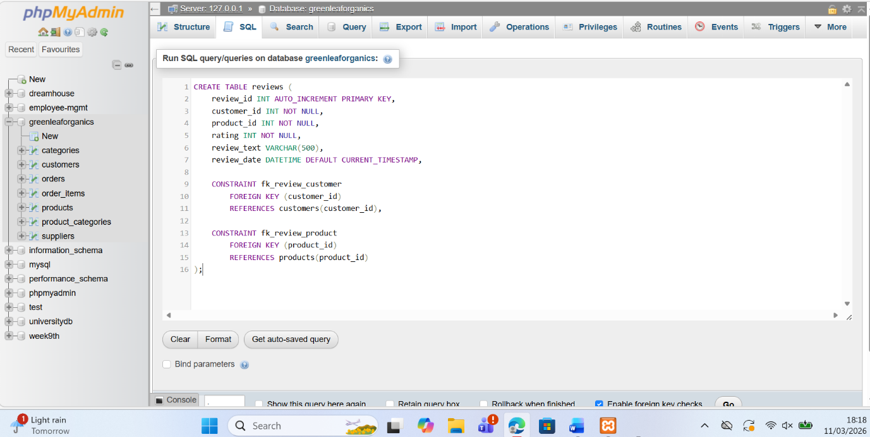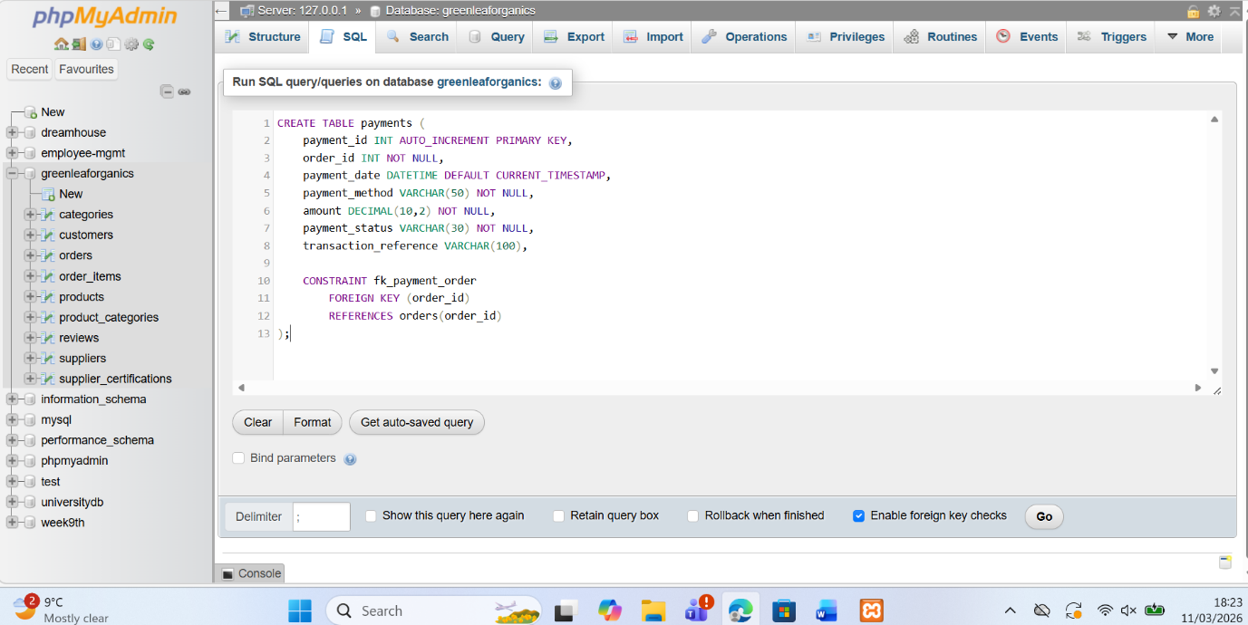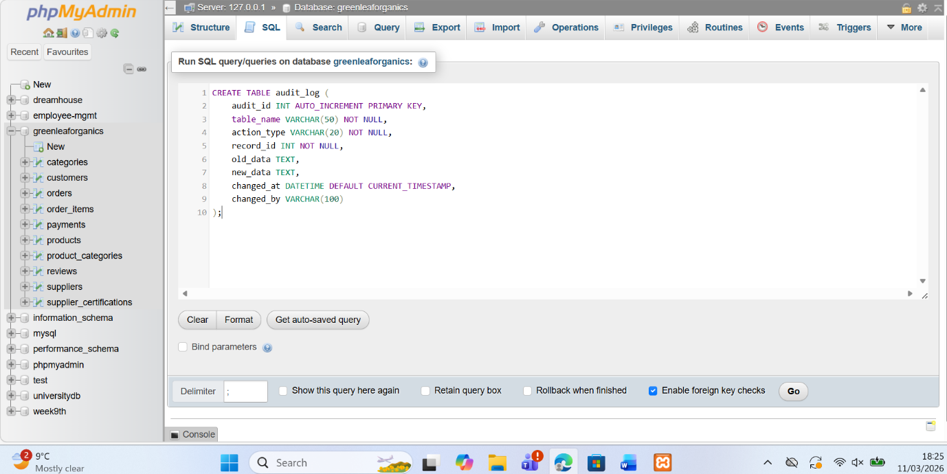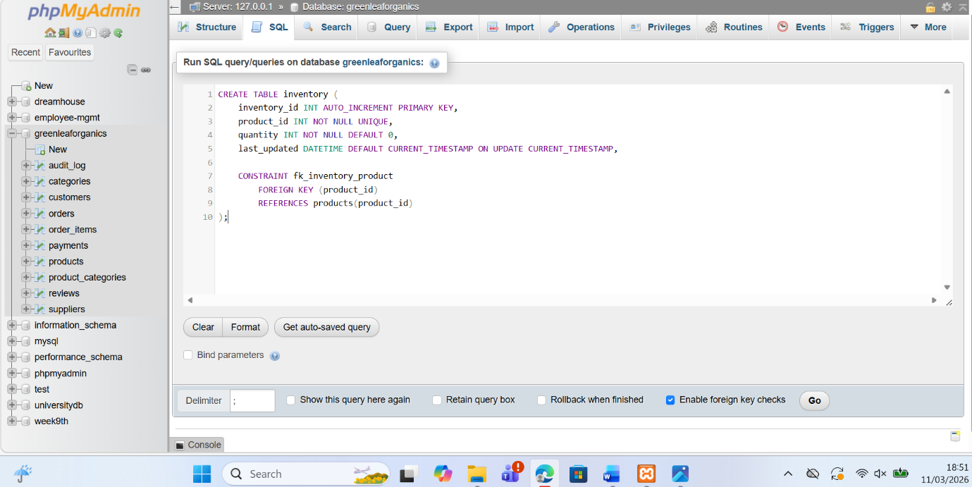

Constraint implementation
Constraints were implemented to ensure data integrity and enforce the relationships defined in the database design. Primary keys were used to uniquely identify each record, while foreign key constraints were added to link related tables such as products with suppliers, orders with customers, and order_items with orders and products. These constraints prevent invalid data from being inserted and ensure that all relationships between entities remain consistent. The screenshots show examples of foreign key definitions within the table creation statements, demonstrating how the database enforces referential integrity automatically within the GreenLeaf Organics system [7].

Sample data insertion
Sample data was inserted into the database to simulate realistic operations within the GreenLeaf Organics system. Using SQL INSERT INTO statements in phpMyAdmin, records were added to tables such as products, orders, and inventory. The screenshots show successful insert operations where products are added to the catalogue and customer orders are recorded. This testing step helps verify that the relationships between tables work correctly and that the constraints do not block valid data. Inserting sample data also allows the system to be tested before real-world use and supports validation of the database functionality [8].
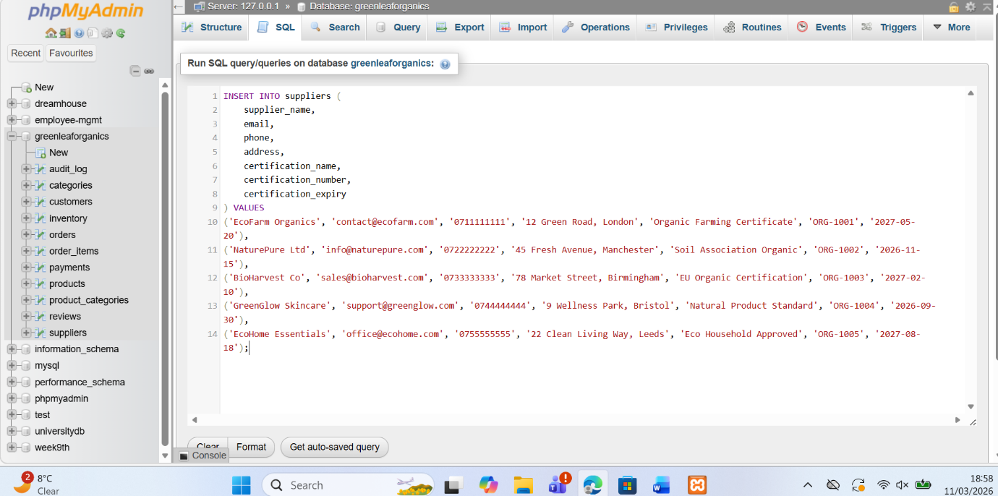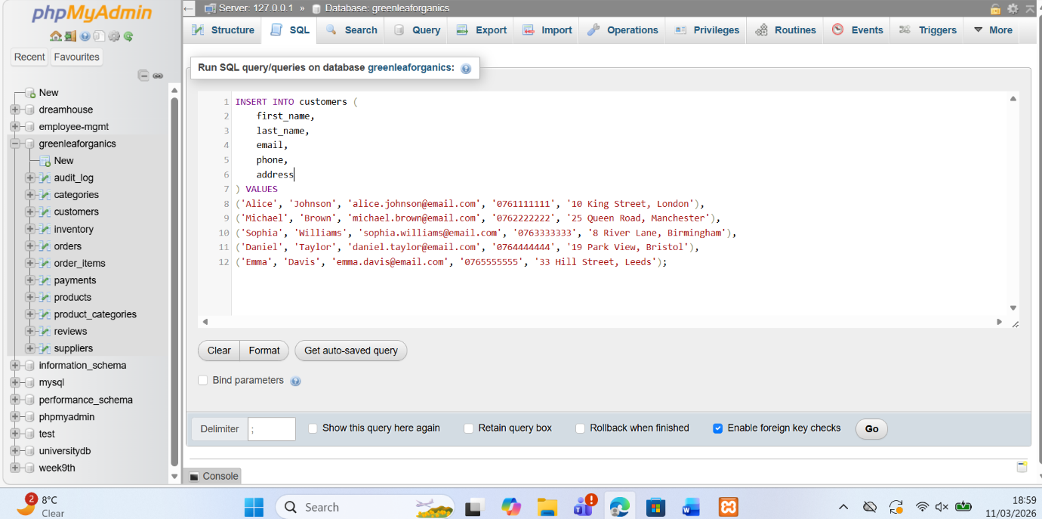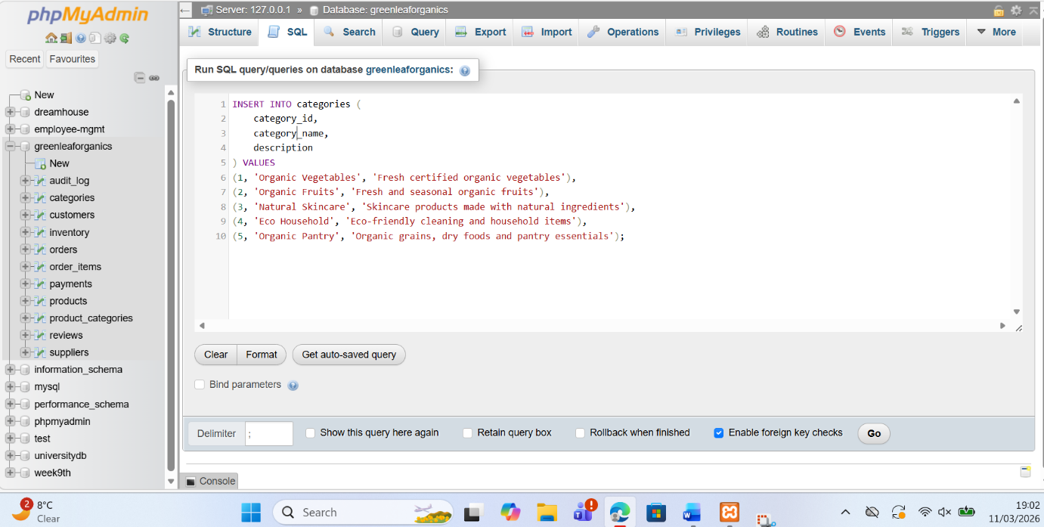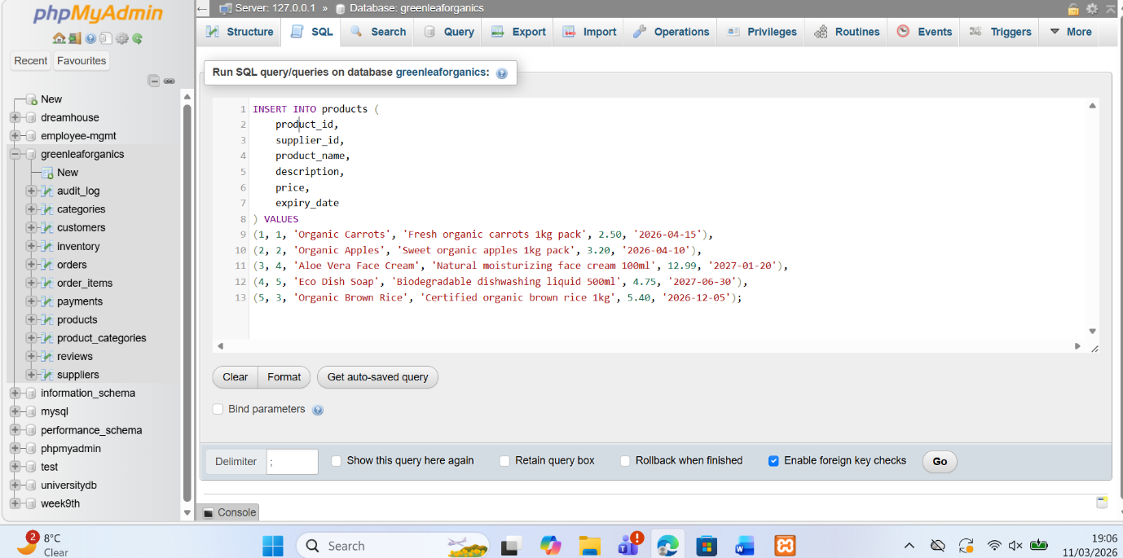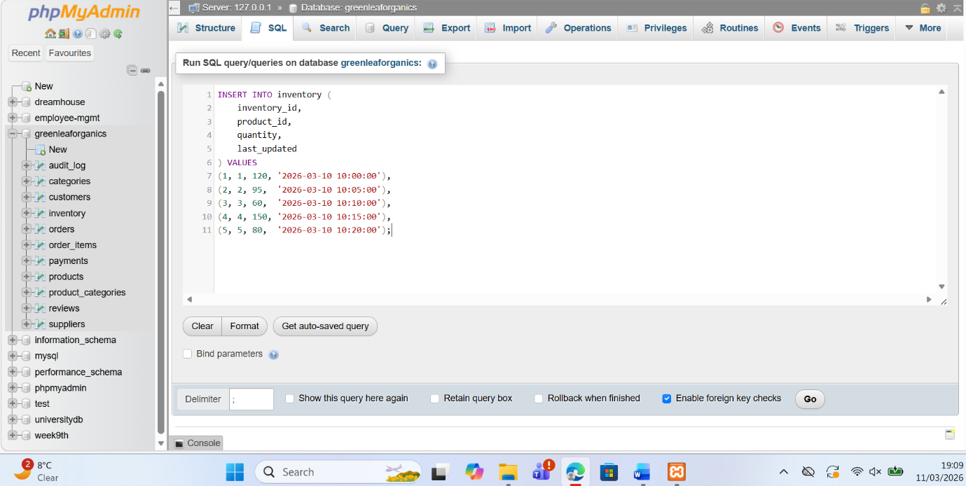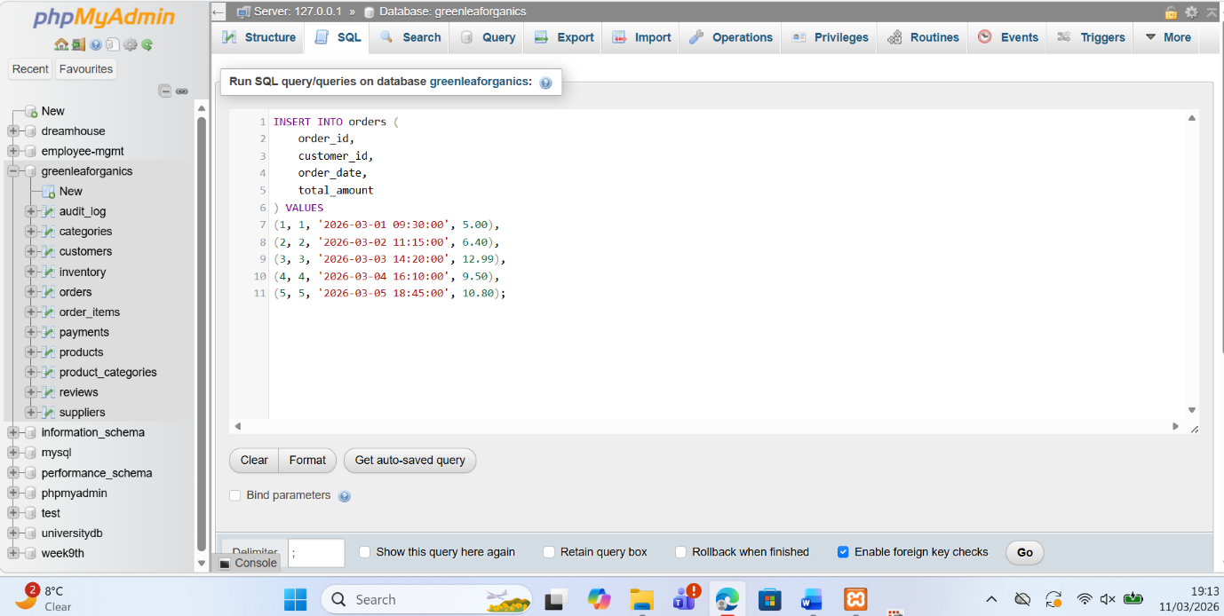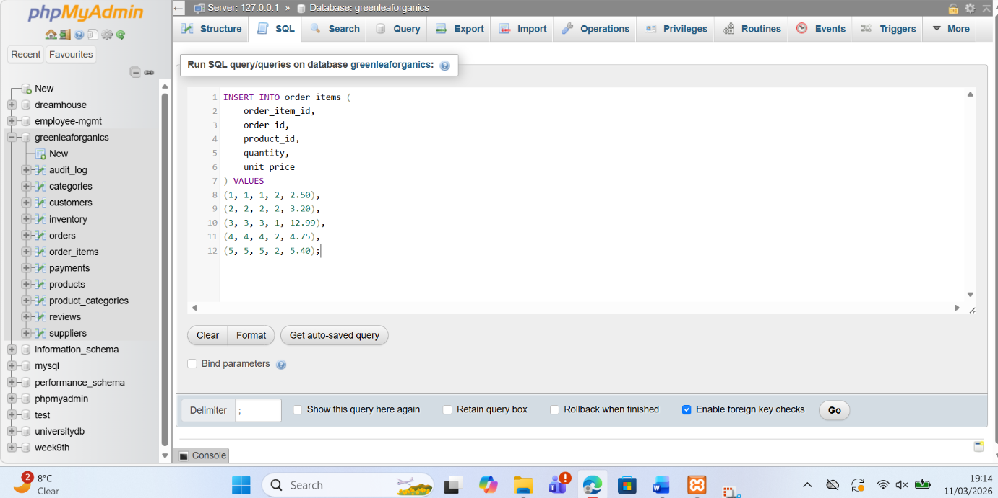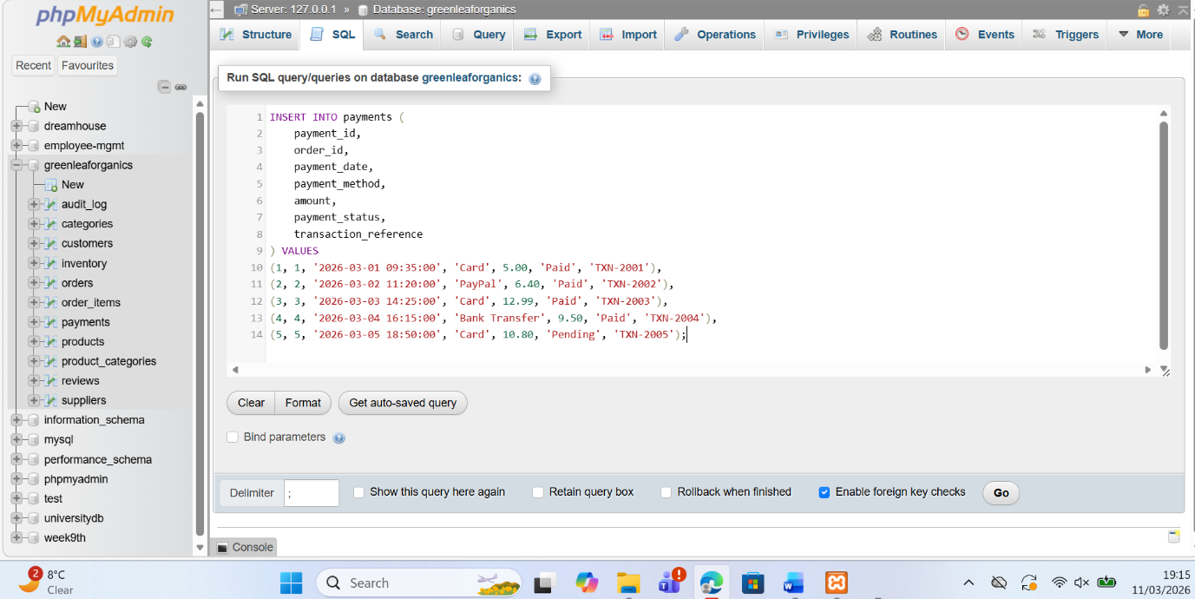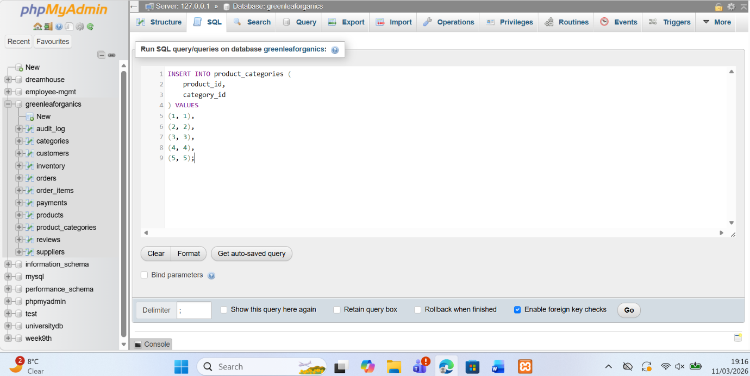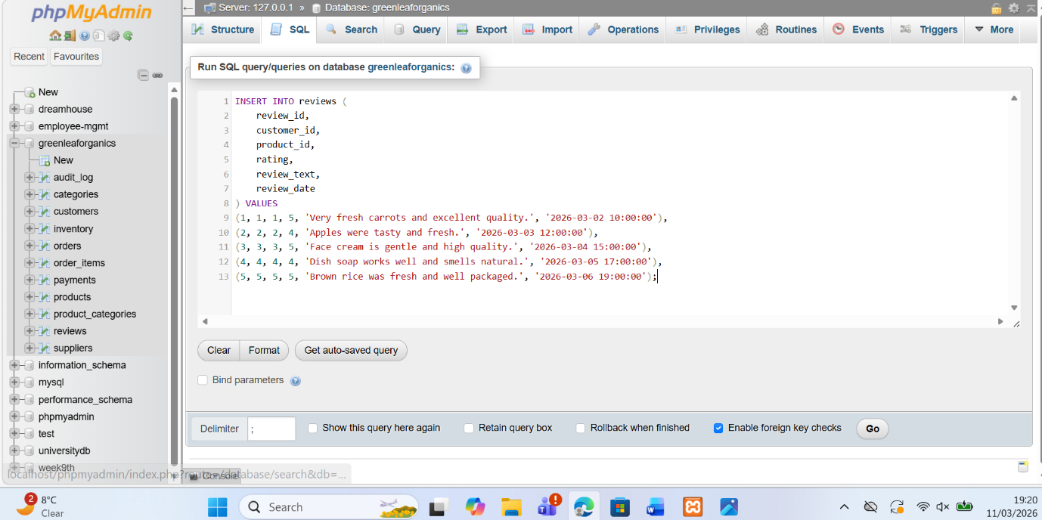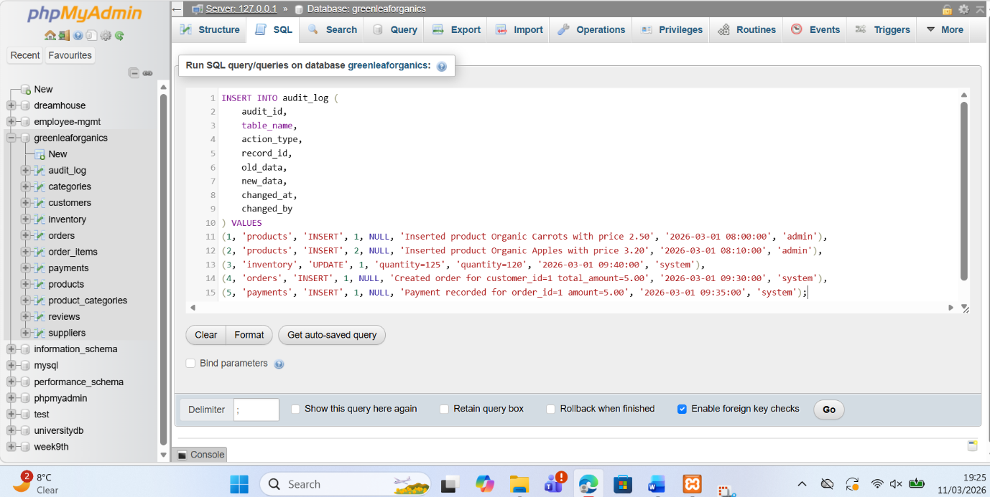

Trigger and stored procedure execution
Trigger and stored procedure execution were implemented to automate important database operations and maintain data consistency. Stored procedures were created to handle tasks such as inserting products, updating inventory quantities, and processing orders using transaction control with COMMIT and ROLLBACK. Triggers were also developed to automatically record database changes in the audit_log table whenever products, orders, or inventory records were modified. The screenshots demonstrate the successful execution of these procedures and triggers in phpMyAdmin, confirming that automated database actions work correctly and help maintain reliable system behaviour within the GreenLeaf Organics platform [9].
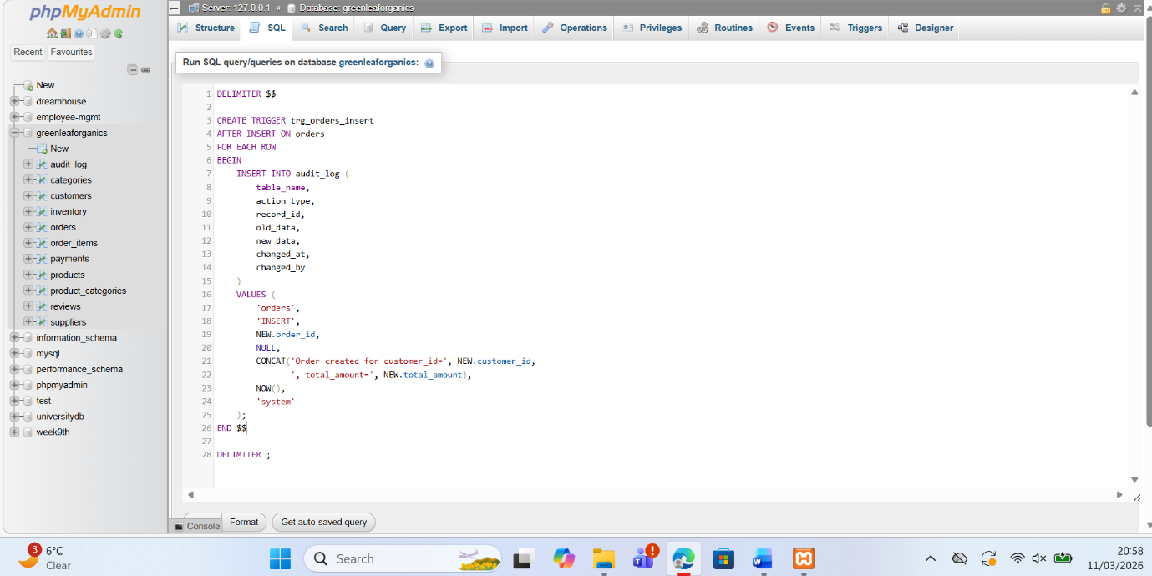
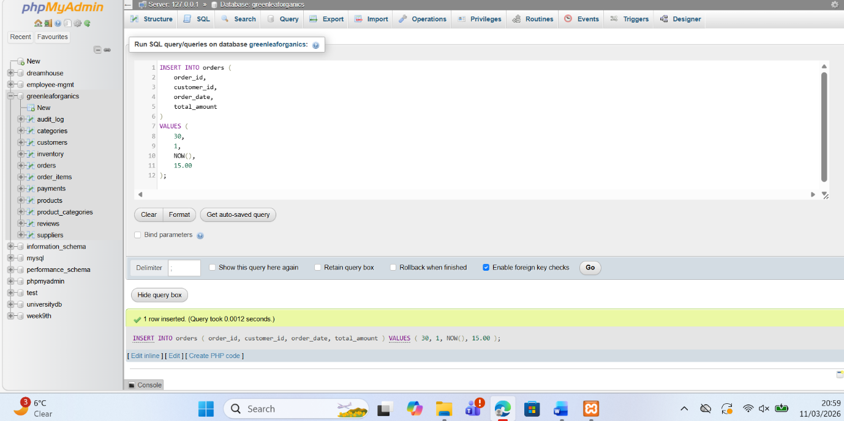
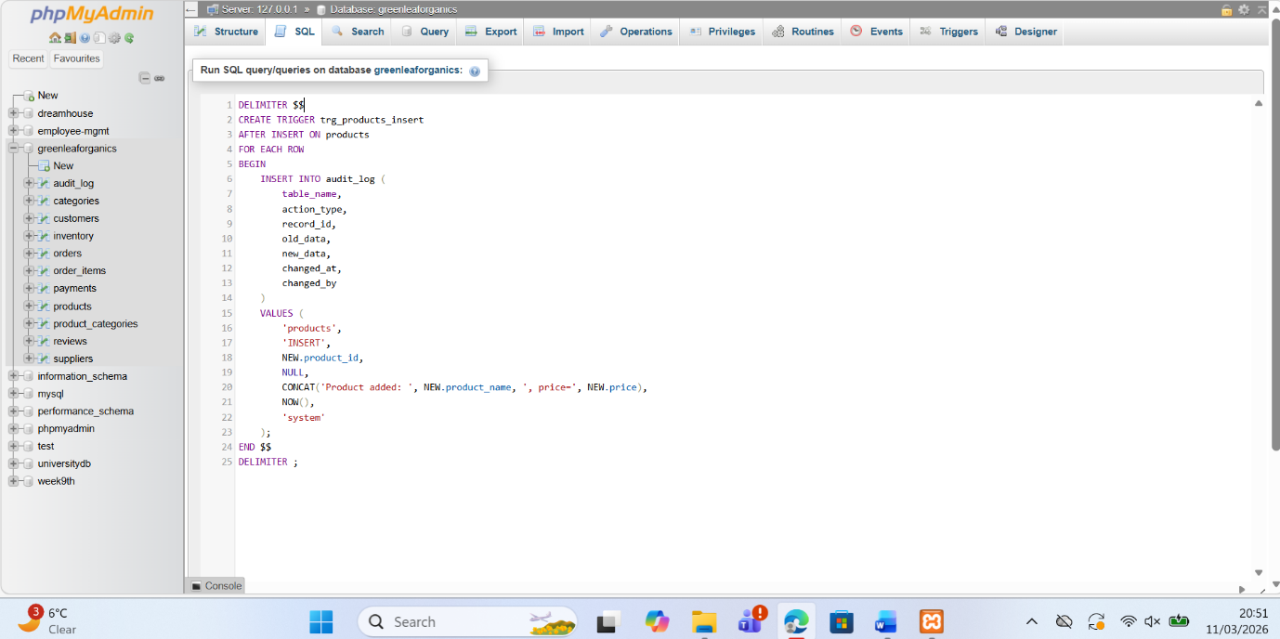
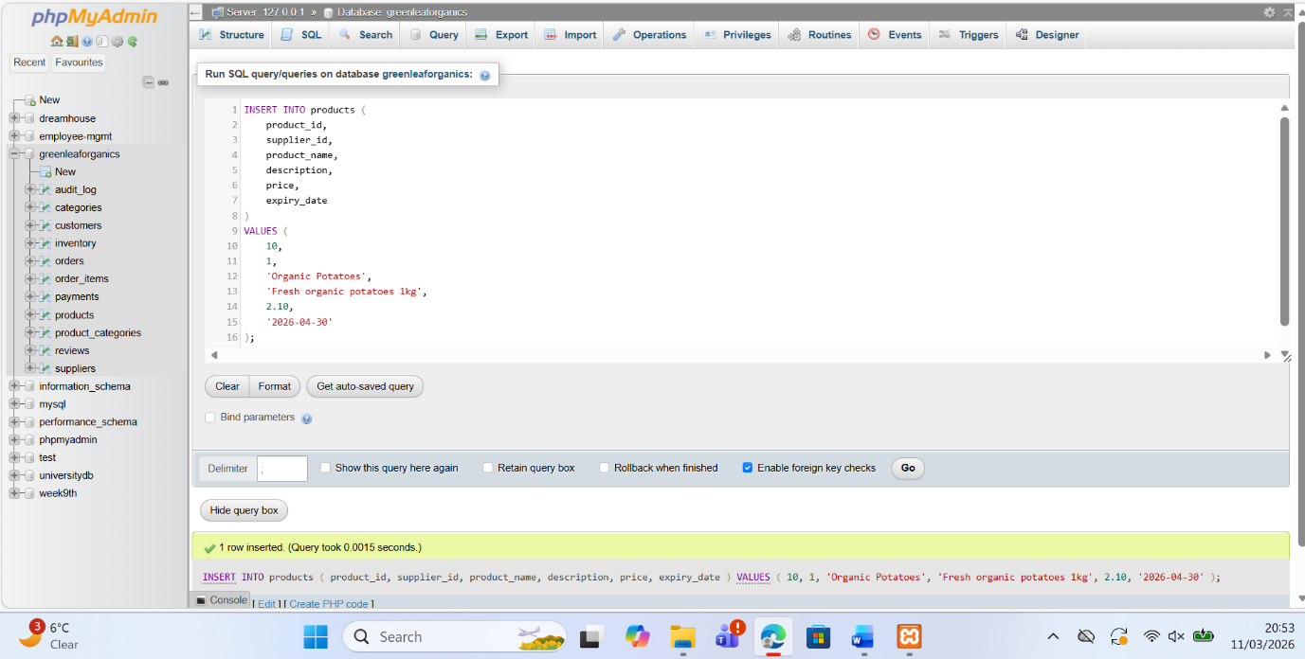
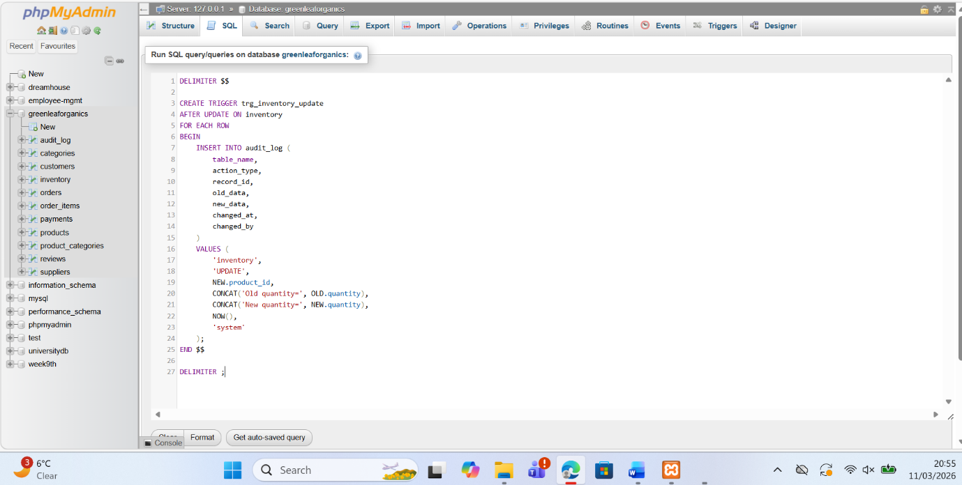

Stored Procedure and Transactional Scenario
CRUD
Stored procedures were used to manage the main Insert, Update, and Delete operations in a controlled and reusable way. The insert procedure was designed to add new records, such as products or customer orders, while making sure that related values were valid before the data was saved. The update procedure was used for changes such as adjusting inventory quantities or modifying product details. The delete procedure handled the removal of selected records, for example outdated reviews, while still respecting the relationships between tables. This approach made the database easier to manage because common actions were centralized inside the database instead of being repeated manually in multiple queries [10].
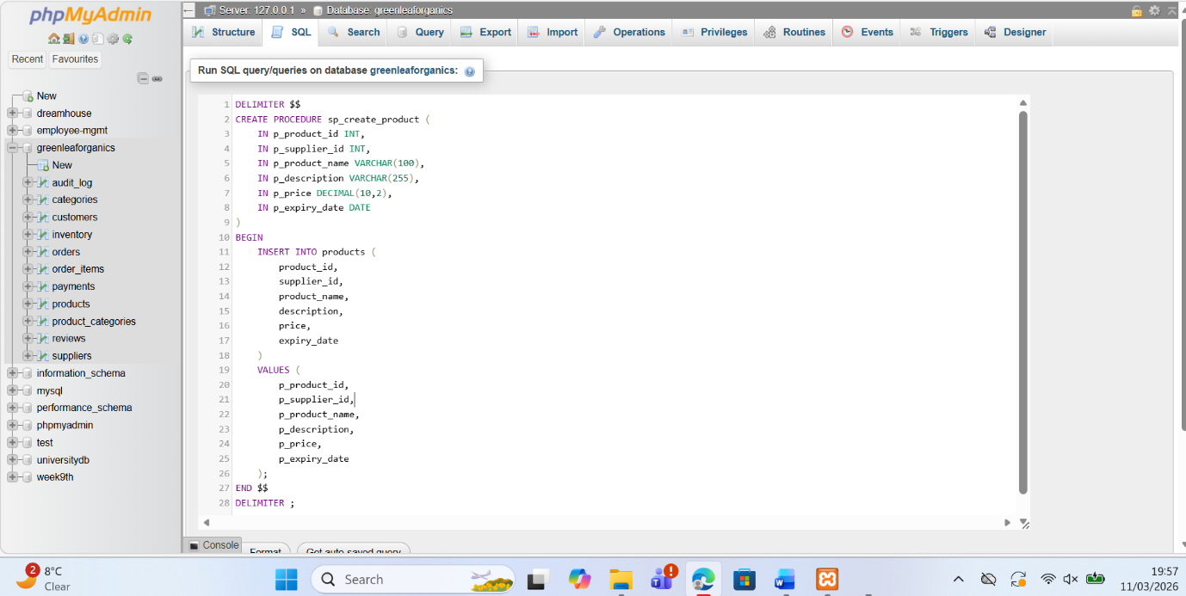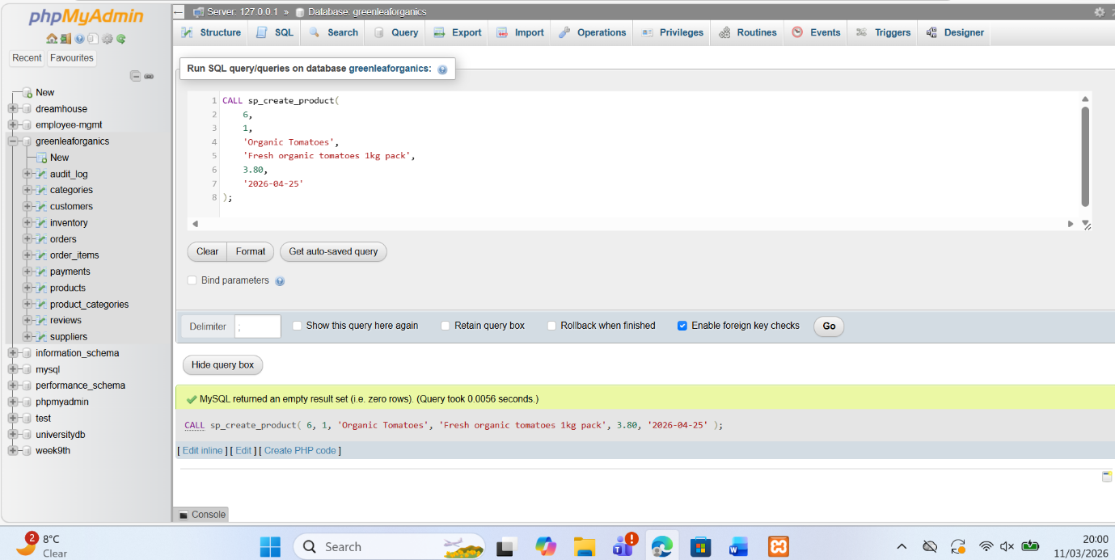
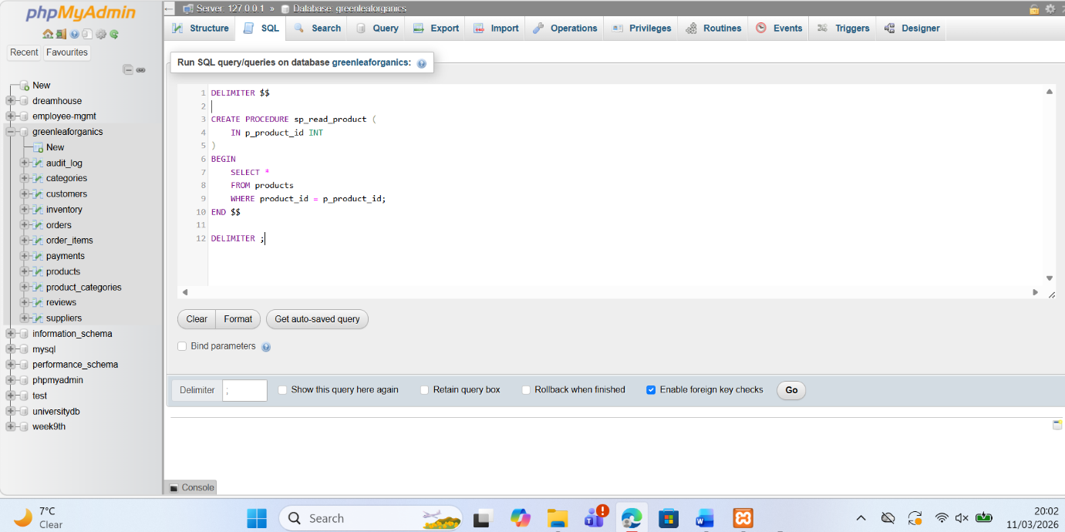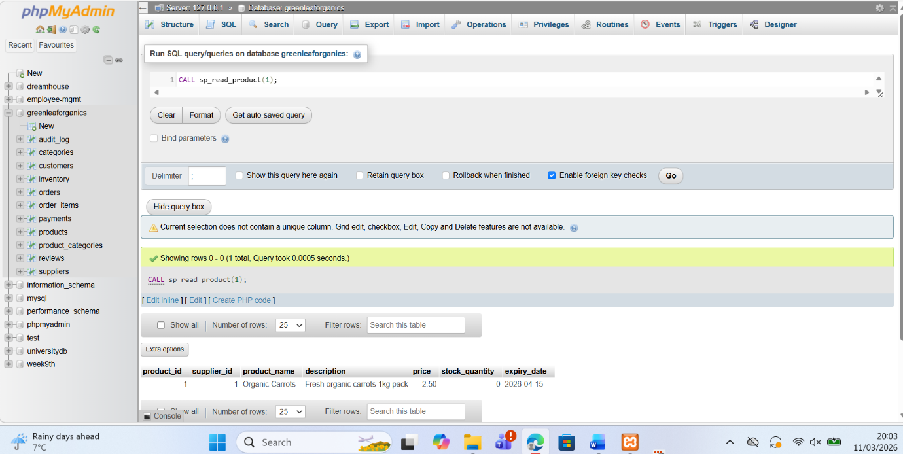
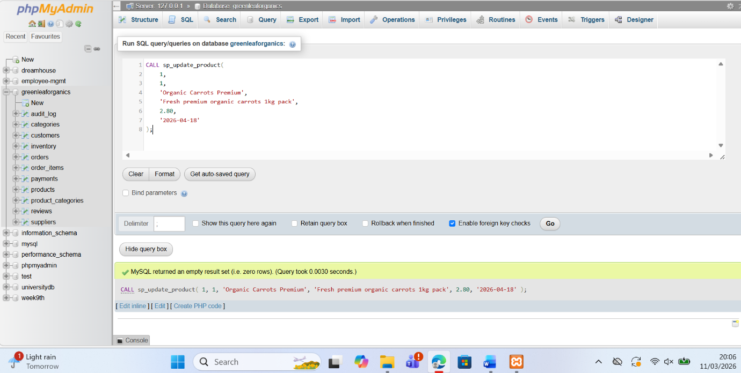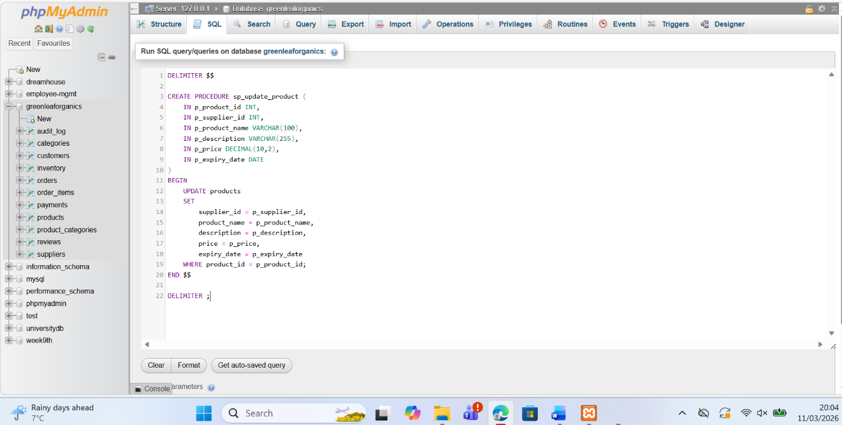
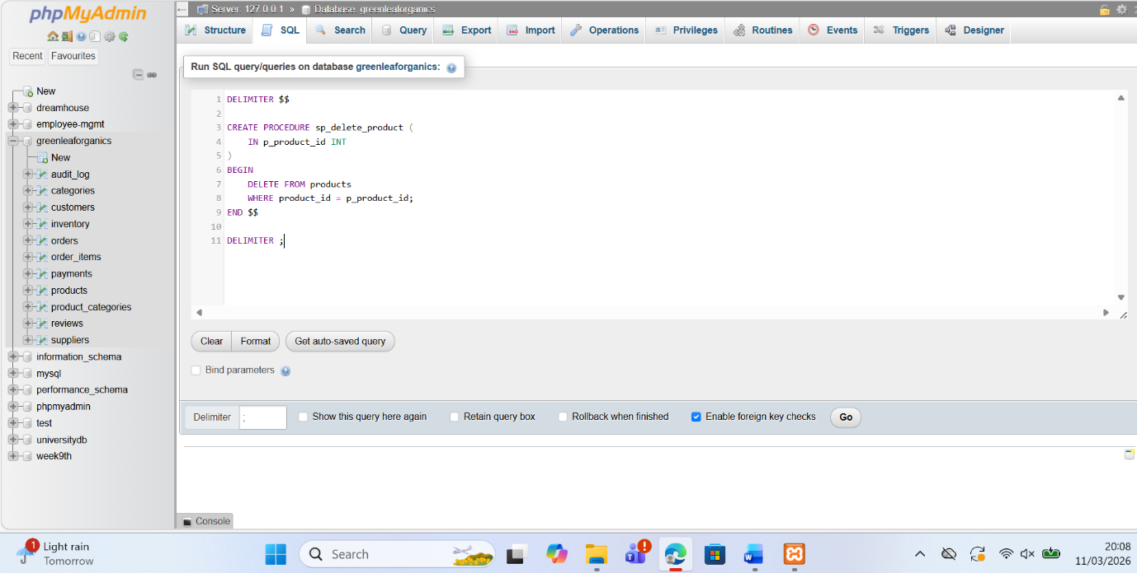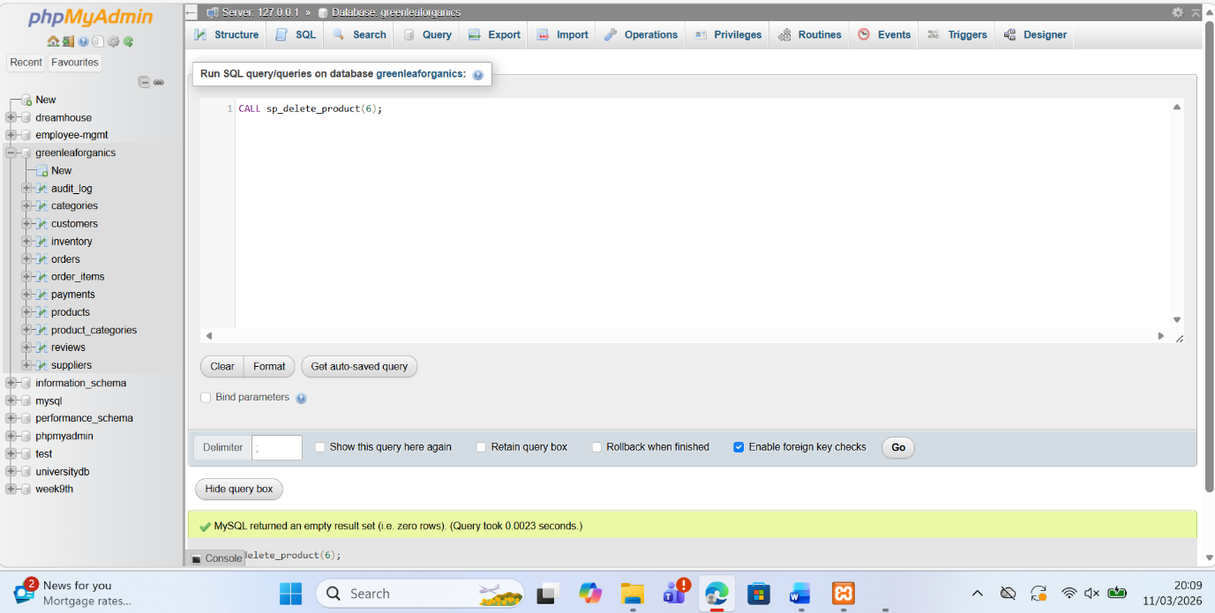
Commit and Rollback
Transaction handling was built into these procedures using START TRANSACTION, COMMIT, and ROLLBACK. This was especially important for operations that involved more than one table. A good example is order processing. When a customer places an order, the system must insert a record into the orders table, insert matching rows into order_items, update the inventory table, and record the payment. These steps are logically connected, so they must succeed together or fail together. If all operations complete successfully, the procedure issues a COMMIT, which permanently saves the transaction. This ensures that the order is stored correctly and that stock levels remain accurate.
Conditional rollback and commit logic were included to make the procedures more realistic and reliable. For example, before confirming an order, the stored procedure checks whether enough stock is available in the inventory table. If the requested quantity is greater than the available stock, the procedure does not continue. Instead, it performs a ROLLBACK, which cancels all changes made during that transaction. This prevents incomplete or inconsistent data, such as an order being recorded without the stock being updated. In contrast, when stock is available and all inserts and updates finish successfully, the procedure uses COMMIT to finalize the transaction. This kind of conditional control is essential in transactional systems because it protects data integrity and prevents business errors such as overselling products or saving partial records [11].
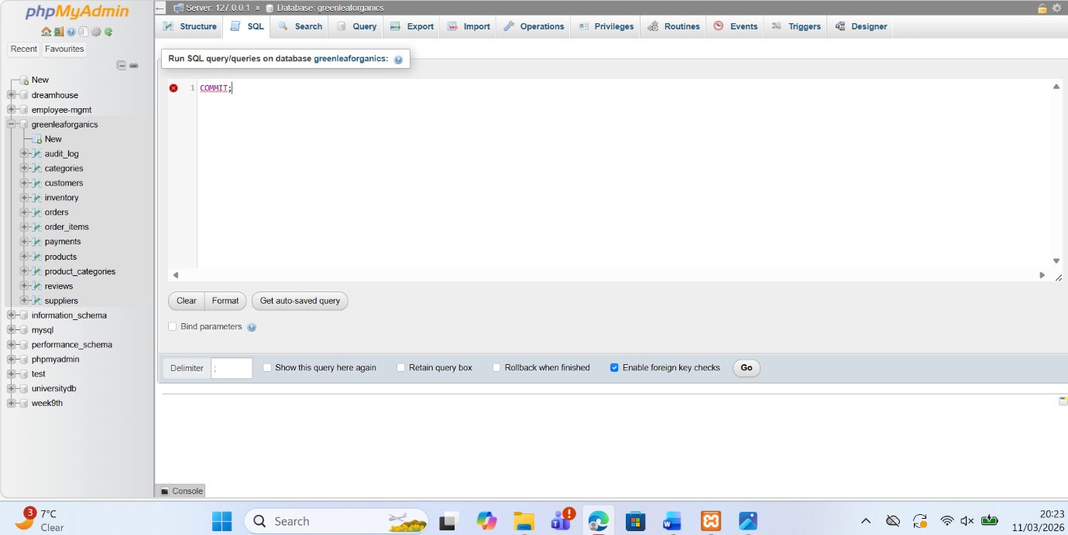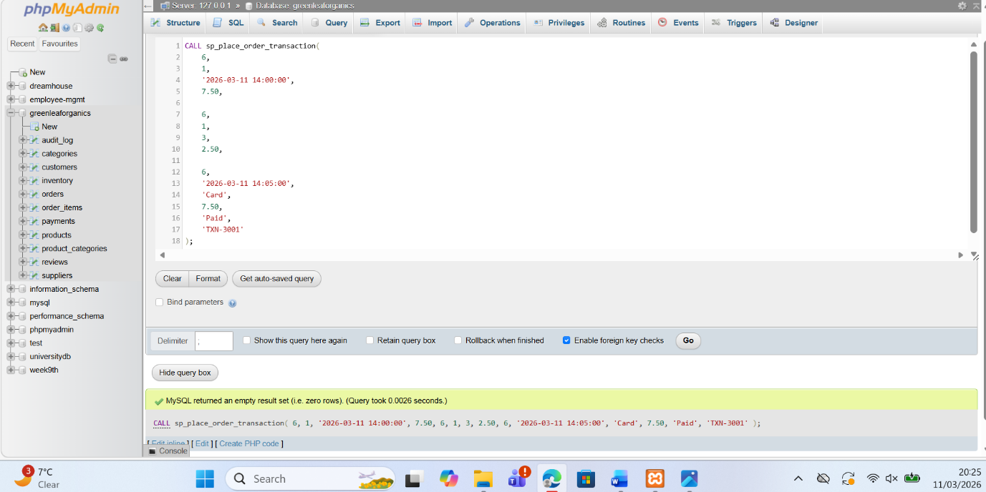

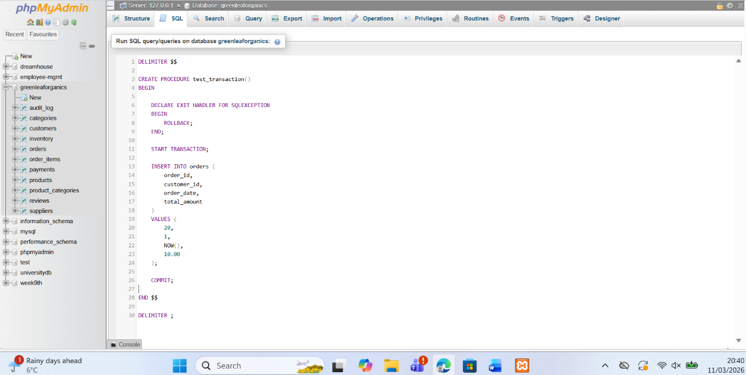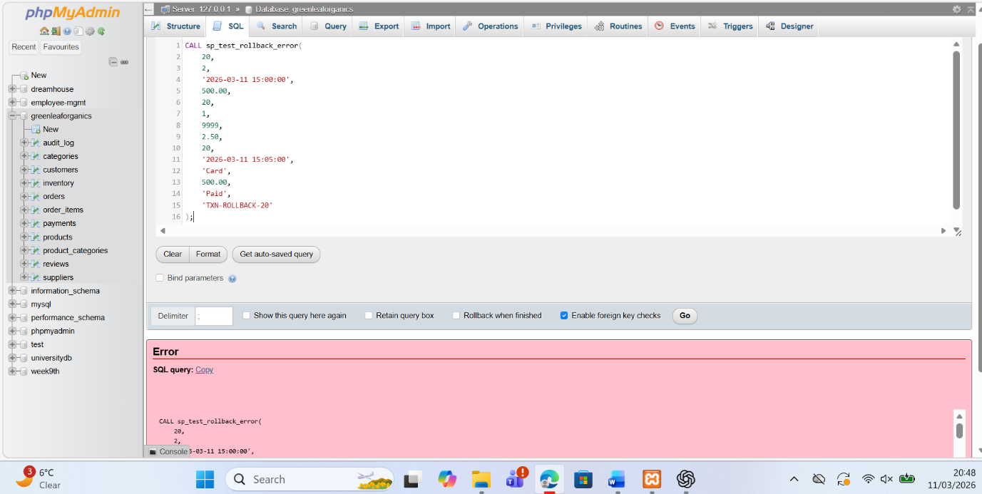

Performance Tuning Enhancement
Performance tuning is an important step in improving the efficiency of the GreenLeaf Organics database. One of the most effective techniques used was indexing. Indexes were created on columns that are frequently used in joins, filtering conditions, and search queries. Examples include indexing the foreign key columns such as supplier_id in the products table, customer_id in the orders table, and product_id in tables such as order_items, reviews, and inventory. These attributes are commonly accessed when retrieving information about orders, products, and customer interactions. By indexing these columns, the database engine can quickly locate matching rows without scanning the entire table, which significantly improves query performance [12].
The indexing strategy focuses on queries that are expected to be executed frequently in the system. For example, operational queries that retrieve a customer’s order history require fast access to the orders table using the customer_id field. Similarly, product-related queries often combine information from products, suppliers, and categories, so indexing the foreign keys used in joins helps reduce the time needed to execute these queries. Inventory management also benefits from indexing the product_id column in the inventory table because stock levels are updated or checked regularly during order processing. By prioritizing indexes on these performance-critical attributes, the database can respond faster to user requests and support real-time operations.
Indexing also improves the overall handling of operational data within the system. When the database grows and more records are added, queries that previously required scanning thousands of rows can instead use indexes to locate data directly. This reduces CPU usage and improves response time, which is especially important for systems that process many transactions or customer requests simultaneously. For example, retrieving product information or validating inventory during an order transaction becomes more efficient when indexes are present on the relevant columns.
Overall, the use of indexing is expected to provide noticeable improvements in query speed and database efficiency. Queries involving joins between tables, such as retrieving orders together with customer information or linking products with categories, will execute more quickly because indexed columns allow the database engine to navigate directly to the required data. As a result, the GreenLeaf Organics system can handle larger datasets and higher transaction volumes while maintaining stable performance and reliable data access [13].
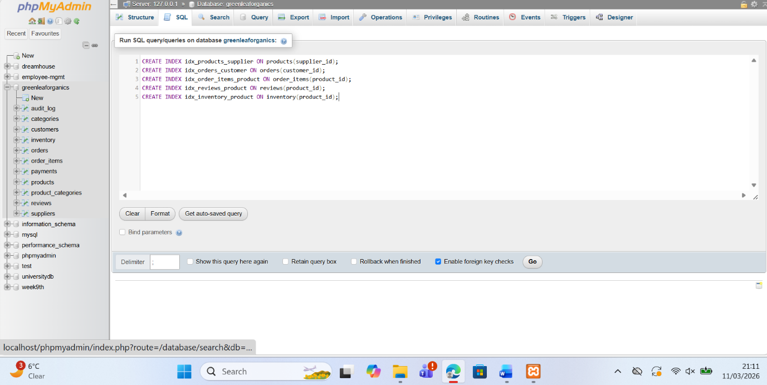

Conclusion and Reflection
The final database solution successfully addresses the operational requirements of the GreenLeaf Organics platform by providing a structured and reliable system for managing suppliers, products, customers, and orders. Through the use of a relational database model, the system organizes information into clearly defined tables with primary and foreign key relationships that maintain data integrity and consistency. Features such as product categorization, inventory tracking, customer reviews, and order processing are all supported through the implemented schema. Additionally, the use of normalization to Third Normal Form ensures that the database minimizes redundancy while maintaining efficient data management. Together, these design decisions allow the system to handle essential business processes such as product listing, customer purchases, and supplier management effectively [14].
During the development of the database, several challenges were encountered. One of the main difficulties involved designing relationships between entities while avoiding redundant data and maintaining normalization. For example, separating product categories through an associative table and structuring the order and order items relationship required careful planning to reflect real business processes accurately. Another challenge was implementing stored procedures with transaction control. Ensuring that operations such as order processing correctly used COMMIT and ROLLBACK required testing different scenarios to confirm that incomplete transactions would not leave the database in an inconsistent state. These issues were addressed through iterative testing and adjustments to the SQL procedures and constraints.
The project also demonstrated the importance of automation and performance optimization. Triggers were implemented to track changes through the audit log, providing transparency and traceability for database actions. Functions and indexes were also introduced to improve query efficiency and simplify data retrieval. These features help the system operate more smoothly, especially when handling larger volumes of transactions or user requests.
In the future, several improvements could further enhance the database system. For example, additional triggers could be introduced to automate more operational tasks, such as automatically updating order totals or sending notifications when inventory levels become low. Security measures such as role-based access control could also be added to restrict access to sensitive data. Furthermore, integrating the database with an application interface or reporting tools could provide better insights into customer behavior and sales performance. Overall, the project demonstrates how careful database design and implementation can support complex business operations while ensuring reliability, scalability, and efficient data management.

References
[1] T. M. Connolly and C. E. Begg, Database Systems: A Practical Approach to Design, Implementation, and Management, 7th ed. Harlow, UK: Pearson, 2021.
[2] A. Silberschatz, H. F. Korth, and S. Sudarshan, Database System Concepts, 7th ed. New York, NY, USA: McGraw-Hill Education, 2020.
[3] T. M. Connolly and C. E. Begg, Database Systems: A Practical Approach to Design, Implementation, and Management, 7th ed. Harlow, U.K.: Pearson, 2021.
[4] T. Taipalus, “The effects of database normalization on decision support system performance,” Information Systems, vol. 136, p. 102636, Feb. 2026.
[5] T. Connolly and C. Begg, Database Systems: A Practical Approach to Design, Implementation, and Management, 7th ed. Harlow, UK: Pearson, 2021.
[6] R. Elmasri and S. B. Navathe, Fundamentals of Database Systems, 7th ed. Hoboken, NJ, USA: Pearson, 2020.
[7] T. M. Connolly and C. E. Begg, Database Systems: A Practical Approach to Design, Implementation, and Management, 7th ed. Harlow, UK: Pearson, 2021.
[8] R. Elmasri and S. B. Navathe, Fundamentals of Database Systems, 7th ed. Hoboken, NJ, USA: Pearson, 2020.
[9] S. Chodorow, “Designing relational databases for scalable applications,” IEEE Software, vol. 38, no. 6, pp. 54–61, Nov.–Dec. 2021.
[10] T. M. Connolly and C. E. Begg, Database Systems: A Practical Approach to Design, Implementation, and Management, 7th ed. Harlow, U.K.: Pearson, 2026.
[11] M. Fotache, M.-I. Cluci, T. Taipalus, and G. Talaba, “The effects of database normalization on decision support system performance,” Information Systems, vol. 136, Art. no. 102636, Feb. 2026.
[12] T. M. Connolly and C. E. Begg, Database Systems: A Practical Approach to Design, Implementation, and Management, 7th ed. Harlow, U.K.: Pearson, 2021.
[13] T. Taipalus, “The effects of database normalization on decision support system performance,” Information Systems, vol. 136, p. 102636, Feb. 2026.
[14] T. M. Connolly and C. E. Begg, Database Systems: A Practical Approach to Design, Implementation, and Management, 7th ed. Harlow, U.K.: Pearson, 2021.

