Principle of Digital Forensics
Module Code: 7CSEF007W
ASSESSMENT 1
STUDENT:
MD ALIF ALAM (21356454)
LECTURER:
CHEE YEUNG

1. Introduction
1.1 Disk Partitioning
Memory management is one of the most complicated aspects of the Linux operating system. It involves the interaction between the kernel and the user space to read and write the contents of storage devices [1]. These storage devices are frequently partitioned; there are various software that may assist creating partitions on the hard disk drive, such as Gparted.
1.2 MBR vs GPT
Modern machines are starting to outperform the ageing DOS/MBR partition tables and BIOS boot system of the original IBM PC. Although various additions and enhancements to the original BIOS have been produced throughout time, its flexibility and extensibility remain limited [2]. Intended to solve booting and partitioning limitations with newer hardware, a replacement for both the BIOS and the MBR partition table was developed by Intel in the late 1990s. This is now called the Unified EFI specification and managed by the UEFI. A subset of this specification includes GUID (globally unique identification) Partition Tables, or GPT, intended to replace the DOS/MBR partition tables [3].
1.3 Purpose of the Report & Methodology
In this paper the topic covered will be, the decoding with a manual approach of two disks partitioned in MBR (Master Boot Record) and GPT (GUID Partition Table) style. The rules to create the partitions are the following:
- Create three partitions
- The size of the partitions must be the three digits of my student id multiplied by three. So, in this case 454 x 3 = 1362
- Format the second partition with NTFS and set the volume label with my surname using a cluster size of 16k in this case VOLUME label = ALAM
- Repeat the same process for creating the partition using GPT
2.0 MBR Analysis
2.1 MBR partition table entry
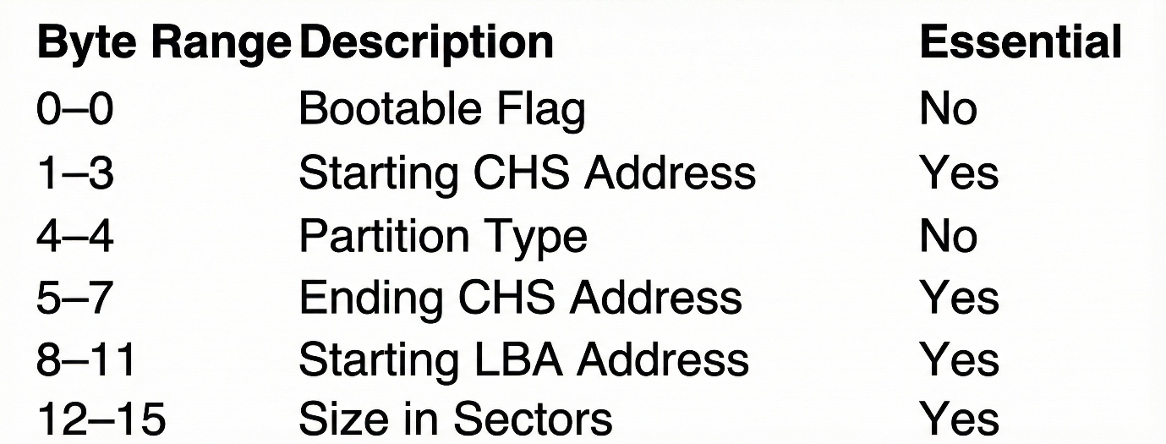
Figure 1.0 Partition table entry [4]
Our analysis will be based on this table entry structure from the Master Boot Record (MBR) partition scheme used in traditional BIOS-based disk partitioning. Each entry is 16 bytes long and describes one partition on a disk. Here is what each field means [4]:
- Byte 0: Bootable flag (0x80 = bootable, 0x00 = not bootable)
- Bytes 1-3: Starting CHS (Cylinder-Head-Sector) address - legacy addressing method, rarely used in modern systems
- Byte 4: Partition type code (identifies the filesystem - e.g., 0x83 for Linux, 0x07 for NTFS, 0x0C for FAT32)
- Bytes 5-7: Ending CHS address - also legacy, not commonly used anymore
- Bytes 8-11: Starting LBA (Logical Block Address) - the actual sector number where the partition begins
- Bytes 12-15: Size of the partition in sectors
2.2 Hex file Analysis
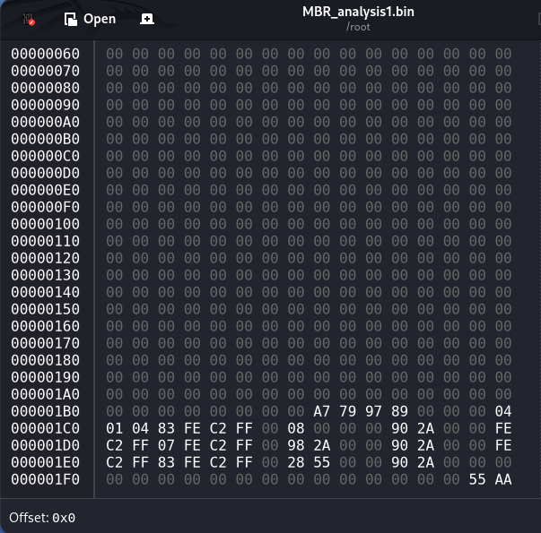
Figure 2.0 Hex Dump MBR Analysis

Manual Hex Decoding
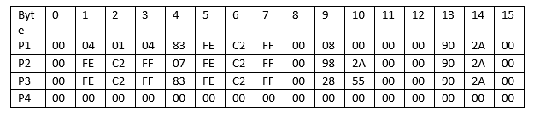
Figure 2.1 Partition table
For Partition 1 we can see the following:
- Byte 0: The value found is 00 we can conduct that this partition is not bootable. If the value was 0x80 than it means is bootable.
- Bytes range 1 to 3 Starting CHS Address: Based on the partition the value found 04 01 04 which is in little endian format, so it needs to be in big endian to decode – 04 01 04
Now conversion from HEX to DEC = 16^0 x 4 + 16^1 x 0 + 16^2 x 1 + 16^3 x 0 + 16^4 x 4 + 16^5 x 0 = 262404 (Starting CHS Address).
- Byte 4 Partition type: Value found is 83 = Linux System
- Bytes range 5 to 7 Ending CHS Address: Based on the partition the value found is FE C2 FF (little endian) – FF C2 FE (Big Endian)
Now conversion from HEX to DEC = 16^0 x 14 + 16^1 x 15 + 16^2 x 2 + 16^3 x 12 + 16^4 x 15 + 16^5 x 15 = 16761598 (Ending CHS Address)
- Bytes range 8 to 11 Starting LBA Address of the partition: Based on the partition table the value found is 00 08 00 00 (little endian) – 00 00 08 00 (Big endian)
Now conversion from HEX to DEC = 16^0 x 0 + 16^1 x 0 + 16^2 x 8 + 16^3 x 0 + 16^4 x 0 + 16^5 x 0 + 16^6 x 0 + 16^7 x 0 = `1040
Value in bytes = 1040 x 512 = 532480 (Partition 1 starts at 532480)
- Bytes range 12 to 15 Size of the partition in the sector: Based on the partition table the value found is 00 90 2A 00 (little endian) – 00 2A 90 00 (Big endian)
Now conversion from HEX to DEC = 16^0 x 0 + 16^1 x 0 + 16^2 x 0 + 16^3 x 9 + 16^4 x 10 + 16^5 x 2 + 16^6 x 0 + 16^7 x 0 = `2789376
Value in bytes = 2789376 x 512 = 1428160512 bytes (Size of the partition in the sector)
For Partition 2 we can see the following:
- Byte 0 : value 00 we can conduct that this partition is not bootable. If the value was 0x80 than it means is bootable.
- Bytes range 1 to 3 Starting CHS Address: Based on the partition the value found FE C2 FF which is in little endian format, so it needs to be in big endian to decode – FF C2 FE
Now conversion from HEX to DEC = 16^0 x 14 + 16^1 x 15 + 16^2 x 2 + 16^3 x 12 + 16^4 x 15 + 16^5 x 15 = 16761598 (Starting CHS Address).
- Byte 4 Partition type: Value found is 07 = NTFS System
- Bytes range 5 to 7 Ending CHS Address: Based on the partition the value found is FE C2 FF (little endian) – FF C2 FE (Big Endian)
Now conversion from HEX to DEC = 16^0 x 14 + 16^1 x 15 + 16^2 x 2 + 16^3 x 12 + 16^4 x 15 + 16^5 x 15 = 16761598 (Ending CHS Address)
- Bytes range 8 to 11 Starting LBA Address of the partition: Based on the partition table the value found is 00 98 2A 00 (little endian) – 00 2A 98 00 (Big endian)
Now conversion from HEX to DEC = 16^0 x 0 + 16^1 x 0 + 16^2 x 8 + 16^3 x 9 + 16^4 x 10 + 16^5 x 2 + 16^6 x 0 + 16^7 x 0 = 2791424
Value in bytes = 2791424 x 512 = (Partition 1 starts at 1.429.209.088)
- Bytes range 12 to 15 Size of the partition in the sector: Based on the partition table the value found is 00 90 2A 00 (little endian) – 00 2A 90 00 (Big endian)
Now conversion from HEX to DEC = 16^0 x 0 + 16^1 x 0 + 16^2 x 0 + 16^3 x 9 + 16^4 x 10 + 16^5 x 2 + 16^6 x 0 + 16^7 x 0 = `2789376
Value in bytes = 2789376 x 512 = 1428160512 bytes (Size of the partition in the sector)
For Partition 3 we can see the following:
- Byte 0 value: 00 we can conduct that this partition is not bootable. If the value was 0x80 than it means is bootable.
- Bytes range 1 to 3 Starting CHS Address: Based on the partition the value found FE C2 FF which is in little endian format, so it needs to be in big endian to decode – FF C2 FE
Now conversion from HEX to DEC = 16^0 x 14 + 16^1 x 15 + 16^2 x 2 + 16^3 x 12 + 16^4 x 15 + 16^5 x 15 = 16761598 (Starting CHS Address).
- Byte 4 Partition type: Value found is 83 = Linux System
- Bytes range 5 to 7 Ending CHS Address: Based on the partition the value found is FE C2 FF (little endian) – FF C2 FE (Big Endian)
Now conversion from HEX to DEC = 16^0 x 14 + 16^1 x 15 + 16^2 x 2 + 16^3 x 12 + 16^4 x 15 + 16^5 x 15 = 16761598 (Ending CHS Address)
- Bytes range 8 to 11 Starting LBA Address of the partition: Based on the partition table the value found is 00 28 55 00 (little endian) – 00 55 28 00 (Big endian)
Now conversion from HEX to DEC = 16^0 x 0 + 16^1 x 0 + 16^2 x 8 + 16^3 x 2 + 16^4 x 5 + 16^5 x 5 + 16^6 x 0 + 16^7 x 0 = 5580800
Value in bytes = 5580800 x 512 = 2.857.369.600 (Partition 1 starts at 2.857.369.600)
- Bytes range 12 to 15 Size of the partition in the sector: Based on the partition table the value found is 00 90 2A 00 (little endian) – 00 2A 90 00 (Big endian)
Now conversion from HEX to DEC = 16^0 x 0 + 16^1 x 0 + 16^2 x 0 + 16^3 x 9 + 16^4 x 10 + 16^5 x 2 + 16^6 x 0 + 16^7 x 0 = `2789376
Value in bytes = 2789376 x 512 = 1428160512 bytes (Size of the partition in the sector)
2.4 Compare partitions to Student ID
Student ID last three digits 454 x 3 = 1362 MB
Size of the Partition 1 = 1428160512 bytes
Size of the Partition 2 = 1428160512 bytes
Size of the Partition 3 = 1428160512 bytes
Formula to Convert bytes in MB = Bytes / (1024 x 1024)
P1 Size in MB = 1428160512 / (1024 X 1024) = 1362 MB
P2 Size in MB = 1428160512 / (1024 X 1024) = 1362 MB
P3 Size in MB = 1428160512 / (1024 X 1024) = 1362 MB
So, from the above calculations it can be stated that ID RULE (1362MB) = P1 Size in MB = P2 Size in MB = P3 Size in MB
2.5 NTFS label = ALAM
Partition 1 type = 83
Partition 2 type = 07
Partition 3 type = 83
Based on the table entry Partition 1 – 3 are Linux System since the partition have been created in a Linux environment however on partition it returned a value of 07 which states that the partition has been formatted in NTFS which stands for New Technology File System. It means that partition 2 has been successfully formatted in NTFS. After thorough research I discovered that the Volume label can be found inside the NTFS boot sector.

3.0 GPT Analysis
3.1 GPT Partition Table
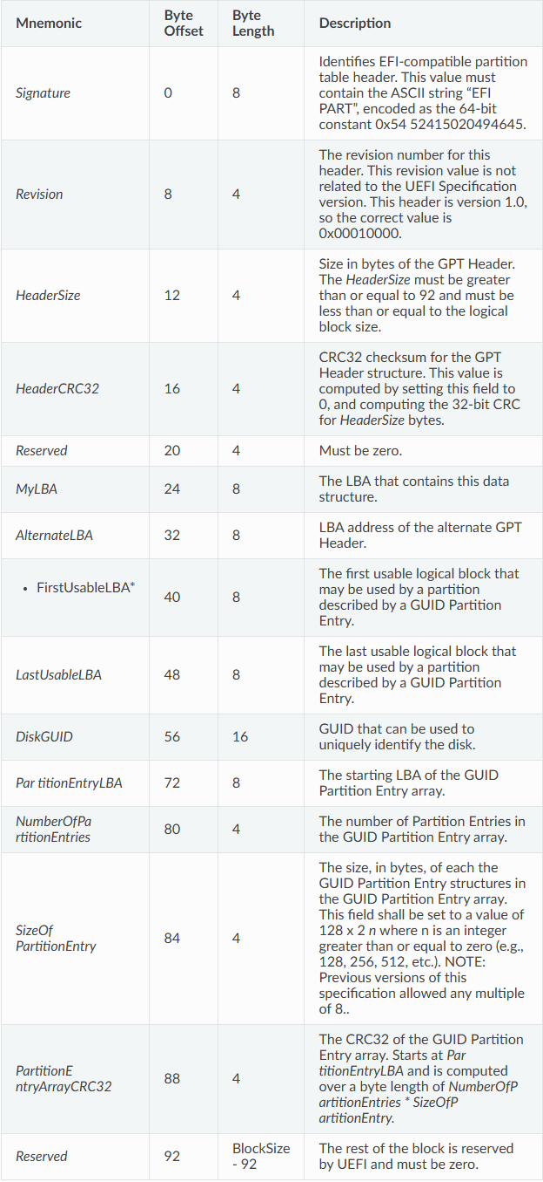
Figure 3.0 GPT Header [5]
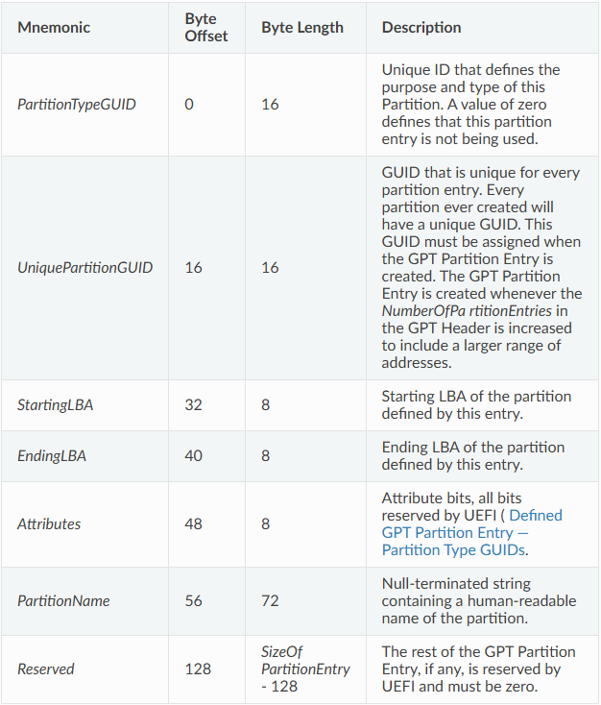
Figure 3.1 GPT Partition Entry [5]
This tables describes the structure of a GPT (Guid Partition Table) Partition Entry which is used to replace MBR(BIOS) to a more modernized partitioning schemes GPT (UEFI).
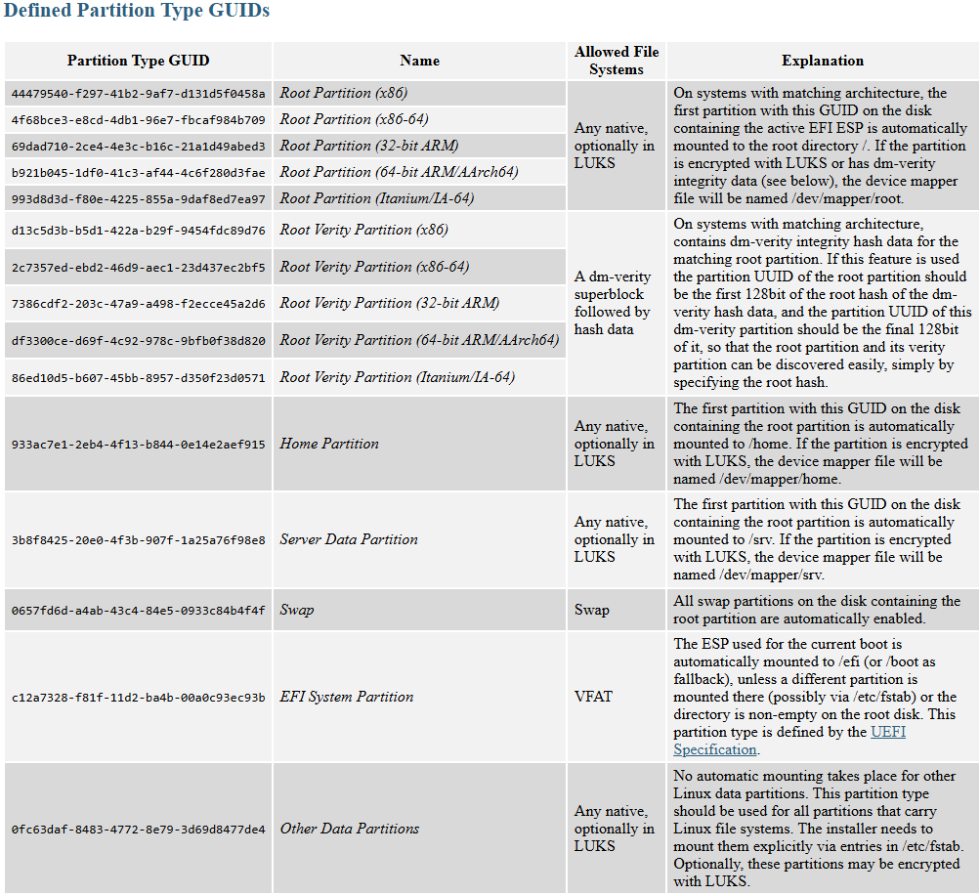
Figure 3.2 GUIDs partition type [6]
Table to identify GUID partition type.

3.2 GPT Analysis
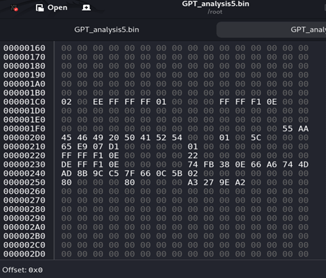
Figure 3.3 Hex Dump GPT Header
Manual GPT Header decoding:
Signature (offset 0x200, length 8)
The offset byte on the screenshot starts at 0x200 – 4546492050415254 by converting this number in decimal and assigning the value on the ascii table we can check if the signature is appropriate.
Expected outcome EFI PART
Conversion HEX to DEC
45 – (4 X 16) +5 = 69 conversion in ASCI - E
46 – (4 X 16) +6 = 70 conversion in ASCI - F
49 – (4 X 16) +9 = 73 conversion in ASCI - I
20 – (4 X 16) +0 = 32 conversion in ASCI - space
50 – (4 X 16) +0 = 80 conversion in ASCI - P
41 – (4 X 16) +1 = 65 conversion in ASCI - A
52 – (4 X 16) +2 = 82 conversion in ASCI - R
54 – (4 X 16) +4 = 84 conversion in ASCI - T
Outcome = EFI PART means it is a Valid GPT header signature
Revision (offset 0x208, length 4)
00 00 01 00 (little endian) – 00 01 00 00 (Big endian)
Based on the table it means that this header version is 1.0
HeaderSize (offset 0x20C, length 4)
Size in bytes of the GPT Header and it must be greater than or equal to 92
5C 00 00 00 (little endian) – 00 00 00 5C (Big endian)
HEX TO DEC
16^0 X 12 + 16^1 X 5 = 92 Bytes
HeaderCRC32 (offset 0x210, length 4)
65 E9 07 D1
Reserved (offset 0x214, length 4)
This part must be zero as we see on our screenshot the value found is: 00 00 00 00
MyLBA (offset 0x218, length 8)
The LBA contains this data structure
Based on the screenshot the value found is:
01 00 00 00 00 00 00 00 (little endian) 00 00 00 00 00 00 00 01 (Big endian)
HEX TO DEC
16^0 X 1 = 1 (GPT Header is at LBA 1)
AlternateLBA Backup header (offset 0x220, length 8)
Based on the Screenshot the value found is:
FF FF F1 0E 00 00 00 00 (little endian) – 00 00 00 00 0E F1 FF FF
HEX TO DEC
16^0 X 15 + 16^1 X 15 + 16^2 X 15 + 16^3 X 15 + 16^4 X 1 + 16^5 X 15 + 16^6 X 14 = 250740735 (GPT Backup header is at LBA 250740735)
FirstUsableLBA (Offset 0x228, length 8)
Based on the screenshot the value found is:
22 00 00 00 00 00 00 00 (little endian) – 00 00 00 00 00 00 00 22(Big endian)
HEX TO DEC
16^0 X 2 + 16^1 X 2 = 34 (First usable LBA IS LBA 34)
LastUsableLBA (Offset 0x230, length 8)
Based on the screenshot the value found is:
DE FF F1 0E 00 00 00 00 (little endian) – 00 00 00 00 0E F1 FF DE (Big Endian)
HEX TO DEC
16^0 X 14 + 16^1 X 13 + 16^2 X 15 + 16^3 X 15 + 16^4 X 1 + 16^5 X 15 + 16^6 X 14 = 250740702 (LastUsableLBA sector)
DiskGuid (Offset 0x238, length 16)
Based on the screenshot the value found is:
74 FB 38 0E 66 A6 74 4D AD 8B 9C C5 7F 66 0C 5B (Unique Identifier of the Disk)
PartitionEntryLBA (Offset 0x248, length 8)
Based on the screenshot the value found is:
02 00 00 00 00 00 00 00 (little endian) – 00 00 00 00 00 00 00 02(Big endian)
HEX TO DEC
16^0 X 2 = 2 (Partition entry LBA starts at 2)
Number of Partition Entries (Offset 0x250, length 4)
Based on the screenshot the value found is:
80 00 00 00 (little endian) – 00 00 00 80 (Big endian)
Hex to Dec
16^1 x 8 = 128 entries
Size of Partition Entry (Offset 0x254, length 4)
Based on the screenshot the value found is:
80 00 00 00 (little endian) – 00 00 00 80 (Big endian)
Hex to Dec
16^1 x 8 = 128 (Size of partition entry)
Partition Entry Array CRC32 (Offset 0x258, length 4)
Based on the screenshot the value found is:
A3 27 9E A2 (little Endian) – A2 9E 27 A3 (Big Endian)
Hex to Dec
16^0 X 3 + 16^1 X 10 + 16^2 X 7 + 16^3 X 2 + 16^4 X 14 + 16^5 X 9 + 16^6 X 2 + 16^7 X 10 = 2728273827 (CRC32 Check SUM)
Reserved (Offset 0X25C)
The rest of the block must be zero because it is reserved by UEFI.
Based on the screenshot the rest of the block are 00.

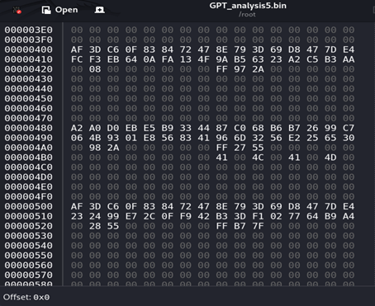
Figure 3.4 Hex Dump Partition Entries
Partition Entry starts at Offset: 0x400
Partition Entry 1 Offset: 0x400 – 0x47f
Partition Type GUID (Offset: 0x400, length 16)
ID that defines the type of Partition. Based on the screenshot the value found is:
AF 3D C6 0F 83 84 72 47 8E 79 3D 69 D8 47 7D E4 in GUID notation (little-endian for first 3 components)
Little endian to Big endian conversion
First component – AF 3D C6 0F – 0FC63DAF
Second component – 83 84 – 8483
Third component – 72 47 – 4772
The rest stays the same – 3D 69 D8 47 7D E4
Result = 0FC63DAF – 8483 – 4772 – 3D69D8477DE4

If the value found was zero it means the partition entry has not been used in this case referring to figure 3.2 GUIDs type it can be stated that the partition type is a Linux system.
Unique Partition GUID (Offset 0x410, length 16)
Anytime a partition is created a unique ID identifier will be assigned it, based on the screenshot above the value found is:
FC F3 EB 64 0A FA 13 4F 9A B5 63 23 A2 C5 B3 AA in GUID notation (little endian for first 3 components)
Little endian to Big endian conversion
First component – FC F3 EB 64 – 64EBF3FC
Second component – 0A FA – FA0A
Third component – 13 4F – 4F13
The rest stays the same - 9A B5 63 23 A2 C5 B3 AA
Result = 64EBF3FC-FA0A-4F13-9AB5-6323A2C5B3AA
Starting LBA (Offset 0x420, length 8)
Based on the screenshot the value found is:
00 08 00 00 00 00 00 00 (little endian) – 00 00 00 00 00 00 08 00 (Big endian)
HEX TO DEC
16^2 X 8 = 2048 (LBA Starts at 2048)
Ending LBA (Offset 0x428, length 8)
Based on the screenshot the value found is:
FF 97 2A 00 00 00 00 00 (Little Endian) – 00 00 00 00 00 2A 97 FF (Big Endian)
HEX TO DEC
16^0 X 15 + 16^1 X 15 + 16^2 X 7 + 16^3 X 9 + 16^4 X 10 + 16^5 X 2 = 2791423 (LBA ends at 2791423
Attributes (Offset 0x430, length 8)
Bits reserved for UEFI
Partition Name (Offset 0x438, length 72)
Based on the screenshot the value found is 0 so on the partition 1 name has not been assigned.
Size of the Partition
To calculate the size of the partition based on the GUID notation the formula is:
Size in Bytes = (ENDING LBA – STARTING LBA + 1) X sector size
(2791423 – 2048 + 1) X 512 = 1428160512
Size in Mbytes = 1428160512 / (1024 x 1024) = 1362 Mb
Partition Entry 2 (Offset: 0x480 – 0x4FF)
Partition Type GUID (Offset: 0x480, length 16)
ID that defines the type of Partition. Based on the screenshot the value found is:
A2 A0 D0 EB E5 B9 33 44 87 C0 68 B6 B7 26 99 C7 in GUID notation (little-endian for first 3 components)
Little endian to Big endian conversion
First component – A2 A0 D0 EB – EBD0A0A2
Second component – E5 B9 – B9E5
Third component – 33 44 – 4433
The rest stays the same – 87 C0 68 B6 B7 26 99 C7
Result = EBD0A0A2 – B9E5 – 4433 – 87C068B6B72699C7

If the value found was zero it means the partition entry has not been used in this case referring to the partition table GUID it can be stated that the partition type is a Microsoft Basic Data used for NTFS.
Unique Partition GUID (Offset 0x490, length 16)
Anytime a partition is created a unique ID identifier will be assigned it, based on the screenshot above the value found is:
06 48 93 01 E8 56 83 41 96 6D 32 56 E2 25 65 30 in GUID notation (little endian for first 3 components)
Little endian to Big endian conversion
First component – 06 48 93 01 – 01934806
Second component – E8 56 – 56E8
Third component –83 41 – 4183
The rest stays the same - 96 6D 32 56 E2 25 65 30
Result = 01934806-56E8-4183-966D-3256E2256530
Starting LBA (Offset 0x4A0, length 8)
Based on the screenshot the value found is:
00 98 2A 00 00 00 00 00 (little endian) – 00 00 00 00 00 2A 98 00 (Big endian)
HEX TO DEC
16^2 X 8 + 16^3 X 9 + 16^4 X 10 + 16^5 X 2 = 2,791,424(LBA Starts at 2791424)
Ending LBA (Offset 0x4A8, length 8)
Based on the screenshot the value found is:
FF 27 55 00 00 00 00 00 (Little Endian) – 00 00 00 00 00 55 27 FF (Big Endian)
HEX TO DEC
16^0 X 15 + 16^1 X 15 + 16^2 X 7 + 16^3 X 2 + 16^4 X 5 + 16^5 X 5 = 5580799 (LBA ends at 5580799)
Attributes (Offset 0x4B0, length 8)
Bits reserved for UEFI
Partition Name (Offset 0x4B8, length 72)
Based on the screenshot the value found is:
41 00 4C 00 41 00 4D 00
ASCII Conversion
41 = A
00 = NULL
4C = L
00 = NULL
41 = A
00 = NULL
4D = M
Result = Partition name ALAM
Size of the Partition
To calculate the size of the partition based on the GUID notation the formula is :
Size in Bytes = (ENDING LBA – STARTING LBA + 1) X sector size
(5580799 – 2791424 + 1) X 512 = 1428160512
Size in Mbytes = 1428160512 / (1024 x 1024) = 1362 Mb
Partition Entry 3 (Offset: 0x500 – 0x57F)
Partition Type GUID (Offset: 0x500, length 16)
ID that defines the type of Partition. Based on the screenshot the value found is:
AF 3D C6 0F 83 84 72 47 8E 79 3D 69 D8 47 7D E4 in GUID notation (little-endian for first 3 components)
Little endian to Big endian conversion
First component – AF 3D C6 0F – 0FC63DAF
Second component – 83 84 – 8483
Third component – 72 47 – 4772
The rest stays the same – 3D 69 D8 47 7D E4
Result = 0FC63DAF – 8483 – 4772 – 3D69D8477DE4

If the value found was zero it means the partition entry has not been used in this case referring to the partition table GUID it can be stated that the partition type is a Linux system.
Unique Partition GUID (Offset 0x510, length 16)
Anytime a partition is created a unique ID identifier will be assigned it, based on the screenshot above the value found is:
23 24 99 E7 2C 0F F9 42 B3 3D F1 02 77 64 B9 A4 in GUID notation (little endian for first 3 components)
Little endian to Big endian conversion
First component – 23 24 99 E7 – E7992423
Second component – 2C 0F – 0F2C
Third component – F9 42 – 42F9
The rest stays the same - B33DF1027764B9A4
Result = E7992423-0F2C-42F9-B33D-F1027764B9A4
Starting LBA (Offset 0x520, length 8)
Based on the screenshot the value found is:
00 28 55 00 00 00 00 00 (little endian) – 00 00 00 00 00 55 28 00 (Big endian)
HEX TO DEC
16^2 X 8 + 16^3 X 2 + 16 ^4 X 5 + 16^5 X 5 = 5580800 (LBA Starts at 5580800)
Ending LBA (Offset 0x528, length 8)
Based on the screenshot the value found is:
FF B7 7F 00 00 00 00 00 (Little Endian) – 00 00 00 00 00 7F B7 FF (Big Endian)
HEX TO DEC
16^0 X 15 + 16^1 X 15 + 16^2 X 7 + 16^3 X 11 + 16^4 X 15 + 16^5 X 7 =8370175 (LBA ends at 8370175
Attributes (Offset 0x530, length 8)
Bits reserved for UEFI
Partition Name (Offset 0x538, length 72)
Based on the screenshot the value found is 0 so on the partition 3 name has not been assigned.
Size of the Partition
To calculate the size of the partition based on the GUID notation the formula is:
Size in Bytes = (ENDING LBA – STARTING LBA + 1) X sector size
(8370175 – 5580800 + 1) X 512 = 1428160512
Size in Mbytes = 1428160512 / (1024 x 1024) = 1362 Mb
3.0 Comparison (MBR vs GPT)
This section compares the two systems using evidence obtained from the hex dump analysis of the disk images.
3.1 Partition Table Capacity
MBR | GPT
From the Manual decoding HEX file, it has been observed that the partition table contains only four 16-byte entries. Only three entries were used the fourth entry was zeroed out. | GPT overcomes this restriction by allowing 128 partition entries, each 128 bytes long.

Conclusion: GPT allows more partition and larger partition table structures compared to MBR.
3.2 Disk Size and Addressing Limits
MBR | GPT
MBR uses 32-bit LBA fields which means the maximum addressable sector count of 2147483648. Each sector is 512byte so the limit of an MBR disk is 2 TB. In the analysis Starting LBA for P2 = 00 98 2A 00 as it shown it uses only 32 bits. | GPT instead uses a 64-bit LBA fields, allowing a disk size of 9.4 ZB (Zettabytes). In the Analysis it can be seen different LBA addresses such as Starting LBA, Ending LBA all using 64-bit LBA field e.g. Offset 0x528 - FF B7 7F 00 00 00 00 00

3.3 Redundancy and Integrity Checking
MBR | GPT
MBR contains only bootloader code, partition table and signature 55 AA | GPT on the other hand has a HeaderCRC32(decoded as 65 E9 07 D1), PartitionEntryArrayCRC32 (A3 27 9E A2) and  An alternateLBA backup header (FF FF F1 0E 00 00 00 00)

3.4 GUID-Based identification vs type Codes
MBR | GPT
File system for each partition is stored as a single byte. In the analysis:  P1 = 83 (Linux)  P2 = 07 (NTFS)  P3 = 83 (Linux) | GPT uses 128-bit GUID assigning a unique ID identifier & partition type. In the analysis P2 Entry offset:0x480 - EBD0A0A2 – B9E5 – 4433 – 87C068B6B72699C7. This is globally unique and standardised across all systems.

3.5 Partition Naming
MBR | GPT
The MBR as we seen in the analysis does not store human-readable partition names | GPT supports UTF-16 partition names inside the partition entry. In the analysis, the second partition stored: 41 00 4C 00 41 00 4D 00 Conversion in ASCII = A L A M

3.6 Boot Process Differences
MBR | GPT
In the HEX Dump it can be observed that the first 446 bytes contains the bootloader code. The MBR has only boot code, partition table & signature | GPT instead includes EFI system partition, fallback protective MBR and no boot code in the GPT header itself
In conclusion, based on hand decoding, GPT shows clear advantages:
- Increased addressing and partitioning capabilities.
- Redundant and self-validating structures
- GUID-based identification
- Names that are human readable
- Improved layout and compatibility with newer firmware
MBR, while simple, demonstrates technical limitations in capacity, adaptability, and resilience. The extracted values closely confirm the differences seen in the examined hex dumps.
4.0 Four Ways a GPT Can be destroyed
Below I listed four ways a GPT can be destroyed through research and documentation:
- Physical Disk damage – There are many ways a hard disk could be damaged from accidentally dropping on the floor to mistakenly pouring coffee on top of it. This damages in most cases corrupts the GPT structure when the sector being damaged contains partition table data [5].
- Malware and Bootkit Attacks - Bootkits specifically target the MBR or GPT, modifying or replacing boot sectors to ensure malicious code runs every time the computer boots, even before the OS loads [7].
- Accidental Overwriting – According to Roderick various disk utilities can accidentally overwrite GPT structures, particularly those that store data in unused areas between the MBR and first partition, which can corrupt the GPT main header or partition table [8]. So, it can be said to mitigate the issue is to use reliable tools to overwrite a sector.
- Power Failure During Write Operations – Power failures at critical times can damage any of the five main GPT data structures: protective MBR, main GPT header, main partition table, backup partition table, and backup GPT header [9].
5.0 Manual GPT Recovery Scenario
The procedure for manually restoring the primary GPT header follows the guidance provided by Rod Smith [8].
5.1 Identify the damage
Before proceeding with the recovery, the first check will be identifying what has been damaged, so the components to look at are:
- Primary GPT Header (LBA 1)
- Backup GPT Header (Last LBA)
- Partition Entry array (LBA 2-33 and its backup at the end of the disk)
In our scenario we will pretend the Primary GPT header is corrupted and the Backup GPT header is intact.
5.2 Locate the Backup GPT header
If the header at LBA 1 is lost, to rebuild it manually will be locating the Last LBA at the end of the disk which refers to the Backup GPT header in our case: LBA 250740735.
5.3 Copy Backup to primary location
Next step will be copying 92 bytes of the backup header into the primary header, just want to clarify that we are not swapping the values, but we are giving them a new location so in this case:
MyLBA = 01 00 00 00 00 00 00 00 (Little Endian)
AlternateLBA = FF FF F1 0E 00 00 00 00 (little endian)
Updated MyLBA = FF FF F1 0E 00 00 00 00 (little endian)
Updated AlternateLBA = 01 00 00 00 00 00 00 00 (little endian)
5.4 Recalculate CRC32
Since there are different values on MyLBA and AlternateLBA the CRC32 will not match up, so it needs to be generated according to the new values allocated, so in this case to recalculate the CRC32:
- Zero out the HeaderCRC32 field (offset 0x210)
- Recalculate CRC32 of the 92-byte header by using the Header size – 5C 00 00 00
- Write the new CRC32 to offset 0x210
5.5 Consistency validation
To validate the reconstruction:
The primary header must successfully reference:
- Correct MyLBA
- Correct backup header LBA
- Valid CRC values
- The backup header must mirror the primary header with swapped LBA locations.
If all consistency checks pass, the GPT has been manually restored.

6.0 Conclusion
The practical analysis conducted in this class enhanced my comprehension of disc architectures, manual interpretation of hex files, and the difference between MBR and GPT. I have also acquired knowledge regarding the potential of a GPT failure and strategies to mitigate such scenarios. However, in case of a corrupted file the practical part demonstrated in the GPT recovery section displays a manual procedure that helps restore a corrupted GPT through backup headers. Overall, this coursework improved my comprehension of hexadecimal interpretation and the use of the GPT or MBR table to determine the meaning of the data retrieved. It has also given practical insight into how to manually detect and correct partition corruption, which is useful in both digital forensics and systems management.

List of references
[1] D. Milošević, M. Petrović, and B. Jovanović, "Comparison analysis of standard disk partitioning and LVM based disk partitioning on Linux systems," in Proc. 2017 13th Int. Conf. on Advanced Technologies, Systems and Services in Telecommunications (TELSIKS), Niš, Serbia, Oct. 2017, pp. 237-240, doi: 10.1109/TELSKS.2017.8246313.
[2] B. J. Nikkel, "Forensic analysis of GPT disks and GUID partition tables," Digital Investigation, vol. 6, no. 1-2, pp. 39-47, Sep. 2009, doi: 10.1016/j.diin.2009.07.001.
[3] Unified EFI Forum, Unified Extensible Firmware Interface (UEFI) Specification, Version 2.11. Available: https://uefi.org/specifications
[4] B. Carrier, File System Forensic Analysis. Upper Saddle River, NJ, USA: Addison-Wesley Professional, 2005.
[5] UEFI Forum, "5. GUID Partition Table (GPT) Disk Layout," in UEFI Specification Version 2.10, Aug. 2022. [Online]. Available: https://uefi.org/specs/UEFI/2.10/05_GUID_Partition_Table_Format.html. [Accessed: Nov. 24, 2025].
[6] Freedesktop.org, "Discoverable Partitions Specification," Freedesktop.org, May 7, 2021. [Online]. Available: https://www.freedesktop.org/wiki/Specifications/DiscoverablePartitionsSpec/. [Accessed: Nov. 24, 2025].
[7] B. Grill, C. Platzer, and J. Eckel, “A practical approach for generic bootkit detection and prevention,” in Proc. EuroSec, Amsterdam, Netherlands, Apr. 2014, pp. 1–6. doi: 10.1145/2592791.2592795.
[8] R. W. Smith, “Repairing GPT Disks,” Rod’s Books, Apr. 18, 2022. [Online]. Available: https://www.rodsbooks.com/gdisk/repairing.html [Accessed: Nov. 24, 2025].
[9] H.-W. Tseng, L. M. Grupp, and S. Swanson, “Understanding the impact of power loss on flash memory,” in DAC ’11: Proc. 48th Design Automation Conf., San Diego, CA, USA, Jun. 2011, pp. 1–6.

