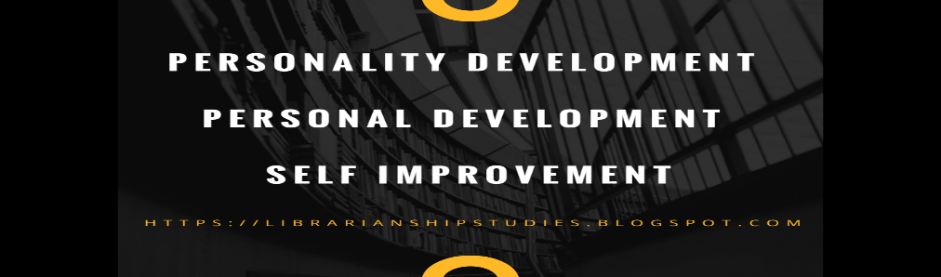Personal Development

  - UWTSD
LukMan Miah| 1815757 | 14/06/2019
Index
- My personal development journey
- SWOT
- SMART
- KOLB
- Johari
- Go Mad
- PDP (Personal development plan)

My Personal Development So Far
Since the beginning of my adventure into my course (Higher Education 2019) we have picked up a decent understanding on various things for example , self improvement abilities, instructions to apply scholar strategy into our consistent life, witch will cause us to comprehend and also to improve our odds to achieve the final objective .
Additionally we have taken in a lot of information on inspiration and also how this will benefit in helping us in completion to this course. We also have learned how crucial it is for us to understand our work in order to know where our efforts will have the biggest impact on our journey. We have touched upon many different points which are going to help us personally develop our skills.
We have done number of lectures showing us different theory’s and theorists and how they use their models in order to progress and adjust these skills that we will use in our current circumstances and also in our future rolls.
When we started we where asked to perform a number of exercises including a 3 year plan with priorities first inline . So for example my 3 year plan was to continue on with higher education attend all of our lectures completing all modules along the way and to gain a good understanding.

SWOT Analysis
A swot analysis is a planning tool used to understand the strength, weakness, opportunity and also threats involved in a project or in a business. It involves specifying the objective of the business of project and identifying the internal and also the external factors that are supportive or unfavorable to achieving the objective.
https:/Rapidbi.com sourced (14/06/2019)
Here I will show some examples of what a swot analysis can be used for :
- Work Shop Sessions
- Planning
- Personal development Plan
- Problem solving
- Product Evaluation
- Competitor Evaluation
- Brainstorm Meetings
Personal SWOT analysis
What I have here is my own analysis witch will empower me to investigate and perceive how I can transform my threats to oppertunitys so as to be increasingly effective later on.

Strengths weakness
- communication skills * shy / without confidence
- Team player *distracted
- Quick learner * lack of I.T skills
- Sociable person

Opportunities Threats
- Develop my career * financially
- Opportunity of business * family commitments
work commitments

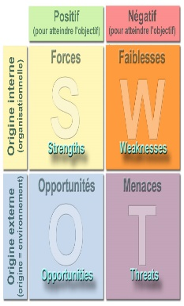
This Photo by Unknown Author is licensed under CC BY-SA

S.M.A.R.T

What are smart goals ? Smart goals are relatively a new idea in 1981 Geeorge T Doran a consultant and also a former director of a corporate planning for Washington water power company published a paper called SMART way to write managements goal and objectives, in the document he introduces SMART goals a tool to create criteria to help improve the chances of success in accomplishing our goals

http:www.smartsheet.com sourced (14/06/2019)

When trying on an objective the majority of this SMART must think about to pick up a maximum capacity and furthermore make it attainable. To state you’re going to contemplate and get a degree is a SMART realistic also achievable and also measurable.

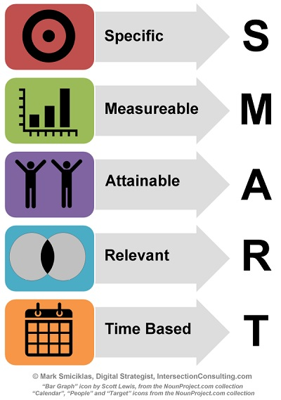
This Photo by Unknown Author is licensed under CC BY-NC

KOLB

David Allen kolb is an American education theorist who’s interests in publication focuses on experimental learning , individual and social changes, career development executive and professional education.

Kolbs learning cycle

David kolbs published his learning style model in 1984 from which he developed his learning style inventory.
Kolbs experiential learning theory works on 2 levels, with being a full stage cycle of learning and for separate learning styles. Much of kolbs theory is concerned with the learner’s internal cognitive process.

http:/www.simplyphycolagy.org

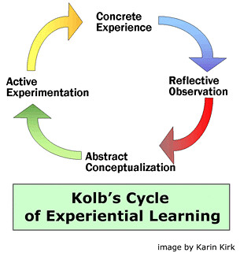
This Photo by Unknown Author is licensed under CC BY-SA-NC

Johari Window

The Johari window is a straight forward and valuable apparatus for outlining and improving mindfulness and common comprehension between people inside a gathering.

Also the Johari window model can likewise be utilized to survey and improve a gathering association with different gallery.

The Johari window model was conducted by an American clinician’s Joseph Luft and Harry Ingam in (1955) whilst examining a bunch element of the collage of California los angelais.

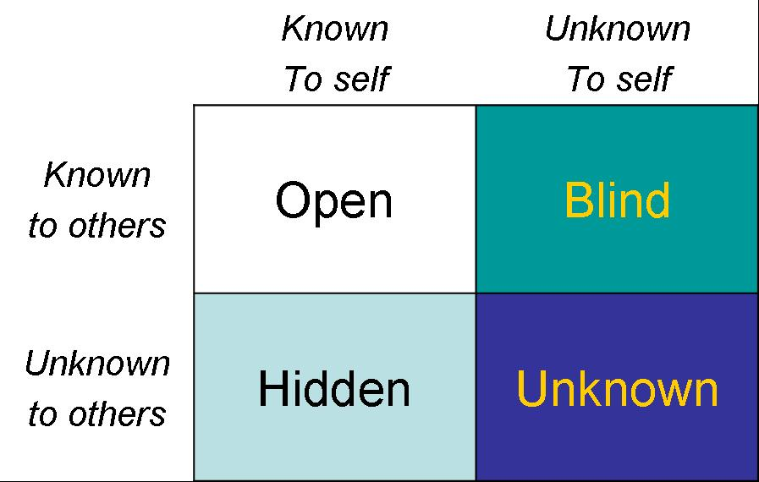
This Photo by Unknown Author is licensed under CC BY-NC

Go MAD
Go M.A.D. stands for go make a difference. It was established and developed by two writers which were Andy Gilbert and Ian Chakravarty. They went to publish their first book there in 1998 called Go mad thinking system.

There is three levels go mad framework which we will have to apply for us to have a better chance of success in our life.
As three levels I ill show an example below :

Level 1
- Reason why
- Define goal
- Possibilities / priorities
Level 2
- Self belief
- Personal responsibilities
- Involving others

Level 3
- Taking actions with results measurements

That would be the basis GO MAD framework and if all of us would apply to all of those shown above there would be no reason to do not change anything in our lives. Every single person should have a think about it how to apply this structure to their life to be able achieve what they were dreaming of.

My example of GO MAD :
As a reason would be opening up my own establishment, which most of us would love to achieve but unfortunately not many of us know where to start and how to set our 3 year also 5 year plan. Nothing will happen without our initiative and knowledge.
As a definition of goal I would choose to carry on my education to became a business man. It may not help me with having easier life but it will definitely will be better life for myself and family.
As a possibilities and priorities I can say that if I will stick to my GO MAD framework and plan what I want to achieve step by step I could finalize my future plans in easy steps.
As a self belief would of chose confidence which got important role in our every day life without this unfortunately we wouldn’t be able to achieve what we really want to achieve. I would love to boost my own confidence which will help me massively achieve what I really want.
As a personal responsibility we need to take actions to achieve goal and make set difference in life. Without any actions unfortunately your success won’t knock to your door itself.
As a involving others we could choose who do we really want to involve on our way to the success, we have to go through good selection and make sure those people which we choose will make a positive difference in our life giving all the possibly could to help us succeed . We can involve family , friends or any other business supporters. We have to remember that we pick right people as it is leading also to work commitments . I will certainly involve others as they may have a big role with my life changing difference to help me achieve success.
As a actions and measure results I will make sure I will do all of this step by step and put into practice to achieve financial freedom. I will gain all knowledge I possibly can to ensure I am going to be confident and self motivated person which is going to succeed in couple of years plan.

Personal Development Plan

My personal development plan would be such a example as :
GOALS
- Finish my education and achieve a certificate
- Be able to open my own business
- Achieve financial freedom by following Go MAD framework
- Be confident and self motivated

PRACTICE
The only way I will be able to achieve this is if I will attend all my lectures and complete all my tasks with positive result. It will help me make small first step to the success.

DEADLINE
I would like to set a 5 years plan which is going to be my deadline leading to my success. My commitment to achieve this will be staying in education and continue my business adventure within 3-5 years which will involve others such a family or friends.

RECOGNAZING THREATHS AND OPORTUNITIES
I will have to do everything in my power to turn my weaknesses into strengths and threats into opportunity. Otherwise I won’t be able to achieve what I really want in my life to help me be financially free and independent.

DEVELOP SKILLS
I would like to apply myself as kinesthetic and hopefully me attending all my lectures would increase my knowledge and benefit me so I will be able to develop my skills.

Find more on http://varl-lecrn.com

USE SUPPORT NETWORK
I am going to use all supports I possibly can to achieve my goals and then evaluate them because of my knowledge I will gain on university .
Will keep researching on business investments and hopefully it will also help me gain more understanding about it all so I could fasten my progress and be able to achieve financial freedom in my set 5 years plan.

MEASURING PROGRESS
After I will finish my university and gain my certificate and then degree I will have better understanding of the position I am currently in .It will also guide me to choose and take correct directions which will help me make my way up to the success and achieve my set goal.

I believe that after achieving certificate to higher education my doors to the success will be open and then I can increase my knowledge and develop my skills to become business man which will be independent and financially free. We have to remember that everyone can do it we cant doubt ourselves and don’t believe that we actually could be in better position than we are at the moment. We can change life, we just have to want to do it and that’s what I am going to do because the University is the biggest opportunity in my life to succeed.

