1704989
Jahanara Uddin
Task 5
Benefits
- Describe and discuss how Marks and Spencer benefits and drawback from having a CRM system-
Macmillian is a charity that is close to marks and spencer’s and they support and care about communities by running programmes
Marks and spencer’s have open coffee shops with in the stores selling only fair trade coffee, this is to increase their footfall.
Marks and spencer’s employees are one of the most important asset
Promoting by using story telling strategies to sell their food and clothing products.
The recent decision by marks and spencer’s to close 100 stores Marks and spencer’s attempted to acquire younger customer base by sub brands, but this has ultimately resulted in confusion to its confusion to its customers as well quality issues and damaging marks and spencer’s reputation. This has lest the company without a clear identity.
Marks and spencer’s have been under pressure to meet demands of their customers and have invested in an automated home delivery warehouse however that system has failed to meet the rising demand.

Marketing Mix is a simple framework which is used by most organisations, it is to put the right product or services in the right place in the right time. This framework was created in 1960 by E. Jerome and McCarthy.
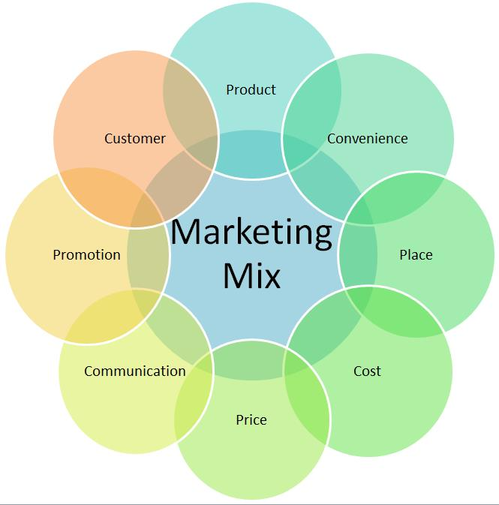

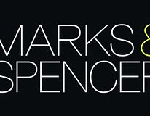

- mainly sells its own brand

- follows a competitive pricing strategy.

- 1000 stores operating in more than 50 countries.

- chooses its marketing strategy very carefully so as to align its advertisement campaign with digital marketing in the stores. uses print mediate ads, mobile ads, and other social media campaigns.
- has around 1000 stores in over countries, and the strength of employees is 83000.

- floors are dived in to floors which mean they have separate section for clothing, gifts, furniture.

- 50 countries.

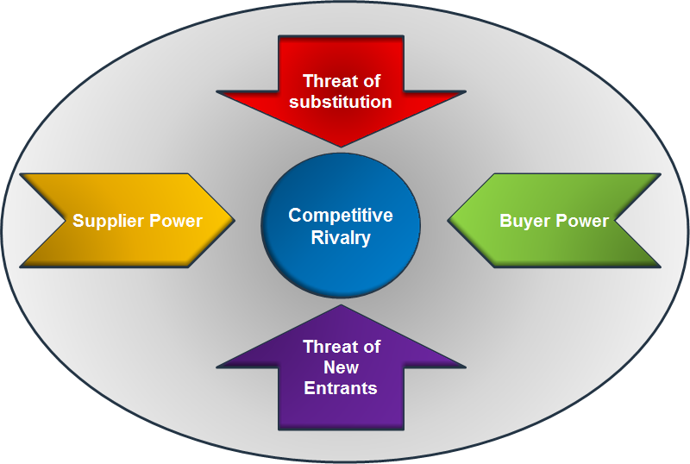

- Marks and spencer’s is particularly vulnerable to competition as it sells not only food and clothes but also apparel household.

- Threat from buyers is high as they have large number of retailers

- Customers can buy subtitle products from other supermarket. The threat is high.

- Entrants of new companies are low because they need a lot of capital investment to set up a successful chain of stores,

- Threat of suppliers are low because they sell own brand products.

McKinney’s seven framework

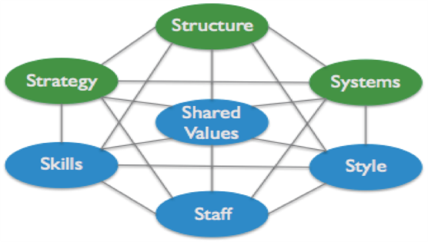

- Encourage through mission statement core values of organisation
- Move to e-commerce
- Changed from high to flat
- Develop CRM systems that provide data and information for organisation and shareholders.
- Using their own brand and stories to support their image
- Most important
- Important for quality and communication

Qamar, A. (2018). The 2018 Retail Crisis Catches Up With Marks and Spencer. [Online]
Available at: https://blog.bham.ac.uk/cityredi/the-2018-retail-crisis-catches-up-with-marks-and-spencer/
[Accessed 24 02 2019].

M&S, 2018. M&S LAUNCHES MOST DIGITAL MARKETING CAMPAIGN TO DATE: “MUST-HAVES”. [Online]
Available at: https://corporate.marksandspencer.com/media/press-releases/2018/mands-launches-most-digital-marketing-campaign-to-date-must-haves
[Accessed 24 02 2019].

M&S. (2014). Putting service in the spotlight. [Online]
Available at: https://corporate.marksandspencer.com/blog/putting-service-in-the-spotlight
[Accessed 05 02 2019].

