Foreign languages and cultural awareness
BMIH5003

Foreign languages and cultural awareness
Lecturer name: GIULIA CHIFARI
Name: SYED AHSAN ALI
Student ID: 2126965

Table of Contents
Scenario: 3
Training plan: 4
Communication: 4
Practical Experiences: 4
Cultural Norms 4
Impact of Culture: 4
Self-Reflection: 5
Description: 5
Feelings 5
Evaluation 5
Analysis: 5
Conclusion: 5
Presentation: 6
References 11

Scenario:
I was the senior HR manager at the Holiday Inn Hotel. In the festive atmosphere of the Holiday Inn Hotel bar, I witnessed a situation where an assistant bartender named Justin misunderstood a guest from Korea, Mr. Lee Jung. This situation proves that cultural knowledge is very important in such places as bars and restaurants where the interactions between the staff and the guests are many and very important (Alomari & Ali, 2019).
Justin is stuck between a rock and a hard place as Mr. Lee Jung comes to the bar to order a drink. Mr. Lee Jung, the introverted businessman, speaks English in a broken way, whereas he uses hesitated gestures to his advantage. While Justin is listening to Mr. Lee Jung's order, he observes the guest's introverted behaviour and assumes it is the guest's uninterestedness or rudeness. Justin starts to become a little bit rude, and his voice becomes a bit irritated.
Justin had a wrong view of Korean cultural norms. In Korean culture, being quiet is usually a way of showing politeness and respect rather than being rude or uninterested. Mr. Lee Jung's tentative gestures and the fact that he doesn't speak English very well may be how he deals with the language barrier and shows the bartender that he is respectful (Boateng, 2007). Nevertheless, Justin's misinterpretation of Mr. Lee Jung's behavior results in a communication breakdown and the guest might feel uncomfortable.
Cultural conflicts like this can happen as a result of many factors, for instance, the difference in the way people communicate, the social norms, and gestures. In this case, Justin's ignorance of Korean customs and social cues was the basis of the misunderstanding. As a result, Justin failed to grasp the cultural context of Mr. Lee Jung's conduct and, therefore, did not react appropriately.
The situation that Justin is talking about makes him understand the need to have cultural awareness and sensitivity to achieve success in cross-cultural interactions in the hospitality industry. To prevent similar misunderstandings in the future, Justin needs to identify several key areas for improvement. Justin realises that he has to educate himself about the cultural practices and customs of guests from different ethnicities and cultures. Through the study of Korean culture, which encompasses social norms, communication styles, and gestures, Justin can, hence, better understand and interpret the guests' behaviour (Edwards & Rees, 2011).
Justin understands the vital role of good communication in the process of overcoming cultural differences. Rather than making conclusions based on first-hand raising, Justin starts to listen actively and to ask for explanations whenever it is needed. Through the use of open-ended questions and the display of genuine interest in the guests' preferences and customs, Justin is looking to achieve better communication and understanding.
To sum up, the situation of Justin and Mr Lee Jung shows the necessity of cultural awareness in the hospitality industry, especially in places like bars and restaurants where travellers are constantly in contact with waiters and guests of great importance. Hospitality professionals like Justin can hence be able to handle cross-cultural interactions with confidence and create a great experience for guests from varied cultural backgrounds by developing cultural awareness, effective communication skills, empathy, flexibility, and a commitment to be lifelong learners.

Training plan:
At the Holiday Inn Hotel, we acknowledge the significance of cultural awareness in the provision of high-quality service to our multicultural guests. The situation of Justin and Mr. Lee Jung is a reminder of the fact that our staff should be able to manage cross-cultural interactions and thus they have to be skilled in this, as well as life in general. Thus, to make all employees able to deal with a similar situation in the future, we have made a thorough staff training plan which is mainly based on the improvement of cultural awareness and sensitivity (Apospori, Nikandrou, Brewster, & Papalexandris, 2008).

Communication:
The main point of communication is to bridge cultural gaps and to obtain a better understanding. The workshops and role-playing exercises will be conducted, teaching the employees to enhance their active listening skills, ask clarifying questions and speak in a suitable manner and tone when dealing with guests from different cultural environments. The Staff will be able to communicate with guests more effectively and through this they will be able to get to know them and build a relationship that is based on respect and understanding.

Practical Experiences:
We will arrange for the staff to have practical experience by including, in our staff development program scenario-based sessions. The above-mentioned sessions will be similar to the actual situation which Justin and Mr. Lee Jung had. Employees will practice their cultural awareness and communication skills in a safe and supportive environment. Through the experience of various situations, our staff will be able to boost their confidence in dealing with the same likewise situations through a professional and empathetic approach (Armstrong, 2014).

Cultural Norms
We will offer all the staff members the training sessions which go into various cultural practices, customs, and norms. The sessions will deal with different aspects of the culture such as communication formats, social behavior, gestures and religious norms. Through the multiple cultures, our staff will acquire a more thorough knowledge of the distinctive backgrounds of our visitors and will be therefore more able to interpret and react correctly to the behaviour of the guests.
Impact of Culture:
The way the staff handle the people of an organisation has a big impact on the culture of the organisation and the feeling of inclusivity and respect. Our top management team will show the way, by setting an example, which will be the best and most effective way to show their commitment to cultural awareness and sensitivity in their relations with staff, guests, etc. Through assistance, motivation, and direction, the staff will be able to motivate and encourage them to accept cultural diversity and achieve excellence in hospitality.
In summary, Holiday Inn Hotel's staff training plan is prepared to give our workers the necessary skills and knowledge to face the challenges of conducting cross-cultural interactions confidently and professionally (Grobler, Warnich, Carrell, Elbert, & Hatflied, 2006). Through cultural education, effective communication skills, empathy, flexibility, scenario-based training, continuous learning, and leadership support, we will make sure that all guests are valued, respected and well-cared for, regardless of their cultural background.

Self-Reflection:

Description:
While I ponder my knowledge about the significance of cultural awareness in the hospitality industry, I recall the path that I have taken, especially at the Holiday Inn Hotel Hotel. At first, my grasp of cultural awareness might have been quite shallow, but gradually, it turned into a more profound understanding of its value in offering excellent service to customers from different countries.

Feelings
Initially, my aim in hospitality was to offer efficient service and fulfil the guests' requirements according to the standard procedures. I knew there was the fact that our guests were culturally diverse but I did not know how I would be affected (Guest, 2011). Nevertheless, as I met different people and dealt with different issues at the Holiday Inn Hotel, I started to see other points of view. One of the instances that will always be in my memory was when I was giving a tour to the Italian students who were at the hotel for a conference. At first, I started the interaction with the same mindset that I was using with the other guests, thus, I concentrated on efficiency and professionalism. On the contrary, as the interaction developed, I understood that my approach was not fitting with them.
Evaluation
That experience was my new knowledge of cultural awareness. I understood that my usual way of doing things, which works well in some situations, may not be good enough for the guests who come from different cultures. By the time I took another step back from the situation and learned some helpful tips, I realised the significance of cultural sensitivity and the necessity of changing my communication style to cater to guests of diverse backgrounds. Gradually, I, for example, sought the chance to learn more about the culture and customs of different societies. I joined the hotel in the sessions of cultural sensitivity training, talked to my colleagues from different backgrounds, and asked the guests about their experiences. By participating in those activities I was able to observe how the cultural differences work and how they affect the interaction of guests (Ichniowski, Shaw, & Prennushi, 1994).
Analysis:
Thinking about these experiences, I am aware of the fact that my cultural awareness has changed tremendously during these years. That which formerly appeared as a side feature of hospitality has now been transformed into the core of my service to guests that I provide to them. Now I can see that cultural awareness is not just about the differences recognition but the act of embracing them and the adaptation of oneself to the guests so that everyone will feel at home.

Conclusion:
my experience at the Holiday Inn Hotel has been vital in moulding my conception of the significance of cultural awareness within the hospitality industry. Through experiences, reflection, and continuous learning, I have come to the understanding that cultural awareness is a very important factor for the guests in terms of their interactions and overall satisfaction (Junaid, Muhammad, & Norazuwa, 2010). From now on, I will be focusing on getting more knowledge about cultural diversity and putting cultural awareness into everything I do in the hospitality industry.

Presentation:

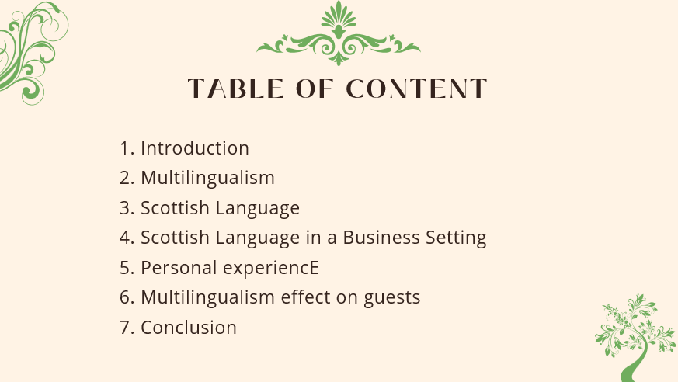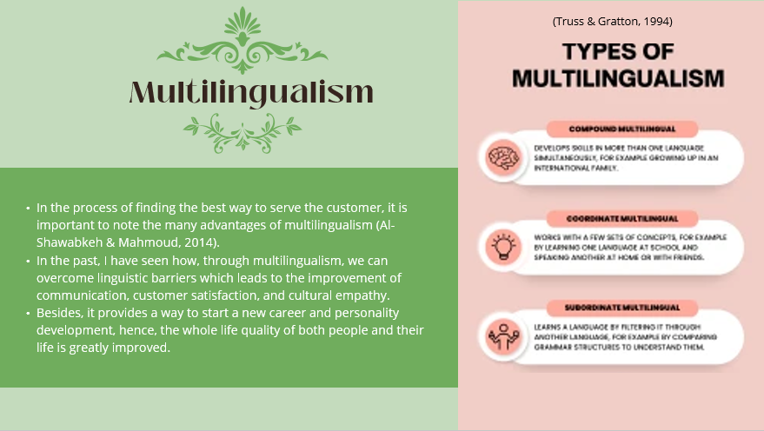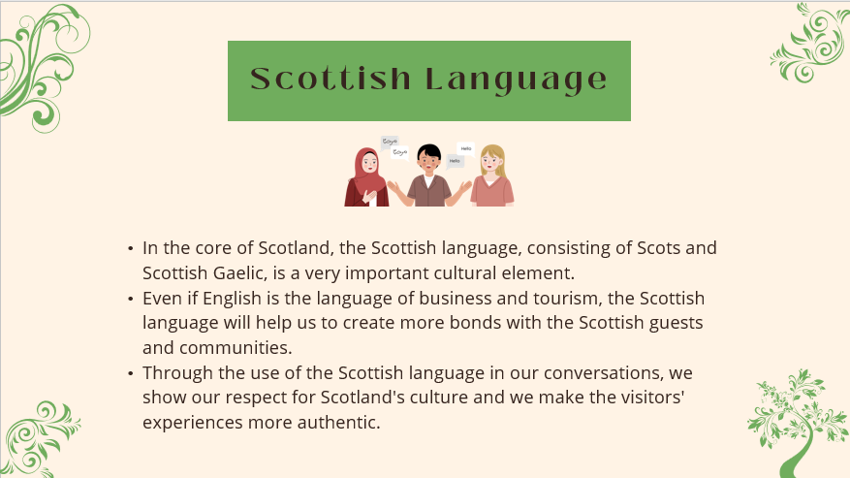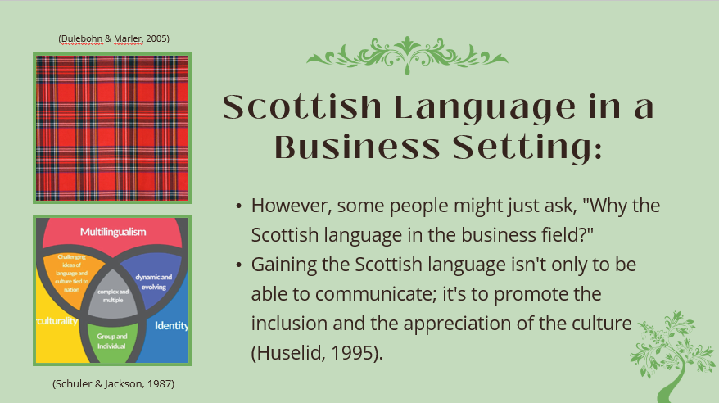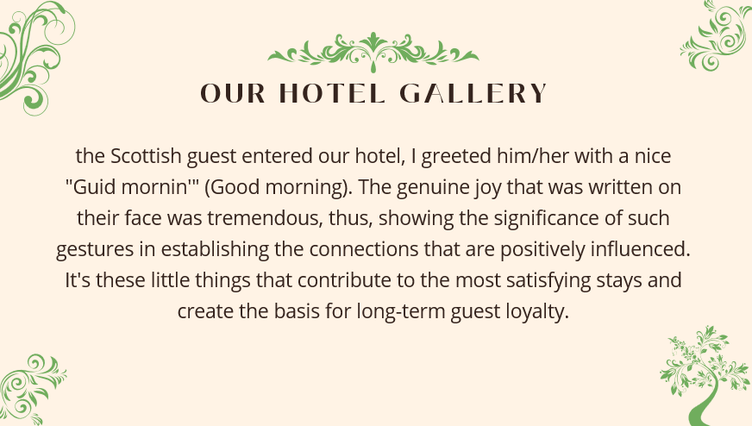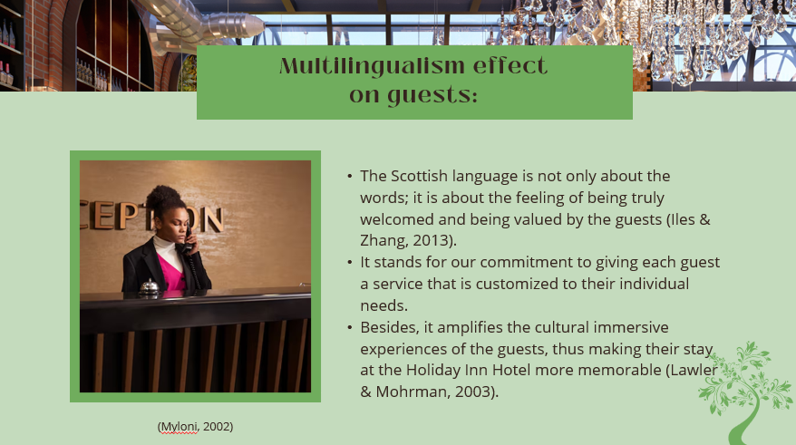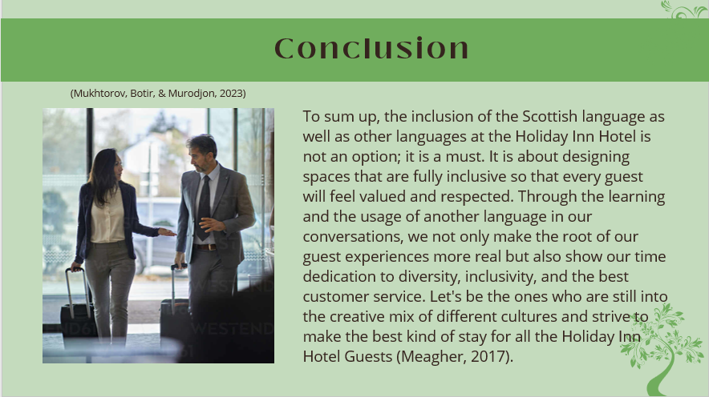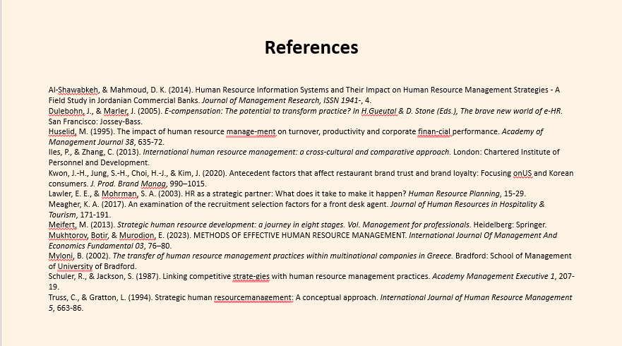

References
Alomari, & Ali, S. (2019). The Role of HumResources Information Systems in Improving the Performance of Human Resources Management. Indian Journal of Science and Technology 12, 01–06.
Apospori, E., Nikandrou, I., Brewster, C., & Papalexandris, N. (2008). HRM and organizational performance in northern and southern Europe. The International Journal of Human Resource Management, 1187–1207.
Armstrong, M. (2014). Armstrong’s handbook of human resource management practice. Thirteenth edition. London: Kogan Page.
Boateng, A. (2007). The role of human resource information systems (HRIS) in strategic human resource management (SHRM). . Master of Science Theses, Accounting Swedish School of Economics and Business Administration. .
Edwards, T., & Rees, C. (2011). International human resource management: globalization, national systems and multinational companies. 2nd ed. Harlow: Pearson Education.
Grobler, P., Warnich, S., Carrell, M., Elbert, N., & Hatflied, R. (2006). Human Resource Management in South Africa. 3rd Edition. London: South-Western.
Guest, D. (2011). HRM and performance: Still searching for some answers. Human Resource Management Journal, 3–12.
Ichniowski, C., Shaw, k., & Prennushi, G. (1994). The effects of human resource management practices onproductivity. New York: Colombia University Press.
Junaid, Z., Muhammad, S., & Norazuwa, M. A. (2010). An Analysis of E-Human Resource Management Practices: A Case Study of State Bank of Pakistan. . European Journal of Social Sciences , 18–26.

