24/07/2023
Module Code: ACCA4024
Student Number: 2237654
Network and cybersecurity essentials
Rachid Aboulachouaq
Analyse Networks and Discuss its Security Postures
University of Wales Trinity Saint David |
Contents
Part 1 2
NIST Cybersecurity Framework 2
Nmap & Wireshark 3
Cyber – Attacks and Mitigations 4
WannaCry and TeleRat 4
Whaling and Pharming 4
Part 2: 5
Topology 5
Software/Hardware for Network Security 6
References 7

Part 1

NIST Cybersecurity Framework
The National Institute of Science and Technology (NIST) cybersecurity framework is a framework built upon existing standards, guideline and practises by organisations to deal with the increasing threat of cyber based crime and attacks [1]. As the task background mentions, the value of digital assets and personal data has increased exponentially in the last 15 or more years. As such, it is extremely important for those in the cybersecurity industry to have the skills and understanding necessary to defend these assets. The NIST cybersecurity framework therefore provides a certain standard for professionals to be working at and also provides organisations with a fundamental idea of how they should defend their networks.

The NIST framework consists of five fundamental functions (Refer to figure 1) that layout the most important thing to consider when producing a cybersecurity programme.

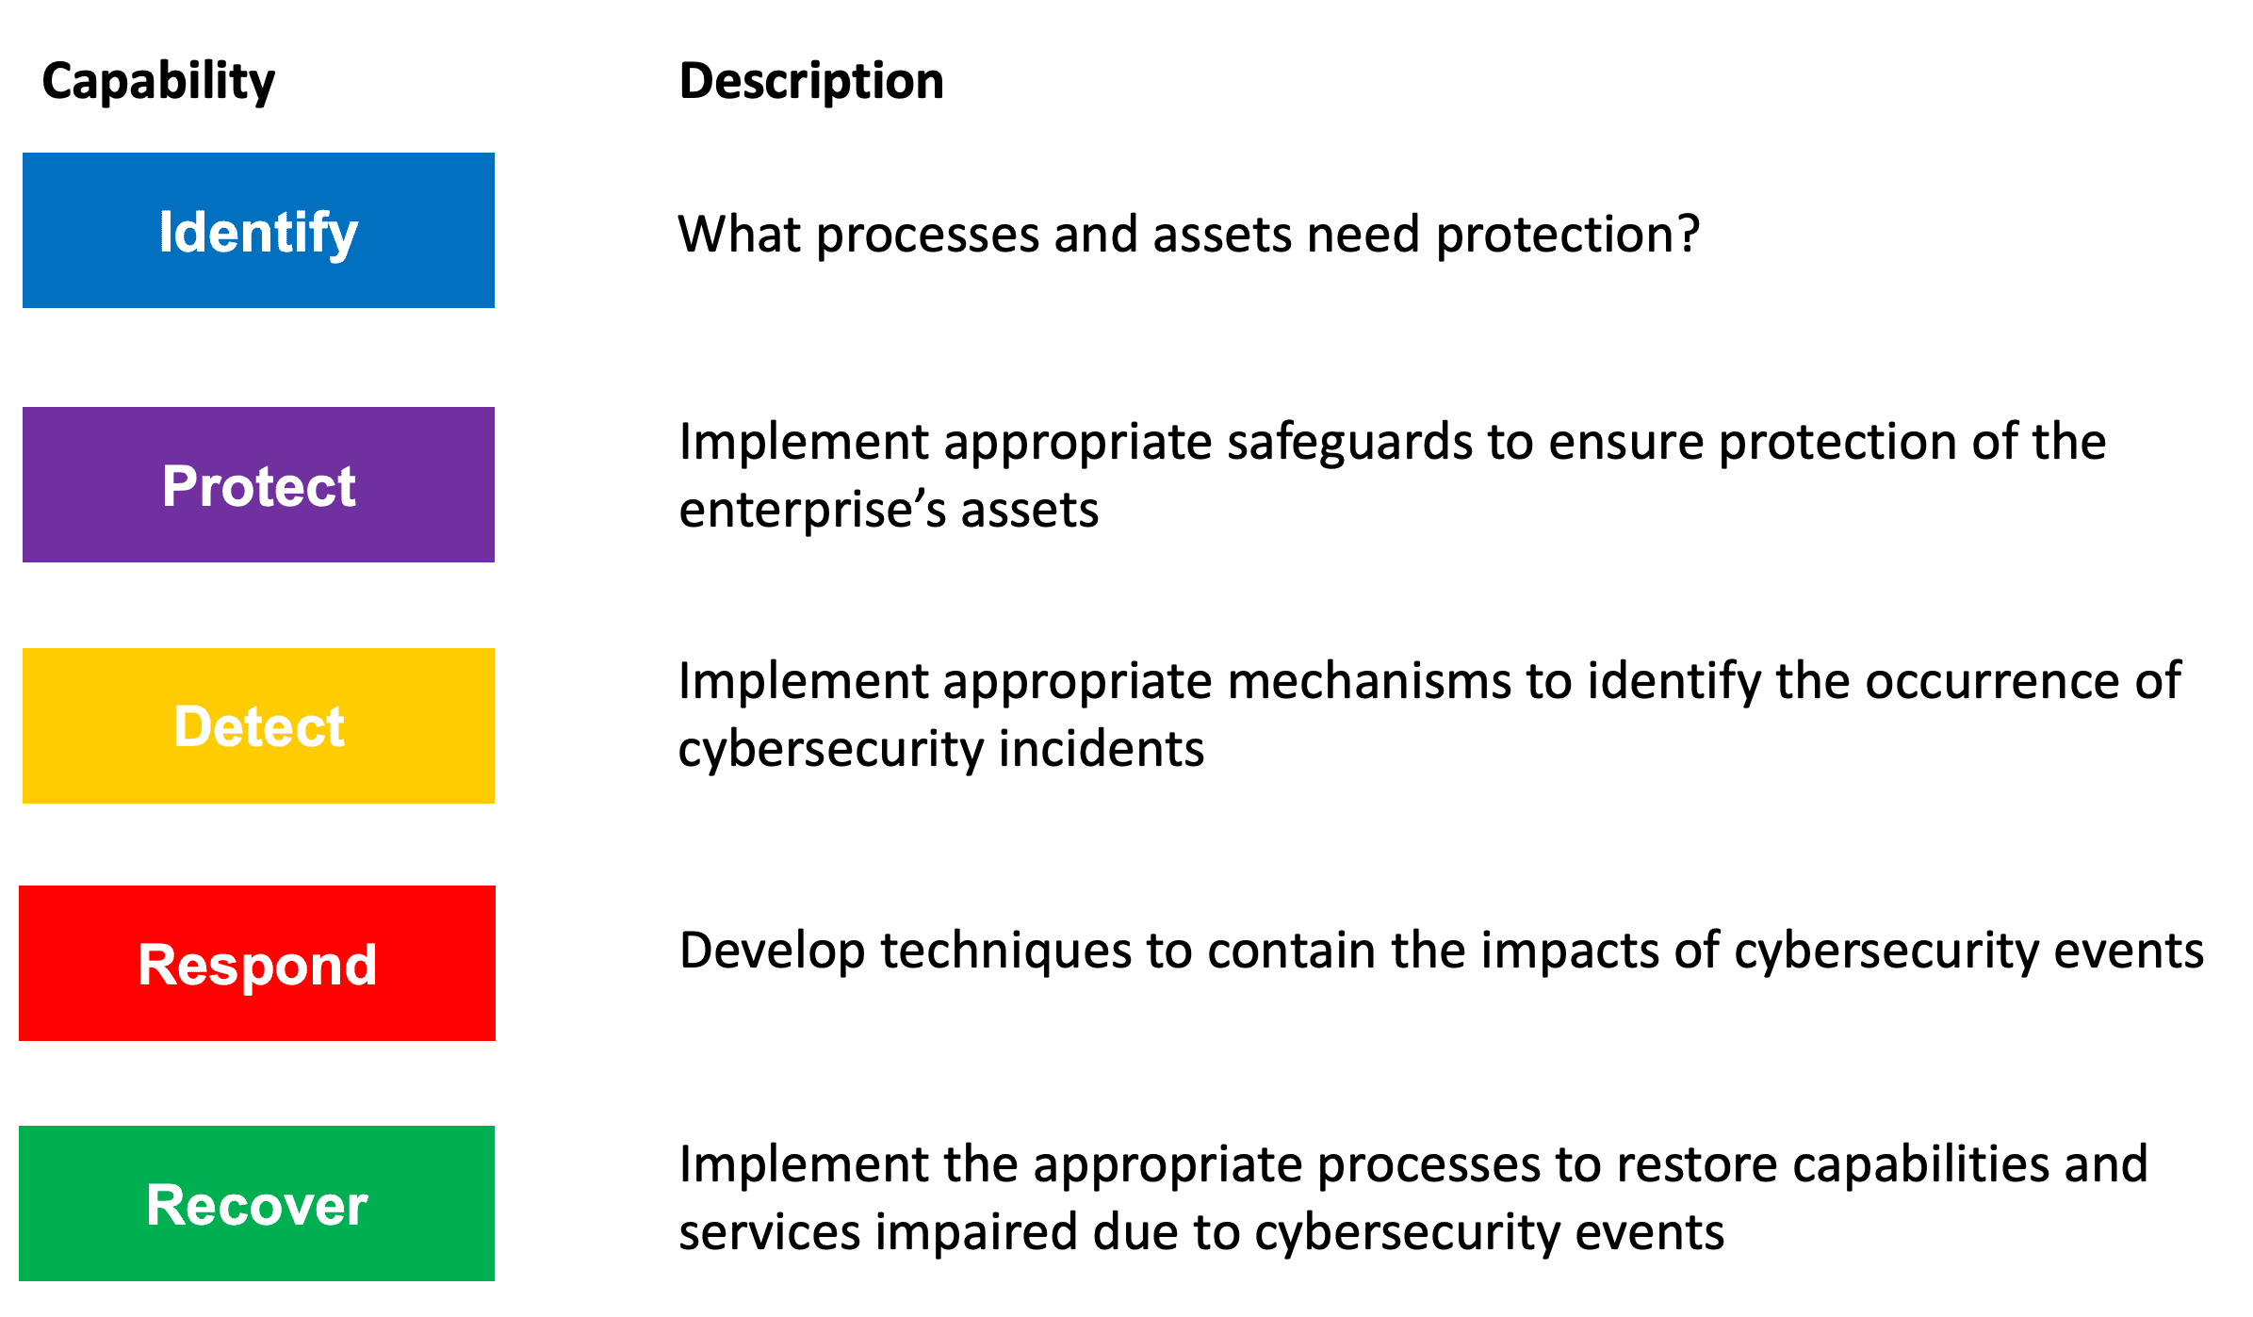
Figure 1: NIST Cybersecurity Framework [2]
‘Detect’ focuses on laying groundwork and raising an awareness in the organisation about any vulnerabilities that their assets may a have [2]. This is almost parallel to the reconnaissance stage of the so-called ‘cyber kill chain’ as it is identifying vulnerabilities and weaknesses in the network to reinforce, as such it is important to constantly be on the watch for such weakness to keep the network secure.
The ‘Protect’ function details how appropriate safeguards must be used to protect and keep vital systems secure, this could include implementing more strict access control or simply increasing the cybersecurity of staff based on their roles [2].
The next function is another essential aspect of a cybersecurity program, being able to detect and identify a potential cyber-attack or anomalies and their impact is important. For example, once the delivery stage of the cyber kill chain has commenced, detecting that and taking action to limit or contain the attack can save a great deal of data and assets of a company.
This then leads on the next principle of ‘Respond’. Having appropriate responses and ensuring these responses can be executed can mitigate the effect of an incident significantly. For example, containing an attack to prevent it spreading further into the network, limiting the damage it can do.
The final function is ‘Recover’, representing the next steps in the aftermath of an attack. This can involve reducing downtime of systems to further mitigate the effect of aftermath, as well as learning from the attack to better protect systems in the future. This can be linked strongly to the ‘Weaponisation’ stage of the cyber kill-chain, as identifying what vulnerabilities the attackers targeted can allow for the company to find ways to remove or reinforce this vulnerability to prevent further similar attacks [2].
An example where the NIST framework is applied is in the Palo Alto Unit 42 threat assessment of Clop Ransomware. In this, they use principles of the NIST framework to provide coverage on the ransomware, such as ways to identify variants and the avenues which attackers use to penetrate systems, the key being phishing emails with macro-enabled documents [3].

Nmap & Wireshark
Nmap, or network mapper, is an open sourced network scanner used to scan IP addresses, ports on a network and installed applications. The function of Nmap is to scan a network to discover what devices are running on a network, the status of ports and services and therefore detect vulnerabilities in a network [4]. Nmap can be used by attackers in the reconnaissance stage to identify vulnerabilities in a network, and allow them to plan an attack through it. For example, Nmap can be used to identify network ports and their status e.g. open, closed, filtered etc. This can give the attackers information on what port they may be able to connect and infiltrate the network. Using application and device information, attackers can also identify what version of software and can exploit known vulnerabilities in that version.
Wireshark is a network packet capture tool, it grabs packets of data being sent across a network connection and displays the information of the packet for analysis and is useful for troubleshooting, like finding out why there is high data loss on a network [5]. In the reconnaissance stage, attackers can use Wireshark in a variety of ways. One way is by grabbing packets of data and extracting it to see what information is being sent on the network and what protocols may be used on the network i.e. telnet, SSH. If data is unencrypted, then attackers can swipe that data for use in the attack, such as sensitive information being communicated between two employees of a company. Attackers may also trace connections on the network, for example finding a supplier company, that has less network security, that the target company has a connection with, and use this information in the attack.

Cyber – Attacks and Mitigations

WannaCry and TeleRat
WannaCry is an example of an internet worm, a malicious piece of code. Worms are characterised by an ability to self-replicate and spread to different devices and networks independently, making them dangerous. The WannaCry worm was a worm that spread in 2017 to many devices. The worm operated by exploiting a backdoor security protocol installed on devices running a specific version of Microsoft windows, created by the USA’s NSA, and would then encrypt data on those devices, demanding payment in cryptocurrency [6].
An effective strategy would be to have more data redundancy, for example storing data in multiple places such as RAID. This can ensure if the ransomware does manage to encrypt data, it is only on one server and can be contained, and so only a small part of the data is lost and needs to be recovered, saving time and money in the recovery phase. Another strategy would have been regular software updates that increase security as the worm exploited a vulnerability in a specific version of software, even though Microsoft had already released the patched version! [6]
TeleRat is an example of trojan spyware, and operated through the Telegram messaging app. TeleRat would disguise itself as feature that told the user how many views their profile had which were fabricated. TeleRat operated by using the Telegram Bot API to communicate with its control server. It would create and populates files on the victim device’s SD card, then send this data to the remote server via the bot plugin, allowing personal and confidential data to be stolen [7]. As TeleRat is a trojan, it parades as a legitimate application to gain access to a device, as such one way to deal with this is to only download application from a legitimate and trusted source such as the developers own website, and by doing research on said ap beforehand to decide whether to download any apk.

Whaling and Pharming
Whaling attacks are similar to phishing and spear phishing wherein it uses fake emails and spoofed websites to trick individuals into performing a certain action or giving specific information. Whaling however focuses on ‘high-value’ individuals, typically senior executives in a company, by spoofing the email address impersonating these individuals attackers can garner lots of trust and other employees are likely to do as they ask. As such, these attacks are worth the effort and research that attackers put into a whaling attack [8].
There are a few mays to counter a whaling attack. One way is for an IT department of a company to flag emails that come in outside of the company’s network, this way people can see that the email is originating from outside the company even though the email address of the sender appears to be legitimate. Another way would be to educate employees in the organisation, raising cyber awareness and therefore increasing the likelihood of spotting a spoofed email.
Pharming is large scale attack wherein victims are redirected to a spoofed version of a legitimate website, wherein they may be asked for login details and personal information before being redirected back to the real website. Attackers then have this data, which can include bank details. The attack is initialised when attackers install malware onto a victim’s system that the redirects them to the fake website, either by a trojan or virus. They can also redirect victims via DNS poisoning, wherein attackers exploit DNS server vulnerabilities, changing the domain name translation process to that of the fake website IP address [9].
One such way we can reduce the risk of these attacks is by running trusted anti-virus/anti-malware software that is able to scan for and block malware from setting up on an individual’s device. Another way is to simply not visit suspicious websites that may contain such malware, using trusted websites. Also only visit secure websites, as to prevent attackers from intercepting data, as such make sure website contain ‘https’ (Hypertext Transfer Protocol Secure).

Part 2:

Topology

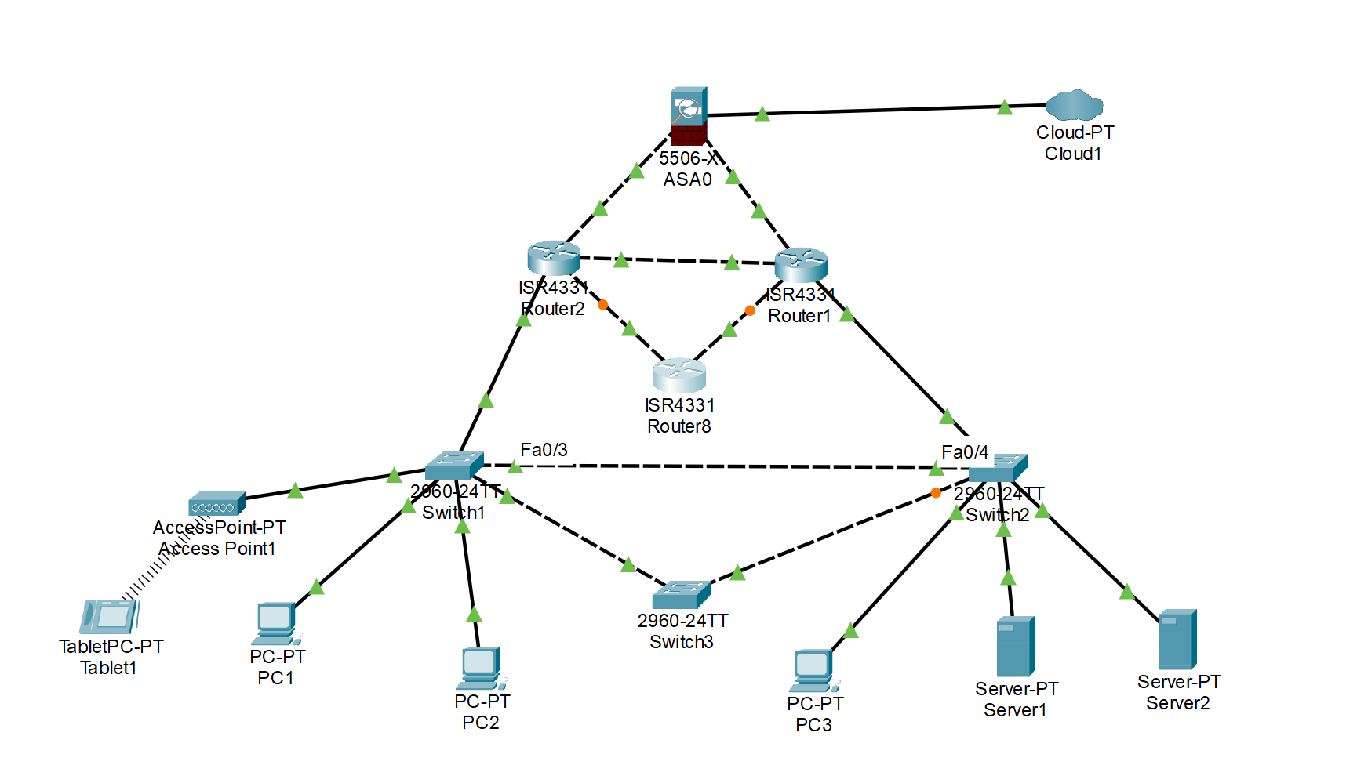
As seen from the above topology, care has been taken to eliminate certain points of failure. For example three switches have been used instead of two, allowing multiple routes for packets to take on a network, but also allowing a rapid crossover time in the event one of the switches fails. The spanning tree protocol will prevent any data loops forming, therefore ensuring optimisation. Similarly three routers have been placed allowing for quick crossover should one fail.

Software/Hardware for Network Security

One technology that can be used to enhance network security is a Firewall. A firewall can be a physical hardware device or software installed on a machine. Firewalls act by monitoring incoming network traffic and blocking unwanted and dangerous connections. For example, a firewall may analyse a packet of data coming through and detect malware within the packet, and will therefore prevent the packet form reaching the network [10].
Another is anti-virus software. Anti-virus software is a program/programmes that scan files and software on devices for known malware such as trojans, viruses, adware etc and remove it from the device. As the nature of malware evolves, so too must anti-virus software, so these programmes must be kept up to date to maximise their effectiveness.
Another way, especially for businesses is to implement a virtual private network (VPN). VPNs allowing company to retain private data and allows effective monitoring of who accesses what on the network, lending to accountability. It allows for encrypted connection, also known as tunnel connection, protecting against attackers from outside the business [11].

References

[1] | Natinal Institue of Science & Technology, “CYBERSECURITY FRAMEWORK,” 13 02 2018. [Online]. Available: https://www.nist.gov/cyberframework/frequently-asked-questions/framework-basics#basics. [Accessed 03 07 2023].
[2] | Balbix, “What is the NIST Cybersecurity Framework?,” [Online]. Available: https://www.balbix.com/insights/nist-cybersecurity-framework/. [Accessed 03 07 2023].
[3] | D. Santos, “Threat Assessement: Clop Ransomware,” Palo Alto Networks: Unit 42, 13 04 2021. [Online]. Available: https://unit42.paloaltonetworks.com/clop-ransomware/. [Accessed 03 07 2023].
[4] | M. Shivanandhan, “What is Nmap and How to Use it – A Tutorial for the Greatest Scanning Tool of All Time,” FreeCodeCamp, 02 10 2020. [Online]. Available: https://www.freecodecamp.org/news/what-is-nmap-and-how-to-use-it-a-tutorial-for-the-greatest-scanning-tool-of-all-time/. [Accessed 15 07 2023].
[5] | CompTIA, “What Is Wireshark and How Is It Used?,” [Online]. Available: https://www.comptia.org/content/articles/what-is-wireshark-and-how-to-use-it. [Accessed 16 07 2023].
[6] | Kaspersky, “What is WannaCry ransomware?,” [Online]. Available: https://www.kaspersky.com/resource-center/threats/ransomware-wannacry. [Accessed 17 07 2023].
[7] | M. Dimitrova, “TeleRAT Android Trojan Uses Telegram Bot API for C&C Communication,” 30 12 2022. [Online]. Available: https://sensorstechforum.com/telerat-android-trojan-telegram-bot-api/. [Accessed 18 07 2023].
[8] | Kaspersky, “What is a Whaling Attack?,” [Online]. Available: https://www.kaspersky.com/resource-center/definitions/what-is-a-whaling-attack. [Accessed 19 07 2023].
[9] | Fortinet, “What is Pharming?,” [Online]. Available: https://www.fortinet.com/resources/cyberglossary/pharming#:~:text=Pharming%20is%20online%20fraud%20that,steal%20their%20credentials%20and%20data.. [Accessed 19 07 2023].
[10] | Check Point Software, “What is a Firewall?,” [Online]. Available: https://www.checkpoint.com/cyber-hub/network-security/what-is-firewall/. [Accessed 20 07 2023].
[11] | Fortinet, “How Does a VPN Work?,” [Online]. Available: https://www.fortinet.com/resources/cyberglossary/how-does-vpn-work#:~:text=The%20VPN%20acts%20as%20an,%2C%20location%2C%20and%20other%20data.. [Accessed 22 07 2023].



