Programme: BA International Hotel Management
Module: Managing Food and Beverage Operations
Module code: BMIH6002
Assignment Title: Student Learning Log
Lecturer Name: Neil Dyer
Student Name: Hasna Jahan
Student ID: 2109022
Table of Contents
Introduction 1
A brief overview of the hotel’s Food and Beverage operation 1
Learning objectives for the placement within the area 2
Reflection on Experience and critical analysis of situation and issues 2
Conclusion 5
References 6

Introduction
This study aims to make a placement development record or learning log reflecting the learning experience and critically reviewing the development within the food and beverage department. Using a reflective model, it will shadow the position of “food and beverage service supervisor” and critically analyse the significance of work-based skills and knowledge for meeting guest service standards. It also reflects issues undertaken by the superior and possible solution using possible theory and practical considerations.
As a student of the module “Hotel Placement – Managing Food and Beverage Operations”, I got the opportunity of work placement at Clarion Hotel where I gained real-life experiences of leading and managing people and business operations. Placement is a type of on-the-job training where individuals perform specific job roles and responsibilities to improve experience and skills (Kite, 2020). MY workplace at Clarion Hotel provided me the opportunity to perform the role and responsibility of “food and beverage service supervisor”.

A brief overview of the hotel’s Food and Beverage operation

Figure 01: The logo of the Clarion Hotel.
Source: (Hotelmix.co.uk, 2024).
The Clarion Hotel is one of the renowned hospitality companies in the UK that has operated in around Europe, Asia, the United States, and South America (Hotelmix.co.uk, 2024). It is a luxurious hotel that earns around £6.6 Million in sales revenue in 2023 (Dora, 2020). The hotel earned its name and fame by managing its food and beverage and guest service standards. The food and beverage division of the hotel is responsible in terms of serving quality food and beverages, keeping the dining space clean, attractive, and tidy, managing inventory and waste, putting stock away, and refilling stock; these all maintain a friendly and welcoming atmosphere in a clean, hygienic, and attractive atmosphere (Kite, 2020).

Learning objectives for the placement within the area
- To improve the work-based key skills needed to lead and manage people and business operations efficiently.
- To understand the workplace issues relating to food and beverage operations to improve the management performance of food and beverage operations systematically.
- To understand and develop the performance criteria as well as technical knowledge needed to meet the guest service standard in their food and beverage services.

Reflection on Experience and critical analysis of situation and issues
This phase will apply the Gibbs reflective model for reflecting on the experience of carrying out the role of “food and beverage service supervisor” and personal development in the selected hotel, Clarion Hotel (Fallon and Rutherford, 2010). It also critically analyses the work-based skill and technical knowledge encountered during the shadowing experience. It also reflects on the issues that arise in Clarion Hotel and must be encountered in the food and beverage department and future action for improving the work vase skill and technical knowledge.

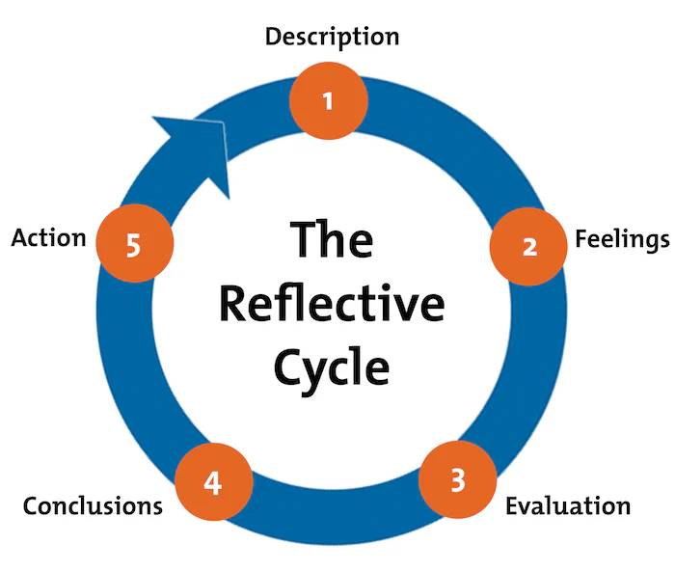
Figure 01: Gibbs Reflective Cycle.
Source: (Kite, 2020).
Description: While attaining the job role of “food and beverage service supervisor” at Clarion Hotel, I had to carry out various duties, including directing and scheduling the beverage servicers, kitchen, and bar staff (Hagg, 2013). I performed the role of a leader at the workplace where I implemented a situational leadership style to lead the team of staff efficiently. Moreover, I took interviews and trained employees of food and beverage in need. I played and assigned work, maintained discipline, managed employee motivation and conflicts, and resolved complaints (Sutherland, 2020). Furthermore, it ensured sanitation, hygiene, and safety standards and maintained recipe standardisation, cost, and waste management. This job placement experience developed my work-based skills and technical knowledge, leadership skills, and management experience which will help me become successful in the hospitality industry (Hotelmix.co.uk, 2024).
Feeling: Before I attained job placement as a “food and beverage service supervisor,” I was not aware of the significance of work-based skills and technical knowledge for professional growth. During the job placement, I gained a deeper understanding and knowledge of communication, leadership, teamwork, planning, conflict management, decision-making, and project management which made me feel confident (UWRSD, 2019). After the job placement, I found I have strength in time management, communication, and teamwork, but I lack technical knowledge like problem-solving, critical thinking, and continuous learning and I understand the significance of developing them to become successful in a leading job position in the hospitality industry.
Evolution: During the job placement, I experienced various positive and negative aspects, which developed my knowledge and helped me understand the impact of the different issues on the Department of Food and its overall operations. For example, the positive and effective thing was my knowledge of situational leadership style which I applied at the workplace and provided coaching, direction, and support to the team members (Vallen, Vallen, and Jerome, 2014). I efficiently applied Belbin’s team role model to manage conflicts among team members as this model helped me to divide the tasks among team members based on their areas of expertise which went well (Sutherland, 2020). I found I lacked problem-solving skills because I failed to understand the reason behind any problem, brainstorm ideas, listen actively to others' opinions, build trust, and implement solutions (Hagg, 2013). However, I got help from my seniors who helped me to implement problem-solving stages that helped me to solve the problems faced by employees to offer exceptional service experiences to the customers which was effective for me. Nevertheless, the negative aspect was that I found the employees of the food and beverage department lacked morale and motivation (Wood, 2012). They only work as they say and do not maintain security and safety standards, discipline, and a lack of invocation in the food and beverage department. However, I applied Theory Y to motivate employees to follow the safety standards and to improve morale with their colleagues and guests at the workplace which helped me to make positive changes in employees' behaviour (Sutherland, 2020).
Analysis: I also developed my technical knowledge, such as problem-solving, critical thinking, and continuous learning, and understood their significance for becoming successful in a leading job position in the hospitality industry (Kite, 2020). Practically implementing leadership styles, motivational theory, and team role models are my strengths which helped me to effectively lead, manage, and impact employees’ behaviours at the workplace (Dermott, 2021). My decision-making skills are my strength that helped me during my placement in Clarion Hotel as I effectively made the decision to implement Theory Y and set penalties for the employees for not obeying safety standards and managing morality at the workplace and gained success in making a positive impact on employees' behaviour (Sutherland, 2020). On the other hand, by applying situational leadership, the organisation can also encourage and motivate employees by cultivating trust and respect, supporting them by giving training and resources to standardize the menu and recipe and giving unique and high-level foods to customers (Hagg, 2013). These can improve employee morale and motivation, solve problems, and stimulate organisational growth and profit.
Conclusion: The overall experience of the job placement made me learn that I have strengths in time management, communication, critical thinking, decision-making skills, leadership skills, and teamwork skills. However, I lack technical knowledge like problem-solving, critical thinking, and continuous learning, and I understand the significance of developing them to become successful in a leading job position in the hospitality industry (Dermott, 2021). On the other hand, I also learned that motivating employees, enhancing their loyalty, and maximizing innovation using motivation models like Theory Y and situational leadership can perform outstandingly (Dermott, 2021).
Action plan: Soon, I will develop my critical thinking as well as problem-solving skills using cause and effect diagrams, rational decision-making models, and reflective cycles because they brainstorm experience and ideas and ensure learning from setbacks (Sutherland, 2020). It also helps to analyze the cause of any problem and find alternatives for forming suitable solutions. Moreover, I will apply motivation theory and model for developing employee morale and motivation while working in supervisory job roles. MY observational skill helped me to identify that Clarion Hotel’s supervisors and leaders in the Food and Beverage department can apply Theory X and Theory Y to provide rewards as well as penalties to manage the positive behaviours of employees at the workplace (Dermott, 2021).

Conclusion
The food and beverage department of a hotel plays a crucial role in maintaining the guest service standard. For this, the food and beverage supervisors need to understand communication, project management, learning, supervising, decisions and other work-based and technical knowledge and skills. Moreover, while supervising the department, various issues can arise, which they can solve using relevant motivational and leadership theories and models.

References
ASET (2017). Good Practice Guide for Work-based and Placement Learning in Higher Education, ASET, Sheffield.
Dermott, R.P. (2021). Treatment of irritable bowel syndrome in outpatients with inflammatory bowel disease using a food and beverage intolerance, food, and beverage avoidance diet. Inflammatory Bowel Diseases, 13(1), pp.91–96.
Dora, J. (2020). Introduction to Human Resource Management. 4th Ed. Kogan Page.
Fallon, M. and Rutherford, D. (2010). Hotel Management and Operations, Wiley, London
Hagg, E (2013). Internship Guide Eleven, The Hague.
Hotelmix.co.uk (2024). Hotel Clarion Hotel Park Avenue, New York, United States. [online] Hotelmix.co.uk. Available at: https://clarion-hotel-park-avenue-new-york.hotelmix.co.uk/.
Johnston, R. Clark, G. Shulver, M. (2012). Service Operations Management, Pearson, London
Kite (2020). Strategic human resource management: A role of the human resource manager in the process of strategy formation. Human Resource Management Review, 2(4), pp.299–315.
Sutherland, K. (2020). Food and beverage: Filtration in the food and beverage industries. Filtration & Separation, 47(2), pp.28–31.
UWTSD (2019). Quality Handbook Chapter 10, Carmarthen.
Vallen, G.K. Vallen, and Jerome J. (2014). Check-in check-out: managing hotel operations. Ninth edition.; Pearson New International.
Wood, R. (2012). Key Concepts in Hospitality Management, Sage, London.

