Starbucks Marketing management A2
LCMB7001

Matthew Kelleher - 1710425
Tushara Balendran – University of Wales Trinity Saint David

Contents
1.0 Introduction 3
2.0 Situational Analysis 3
2.1 PESTLE AnalPESTLE Analysis 3
Political Factors 3
Economic Factors 4
Sociological Factors 4
Technological Factors 5
PESTLE Analysis- Advantages and Disadvantages 5
2.2 Porters Five Force Analysis 6
Bargain Power of Supplier 6
Rivalry amongst 6
Bargain power of consumers 6
Threat of Substitute Product 7
Threat of New Entrants 7
1.1 SWOT Analysis 7
Strengths 7
Weaknesses 8
Opportunities 8
Threats 9
3.0 Strategic marketing analysis 9
3.1 Segmentation 9
Demographic 9
Geographic 10
Behavioural 10
3.2 Targeting 10
3.3 Positioning 11
Perceptual map of Starbucks 11
2.0 Marketing mix 12
2.1 7 P’s marketing mix model 12
Product 12
Starbucks Product Life Cycle 12
Price 13
Place 14
Promotion 15
People 15
Process 15
Physical evidence 15
3.0 Recommendations 16
3.1 Ansoff Matrix 16
Market Penetration 16
Product Development 17
Market Development 17
Diversification 17
6.0 Conclusion 17
References 19

Introduction
According to Thabit and Raewi (2018), the main element for Starbucks to enhance success is through marketing. Marketing has become a key channel for organisations to communicate and engage with customers due to the multiple platforms and channels of communicating. Marketing involves various strategies with all strategies having the same aim which is to promote products of the organisation by increasing and enhancing the engagement and satisfaction of customers. The purpose of this assignment is to analyse Starbucks internal and external business environment, Starbucks segmentation, targeting and positioning, and Starbucks market mix in order to highlight the strategies that are used by Starbucks. The assignment will end with future recommendations that Starbucks could implement to increase and raise brand awareness. The first section will use situational analysis techniques such as PEST Analysis, Five Force Analysis and SWOT analysis to analyse Starbucks internal and external business environment. The second section will consist of Starbucks Strategic planning using techniques such as segmentation, targeting, positioning and perceptual map to analyse Starbucks target and positioning in the current market. The third section will consist of Starbucks marketing mix being analysed this will be conducted through the exploration of the 7’ps marketing mix. Lastly, Ansoff Matrix will be adapted to recommend strategies that can be implemented by Starbucks to increase and raise brand awareness and customer engagement through marketing strategies.

2.0 Situational Analysis

2.1 PESTLE Analysis
The external business environment has many factors that can affect and impact on the success of Starbucks marketing projects. External factors cannot be controlled by Starbucks and influence the decision making of Starbuck [Marton et al, 2021]. To analyse the external business environment of Starbucks a situational analysis model known as PESTLE Analysis will be conducted. PESTLE Analysis is an anacronym of six external factors that are analysed which are political, economic, sociological, technological legal and environmental [Guno et al, 2021].

Political Factors
During the year 2020, Starbucks were forced by the prime minister Boris Johnson to close stores in the UK due to a national lockdown which was caused by the coronavirus, thus is known as the coronavirus pandemic lockdown (Sv et al, 2021). At present there is a new strain of the coronavirus in India, which is more lethal than the previous strain, this could potentially influence a third lockdown in the UK. Coronavirus, lockdown, and store closures pose as a threat to Starbucks. During the lockdown Starbucks reported losses of £3.28B (Lucas, 2020), due to the behaviours of customers changing as an impact of the lockdown with individuals shifting to purchasing products online (Debnath, 2020). During this period, Starbucks have used their strong presence to bring awareness to customers of a new collaboration with service such as UberEATS, Deliveroo, just eat and more to deliver Starbucks product to customers via online (Tsan-Ming, 2020).
Depending on the country that Starbucks are operating and distributing products in, Corporate Tax and laws differ. In the Uk Corporate Tax is currently 19% there was discussions in parliament to reduce Corporate Tax to 17%, however this did not happen (Open Government Licence, 2021). The price of Corporate Tax in the UK poses as a threat to Starbucks due to the increase in expenses and previous incidents relating to tax avoidance. In the year 2012, it was revealed that Starbucks had only paid taxes twice in fifteen years while conducting business in the UK (Campbell and Helleloid, 2016). Recently in 2018 it was reported, Starbucks had paid taxes of £18.3M to the government and £348M to parent businesses for the licencing of the Starbucks brand (Neate, 2019).
Trading laws between the UK and EU can pose as a threat to Starbucks when importing and exporting products. The UK are no longer apart of the European Union with tax laws implemented on the 1st January 2021 for the importing and exporting of goods between the two boarders [CIPD, 2021]. This can affect the efficiency of Starbucks and future strategies.

Economic Factors
The current economy in the UK has decreased by 20.4% during the first quarter of 2020 as an impact of Starbucks (Office of National statistics, 2021). This decrease is a worser decrease in the economy than the 2016 financial crisis (Tapsfield, 2020). This is a threat to Starbucks due to consumers will buy less and sales of product will decrease. Starbucks could implement price strategies on their products and use promoting strategies to attract new customers.
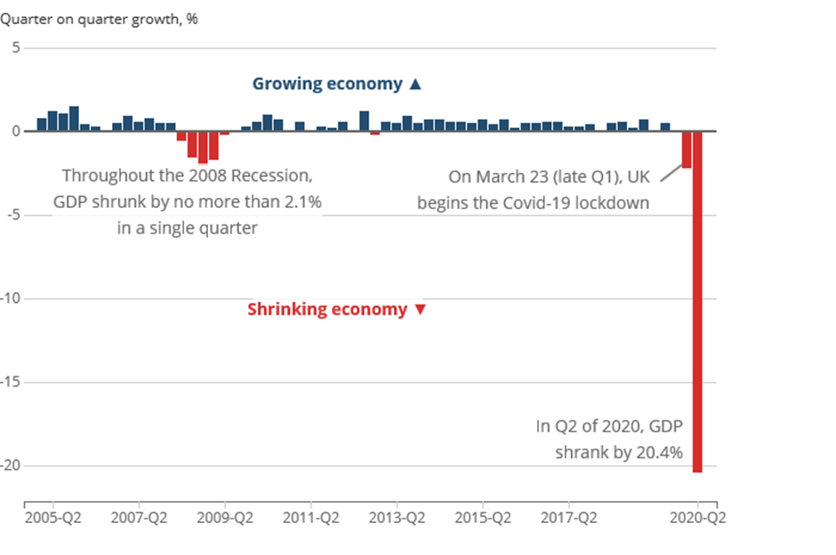
Graph 1: UK GDP growth between 2005-2020 (Office of National Statistic, 2021)
The bank of Monetary Policy Committee and the Bank of England slashed interest rates during 2020 for the borrowing of funds from .75% to .25% (Guershon, 2020), as an impact of Brexit uncertainty and Covid-19 Pandemic. This will impose an opportunity for Starbucks as funds can be borrowed at cheaper rates and payback will not be as costly.
The Coffee industry was valued at an estimated £73.83B in 2019 and an estimated growth to reach £112.50B, this 6.2 % rise is estimated between 2020-2026 (Business Wire, 2021). This poses as an opportunity for Starbucks due to the increase in consumers meaning there is possibility for increased sales and enhanced revenues which can be invested in new product and promotional programmes.

Social/Cultural Factors
Coffee consumers are getting younger with the age of consumers decreasing. Coffee consumers are starting to consume coffee from the age of 12 years old (Ellis, 2018). This is an Opportunity for Starbucks to develop new strategies to reach out to the younger aged consumers.
Consumers expect Starbucks to be ethical and produce products that are recyclable and environmentally friendly, This imposing as an opportunity for Starbucks. Starbucks have strategies in practice that show their environmental responsibilities by separating and recycling instore waste through several categories such as left-over foods coffee grounds and organic waste, cardboards, general waste, aluminium cream cannisters, paper cups, expresso capsules and mixed plastics. This allows for 90% of Starbucks packaging and waste to be recycled and not dumped on land hill sites (Starbucks Corporation, 2021). However, during the pandemic Starbucks have stopped using reusable cups due to health issues and commit to adapt to packages that are reusable as well as compostable and recyclable packaging to ensure and prioritise safety and health of consumers (Starbuck Stories, 2020). Due to the desire of consumers and health related situations, Starbucks have reduced sugar by 25% in beverages and 17% in food products (Starbucks Corporation, 2020c). Starbucks coffee bean is also 99% ethically sourced, this develops the growth and life of the farmers while achieving competitive advantage (Campbell and Helleloid, 2016).

Technological Factors
The improvement of technology is an opportunity for Starbucks due to several factors. Firstly, Starbucks partners can be taught how to use new technology when brewing the perfect coffee. According to Starbucks Corporation (2021b), barristers are currently using custom designed machines to produce expresso coffee as it creates unique accuracy when grinding the Arabica coffee bean and releasing the perfect shot precisely timed which is required to deliver the favour at its peak. Secondly Starbucks can reach out to new and existing customers through smart phones and devices (Krishna, 2018). This allows instant communication and product promotions to consumers wherever they are directly. Starbucks have several strategies and promotional campaigns that are implemented through technology such as the Starbucks App, Starbucks official website and emails (Krishna, 2018).
Technology usage has increased during the Covid-19 pandemic with online retail markets rapidly growing and evolving due to e-commerce systems (Dannenberg et al, 2020). According to () In recent years there has been a 73% increase in consumers discovering brands online. This can be an opportunity for Starbucks to promote products online and attract new and existing consumers. However, there is the risk attached due to the high limits of fraud. During the lockdown period £16M was loss due to fraudsters using e-commerce systems.
Existing and new technology for communications are an opportunity for Starbucks. Starbucks have a strong social media image, communicating and promoting the brand on social media platforms such as twitter, snapchat, facebook and Instagram (Dolbeau-Bandin and Donzelle, 2017). According to Novak and Richmond (2019), platforms such as Twitter, Instagram, Snapchat, Facebook, etc are perfect strategies for marketing products and brand while providing Starbucks the access to communicate with consumers and receive feedback to create new innovative products and services

PESTLE Analysis- Advantages and Disadvantages
According to Gino et al (2021), PESTLE analysis is a useful business technique that is used by marketers when strategic planning, business planning, product development planning and marketing at organisational level. However, like all models and techniques there is not a one way fits all policy. The advantages of PESTLE analysis include the model is easy to adapt, only cost is time spent analysing, alerts threats, influences future decision making, highlights opportunities to exploit and more (Gino et al, 2021; Mihailova, 2020). However, there are several disadvantages to the model which are explained by Mihailova (2020), changes in society make planning of the PESTLE analysis hard to predict, gives a list without a critical analysis, and analysis can be developed through assumptions and not facts.

2.2 Porters Five Force Analysis
Porters five force competitive analytical model can be adapted to Starbucks when analysing influences and factors of the industrial environmental to establish future strategies (Fadhlillah and Zpalanzani, 2020). The model has five factors which are represented below in figure 1.
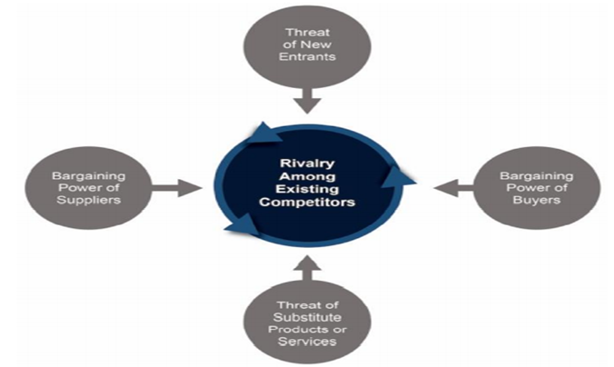
Figure 1: Porters Five Force Analysis (Fadlilah and Zpalanzani, 2020)

Bargaining Power of Suppliers
Starbucks work closely with numerous individual suppliers across the world. It is paramount for individual suppliers to do business with Starbucks due to the volume of the order. There are many suppliers so switching costs will not discomfort Starbucks with the number of individual farmers who want to do business with Starbucks. Individual farmers compete against each other to produce increased quantity and quality coffee beans to supply to Starbucks and receive revenue. As Starbucks can easily substitute suppliers the bargain power of the supplier decreases. Starbucks C.A.F.E programme helps fund and support individual farmers and their families offering equipment, knowledge, and support for farmers while family benefits are education for children, better living and support. Starbucks coffee beans are also 99% ethically sourced which means that farmers need to produce quality ethical Arabica coffee. Offering better live opportunities for workers and families, motivates individuals and builds better relations (Dietz et al, 2020).

Industry Rivalry
Starbucks compete against specialist coffee houses, cafes, and fast service restaurant. Starbucks main competitors in the UK are Costa Coffee, Café Nero, and McDonalds there are also specialist coffee house, small coffee stores and cafes (Han et al, 2020; Kelliher and Richardson, 2019). However, regardless of the fierce levels of competition Starbucks sold the most products with 21,380M sales with Dunkin Donuts next-best selling 9,229M products (Finances Online, 2021). Starbucks own 40% of the U.S coffee stores market share owning two fifths of the market where Dunkin Donuts own one fifth of the market (Browns, 2019).

Bargaining Power of Buyers
Costs of switching is low for consumers as they can switch to Starbucks competitors and buy products for a cheaper price. Starbucks price per 100ml is 42p with McDonalds 34p and Greggs 38p (Nightingale, 2019). Hans et al (2018), claims that 53% of Starbucks consumers have purchased products from Dunkin Donuts and 38% of consumers had purchased products at McDonalds.
Starbucks consumer purchases are of a small quantity as consumers so not order products in mass at one time. However, consumer quantity of purchases has not affected Starbucks income revenue as Starbucks beverage sales accounted for 75% of product revenue at the end of fiscal year 2020 (Starbucks Annual Report, 2020).
Starbucks consumers can also purchase the same product from elsewhere that is more convenient and accessible. For instance. there could be a café in the workplace, a vending machine at the store, petrol station, local store or even the supermarket. However, Starbucks stores are availability for consumers is high as Starbucks have stores on high streets. Shopping centres, motorways and more.

Threat of Substitute Product
There are many substitute products for consumers to purchase that are similar and offer mor availability to the consumer. For instance, there are milkshakes, fruit juices, energy bars, energy drinks, and more. Starbucks have attempted to counterbalance this by producing bags of top selling coffee beans in bags at superstores, Teavana tea bags in boxes at superstores and bottled versions of drinks for on the go. Starbucks have also developed equipment for consumers to brew beverages from home such as milk frothier and the Verismo coffee brewer [Starbucks Corporation, 2021d].
Consumers switching cost to substitute is low as replacement products are widely available and accessible. Consumers can purchase replacements from local stores and supermarkets for cheaper a cheaper price with no inconvenience. The internet also allows consumers to compare products that have similar affect to Starbucks products that fulfil their needs and wants.

Threat of New Entrants
Starbucks compete against national coffee store chains and local coffeehouse stores. It is not hard to join the coffee industry, with low rent for shopfront and equipment. However, to compete against Starbucks new entrants find it hard to compete due to lack of financial resources. To develop a brand like Starbucks has not come cheap and is earned through building strong relations with consumers and stakeholders, caring for the environment, and supply quality coffee of the highest standards (Starbucks Corporation, 2021).
However, new entrants can take a small share of the market and this can decrease the market share owned by Starbucks. This is due to low-cost admissions and consumers expectations are lower than they would be if purchasing from Starbucks.

SWOT Analysis

Strengths
Starbucks main strengths can be seen through their strong brand image, reputation, portfolio, and financial revenue.
Starbucks are seen as the largest coffeehouse chain in the coffee industry worldwide operating 32,660 stores worldwide which are company operated and licensed stores (Starbucks Annual Report, 2020). According to Goh et al (2020), Starbucks operate in approximately 50 countries with stores in the US, Japan, Canada, UK, and more. There are currently 748 Starbucks stores in the UK (Lock, 2021).
Starbucks customers are loyalist, this can be seen through the increased consumer rate of downloading the Starbucks app and through new applicants for Starbucks Loyalty Card [REF]. According to Statista (2021), Starbucks were currently valued at £11.2B end of fiscal year 2020 and have steadily grown since 2010, shown below.
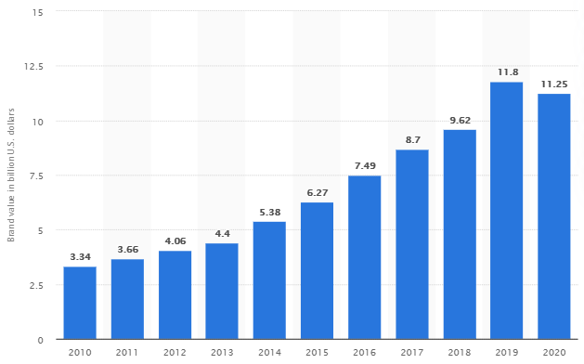
Starbucks brand value 2010-2020 (Statista, 2021).
Starbucks have a strong brand portfolio, products are sold under Starbucks owned brands such as Evolution fresh, Starbucks refreshers, La Boulange, Seattle’s Best Coffee, Tazo, Teavana and Verismo (Yurtseven and Sandir, 2018). Starbucks also distribute merchandise products which include equipment to brew coffee and tea, Starbucks Verismo system, packaged products and goods, accessories and mugs, gifts and more {Krishna, 2018). Starbucks implement extensive experience and competitive advantage when promoting towards the sales of each promotion and product in Starbucks portfolio due to shared believes and features of products associated to highest quality in return of a premium price.

Weaknesses
During 2020, Starbucks had a rare decrease in sales revenue due to the coronavirus pandemic. Total revenues decreased by 5% to approximately £6B with net earning slashed by half to approximately £320B and shares declined approximately 23p per share (Maze, 2020). Despite Starbucks presence in approximately 50 countries the majority of revenue is generated from the American sector with 70% of total revenues for the 2020 fiscal year (Starbucks Annual Report, 2020). Prices are also higher than competitors and consumers can switch with no inconvenience for a cheaper cost. Starbucks brand image has weakened over the past year due to incidents that have been highlighted in the media such as Starbucks tax avoidance, the arrest of two African males, discrimination of customers due to partners cup messages and more (Demarcus et al, 2021). Products of Starbucks are easily imitated, and the Starbucks do not own copyrights to coffee beans.

Opportunities
Starbucks can strengthen brand portfolio through diversification. Starbucks can explore new product ranges such as Starbucks energy bars, Coffee, and Ice cream (which has been a success in Italy). Starbucks could adapt a price skimming strategy to undercut the prices of competitors prices. Starbucks formed a partnership with Pepsi known as “North American Coffee Partnership” (NACP) which thought for cold coffee drinks to be distributed from Supermarkets. Using the same Strategic cooperation Starbucks can venture into new styles of beverages such teaming up with jack Daniels and distributing Irish Coffee (Whiskey and Coffee). Starbucks could implement a subscription package for consumers who have purchased equipment to brew specialised coffee at home. Social media and smart devices are used by the majority of the world population and Starbucks have a good social media reputation (Dolbeau-Bandin and Donzelle, 2017). Promoting new product ideas for consumers feedback alongside surveys and live chats on social media can create new product and promotion ideas.

Threats
Coronavirus pandemic and lockdown is a threat to Starbucks as if stores are forced to close again, Starbucks revenue will decrease again like it did in 2020 (Sv et al, 2021). The departure of Howard Schultz is a concern for Starbucks. Howard Schultz retired from CEO in 2000 having to return in 2008 due to Strategies changing and Starbucks losing its brand image as the third place to becoming a fast-serving coffee store. Prices of raw material such as the Arabica Coffee bean can rise due to environmental issues such as weather, floods, and overheating. This increases the cost of goods purchased and decrease in revenue and profits.

3.0 Strategic marketing analysis

3.1 Segmentation

Demographic
The majority of Starbucks consumers are aged between 25-54 years of age belong to generation x and Y (Numerator, 2021). with these generations knowledge of technology growing (Muslim et al, 2020). Starbucks can use strategies to promote brand to theses generations through smart devices.

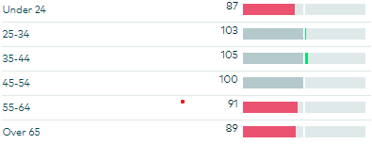
Starbucks consumer age range (Numerator, 2021).
Majority of Starbucks consumers are educated either having received an advanced degree or attending college/university at present (Dillip et al, 2021). This is emphasised by Chang (2020) who claims that 59.5% of Starbucks consumers have a university or college degree.
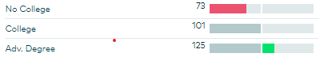
Starbucks consumer educational level (Numerator, 2021).
Starbucks genders vary depending on the location of the store. According to Ali et al and jun et al (2019; 2019), there were 61.7% male consumers in one location and in another there was 55.9% female consumers. Starbucks can aim promotions to all genders and have recently added gender neutral toilets as a strategy to welcome the LGBT community (Timmel, 2017) According to Hung Kee et al (2021) Starbucks main base of consumers consist of three occupations students, employees, and professionals. In one store results showed that 89.5% were students with 6.7% employed (Pandey et al, 2021).

Geographic
Starbucks distribute products in multiple regions such as Europe, Middle East, and Africa (EMEA) China/Asia (CAP), and America. Starbucks accumulated the highest revenue from the American region with 79% of revenue income (Starbucks Annual Report, 2020).
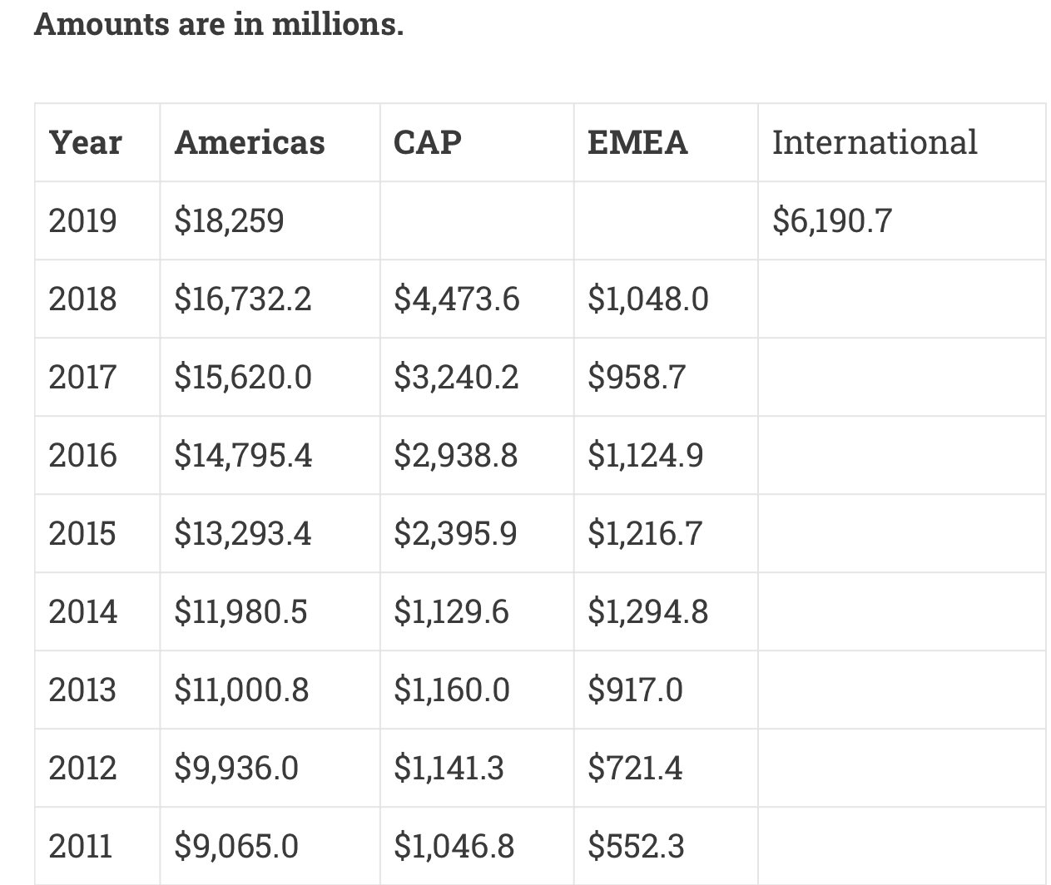
Starbucks Regional Revenue income from 2011-2019 (Pratap, 2021)

Behavioural
Starbucks consumers show a degree of loyalty with consumers committing to loyalty cards with fund of consumers loyalty cards bringing revenue of £1.3B. Starbucks loyalty card is designed for convenience of consumers payment method, increase visit to store, share gifts, and is connected to Starbucks reward systems (Starbucks Annual Report 2019/20, 2020d). Starbucks users are regular and purchase coffee on average 16 times a month (Gaile, 2017). Consumers expect to be able to enjoy high quality of coffee in an atmosphere which is relaxing, an environment to conduct work and a place to meet with family and friends. Starbucks stores are designed for consumers to be able to relax between home and work with free wi-fi offered, comfortable seating, peaceful music, personalised messages on cups and polite workforce (Logan, 2019). The personality of consumers is determined, easy going and ambitious.

3.2 Targeting
Starbucks target consumers consist of men and women from all region who enjoy specialised coffee with a relaxing environment to meet friends/family or conduct work away from the office. The age range of consumers are 25-55 years of age whom, are educated attending university or currently working. Consumers who are loyal and intend to purchase products regularly regardless where they are such as motorway service stations, supermarket, high streets, and shopping centres.

3.3 Positioning
Starbucks use a hybrid of strategies to position the brand in the perfect position in the market such as mono segment positioning, adaptive positioning, standby positioning, and differentiation strategy.
Starbucks mono segmentation positioning consists of aiming the brand at consumers who are willing to pay premium prices for a high-quality coffee, products, and service.
Starbucks adaptive positioning should consist of healthy products due to awareness from consumers wanting healthier products. Starbucks distribute coffee beverages that are of low calories for consumers, iced Americano has 11 calories, caffe misto has 63 calories and more (Cosmopolitan, 2021).
Starbucks standby positioning consists of waiting a period to enter the market with certain products to wait for demand to increase such as easter and Christmas product promotions.
Starbucks differentiation Strategy consists of the store operating in several regions in highly visible locations which increase availability for consumers. Starbucks originally focused on the younger generation but with rapid extension and development Starbucks now aim products at consumers aged between 26-45 years of age who expect to pay premium prices for products as well as the option for healthier alternatives (Yurtseven and Sandir, 2018).

Perceptual map of Starbucks
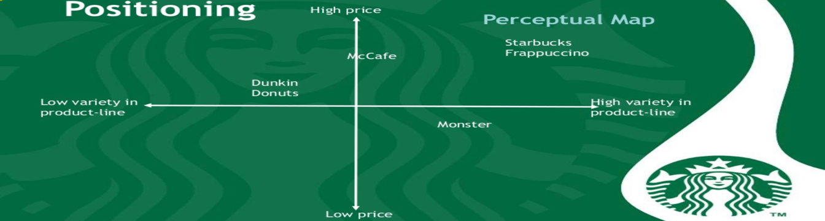
According to Coltekin et al (2017), a perceptual map is a visual tool created to highlight how consumers of the target market perceive and understand the companies positioning of products
Starbucks Perceptual map (Mathur, 2015).
When analysing the data and Starbucks conceptual map, it is clear to see that customers see Starbucks as brand which offer a high range of products at a high price. However, this does not faze customers of Starbucks as they believe that products of a high quality will come at a price which is high. Starbucks environment and the third place to be between work is a culture that customers have brought in to over the years. McCafé are a fast-food restaurant that serve coffee. McCafé do not have a wide range of coffee beverages compared to Starbucks. McCafé prices are on the high side of pricing. However, Starbucks products are priced at a higher cost. Monsters have a variety of products and the brand is known by many individuals across the world. Products are priced cheaper than Starbucks. This could become a threat to Starbucks due to Monster using pricing strategies to undercut the product prices of Starbucks.

Marketing mix

7 P’s marketing mix model

Product
According to Kotler and Armstrong (2020), products can be tangible/intangible which are introduced to the market for response, consumption and use and aims to satisfy the want and needs of consumers.
Starbucks have a wide range and variety of beverages such as hot coffees, hot teas, hot drinks, cold coffees, Frappuccino, ice teas and more. Hot coffees include Blonde Roast, caffe Misto, Pike Place Roast and more. Hot drinks consist of hot chocolate, white hot chocolate, steamed apple juice and more. Frappuccino beverages consists of Mocha Cookie Crumble, strawberry funnel cake Frappuccino blended beverage, Espresso Frappuccino blended beverage and more (Starbucks Coffee Company, 2021).

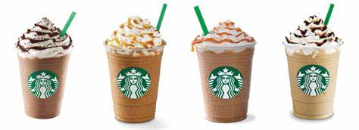
Starbucks beverages (Avenue K, 2021)

Starbucks family branding strategy consists of the organisation using its brand name for variety of products. Starbucks sell a variety of specialised beverages, food, and merchandises in store. During the fiscal year 2019/20, Starbucks beverages sales accounted for $14,337.5M (67%), food sales $3,799.2M (16%) and merchandise $5,381M (Starbucks Annual Statement, 2020).

Starbucks Product Life Cycle

Starbucks Product Life Cycle (Self-made)
Starbucks beverages are in the maturity stage of the product life cycle. The revenues of Starbucks beverages have increased slowly over the past years and the company has made minimal adjustments to beverages. As they say why try to fix something if it is not broken. Starbucks rely on the loyalty of existing customers to purchase beloved beverages that already exist, for this reason over the years Starbucks has managed to decrease expenses and time spent on these products.
Starbucks food, snacks and breakfast products are within the growth stage. Starbucks food items are sold in stores and are easy to locate. Starbucks food products are increasingly growing in sales and are constantly building brand awareness of the company being a place that family can have a light lunch with family or friends.

Price
Starbucks use a hybrid pricing strategy which combines of geographical pricing, premium pricing, and psychological pricing.
Starbucks geographic pricing strategy consists of pricing products at different prices depending on the country or city that the store is operating from. The illustration below shows that the cheapest place to purchase a small latte would be in Turkey costing £1.26 and the dearest place to buy a small latte would be in Denmark costing £4.28 (Nikolic, 2019). Currently the cost of a Starbucks small Latte in the UK would be £2.25.

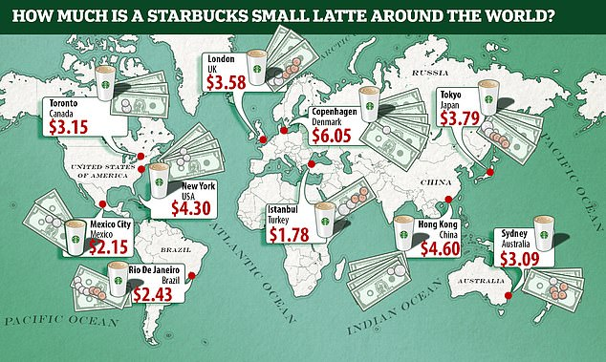
Starbucks of small Latte across the world (Nikolic, 2019).

Starbucks premium pricing strategy consists of products being priced higher than the competition and the average of the coffee industry market (Victor et al, 2019). Starbucks can price products higher than competitors and market average due to consumers expect to pay an increased price for a better-quality product (Pandey, 2021).
Starbucks psychological pricing strategy consists of using a price points perspective. Products are priced with an uneven value, thus makes the customer believe and feel that they are purchasing a bargain and saving money. An example of this type of pricing would be Frappuccino are priced at £3.90 for a large cup (Fast Food Menu and Prices, 2021). This influences the customer to believe they are saving 10p due to the product not being priced to the nearest pound (Boz et al, 2019).

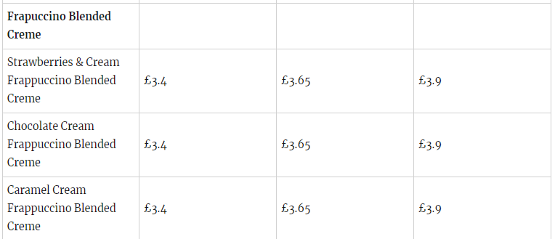
Table: Pricing of Starbucks Frappuccino in the UK (Fast Food Menu and Prices, 2021)

Place
Starbucks occupy coffeehouses around the globe in all five continents and approximately 80 countries, below is an illustration of Starbucks global presence. Starbuck products can be purchased from three places which are company operated stores, licensed stores and grocery and food service accounts (Starbucks Annual Report, 2020).
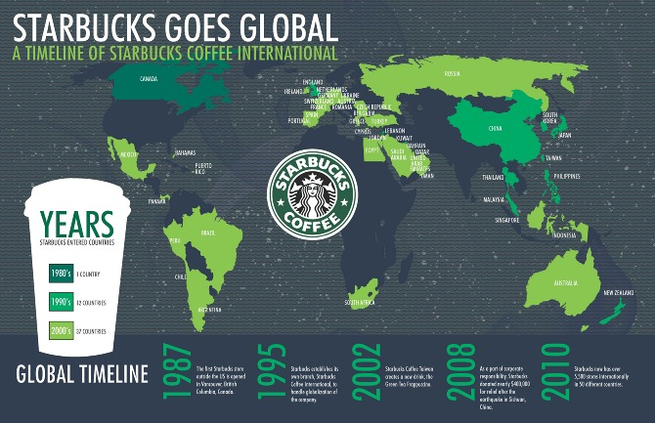
Starbucks Global Map (Hillary Richt, 2021).
At the end of fiscal year 2020, there were 16,637 company-operated stores, accounting for 51% off all stores. With 10,109 stores in America and 6,528 stores internationally, company-operated stores account for 81% of Starbucks revenue. The majority of Company-Operated stores of Starbucks are leased and can be located at highly visible and highly trafficked locations (Starbucks Annual Report, 2020).
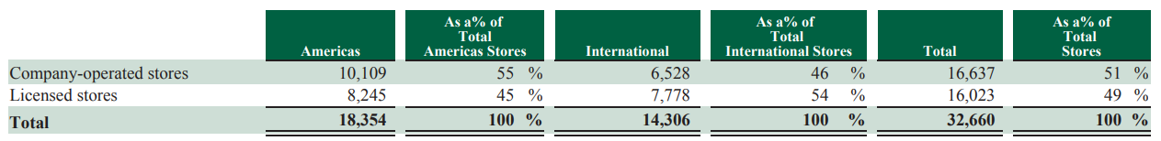
Starbucks Company-Operated and Licensed Stores (Starbucks Annual Report, 2021)
The table above shows that at the end of 2020 there was 16,023 licenced stores which accounts for 49% of total Starbucks stores and 10% of Starbucks total net revenues (Starbucks Annual Report, 2020).
Starbucks also supply products through national supermarket chains in the UK such as Sainsbury’s, Asda, Tesco and more. However, Starbucks only have a selected range to be purchased from stores with only the highest rated products making the shelves such as Starbucks Mocha Chocolate Frappuccino, Starbucks Seattle Latte, Starbucks Expresso Colombia and more (Starbucks Annual report, 2020).

Promotion
Starbucks use a variety of fundamentals of marketing the communication mix which include prints, sales promotions, direct marketing, public relations, events and experiences, and media advertisement in an integrated approach to communicate their marketing message to customers within the target market (Duralia, 2018). Starbucks marketing message aims to relate consumption of services and products with the specific perception of enjoying rich/quality coffee while living life to the fullest. Starbucks core promotional message is how they have positioned stores to be the “third place away from home” where customers can enjoy quality time with friends and family.

People
Starbucks have an astonishing workforce with roughly 349,000 partners employed across the globe at the end of 2020. Approximately there are 121,000 partners employed internationally with roughly 118,000 employed within Company-Operated stores and the remaining partners in regional support operations (Starbucks Annual Report, 2020).

Process
Starbucks success is related to a range of critical process which consists of researching new products, recruitment and selection of employees, customer service processes sales, marketing research and more (Starbucks Corporation, 2021). Starbucks aim to increase efficiency through building relations with all stakeholders during these processes. Other processes which are important to Starbucks are new store licences, inventory management, approval process, coffee preparation and more.

Physical evidence
Items which relate to brand recognition of Starbucks is seen as physical evidence. There are many ways that Starbucks can be seen physically which include partners uniforms, Starbucks siren logo, online, cups, posters and more.
Starbucks logo has remained the same as the original design minus a few changes, which were down to international sensibility. Starbucks stores are unique and the comfortably designed, with each store being deafferented regarding the community culture.

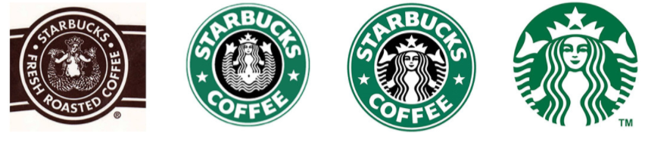
Starbucks change of logo (Nuala, 2020).

Recommendations

Ansoff Matrix
According to Maamoun (2019), Ansoff’s Matrix is a tool that can be used by marketing managers for marketing planning which assists as companies’ determination regarding product and market growth strategy. The model consists of four options considering generic growth such as market penetration, market development, product development and diversification.
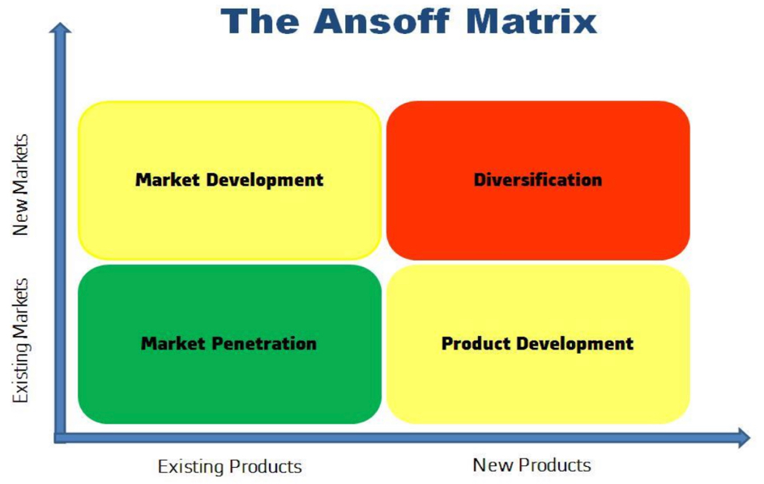
Ansoff Matrix (Maamoun, 2019)

Market Penetration
Asserting existing products into the current market is known as market penetration, which increases the companies share in the current market. Starbucks can implement market penetration strategy in various ways (Ye et al, 2018). For example, Starbucks could change policies relating to price and reduce the price of products. Starbucks could also increase marketing or promotional strategies, for example, personal selling is a method which can be used to penetrate the current market. Starbucks are internationally known and are the most famous coffee house chain in the world. To adapt this strategy Starbucks should offer constant rewards and offer exclusive loyalty membership cards. Discounts influence customers to purchase products from stores which increase sales and customer satisfaction (Miguels et al, 2016). While offering exclusive loyalty membership cards to the elite loyalists influence customers to become more loyal. In recent years, Starbucks have adapted strategies such as customising customers cups with messages and customer name, thus has increased connectivity between customers and the brand.

Product Development
Product development is a strategy for Starbucks to adapt to grow. During this stage Starbucks are encouraged to expand the product portfolio through the introduction of new products that can be distributed in the current market (Ye et al, 2018). In the past Starbucks have adapted product development strategy when introducing Starbucks loyalty cards, gift cards and ready brewed coffee for customers. Two recommendations for Starbucks relating to product development strategy would be to develop an alcohol-based beverage and develop a new energy-based beverage for consumers. An alcohol-based beverage would increase sales during the later periods in the day which would increase revenue and brand awareness. Creating a new energy drink would be a perfect solution in today’s era as the energy beverage industry is booming.

Market Development
Market expansion is known as market development and this is an important strategy. Market expansion strategy consists of Starbucks expanding in new markets with current products (Ye et al, 2018). This strategy can be used by Starbucks to either expand demographically or geographically. According to Prasetyo (2017), through exploring new markets or targeting a new base of customers can increase the company’s sales of products and market share. Starbucks operates worldwide and continues to expand within new markets that the company was not before present. Starbucks have recently adapted this strategy and expanded in regions such as Kuwait and New Zealand to name a few. This strategy has earnt Starbucks an increased revenue over the years due to every country Starbucks operates in the company makes profit. A recommended strategy for market expansion that Starbucks could implement in the UK could be to build a roastery in the heart of London. Starbucks have had success previous in Italy with a luxurious roastery venue and this strategy can work in London.

Diversification
Diversification is a strategy for companies to grow, the strategy insinuates that Starbucks should introduce newly developed products for markets which are new. According to Ye et al (2018), Diversification is the riskiest strategy with in the Ansoff matrix due to the company venturing into unknown territory with new products. However, the strategy can bring increased benefits to the company if implemented efficiently (Prasetyo, 2017). Starbucks operate around the world and distribute various flavours and ranges of coffee. However, the company could diversify into the food industry. Starbucks already sell breakfast, coffee, and lunches like competitors McDonalds. Starbucks could expand further into the food industry and collaborate with the food market. This strategy could increase revenue and allows the company to focus on foods rather than snacks with coffee. This is an opportunity for Starbucks to increase Starbucks market share and revenue within the food industry.

6.0 Conclusion
Starbucks have faced difficult times in the past two years due to the loss of income which was an impact of the lockdown and coronavirus pandemic. However, Starbucks are in a growing market and have opportunities to enhance brand awareness such as consumers of coffee are becoming younger and the enhancement of technology which will allow Starbucks to communicate and engage with a new target market. Starbucks are known worldwide and have a strong hold within the coffee industry. The coffee market is hard to enter and suppliers to do not hold Starbucks ransom for products. Starbucks have increased brand equity over the years through targeting a market across all regions that consists of men and women of all ages from an educational or employed background. Starbucks distribute a variety and range of products such as snacks beverages merchandises and appliances. Staff are key to Starbucks marketing success due to their extent training they receive, staff are polite and well mannered, write uplifting messages on cups and wear the jazzy green uniform with the Starbucks logo. However, Starbucks could implement new strategies in the future that would raise brand awareness and satisfy customers of the company could be to create an energy-based beverage or expand in the U.K. market by building a roastery in the centre of London.

References
Ali, R. Munandar, J. M. Syamsun, M. (2019) ‘The effect of green perceived quality, green perceived value, green perceived risk, green satisfaction and green trust in stimulating green brand equity Starbucks, West Java’, International Journal of Research and Review, 6 (2), pp. 74-78.
Avenue K (2021) Starbucks Coffee. Available at: https://www.avenuek.com.my/tenant/starbucks/ [Accessed: 14th May 2021].
Brown, N. (2019) Nearly four of every five US coffee shops are now Starbucks, Dunkin’ or JAB Brands. Available at: https://dailycoffeenews.com/2019/10/25/nearly-four-of-every-five-us-coffee-shops-are-now-starbucks-dunkin-or-jab-brands/#:~:text=Starbucks%20maintains%20a%20whopping%2040%25%20share%20of%20the,coffee%20shop%20market%2C%20according%20to%20the%202020%20report. [Accessed: 12th April 2020].
Boz, Hakan. Arsian, A. Koc, E. (2017) ‘Neuromarketing aspect of tourism pricing psychology’, Tourism Management Perspective, 23, pp. 119-128.
Cosmopolitan (2021) 19 Starbucks drinks under 100 calories. Available at: https://www.cosmopolitan.com/uk/body/diet-nutrition/a45874/low-calorie-starbucks-drinks/ [Accessed: 13th May 2021].
Dolbeau-Bandin, C. Donzelle, B. (2017) ‘Brands and social media: towards a unification of social temporalities? The case of Starbucks Coffee Company France’, Numbers, 6 (2), pp. 305-330.
Business Wire (2021) Global coffee market (2020 to 2026) – industry perspective, comprehensive analysis and forecast – researchandmarkets,com. Available at: Global Coffee Market (2020 to 2026) - Industry Perspective, Comprehensive Analysis and Forecast - ResearchAndMarkets.com | Business Wire [Accessed: 3rd April 2021].
Campbell, K. Helleloid, D. (2016) ‘Starbucks: social responsibility and tax avoidance’, Journal of Accounting Education, 37, pp. 38-60.
Chang, W. J. (2020) ‘Experiential marketing, brand image and brand loyalty: A case study of Starbucks. British Food Journal, 123 (1), pp. 209-223.
CIPD (2021) Recent and forthcoming legislation. Available at: https://www.cipd.co.uk/knowledge/fundamentals/emp-law/about/legislation-updates [Accessed: 13th 2021].
Coltekin, A. Brychtová, A. Griffin, A-L. Robinson, A-C. Imhof, M. Pettit, C. (2017) ‘Perceptual complexity of soil-landscape maps: a user evaluation of colour organization in legend designs using eye tracking’, International Journal of Digital Earth, 10 (6), pp. 560-568.
Dannenberg, P. Fuchs, M. Riedler, T. Wiedemann, C. (2020) ‘Digital Transition by Covid-19 pandemic? The German food online retail’, Special Issue: The Geography of the COVID-19 Pandemic, 111 (3), pp. 543-560.
Debnath, S. (2020) ‘Impact of Covid-19 on consumer purchase behaviour in retail sector – study based in Kolkata area’, UGC Care Journal, 31 (56), pp. 103-115.
DeMarcus, A. Jenkins, A. Tichavakunda, A. Coles, J. A. (2021) ‘The second ID: critical race counter stories of campus police interactions with Black men at Historically White Institutions’, Race Ethnicity and Education, 24 (2), pp. 149-166,
Dietz, T. Chong, A. E. Grabs, J. Kilian, B. (2020) ‘How effective is multiple certifications in improving the economic conditions of smallholder farmers? Evidence from an impact evaluation in Columbia coffee belt’, The Journal of Development Studies, 56 (6), pp.1141-1160.
Dillip, D. Sinha, Wen, C. P. Hung kee, D. M. Ching, C. S. Ke Er, L. Agarwal, S. Pandey, R. Putra, T. W. Sin, L. G. Yan, Y. W. (2021) ‘The influence of brand equity on consumer purchase decisions at Starbucks’, International Journal of Accounting and Finance in Asia Pacific, 4 (1), pp. 37-50.
Duralia, O. (2018) ‘Integrated marketing communications and its impact on consumer behaviour’, Studies in Business economics’, 13 (2), pp. 92-102.
Ellis, S. (2018) Top coffee industry trends this year. Available at: https://www.coffeeteaclub.co.uk/coffee-industry-trends-this-year/ [Accessed: 3rd April 2021].
Fadhlilah, R. N. Zpalanzani, A. (2020) ‘Business opportunity for wedding photography in Bandung city using Porters Five Force Analysis: case study of the lunar story’, Economics, Business and Management Research, 160, pp. 247-252.
Fast Food Menu and Price (2021) Starbucks menu prices in the UK. Available at: https://fastfoodprice.co.uk/starbucks-menu-prices-uk/ [Accessed: 12th May 2021).
Gailie, B. (2017) 21 incredible Starbucks statistics. Available at: https://brandongaille.com/20-incredible-starbucks-statistics/#:~:text=The%20average%20Starbucks%20customer%20visits%206%20times%20per,are%2087%2C000%20possible%20drink%20combinations%20offered%20at%20Starbucks. [Accessed: 13th May 2021].
Guno, C. S. Collera, A. A. Agaton, C. B. (2021) ‘Barriers and Drivers of Transition to Sustainable Public Transport in the Philippines’, World Electric Vehicle Journal, 12 (46), pp. 1-22.
Goh, S. Y. Hung Kee, D. M. Ooi, Q. E. Boo, J. J. Chen, P. Y. Alosaimi, A. Ghansal, M. (2020) ‘Organizational culture at Starbucks’, Journal of the Community Development in ASIA, 3 (2), PP. 28-34.
Guershon, S. (2021) Bank of England base rates. Available at: https://www.bankrate.com/uk/mortgages/bank-of-england-base-rate/ [Accessed: 3rd April 2021].
Guno, C. S. Collera, A. A. Agaton, C. B. (2021) ‘barriers and drivers of transition in the Philippines’, World Electric Vehicle Journal, 21 (46), pp. 1-22.
Han, H. Nguyen, H. N. Song, H. Chua, B-L. Lee, S. Kim, W. (2018) ‘Drivers of brand loyalty in the chain coffee shop industry’, International Journal of Hospitality Management, 72, pp. 86-97.
Hillary Richt (2021) Starbucks mapographic. Available at: https://cargocollective.com/hricht/Mapographic [Accessed: 12th May 2021].
Hung kee, D. M. Faheem, M. Ai-Anesi, S. A. L. Imran, M. Y. Hazrul, M. Khairi, A. A. (2021) ‘Navigating through the COVID-19 crisis: a case study of Starbucks’, International Journal of Accounting and Finance in Asia Pacific, 4 (1), pp. 24-36.
Jun, Y. Ma, Y. Lee, H. (2019) ‘Empirical study of space localisation approach on brand attitude: the case of Starbucks in South Korea’, Activities of Design Research, 32 (4), pp. 27-36.
Kotler, P. Armstrong, G. (2020) Principles of marketing. 18th Ed. Harlow: Pearson Education limited.
Krishna, C. (2018) ‘Starbucks community strategies – more than just a cup of coffee’, IUP Journal of Skills, 12 (3), pp. 23-53.
Lock, S. (2021) Countries with the most Starbucks in Europe 2021. Available at: https://www.statista.com/statistics/541629/number-of-starbucks-stores-in-europe/ [Accessed: 7th March 2021].
Logan, N. (2019) ‘Corporate personhood and the corporate responsibility’, Journal of Business ethics, 154, pp. 977-988.
Lucas, A. (2020) Starbucks says it lost $3 billion in revenue in last quarter due to coronavirus pandemic. Available at: https://www.cnbc.com/2020/06/10/starbucks-says-it-lost-3-billion-in-revenue-in-latest-quarter-due-to-coronavirus-pandemic.html [Accessed: 5th April 2021].
Maamoun, A. (2019) ‘Coffee-infused Coke? Yes please’, Global journal of Business Pedagogy, 3 (3), pp. 16-24.
Mihailova, M. (2020) ‘The state of agriculture in Bulgaria – PESTLE analysis’, Bulgarian Journal of Agriculture Science, 26 (5), pp. 935–943.
Marton, Pizzoli, S. F. M. Vergani, L. Mazzocco, K. Monzani, D. Bailo, L. Pancani, L. Pravettoni, G. (2021) ‘Patients’ health locus of control and preferences about the role that they wat to play in the medical decision- making process’, Psychology, Health and Medicine, 26 (2), pp. 260-266.
Maze, J. (2020) Starbucks hit with a rare sales declines as pandemic shuts store. Available at: https://www.restaurantbusinessonline.com/financing/starbucks-hit-rare-sales-decline-pandemic-shuts-stores [Accessed: 12th March 2021].
Miguels, V. L. camanho, A. S. Cunha, J. F. (2016) ‘Evaluating the short‐term effect of cross‐market discounts in purchases using neural networks: A case in retail sector’, Expert Systems, 38 (2), pp. 1-14.
Muslim, A. Harun, A. Ismael, D. Othman, B. (2020) ‘Social media experience, attitude and behavioural intention towards umrah package among generation X and Y’, Management Science Letters, 10, pp. 1-19.
Neate, R. (2019) Starbucks pays £18.3M tax but £348M in dividends. Available at: https://www.theguardian.com/business/2019/jun/27/starbucks-emea-pays-183m-tax-but-348m-in-royalty-payments [Accessed: 3rd March 2021].
Nikolic, I. (2019) Denmark is the most expensive country in the world to buy a Starbucks coffee - $6.05 for a tall latte - with Turkey the cheapest at $1.78. Available at: https://www.dailymail.co.uk/news/article-7528149/Denmarks-6-05-Starbucks-latte-named-expensive-world.html [Accessed: 12th May 2021].
Nightingale, L. (2019) We compared Costa, Starbucks, and Nero with six others to find best value coffee. Available at: https://www.getsurrey.co.uk/whats-on/food-drink-news/compared-costa-starbucks-caff-nero-15924225 [Accessed: 12th April 2021].
Novak, A. Richmond, J.C. (2019) ‘E-racing together: how Starbucks reshaped and deflected racial conversations on social media’, Public Relations Review, 45 (3), pp. 1-11.
Nuala (2020) Branding: what is it and why is it important? Available at: https://madebyextreme.com/insights/branding-what-is-it-and-why-is-it-important [Accessed: 12th May 2021].
Numerator (2021) Starbucks. Available at: https://snapshot.numerator.com/brand/starbucks [Accessed: 3rd March 2021).
Office of National Statistics (2021) GDP first quarterly estimate, UK: April to June 2020. Available: https://www.ons.gov.uk/economy/grossdomesticproductgdp/bulletins/gdpfirstquarterlyestimateukapriltojune2020 [Accessed: 3rd April 2021].
Open Government License (2021) Changes to Corporate Tax rates from 1 April 2020. Available at: https://www.gov.uk/government/publications/changes-to-corporation-tax-rates-from-1-april-2020 [Accessed: 3rd April 2021].
Pandey, R. Ganatra, V. Jamnik, S. Goel, P. Goyal, P. Xuan, C. L. Hung kee, D. M. Mein, H. H. En, L. X. Zen, L. J. (2021) ‘An empirical study on customer satisfaction, perception, brand image in Starbucks coffee in India, Asia’, International Journal of Tourism and Hospitality in Asia Pacific, 4 (1), pp. 53-63.
Prasetyo, P. K. (2017) ‘Productivity of textile industry and textile products in central Java’, Journal of economics and Policy, 10 (2), pp. 257-272.
Pratap, A. (2020) Starbucks revenue by geographic segment. Available at: http://statstic.com/starbucks-revenue-by-geographical-segment/ [Accessed:13th May 2021].
Starbucks Annual Report (2020) Segment financial information. Available at: https://s22.q4cdn.com/869488222/files/doc_financials/2020/ar/2020-Starbucks-Annual-Report.pdf [Accessed: 12th April 2021].
Starbucks Annual Report (2020) Risk related to operating a global business. Available at: https://s22.q4cdn.com/869488222/files/doc_financials/2020/ar/2020-Starbucks-Annual-Report.pdf [Accessed: 12th April 2021].
Starbucks Annual Report (2020) Company-operated stores. Available at: https://s22.q4cdn.com/869488222/files/doc_financials/2020/ar/2020-Starbucks-Annual-Report.pdf
Starbucks Annual Report (2020) store value cards and loyalty cards. Available at: https://s22.q4cdn.com/869488222/files/doc_financials/2020/ar/2020-Starbucks-Annual-Report.pdf [Accessed: 12th April 2021].
Starbucks Coffee Company (2021) Starbucks menu. Available at: https://www.starbucks.co.uk/menu/drinks/frappuccinor-blended-beverages/cream-frappuccinor [Accessed: 14th May 2021].
Starbucks Corporation (2021) Get recycling! And get rewarded. Available at: https://www.starbucks.co.uk/responsibility/environment/recycling [Accessed: 3rd April 2021].
Starbucks Corporation (2021b) The best equipment. Available at: https://www.starbucks.co.uk/coffee/espresso/tools [Accessed: 3rd March 2021].
Starbucks Corporation (2021c) Health and Wellness. Available at: https://www.starbucks.co.uk/responsibility/healthandwellness/our-journey-so-far [Accessed: 3rd April 2021].
Starbucks Corporation (2021d) Introducing Starbucks by Nespresso for Vertuo. Available at: https://athome.starbucks.com/introducing-starbucks-nespresso-vertuo/ [Accessed: 12th April 2021].
Statista (2021) Brand value of Starbucks worldwide from 2010 to 2020. Available at: https://www.statista.com/statistics/1033406/starbucks-brand-value-worldwide/ [Accessed: 12th April 2021].
Sv, P. Lathabhavan, R. Ittamalla, R. (2021) ‘What concerns Indian general public on second wave of Covid-19? A report on social media opinions’, Diabetes and Metabolic Syndrome: Clinical Research and Reviews, 15, pp. 829-830.
Tapsfield, J. (2020) UK reels from biggest COVID hit of any major economy with GDP slumping a fifth as the country officially plunges into recession and Rishi Sunak warns of jobs bloodbath - but glimmer of hope as growth rebounded by 8.7% in June. Available at: https://www.dailymail.co.uk/news/article-8618571/UK-OFFICIALLY-recession-plunging-shocking-20-4.html [Accessed: 3rd March 2021].
Timmel, N. (2017) How Starbucks quietly relieved the problem of transgender friendly bathrooms. Available at: https://goodmenproject.com/ethics-values/how-starbucks-quietly-relieved-the-problem-of-transgender-friendly-bathrooms-dg/ [Accessed: 5th April 2021].
Thabit, T. H. Raewf, M. B. (2018) ‘The evaluation of marketing mix elements: A case study’, International Journal of Social Sciences & Educational Studies, 4 (4), pp. 100-109.
Tsan-Ming, C. Shu, G. Na, L. Xiutian. (2020) ‘Optimal pricing in on-demand-service-platform-operations-with hired agents and risk-sensitive customers on the blackchain era’, European Journal of Operational Research, 284 (3), pp. 1031-1042.
Victor, V. Thoppan, J. J. Fekete-Farkas, M. Grabara, J. (2019) ‘Pricing strategies in the era of digitalisation and the perceived shift in consumer behaviour of youth in Poland’, Journal of International Studies, 12 (3), pp. 74-91.
Ye, M. Lu, W. Flanagan, R. Ye, K. (2018) ‘Diversification in the international construction business’, Construction Management and Economics, 36 (6), pp.348-361.
Yurtseven, O. Sandir, S. (2018) ‘Customer satisfaction in the context of brand positioning in service sector: A case study of Starbucks in Ankara’, Business and Management Studies: An internal Journal, 6 (2), pp. 550-564.

