Essential skills for study and employment
Aftab Hussain
Student Number 2212164
Submission Date: 22nd Nov. 2022 – 3PM
Task 1a
After I graduate from university. I will have developed the skills that I need in most organizations, such as computers. As they are used worldwide [1]. As a computer student, I am learning the essential skills that an organization would look for, In this course. I am using different software and programs.
I will be giving a presentation which can give me confidence and the ability to give presentations in board meetings, public speaking as some organization requires these skills. Many businesses want their employees to have effective communication skills. some companies like to see how an employee can clearly put across their ideas and their wiliness to listen to others. Employers will be keen to see how you build reports, persuade, and negotiate with clients [2].
Many industries will require employees to have skillful writing skills, which is needed. In most workplaces, it is for email, letter, memo, and financial letter or business-related invoices.
Depending on some of the positions, some employers may demand candidates to have advanced writing skills, while others merely want them to have just the basic language skills.
You should be able to work as a team. Share ideas and listen to colleagues' points of view. Producing innovative ideas and working affecting as a team [3].
As an employee, you might have to adapt to new situations and face new challenges to learn new skills that required by some companies, which shows the employer that you can understand simple or advance instructions and follow them to meet the deadlines [4].

Reference
[1] Frey, C.B. and Osborne, M.A., 2017. The future of employment: How susceptible are jobs to computerisation? Technological forecasting and social change, 114, pp.254-280
[2] Tian, S. and Mahmud, M., 2018. A study of academic oral presentation anxiety and strategy employment of EFL graduate students. Indonesian Journal of EFL and Linguistics, 3(2), pp.149-170.
[3] Drake, R., Goldsmith, G. and Strachan, R., 2006. A novel approach to teaching teamwork. Teaching in Higher Education, 11(1), pp.33-46.
[4] Cottrell, S., 2019. The study skills handbook. Bloomsbury Publishing.

.

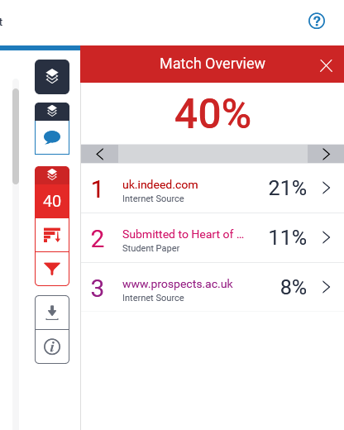
Task 1 b
similarity score.
My Similarity score is 40% and should be no more than 30% the lower the better. I would like to improve by using paragraphing tools and looking at different adjectives. also, by looking at other sources for information and researching the most common and non-common essential skills for studying and employment. I will look at the skills I am currently studying compared to what is needed in organizations. I will proofread it to make sure that I am not copying and pasting anything. that is not essential or related, so that my similarity score is low for next time.
Score: 67
I scored 67% myself because I used a wide range of literature, which includes the references I researched whilst completing the task. I also showed a good understanding of the concepts and principles of this task and interpreted qualitive and quantitative data accurately.

Task 2 a
e-portfolio link

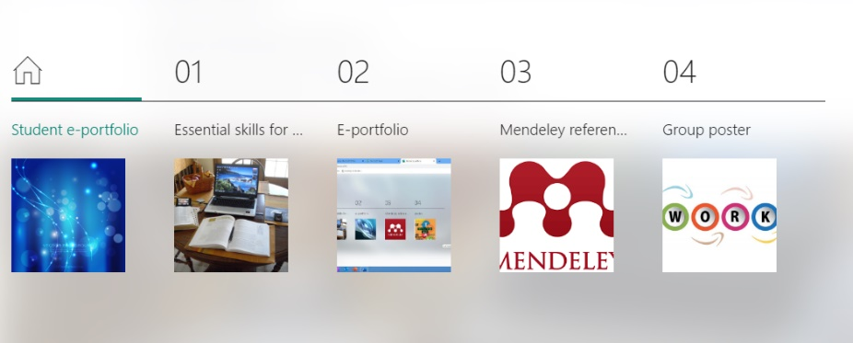
I have created my e-portfolio in Microsoft sway I have included all the tasks in this portfolio.
Task no 1 can be found in section 1 on page 1 of my e-portfolio.
Task 2 is the e-portfolio itself.
Task 3 is the Mendeley reference manger tool which is in section 3 on page 3.
Task 4 is a group poster which is on section 4 on page 4
https://sway.office.com/YXMV4dM2FUfueGqy?ref=Link
Video link for Microsoft sway
https://uowtsd-my.sharepoint.com/personal/2212164_student_uwtsd_ac_uk/_layouts/15/onedrive.aspx?id=%2Fpersonal%2F2212164%5Fstudent%5Fuwtsd%5Fac%5Fuk%2FDocuments%2FAttachments

Task 3
Mendeley reference manager

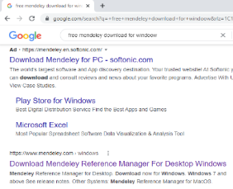
(1) go into google and type for Mendeley reference manager. Once you have found the site it will ask you to accept all cookies and download the application.

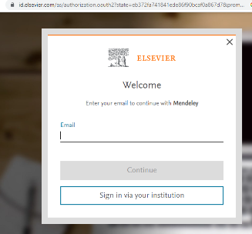
(2) once you have downloaded the application. You must register a new account which will require an email address, a new password and family name.

(3) Once the application is installed, you will need to re-enter the email address and password you used to register. You should then see the application load, and it will be your Mendeley library as shown above.

(4) How to load files and books on Mendeley tool manager. There are three ways to load information that you might need for your work. One way is that you can enter the details of the website and author details manually. The second way is to use the identifier tool which you will get from the main website of your search copy and paste the code into the identifier box. Third way is to a web importer.

(5) I have added a reference book to my library as seen above.

(6) know add Mendeley reference tool on to Microsoft word. Go back to the website where you got Mendeley reference and download Mendeley cite. This screen will appear click get it now.

(7) Use Madeley reference tool on Microsoft word you can do that by going into Microsoft word. Click onto the reference tab in the taskbar as shown in the picture with a blue line underneath it. You will see Mendeley icon there. Once you have clicked it, it will appear on the task as shown above in the picture with your library on the right-hand side.

References
[1] Simarmata, J.E., Dewi, N.P.Y.A., Sila, V.U.R., Sele, Y. and Shidik, M.A., 2021. Training on The Utilization of Desktop Mendeley as a Reference Tool in Writing Scientific Papers for Teachers of SMP Swasta Gita Surya Eban. ABDIMAS TALENTA: Jurnal Pengabdian Kepada Masyarakat, 6(1), pp.161-167.
[2] Saxena, R. and Kaushik, J.S., 2022. Referencing Made Easy: Reference Management Software's. Indian Pediatrics, 59(3), pp.245-249.
[3] Mahbub, I.S.P. and Hadina, H., 2021. A SYSTEMATIC OVERVIEW OF ISSUES FOR DEVELOPING EFL LEARNERS’ORAL ENGLISH COMMUNICATION SKILLS. Journal of Language and Education, 7(1 (25)), pp.229-240.
[4] Top Tip Bio, “How to Use Mendeley Reference Manager (Complete Beginner's Guide)”, available at: <https://www.google.com/url?sa=t&rct=j&q=&esrc=s&source=web&cd=&cad=rja&uact=8&ved=2ahUKEwi_mZWNw9X6AhXARkEAHUjpAe4QFnoECAgQAw&url=https%3A%2F%2Fwww.youtube.com%2Fwatch%3Fv%3DOzFHGFnAM2Q&usg=AOvVaw09bwxIuCh_Qs2Y1Z1jqsqf>, accessed on 14 Nov 2022.

Task 4
Poster ‘Life is a Team Sport’
Screenshot poster

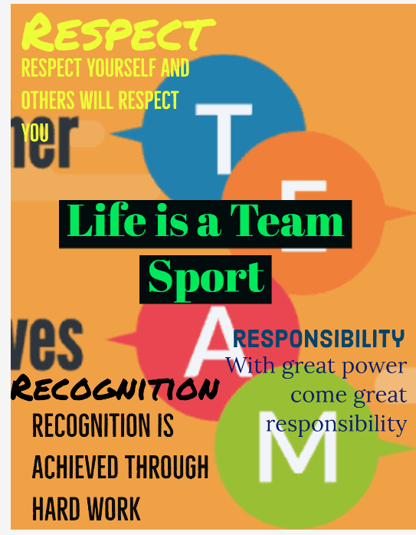
[1] Respect [2] Adobe Express [3] Responsibility [4] Recognition
My task was to think of a design for a group poster. And how I can make it stand out and making sure the main point off this poster is clear. I did that by using unique style of the font and size. By adding in bright colours on the main points of the poster. I also gave my team ideas on what we could write focusing on our poster. As a team we communicated well we all listen to one another ideas. In my team they were 3 team members.
Group Members Names: Jure, Muhammed, and myself (Aftab Hussain)

References
Respect
[1] "75 Powerful Respect Quotes," Planet of Success, Apr. 28, 2020. Accessed: Nov. 11, 2022. [Online]. Available: http://www.planetofsuccess.com/blog/2017/powerful-respect-quotes/
Adobe Express
[2] "Free A3 Poster Maker," Adobe Express, 2022.Accessed: Nov. 11, 2022. [Online]. Available: https://www.adobe.com/express/create/poster/a3
Responsibility
[3] "With great power comes great responsibility quote design 1," fppt, 2022.Accessed: Nov. 11, 2022. [Online]. Available: https://www.free-power-point-templates.com/free-quote-powerpoint-template-design/with-great-power-comes-great-responsibility-quote-design-1/?nowprocket=1
Recognition
[4] "Pin on EveryDay Quotes," pinterest, 2022.Accessed: Nov. 11, 2022. [Online]. Available: https://www.pinterest.com/pin/33-recognition-quotes--732327589398345726/

