University of Wales Trinity Saint David
School of Engineering

Engineering project technical report
Sami Naas
2203564

Motorsport Engineering
03/12/2022
Work shop and practice ACHA4011


Contents
1 Introduction 2
2 Engineering team structure 3
2.1 Team members 3
2.2 Team structure 4
3 product development 7
4 Issues, Legislation & Standards 10
5 Personal Development Plan 12
6 Conclusion 12
7 Reference List 13

Figure 1:functional organisation structure 5
Figure 2: example of a matrix team structure 6
Figure 3: shows the workflow of the engine development 7
Figure 4:shows the Skoda (2018) test engine test rig 9
Figure 5:shows the 2019 carbon footprint and the different areas it was split up into. (F1 2019) 10

Introduction
This technical report will investigate the development of an engine built for endurance racing. It will investigate how teams are structured and the type of people who would be good in an engineering team. The development process will be looked at in detail to determine a team structure and workflow process. In addition to this it is important to investigate the different issues, legislation and standards surrounding the development of an endurance racing engine.

Engineering team structure
When an engineering firm takes on the development of a new project allot of different specialities, skills and departments are needed to ensure the product meets the customers or users’ requirements. This requires the use of teamwork between different people to ensure the products success. The Leonardo Davinci Graduate School of Engineering (ESILV) (2019) describe the importance of teamwork as being “core of technical and engineering operations”.

Team members
When developing a product as the people selected are very important to the operation of a team. In an engineering setting it is important to have representatives of different elements of the production process from imagination to manufacture. Research done by Belbin (2010) shows the different types of people in a team and their attributes. Belbin outlines 9 different categories and each have a place in the team:
- Shapers – people who challenge the way things are done and try to improve the teams process and outcome of the product. They are allows described as being ideal for leadership roles.
- Coordinators – people who listen to other members of the team and use the information to organise them to complete a project or task. This another role that is suited to a leadership role
- Plant-Innovator – people who are good at problem solving and are creative. This role is undertaking the initial design and invention of a product that solves the customers problems or meets their needs
- Team workers – people who support the members of a team and have good people skills. There main function in a team is to avoid interpersonal problems arising in a team and help the teamwork in a more cooperative manner. They are usually suited to team leadership roles who work under a higher management.
- Resource investigators – people who are good at communicating with outside the team and are good at negotiating with people. They are suited to communicating with customers, users and contractors for projects
- Implementors – people who have a loyalty to the company they work for and have a strong drive to get work done in a swift and organised fashion.
- Complete finishers – people who strive for perfection and will take their time to proof check their work to the highest standard.
- Monitor evaluators – people who are suited to evaluating suggestions and solving problems. They are described as having a high critical thinking ability and able to make important decisions.
- Specialists – people who have a high level of knowledge in their field. They are described in the book as not being the best team players but are still important to the team especially in an engineering environment.

Team structure
Once the right people have been chosen for an engineering project a team structure needs to be implemented to ensure the members are completing the work to the right standard whilst doing it efficiently.
The first type of team structure is one of the most common called a functional organisational structure. This is where people are grouped interms of function and are plaaced under a group leader that will then report to an overall leader or project leader (REF). This can work well in an engineering enviroment as each group takes on a diffent role of product development. For example in a Racing team developing a new car this structere could be implemented where each team is made up of different types of engineers focusing on one area of development. This helps to split up the work and ensure that the people with the right skills are working on the right project. Figure 1 illustrates an example of how each team is layed out.

Technical director

Group 3 – Aerodynamics
- Group leader
- Engineer 1
- Engineer 2
- Engineer3

Group 2 – engine
- Group leader
- Engineer 1
- Engineer 2
- Engineer 3

Group 4 – manufacturing
- Group leader
- Engineer 1
- Engineer 2
- Engineer3

Group 1- electrical components
- Group leader
- Engineer 1
- Engineer2
- Engineer 3

Figure 1:functional organisation structure
This structure dose poses some issues when it comes to the overall development of the race car as communication may be limited between teams which can create packaging issues for different components. As each team is made up of specialists from that area, they will design their area to suit their needs which may cause issues for other areas, or it could be very difficult to manufacture. An example of this could be in the development in a new engine. If other teams’ needs are not considered, the possible problems could arise including it being too big to fit into the aero package or run to hot that it cases electrical problems.
To fix this another team structure can be used to include more communication between specialists or to include different specialities in the development process. to achieve this a matrix structure can be used. Asana (2021) defines the matrix structure as “a company structure where teams report to multiple leaders. The matrix design keeps open communication between teams and can help companies create more innovative products and services. Using this structure prevents teams from needing to realign every time a new project begins.”. This would mean that different engineers such as design, mechanical, aero, electronic and manufacturing engineers will all work together in one group. This would allow for the original prototype of a design be passed through different specialist to ensure that it will fit the requirements from other development teams. Figure 2 shows an example of how a matrix structure would be laid out for a race car development.

Technical director

 | Electrical specialist | Engine specialist | Aero specialist | Design specialist | Manufacturing specialist | Team leader
Group 1- electric | 5 | 1 | 1 | 2 | 1 | 1
Group 2 – engine | 1 | 5 | 1 | 2 | 1 | 1
Group 3- aero | 1 | 1 | 5 | 2 | 1 | 1
Group 4- manufacturing | 1 | 1 | 1 | 1 | 5 | 1
Figure 2: example of a matrix team structure
The Matrix structure allows for all the different development teams to have a say in what the other teams are doing. This should reduce the number of problems when the different systems come together. It also allows for information to be relayed to between teams when the groups meet. An example of this during a group 2 meeting they will have the electrical specialist to see if their design will work with the components they designed. the matrix structure also allows the team leaders to give the technical director more accurate information about the whole car instead of specifications that won’t work when the all the components go into the car.
However, there are disadvantages to this structure. One of the main disadvantages is the complexity of the system which can make it difficult to organise the people into the right groups. Another problem is that people can get confused with who they need to report to as they are in 2 groups, both the specialist group and the development group. Friction between members can also be created when trying to decide what compromises will have to be taken and who gets overall authority.

product development
This section will look at the how the development of a race engine would be managed. The aims of the product would be to create a high RPM engine that is built for endurance racing so it would have to meet certain requirements based on the user requirements and the racing series rules.

To develop an engine, it would require allot of different types of engineers and other staff to aid the development process. the first consideration would be to create a team structure in order to ensure the development process is efficient and successful. The structure that would work best is one that uses a matrix structure to organise the teams. To further aid the development process it would be beneficial to create a workflow process to control how the engine is developed. Figure 3 shows the workflow process of engine development.

Initial ideas and generation of design criteria
Analysis of racing series technical regulations
First round of iterative design, prototyping and testing
Second round of iterative design, prototyping and testing
Continuation of iterative design prosses until design criteria has been met.

Figure 3: shows the workflow of the engine development

This system is based around the iterative design prosses, this process uses continual development in a cyclical structure to improve a product. It is enchased by the uses of rapid prototyping, client feed, testing and focus groups. There are allot of benefits to the iterative design which is why it is appropriate for an engineering environment. The pacific research laboratories (2020) highlight 5 main benefits to the design prosses.

- Greater efficiency and faster time to market
- Lower product development costs
- Thorough product testing
- Fewer redesigns
- More user-friendly products
Throughout product testing is one of the most important factors in the engine development process due to the nature of the engine. As it is being created for endurance racing it will be running from anywhere between 6 and 24hours at a time. Due to this the engine will have to be tested continuous through the development process to ensure that it can cope with the stresses of its environment. The iterative prosses allows for this to take place after each design change to ensure that any changes will not affect the reliability.

The matrix team structure would complement the workflow process as it would allow for constant communication between the different development teams. The teams will be sorted to the different areas of development as follows:
- Design team
- Simulation team
- Test team
- Technical regulation team
- Manufacture team
- Quality control teams
Each team will consist of a team leader with the remaining members being specialists in that area. There will also be a member of each team be attached to another team, this will allow for easy communication between teams. This would reduce the workload on the engineers as it splits the workload up. It will also improve the quality of the products as specialists’ engineers will be working in that area. Having members of other teams working alongside other teams should help to reduce any issues between the teams.

Another very important issue is the quality of the product. To ensure quality different methods can be implemented. The first of which is having manufacturing specialists in the development process the national careers services highlight some of the tasks a manufacturing engineer is responsible. The key ones are that they can work with the engineers to identify the best manufacturing processes for the task. They can come up with cost saving methods and fix problems in the design of a product. All these attributes can help to reduce the problems when it comes to building the physical products. As well as this having a quality control team will be able to oversee all the areas of development to help identify and eliminate any problems over the development prosses.
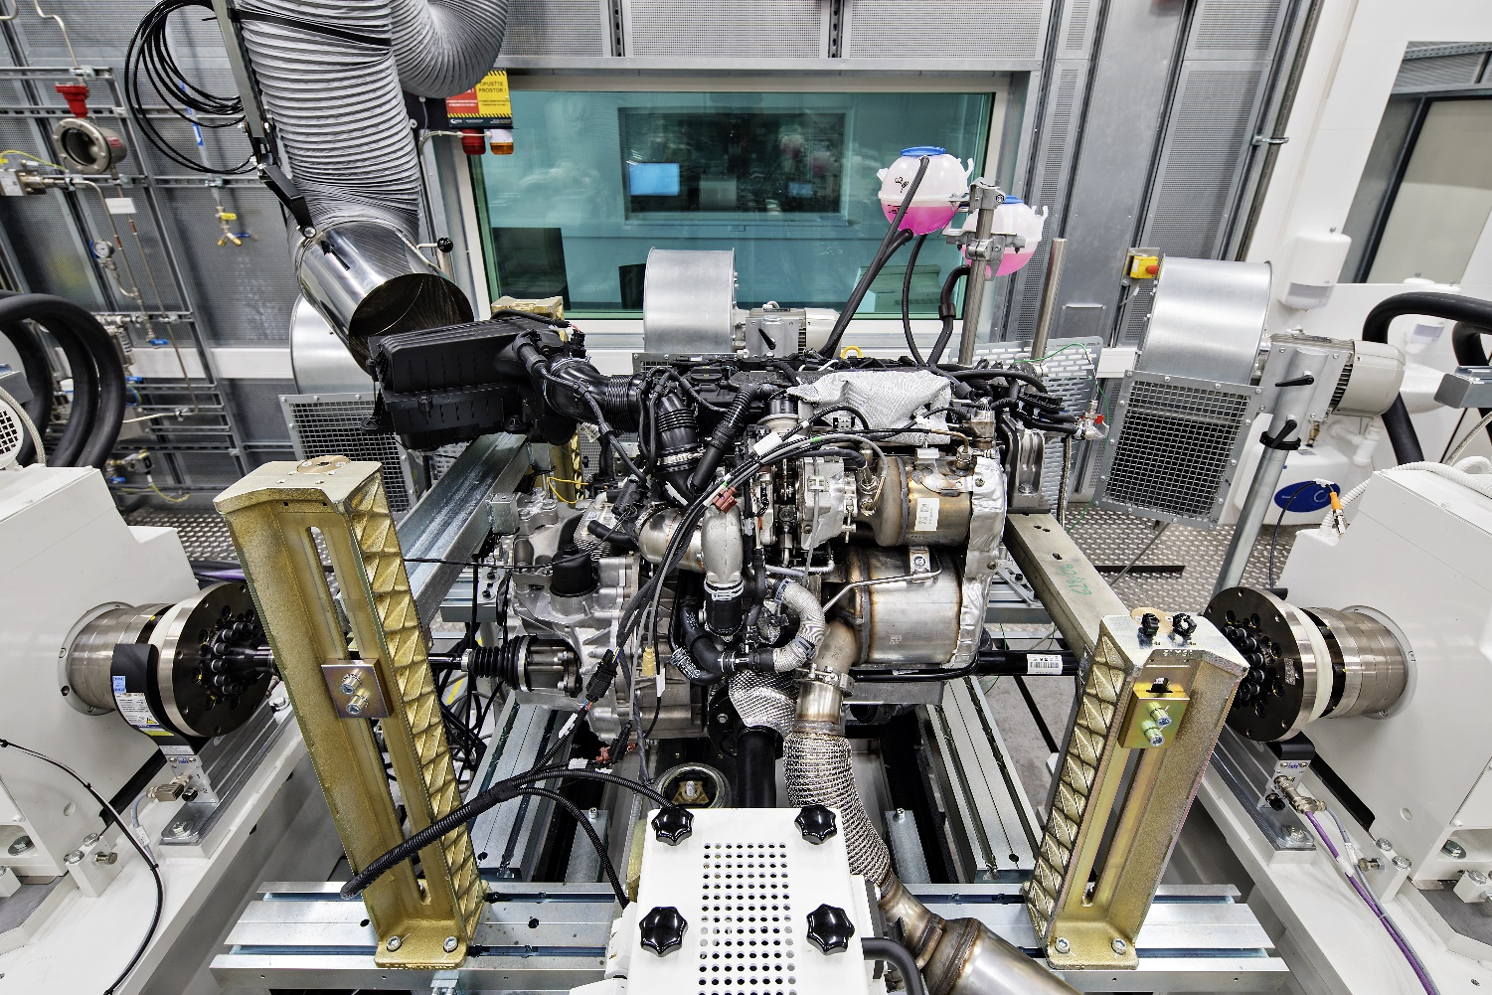
The final quality control method if having a dedicated test team as they will be able to understand how the engine behaves under extreme stresses. This could then be fed back to the design team so the necessary changes can be made to ensure the engine can run in the top performance range for as long as possible. Skoda (2018) use special engine rigs to test their engines the engineers “link the engine with an electric engine brake and connect it to the required measurement devices, fuel supply and cooling water supply. The engine test is an automated operation controlled by an automatic system.” This system can change different variables such as external temperature, fuel flow, air quality or different stresses on the engine to simulate different environments. This will give the engineers a better understanding of how their engine works and where different failures could happen.
Figure 4:shows the Skoda (2018) test engine test rig

Issues, Legislation & Standards

This section will look at the different issues related to the engine development and legislation and standards relate to it. One of the most important issues for the sustainability of the business is the environmental issues related to the development. As race cars aren’t on the road, they don’t have to comply with allot of the environmental legislation that road going cars have to follow. However, as engineers we have a responsibility to create sustainable solutions that don’t cause detrimental effect to the environment. One of the biggest racing series Formula 1 is has been making allot of changes to its racing to accommodate this. In 2014 F1 moved away from the 2.4 litter V8 to a 1.6 litter V6 to keep up with changes in environmental thinking. In 2019 F1 published the sustainability strategy report that highlighted changes that they were making to the sport to make it net zero.
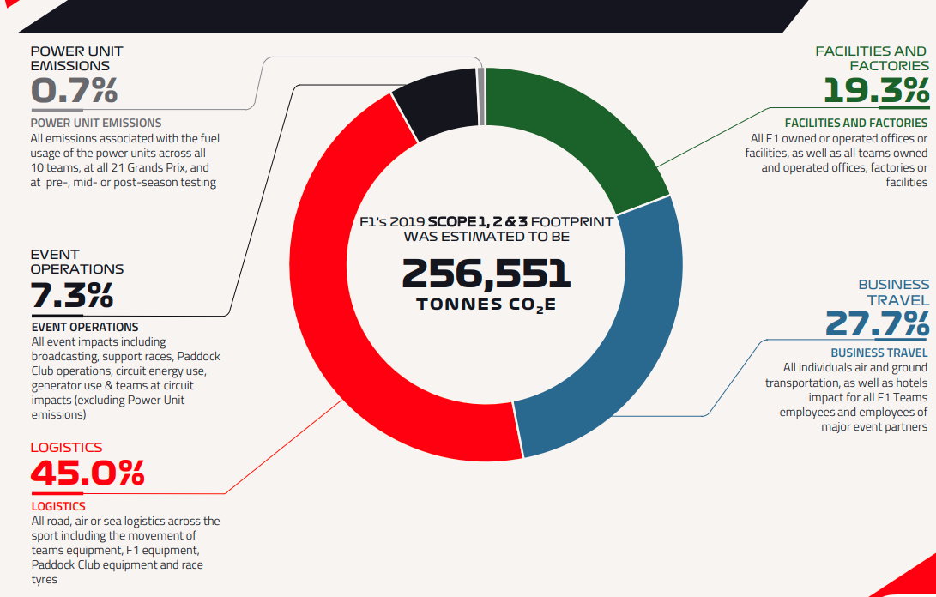
Figure 5:shows the 2019 carbon footprint and the different areas it was split up into. (F1 2019)

Since 1802 the UK government has been adding new legislations and standards to keep both workers and users safe. Every employer must carry out a risk assessment for each area of their business, this can include any where from office work to testing labs to a machine shop. This is done to protect workers and the employer as it ensures that people carrying out tasks are aware of the risks or have been trained to do so. the 1999 regulation from government “The Management of Health and Safety at Work Regulations 1999” highlights the need for a risk assessment to be carried out.
3.— (1) Every employer shall make a suitable and sufficient assessment of—
(a)the risks to the health and safety of his employees to which they are exposed whilst they are at work; and
(b)the risks to the health and safety of persons not in his employment arising out of or in connection with the conduct by him of his undertaking.

In addition to health and safety legislation it is important to follow different standards for a product. One of the biggest standards organisations is the international standards organisation (ISO). They were created to “provide a strong basis for the development of national and international regulation, helping save time and reduce barriers to international trade.”. Changes they have made include creating standard sizes for allot of different components, this allowed for parts to be bought from other manufactures such as bolts or fasteners and they all met the same standards such as quality or thread pitch. To ensure quality products an engine developed to use ISO compliant parts and fasteners would perform better as parts would be easier to source without having to develop them in house.
An example of a standard that would have to be considered in the development of an engine is ISO 15550:2016. This determines a standard for the method of measuring engine power. This was created so engines can be comparable with each other. For an engine that doesn’t meet this standard the power figure could be very different if the methodology and process for the ISO standard was not followed. Another factor to consider when developing an engine for a racing series is that it must follow the technical regulations from that series usually set out by the FIA. If it does not meet it would be deemed an illegal engine and would not be allowed to be used by a team. To ensure that the engine can complete it is crucial for engineers to clearly understand the regulations.

Personal Development Plan
After finishing my undergraduate in Motorsport Engineering, I wasn’t to do several things in the motorsport industry. I want to be able to work track side in Formula 1 and the dream would be to work for McLaren. I also want to get involved in other racing series such as the WRC or WECC. I want to be able to use my hands in some roles such as getting the cars set up or conducting tests on them during the development stage. I think it is important for me to be able to find a role in which I get to practical work or design work as well as I enjoy that allot more and fell like I am more skilled in those areas. Further in the future I want to work for a company like Rodin Cars who develop race cars that don’t conform to any technical regulations. I like the idea of pushing the limits of what a race car can do and would love to be involved in that.

6 Conclusion

In summary there is allot of different considerations that would need to be made when developing a product. It is very important to select the right people and structure them in a way that allows them to work efficiently as well as communicating well with others. During the development of a product there are allot of other factors that could affect the product, this includes everything from testing and finding new ways overcoming problems to making sure your product meets certain standards to allow it to enter the market. This is a very important factor for all engineers as it could easily decide whether a product can be entered into certain markets. Whilst there are less standards and legislation surrounding the motorsport industry there are technical regulations that must be met instead. During the manufacturing stages however, there are certain health and safety laws that must be followed, and these should be thoroughly investigated before taking any action in the development of a product

Reference List

Belbin, R.M. (2010) Management teams: why they succeed or fail. 3rd ed. Oxford, U.K: Butterworth-Heinemann.
ESILV (2019) Engineering teamwork 101, ESILV Graduate School of Engineering, Paris. Available at: https://www.esilv.fr/en/engineering-and-teamwork-3-fundamental-skills/#:~:text=Engineering%20and%20teamwork%20are%20a,of%20technical%20and%20engineering%20operations. (Accessed: November 23, 2022).
Asana (2021). What is a matrix organization and how does it work? [online] Asana. Available at: https://asana.com/resources/matrix-organization.

Engineering Department | Pacific Research Labsinfo@pacific-research.comPRL’s engineers have dozens of manufacturing options available to help you solve any challenge facing your product: CNC machining (2020) 5 advantages of iterative design and prototyping, Pacific Research. Available at: https://www.pacific-research.com/5-advantages-of-iterative-design-and-prototyping-prl/ (Accessed: November 30, 2022).
ŠKODA Storyboard. (2018). 360° Tour: How Engines Are Tested. [online] Available at: https://www.skoda-storyboard.com/en/skoda-world/innovation-and-technology/technology/360-tour-how-engines-are-tested/#:~:text=Engineers%20link%20the%20engine%20with [Accessed 4 Dec. 2022].
Barretto, L. (2022). Net Zero Carbon: How Formula 1 is going to meet this ambitious target by 2030 | Formula 1®. [online] www.formula1.com. Available at: https://www.formula1.com/en/latest/article.net-zero-carbon-how-formula-1-is-going-to-meet-this-ambitious-target-by-2030.5QsK9NpYbz7pXp7423I3iJ.html.
Legislation.Gov.Uk (2011). The Management of Health and Safety at Work Regulations 1999. [online] Legislation.gov.uk. Available at: https://www.legislation.gov.uk/uksi/1999/3242/regulation/3/made.
ISO. (2019). Benefits of standards. [online] Available at: https://www.iso.org/benefits-of-standards.html.
‌ISO 15550:2016. [online] ISO. Available at: https://www.iso.org/standard/70030.html [Accessed 4 Dec. 2022].
‌

