Museum exhibition proposal
Will you enter the… Labyrinth?

Venue: The British Museum
Date: 8th September 2019 – 22nd August 2020 (gives around 2 weeks for new exhibit to be set up)
Subject: ancient Greek gods and monsters

The premise behind this exhibit is to teach the general public, specifically school children, about the mythologies of ‘ancient’ civilisations in a fun and interactive way. This is not a religious exhibit due to the nature of the beliefs in these civilisations. There their beliefs were a part of every aspect of their lives and as such this exhibit aims to bring these beliefs into frontal focus so that a base understanding is laid out upon which further interest may grow. It is a great shame that ancient cultures are not a part of the school curriculum, hence the need for something like this exhibition to be made available to the public in a fun and interactive way.
The exhibit is to be laid out in the style of a labyrinth, with partitions creating the maze (the design of which can be seen in the images provided). A red light on the floor will guide visitors through the labyrinth, in the same way Ariadne’s thread helped guide Theseus (Carpenter. 1991: 163). If visitors just follow this way, they will only see images, artefacts and information attaining to the gods. Should visitors stray from the light, only then will they see different monsters. All of this is designed to replicate the Cretan labyrinth from Greek mythology (details of which can be found in various mythology texts, including Carpenter. 1991). The idea behind this exhibit is that it will change yearly to reflect a different culture, with the labyrinth layout remaining. This way visitors may return year after year to a familiar exhibit but learn something new each time. Within the exhibit space there will be limited lighting with spotlights highlighting artefacts and textual information. There will also be recorded sounds playing within the space, (lightning, wind, growls) this adds to the atmosphere being created.
The artefacts that will be required for this exhibit, as well as its future models, will not exceed, unless necessary, those already held within the British Museum collection. Because this exhibit is mostly aimed to be accessible to children of primary school age, the objects exhibited will be kept limited to those with the ‘wow’ factor. These accompany the images of gods/monsters and pieces of text that will adorn the walls. By keeping the artefacts limited to ‘wow’ pieces it ensures younger visitors do not lose interest. Those that will be displayed will be statues, large vases etc. specifically those that would tower over the smaller visitors. They will be displayed singularly in cabinets built into the partitioning walls of the exhibit, with underlighting highlighting the artefacts. These cabinets will all be standardised sizes so that they may be used year after year, accommodating the new objects.
To accompany the exhibition, we will also be producing audio guides. This will reduce the amount of text that has to be read by visitors; instead information can be received at the visitor’s discretion. Much like those produced for children in other establishments, here all audio guides will have fun information provided in a story like manner. To save money a limited number of audio guides will be available on site, with the guide being available digitally online, allowing visitors to use their own smartphones to access the material. The guide will tell the myths surrounding the different gods and monsters, as well as the labyrinth, as prompted around the maze.
The theme for this exhibit and the subsequent redesigning of it follows the history of the museum. The original objects in the British Museum originated from Greece and Egypt (as well as other ancient cultures), this focus is something we still see in the collections held by the museum today. Hence this exhibit is very much in keeping with the museum’s current collections, as well as the original roots of the museum.
While the cost for the exhibit may be initially high (for construction), continued cost should be relatively low. No extra staff would be required for regular work; however, a changeover team would be needed for the quick turn around in the exhibit each year. This would be a real blockbuster exhibit targeted at schools and families, hence the revenue created would be large and continuous. The upfront cost of the exhibition will be subsidised by a lottery grant obtained to help foster an interest in children about the classical worlds. Further costs may be subsidised by various institutes and universities as in future they may benefit from more students studying the classical world at a higher level (something this exhibit hopes to start the road towards). The ethos fits in with a moto the BBC once had: to ‘inform, educate and entertain’ (Higgins. 2014: The Guardian). They may also be a possible body to donate towards the initial cost of construction.

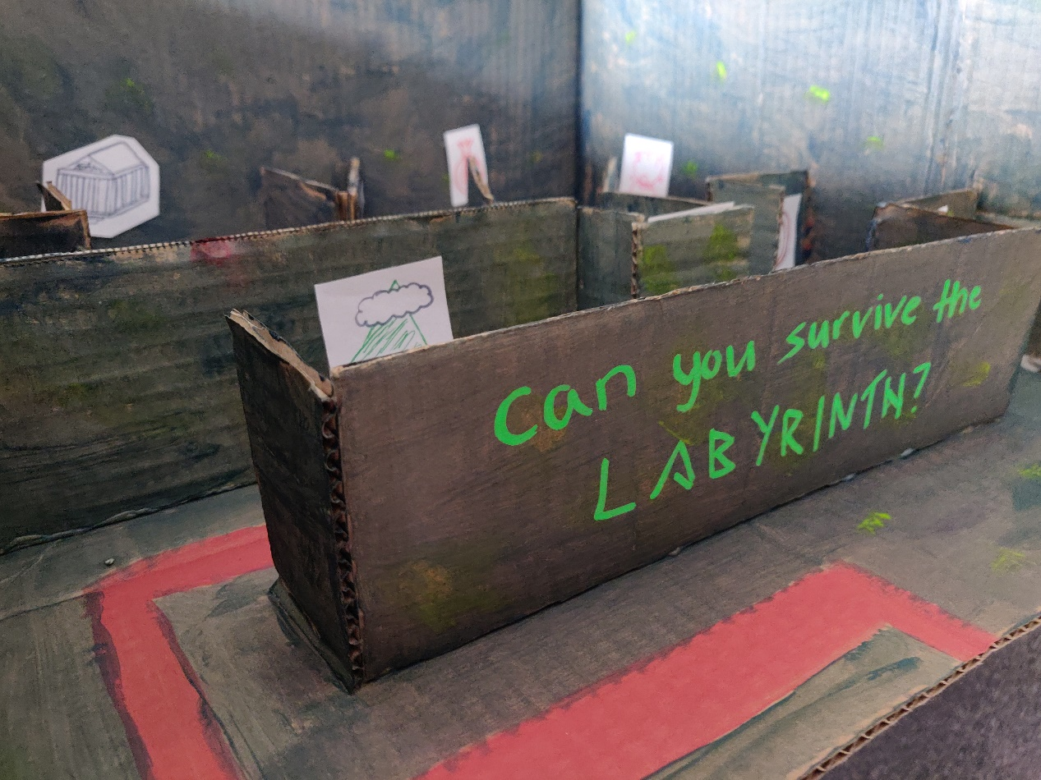

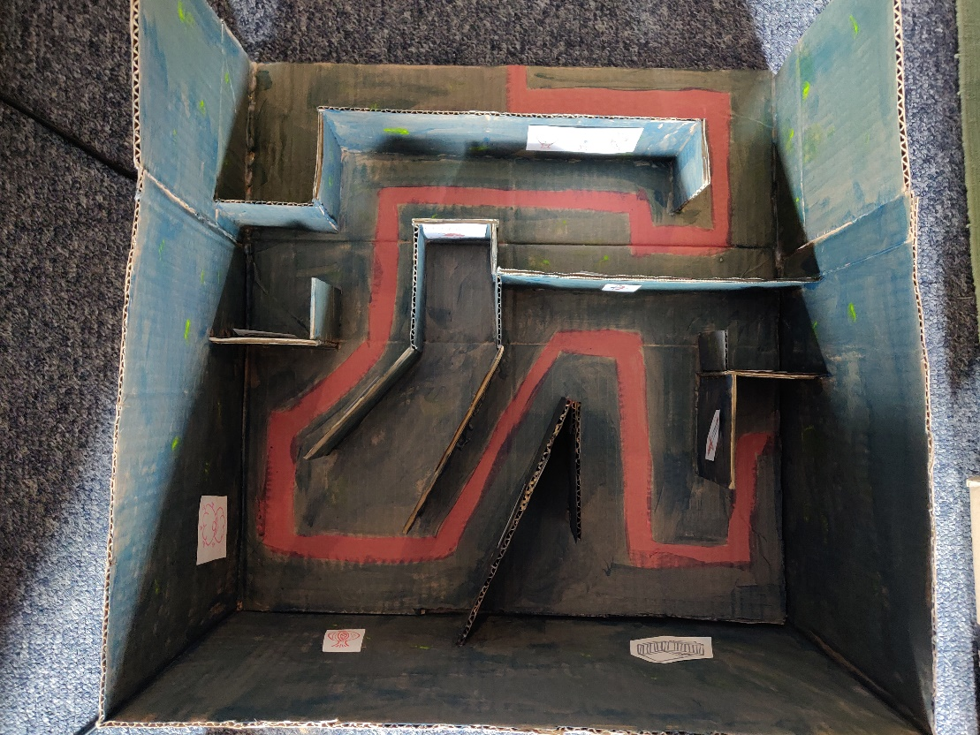

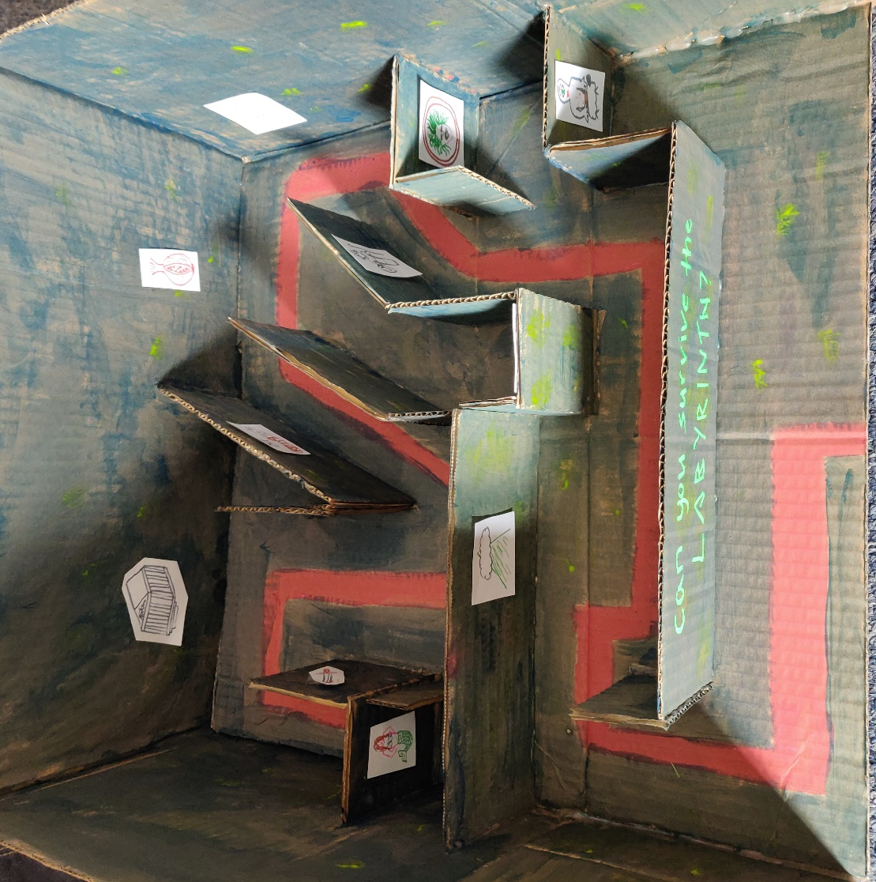

Bibliography
Carpenter, T.H. 1991. Art and Myth in Ancient Greece. United Kingdom: Thames and Hudson
Higgins, C. 2014. The BBC informs, educates and entertains – but in what order? Available from: The Guardian Online: https://www.theguardian.com/media/2014/jul/01/bbc-inform-educate-entertain-order Accessed 15/04/2019

Images
Proposed exhibit 3D model. ©Martha Warren. 15th April 2019. Lampeter, Wales.

