Freak out!
The new monthly magazine for teenagers suffering with anxiety
 |  |  | 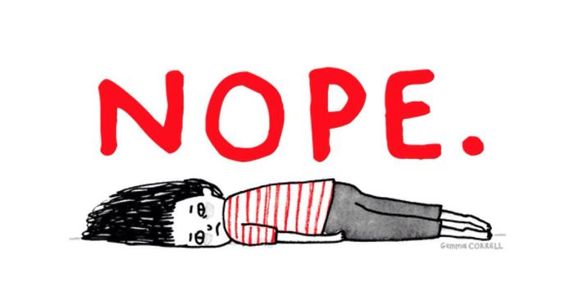
Anxious? | Scared? | Just can’t face it?
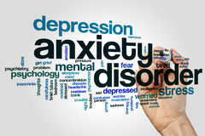

Do you suffer with anxiety?

What is teenage anxiety all about anyway?

With all the changes that are happening during the teenage years, it’s not surprising that sometimes you will feel anxious and worry about things.
You might be concerned about your appearance more than ever before, you might have exams coming up, perhaps you are experiencing some problems at home or with your friends, or maybe you’re just generally struggling with everyday life and wondering what will happen in the future.
You might be able to see that what you are worrying about has changed over time. As a younger teenager you might have been more concerned that you were not getting on with your peer group, but now you are more worried about the arguments you are having with your parents. On the other hand, you might feel that you are facing several issues all at the same time and that they are really getting on top of you. Sometimes it helps just to focus on one thing at a time. If you can choose, for instance, to focus on your upcoming exams and resist an argument with your parents, you might not feel that you are ‘overwhelmed by the ‘storm and stress’ of everything happening at once.’ (Hayes, 1994, p.780)

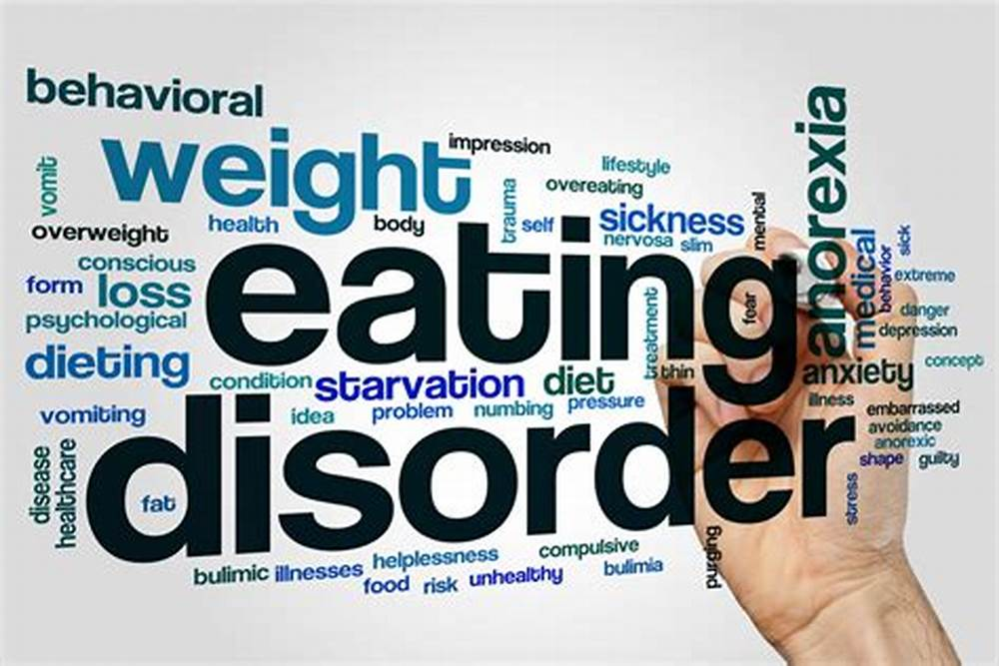
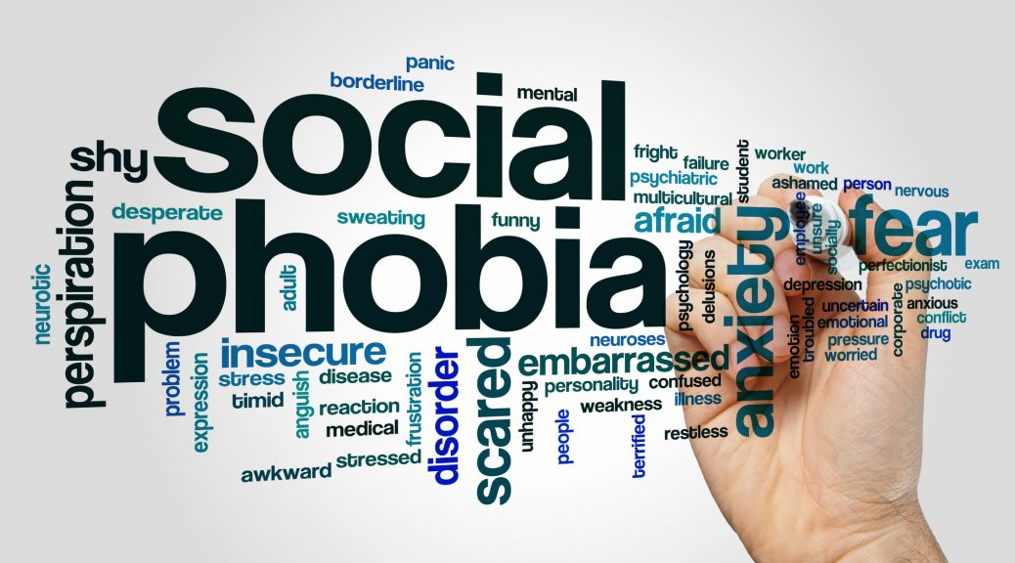

Symptoms and types of anxiety

What does it feel like and how bad can it get?

You know you’re feeling anxious because you feel one or more of these:
stress edginess apprehension the jitters worry jumpiness nervousness the shakes fear butterflies uneasiness freaking out panic disquiet agitation angst (Shab, 2008)
Some of this is quite normal as it goes back to prehistoric times when our ‘fight or flight’ instinct was really needed to cope with danger. It is quite normal for everyone to feel nervous before an interview or when speaking in public. That’s what adrenaline does to you.
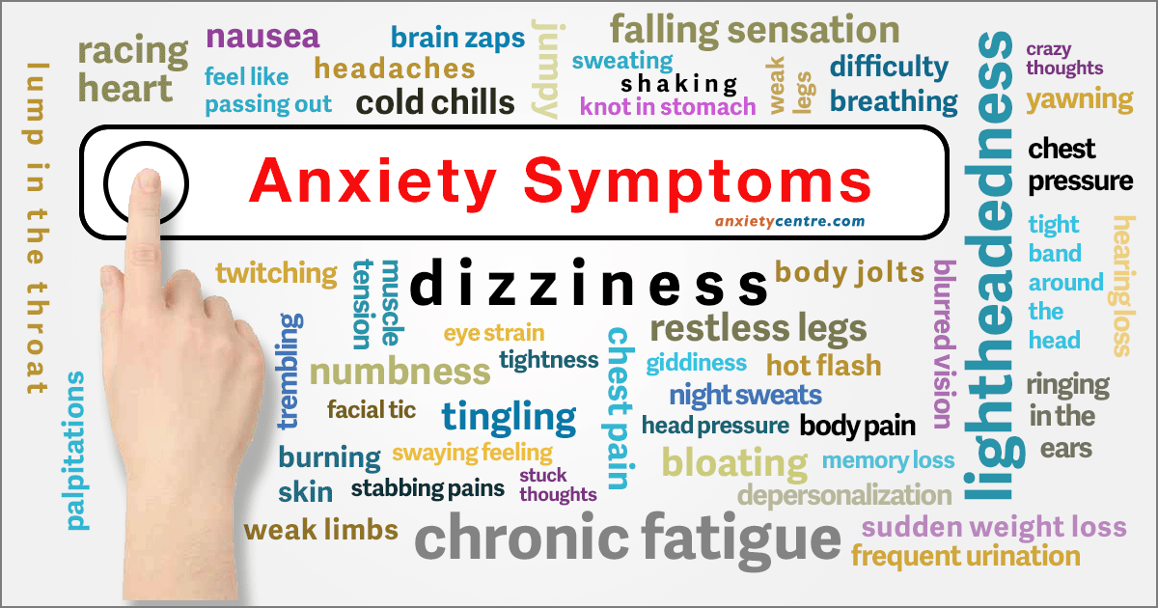
However, sometimes our brains cause too much hormone to be released and that makes us over-react to situations and feel really bad. If this is happening far too often it is a sign that the anxiety has become a disorder.
There are several types of Anxiety Disorder and you may be suffering from one or more of them, depending on your current situation and the way that you naturally deal with issues.
Generalised Anxiety Disorder is common amongst teenagers (Abraham, 2018). It’s when you become uncontrollably anxious about a lot of different things at the same time (eg. People, places, ideas and things). You might feel that you need support or reassurance from family and friends to make you feel better.
Social Anxiety Disorder is the most common type of anxiety disorder (Abraham, 2018). People who suffer from this find that they are so uncomfortable in social situations that if affects them physically. They might find it difficult to speak, blush strongly, stammer, sweat or feel sick. This type of anxiety can lead to teenagers seeming to be very shy and/or isolating themselves.

Another type of anxiety is Obsessive Compulsive Disorder in which people deal with negative thoughts by engaging in intense ritualistic behaviour such as repeated washing or cleaning, and this starts to disrupt their life.
Panic Disorder, or panic attacks, are another type of anxiety, this time involving a severe sense of three or more of the following: rapid heart rate, shortness of breath, sweating, shaking, dizziness, nausea, losing your sense of reality or fearing that you are going to die.
Some children and young people suffer from what is called Separation Anxiety. This is when they feel very uncomfortable when they find themselves separated from familiar places or people such as close family. This becomes a real problem if it stops the young person from wanting to visit friends or go to school.
Then there’s another type of anxiety that most people have, and that’s phobias. This is when we react to certain situations or things with intense fear, such as heights or spiders. People with phobias tend to avoid those stimuli as much as they can.
Finally, severe anxiety can be caused if you experience or witness a traumatic even, and if the symptoms persist for more than a month (flashbacks, being very jumpy, nightmares and panic attacks) you could be diagnosed with Post-Traumatic Stress Disorder.

Adults often get treated for anxiety with medicines, but since young people’s brains are still developing, the medical profession is usually reluctant to prescribe drugs to them.
Instead, there are a range of non-medical techniques that can be used with teenagers, and a number of self-help activities that should be tried.
Cerys  A Case Study  Cerys is 17 and a quiet girl. Some people think that she is moody and miserable, but they don’t know what’s going on inside her head.  When she does speak in a group, which isn’t often, she usually says something negative, makes a sarcastic or critical remark that people think is rude and unnecessary. Most of the time she is happy to sit alone and scan through her mobile phone.  What people can’t see is that Cerys is very anxious. She really struggles to relax socially. It takes ages for people to get to know her properly because of the barriers she puts up. Most people don’t bother talking to her after a couple of times.  Cerys knows the feelings of anxiety, but she doesn’t understand that this is what makes her behave in an unfriendly way.  She doesn’t make the connection between her feelings and her situation. She’s worried about the health of her grandmother, who she lives with, she’s concerned that she failed her GCSEs and she can’t see herself ever getting a decent job or a good life.  Cerys would like to feel better and she knows that she needs help to find a way out of her anxieties, but most of the time she can’t see the point in making an effort and just looks on from the sidelines.  The only time it is different is when she goes to youth club. The only person she can talk to properly is Angela, a youth worker, who always has time for her and always seems to understand and make things better for a while. |   Cerys’ Youth Worker, Angela  A different perspective  Angela knows that Cerys is different on the inside. Beyond that hard shell there’s a young woman with hopes and dreams. She’s a bright enough girl and when she’s feeling positive she can be really energetic and quite a lot of fun, super to be around. The trouble is that people hardly ever see that side of Cerys. Most of the time she’s wrapped up in her own world and not joining in with everyone else.  Angela has made it her job to understand what is going on in Cerys’s world. She has been consistent and kind, listening and encouraging Cerys to talk about her life. Cerys has come to trust Angela and lately they have been talking about different options that Cerys might explore: going to college or getting some help with job interview practice, both of which Cerys dreads.  Angela knows that if she can informally educate Cerys about her options and get her to express her likes and dislikes better, Cerys might feel more empowered to take the next step towards training or working. (YWWRG, 2018)  She also knows that good youth workers can help to build confidence and resilience in young people, so that they are more able to participate with others and to express and realise their own goals. (LSIS, 2012)  Angela talks to Cerys as often as she can, checking that Grandma is okay, and suggesting people that might be able to help, and she encourages Cerys to join in and help at the youth drop-in, which is giving Cerys the opportunity to try new things and to build her confidence step by step.  Gradually, Cerys is beginning to feel some of her anxieties reducing, because she knows that she has someone to turn to for help and support and a place where she can relax and be herself.

How anxious are you?

Take our short questionnaire…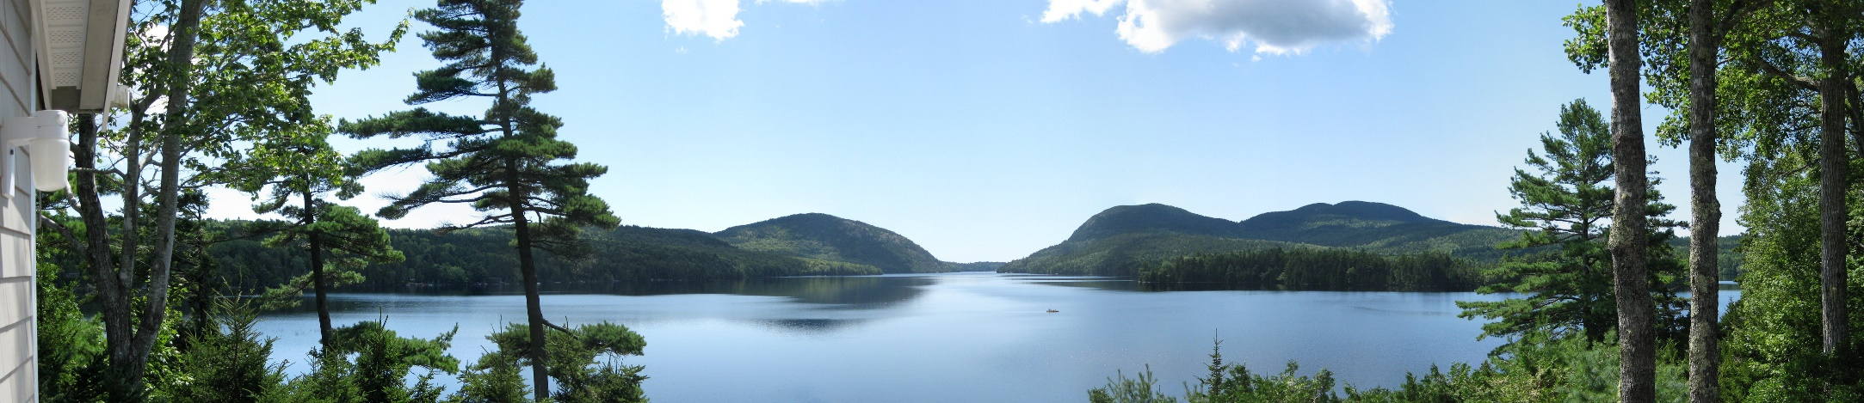
For each question, give yourself a score between 1 and 5, where 1 is Yes, I strongly agree and 5 is No, this isn’t me at all.  - I am a worrier.  - I need to feel in control.  - I get lost in my thoughts for ages sometimes.  - I feel emotional a lot of the time.  - I am restless at night and only get a few hours’ sleep at a time.  - I often feel overwhelmed by things.  - I am always on the go and never find time to take a break.  - I am busy all day every day and have far too much to do.  - The last year has been very unsettled with lots of challenges and pressures. | - I am not very confident and comfortable with myself.  - When I try to rest I get fearful, stressed, shaky, upset stomach or dizzy.  - I avoid social situations or gatherings because I get nervous or anxious.  - I get scared that I might get into a situation or a place where I might not be able to escape quickly.  - I feel afraid or worried most of the time. Things have become very difficult.  - I get very concerned about what people think of me.  - I always have a lot of nervous energy.  - I hate confrontation. When there’s a problem, I avoid it. |  | - I’m constantly searching the internet for answers about how I am feeling.  - I have never talked to a doctor about my anxiety or my anxiety symptoms.  - I can’t stop worrying about uncertainty or danger until it has been resolved.  Add up your scores. The lower your score, the higher your anxiety levels.  If you are concerned, you should seek help.  You may wish to speak to friends or family first.  You can try some of the self-help techniques we suggest in the next section.  You can also speak to professionals.  Useful contacts are provided at the end of the magazine.  (Adapted from anxietycentre.com)

Some Self-Help Ideas

Banish Anxiety, Relax and Be Your Calm Self
- One of the best things you can do is Exercise. This is because it causes the brain to release chemicals that make you feel good (endorphins).  - A Healthy Diet is also very important. Your mind can’t be healthy if your body isn’t. It will also help you to become fitter as you exercise.  - Being around people who provide you with lots of positive Feedback is key. Choose to be around people who make you feel valued when you are feeling low.  - If your dreams and ideas seem outrageous to some, choose to be around people who will Support you better. Seek out an environment where you can share what’s on your mind without too much stress.  - Why not learn how to Meditate? Controlled breathing and deep relaxation can provide a powerful rest for a stressed mind.  - Even if you suffer with social anxiety, joining a Club can be really good for you. You’ll find others with similar interests, make new friends and be occupied with a range of activities.  - When it comes to anxiety, there are many Self-Help books and workbooks available to help you work through your issues in your own time, such as ‘The Anxiety Workbook For Teens: Activities to Help You Deal With Anxiety & Worry’ – by Lisa Shab. (You can find it online)  - One of Lisa Shab’s techniques is to ask yourself, “What’s the worst that could happen?” Think about that next time you’re anxious and see how well it can lower your stress level. |  | 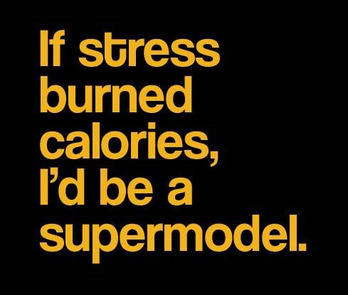  - Talking about your anxiety provides you with a type of Therapy that will help you to cope with it. You will learn how to find what causes your anxiety and the negative thoughts that it creates. You will also learn how to think and behave differently, which will help to reduce or eliminate the anxiety.  - In addition to all these ideas about how to cope, you could keep a Journal, which is a safe place to record your thoughts and feelings and let go of some of your anxieties.  - There are lots of ‘positivity phrases’ out there on the internet. Pin a few around your room. Better still, make some up for yourself.  - Relax with a cup of tea. Treat yourself to a mindfulness colouring book or do our Wordsearch on page 7.  (1-10 adapted from calmclinic.com)

Did you know…?

Some interesting facts about anxiety
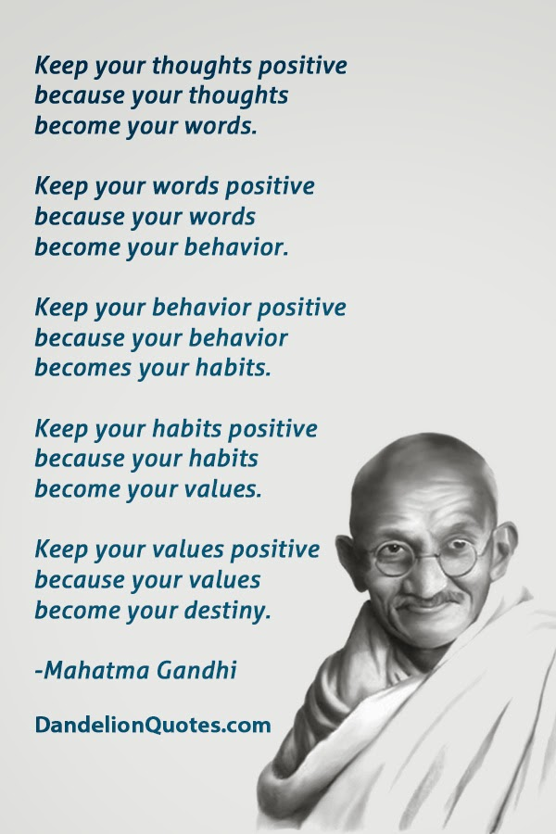
- Anxiety is a feeling of fear or panic. Feeling generally anxious sometimes is normal. Most people worry about something - money or exams - but once the difficult situation is over, you feel better and calm down. With as many as one in six young people experiencing anxiety at some point, it is very common to have anxiety. (young Minds, 2019)

- Take a look at this video published by Young Minds and see how other young people describe their anxiety and their coping mechanisms: https://www.youtube.com/watch?v=mprhqMRz5PU

- If you suffer with social anxiety disorder it is very easy to start using drugs or alcohol as a coping mechanism. This is not a good idea. Try to use some of the other techniques we suggest.

- Why not take a look at some of the many self-help worksheets that are available on the internet. They cover many different types of anxiety and are something you can do yourself. This particular website has 15 such worksheets: https://positivepsychologyprogram.com/anxiety-worksheets/ and we have reproduced one of them for you on page 8.

- The magazine Children & Young People Now reported on 10th May 2019 that anxiety is found to be a key factor in youth unemployment. One in four young people aged 16 to 25 were still unemployed a year after leaving school, and 55% of the 2000 young people questioned felt that anxiety was the main reason they had not yet found a job.

- Only 2% to 3% of children and adolescents are affected by Obsessive Compulsive Disorder, but it is important to get this properly diagnosed, because it is estimated that 10% of these children and young people go on to attempt suicide.

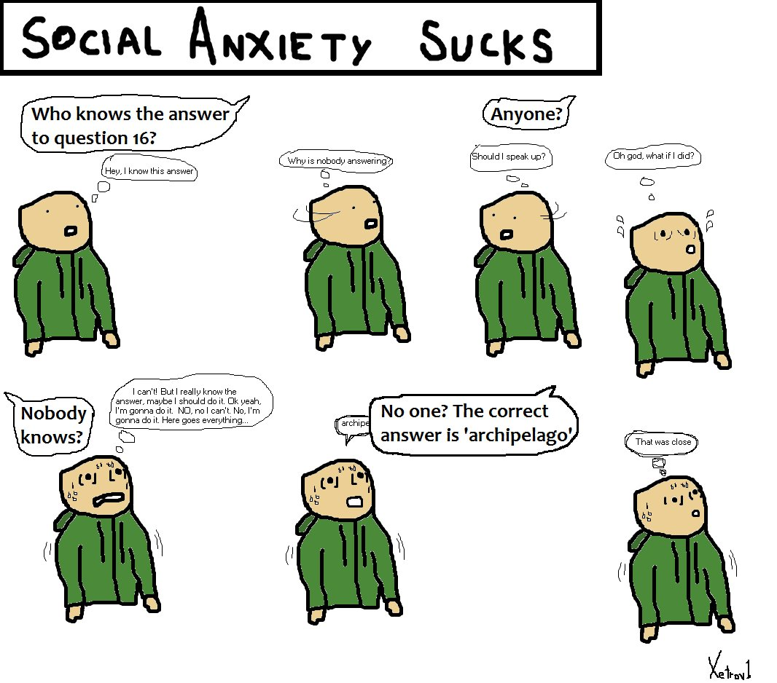
Word Search
R | E | M | M | A | T | S | A | E | P
T | A | N | X | I | E | T | Y | H | E
E | L | E | O | M | K | R | E | T | C
T | A | E | W | S | A | E | M | A | A
R | M | C | U | T | H | S | S | E | E
A | B | E | R | U | S | S | E | R | P
E | I | T | S | G | O | E | P | B
H | M | L | E | H | W | R | E | V | O

Find: Anxiety, Stress, Pressure, Peace, Try, Heart, Sweat, Shake, Breathe, Overwhelm, Stammer

Challenging anxious thoughts
A worksheet for you…

Anxiety can be a healthy emotion – it forces us to focus on our problems, and work hard to solve them. But sometimes anxiety grows out of control, an does just the opposite. It cripples our ability to solve problems. When this happens, irrational thoughts often play a role.
In this exercise, we will practice catching our irrational thoughts, and replacing them with rational alternatives. With enough practice, this will become a natural process that can help you manage anxiety.

Describe a common situation that triggers your anxiety:
Example: ‘giving a speech in front of a crowd’ or ‘driving in rush hour traffic’

Anxiety distorts our thinking by causing us to overestimate the likelihood of something going wrong, and imagine the potential consequences as worse than they really are. Sometimes, just taking a moment to think about these facts can help us recognize our irrational thoughts.

Imagine you are faced with the anxiety-producing situation from above. Describe the…
Worst outcome:

Best outcome:

Likely outcome:

Imagine the worst outcome comes true. Would it still matter…
1 week from now:
1 month from now:
1 year from now:

Usually, anxious thoughts focus on the worst possible outcomes, even when they aren’t likely. For example, a person who is nervous about giving a speech might think: ‘I am going to forget everything and embarrass myself, and I’ll never live it down’. As an outside observer, we know that an alternate, more rational thought might be: ’My speech might only be OK, but if I do mess up, everyone will forget about it soon enough’.
Using your own ‘worst outcome’ and ‘likely outcome’ from above, describe your…
Irrational thought:

Rational thought:

(from TherapistAid.com,2019) (Worksheet dated 2016)

Where to find help
Nearby, on the internet and by phone…

Locally:
- Tanyard Youth Project, on the Commons in Pembroke
- Milford Youth Matters, at the Leisure Centre in Milford Haven
- The Hive in Haverfordwest
- POINT, in Fishguard
- Or other youth groups to be found at http://www.pembrokeshireyouth.co.uk/
Online and By Phone:
childline
- www.childline.org.uk
- If you're under 19 you can confidentially call, email or chat online about any problem big or small
- Freephone 24h helpline: 0800 1111
- Sign up for a childline account on the website to be able to message a counsellor anytime without using your email address
- Chat 1:1 with an online advisor
No Panic
- www.nopanic.org.uk
- No Panic are the people to call if you are suffering from panic attacks, OCD, phobias, and other related anxiety disorders.
- Helpline: 0844 967 4848 (Daily 10:00 – 22:00 Charges apply)
- Youth Helpline for 13 - 20 yr olds: 0330 606 1174 (Mon - Fri 15:00 – 18:00 Charges apply)
- Having a panic attack? Crisis number with recording of a breathing technique: 01952 680835 (24 hr)
- Email: admin@nopanic.org.uk
The Mix
- www.themix.org.uk
- If you're under 25 you can talk to The Mix for free on the phone, by email or on their webchat. You can also use their phone counselling service, or get more information on support services you might need.
- Freephone: 0808 808 4994 (13:00-23:00 daily)
YoungMinds Crisis Messenger
- Provides free, 24/7 crisis support across the UK if you are experiencing a mental health crisis
- If you need urgent help text YM to 85258
- All texts are answered by trained volunteers, with support from experienced clinical supervisors
- Texts are free from EE, O2, Vodafone, 3, Virgin Mobile, BT Mobile, GiffGaff, Tesco Mobile and Telecom Plus.

Back page

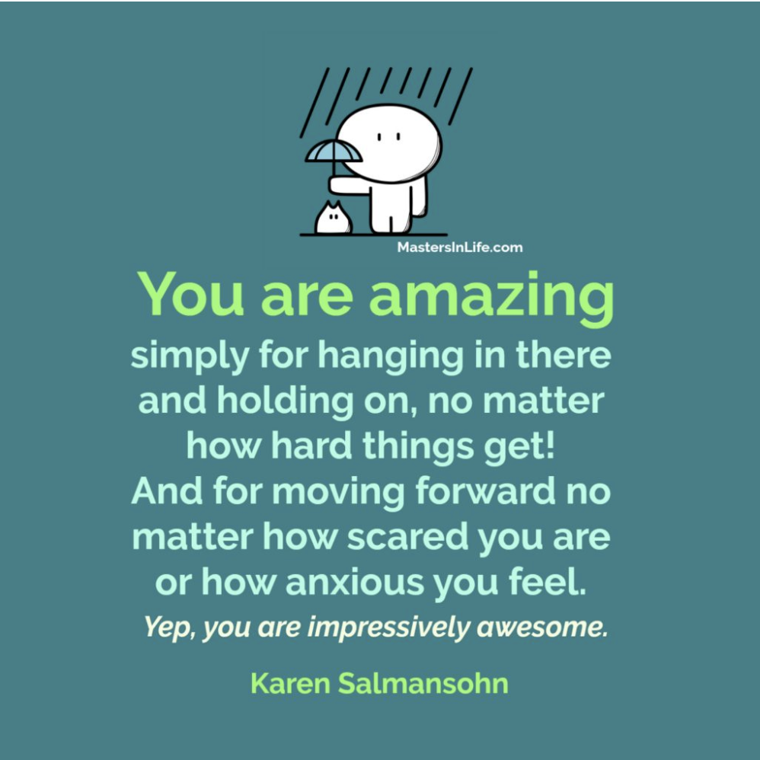

Thank You for Reading

1706862 Publications 2019

