DIGITAL SURVEYING

Ryan Evans
1910852

Essay Assignment

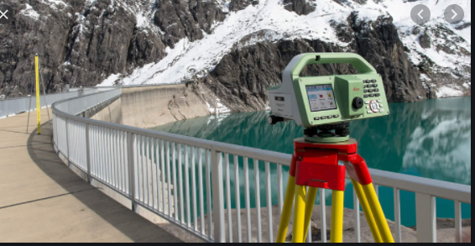

Contents Page
Page 1 – Front Cover
Page 2 – Contents Page
Page 3 – A brief history of surveying, Egypt
Page 4 – Babylon, Greece and Rome
Page 5 – Britain, Europe
Page 6 – Early 19th Century, Todays land surveying, Summary of evolution of traditional
Surveying.
Page 7 – Surveying listed buildings.
Page 8 – Planning, Field work, Tools used for surveying, conclusion.
Page 9 – References

Brief History of Surveying
The purpose of surveying is to use angles, distance, and altitudes of a lands surface to enable you to plot them onto a map accurately. It can also enable you to mark the positions of any proposed construction or engineering works to situate them accurately. It has three main elements in which it can be used for:
- Mapping and Planning
- Analysing engineering operations
- Setting out an engineering operation.
Surveying has been used for thousands of years. “The history of surveying dates back to ancient times, with a recorded land register in Egypt in 3000BC, and re-establishment of farm boundaries following floods of the Nile River and construction of the Great Pyramid of Giza recorded about the same time.” (ICSM 2021). There is a wide array of evidence showing surveying in time periods throughout history.
Egypt
The Pyramid of Giza, Egypt is of a North, South orientation and has a near-perfect square base. This is evidence to show that there was surveying that took place to achieve this. There is also evidence that the ancient Egyptians used surveying to outline boundaries. The River Nile flooded annually, and the damage caused meant that boundaries had to be re-established to outline farmland. Surveying must have been used to achieve this. The Egyptians used the human arm as a form of measuring tool. These measurements are broken down into three main categories:
- Cubit – Commonly thought of as the distance from the elbow to the tip of the fingers.
- Palm – Palm of hand
- Digits – Length of fingers
The fourth measurement used was the ‘Rod’ which was equivalent to 100 Cubits. This is shown in the image below:
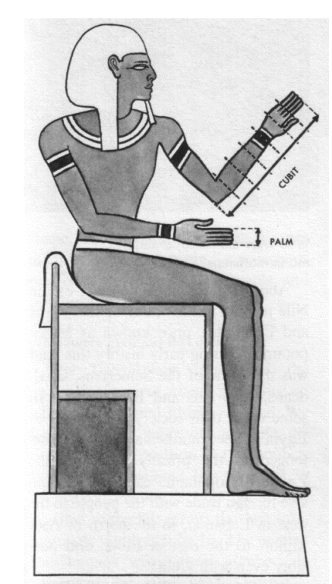
(History of Science 2017)
Obviously, this was not entirely accurate as the measurements would alter depending on who was measuring as there is no guarantee the measurements would be the same between any two people. There were three main surveying tools used in surveying by the Ancient Egyptians. These were a ‘cubit rod’ which allowed measurement over shorter distances, the ‘plumb-bob’, which was used in construction to establish a vertical reference line and “calibrated rope of 100 cubits for longer measurements” (Paulson 2005). The rope had regular knots at known distances apart to enable accurate measurements of distance.
Babylon
Babylon is where Iraq is situated nowadays. The surveying techniques that were established by the Ancient Egyptians were carried on by the Babylonians. However, the Babylonians were known to use boundary stones to mark out territory and boundaries. The stones contained information of “details of the property, the surveyor, the owner and property history” (Jurovich 2021). This was an important milestone in surveying. An image of one of these is shown below:
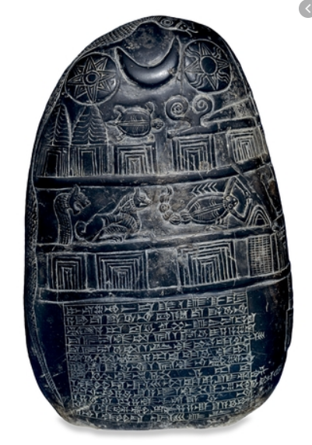
(Britishmuseum 2015)
As you can see the boundary markers contain a lot of information.
Greece and Rome
Ancient Rome developed the ‘Groma’ at around 400BC. The Groma would become a very important tool for the Romans and was used to divide the Roman Empire so that they could enforce taxation throughout. “The Romans were the first civilization to recognize land surveying as a profession, and an honourable one at that.” (G2Surveys 2019). The Groma was used to mark orthogonal alignments which would benefit the Romans in the constructions of roads, walls, and other constructions in which they became famed for. Below is an image of the ‘Groma’:
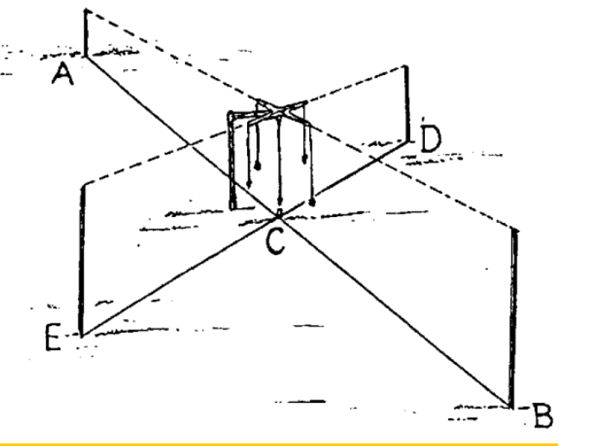(Boccalieri 2006)

Ancient Greece also had an influential role to play in the history of surveying. They were the first to use geometry and it enabled them to establish and develop accurate land separation. They were also the first to develop the ‘diopter’. “This was a portable tool that used a culmination of a cogwheel and water level to measure terrestrial and astronomical figures on a property.” (Courthousedirect 2018). It is thought to be the first piece of surveying equipment and dates back to around 120BC. It is common perception that the diopter is the bases in which the modern ‘theodolite’ was developed in more recent times.
Britain
The next important milestone in the history of land surveying was in Britain and established by William the Conqueror in 1086. William the Conqueror developed what is known as ‘the doomsday book’. The book did not contain exact locations of land boundaries but included who owned plots of land, how big the plots were, what the boundaries were and who lived there. He thought this was a way to maximise his revenues through tax and establish who could fight for him through wars. “The survey was a massive enterprise, and the record of that survey, Domesday Book, was a remarkable achievement. There is nothing like it in England until the censuses of the 19th century.” (Nationalarchives 2021)
Europe
In 1571 the first theodolite was made. The theodolite gives us the ability to establish accurate boundary lines. However, it was in the 1800s that the boundaries that were marked were put onto maps. This was when triangulation started being used to plot boundaries in Europe. The theodolite was adapted numerous times and in 1787 “Jesse Ramsden further developed the trusty theodolite by creating a tool that measured angles in planes.” (CourthouseDirect 2018). The image below shows the theodolite:
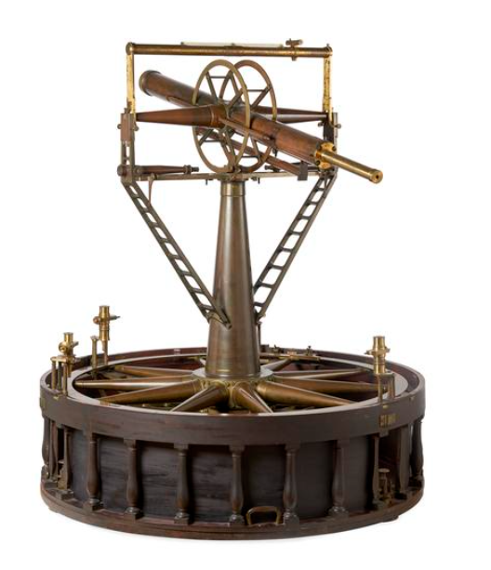
(Sciencemuseumgroup 2021)
The theodolite measures the angles of landmarks in the distance and with the use of triganomatry accurate distances can be obtained. This allows accurate maps to be formed.

Early 19th Century
During early 19th Century the industrial revolution started. This meant that there was an increase in the use of surveying as there would be more construction taking place with regards of roads and buildings etc. These would have to be very accurately completed as cities were starting to be formed. It was during this time that surveying became a profession.
Today’s Land Surveying
Today’s land surveying relies on the same methods as it has done for thousands of years. However, as technologies have improved so can carry out land surveying more accurately and efficiently. Modern technologies have seen new equipment such as laser levels, and laser scanners come into use and has allowed efficiency of land surveying to increase. Other technologies such as GPS has also allowed land surveying to become more efficient and more accurate.

Summary of the evolution of traditional surveying
Pacing
Pacing is a very basic form of measuring distance. One step would count as one measurement. It is usually used when measuring distances between two objects. However, everyone’s pace would be different as people walk differently and have different size legs etc. it is also very difficult to keep every pace consistent due to differences in terrain and if objects obstruct your path.
Surveyors Chain
The surveyor’s chain is exactly twenty-two yards long. It consists of one hundred solid links that enable easy measurement. When the chain is outstretched, the links can be counted, and the distance can be measured. Ten chains are the equivalent to exactly one acre.
Surveyor’s tape
Surveyors originally used metal measuring tapes that were solid and different lengths. The longer lengths were used for flat, open spaces and smaller tapes were used for inclines. Skilled surveyors were able to achieve very accurate measurements using these techniques.
Compass
“An instrument used by surveyors for measuring horizontal angles and for determining the magnetic bearing of a line of sight; consists of a pivoted magnetic needle, a graduated horizontal circle, and a sighting device.” (Encyclopedia2 2021)
Plumb bob and Line
The plumb bob and line is a triangular fixture with a weight hanging from the apex with a weight attached. The concept of the plumb bob and line is to allow you to establish a perfectly vertical reference line. Obviously, this is essential in construction and has been widely used throughout history with evidence of it being used in surveying by the Ancient Egypt.
Plane Table
“Plane table surveying is a quick way to scope the layout of a job site. And with this method, you can plot a plan and make field observations at the same time. It can be useful in the following situations:

You need to perform small-scale surveying, like mapping out a field.
You need to survey an industrial area where a compass survey does not get any result.
You need to fill in details between survey stations that are fixed by a triangulation or theodolite traversing method.
Plane table surveying is usually for cases where a high degree of precision isn’t needed, and it’s primarily used for small-scale or medium-scale mapping.” (Engineerssupply 2021)

Surveying Listed Buildings
There are three types of listed building classifications. These are Grade I, Grade II* and grade II. The majority of listed buildings are Grade II and 91.7% of listed buildings are in fact Grade II. There are four main reasons for carrying out surveys on listed buildings:
- Fulfilment of building legislation
- Retrofit Plan
- Detailed plan of building
- As-existing conditions.
Obviously when a survey is carried out it is important to get an accurate and detailed description of the state of the building in question and in the case of listed buildings it is important to note if any alterations or maintenance have taken place and if so, what materials were used. The survey of a listed building is a very long process, and an in-depth analysis of the building is required. There are five main segments of the process. These are listed below:
Planning
Planning is an integral part of surveying listed buildings. It is essential that you gather as much information on a listed building as possible before even turning up on site to carry out the survey. It is important to source any as-built drawings of the building to get a knowledge of what the building looked like when built and if it is the same layout when you turn up on it. An asbestos register would also be an important piece of information as it provides the surveyor with key information of the location of any asbestos in these buildings in case construction work is due to take place. As listed buildings are typically historic there is a high percentage chance that asbestos has been used at some point in that buildings history whilst carrying out maintenance or repairs. Another key source of information would be if there have been any previous planning applications for construction work to be carried out on the building and if granted, whether it has been signed off as being in accordance with the Building Regulations. Again, as listed buildings are typically historic buildings, Health and Safety is of key importance before entering a building. These buildings could be in seriously bad condition and if a surveyor is given access, it is essential that a risk assessment has been carried out to ensure the level of risk to the surveyor is kept to a minimum. Very often, listed buildings are in such bad condition that surveyors are not given access to carry out a survey.
Field Work
When your information is gathered and health and safety requirements are met, a surveyor can enter a property to carry out a survey. The level of detail needed is very high. Before the survey takes place, you should ensure that as much information is gathered as possible. You should try to establish when the build was constructed, the layout, the elevation, even drainage systems. All this information can be used to get a good idea of the building before arrival.
When all information is gathered a site visit should be completed. According to ‘NPAHeritage’ there are four main concerns to look for when carrying out a survey:
- “Structural problems
- Damp
- Timber decay.
- Problems requiring immediate or substantial financial investment.” (NPAHertiage 2021)
It is important to get as much detail on the walls, floors, ceilings, roofs and drains as possible when completing the survey. It is important to check for any damage, try to find out the materials used and if it needs repairs.

Reports
When all the field work is complete a report must be written up with the results. It is important that the report is in ABC format and is easy to follow and understand.

Tools used for Surveying listed buildings.
The basics

When carrying out a survey there are basics ‘tools’ that are needed. You must ensure all relative PPE is worn such as hi-vis vests, hard hats, safety boots etc. Obviously, you will need a notebook to mark down your results. A ladder is essential and basic tools such as screwdrivers can also be used to do a more intrusive survey.

Other important equipment.
In modern day surveying, technology has improved the efficiency and accuracy of the information gathered by the surveyor. Laser measuring tapes can be used to measure distances of objects throughout the building. This is much faster and much more accurate than using traditional measuring tapes. Thermal cameras can also be used during a survey. These can be very beneficial in detecting where heat loss is most prominent in a build. Moisture detectors are also very beneficial in diagnosing any damp spots in a build.

Conclusion
Surveying has been around for thousands of years. The key aspects of surveying have stayed with us from the times of Ancient Egypt. Surveying has been of huge importance through the years and has been used in land boundaries being formed to establishing the state of any builds that are surveyed today. The introduction of new technologies has improved the standard of surveying greatly and more accurate and efficient surveys are now able to be carried out. Laser technology has allowed non-intrusive surveying to take place and again, the accuracy of measurements etc has improved greatly. Surveying will always be an important part of the construction industry and it will be interesting to see how new technology will benefit it in the future.

References
Boccalieri, E (2006) How to use the Roman Groma.
Available at: How to use the Roman groma | De Legione Romana
Accessed 17th April 2021.
British Museum (2015) Ancient to medieval (and slightly later history)
Available at: https://archaicwonder.tumblr.com/post/112447397831/kassite-kudurru-boundary-stone-c-1125-1100-bc
Accessed: 16th April 2021
CourthouseDirect (2018) The history of land surveying
Available at: The History of Land Surveying (courthousedirect.com)
Accessed: 17th April 2021
Encyclopedia2 (2021) Independent damp surveyors
Available at: Surveyor's compass | Article about surveyor's compass by The Free Dictionary
Accessed: 23rd April 2021
EngineersSupply (2021) What is a plane table?
Available at: Survey Equipment – Plane Table Surveying | Engineering Supply - EngineerSupply
Accessed: 22nd April 2021
G2Surveys (2019) Land Surveying in Ancient Times
Available at: Land surveying in ancient times (g2surveys.co.za)
Accessed: 17th April 2021
History of science (2017) Egyptians standard measure of length
Available at: HISTORY OF SCIENCE: Egyptians standard measure of length (historyofsciences.blogspot.com)
Accessed: 15th April 2021
ICSM (2021) Evolution of surveying and surveying technology
Available at: Evolution of surveying and surveying technology | Intergovernmental Committee on Surveying and Mapping (icsm.gov.au)
Accessed: 15th April 2021
Jurovich Surveyors (2021) Short history of land surveying
Available at: Short History of Land Surveying | Jurovich Surveying Perth
Accessed: 16th April 2021
NPAHeritage (2021) Listed Building Surveys
Available at: Listed Building Survey - Listed Building Surveyors | Historic Surveys (npaheritage.com)
Accessed: 23rd April 2021
The National Archives (2021) Discover Doomsday
Available at: Domesday Book | Discover Domesday (nationalarchives.gov.uk)
Accessed: 22nd April 2021
Paulson, J (2005) Surveying in Ancient Egypt
Available at: Microsoft Word - wshs02_02_paulson.doc (fig.net)
Accessed: 15th April 2021
ScienceMuseamGroup (2021) Theodolite used for the principal triangulation of Great Britain.
Available at: Theodolite used for the Principal Triangulation of Great Britain | Science Museum Group Collection
Accessed: 22nd April 2021

