

Paryse Natalie Samuels
Student Number: 2222670
BA (Hons) Business Law
University Of Wales Trinity Saint David
Date Of Submission: 05/12/2025
Word Count:7,554

“Are managers equipped to lead?”
An investigation into employee relations, emotional intelligence, and behavioural ethics
Abstract
This study examines whether managers in major British organisations are sufficiently trained to lead ethically and emotionally intelligently, and whether present managerial actions appropriately support employee wellness, communication, trust, and overall work satisfaction. Analysis shows that the ethical capacity of managers is a crucial societal issue in current work environments due to the growing demands for moral accountability, particularly transparency when focusing on employees. Drawing upon literature that contrasts traditional leadership models with modern ethical and emotionally intelligent approaches, the study finds that despite the evolution of leadership theory, many British employees continue to experience various issues such as inconsistent managerial behaviour, a lack of empathy, and insufficient conflict resolution skills. A qualitative study undertaken by employed individuals shows their views of managerial ethics and emotional intelligence

Declarations
This work has not previously been accepted in substance for any degree and is not being concurrently submitted in candidature for any degree.
STATEMENT 1
This dissertation is being submitted in partial fulfilment of the requirements for the degree of BA/BSc.
STATEMENT 2
This dissertation is the result of my own independent work/investigation, except where otherwise stated.
Other sources are acknowledged in the Reference Section.
STATEMENT 3
I hereby give consent for my dissertation, if accepted, to be available for photocopying and for interlibrary loan, and for the title and summary to be made available to outside organisations.
STATEMENT 4
I hereby give consent for my dissertation, if accepted, to be available on the university’s IT system to those who have consent to use the system.

Student’s Name: Paryse Natalie Samuels

Signed: paryse samuels

Date: 05/12/2025

Table of Contents

Introduction chapter 1
Research aims and objectives 2
Scope of the study 3
Literature review 4
Methods 5
Research Findings 6
Discussion 7
Conclusion 8
Bibliography 9

Introduction chapter

Leadership within contemporary businesses over the course of time has undergone substantial development, as management progresses, individuals in position of authority are increasingly required to display traits associated with emotional intelligence, ethical judgement, and stronger interpersonal abilities towards employees in addition to traditional workload tasks. Traditionally, managerial responsibilities were characterised by authority, work distribution, and operational control, reflecting classical models that prioritised productivity and uniformity (Nicolescu and Nicolescu, 2025). Although these methods provided structural clarity, they frequently ignore the emotional and relational aspects of leadership that are of significance, particularly in today’s work environment.

The organisational settings today can be more complex, changing, and psychologically demanding for employees in comparison to the past. According to research, trust, employee well-being, and organisational leadership practices are all significantly impacted by ethical leadership and focus on overall employee ethics contributes to an increase in a positive and more productive working environment, (Sookdawoor and Grobler, 2022). The relevance of leader behaviour is evident and further underscored in sectors such as retail, where poor leadership practices and career discontent have been related to unpleasant working experiences and reduced employee engagement, (Whysall, Foster, and Harris, 2009).

Furthermore, previous leadership was frequently seen as a position of power rather than a moral and ethical obligation. However, contemporary workplaces demand managers to traverse complicated interpersonal relationships, display emotional intelligence, and support ethical values that promote employee health (Miao, Humphrey, and Qian, 2021). Despite this development, many employees continue to report feeling underpaid, neglected, or unfairly treated. Management Today’s collaborative report with the Institute of Leadership & Management found that 50% of UK employees believe their organisation prioritises profit over people, suggesting that ethical responsibility is still not embedded consistently within managerial culture (Sookdawoor & Grobler, 2022). This suggests that British employees feel as though they are overlooked, particularly believing that their business prioritises profit over their employees, therefore showing that social ethical responsibility can still often be neglected. This contributes to the main issue that drives this research: are managers genuinely capable of leading in an ethical and responsible manner, or do organisational pressures promote actions that compromise the rights and experiences of employees?

The research challenge is further strengthened by evidence that employee disputes typically go undetected. Fleming, (2024) states that job discontent within British retail contexts usually originates from emotional reactions to interpersonal interactions, perceived unfairness, and workplace demands. When managerial actions fail to address these challenges, employees may disengage, resulting in reduced productivity, increased turnover intentions, and diminished trust. Contemporary British survey results also stress the need for emotionally intelligent leadership, with studies demonstrating that emotional intelligence based managerial behaviour corresponds highly with enhanced morale and communication (Sarwar et al., 2020). However, it is still unclear how much emotional intelligence and ethical consciousness managers now possess to properly manage these issues.

The scrutiny of leadership quality has increased due to several factors, such as changing employee expectations, growing concerns on mental health and well-being, and importantly unethical behaviour. Research establishes that in the year of 2022-2023, a number of 875,000 employees un the UK experienced stress related to their career, as well as mental health factors such as anxiety and depression, which thus in turn resulted in 17.1 million lost working days, (Mental Health Foundation, 2023). These concerns demonstrate the need for studies that examine how well managerial actions promote fairness and improved employee morale.

Emotional intelligence has evolved as a significant component of current leadership theory because it enables managers to identify emotional cues, regulate their emotions, and handle conflict empathetically (Morrissey, 2024). The capacity to emotionally connect with people is increasingly seen as an essential managerial skill rather than an optional addition in workplaces marked by cultural diversity, hybrid working methods, and increased stress. Research also reveals that leaders with high emotional intelligence are better equipped to address mental health difficulties, manage disagreements impartially, and promote psychologically safe working settings (Rachmad, 2022). However, the expectations of today's workforce may not be met by traditional leadership styles, especially those that emphasise transactional control or hierarchical authority. This raises the question of whether managers receive sufficient development and training.

Research aims and objectives

To investigate how emotionally intelligent and ethical leadership methods influence relationships between employees and managers in significant British organisations, particularly on communication, job satisfaction, and workplace performance.

Objectives
Objective 1. To compare the ethical and emotionally intelligent leadership strategies employed in modern businesses to traditional managerial techniques.
Objective 2. To obtain and examine employee viewpoints on how various leadership practices influence
interactions and experiences at work using an anonymous survey.
Objective 3. To assess the impact of present leadership development and training programs and determine how they might be enhanced to better support moral and people-centred management.

Scope of the study

This research studies methods for leadership within large UK-based businesses across multiple industries to capture individual employee experiences. The study examines conventional and contemporary leadership theories, emotional intelligence, workplace ethics, and employee attitudes using an anonymous qualitative survey among individuals who are presently or recently employed. Due to limitations, managerial interviews, small firms, and multinational organisations are excluded. This research is justified since employee experiences directly affect morale, turnover and performance, and concerns about unethical leadership have escalated, with UK reports emphasising toxic cultures and insufficient accountability (The Guardian, 2021). Although emotional intelligence is becoming a growing necessity in leadership development, there fails to be ample evidence from the UK that demonstrates how well these abilities are used in everyday circumstances. By exploring whether managers possess the ethical awareness and emotional competency necessary in modern settings, the research tackles a critical question: Are contemporary leaders assisting employees, or do present managerial actions fall short of today’s ethical and ethical demands?

Literature review

2.1 objective 1: Compare contemporary ethical and emotionally intelligent leadership approaches with traditional leadership models in modern UK workplaces.

Traditional leadership theories such as trait theory, authoritarian models and transaction centred leadership were formed during periods where organisational hierarchies were rigorous, male dominated working environments and often employee wellness was mostly disregarded, (Northouse, 2021). According to trait theory, leaders are “born, not made,” depending on intrinsic traits such as self-assurance, confidence, or decisiveness. Transactional leadership on the other hand, places a strong emphasis on systems of reward, punishment, control, and compliance (Bass, 1985).

Initial research by Burns (1978) described transactional leadership as a paradigm where people carry out orders under clear hierarchies. These models have been extensively utilised in a variety of UK industries, such as retail, logistics and hospitality, especially where command chains and organised procedures are crucial (Hucynski and Buchanan, (2020). However, critics suggest that conventional models ignore cultural variances, personal feelings, and contemporary demands for participative leadership (Yukl, 2019). Although these methods encourage productivity, they often fail to support wellness or trust which is two crucial components of contemporary employee happiness. Thus, it can appear to be shown that leadership frameworks that incorporate ethical and emotional intelligence have been made possible due to evolving from the shortcomings of previous models.

There are multiple core principles that management can utilise in relation to ethical moral behaviour, these traits are often; trust, communication honesty, and transparency, which are all highlighted by ethical leadership (Brown & Treviño, 2006). The expanding importance correlates with widespread concerns about corporate misbehaviour, with numerous UK cases involving unethical executive behaviour (The Guardian, 2023). Ethical leadership theory implies leaders impact workplace conduct through role modelling and values-driven decision making (Treviño et al., 2014). The importance of ethical leadership is that it necessitates transparency and shared moral responsibility, in contrast to authoritarian methods. However, researchers say certain organisations practice “ethics washing,” when ethics appear in policy documents but are not enacted (Greenwood & van Buren, 2017). Systems that prioritise performance over integrity cannot encourage ethical leadership, Therefore, the need to examine whether managers are genuinely equipped to lead ethically is supported by the discrepancy between ethical expectations and practice.

The definition of emotional intelligence refers to detecting and managing emotions in both one and other people (Mayer, Caruso & Salovey, 2016). In relation to the working environment with diverse teams, hybrid work, and growing mental health problems, its significance over time has increased. Goleman’s emotional intelligence model (1995) identifies self-awareness, self-regulation, motivation, empathy, and social skills as important components. Research shows that conflict is lessened and the work environment is improved by leaders with higher levels of emotional intelligence (Schute and Loi, p.47., 2014). Therefore, by prioritising measures that incorporate emotional intelligence practices, employees are needs are met with. On the hand, studies show that leaders with lower levels of this capability may behave unpredictably or insensitively, undermining morale (Prentice et al., 2020) Scholars claim that emotional intelligence is difficult to assess reliably. Despite these limits however, EI is an essential leadership skill, yet studies show that many managers lack it.

The traditional methods of emotionally intelligent practices used with in the twentieth century are often contextualised as aiming to provide employees with social, practical, and personal intelligence practices (Salovey, Mayer, and Caruso, 2004). These practices were typically focused on teamwork, communication, and people skills. The outcome of this research provides specific tests applied in this previous day of age, which resulted in the Mayer-Salovey-Caruso emotional intelligence test (MSCEIT) to measure intelligence approaches used with businesspeople (leaders) as well as educators. The test itself was introduced in 2002; however, it was developed in 1997 from the ability model of emotional intelligence. It was used to assess business professionals' ability to identify emotional cues, use emotions to solve problems, decipher emotional complexities, and control their own and other people's emotions amongst employees (Maul, 2012). This was considered a breakthrough as it aids in determining leadership, decision-making, and people skills strengths and areas for improvement that are still used in training in this modern century. The model consists of four additional specialist skills: (1) the capacity for precise perception, evaluation, and expression of emotion (3) the capacity to comprehend emotion and emotional knowledge ("perceiving emotions"); (2) the capacity to access and/or produce feelings when they support thought ("using emotions," also known as "emotional facilitation of thought"); (4) the capacity to control emotions in order to encourage emotional and intellectual development ("managing emotions"), (Maul, 2012).

The test itself was thought to strengthen decision making skills through emotional intelligence with in, in this instance, business leaders and their employees. Employers that used this model and scored highly were thought to be better at managing stress amongst employees, by using emotional perception and conflict resolution in the workplace (Druskat, Mount, and Sala, 2013). The approach has been used in businesses such as Johnson and Johnson’s consumer and personal care group by generally balancing emotional skills with organisational goals, such as being employed by a business to assess managers' capacity to recognise and control their emotions in high-stress scenarios, including project deadlines or corporate deadlines, (Druskat, Mount, and Sala, 2013). In addition to this method, other businesses also incorporated methods to support empowerment through employees; for example, British Petroleum (BP) promoted employee empowerment through programs like "Project 1990" and established flatter structures of management and fewer managerial tiers in the 1990s. This change was made to speed up decision making and encourage more direct interaction from staff members at all levels. Although these conceptual theories were previously adapted, it can be criticised that these methods of emotional intelligence are not at the same level of depth that modern ones are, therefore providing evidence that a requirement of more practices that positively impact employees is evident in large businesses.

Compared to earlier methods, contemporary ethical leadership techniques have made considerable progress, placing an emphasis on sustainability, openness, and inclusivity. Laasch (2021) explains in Principles of Management that modern leadership incorporates ethics, responsibility, and sustainability at its foundation, bringing business procedures into line with social ideals, choosing profit maximisation and immediate advantages, sometimes at the expense of ethical issues, was the main focus of twentieth century leadership styles, which were frequently distinguished by an upward structure of hierarchy. Leaders were more inclined to take a transactional approach, giving performance and employee compliance importance over moral conduct or long-term social consequences, (Rachmad, 2022). The move toward transformational leadership, which promotes empowerment, moral decision making, and building trust within teams, is one notable advancement in contemporary leadership approaches. Today's leaders must be emotionally intelligent, actively listen to their staff, and make choices that will benefit the company and society overall (Muff, Delacoste, and Dyllick, 2022).

This contrasts with earlier models that frequently valued efficiency and financial performance over the welfare of employees. Furthermore, the concepts of sustainability and corporate social responsibility (CSR) are integrated into contemporary ethical leadership. Businesses are being held increasingly responsible for their social contributions, environmental effects, and moral business practices. For instance, CEOs are now expected to actively promote good change rather than merely comply with rules and regulations by promoting diversity, ensuring fair labour standards, and prioritising sustainability (Laasch, 2021). On the other hand, previous methods frequently prioritised profits over wider societal concerns. Despite advancements, there are still issues with how ethics and sustainability are integrated into leadership. In complicated global settings, making ethical decisions frequently involves balancing competing interests, and some leaders may still find it difficult to match their financial goals with their wider societal obligations, (Cropanzano and Mitchell 2005). Modern procedures, however, represent a significant advancement that promotes social trust and long-term business wellbeing for employees.

Objective 2: To obtain and examine employee viewpoints on how various leadership practices influence interactions and experiences at work using an anonymous survey.

The analysis of key employee concerns to support survey research

To enhance group and organisational performance, organisations must focus on the root causes of conflicts and address those issues. Disagreements or differing objectives that might have negative effects on those concerned are referred to as confrontations. Two familiar challenges that employees raise with their management involving leadership are mental health and wellbeing concerns as well as conflict resolution amongst other employees, (Winardi, Prentice, and weaven, 2022). Furthermore, research suggests that conflict resolution in relation to group functioning can be severely harmed by ongoing relationship conflicts, particularly when those conflicts are negative, trivial, and hostile (Winardi, Prentice and weaven, 2022). For instance, if members of the group disagree on projects, they will resent other participants and link this task related disagreement to personality problems, which is why it is of importance to manage this common issue effectively.

Consequently, research states that to resolve issues such as this, it is vital to promote active communication, as it promotes an open discussion in which all participants are free to voice their opinions without interference, (Bhakuni, rana, and Bhanot, p.97, 2024). This method helps people focus on topics rather than individuals and helps to clear up misunderstandings. In addition to this, it is important to consider all pathways of conflict resolution that emerge amongst workplaces, which is why facilitating mediation with an unbiased third party to identify similar attitudes and differences and come to a compromise as well as encouraging workplace members to train in emotional intelligence courses will allow them to empathise with others and manage emotions effectively (Liddle, 2023). Mental health is also a significant challenge; however, the offer of crisis support, mental health resources, and private counselling service initiatives assists staff members in successfully resolving personal and professional issues. Availability of Resources for Mental Health where employees can readily seek assistance if therapists are available on-site or virtually, if mental health apps (like Headspace or Calm) have funding, or if mental health hotlines are available, as well as candid dialogue with regular check ins, (World Health Organisation, 2022).

The issues of mental health and conflict resolution have been approached by management in different but complementary ways. Interpersonal dynamics, encouraging cooperation through active communication, and mediation are the main focuses of conflict resolution techniques. To reduce long term group dysfunction, these strategies emphasise candid conversations that assist teams in concentrating on work rather than personal complaints (Winardi, Prentice, and Weaven, 2022). By addressing the underlying causes of conflicts, tools such as emotional intelligence training help employees negotiate interpersonal issues with empathy. On the other hand, mental health interventions use systemic assistance to address individual well-being. Both personal and professional difficulties are addressed by programs like mental health apps, counsellor access, and employee assistance programs. These Regular check ins and flexible work schedules help employees become more resilient to stress and burnout (World Health Organisation, 2022). Although one strategy focuses on group harmony and the other on individual stability, both strategies seek to create a positive work environment.

Objective 3: To assess the impact of present leadership development and training programs and determine how they might be enhanced to better support moral and people-centred management.

Numerous studies have examined how well emotional intelligence management techniques may develop good leadership, with professionals highlighting how they can encourage employee engagement, teamwork, and organisational success. In the Handbook of Research on Employee Voice, Wilkinson et al. (2020) draw attention to the crucial relationship between emotional intelligence and leadership, arguing that EI practices improve leader's capacity to identify, understand, and control emotions both their own and those of others thereby building a healthy work environment. Strong emotional intelligence in leadership enables leaders to function as sympathetic facilitators by addressing fundamental issues like employee discontent and disengagement. Employee voice is a critical component of organisational performance, and leaders with high emotional intelligence are adept at hearing their concerns, resolving disputes, and building trust. According to Priya et al., (2025), companies with emotional intelligence trained executives are more likely to maintain inclusive workplaces where staff members are respected and feel heard.

Consequently, this enhances dedication and output. However, Rivers et al. (2020) suggests how well emotional intelligence methods are implemented and how it also affects how effective they are. For example, context sensitive, evidence-based leadership development in emotional intelligence should be tailored to the needs of individual organisations. Even though instruments like the Mayer-Salovey-Caruso Emotional Intelligence Test and the MSCEIT have been used, their use needs to go beyond measurement to promote significant behavioural changes. According to Wilkinson et al. (2020), if superficial EI techniques are not combined with more comprehensive frameworks for leadership development, they might not yield long term advantages. The format of the emotional intelligence test is particularly effective at helping leaders become more self-aware. According to Rivers et al. (2020), leaders can react to workplace issues more intelligently if they have a better grasp of how they feel and control their emotions. For instance, leaders might modify their management and communication approaches to create a more peaceful workplace by identifying stressors or interpersonal issues. This increased self-awareness acts as a stimulant for behavioural shifts, pushing leaders to take more inclusive, constructive, and sympathetic stances.
Additionally, the MSCEIT and emotional intelligence test encourage the growth of people skills that are necessary for successful leadership. It improves leaders’ capacity to settle disputes and inspire groups by teaching them how to effectively read emotional cues and control interpersonal dynamics. According to Rivers et al. (2020), these enhancements are consistent with transformative leadership. Although these benefits are effective, emotional intelligence-based leadership practices can have faults. The issues addressed by Wilkinson et al. (2020) show that the hazards of relying too much on emotional intelligence tests or the possibility that leaders might misuse them to manipulate others may be a concern. However, these approaches support combining emotional intelligence with moral leadership values and ongoing professional growth to combat these problems.

Contemporary solutions in large UK companies could be enhanced by two strategies: personalised employee support and digital platforms for employee feedback. Each strategy has its own advantages and disadvantages, but they both centre on improving communication, attending to individual needs, and creating a positive work atmosphere. Evaluation platforms and other AI-powered digital technologies are being used increasingly to examine conflicts and keep a focus on staff satisfaction. Since these solutions offer immediate feedback, businesses can respond quickly to problems. Digital feedback systems can assess employee mood on a broad scale and spot trends or early indicators of discontent or disengagement, (Budhwar et al., 2022). By doing this, they enable managers to resolve issues before they become more serious disputes that could have a negative effect on morale and productivity. By doing so the benefits are of many, such as immediate conflict detection tools enable prompt reactions to potential problems by giving instant insights into the emotional and mental states of employees (Budhwar et al., 2022).

Additionally, anonymity and openness compared to more conventional face to face contacts, allow employees to feel more at ease voicing their issues via digital channels, which can result in more truthful and honest responses. Data driven decisions also Use real-time data, and managers can develop solutions and make evidence-based decisions to oversee problems more successfully, (Gallo et al., 2022). Alternatively, privacy issues where the constant use of tracking employees’ opinions raises concerns about data ethics and privacy. Constant surveillance may make employees uneasy, which could reduce management's legitimacy, as well as the issue of lack of nuance, because although AI systems are capable of identifying patterns, they might not be able to pick up on the emotional nuances of human interaction, which could lead to misunderstandings about conflicts or the failure to recognize personal dynamics that call for personal involvement as it is more personal (Budhwar et al., 2022).

On the other hand, Meske and Junglas (2021), calls attention to the fact that employees are increasingly looking for an individual approach that tackles their unique problems, particularly in remote or hybrid work. Businesses could use this approach to show their dedication to the welfare of their employees by offering tailored support, which promotes trust and sustained engagement. The benefit of using this approach is of many, Enhanced Staff engagement when workers receive individualised help that meets their specific requirements, they may feel appreciated and supported, which can result in increased job satisfaction. Additionally, talent preservation is a benefit as well Since workers are more inclined to stick with companies that support their professional and personal growth, providing individualised support can help draw in and keep hardworking employees (Meske and Junglas (2021). Nevertheless, downfalls of these modern approaches are that it can be expensive and time-consuming to provide individualised help, especially for bigger businesses that must serve varied personnel, (Simons, 2002). Additionally, if certain employees receive more attention than others, individual support may unintentionally give the impression that someone is being treated unfairly or with partiality if it is not handled appropriately.

Methods

Approach of research
This dissertation will use a qualitative research approach by use of an anonymous, open-ended survey to investigate how employees in large scale British businesses perceive management ethics, emotional intelligence, and leadership potential. Because the research seeks to comprehend individual experiences, contextual significance, and subjective perceptions of workplace leadership aspects that cannot be adequately captured by numerical data alone a qualitative approach was used. Participants can communicate how managerial practices affect their emotional well-being, trust, engagement, and sense of fairness using qualitative research, which prioritises depth and detail, (Taherdoost, 2022).

The choice of a qualitative survey is consistent with the more general framework of research on emotional intelligence and leadership. Research shows that emotionally intelligent leadership has an impact on workplace cohesion, employee empowerment, and conflict resolution (Gaya et al., 2025). Open-ended personal narratives are the most effective way to examine these intricate interpersonal processes. Furthermore, the qualitative approach enhances the study's capacity to examine whether managers successfully implement emotional and ethical practices in actual workplace contexts, since emotional intelligence research frequently depends on personal descriptions of interpersonal interactions (Efrat and Zait, 2024).

The study's goal is to investigate "whether managers are adequately equipped to lead," this strategy is particularly appropriate. This entails figuring out organisational procedures, attitudes, and behavioural patterns that either help or impede effective leadership. This qualitative design allows for the inductive emergence of new, unexpected topics, in contrast to quantitative research that evaluate predefined variables. Given the dynamic nature of workplace ethics, digital feedback technology, and the shifting expectations that employees have of managerial behaviour, this is crucial (Walker, 2024).

Data sampling strategy

Participants that fit the study's inclusion criteria will be found using a purposive sampling technique. Participants must be at least eighteen years old, have experience working with managers, and be employed in a sizable UK-based company either recently or currently. Because the study calls for participants who have firsthand experience with workplace leadership, purposeful sampling is suitable. Purposive sampling guarantees that the responses collected will meaningfully reflect leadership interactions, (Ahmad and Wilkins, 2025), whereas collecting data from a random sample may include people whose experiences are irrelevant to the research aims.

Research tools and materials

The process of gathering and preparing data will be aided by a few methods. The survey responses will be created, distributed, and safely stored using Microsoft Forms. After data collection, it will be exported into analysis preparation. Responses will be systematically organised, and the results will be arranged according to a quantitative analysis template. These technologies are accessible, affordable, and useful for replication by other researchers, and they are suitable for quantitative research.

Methods of data analysis

Descriptive statistical techniques will be used to assess the quantitative responses when data collection is finished. Recurrent counts, percentage distributions, mean scores for Likert-scale questions, and comparative patterns between other categories will all be components of this. Measurable patterns in emotional intelligence, fairness, communication, support, and ethical leadership can be found attributed to the survey's structured form, which facilitates numerical analysis, (south et al., 2022).
Next, the dataset will be cleaned to eliminate any incomplete or inaccurate submissions. After that, the questions will be grouped into thematic categories including communication, ethics, emotional intelligence, and conflict resolution. The data's distribution patterns and central tendencies will be summarised using descriptive statistics. Tables or charts will be used to properly display the results, making interpretation simple.
Likert scales will be given numerical values and closed-ended responses will be quantitatively coded before analysis. This coding procedure makes it possible to compare responses objectively and consistently. To ensure that the results accurately reflect participant replies, coding will be directly guided by the survey's format rather than by pre-existing hypotheses. Numerical data patterns will assist show broad trends in employee perceptions because leadership experiences differ amongst businesses.

Ethical considerations
Given that individuals may reflect on stress, conflict, or unfavourable interactions at work, ethical considerations are crucial. The study will adhere to university ethical standards and the principles under the Data protection act (2018). Before starting the survey, participants will be fully informed about the objective of the study, that participation is voluntary, and how their data will be used. By choosing an agreement option on the first page, they will give their informed permission.
By making sure that no names, job titles, organisation names, or email addresses are gathered, anonymity will be maintained. Password-protected, university-approved systems will be used to securely store all data. At any time prior to submission, participants will have the option to withdraw by leaving the survey. Additionally, they will be reminded to only respond to questions they feel comfortable answering and to avoid naming any individuals or businesses. These ethical precautions guarantee adherence to study guidelines and safeguard the welfare of participants.

Rationale of methods
The use of this methodology has multiple strengths of it use, including the capacity to identify statistical trends in leadership perceptions, the increased transparency of participants because of anonymity, the relevance guaranteed by purposeful sampling, and the lucidity of the quantitative analysis. Additionally, participants from all around the UK can access the online format. The absence of follow-up questions, the potential for self-selection bias, and the incapacity to generalise results to all UK organisations are some of the drawbacks. Even with closed-ended questions, responses might differ in depth, and comparisons between other industries or jobs are limited by the lack of demographic data. When interpreting the results, these restrictions will be noted, (Pereira, 2023).

Research Findings

Participant demographic

Figure 1
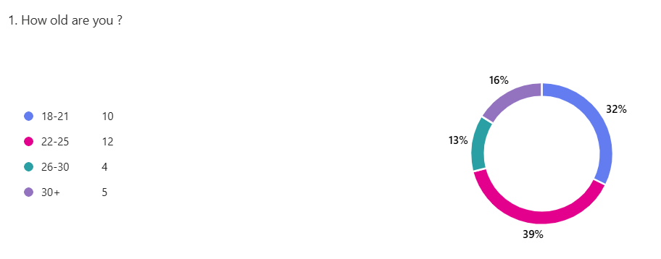

The greatest number of respondents were in the 18-25 age range, with lesser percentages in the 26-30 and 30 plus range. This suggests that the sample was primarily young and employed

Career sector experience

Figure 2

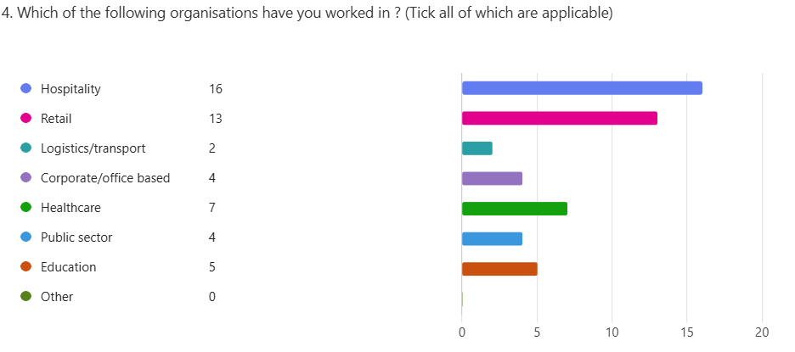
The majority of participants reported having worked in retail and hospitality, followed by positions in the public sector and healthcare, indicating that the results mostly represent service-based work contexts.

Measurements of interaction with leaders/management

Figure 3
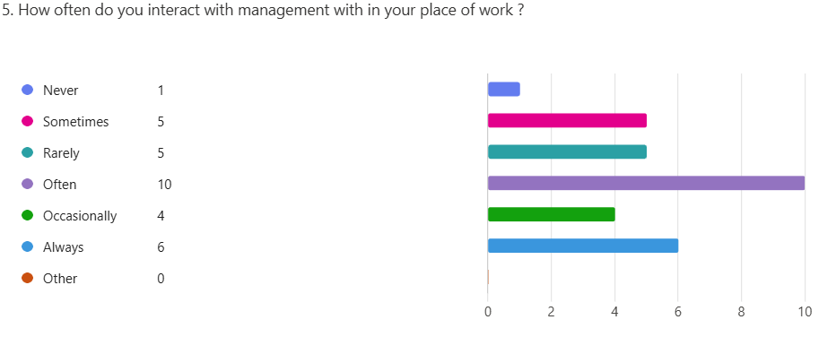
The vast majority of respondents said they frequently or always interacted with management, suggesting that participants were regularly exposed to managerial behaviour.

Emotional intelligence in leadership

Figure 4 – empathy shown by managers Q6 : “managers present empathy when employees are struggling”
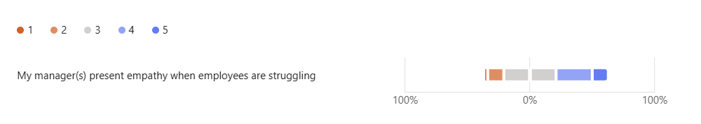

The findings reveal conflicting opinions about empathy, with a sizable minority reporting low levels of management empathy and many respondents choosing mid-to-high rates.

Figure 5- manager’s self awareness

Figure 5 Q7 “managers demonstrate self awareness at work”

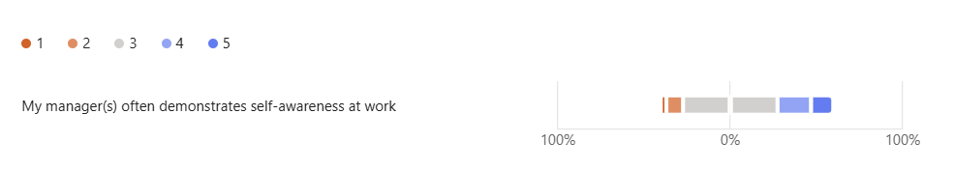

Although higher evaluations were more prevalent, responses were distributed across the scale, indicating that numerous employees believe their managers possess some degree of self-awareness.

“positive examples of emotional intelligence”

Figure 6
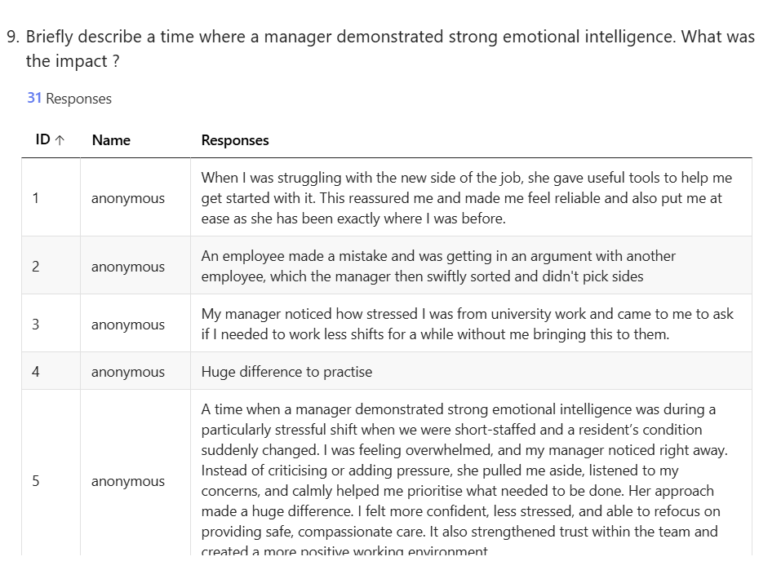
Emotionally intelligent leadership is present but inconsistent, as evidenced by the examples provided by participants, including emotional support, dispute resolution, time off for mental health, and reassurance during stressful situations.

Figure 7- lack of emotional intelligence and the impact on employees

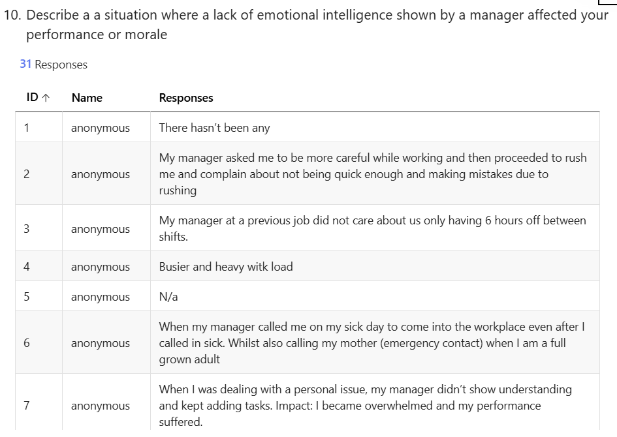

Shouting, a lack of empathy during illness, severe workload pressure, and poor emotional regulation from management were among the unpleasant experiences reported by many respondents, which they connected to lower morale and more stress.

Ethical leadership and fairness

Figure 8- unethical managerial behaviour , Q 14: “ have you experienced unethical behaviour by management?

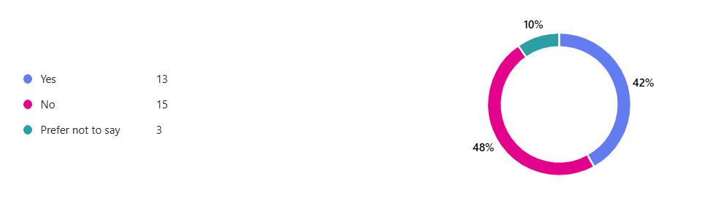
A divide across workplaces was evident as over half of respondents said they had encountered unethical managerial behaviour, while a comparable percentage said they had not.

Figure 9- explanation of unethical behaviour q 15: if yes, describe the behaviour

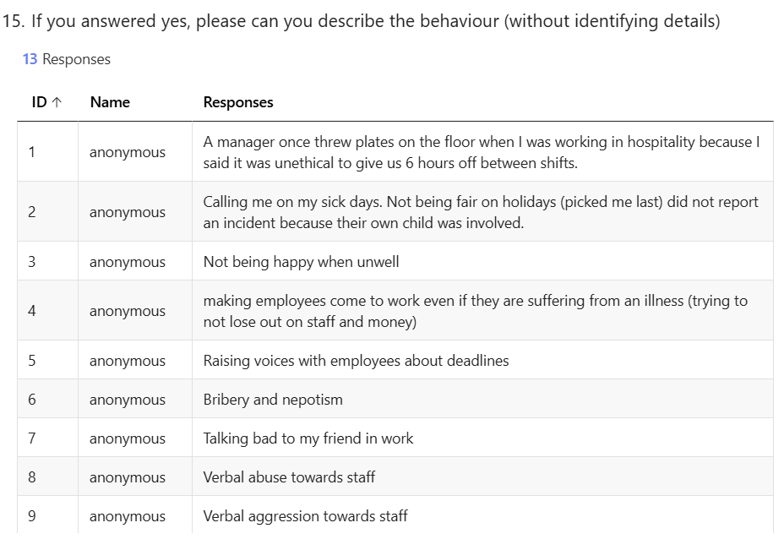
Behaviours reported included favouritism, bribery, verbal abuse, nepotism, pressure to work while struggling with illness and inappropriate conflict handling

Figure 9- Businesses prioritising employee well being over profit Q 13

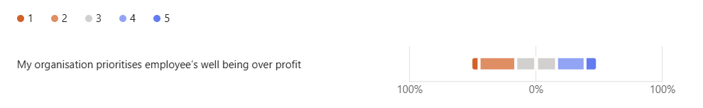

Although higher evaluations were less prevalent, responses were moderately dispersed, indicating that many employees believe profit frequently takes precedence over well-being.

Figure 10 - consistency and fairness- q 11 managers act consistently and with fairness

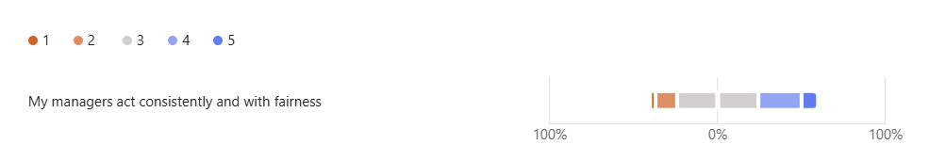

A significant percentage of respondents chose neutral or lower scores, indicating inconsistent ethical practice, even though some respondents thought the leadership was fair and consistent.

Conflict resolution

Figure 11- The effectiveness of conflict resolution Q 8: managers resolve workplace conflict effectively.

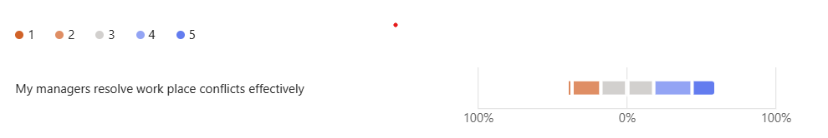
Although some respondents expressed discontent with the way disagreements are handled, the data indicates a moderate level of confidence in the ability to resolve problems.

Figure 12 - How management responds to conflict, Q20 : “managers respond appropriately when conflict occurs.”

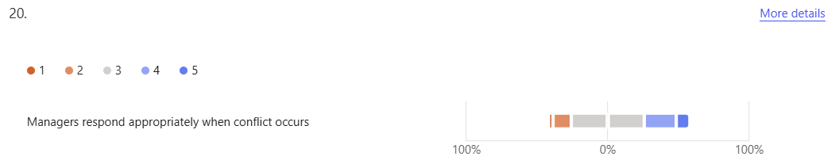

The majority of respondents chose mid-range answers, suggesting that conflict is not always handled consistently or successfully.

Figure 13- communication effectiveness Q21 : managers encourage healthy communication openly

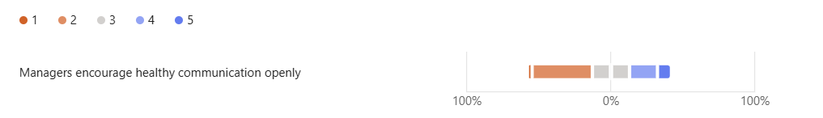

The findings demonstrate a range of experiences and a clear group of negative feedback, indicating that open communication is not always emphasised in workplaces.

Leadership motivation and capableness

Figure 14- leadership impact on motivation Q23: managerial behaviour affects my motivation

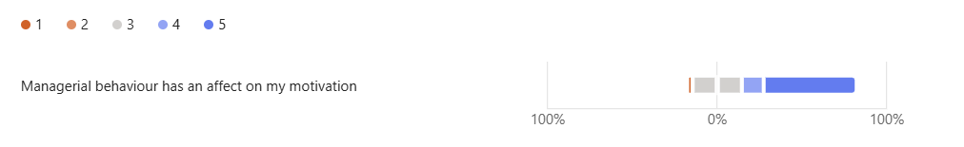

Higher scores were chosen by most respondents, suggesting that managerial behaviour has significant effects on employee motivation.

Figure 15- managers preparedness to lead- Q22: managers are equipped to lead adequately

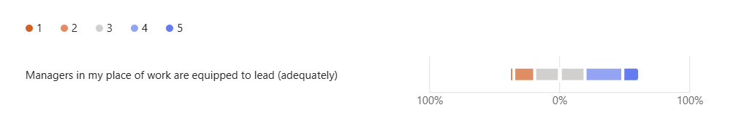
Employee uncertainty about managers’ general readiness to lead effectively is indicated by the mixed scores, many of which were neutral.

Well being support at work

Figure 16- services for well being support availability: Q 18 wellbeing or support practices available at work

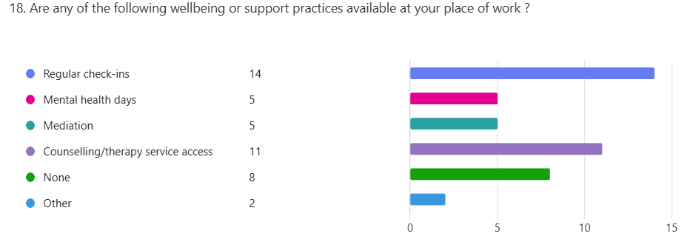

The most popular forms of assistance were counselling services and routine check-ins, but a significant portion of employees said they had no access to any kind of support.

Figure 17- Q 19 how can employers support mental health better?

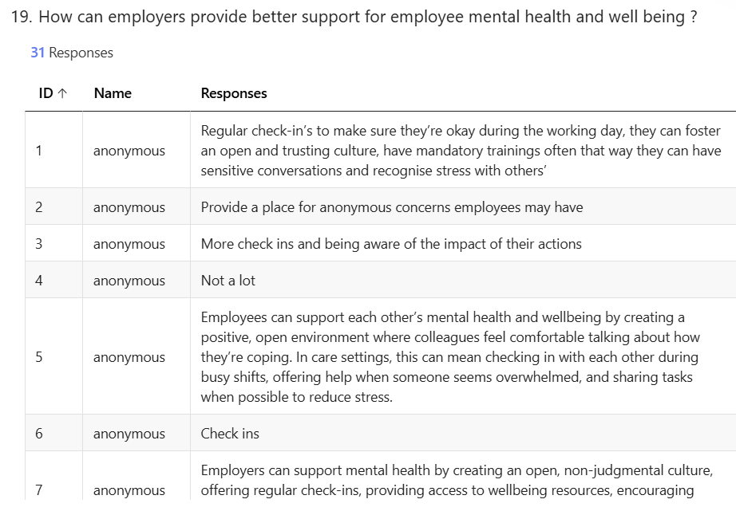

Participants stressed regular check-ins, open communication, access to wellbeing tools, non-judgemental workplace culture, and stress awareness.

Recommendations and leadership improvement

Figure 18
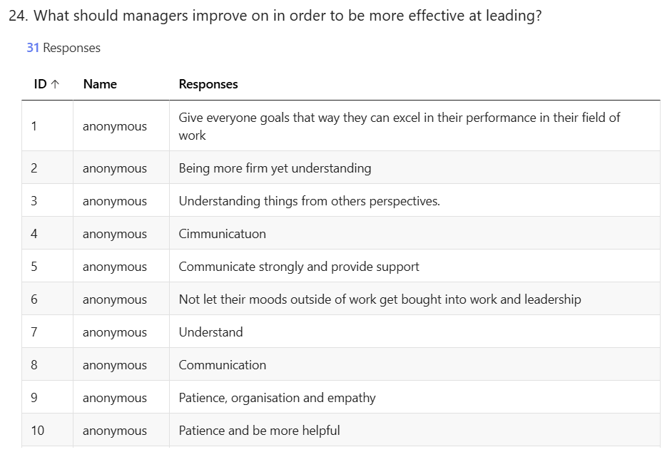

The most often mentioned areas for improvement were communication, empathy, patience, understanding staff, and constructive criticism.

Figure 19
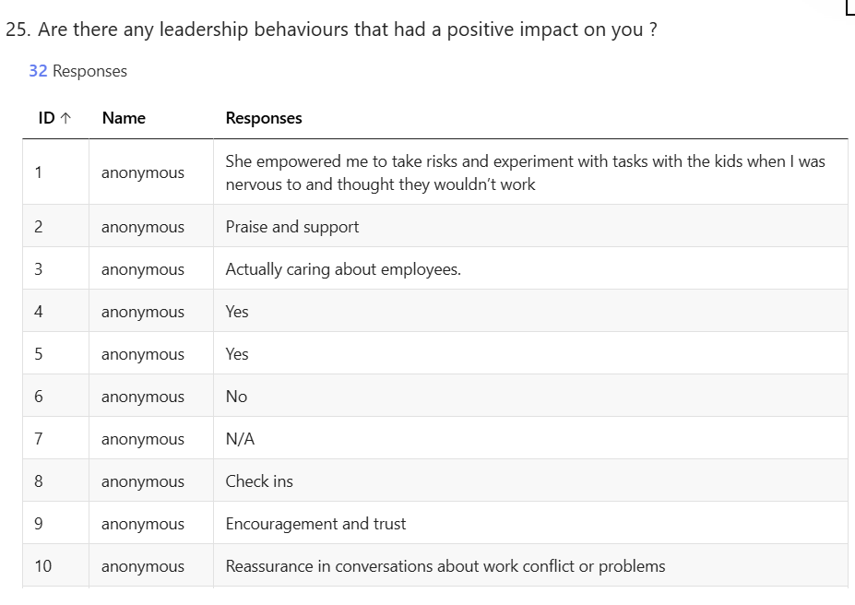

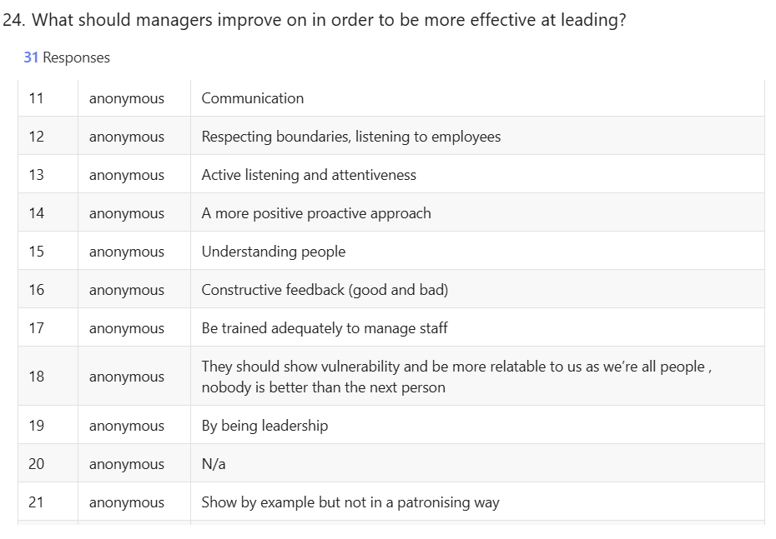

Praise, support, encouragement, trust, training, feedback, and teamwork were mentioned by respondents as having positive impacts.

Figure 20- workplace improvements

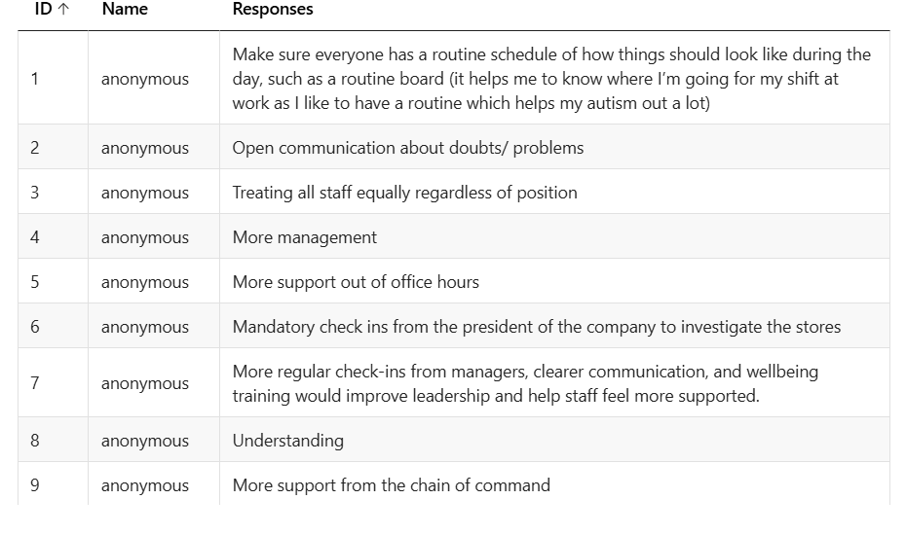

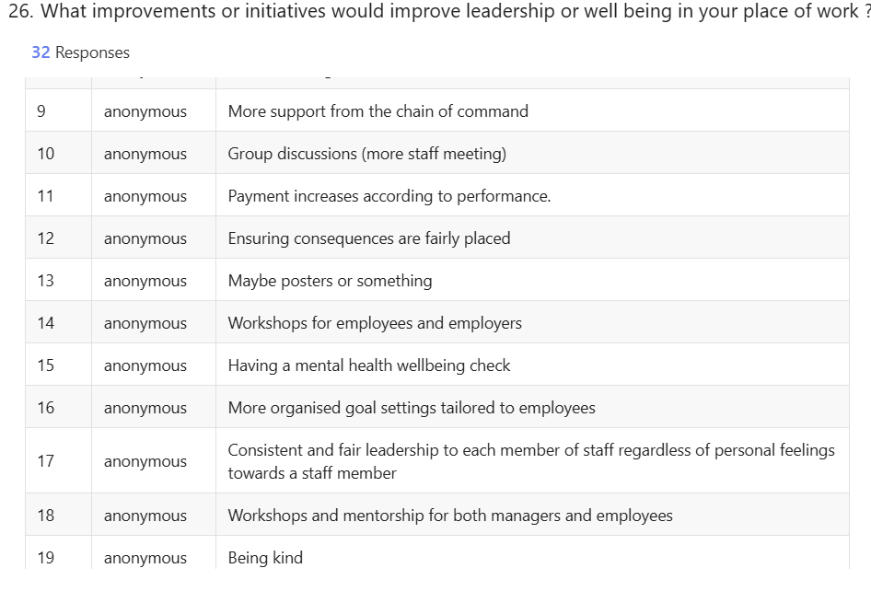

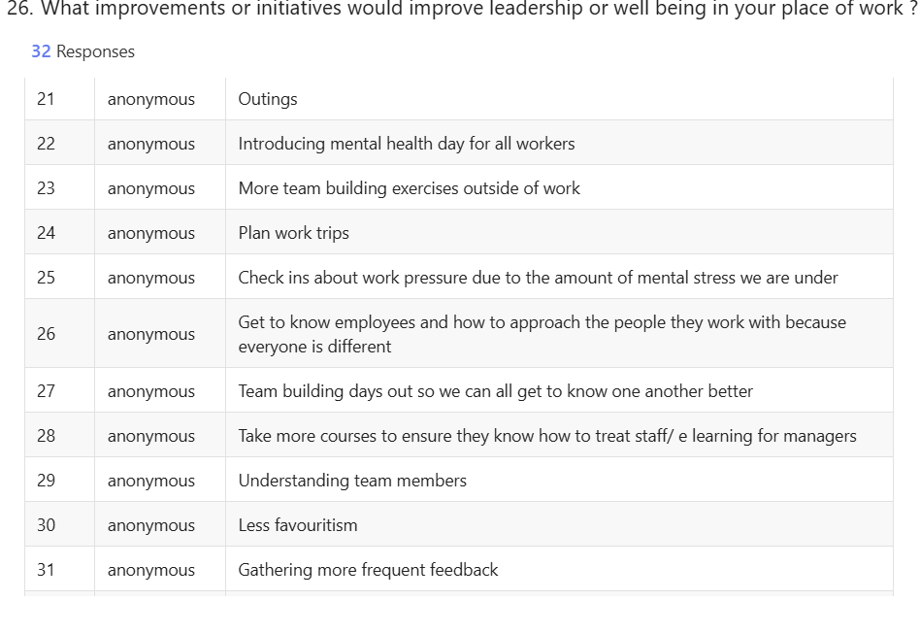
Regular check-ins, mental health days, workshops, consistent leadership, less favouritism, improved feedback mechanisms, and manager wellbeing training were all suggested by participants.

Discussion

The results of the qualitative survey examining whether managers are sufficiently prepared to lead are presented and analysed in this chapter, with particular attention to emotional intelligence, ethical leadership, employee wellness, communication, and conflict resolution. The results are directly related to the objectives of the study and the current body of literature

According to the demographic results, most respondents were between the ages of 18 and 25 (Q1's previously displayed figure), indicating that the sample primarily consists of early-career workers. This is important since younger workers are more sensitive to leadership behaviour and frequently work in front-line positions with managers (Jackson, 2023). The majority of participants worked in retail and hospitality, followed by public services and healthcare, according to industry representation (Q4's figure). Examining emotional intelligence and ethical leadership is important since these industries have significant levels of emotional labour and consumer engagement (Gabriel, Diefendroff and Grandey 2023). Furthermore, Q5's figure demonstrates that the majority of participants had regular interactions with management, indicating that respondents were in a good position to assess leadership methods.

A key component of the results was how emotional intelligence was perceived. The statistic for Q7 demonstrates that opinions on managerial empathy were divided, with many respondents choosing moderate to high ratings and a sizable percentage expressing low empathy. This supports Goleman's (1995) view that empathy is a fundamental element of emotionally intelligent leadership, although it is still not regularly used in everyday circumstances. While a lack of empathy has been connected to higher stress levels and lower morale, managers who exhibit empathy promote psychological safety and trust (Fteiha and Awwad, 2020). Similar variation in management self-awareness is seen in Q6's figure, indicating that although some managers exhibit thoughtful leadership, others are unaware of how their actions impact their staff. This bolsters the assertion made by Crawford (2023) that emotional intelligence skills are not equally developed.

These tendencies are further shown by the open-ended responses. Positive emotional intelligence behaviours included leaders providing reassurance, modifying workloads amid personal challenges, settling conflicts amicably, and promoting open communication, as seen in Q9's figure. These results support the claim made by Lie and Visram (2022) that emotionally savvy leadership improves resilience and engagement. On the other hand, Q10's figure demonstrates that emotionally unintelligent behaviours included yelling, disregarding employee concerns, pressing employees to work when ill, and exhibiting impatience under duress. Goleman (2020) found that managers with low emotional intelligence experience burnout and decreased performance. These experiences were linked to anxiety, emotional weariness, and demotivation.

Another major theme was ethical leadership. The data for Q14 indicates that a sizable percentage of workers had encountered unethical management practices. Favouritism, verbal abuse, forcing employees to work when ill, nepotism, and abuse of authority were all included in Q15's statistic. These results clearly support Hester and Rogers (2021) research on ethical leadership, which is based on moral behaviour, justice, and integrity. They also show how the absence of ethical leadership immediately erodes employee trust. Bieti's (2021) criticism of "ethics washing," in which organisations promote ethical ideals symbolically without integrating them behaviourally, is supported by the continuation of unethical activities found in these results.

It was also clear that profit and employee well-being were at conflict. The data for Q13 indicates that a large number of participants did not think that their organisation put well-being ahead of profit. This supports young’s et al., (2022) claim that transactional leadership paradigms, which put productivity ahead of people, are still prevalent in many businesses. These results strongly corroborate Keller’s (2023) claim that while CSR and sustainability are being advocated more and more, their actual use is still uneven. In line with Mullin’s and Mclean’s (2019) findings on toxic performance cultures, the belief that profit takes precedence over welfare was often associated with overworking, insufficient mental health assistance, and a lack of managerial compassion.

Communication and conflict resolution were also thoroughly studied. According to Q20's figure, opinions of managers' ability to resolve conflicts were typically modest, with a noticeable lack of satisfaction. Further difference in whether managers actively promote healthy communication may be seen in Q21's figure. These findings are consistent with those of Mccarthy and Pearce, (2025), who found that unresolved interpersonal conflict seriously impairs trust and team performance. Additionally, Petry (2024) research emphasises the importance of active communication for successful conflict resolution; yet, the current results indicate that many managers find it difficult to encourage candid discussion. The suggestions made by participants supported Hann and Heery's (2019) assertion that mediation and emotional intelligence training are crucial for preventing conflict escalation.

Employee wellbeing support produced mixed results. Q18’s figure shows that although some workplaces provide check-ins and counselling, a notable proportion reported having no formal wellbeing support. This reflects the research found by Mckee, Dunnell and Anderson (2021), warning that inadequate workplace mental health provision contributes to rising stress-related illness. Additionally, Q19’s figure shows that many employees felt insufficiently supported by management, reinforcing Altman’s et al., (2021) findings that wellbeing outcomes are strongly shaped by managerial behaviour rather than policy statements alone. The absence of structured wellbeing frameworks suggests a gap between organisational intent and lived employee experience.
Leadership capability and motivation were closely linked in the findings. Q23’s figure shows that managerial behaviour had a strong influence on employee motivation, with many respondents indicating that leadership directly affected their engagement and productivity. This aligns with transformational leadership theory by Bass, which emphasises the motivational power of supportive and inspiring leadership (Palmer, 2024). Q22’s figure shows that opinions on whether managers are adequately equipped to lead were mixed, with many selecting neutral responses. This suggests uncertainty rather than confidence in leadership competence, supporting the Chartered Management Institute’s (2021) finding that a large proportion of UK managers receive little formal training.

Participants provided specific suggestions for enhancing leadership. Employees desired better communication, active listening, emotional awareness, consistent treatment, and insightful feedback, according to Q24's figure. beneficial leadership actions including encouragement, acknowledgement, fairness, and emotional support had a significant beneficial impact on morale, as Q25's chart demonstrates. Regular wellness check-ins, compensated mental health services, mediation training, leadership development programs, and organised communication systems were among the suggested improvements, as seen in Q26's figure. These suggestions firmly support the claim made by London (2021) that emotional intelligence should not be viewed as a one-time intervention but rather as a component of continuous leadership development.

The results also revealed the importance of technology and tailored assistance. Participants' support for digital feedback systems is consistent with research by Sampath et al. (2024) that shows AI-based monitoring can identify discontent early and facilitate prompt intervention. However, worries about privacy and surveillance are similar to McParland and Connoly (2020) caution that over-monitoring could undermine confidence. Similar to Meske and Junglas's (2021) claim that customised wellbeing techniques improve engagement and retention, calls for personalised employee support also reflect this point. However, Joseph and Alhassan (2023) warns that if perceived favouritism is not carefully handled, it can compromise fairness.Overall, the results strongly imply that although ethical leadership and emotional intelligence are widely acknowledged as crucial, their actual implementation varies among large UK businesses. Workers often see a gap between leadership principles day to day. These findings corroborate research showing that organisational culture, accountability frameworks, ethical reinforcement, and structural training all influence leadership performance (McLaughlin and Kunk-Czaplicki 2020)

From a theoretical standpoint, the results support emotional intelligence theory Goleman (1995) by showing that employees' perceptions of leadership are heavily influenced by empathy, self-awareness, and emotional regulation (Scott and Freeman, 2021). Additionally, they confirm ethical leadership models by demonstrating the direct impact of fairness, openness, and moral behaviour on engagement and trust (Akkaya, 2020). According to Sarwar et al. (2020), emotionally intelligent leaders are more likely to make moral choices and create psychologically secure settings, which is further supported by the evidence.

In summary, the results and discussion show that many managers lack the necessary skills to lead in ways that are both emotionally intelligent and morally sound. Although there were clear instances of positive leadership, they weren't always present in all businesses. Workers still express unfulfilled demands in the areas of communication, empathy, justice, and mental health care. These results clearly answer the main research issue of the dissertation and emphasise how urgently modern UK workplaces require better leadership development, more robust ethical accountability, and more complete wellbeing frameworks.

Conclusion
The emphasis on employee interactions, emotional intelligence, and behavioural ethics, this dissertation aimed to investigate whether managers in large UK businesses are sufficiently prepared to lead. This study has offered insight into how leadership is experienced in practice and whether modern organisational leadership satisfies contemporary expectations of ethical, emotionally intelligent, and people-centered management through a critical review of the body of existing literature and the collection of primary qualitative data from employees across multiple sectors. According to the literature review, traditional leadership models, such as transactional and authoritarian approaches prioritised performance, control, and efficiency over the welfare of employees.

On the other hand, modern leadership philosophy places more emphasis on transformational leadership, ethical responsibility, and emotional intelligence. While ethical leadership theory focused fairness, transparency, and integrity, models by Goleman (1995) and Mayer, Caruso, and Salovey (2016) emphasised the significance of empathy, self-awareness, and emotional regulation (Brown & Treviño, 2006). Despite this theoretical advancement, the research also indicated that there is still a big disconnect between leadership principles and real-world application, especially in high-stress and profit-driven settings.

The employee survey's results provided compelling evidence for this hypothesised gap. Positive experiences with emotionally intelligent and moral leadership were reported by a few participants, but these were not always shared by all organisations. In addition to being frequently exposed to emotionally stupid behaviours like yelling, a lack of emotional support, and pressure to achieve despite personal or mental health issues, many respondents said that managers had low to moderate levels of empathy and self-awareness. These results support the claim that, while being generally hailed as a crucial leadership skill, emotional intelligence is still not consistently incorporated into managerial practice.
Inconsistency was also demonstrated by ethical leadership. Favouritism, verbal abuse, and abuse of power were among the unethical managerial behaviours that a significant portion of participants reported experiencing. There was also a clear view that business frequently takes precedence over the welfare of employees. These results are consistent with the concerns expressed in the literature about "ethics washing," which is the practice of organisations publicly promoting moral principles that are not regularly upheld in routine managerial behaviour. The findings thus imply that while ethical leadership is officially acknowledged as essential, it is not always successfully implemented or exemplified in businesses.

The study's overall findings indicate that many managers are still ill-prepared to handle the moral and emotional challenges of contemporary leadership. Although organisational policy and leadership theory have advanced, practical implementation is still uneven. The results show how urgently better leadership development programs that emphasise conflict resolution, emotional intelligence, ethical decision-making, and mental health awareness are needed. Additionally, leadership development needs to be ongoing, context-sensitive, and supported by organisational culture and accountability.

Bibliography (A-Z)

- Nicolescu, O., and Nicolescu, C. (2025) Redefining Management: The Manager/Leader–Relevant Stakeholder Paradigm. Oxford: Taylor & Francis. Available at: https://doi.org/10.4324/9781003540656.
- Sookdawoor, O. and Grobler, A., 2022. The dynamics of ethical climate:
mediating effects of ethical leadership and workplace pressures on
organisational citizenship behaviour. Cogent Business &amp; Management, 9(1),
p.212.
3. Mental Health Foundation (2023). Mental health at work: statistics. [online] www.mentalhealth.org.uk. Available at: https://www.mentalhealth.org.uk/explore-mental-health/statistics/mental-health-work-statistics.
4. Miao, C., Humphrey, R.H. and Qian, S., 2021. Emotional intelligence and servant leadership: A meta‐analytic review. Business ethics, the environment & responsibility, 30(2), pp.231-243.
5. Fleming, William J. "Employee well‐being outcomes from individual‐level mental health interventions: Cross‐sectional evidence from the United Kingdom." Industrial Relations Journal 55, no. 2 (2024): 162-182.
6. Sarwar, H., Ishaq, M.I., Amin, A. and Ahmed, R., 2020. Ethical
leadership, work engagement, employees’ well-being, and performance: cross-cultural
comparison. Journal of Sustainable Tourism, 28(12), pp.2008-2026
7. Morrissey, H. (2024) In 35 years, I have seen a host of business leaders – the good
ones all shared these qualities, The Telegraph. Available at:
https://www.telegraph.co.uk/authors/h/ha-he/helena-morrissey/ (Accessed: 10 October
2025).
8. Rachmad, Y.E., 2022. Psychological Leadership Theory.
9. Work does not need to a be a finish line you cross at the end of an exhausting week. (2021). The Guardian. [online] 30 Nov. Available at: https://www.theguardian.com/commentisfree/2021/nov/30/toxic-workplace-cultures-are-sacrificing-employees-health-and-it-doesnt-have-to-be-this-way [Accessed 12 august. 2025].

10. Salovey, P., Mayer, J. and Caruso, D., 2004. Emotional intelligence: Theory, findings, and implications. Psychological inquiry, 15(3), pp.197-215.

11. Maul, A., 2012. The validity of the Mayer–Salovey–Caruso Emotional Intelligence Test (MSCEIT) as a measure of emotional intelligence. Emotion Review, 4(4), pp.394-402.

12. Druskat, V.U., Mount, G. and Sala, F., 2013. Linking emotional intelligence and performance at work: Current research evidence with individuals and groups. Psychology Press.

13. Cross, J., Earl, M.J. and Sampler, J.L., 1997. Transformation of the IT function at British Petroleum. Mis Quarterly, pp.401-423.

14. Laasch, O. (2021) Principles of management: practicing ethics, responsibility, sustainability. Second edition. London: SAGE.

15. Muff, K., Delacoste, C. and Dyllick, T. (2022) ‘Responsible Leadership Competencies in leaders around the world: Assessing stakeholder engagement, ethics and values, systems thinking and innovation competencies in leaders around the world’, Corporate social-responsibility and environmental management, 29(1), pp. 273–292. Available at: https://doi.org/10.1002/csr.2216.

16. Winardi, M.A., Prentice, C. and Weaven, S., 2022. Systematic literature review on emotional intelligence and conflict management. Journal of global scholars of marketing science, 32(3), pp.372-397.

17. Liddle, D., 2023. Managing conflict: A practical guide to resolution in the workplace. Kogan Page Publishers.

18. World Health Organization, 2022. WHO guidelines on mental health at work. World Health Organization.

19. Wilkinson, A., Donaghey, J., Dundon, T. and Freeman, R.B. eds., 2020. Handbook of research on employee voice. Edward Elgar Publishing.

20. Rivers, S.E., Handley-Miner, I.J., Mayer, J.D., and Caruso, D.R., 2020. 29. Emotional Intelligence. by RJ Stenberg. 2nd Edition. Cambridge: Cambridge University Press, XXII, 1250, pp.709-735.

21. Budhwar, P., Malik, A., De Silva, M.T. and Thevisuthan, P., 2022. Artificial intelligence–challenges and opportunities for international HRM: a review and research agenda. The International Journal of human resource management, 33(6), pp.1065-1097.

22. Meske, C. and Junglas, I., 2021. Investigating the elicitation of employees’ support towards digital workplace transformation. Behaviour & Information Technology, 40(11), pp.1120-1136.

23. Bass, B.M. & Riggio, R.E. (2006). Transformational Leadership. 2nd ed. Lawrence Erlbaum.

24. Brown, M.E. & Mitchell, M.S. (2010). “Ethical and Unethical Leadership.” Business Ethics Quarterly, 20(4), 583–616.

25. Brown, M.E. & Treviño, L.K. (2006). “Ethical leadership: A review and future directions.” Leadership Quarterly, 17(6), 595–616.

26. Burns, J.M. (1978). Leadership. Harper & Row.

27. Cherniss, C. (2010). Emotional Intelligence: Toward Clarification of a Concept. Wiley.

28. CIPD (2022). Learning and Skills Report.

29. CIPD (2023). Good Work Index.

30. Colquitt, J.A. (2001). “On the dimensionality of organisational justice.” Journal of Applied Psychology, 86(3), 386–400.

31. Cropanzano, R. & Mitchell, M.S. (2005). “Social exchange theory: An interdisciplinary review.” Journal of Management, 31(6), 874–900.

32. Dirks, K.T. & Ferrin, D.L. (2002). “Trust in leadership.” Journal of Applied Psychology, 87(4), 611–628.

33. Huczynski, A. & Buchanan, D. (2020). Organisational Behaviour. 10th ed.
34. Hutchins, H.M. & Burke, L.A. (2007). “Identifying trainers’ knowledge base.” Human Resource Development Quarterly, 18(2), 159–178.
(Hutchins and Burke, P.50, 2007)- human resource development
35. Schutte, N.S. & Loi, N. (2014). “Connections between EI and wellbeing.” Personality and Individual Differences, 65, 47–52.
(Schute and Loi, p.47., 2014)
36. Simons, T. (2002). “Behavioural integrity.” Organisation Science, 13(1), 18–35.
(Simons, 2002)
Behavioural ethics

37. Bhakuni, S., Rana, A., and Bhanot, B. (2024) ‘Techniques for Managing Employee Relations and Conflict Resolution within the Workplace’, Journal of Business and Management Studies, 6(3), pp. 94–102. Available at: https://doi.org/10.32996/jbms.2024.6.3.10.
38. Kis, J. and Tudoran, D. (2023) ‘Integrating Employee Feedback into the Continuous Improvement of Performance Management’, Review of International Comparative Management, 24(5), pp. 760–772. Available at: https://doi.org/10.24818/RMCI.2023.5.760.
39. Gallo, J. et al. (2022) ‘Investigating the interaction between the feedback orientation & the feedback environment on employee performance’, Journal of management & engineering integration, 15(1), pp. 57–69. Available at: https://doi.org/10.62704/10057/24786.
40. Priya, V.J.M. and Jayakani, S. (2025) ‘Enhancing Workplace Performance: The Impact of Emotional Intelligence Training on Women Employees’, Journal of neonatal surgery, 14(9S), pp. 294–299. Available at: https://doi.org/10.52783/jns.v14.2658.
41. Taherdoost, H., 2022. What are different research approaches? Comprehensive review of qualitative, quantitative, and mixed method research, their applications, types, and limitations. Journal of Management Science & Engineering Research, 5(1), pp.53-63.
42. Gaya, Y.K. et al. (2025) ‘Assessing the Impact of Emotional Intelligence on Employee Performance: Toward an Integrated Emotional Intelligence Framework’, Managing global transitions, 23(1), pp. 27–114. Available at: https://doi.org/10.26493/1854-6935.23.27-48.
43. Efrat, A. and Zait, A. (2024) ‘The Effect of Personality Characteristics on the Development of Interpersonal Communication Skills Through One-Time Training’, Scientific Annals of Economics and Business, 71(2), pp. 265–283. Available at: https://doi.org/10.47743/saeb-2024-0018.
44. Walker, K. (2024) ‘Employee feedback: how to provide feedback and recognition regularly’, Strategic HR review, 23(2), pp. 46–50. Available at: https://doi.org/10.1108/SHR-12-2023-0069.
45. Ahmad, M., and Wilkins, S. (2025) ‘Purposive sampling in qualitative research: a framework for the entire journey’, Quality & quantity, 59(2), pp. 1461–1479. Available at: https://doi.org/10.1007/s11135-024-02022-5.
46. South, L. et al. (2022) ‘Effective Use of Likert Scales in Visualization Evaluations: A Systematic Review’, Computer graphics forum, 41(3), pp. 43–55. Available at: https://doi.org/10.1111/cgf.14521.
47. Regulation, P., 2018. General data protection regulation. Intouch, 25, pp.1-5.
48. Pereira, L.F. (2023) ‘Business research methods: systematic literature review’, International journal of management concepts and philosophy, 16(2), pp. 145–159. Available at: https://doi.org/10.1504/IJMCP.2023.130029.
49. Jackson, I. (2023). More than half of younger workers say benefits are top priority when job hunting, report finds. [online] www.peoplemanagement.co.uk. Available at: https://www.peoplemanagement.co.uk/article/1851721/half-younger-workers-say-benefits-top-priority-when-job-hunting-report-finds.

50. Gabriel, A.S., Diefendorff, J.M. and Grandey, A.A. (2023) ‘The acceleration of emotional labor research: Navigating the past and steering toward the future’, Personnel psychology, 76(2), pp. 511–545. Available at: https://doi.org/10.1111/peps.12576.

51. Fteiha, M. and Awwad, N. (2020) ‘Emotional intelligence and its relationship with stress coping style’, Health psychology open, 7(2), p. 2055102920970416. Available at: https://doi.org/10.1177/2055102920970416.

52. Crawford, J. (ed.) (2023) Leadership advancing great leaders and leadership. London: IntechOpen.

53. Lie, M. and Visram, S. (2022) ‘Building capacity for mental health resilience – local impact of the UK Better Mental Health Fund’, European journal of public health, 32(Supplement_3). Available at: https://doi.org/10.1093/eurpub/ckac131.480.

54. Goleman, D. (2020) Emotional intelligence : why it can matter more than IQ. 25th anniversary edition, with a new introduction [cover]. London: Bloomsbury Publishing.

55. Hester, R. and Rogers, A., 2021. Morals and ethics in leadership and management. In Leading, managing, caring: understanding leadership and management in health and social care (pp. 401-425). Routledge.

56. Young, H.R. et al. (2021) ‘A Meta-Analysis of Transactional Leadership and Follower Performance: Double-Edged Effects of LMX and Empowerment’, Journal of management, 47(5), pp. 1255–1280. Available at: https://doi.org/10.1177/0149206320908646.

57. McCarthy, K. and Pearce, J.L. (2025) ‘Supporting resolution: the impact of supervisors on workplace conflict management’, The International journal of conflict management, 36(3), pp. 650–674. Available at: https://doi.org/10.1108/IJCMA-10-2024-0276.

58. Petry, B.A. (2024) ‘Recognizing Social Distance in Visionary Leadership Communication: A Potent Prescription for Organizational Health’, International journal of business communication (Thousand Oaks, Calif.) [Preprint]. Available at: https://doi.org/10.1177/23294884241308852.

59. Hann, D., Nash, D. and Heery, E. (2019) ‘Workplace conflict resolution in Wales: The unexpected prevalence of alternative dispute resolution’, Economic and industrial democracy, 40(3), pp. 776–802. Available at: https://doi.org/10.1177/0143831X16663013.

60. Gordon, S. and Parikh, A. (2021) ‘Supporting employee well-being: The case of independent restaurants’, Journal of foodservice business research, 24(2), pp. 215–234. Available at: https://doi.org/10.1080/15378020.2020.1842956.

61. McKee, M., Dunnell, K., Anderson, M., Brayne, C., Charlesworth, A., Johnston-Webber, C., Knapp, M., McGuire, A., Newton, J.N., Taylor, D. and Watt, R.G., 2021. The changing health needs of the UK population. The Lancet, 397(10288), pp.1979-1991.

62. Altman, J. et al. (2023) ‘Perceived Workplace Support for Employee Participation in Workplace Wellness Programs: A Brief Report’, Merits, 3(3), pp. 494–503. Available at: https://doi.org/10.3390/merits3030029.

63. Palmer, R. (2024) ‘TOWARD A TRANSFORMATIONAL-LEADERSHIP HOMILETIC: USING BASS’S TRANSFORMATIONAL LEADERSHIP COMPONENTS FOR EXPOSITORY PREACHING THAT CONNECTS WITH GEN Z’, The journal of applied Christian leadership, 18(2), pp. 72–83.

64. Chartered Management Institute (2021) ‘Investment in Management Skills Crucial to “Levelling Up”, Say Business Leaders’, Politics Home.

65. Sampath, K. et al. (2024) ‘AI-Powered Employee Performance Evaluation Systems in HR Management’, in 2024 7th International Conference on Circuit Power and Computing Technologies (ICCPCT). IEEE, pp. 703–708. Available at: https://doi.org/10.1109/ICCPCT61902.2024.10673159.

66. McParland, C. and Connolly, R. (2020) ‘Dataveillance in the workplace: Managing the impact of innovation’, Business systems research, 11(1), pp. 106–124. Available at: https://doi.org/10.2478/bsrj-2020-0008.

67. Meske, C. and Junglas, I. (2021) ‘Investigating the elicitation of employees’ support towards digital workplace transformation’, Behaviour & information technology, 40(11), pp. 1120–1136. Available at: https://doi.org/10.1080/0144929X.2020.1742382.

68. Joseph, S. and Alhassan, I., 2023. Favouritism in higher Education institutions: Exploring the drivers, consequences and policy implications. European Journal of Human Resource, 7(1), pp.31-45.

69. McLaughlin, C.P. and Kunk-Czaplicki, J.A. (2020) ‘Leadership: Theory and Practice by Peter G. Northouse (review)’, Journal of college student development. Baltimore: Johns Hopkins University Press, pp. 260–261. Available at: https://doi.org/10.1353/csd.2020.0023.

70. Scott, D. and Freeman, R.E. (2021) Models of leadership : in Plato and beyond. First edition. Oxford, United Kingdom: Oxford University Press.

71. Akkaya, B. (ed.) (2020) Agile business leadership methods for industry 4.0. 1st ed. Bingley, England: Emerald Publishing.

‌

