Module Assessment [Component [1]

Entitled
Student Learning Log

Module
BMIH 6003 – Managing Guest Service Operations

Student Name
Rukhsana Kousar

Student Number
2128265

Lecturer
Jessica Newport
Statement of Acknowledgement

I hereby confirm this assignment has been completed independent of any artificial intelligence (AI) generative support tools and/or software in the preparation, research and writing of this work. This work is mine alone. All sources have been appropriately cited

Introduction

In this report, I will examine how my job experience in the company affected my personal growth. My work placement as a front desk and back office supervisor of “Ibis Hotel Bradford Shipley” which a reputable company in the UK. It has Modern 78 bedroom hotel situated close to Bradford and Leeds on the banks of the Leeds Liverpool Canal. I am currently 3rd week onto my 10 week placement. In my report, I will also assess my technical and practical expertise, the many challenges I encountered inside the company, and my plan of action to guarantee further improvement.

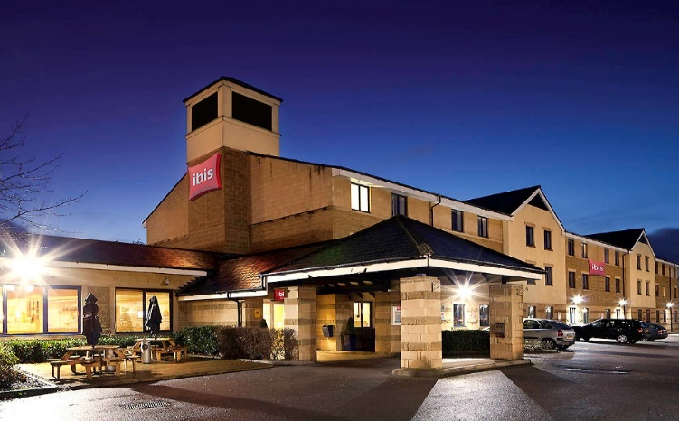

Figure: “Ibis Hotel Bradford Shipley” (Helo et al, 2022)

Gibbs’ Model
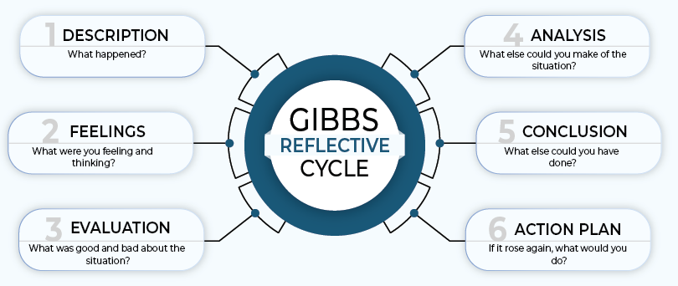

Figure: The model (Kedah et al, 2023).

Description
As I was managing customers and in charge of their services, I went through a very important period in my professional career at the “Ibis Hotel Bradford Shipley”. For me, the trip was both exciting and difficult, which helped me pick up new abilities (Hadjielias et al, 2022).

Feelings
My overall emotions are positive since I feel supported in growing my confidence by my employment at the “Ibis Hotel Bradford Shipley” and my direct customer interaction. I encountered a variety of challenges at work, but I overcame them by using my inventiveness and asking for help from front desk management (Helo et al, 2022).

Evaluation
As the front desk and back office supervisor for the company, I had excellent time management skills and was a competent communicator with others. Nevertheless, I had trouble managing the demands of my job and interacting with visitors from various cultural backgrounds (QAA, 2018)

Analysis
I have determined that in order to enhance my performance as a front desk and back office supervisor, I must cultivate my cultural awareness and increase my ability to engage with individuals from other backgrounds.

Conclusion
To sum up, in order to improve as a professional in the cutthroat industry, I must constantly address my areas of weakness and acquire new skills because it is a personal perspective (Hagg, 2013)

Action plan
As stated by Li et al. (2023), I want to cultivate a robust professional network, participate in cultural organisations, and pursue further education to bridge the skill gaps I discovered while working as the front desk and back office supervisor at “Ibis Hotel Bradford Shipley”.

Section 1: Reflection on Experience and Personal Development

Improvement of Interaction
According to Nojeem et al. (2023), these exercises helped me hone my professional communication abilities. Working for the company allowed me to contact with consumers, hear out their needs and wishes, and introduce them to new services, which really helped me to enhance my communication skills.

Taking Lessons from Difficulties
I have picked up new abilities and information from various scenarios and pros at the “Ibis Hotel Bradford Shipley”. The job presented many problems, which I had to learn how to overcome. For instance, I overcome interpersonal interaction issues as a front desk and back office supervisor by honing my gestures and communication skills (Lilien et al, 2022).

Leadership Development:
My time at the “Ibis Hotel Bradford Shipley” significantly enhanced my leadership capabilities, which in turn enhanced my personal and professional talents. I was supervised by experienced front desk managers who helped me pick up their leadership techniques (Le et al, 2022).

Section 2: Critical Analysis of Work-Based Skills and Technical Knowledge
Enhancement of Technical Skills
I learnt how to utilise hotel management software and use it correctly to provide services to consumers when I worked as a front desk and back office supervisor. In order to become more efficient, I have effectively provided services like check-ins, reservations, monitoring, etc. by employing this (Hadjielias et al, 2022).

Assessment of Core Capabilities
Developing my leadership, communication, and problem-solving abilities are a few things that will help me advance professionally. I gained a variety of job-related abilities and expertise at “Ibis Hotel Bradford Shipley” while assuming the duties of the front desk supervisor (Casado, 2012)

Use of Theoretical Information
Since I had no prior experience working in the hotel sector, I utilised the theoretical information I had learnt in school before joining “Ibis Hotel Bradford Shipley”. This helped me a lot as I tackled the first few months of my job as a front-office supervisor. Additionally, I discovered that applying theoretical knowledge more effectively with the help of experts is possible
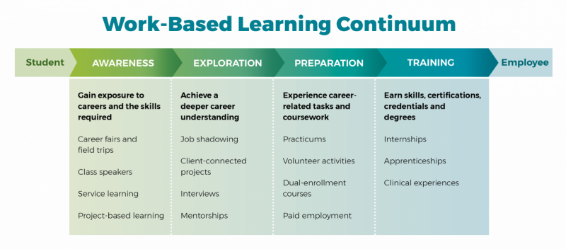
Figure: Worked-based skills (Le et al, 2022)

Section 3: Reflection on Organisational Issues
Absence of workers
There was a severe staffing deficit across the business during the busiest travel season, which negatively impacted morale for those who had to put in additional hours. In addition, it had a detrimental effect on workers' performance and decreased their level of satisfaction at the time (Bardi, 2010)

Departmental communication
Although “Ibis Hotel Bradford Shipley” was a successful company, it still has certain problems that need to be fixed if it wants to function even better. One problem I encountered while working was a lack of communication and connections between the organisation's divisions, which affected the front desk and back office department's performance and reduced the quality of services provided (Helo et al, 2022).

Handling Conflicts at Work
A variety of experts are from various ethnic backgrounds work at the “Ibis Hotel Bradford Shipley”, which sometimes causes problems by escalating confrontations among co-workers. Additionally, the organisation's management failed to create a cooperative work atmosphere, which resulted to a rise in workplace disputes (Kedah et al, 2023).

Section 4: Future Action Plan

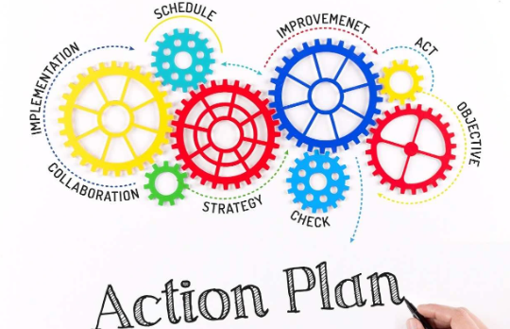

Figure: Action plan (ASET, 2017)

Making Plans for Ongoing Education
Since learning has no boundaries, I will concentrate on learning new things constantly in order to develop into a successful professional. This will help me get an advantage in the cutthroat employment market and be very important in helping me quickly accomplish my career objectives. In order to achieve continuous progress, I will routinely assess my actions to discover various concerns pertaining to my abilities and activities (Nojeem et al., 2023).

Creating Professional Objectives
To become a more successful professional in the future, for instance, I will work on my leadership, technology, and communication objectives (Li et al., 2023). In order to become a successful professional, I will first define a goal for myself, then determine the essential information and abilities needed to attain it.

Boost abilities in providing customer service.
I will focus on improving both my professional conduct and my problem-solving techniques so that I can effortlessly please clients and visitors and improve their stay at the “Ibis Hotel Bradford Shipley” (Lilien et al, 2022). I will concentrate on honing my customer service abilities since I want to advance in the hospitality sector and open up more chances in the future.

Conclusion
Ultimately, my experiencing the epic roles I held during the two work placements at different holes greatly improved my leadership skills, the technical know-how of specific knowledge and talent, which has also strengthened my personal and professional qualities. My goal is to become a better professional by always learning new things and gaining experience in the real-world, work setting. Whilst at ‘Ibis’ indeed I was able to build on personal development with my new-found confidence, in addition to the professional calibre of new, learned new skills and knowledge. Under the guidance of seasoned front desk supervisors, indeed I was able to absorb occupational team-building and supervisory skills of leadership.

References
ASET (2017) Good Practice Guide for Workbased and Placement Learning in Higher Education. Sheffield: ASET.
Bardi, J. (2010) Hotel Front Office Management.5 th Ed. London: Wiley.
Casado, M. (2012) Housekeeping Management. 2 nd Ed. London: Wiley.
Hadjielias, E., Christofi, M. and Tarba, S., (2022). Contextualizing small business resilience during the COVID-19 pandemic: evidence from small business owner-managers. Small Business Economics, pp.1-30.
Hagg, E. (2013) Internship Guide: Work Placements Step by Step. 5th Ed. The Hague: Eleven International Publishing.
Helo, P. and Hao, Y., (2022). Artificial intelligence in operations management and supply chain management: An exploratory case study. Production Planning & Control, 33(16), pp.1573-1590.
Kedah, Z. (2023). Use of e-commerce in the world of business. Startupreneur Business Digital (SABDA Journal), 2(1), 51-60. MU
Le, T.T. and Nguyen, V.K., (2022). Effects of quick response to COVID-19 with change in corporate governance principles on SMEs’ business continuity: evidence in Vietnam. Corporate Governance: The International Journal of Business in Society.
Li, J., Lin, Z., & Zhang, X. (2023). The Study on the Effectiveness of Sustainable Customer Relationship Management: Evidence from the Online Shopping Industry. Sustainability, 15(7), 5911.
Lilien, G.L., Petersen, A.J. and Wuyts, S. eds., (2022). Handbook of business-to-business marketing. Edward Elgar Publishing.
Nojeem, L., Shun, M., Embouma, M., Inokon, A., & Browndi, I. (2023). Customer Relationship Management and Algebraic Multigrid: An Analysis of Integration and Performance. International Journal of Basic and Applied Sciences, 10(2023), 129-135
QAA (2018) UK Quality Code, Advice and Guidance: Work-based Learning. London: QAA.

