Ice Sculpture Exhibition & Live Carving

Student name: Andrea Bardoczi
Student no: 2209718
Lecturer: Christopher Wilkin
Module: BMIH 6007

Table of Contents
Presentation 4
Event Content and Context 4
Market factors 4
Operational factors 6
Financial factors 7
Reference 9
Power point presentation……………………………………………………………………..11

Event Content and Context
Background and proposed focus
- The focus of the event, "Ice Sculpture Exhibition & Live Carving," will be presenting the winter scenes and wildlife of Nottingham City through the creation of ice-based sculptures.
- It will also focus on presenting some live carving related to several seasonal elements and Nottingham’s sculptural monuments will also be presented.
- The type and nature of this event will be based on the "Exhibition" type and will be held in winter in The Nottingham Belfry hospitality company.
The Nottingham Belfry will be created as an exhibition-based event with the help of the MICE industry of Nottingham, which is named "Ice Sculpture Exhibition & Live Carving." This event will be based on the exhibition process, and some live carving will be presented to attract customers. The event will happen in the winter when the number of tourists will also increase.

Market factors
Target market
- The potential target market for this event will be all age groups of the population in Nottingham.
- The people of Nottingham have been found to have a huge interest in some events like this happening in the city (White et al. 2023).
- The age group of almost 5 to 6 years till above 60 years of people are managed to be the potential target market for this event.
- It is evident that, in Nottingham, every person is seeking to explore some new things regarding their long holiday time which is winter (Saliteet al. 2024).
- The company The Nottingham Belfry has used its customer base and other audiences in Nottingham to attend this event based on an exhibition, followed by some ice sculpture and live carving of Nottingham's cultural aspects.
It has been evident that the people of Nottingham are willing to spend their leisure time on various entertainment mediums that are mainly societal. Following this, the company The Nottingham Belfry is going to create an event called "Ice Sculpture Exhibition & Live Carving" in order to attract all age groups of the population towards it. Maintaining the cultural aspects and sculptural reputation of Nottingham, all the age groups of people are found to be appropriate to attend the event.
Demand and Supply
- Being a major festive city, Nottingham's population has the demand for this kind of exhibition-based event to happen in the city (Whitehead, 2024).
- It has been evident that having a large crowd in local and regional areas of Nottingham, the demand for this kind of event has increased in Nottingham (Kew, 2023).
- The supply for raw materials that are going to be used in the event mainly is supplied from some internal sources of the country.
- Other than that, the hill-based areas of the UK are the prime source of supplying raw materials like, Ice blocks, display stands, carving tools, and others.
- The assistance of the MICE industry is also responsible for managing the supply of the event (Litvinova-Kulikova et al. 2023).
It has been evident that the demand and supply for this event in Nottingham Belfry Hotel, the consideration factors are found to be involved within the city and some other places too. It has been observed that the people of Nottingham are interested in this kind of event happening in the city in wintertime. Along with this, the festivity of Nottingham is another scope for increased demand for exhibition-based events. Therefore, the proposition of the MICE industry has been found to be responsible.
Competition
- The events that are based on some sculptural presentation or exhibition types can impact this event in Nottingham Belfry.
- Some sculptural events have been found in Nottingham such are "Winter Wonderland" or "Nature in Ice" which can be the same kind of event following the competitors of "Ice Sculpture Exhibition & Live Carving" (Neuhoferet al. 2024).
- Time can be a competitive factor for this event, that can be impactful towards the success of the event in a particular time.
- Some other companies within the hospitality sector can create competitiveness in determining and creating more winter-based programs and Christmas celebration presentations into the company (Preston, 2020).
It can be said that the competitive factor for this event can be followed by some events including cultural presentations and some exhibition-based projects in Nottingham City. It has also been evident that several other hospitality sectors are also eager to arrange some winter-based events based on the winter Wonderland or nature-in-ice kind of events that can be some strong competitors of this event. There has also been evidence that the factor of time management to determine the success rate and the presentation capability of the event can be a competitive factor for the Company Nottingham Belfry.
Marketing activity
- The marketing activity of this kind of event can be feasible through following social media marketing.
- As this event is targeted to a group of people, therefore, the advertising process through social media can reach out to every single person in the UK and outside of the UK too (Tuten, 2023).
- Other than that, some social media campaigns can also be created to make people aware of the cultural and traditional awareness of Nottingham (Kew, 2023).
- The live demonstration of the events through presenting it on a giant screen in between the city can also be a significant marketing activity.
Following the marketing procedures of this event, it has been identified that social media can be an appropriate protocol for managing the marketing aspects of this event. It has been evident that prospects of social media campaigns can be beneficial in order to maintain audience engagement towards the event.

Operational factors
Venue availability
- The venue for this event will be the banquet of the Nottingham Belfry Hotel, as it has a quality large auditorium and can accommodate multiple people together (Saunavaara et al., 2023).
- The availability of this venue is found to be feasible in order to arrange this event systematically in Nottingham Belfry.
- As a venue, Nottingham Belfry is suitable as it is versatile and well-equipped with several arrangements and facilities (Thenottinghambelfry, 2024).
- This venue is suitable for managing some social gatherings and events based on public gatherings as well.
It has been identified that as a venue Nottingham Belfry has been identified to have several facilities and accommodations to arrange the events based on winter charm.
Skills required
- The skills that are required to manage this kind of event are proper event planning and knowledge of setting the schedule (KURNIAWAN et al. 2023).
- Skills regarding advertising procedures should also be feasible in managing the marketing activities for the promotional process of the event.
- In managing the food and accommodation, proper hospitality skills are also required for managing this kind of event (Jokela and Huhmarniemi, 2022).
It has been evident that, in managing the event of Nottingham Belfry, the required skill set is mainly included with event planning skills, to manage the huge gatherings. Along with this, knowledge of marketing is also required for promotional activities. Having excellent hospitality skills is also required to manage this event.
Resources
- For managing the resources of catering, the event planner team should contact some excellent A-class category's catering services to manage the food section.
- Consideration of the lighting groups for managing the lighting for the events can be done. In this case, some renowned decorators can be contacted through the assistance of the MICE industry (Hind et al. 2023).
- Arranging the parking and seating capacity, the organisations that are event manager groups will be contacted to manage these services.
It can be said that the resources will be allocated with the assistance of the MICE industry. This industrial assistance can be received through connections between some renowned light and decorators and event management companies.

Financial factors
Cost and predicted revenue
Competitors | Estimated annual revenue (GBP) | Growth rate | Key factors contributing to revenue
Frosty Creations | 330,000 GBP | 10% | There is high demand for several corporate events and festivals (Jokela et al., 2021)
Ice Artistry | 520,000 GBP | 14% | There are partnerships in the wedding sector
Arctic Sculptors | 420,000 GBP | 13% | Seasonal festivals and tourism activities
Table 1: Competitors’ revenue analysis
(Source: Self-developed)
It is seen from the above table that Frosty Creations has a predicted revenue of 3,30,000 GBP with a growth rate of 10%, led by high demands for several corporate events and festivals. Ice Artistry earns around 520,000 GBP yearly, increasing by 14% by getting partnered with other organisations in the wedding sector. Arctic Sculptors secures around 420,000 GBP per year while increasing the rate by 13% accelerated by seasonal occasions and tourism operations.
Funding sources
- The funding of the event will come from the investment of sponsors towards the event (Jackson, 2021).
- These sponsors will be some local partners and sculpture companies as well.
- The source of the revenue generation for this event will be the food and beverage section, merchandise sales and the sales rate of VIP tickets.
It can be expected that the event will be run in profit following the total income and expected expenditure of the whole event. In this case, the inclusion of several market objectives, like valuable guests and local partnerships are found to be evident in managing the high profit of the event.
Timeline
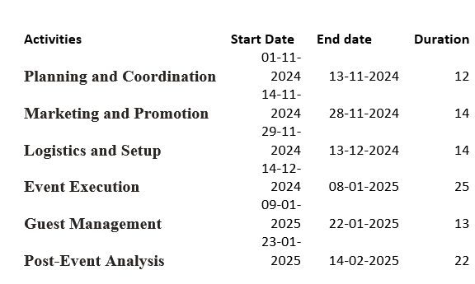
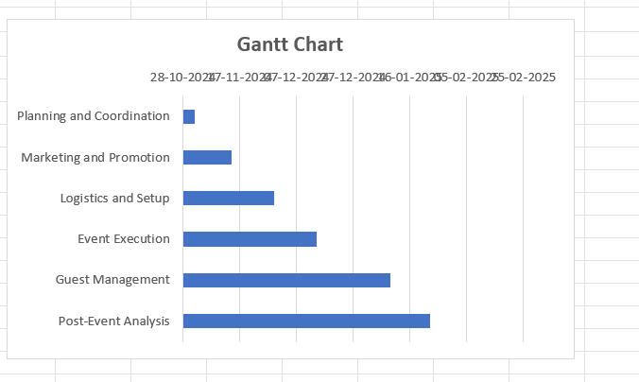

Reference:
Hind, D.W., Zamzuri, N.H., Baba, N., Hasan, Z. and Disimulacion, M.A.T., (2023). International Best Practice in Creative Event Design. Prasetiya Mulya Publishing.
Jackson, A. (2021). Shaping perspectives of Antarctica: a study of the value and production of Antarctic visual art.
Jokela, T., and Huhmarniemi, M. (2022). Arctic art education in changing nature and culture. Education in the North, 29(2), 4-27.
Jokela, T., Huhmarniemi, M., Beer, R., and Soloviova, A. (2021). Mapping new genre Arctic art. Arctic yearbook, 2021.
Kew, T., (2023). # rebelnotts Literary tourism in Alan Sillitoe's Nottingham. In The multicultural Midlands (pp. 53-70). Manchester University Press.
KURNIAWAN, D., MARLAPA, E., SOELTON, M., BUANA, D.R., THOULLON, M.S., YUSSOFF, Y.M. and NAIBAHO, M.C., (2023), November. Increase The Potential of Quality Management To Expand The Relationship With The Parties. In ICCD (Vol. 5, No. 1, pp. 507-513).
Litvinova-Kulikova, L., Aliyeva, Z. and David, L.D., (2023). MICE tourism: How the pandemic has changed it. Journal of Tourism and Services, 14(26), pp.197-218.
Neuhofer, B., Celuch, K. and Rihova, I., (2024). The future of transformative events: an event leaders’ perspective. International Journal of Contemporary Hospitality Management.
Preston, V. K. (2020). Queer and indigenous art: Performing ice times in climate crisis. Theatre Journal, 72(2), 143-162.
Salite, D., Miao, Y., Turner, E. and Feng, Y., (2024). Assessing the adoption of sustainable heating technologies in the United Kingdom–A case study of socioeconomically deprived neighbourhoods of Nottingham city. Technology in Society, 77, p.102508.
Saunavaara, J., Partanen, M., Tanaka, M., and Fukuyama, T. (2023). Ice-breaking tourism and local resilience building. Tourism Review International, 27(1), 35-49.
Thenottinghambelfry, (2024). STAY WITH US. Available at: https://www.thenottinghambelfry.co.uk/ [Accessed on: 04.10.2024]
Tuten, T.L., 2023. Social media marketing. Sage publications limited.
White, J.T., Hickie, J., Orr, A., Jackson, C. and Richardson, R., (2023). The experience economy in UK city centres: A multidimensional and interconnected response to the ‘death of the high street’?. Urban Studies, 60(10), pp.1833-1852.
Whitehead, G.D., (2024). The Performance of Viking Identity in Museums: Useful Heritage in the British Isles, Iceland, and Norway. Taylor & Francis.




