
[Document title]
[Document subtitle]

[Date]
[Company name]
[Company address]

Executive Summary

Leave a blank page, write the report then go back to write your summary. An Executive Summary should summarise the whole report in about 10% of your word count – therefore, should not exceed a page (approx. 250 – 300 words). There, should be an overview of the terms of reference to your report, an overview of key findings, and an indication of conclusions drawn. The reader should be able to read an Executive Summary and have a good understanding of the content without having to read the whole document. The content of an Executive Summary does NOT count towards your word count.

Table of content

Table of Contents
1.0 Introduction 3
2.0 Main Body 4
2.1 Background of Audi………………………………..……………………………………………………………………….4
2.2 Implementing Changes …………………………………………………………………………………………………..5
2.3 Changing Models…………………………………………………………………………………………………………….7
2.4 Leadership – Management of Complex Areas …………………………………………………………………9
2.5 Culture………………….………………………………………………………………………………………………………10
2.6 Change Agents ………….……………………………………………………………………….……………………….11
Conclusion …………………………………………………………………………………………………………………………………12
Recommendation…………………………..………………………………………………………………………………………….12
Reference list……………………………………………………………………………………………………………………………..14
Appendices………………………………………………………………………………………………………………………………..16

- Introduction

  - Terms of Reference
This report has been put together upon the request to looking at Amazon as an innovative company and analysing Alexa as an innovation. This report has been requested by Davina Evans CEO of Amazon on 10th of January 2022 and It has been completed by Bettina Silsby an Innovative Manager of Amazon on the 24th of March 2022.
The purpose of this report is to explain what innovation and creativity is, through identifying innovation opportunities in the development of Alexa Echo first generation. The report will be looking at the thinking process through applying innovation matrix and the six-thinking hat. Each innovation can be open and close innovation, it will be identified in the report where e Alexa can fit. In the innovation process organisations are taking risk and it is important to have clear understanding of all the risk in the early stage, Lewin Force Field Analysis can help explain all the forces can affect the innovation and put barriers or risk factors in the innovation process of Alexa. The report must look at the leadership style of Amazon, to understand the openness of the leader for innovations and creativity. It will be a conclusion draw out to close the report.
To create this report and have critical view on the all-organisation primary and secondary sours have been analysed, for example Articles, Journals, websites, and Books.
  - Background of Amazon
According to Mc Fadden (2021) Amazon was find in 1994. Amazon is an e-commerce company. The organisation has developed e-commerce technology and made the agile and innovative in any aspect that the organisation does. Amazon is offering wide range of product and through online groceries all over the word. Amazon other important sector is the technologies and been innovative. One of amazon cure value is leading in innovation and simplify people life. (Gaille, 2020) The online website Visual Capitalist have published the Rank: The most innovative Companies in 2021 and Amazon have become the third place on this list. (Ang, 2021)

- Main Findings

  - Overview of the Innovation Opportunity

Echo is essentially a ‘smart speaker’ animated by a voice-controlled, intelligent personal assistant who responds to the name Alexa. The low-cost unit is capable of voice interaction, playing music, controlling devices in the home, and basic conversation about the weather, local traffic, and publicly available information. (Winters, 2016)Alexa have been identified in the Amazon Lab126 by small group of people. (Brustein, 2016) Alexa is a virtual assistant technology largely based on a Polish speech synthesiser named Ivona, bought by Amazon in 2013. (Westerby, 2020) According to Winters (2016) At Amazon Corporation, there are now 5,000 people working on Alexa and related technologies. Alexa is very complex device and until this day Alexa is a major investment of money and people power, Alexa is a massive indication of to the Amazon core Value “Invent and Simplify” (BusinessMavericks, 2021) and is showing Amazon interest on artificial intelligence and related sciences. Jeff Bezos the CEO of Amazon been very convinced by Alexa success since the minute when Jeff heard about the idea. The organisation has set a $100 million venture capital fund – Alexa fund- to fuel voice-technology innovation in the worlds of business and academics. (Winters, 2016)
  - Type of Innovation
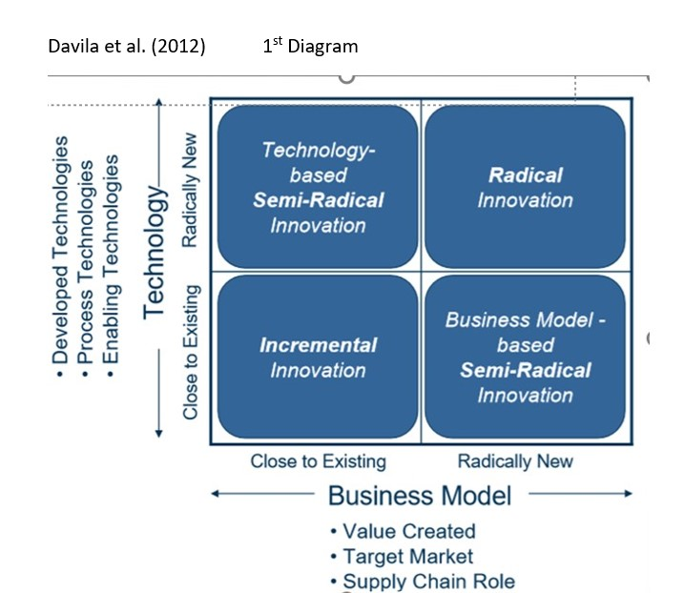
Innovation usually driven by the ability to see connection, to spot opportunities and to take advantage of them. (Tidd, 2013) Amazon have seeing an opportunity in the normal speaker turn to voice controlled virtual assistant in 2014. (Lacoma, 2021) Creativity is about unleashing the potential of the mind to conceive new ideas. (BusinessInsider, 2013) The creativity behind Alexa was create a virtual assistant that can help people in small task, as turn on light, read news, set up alarm. Davila (2012) Innovation Matrix it is looking at four types of innovation. This Matrix putting the innovation in four categories, it can help understand that how new innovation will affect the organisation, and giving a indication to the change in the business model to able to bring the new product to the market in the success way. How organisation innovate affects what organisation innovate, understanding the nature of the change required is vital so through this Matrix the innovation effort can be managed, funded, and resourced appropriately. (Tony Davila, 2012) Applying the innovation matrix (see 1st diagram) to Alexa can fit in to technological and radical innovation. According to Connor (2005) radical innovation is the commercialization of product and technologies that have strong impact on the market, and the firm in terms to create new businesses. Alexa certainly had a impact on the market as consumer never see technology that is functioning as virtual assistant in the UK market. According to Brunstein (2016) Intelligence Research Partners issued a report, and the report have stated that Amazon had sold more than 3 million devices, with 1 million of those sales happening during the 2015 holiday season. Alexa have created a new business and have ad new areas to Amazon business model. Amazon had to set up new data collection analysis department to collect date from customer habits, to help Alexa in the further developments. According to Pratt Amazon as a radical innovation having entered the virtual space completely by leveraging emerging technologies to create a new complex business model, through shopping only with command given to a virtual assistant and the next day the goods will be delivered to our door. . Alexa have changed the industry by introducing a technology that is help control people homes. Before Alexa, it was smart phones with google assistant or apple phone with Sri able to complete internet search or task on the device, but Alexa is the first technology that can control other technologies inside homes.
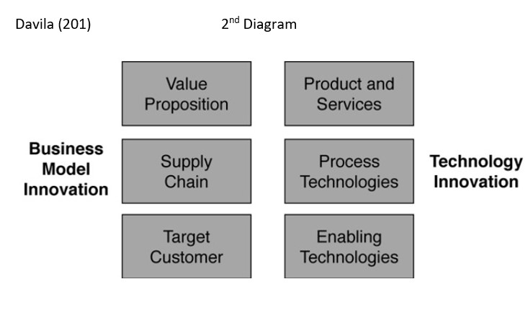
According to Davila (2012) rarely does a technology change occur without also causing a change in business processes. The second diagram explain that the organisation must implement changes to the organisation model to able sell and manufacture the new product. According to Davila (2012) Radical innovation involves substantial change to either the business model or the technology of an organisation—but not to both. Amazon have implemented the 2nd model and made change in setting up Alexa fund and adding a new sector that is only concentrate on developing. Alexa development was out of the box thinking process. According to Charly (2022) out of box thinking it is referred to creative thinking. Out of the box thinking requires a willingness to go beyond normal boundaries and usual approaches to anything. Not many people have understood Jeff Bezos why turning to a speaker to voice controlled devices and why people need that. When it launched, Amazon’s critics jumped to mock the company. Some called it a useless gimmick; others pointed to it as evidence of Amazon’s Orwellian tendencies. (Brustein, 2016) And there yet Alexa was biggest hit in Amazon history.
  - The Creativity Thinking Process

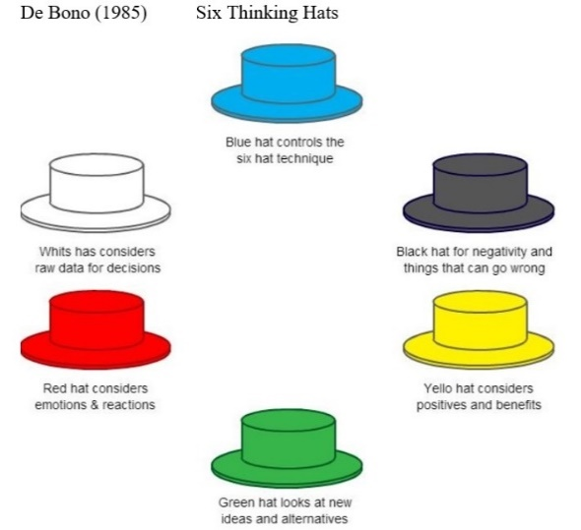
Creativity is assumed break away from existed knowledge and use some sort of extraordinary thought process to leap into the unknown. (Markman, 2009) According to Brunstein (2016), a small group of people worked at the Lab 126 to building Amazon’s new voice-controlled speaker. Amazon thinking process was team thinking process based on the CEO vision about this genius product. Jeff Bezos was much in love with the idea in the first place, there for Bezos failed to look at the product in the rational way. De Bono (1985) have developed the Six Thinking Hat’s tool. It can be used look at decision from number of important perspectives and help planning with mix ambition, skills in execution, public sensitivity, creativity in contingency way. (MindTools, 2022) According to the Kim (2016) Amazon leader Bezos was huge supporter of the device. Bezos has held team high standard due to the unusual nature of the product. Under the White hat Bezos point it out the average latency of existing voice-recognition technology was 2.5 to three seconds, Bezos set the goal at two second, but the best solution would be one second. (Kim, 2016) To achieve the set goals with Alexa leaders had to implement changes. Lewin (1951) model is talk about three steeps unfreeze, change, freeze. The unfreeze stage is about preparing everyone before the change is happen. (Connelly, 2020) Innovation it will bring changes to organisation and the unfreeze stage is preparing the innovation before the change can happen. In this stage in the lab 126 was working hard to develop Alexa first generation and Amazon was working on an impactful marketing strategy to shock the market with Alexa success. Amazon have opened its free Alexa Voice Service (AVS) to third-party hardware makers to integrate into their devices, enabling, for example a manufacturer to turn a Wi-Fi alarm clock into a voice-actuated Alexa-enabled clock radio. (Kass, 2015) Also, Alexa fund was set up for fund the innovation process.

  - Model of Innovation

    - Open and Closed Innovation Model
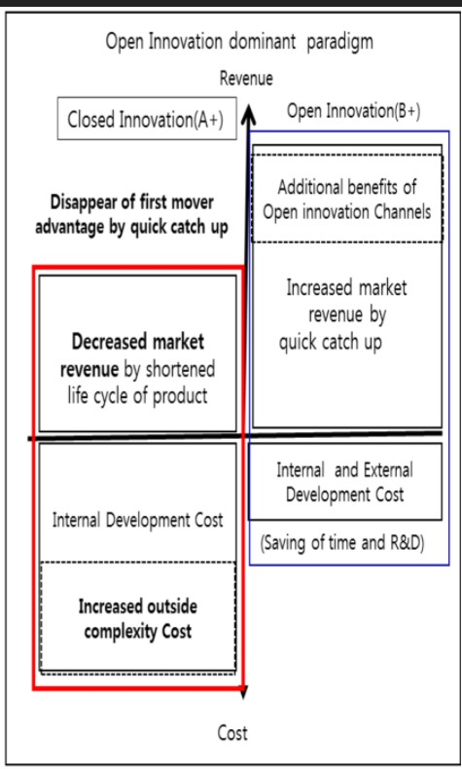
According to Snaps.com (2022) The open innovation model is a term that relates to and promotes the idea of taking and carrying out a modern approach towards innovation by adopting methodologies from the technology industry such as agile project management techniques, proper time allocation dedicated towards proper experimentation and testing for creating a better, more effective, and more efficient program. The advantages to using an open innovation approach, it can lead to better quality and results, as is taking in outside parties’ views and external ideas can comprehends in the process. In the open innovation customers can interact in the early stage of the innovation, in the case of Alexa, Amazon have open up a Alexa fund that is able people to explore people with voice control. According JSK (2018) Amazon is relying on open-source innovation to build the capability of its cloud-based voice service platform. Amazon is providing a Alexa skills development platform for the third party developers to increase the utility of Alexa and the consequent consumer benefits. Using open innovation have helped for Amazon to create a much more accurate market research. Outside developers have created more than 30,000 skills for Alexa, (JSK, 2018) if Amazon would chose to use closed innovation that 30,000 skills development would take much longer time or will be still not be developed. Disadvantage of using open model is information can leak out before the product put on the market. Also, can increase complexity of controlling the innovation process. The 4th diagram created by Yun (2018) is showing the benefits of using closed innovation or a mix approach.
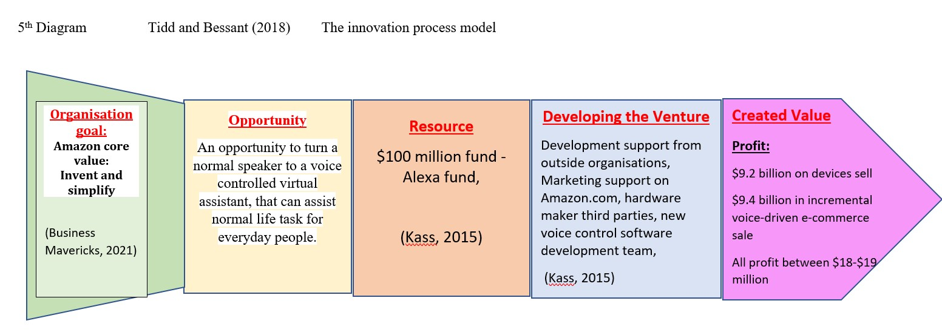
    - The Innovation Process

According to Tidd and Bessant (2018) Innovation Process model it is four stages can be identified in the innovation process: The fish tail is the organisation values and goals, first stage is a recognising the opportunity, the second is finding the resources, third is developing the venture and the fourth is creating a value. The model is explaining that the innovation process describes the path of translating new and/or existing knowledge into marketable solutions. The implementation of Innovation process model can help to have something decisive that put the organisation ahead of others. This model can help designed the path of an idea from generation, through development, to market entry. Applying this model to Alexa innovation process please see the 4th diagram, have clearly showing the process that led to a huge profit and the success of behind Alexa.

    - 4P’s to Innovation
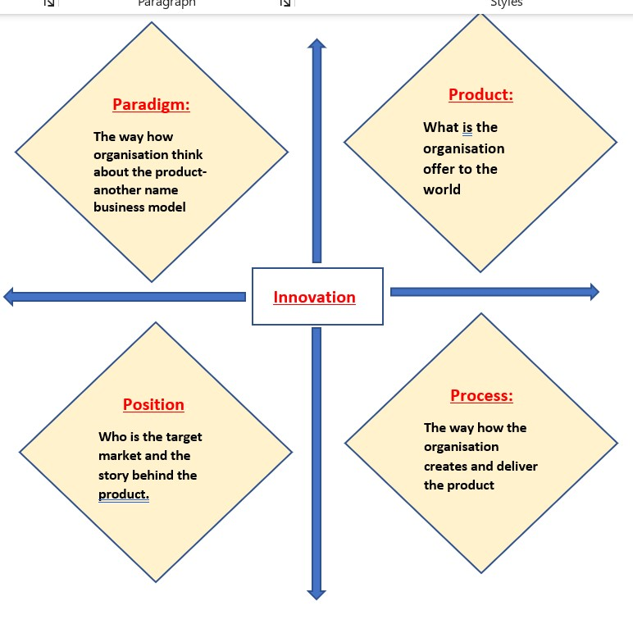
The innovation mix or the 4'Ps is a model that was developed by John Bessant and Joe Tidd (2013) please see the diagram. According to Ibarborda (2020) The innovation mix or the 4Ps model it is giving a direction of where the innovation is going, and in which areas of the organisation need to innovate. The Innovation space supports the idea generation process and how organisation can incubate a new idea. This model is looking at the innovation and giving out 4 different directions to for the innovation. Product innovation is Alexa as a voice controlled virtual assistant offering help managing small task, setting alarms, create shopping list, or answer questions of the consumer. Position: Alexa been created to everyday people any financial background in any age group, also can target businesses as Alexa can set up group calls. Process: Alexa been created as an open innovation people could fallow all the development process and add any ideas for development. Paradigm: Amazon created a new business sector for Alexa, and Alexa have changed the business model of Amazon.
This model will work better Incremental innovation and offer more detail on each section. In the application not any new information been discovered regarding to the innovation process, the model given a direction of the innovation purpose.

  - Assessment of the Effectiveness
To bring about any change, the balance between the forces which maintain the social self-regulation at a given level has to be upset. (Lewin, 1948) Force Field analysis created by Lewin, help understand for leaders the different factors for and against the change that innovation will bring to the organisation. The report have carried out forcefield analysis please refer to this sheet: Force Field Analysis - Worksheet 2.pdf that is explaining the force for changes are much more stronger, that is go against the change.

    - Barriers & Risks
The innovation of Alexa has been questioned from the begging. The main risk was people will not need a product that is look like a speaker and can react for voice command, as other smart phone companies already developed voice control phones. Those companies much more advanced in technological development and have established background. The other risk it is the privacy of the customer. Alexa able to listen of any conversation and tracking shopping habits, the aim for that to offer product for the customers favourite product and encourage customers to shop on Amazon market again. Many people questioned that how much Alexa listen to any conversation and Amazon recording that so felt like being watch by the company. Also, if the product would not be a success could damage the company name.
  - Leadership & Management
The leadership team should design the innovation portfolios and identify the role of business models and technology change to lead to truly significant value creation. (Tony Davila, 2012) It is leadership’s responsibility to make clear to the team who are the targets for value creation from innovation. Amazon have stated fourteen core values and one is the innovation. According to Gaille (2020) the organisation looking for people who are willing to try new things, surprise others with new ideas and can pull inspiration from virtually everywhere. Also, Jeff Bezos be in called perfectionist many times. Jeff Bezos have stated in the online article this quote is “I knew that if I failed, I wouldn’t regret that, but I knew the one thing I might regret is not trying.” (In-Business.org 2017) That mind set a perfect to be lead an innovative company. Jeff Bezos is widely recognized as a transformational leaders, Jeff is someone who motivates and inspires team members to achieve more than they thought possible. Bezos ensures that everyone in the team is committed to the vision for the organisation. (Quellmalz, 2021)
- Conclusion
Jeff Bezos have seen a vision in Alexa how no one did. Scientist in the lab were sceptical of the need of the product. Jeff have chosen to use an open innovation product that was great risk to other companies will copy the product and develop it in the quicker way. The report discovered Alexa been success many ways and made for the organisation a large profit. It is approving the fact, in innovation have to take risk to achieve big outcome. Through the innovation models organisation can measure risk and the use of tools can help make a rational decision to go with the new product or stuck to the old ways.
- References

References
Ang, C., 2021. Ranked: The Most Innovative Companies in 2021. [Online]
Available at: https://www.visualcapitalist.com/ranked-the-most-innovative-companies-in-2021/
[Accessed 05 03 2022].
Ayers, G. C. O. a. A. D., 2005. Building a Radical Innovation Compentensy. Research technology managemen, 48(1), p. 24.
Brustein, J., 2016. The Real Story of How Amazon Built the Echo. [Online]
Available at: https://www.bloomberg.com/features/2016-amazon-echo/
[Accessed 14 03 2022].
BusinessInsider, 2013. There's A Critical Difference Between Creativity And Innovation. [Online]
Available at: https://www.businessinsider.com/difference-between-creativity-and-innovation-2013-4?r=US&IR=T
[Accessed 05 03 2020].
BusinessMavericks, 2021. Amazon Mission Statement, Vision Statement and Crore Values. [Online]
Available at: https://businessmavericks.org/amazon-mission-statement-vision-statement/
[Accessed 10 03 2022].
Connelly, M., 2020. The Kurt Lewin. [Online]
Available at: https://www.change-management-coach.com/kurt_lewin.html
[Accessed 14 03 2022].
Cross, R., 2020. Echo Dot 1st vs. 2nd vs. 3rd vs. 4th Generation Comparison. [Online]
Available at: https://www.smartsmartersmartest.com/echo-dot-1st-vs-2nd-vs-3rd-vs-4th-generation-comparison/
[Accessed 07 03 2022].
EPM, 2021. Force Field Analysis by Kurt Lewin exxplaned version. [Online]
Available at: https://www.youtube.com/watch?v=6gMctSxpZCE
[Accessed 12 03 2022].
Fadden, C. M., 2021. A Very Brief History of Amazon: The Everything Store. [Online]
Available at: https://interestingengineering.com/a-very-brief-history-of-amazon-the-everything-store
[Accessed 05 03 2022].
Gaille, B., 2020. 14 Core Values of Amazon: Its Mission and Vision Statement. [Online]
Available at: https://brandongaille.com/core-values-of-amazon/
[Accessed 21 03 2022].
Gistic.org, 2022. The Innovation of Technologies and its Three Types. [Online]
Available at: http://www.gistic.org/the-innovation-of-technologies-and-its-three-types/
[Accessed 13 03 2022].
GoodNewsNetwork, 2020. Quote of the day. [Online]
Available at: https://www.goodnewsnetwork.org/dr-albert-szent-gyorgyi-quote-on-innovation/
[Accessed 07 03 2022].
Ibarborda, W., 2020. What are the 4ps of Innovation. [Online]
Available at: https://treehozz.com/what-are-the-4ps-of-innovation
[Accessed 14 03 2022].
In-Bussiness.org, 2017. Jeff Bezos Leadership Style – An Inspirational Entrepreneur. [Online]
Available at: https://www.in-business.org.uk/wp-content/uploads/2017/07/Jeff-Bezos-Leadership-Style.pdf
[Accessed 21 03 2022].
Jinhyo Joseph Yun, J. J. K. X. Z., 2018. Benefits and Costs of Closed Innovation Strategy: Analysis of Samsung’s Galaxy Note 7 Explosion and Withdrawal Scandal. Journal of Open Innovation,: Technology, Market and Complexity, p. 5.
Johnson, S., 2010. Where good ideas come from?. London: Allen Lane.
JSK, 2018. Open Innovation at Amazon Alexa: Crowd-sourcing Its Way to Platform Dominance. [Online]
Available at: https://digital.hbs.edu/platform-rctom/submission/open-innovation-at-amazon-alexa-crowd-sourcing-its-way-to-platform-dominance/
[Accessed 10 03 2022].
Kass, D., 2015. Amazon Directs $100 Million to Develop Alexa Voice Technology. [Online]
Available at: https://www.channelfutures.com/sales-marketing/amazon-directs-100-million-to-develop-alexa-voice-technology
[Accessed 10 03 2022].
Kim, E., 2016. The inside story of how Amazon created Echo, the next billion-dollar business no one saw coming. [Online]
Available at: https://www.businessinsider.com/the-inside-story-of-how-amazon-created-echo-2016-4?r=US&IR=T
[Accessed 07 03 2022].
Lewin, K., 1948. Resolving Social Conflict. New York: Harper and Row.
Markman, A. a. W. K., 2009. Tools for innovation. New Yourk: Oxford University Press..
MindTools, 2022. Six Thinking Hats®Looking at a Decision in Different Ways. [Online]
Available at: https://www.mindtools.com/pages/article/newTED_07.htm#:~:text=%20Six%20Thinking%20Hats%20for%20Decision%20Making%20,5%20Black%20Hat%3A%20%22the%20Judge%27s%20Hat%22%20More%20
[Accessed 07 03 2022].
Noppe, L. D., 2011. Encyclopedia of Creativity. Sience Direct, pp. 497-502.
Quellmalz, R., 2021. An Inside Look At Jeff Bezos’ Billion-Dollar Leadership. [Online]
Available at: https://topicinsights.com/leadership-management/jeff-bezos-leadership/
[Accessed 21 03 2022].
Rawes, E., 2020. Amazon Echo (3rd Gen) vs. Amazon Echo (4th Gen). [Online]
Available at: https://www.digitaltrends.com/home/amazon-echo-3rd-gen-vs-amazon-echo-4th-gen/
[Accessed 13 03 2022].
Snnaps.com, 2022. OPEN INNOVATION MODEL. [Online]
Available at: https://www.sinnaps.com/en/project-management-blog/open-innovation-model#:~:text=Open%20Innovation%20Model.%20The%20open%20innovation%20model%20is,proper%20time%20allocation%20dedicated%20towards%20proper%20experimentation%20
[Accessed 10 03 2022].
Tidd, J., 2014. Innplamenting an innovation process. [Online]
Available at: https://www.youtube.com/watch?v=l9sNGnxMEXE
[Accessed 15 03 2022].
Tony Davila, M. E. R. S., 2012. Making Innovation Work: How to Manage It, Measure It, and Profit from It,. Updated edition ed. New Yersey: Pearson..
Ungarino, R., 2018. Amazon's Alexa could be a $19 billion business by 2021, RBC says. [Online]
Available at: https://markets.businessinsider.com/news/stocks/amazon-stock-price-alexa-19-billion-business-rbc-says-2018-12-1027829391#:~:text=Amazon%20%27s%20Alexa%20could%20generate%20between%20%2418%20billion,45%25%20higher%20than%20its%20estimate%20from%20last%20ye
[Accessed 10 03 2022].
Westerby, N., 2020. The Gdańsk man who brought US giant Amazon to Poland. [Online]
Available at: https://www.thefirstnews.com/article/the-gdansk-man-who-brought-us-giant-amazon-to-poland-12713
[Accessed 13 03 2022].
Winters, J., 2016. Alexa and Innovation Research at Amazon. [Online]
Available at: https://www.plu.edu/innovation-studies/news/alexa-and-innovation-research-at-amazon/#:~:text=Alexa%20is%20a%20major%20opportunity%20for%20innovators%20who,Minsky%20while%20I%20was%20an%20employee%20at%20Microsoft.
[Accessed 13 03 2022].

5.0. Appendices

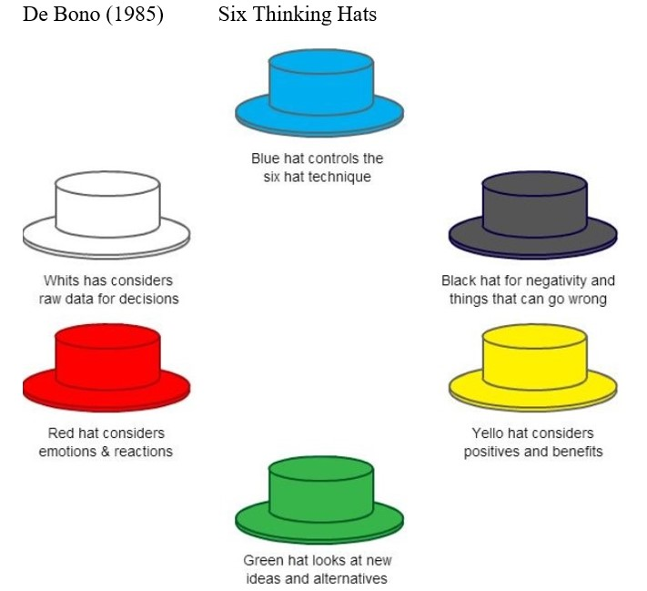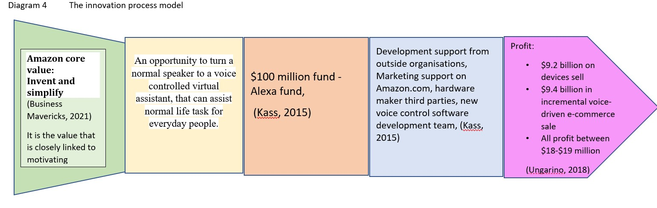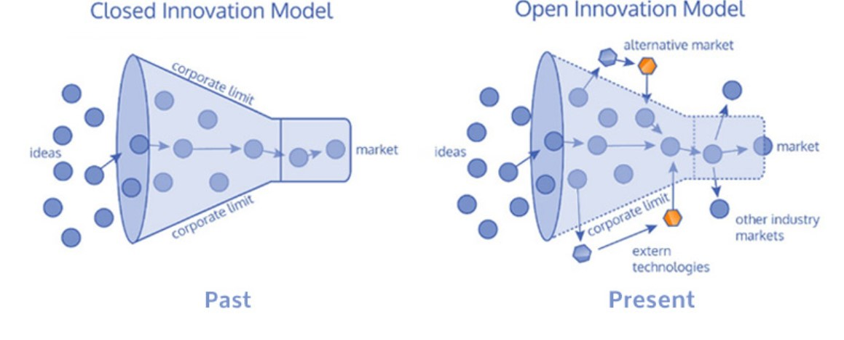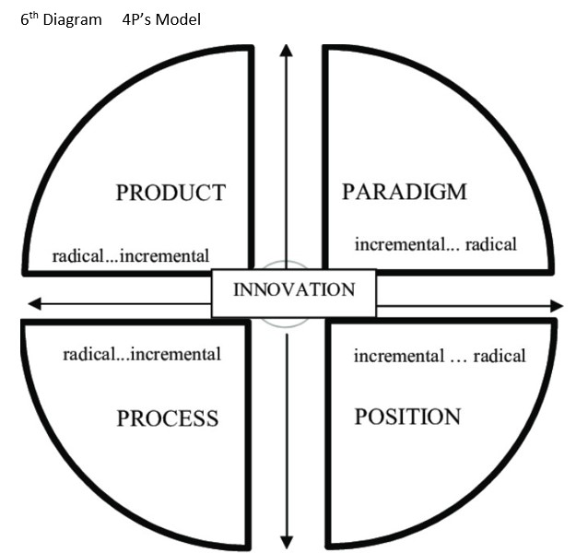
Task 2

- Question 1- Critical evaluation how innovation and creativity can support business advantage

According to Ward (2014) Business innovation is the process of making something new or improved that better serves a business. Innovation can apply for product, service, efforts, policies, or business models. Creativity usually refers to the act of generating new ideas itself, regardless of whether those ideas result in measurable outcome or solutions. (Indeed, 2022) Thinking creatively is the key in innovation, through creativity business can identify new ways to do things and create tangible products that is contribute to the innovation outcome. Innovation can help grow businesses, through adding an extra value and profit merging to any organisation. Through creative thinking businesses can develop new ways and adapt to the contently changing market it is allowing business to stay ahead of competition. Also, through innovation business can take advantage of technologies. Technologies can help produce better product, offer better service, track performance, or analyse the market. Thu innovation have lots of positive effect on businesses can come with many risks. According to Shultz (2021) innovation can be extremely expensive and the profit are not guaranteed. Also, innovation is very time consuming, the time that businesses spend innovation and leaders not focusing on existed product, marketing and sales can risk falling behind casual and profit lost from an excited product. Another great risk is the innovation outcome never guarantied. Businesses spending money, time and labouring create something and that is unsuccess, on the top of the loss will the product damage the reputation of the business. Thus, many risk but businesses all about taking risk and creating something that is make them unique. Tredgold (2022) have stated the right innovation will allow businesses to offer something unique to the customers and allow business to stand out from the competition to win the customers.

References:
Ward, S. (2020) What is business innovation [online] Available at: Business Innovation: What Is It? (thebalancesmb.com) (Accessed: 21/03/2022)
Indeed (2021) Innovation and Creativity: What is the difference? [online] Available at: Innovation and Creativity: What's the Difference? | Indeed.com (Accessed: 21/03/2022)
Shultz, H. (2021) Why Innovation is Essential for Business Success [online] Available at: Why Innovation Is Essential for Business Success - 2022 - MasterClass (Accessed 21/03/2022)
Tredgold, G. (2022) 4 Reason Why You Need to Focus on Innovation [online] Available at: 4 Reasons Why You Need To Focus On Innovation | Inc.com (Accessed: 21/03/2022)

- Reflection on innovation model’s lecture

