
Student name:Daniela Ionela Bruma
Student ID number:2128799
Programme: BA International Hotel Management
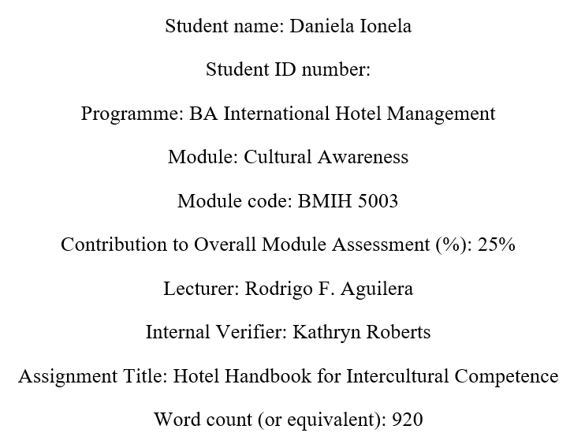
Executive summary
This paper is a brief explanation about cultural competence and cultural awareness. It provides information of cultural difference between UK and UAE people, their behaviour and traditions. How the hotel staffs should communicate and behave with the customers of different cultural background is provided with recommendation of correct and incorrect tasks.
Table of Contents
Introduction 4
Intercultural competence and importance of cultural understanding in a global marketplace 5
Analysis between UK and UAE to identify key cultural differences customs and behaviour 5
The United Kingdom cultures (London Marriott Hotel County Hall) 5
Culture of UAE (guest’s home country and culture) 6
Country differences applying Hofstede’s model of cultural behaviour 6
Summary 7
Recommendation 7
References 9

Introduction
cultural awareness is reported as being sensitive to the differences and similarities between two cultures when communicating with another cultural person. When people become culturally aware they understand the values and beliefs different cultures portray. Cultural awareness is also about recognising that there are differences in values of persons that are shaped by different cultural backgrounds (Smith, 2012). This report will hence show the importance of cultural awareness, difference between cultural background, and will offer some recommendations to hotel Staffs for better service provision at London Marriott Hotel. Cultural Difference between the UK and Arab Emirates will be presented in the following sections to provide a valuable insight of cultural understanding.

Intercultural competence and importance of cultural understanding in a global marketplace
Intercultural competence is known as the ability to act effectively across cultures, to think and act properly and to communicate and work with people from different cultural backgrounds at ease. A perfect example of intercultural differences is presenting different attitudes to politeness in different cultures (Hall and Hall, 2014). Such as what may consider as politeness in one country can be seen as rude in another country. For example, in Argentina people are not afraid to do body touch during conversation and while communicating that distance is very close as they think the person who maintains distant is rude or cold, whereas in countries like Japan people must keep an appropriate distance from each other while communicating as well as they do not do body touch as touching an unknown person while conversating is considered rude.
Therefore, cultural understanding is very important in a global marketplace. To keep the business running, employees and employers both must understand the differences of culture (Hachlafi, 2021). Good cultural understanding can result in effective communication leading to clearer and direct perspectives of the opposite person. It also helps in building strong relationship with businesspersons, customers, and business partners from different cultures as it demonstrates how a person respects or trusts or is willing to adapt to the needs and expectations of others. It also promotes workplace diversity and inclusion as well as it supports in conflict resolution.

Analysis between UK and UAE to identify key cultural differences customs and behaviour

The United Kingdom cultures (London Marriott Hotel County Hall)
London Marriott County Hall Hotel is listed as grade-2 hotel in the South Bank of London. The hotel has 206 bedrooms, and its target customers are luxury travellers. Marriott international is world’s 308th most valuable company by market capital. Be a grade two listed building London Marriott hotels building structure represents special interest and warranting every effort to preserve that building as it has a long history. Because of that it represents a different culture do its target customers. Such as the UK has a deep sense of history, and they want to preserve every inch of that history and historical structures (Sawe, 2022). The people are also rich in different tradition, and they love literature and arts. They are very sports person and has diverse ethnic communities as they prefer multiculturalism. The dressing sense and speaking are also westernised.

Culture of UAE (guest’s home country and culture)
Majority of the customers visiting the London Marriott County Hall hotel are people from UAE or United Arab Emirates. Based on the religion travellers of UAE are Muslims and they have a very different living pattern and dress codes (Kelly, 2017). There are differences between Middle Eastern countries and Western countries depending on cultures, traditions, religion, power distance, and communication pattern. UAE travellers mostly prefer Middle Eastern foods that are halal certified. Their food choices are non-alcoholic and most of them prefer a distance while communicating with opposite genders (Watson, 2008). Based on power most of the men are influential and hold power over others. They communicate with strangers easily as they think everyone feels happy while meeting with new persons.

Country differences applying Hofstede’s model of cultural behaviour
From the information found above about two countries of UK and UAE it is still a wonder that two countries in this single world can be so different. To represent main differences of cultural behaviour and customs Hofstede’s model of cultural differences is presented below-
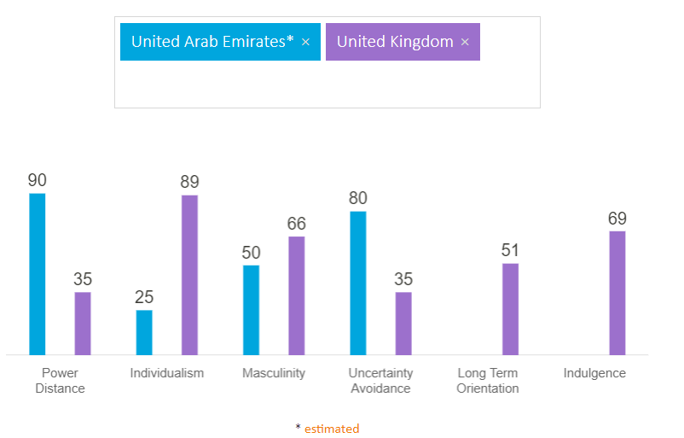
Figure- Cultural difference between UK and UAE Source- (Hofstede Insights, 2022)
This model represents that the power distance in UAE culture is higher than United Kingdom. People with higher power holds most of the authority over lower powered ones which miss sometimes may result in inequality (Samovar et al., 2013). Arabian people love to stay with their families, and they prefer collectivism, but it is different in UK as people prefer independence and self-freedom. Arabians hates facing uncertain events and dislikes risk taking which is rather opposite in British people.

Summary
The world is full of different people and traditions. Most of the people has some kind of differences in their cultural practises. From the analysis it was found that the UK and UAE cultures are different. UK people have behaviour of individualism, they use democracy, always ready to take risks. But Arabians are more collective in nature and they have distance in power as well as avoid risks to be less critical. It is better for the service providers to be informed about these different cultures and cultural practises to ensure that they can offer best service that meets the needs of the guests.

Recommendation
As the hotels staffs will interact with customers directly, so they need to be informed about cultural differences and should be culturally competent. London Marriott Hotel’s employees are hired based on their excellent skills and experiences. They are train to offer diverse services that meets the needs of the customers from different cultural backgrounds. Therefore, the hotel provides recommendation
- Staffs must offer prayer matts at guest rooms and add qibla signs and shouldn’t play loud music during praying times to show respect (Abramson et al., 2018). Employees must be careful while service beverages.
- Staffs must keep an Arabian interpreter as there may be travellers who may find it hard to understand english.
Cultural etiquette | DO | DON’T
Religious practise | Offer prayer matts at guest rooms and add qibla signs | Play loud music during praying times to show respect (Abramson et al., 2018)
Alcohol | Serve non-alcoholic foods and beverages | Offer alcoholic foods
Communication | Communicate with male persons for decision-making (Samovar et al., 2013) | Communicate with close distance with female
Arts and crafts | Use scriptures or writing at guestrooms for Arabians (Timm, 2011). | Put animal or human pictures or sculptures in guestrooms

References
Abramson, N. et al. (2018) Managing cultural differences : global leadership for the 21st century. 10th edition. Abingdon, Oxon: Routledge.
British Council (2022) Arabic language and Arab culture [online]. Available from: https://www.britishcouncil.org/sites/default/files/arabic_language_and_culture_education_pack.pdf (Accessed 10 June 2023).
Chevening (2022) British life and culture | Chevening [online]. Available from: https://www.chevening.org/current-cheveners/living-in-the-uk/british-life-and-culture/ (Accessed 10 June 2023).
Hachlafi, S. (2021) 5 interesting facts about Arabic culture from an IFBI employee [online]. Available from: https://www.infarmbureau.com/inside-story/articles/5-interesting-facts-about-arabic-culture-from-an-ifbi-employee (Accessed 10 June 2023).
Hall, E. and Hall, M. (2014) Understanding cultural differences. Boston, Mass.: Intercultural Press.
Hofstede Insights (2022) Compare countries - Hofstede Insights [online]. Available from: https://www.hofstede-insights.com/product/compare-countries/ (Accessed 8 June 2023).
Kelly, T. (2017) 11 Traditional Emirati Customs All Visitors Should Know About [online]. Available from: https://theculturetrip.com/middle-east/united-arab-emirates/articles/11-traditional-emirati-customs-all-visitors-should-know-about/ (Accessed Accessed 3 June 2023).
Samovar, L. et al. (2013) Communication between cultures. 8th edition. Boston, Mass.: Wadsworth/Cengage Learning.
Sawe, B. (2022) What is British Culture? [online]. Available from: https://www.worldatlas.com/articles/what-is-british-culture.html (Accessed 3 June 2023).
Timm, A. (2011) Intercultural problems in the tourism industry. Munich: Grin Verlag.
Watson, S. (2008) Respecting cultural differences. Collingwood, ON: Saunders Book Co.

