
Jack Lewis (2011032)

Assignment 2 – The role of zoos in wildlife conservation
Table of Contents
1 Introduction 1
2 Zoos’ Role in Wildlife Conservation 1
2.1 UK and European Legislation 1
2.2 International Union for Conservation of Nature (IUCN) 1
2.2.1 Red List 2
2.2.2 Green Status of Species 3
2.3 Case Study 1 – Welfare of Bears in Polish Zoos 3
2.4 Case Study 2 – Plantasia Zoo – Swansea 5
2.5 Case Study 3 – Golden Lion Tamarin (Leontopithecus Rosalia) 6
2.6 Case Study 4 – Northern White Rhinoceros (Ceratotherium simum) ssp. cottoni 7
2.7 Evolution 8
3 Conclusion 9
4 References 10
5 Bibliography 12

Figure 1 - United for Life and Livelihoods (IUCN, 2023). 2
Figure 2 – IUCN Red List Key (FSC Biolinks, 2021). 3
Figure 3 - Bear in Captivity - Polish Zoo (Four Paws, 2021). 4
Figure 4 - Polar Bear Enclosure at Warsaw Zoo (Bear Conservation, 2021). 5
Figure 5 - Edwards's pheasant (Viêt Nature, 2020). 6
Figure 6 - Golden Lion Tamarin (Taronga Conservation Society Australia, 2017). 7
Figure 7 - Northern White Rhinoceros (Busby, 2022). 8

Introduction

Are zoos good for wildlife conservation, and is their work necessary? This report will explore the history of zoos, and how modern-day zoos have changed compared to the past. In addition, this report will use case studies to try and understand what procedures and legislation are in place to help wildlife's welfare. Furthermore, the report will evaluate how zoos may look in the future and how advancing scientific technology may play a part in the evolution of zoos.

Zoos’ Role in Wildlife Conservation

National Geographic (2022) states that “a zoo is a place where animals live in captivity and are put on display for people to view. The word “zoo” is short for “zoological park” (National Geographic, 2022). This statement could suggest that a zoo's sole purpose is for human entertainment. However, it could be argued that this view now seems outdated, as it may have been true with zoos of the past, which were renowned for exploiting animals, and viewing them as business assets to make money off (Safina, 2018). To support this view, Phillips (2015) believes that modern-day zoos are now a vital resource for scientific research, and education, along with playing a key role in animal conservation. In addition, it could be said that zoos may be the key to holding onto certain species that are struggling, as the United Nations (UN) (2019), reports that “Nature’s dangerous decline ‘unprecedented’; Species extinction rates ‘accelerating” (UN, 2019). Furthermore, Rose and Riley (2022) explain that modern-day zoos provide a recreational aspect, but zoos of the future need to offer an additional element in the way of helping and supporting the mental health and well-being of the animals as well as the humans, including both visitors as well as employees.

UK and European Legislation

The legislation in place throughout Europe to protect animals kept in zoos is known as the Zoos Directive (1999). This piece of legislation not only protects but also promotes the conservation of captive wildlife within Europe (The Zoos Directive 1999). Furthermore, the European Association of Zoos and Aquaria (EAZA), introduced a Code of Ethics (EAZA, 2009), to reinforce the main piece of legislation. In addition, the UK also utilises its own act known as Zoo Licensing Act 1981, which involves a licensing system as well as yearly inspections that are carried out by government-appointed veterinary inspectors, in order to assess animal welfare within zoos in the UK (British Veterinary Association, 2019).

International Union for Conservation of Nature (IUCN)

IUCN was created in 1948 and has since become the largest environmental network in the world. Figure 2 (below) is a diagram showing the size of the organisation, with over 1,400 members and 15,000 experts working together. The key principle aim of this organisation is to provide benefits to people and nature (IUCN, 2023).

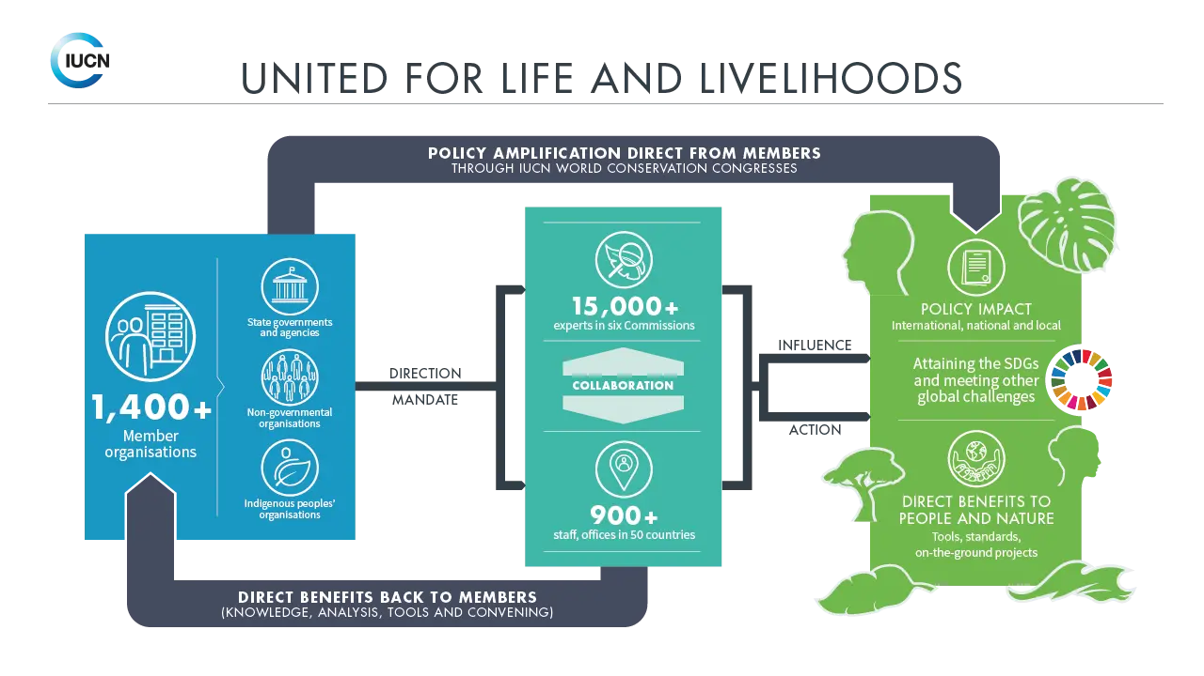
Figure 1 - United for Life and Livelihoods (IUCN, 2023).

Red List

The IUCN Red List is a tool created to indicate species' global population size, range, and habitat. The Red List also shows the threats towards certain species and the conservation effort that is needed to protect them. This highly important tool is used worldwide by many organisations, some of which include wildlife departments, government agencies, non-governmental organisations (NGOs), educational organisations, and natural resource planners (International Union for Conservation of Nature, 2022).

How Does it Work?

As stated by FSC Biolinks (2021), the IUCN will carry out thorough assessments of certain species in order to collect information, which in turn allows the IUCN to gauge the extinction risk of that species and assign it to one of eight different categories. Figure 4 (below) shows seven out of the eight categories, the eighth category that isn’t shown is ‘Data Deficient’ (FSC Biolinks, 2012), which means that there is not enough data on a certain species for it to be categorised. Here is a brief explanation of the seven categories shown in figure 4:

- EX – Extinct – Thought to be completely extinct worldwide.
- EW – Extinct in the Wild – Only exist in captivity.
- CR – Critically Endangered – At very high risk of extinction (only in the wild).
- EN – Endangered – At high risk of extinction (only in the wild).
- VU – Vulnerable – At risk of extinction (only in the wild).
- NT – Near Threatened – At a level to cause concern.
- LC – Least Concern – Minimal risk of extinction, with widespread distribution.
(FSC Biolinks, 2021).

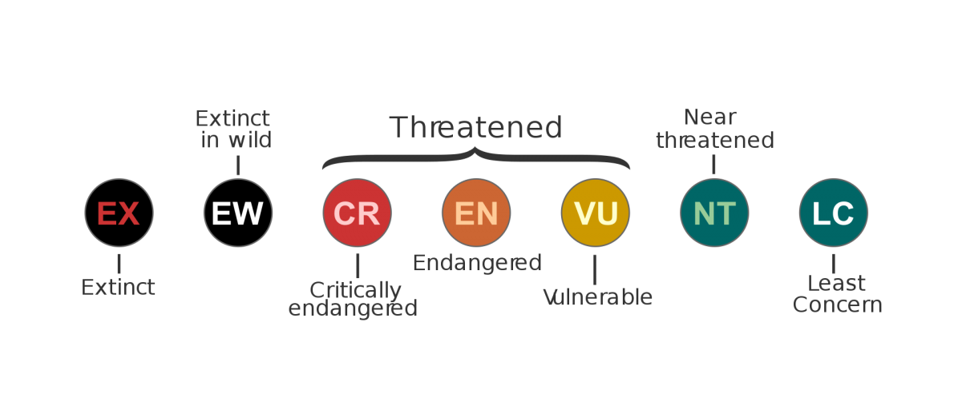
Figure 2 – IUCN Red List Key (FSC Biolinks, 2021).

Green Status of Species

It is suggested by the Zoological Society of London (ZSL) (2022), that the IUCN Green Status of Species is a tool created in 2021, to show how a certain species is managing within the ecological system in which it lives. Additionally, the tool also shows how a species has recovered due to the conservation efforts given. The main aim of this tool is not only to allow a species to survive but to thrive.

Case Study 1 – Welfare of Bears in Polish Zoos

Figure 1 (below) is a photo of a bear in a Polish zoo, the picture shows the terrible conditions in which bears were forced to live in. A study by Maślak et al (2015), which looked at bears that were kept in captivity between 2007-2009, goes into depth about the extremely poor standards by which some of these bears were kept. The results from this study were then put forward to the Polish government to tackle this problem (Maślak et al, 2015, p24-36).

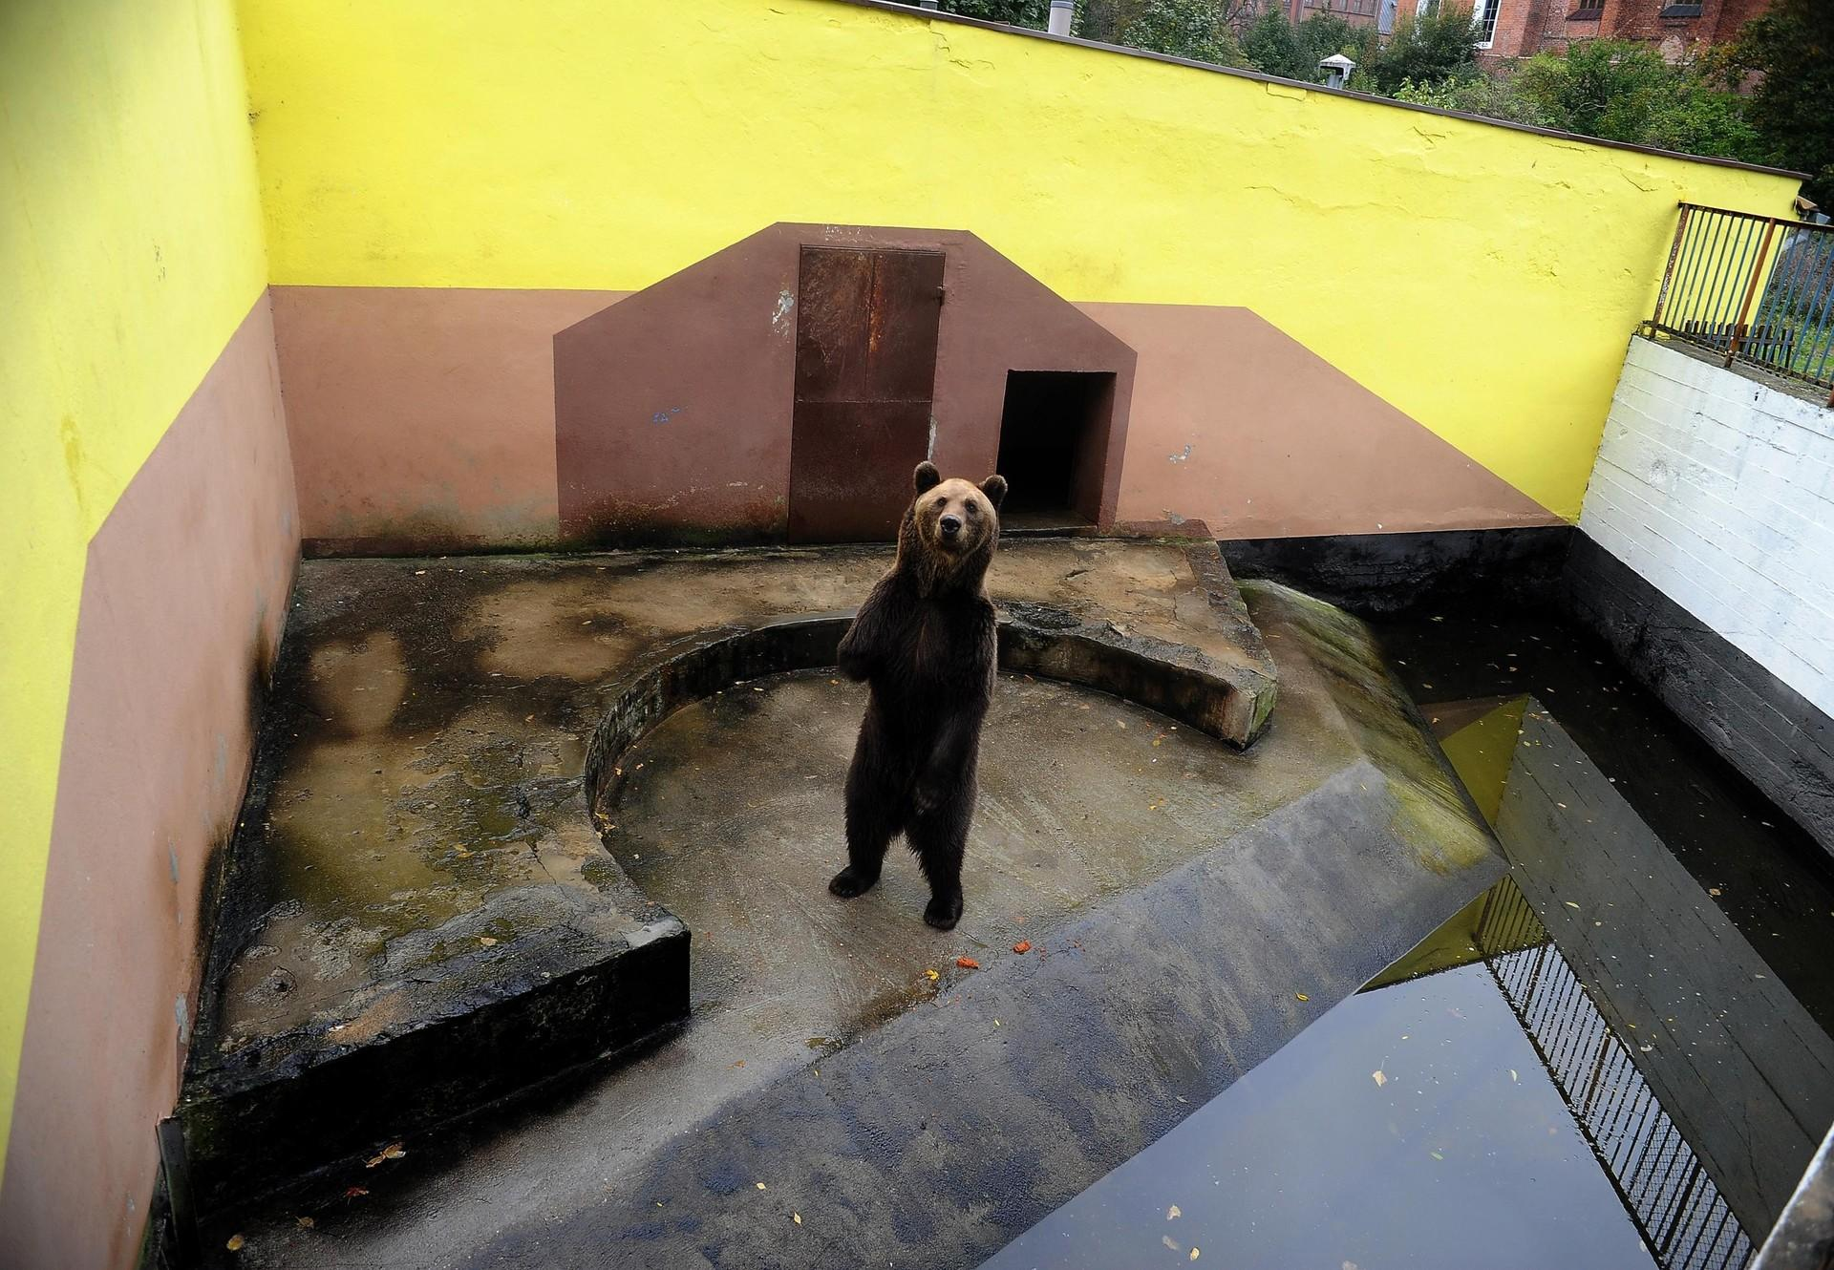
Figure 3 - Bear in Captivity - Polish Zoo (Four Paws, 2021).
The Bear Conservation (2021), explored and investigated the welfare of polar bears (Ursus maritimus), which are classed as vulnerable on the Red List Status (Wiig et al, 2015). Bear Conservation (2021) lists some concerns about how the animals are kept. Some of the concerns on the list include an unsuitably sized enclosure for animals of this size, as can be seen in figure 4 below of Warsaw Zoo. Also outlined on the list are climate conditions that are unsuitable for this species of animal, and then the article goes on to state noticeable and unusual behaviour in the bears, which is believed to be related to stress. Investigations show that the bears were being kept in unsatisfactory conditions and needed to be relocated to a more suitable facility. Although it is suggested that the bears should be relocated, it is clear to see from the images that the bears are in no fit condition to live and survive in the wild. Therefore, it could be argued that the bears will never experience life in the wild and, as a result, would need to be relocated to another more suitable captivity program.

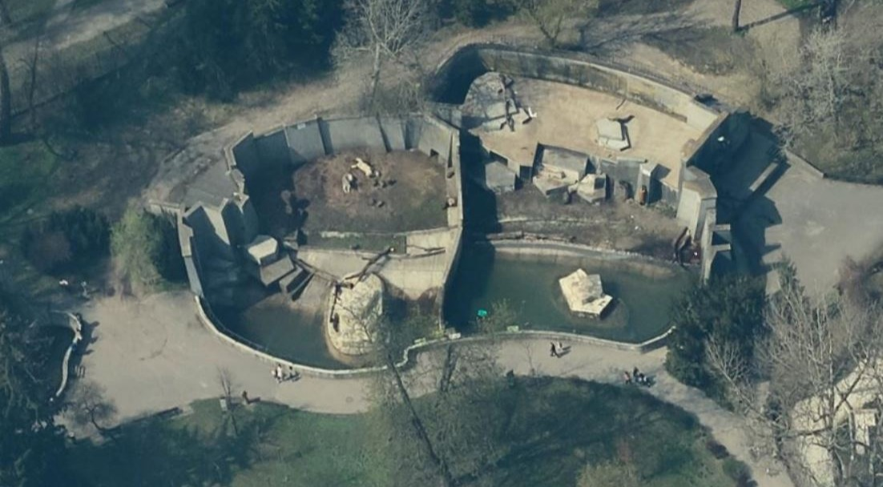
Figure 4 - Polar Bear Enclosure at Warsaw Zoo (Bear Conservation, 2021).

Case Study 2 – Plantasia Zoo – Swansea

Plantasia has the view that modern-day zoos play a massive part in wildlife conservation, as well as a vital educational resource. It was stated by Williams (2022) that Plantasia zoo can only acquire animals from other zoos and not directly from the wild. In addition, all the animals that are kept at Plantasia have paperwork that records all the individual species' details, namely which zoo the animals have previously come from, breeding and behaviour records, as well as the age and sex of the animal (European Professional Zookeeper Qualification Framework, 2018).

Plantasia admits that it struggles to cope with the ever-growing pressure from people abandoning unwanted exotic pets at the zoo's door. Williams (2022) suggests that people may not understand the commitment that is needed to look after some of the more unusual and exotic pets. It was discussed that Plantasia is unable to accept these unwanted pets, suggesting that the unwanted pets can usually end up being released into the countryside by their owners. As a result of this, these non-native species, when released into the wild may go on to outcompete some of the native species, causing massive problems to the UK’s ecosystem. Therefore, it could be argued whether the presence of zoos is encouraging invasive species. It could be viewed that when Plantasia showcase a new animal species, this influences the visitors to then want that newly, fashionable, and desirable pet in a domestic setting, and in turn encouraging people purchasing said unique, non-native animals.

Williams (2022) explained a captive breeding for release project in detail that involves Edwards’s pheasants (Lophura edwardsi) (see figure 5 below). This species of pheasant is recorded as critically endangered on the IUCN Red List (Birdlife International, 2018). Plantasia had two of these species in 2021, but after successful breading had seven in 2022. Furthermore, Williams described how other zoos were a part of this conservation project, which included the likes of the London Zoo. Williams also stated that some of the Edwards’s pheasants involved in this large conservation project would hopefully go on to be released into the wild, in the hope to increase population size.

Furthermore, it is viewed by Wentz (2018) that captive breeding projects may have long-term negative impacts. Wentz believes that species involved in these programs can over time evolve and adapt to human interaction, where the animal can rely on being provided with a constant food source. These traits can become ingrained into the species' genes, which in turn could be inherited by the offspring when released into the wild. In addition, it is suggested that this trait of relying on human-influenced environments could mean that the animal struggles to survive in their natural habitat.

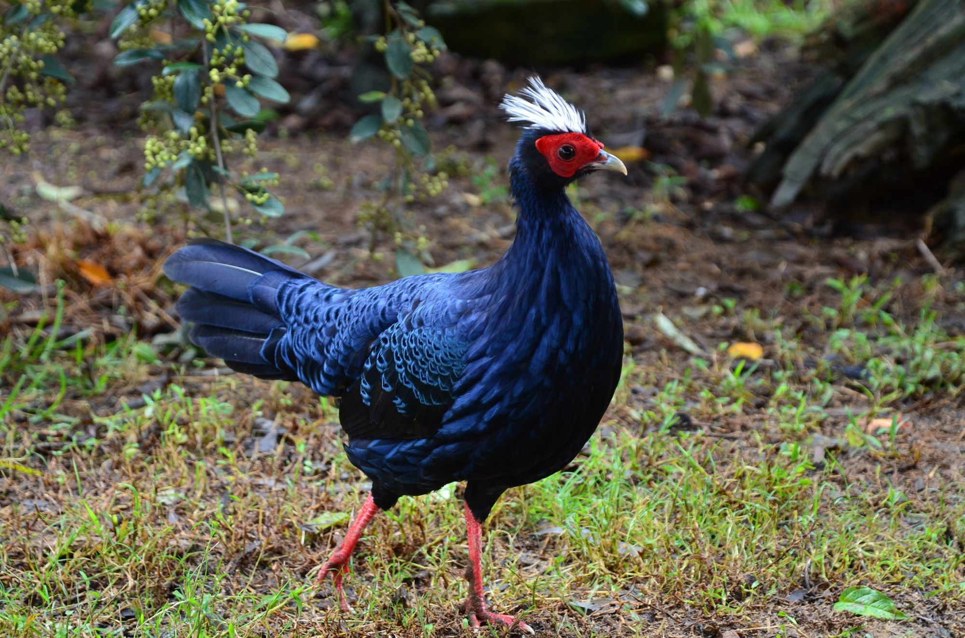
Figure 5 - Edwards's pheasant (Viêt Nature, 2020).

Case Study 3 – Golden Lion Tamarin (Leontopithecus Rosalia)

The golden lion tamarin (see figure 6 below) population declined massively in the 1980s as a result of habitat loss caused by logging and mining, along with threats from poaching. A huge conservation effort was made to prevent this species from going extinct. It was believed that a key milestone was reached in 2003 when the golden lion tamarin was moved from critically endangered, to endangered on the IUCN Red List (Taronga Conservation Society Australia, 2017) (IUCN, 2018). Ruiz-Miranda et al (2021), who carried out an assessment of the golden lion tamarin population in 2015, showed that the species remains on the endangered list. Although there is still more work to be done, it could be considered that the golden lion tamarin is a success story, partly due to the IUCN’s Red List tool being utilised. Furthermore, it is thought that around a third of all golden lion tamarin monkeys in the wild were raised and cared for by humans (Taronga Conservation Society Australia, 2017) (IUCN, 2018). As discussed above, this captive breeding for release method of conservation can have long-term negative impacts on a species, especially when considering that around 33% of the wild population of this species has been raised this way. The full impact of this process should be monitored closely throughout the future generations of this species. Additionally, Ruiz-Miranda et al (2021) believe that the current population status of this species stands at 1400 mature individuals and declining. It is suggested that this is a result of a fragmented population in the wild due to the pressures from deforestation. It could be said that this problem needs to be addressed, which in turn, may allow the conservation effort for this species more successful.

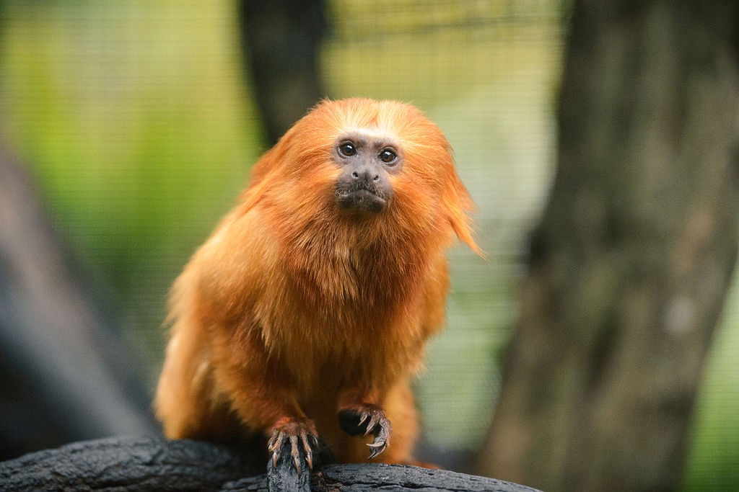
Figure 6 - Golden Lion Tamarin (Taronga Conservation Society Australia, 2017).

Case Study 4 – Northern White Rhinoceros (Ceratotherium simum) ssp. cottoni

The northern white rhino (see figure 7 below), could be considered a conservation failure. This subspecies was believed to have been common in the 1960s throughout several countries in Africa, but due to serious pressures from poaching, the population of this species has crashed (Flora & Fauna International, 2023) (Pickerell, 2006). It is reported by Cannon (2023), that there are only two of the species left in the world, consisting of a mother and a daughter named Najin (mother), and Fatu (daughter), which would suggest that there is no way back for this subspecies. It is stated by Brownlee (2022) that these two remaining northern white rhinos live in a 700-acre enclosure and require 24-hour, around-the-clock armed protection from poachers. This in turn puts the northern white rhino as critically endangered on the IUCN Red List, as stated in an assessment which was carried out by Emslie (2020), on behalf of the IUCN. This drastic reduction in population has caused a genetic bottleneck in this species, which could mean that any conservation effort to increase the population is at risk of inbreeding as a result of limited variation in the genes (National Geographic, 2022). It is clear to see that human intervention has not only put this species in danger because of poaching, but human intervention is now also the only chance that this subspecies has of surviving, due to the massive conservation effort they receive. When looking at the risk of inbreeding and the problems that it could bring, along with the financial cost of scientific research programs and armed protection, the question could be asked - is saving this species all that beneficial, or are we doing it because we feel like it’s the ethical thing to do?

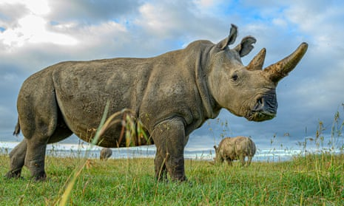
Figure 7 - Northern White Rhinoceros (Busby, 2022).
Furthermore, it is believed that there is still hope for the northern white rhino. An organisation called BioRescue which is based in Berlin, are attempting to create lab-grown sperm cells and eggs. The group of scientists behind this project have been able to convert stem cells into primordial germ cells (PGCS). This process will use frozen sperm from deceased male northern white rhinos, which will then be used to try and impregnate Fatu by using IVF techniques. This could be considered a relatively big breakthrough in the path towards saving this subspecies (Cannon, 2023) (Brownlee, 2022).

Science could hold the key to saving endangered species. Advancements in scientific research have reached the point now where scientists believe that they are able to bring back extinct species (de-extinction). It is suggested by Ashworth (2023), that scientists have been working on bringing back species such as the woolly mammoth (Mammuthus primigenius), thylacine (Thylacinus cynocephalus), and more recently added to the list, the dodo (Raphus cucullatus). This raises the question whether this advancement in scientific research is the answer to saving some of the world's most endangered species? This seems to be highly debatable, as it is stated that “while some argue de-extinction could help to restore damaged ecosystems, others believe it is an expensive distraction from the threats facing living species.” (Ashworth, 2023).

Summary – Evolution

This leads to a further question about what role do zoos have to play in saving some of the most vulnerable species? There is a theory by Thomas (2017) that the world is in the midst of a sixth genesis, and that biodiversity is actually increasing. Thomas believes that even though certain species are declining at an alarming rate, this has only allowed other species to take advantage, where they can spread into unnatural habitats, which in turn could induce the natural speciation process, allowing the species to adapt and evolve into new species. As famously discovered by Charles Darwin, this is all part of evolution, a process that has happened since time began (Radeva & Darwin, 2019). This begs the question – is trying to hold on to, or in some cases bringing back species (de-extinction), ethical or should we just let the natural process of evolution take its course?

Conclusion

To conclude, human intervention, in the way of conservation programs is truly the only chance that some species have of surviving, but when the population of a species is so seriously reduced, is the effort and financial cost worth it? The Polish zoos mentioned above, seem to be more like the zoos of old, where the animals are kept for entertainment purposes only and don’t hold any interest in the animal's welfare. It is clear to see that the legislation currently in place throughout Europe is ineffective when looking at these poorly kept captive bears. It could be suggested that a review of current legislation and a plan to implement that legislation may be needed.

References

Ashworth, J. (2023) Dodo ‘de-extinction’ announcement causes conservation debate. Available at: https://www.nhm.ac.uk/discover/news/2023/february/dodo-de-extinction-announcement-causes-conservation-debate.html (Accessed: March 9, 2023).

Bear Conservation. (2021) Captive polar bears: Warsaw Zoological Gardens. Available at: http://www.bearconservation.org.uk/captive-polar-bears-warsaw-zoological-gardens/ (Accessed: March 9, 2023).

BirdLife International. (2018) Lophura edwardsi. The IUCN Red List of Threatened Species 2018: e.T45354985A129928203. Available at: https://dx.doi.org/10.2305/IUCN.UK.2018-2.RLTS.T45354985A129928203.en (Accessed: March 9, 2023).

British Veterinary Association. (2019) ‘Birds of prey should not be tethered’ Veterinary Record, 185(1), pp. 5–5. Available at: https://doi.org/10.1136/vr.l4526.

Brownlee, S. (2022) Guardians of the Northern white rhino: The worlds most endangered species. Available at: https://www.euronews.com/green/2021/10/26/guardians-of-the-northern-white-rhino-the-world-s-most-endangered-species (Accessed: March 6, 2023).

Busby, M. (2022) Return of the rhino: can we bring the northern white back from extinction? Available at: https://www.theguardian.com/science/2022/dec/18/return-of-the-northern-white-rhino-back-from-extinction (Accessed: February 20, 2023).

Cannon, A (2023) Northern white rhinoceros could be brought back from the brink of extinction. Available at: https://www.biotechniques.com/cell-and-tissue-biology/northern-white-rhinoceros-could-be-brought-back-from-the-brink-of-extinction/ (Accessed: February 20, 2023).

Emslie, R. (2020) Northern White Rhino. Available at: https://dx.doi.org/10.2305/IUCN.UK.2020-1.RLTS.T4183A45813838.en (Accessed: February 20, 2023).

European Association of Zoos and Aquaria, (2009). Code of Ethics. Available at: https://www.eaza.net/assets/Uploads/Standards-and-policies/EAZA-Code-of-Ethics-2009.pdf (Accessed: February 27, 2023).

European Professional Zookeeper Qualification Framework. (2018) 2.8 Record Keeping. Available at: https://www.zookeepers.eu/framework/area-2-animal-management/2-8-record-keeping/ (Accessed: March 8, 2023).

Flora & Fauna International. (2023) Northern white rhino. Available at: https://www.fauna-flora.org/species/northern-white-rhino/ (Accessed: March 6, 2023).

Four Paws. (2021) Bears in Poland. Available at: https://saddestbears.four-paws.org/bears-in-poland (Accessed: February 23, 2023).

FSC Biolinks. (2021) Exploring the IUCN Red List of Threatened Species. Available at: https://www.fscbiodiversity.uk/blog/exploring-iucn-red-list-threatened-species (Accessed: March 2, 2023).

International Union for Conservation of Nature. (2022) Background & History. Available at: https://www.iucnredlist.org/about/background-history (Accessed: February 23, 2023).

International Union for Conservation of Nature. (2023) About IUCN. Available at: https://www.iucn.org/about-iucn (Accessed: February 27, 2023).

International Union for Conservation of Nature. (2018) Golden lion tamarin makes a comeback. Available at: https://www.iucn.nl/en/story/golden-lion-tamarin-makes-a-comeback/ (Accessed: February 20, 2023).

Maślak, R. Sergiel, A. Bowles, D & Paśko, L. (2016) The Welfare of Bears in Zoos: A Case Study of Poland, Journal of Applied Animal Welfare Science, 19:1, 24-36, DOI: 10.1080/10888705.2015.1071671

National Geographic. (2022) Genetic Bottleneck. Available at: https://education.nationalgeographic.org/resource/genetic-bottleneck/ (Accessed: March 20, 2023).

National Geographic. (2022) Zoo. Available at: https://education.nationalgeographic.org/resource/zoo (Accessed: February 14, 2023).

Phillips, K. (2015) The ethical evolution of zoos. Available at: https://www.abc.net.au/radionational/programs/rearvision/the-ethical-history-of-zoos/6869776 (Accessed: February 14, 2023).

Radeva, S. and Darwin, C. (2019) Charles Darwin’s On the origin of species. London: Puffin.

Rose, P.E. and Riley, L.M. (2022) ‘Expanding the role of the future zoo: Wellbeing should become the fifth aim for modern zoos’, Frontiers in psychology, 13. Available at: https://doi.org/10.3389/fpsyg.2022.1018722.

Ruiz-Miranda, C.R. Pissinatti, A. Kierulff, M.C.M. Oliveira, L.C. Mittermeier, R.A. Valença-Montenegro, M.M. de-Oliveira, P. & Jerusalinsky, L. (2021) Golden Lion Tamarin. Available at: https://dx.doi.org/10.2305/IUCN.UK.2021-1.RLTS.T11506A192327291.en (Accessed: February 20, 2023).

Safina, C. (2018) ‘Where Are Zoos Going-or Are They Gone?’, Journal of applied animal welfare science, 21(sup1), pp. 4–11. Available at: https://doi.org/10.1080/10888705.2018.1515015.

Taronga Conservation Society Australia. (2017) 10 endangered species saved from extinction by zoos. Available at: https://medium.com/taronga-conservation-society-australia/10-endangered-species-saved-from-extinction-by-zoos-682c454d0125 (Accessed: February 20, 2023).

The Zoos Directive 1999, 22/EC. Available at: https://environment.ec.europa.eu/topics/nature-and-biodiversity/zoos-directive_en (Accessed: February 27, 2023).

Thomas, C.D. (2017) The sixth mass genesis? New species are coming into existence faster than ever thanks to humans. Available at: https://theconversation.com/the-sixth-mass-genesis-new-species-are-coming-into-existence-faster-than-ever-thanks-to-humans-80527 (Accessed: March 10, 2023).

United Nations. (2019) UN Report: Nature’s Dangerous Decline ‘Unprecedented’; Species Extinction Rate ‘Accelerated’. Available at: https://www.un.org/sustainabledevelopment/blog/2019/05/nature-decline-unprecedented-report/ (Accessed: February 20, 2023).

Viêt Nature. (2020) About Vietnam Pheasant. Available at: https://vietnampheasant.org/about-vietnam-pheasant.html (Accessed: March 12, 2023).

Wentz, N. (2018) Captive Breeding Programs: Beneficial of Harmful? Available at: https://conservationbiologynews.wordpress.com/2018/10/31/captive-breeding-programs-beneficial-or-harmful/ (Accessed: March 12, 2023).

Wiig, Ø., Amstrup, S., Atwood, T., Laidre, K., Lunn, N., Obbard, M., Regehr, E. & Thiemann, G. (2015) Ursus maritimus. The IUCN Red List of Threatened Species 2015: e.T22823A14871490. Available at: https://dx.doi.org/10.2305/IUCN.UK.2015-4.RLTS.T22823A14871490.en. (Accessed March 10, 2023).

Williams, A. (2022) Conversation with Jack Lewis, 24 October.

Zoo Licensing Act 1981, c. 37. Available at: https://www.legislation.gov.uk/ukpga/1981/37 (Accessed: March 6, 2023).

Zoological Society of London. (2022) UICN’s New ‘Green Status of Species’ will Help Measure Impact of Conservation on Wildlife. Available at: https://www.zsl.org/news-and-events/feature/iucns-new-green-status-species-will-help-measure-impact-conservation-wildlife (Accessed: February 24, 2023).

Bibliography

Pickerell, J. (2006) Top 10: Conservation successes and failures. Available at: https://www.newscientist.com/article/dn9963-top-10-conservation-successes-and-failures/ (Accessed: February 20, 2023).

