John Dunkley-Williams (1903715)
13/01/2020
Module ACCB4013
Following are Dataflow Diagrams and an Entity Relationship Diagram for the design of a system solution to the problem scenario, involving the catering company: Celtic Caterers.
Information Engineering Level 4 Assessment
Practical Test Analysis of Systems requirements

Celtic Caterers Context Diagram

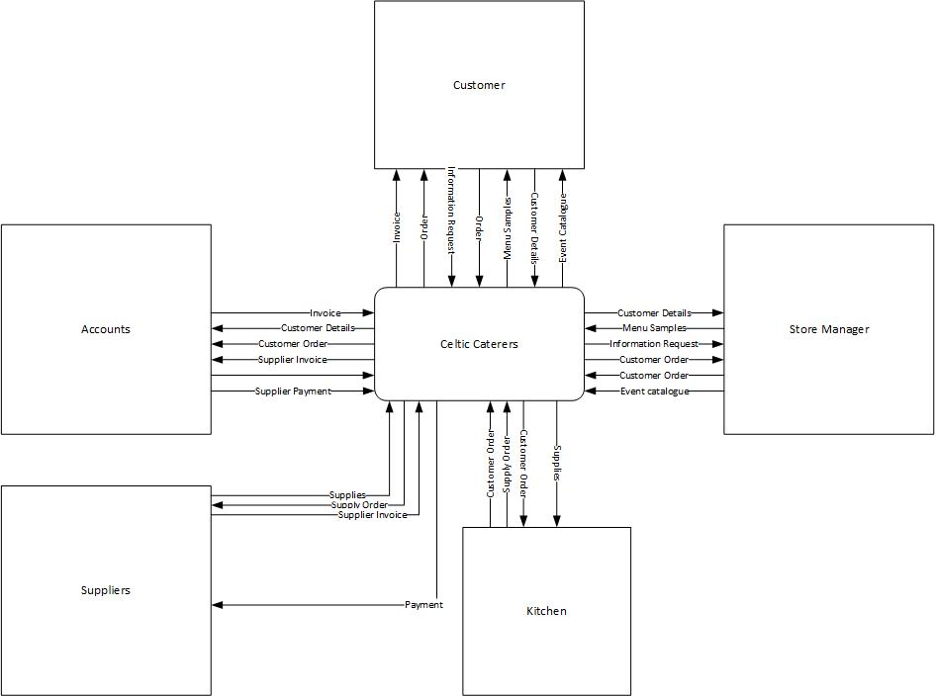

Celtic Caterers Level 0 DFD

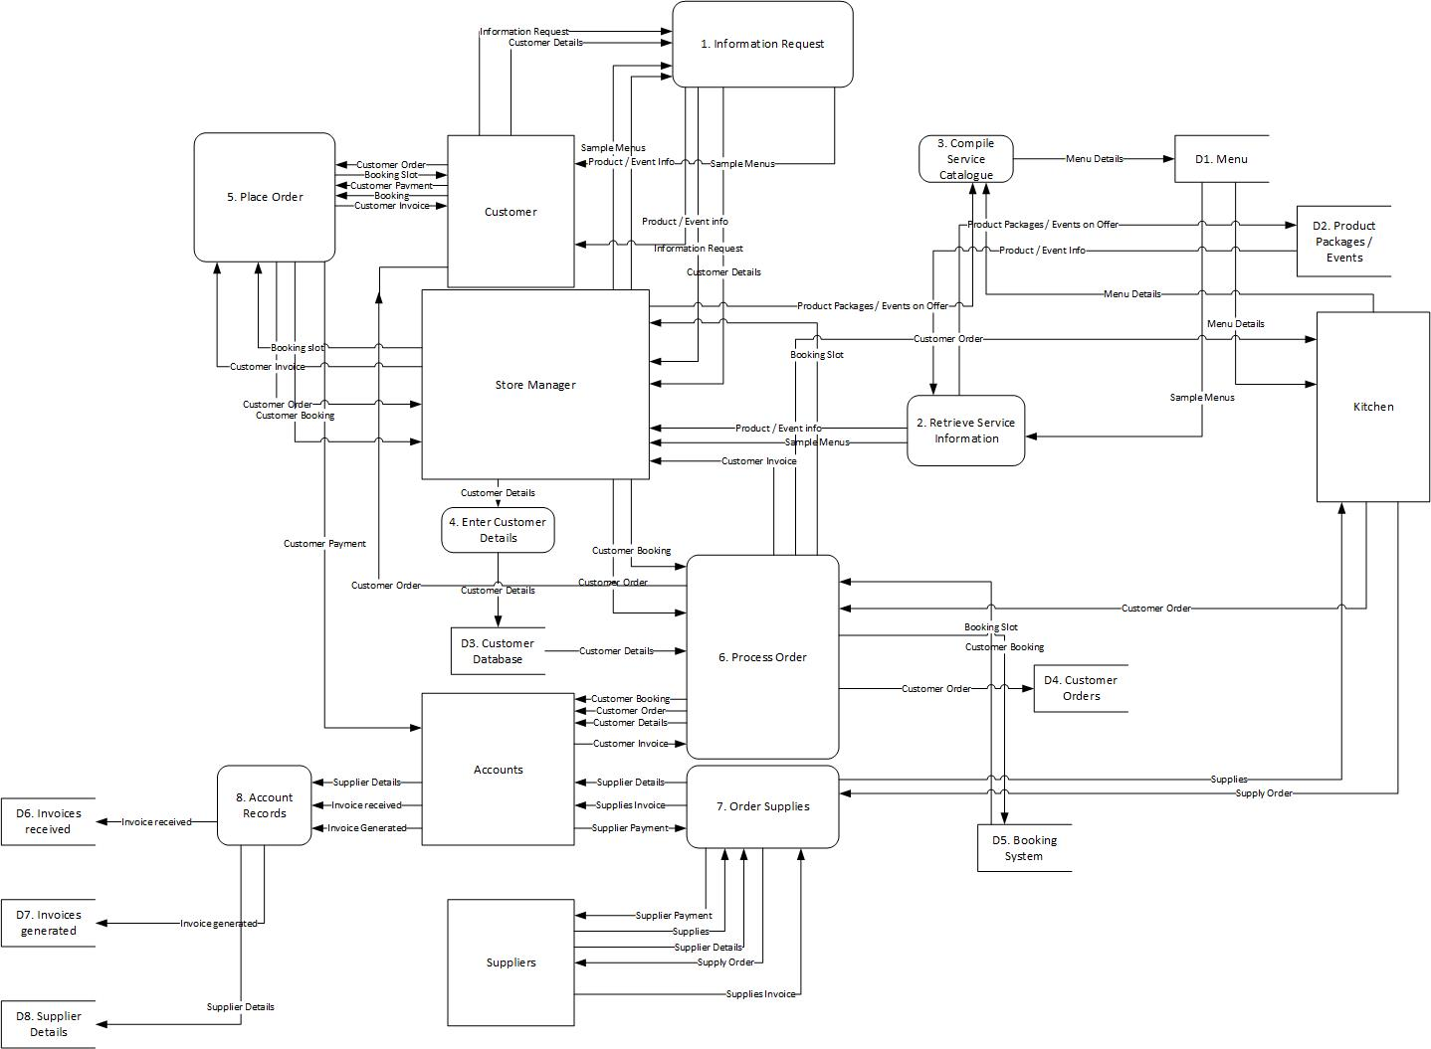

Celtic Caterers Level 1 DFD

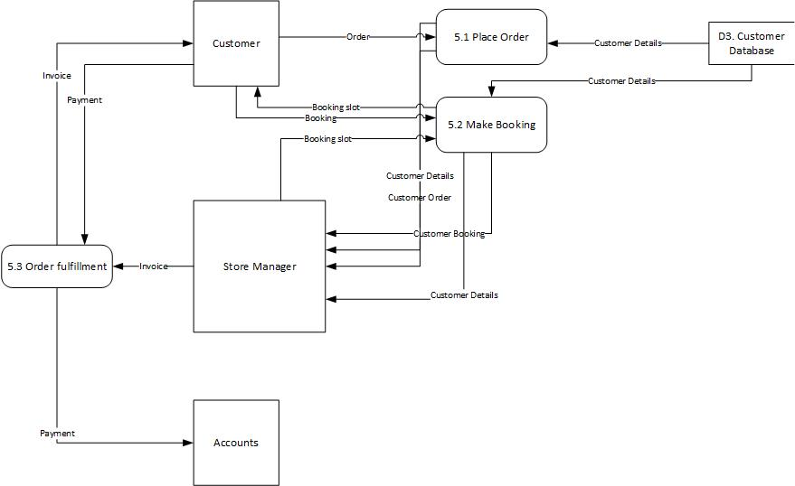

Celtic Caterers ERD



