ECEY4005 2311745 Word Count – 2787

Portfolio
Section One – Activity Plan.
Exploring and learning through edible sand.
Cloud dough can be used as an alternative. To make this add half a cup of baby lotion and a cup of flour, adapt for various amounts.
To make the edible sand, grind cereal and add brown sugar for various textures.

Edible sand/ Cloud Dough.

Edible sand being child friendly as at the age of two children are still exploring with their senses, including their mouth.
Adding moulding trays, moulding shapes, buckets, and spades.

Edible sand is good for indoor and outdoor play.

Adding food colouring to either mixture adds to the excitement of play with various colours to choose from.
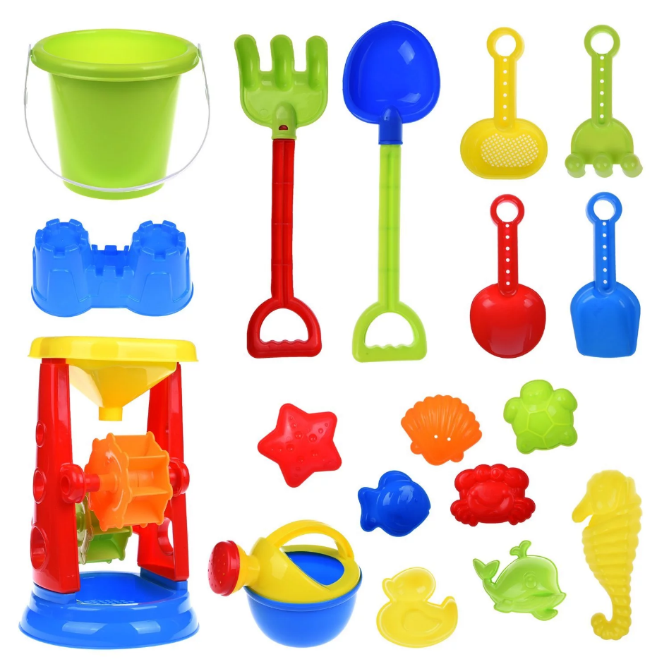
Firstly, set out in a tuft tray will be edible sand made from the ingredients above. In a blender combine a natural-coloured cereal along with brown sugar and blend until a grained consistency, to add colour chose desired colour food colouring and add and blend once more for full coverage. Spread sand evenly in the tuft tray and add items such as small buckets, spades, rakes, various shape moulds and items relating to the image seen below. The alternative mixture of cloud dough can be used as appose to sand as some children may not like the texture of the sand. To make this, firstly mix half a cup of baby lotion and a cup of flour in a bowl and mix with a spoon until combined into a crumbly texture, then empty contents of the bowl into some cling film and wrap, kneed the mixture together until a dough like consistency is formed. To develop this further one can also add food colouring as required for a more appealing look.

Source: Bing.com (2024).
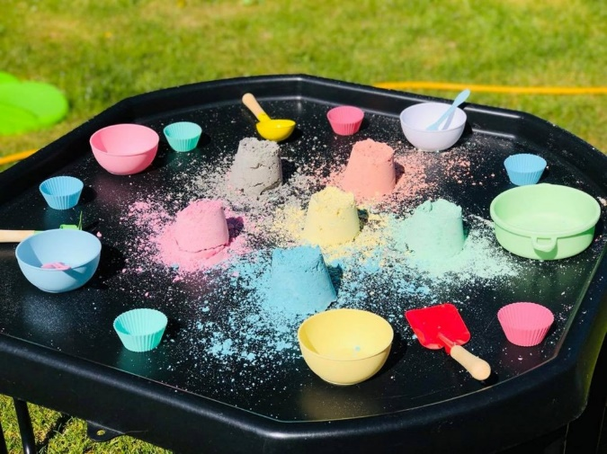
This type of play supports various stages of a child’s development, it helps with their fine motor skills, brain development, creativity, and supports their holistic development. Göncü and Vadeboncoeur (2017) suggest that as children begin to explore the world it is a sense of escape from reality as they filter their feelings and emotions into new challenges, they can express these emotions develop and learn through play. Whilst playing with sand they are forming shapes using their imagination, connecting with their emotions, and overcoming challenges perhaps if the sand crumbles easily they will have to learn to develop the way they are playing with the sand for a better outcome. For instance, if they were building a sandcastle using the buckets and spade and the sandcastle was not forming the shape of the bucket children would need to explore various ideas maybe by filling the bucket more so the consistency of the sand becomes thicker to have a better forming castle for the result. Bailey. (2023) discusses points of Piaget’s theory of cognitive development which implies that children’s stages of development are varied, and they will learn and understand information and obtain skills to become productive as they grow. For a child this may not be such an easy process to think of, but they may solve the problem independently by being consistent and using their cognitive development to understand the process how the sand works this being Piaget’s explanation of the preoperational stage of their cognitive development and trying over and over to gain their desired build with the sand. Children may also want support and ask for help, an adult will observe the child trying first and agree to help when a child requests, this seen as supportive play. Children may also begin exploring with colours if food colouring was used to make the sand colourful, this helping them recognise colours and perhaps adapting their play to associate various colours with items, if there is a mould shaped like a strawberry they may choose the red coloured sand to form the shape of the strawberry developing their brain to associate that strawberries are red. Children are also having sensory interaction with various textures from the blend of the cereal and the sugar. Findings show that McLeod (2024) supports that play has positive outcomes on cognitive development, they also say that Piaget’s theory behind this shows that allowing children to have an active imagination and interaction with the environment gives children the enjoyment of independent exploration. With this being edible sand and children being young they are sometimes still exploring with putting things in their mouth to develop their understanding and this will be safe for them to do so. Holistic development of a child is about supporting the whole growth of a child, this being five aspects which are, physical, social, emotional, intellectual, and spiritual. Mcilroy. (2024) implies that to support all aspects of a child’s growth all activities and learning must consider most if not all these aspects while planning activities and setting up areas of play. There are numerous ways of supporting all these aspects for children’s development and growth, supporting this with enabling and engaging environments for them to be able to move as freely as possible for self-directed and supportive play. This play station with the edible sand can support most of the areas needed for a child’s holistic development as it has the physical aspect to support their fine motor skills, it can support their social skills as this is an area where children can come together to explore and help also to learn to share and take turns which supports other aspects such as their emotional and intellectual development. To develop this activity further one could draw shapes of shells or creatures such as crabs on the tuft tray for the children to use items such as the rake to find the items drawn as part of a game of hide and seek for fun but also for the intellectual part of their brain development and to challenge them. This type of play is also versatile as this is something that can be good for indoor and outdoor use. When used outdoor this will help children to explore more of the environment around them and have options on how they learn and play.

Source: Bing.com (2024).

Section Two:
Role of the adult.
The main role of the adult is to ensure children have an engaging environment to be able to freely play to ensure their holistic development and give them opportunities and the freedom to explore and discover as they learn in their educational environment. Giving children the opportunities to run freely outdoors can benefit their physical health and allow them to use their imagination to explore with nature and the environment as well as engaging environments inside with a range of various activities and options for them to explore. Welsh Government (2018) show that the four purposes of the curriculum in Wales are for children to become ambitious and capable learners, this will be for them to express and build knowledge and skills. It will help them to enjoy challenges and to solve problems. The NSPCC (2023) support the four purposes of the curriculum in Wales and express that all children are to be healthy, confident individuals who have plenty of physical activity, who form positive relationships, have support on how to keep well and safe in everyday life and building resilience and confidence to support with everyday challenges. All these points above are important as implied by the Welsh Government (2023) that every child is entitled to basic rights but also as professionals it is needed for practitioners to support children to help them understand the importance of their rights. Unicef (no date) comply with the fact that every child has rights and that making them aware of them is important and that no right is more or less important than another, examples of rights children have are the right to freedom and expression, Article 13 and the right to relax and play, Article 31. Children can develop and express when playing and practitioners can assist them whilst dealing with their individual needs, it is equally important for practitioners to help children to set goals for themselves and become a positive role model for others along the way, Kenneth, et al (2007). Play helps with children’s brain development to build on their imagination as FTF (2024) suggest that a child’s brain has the best opportunities to develop in their early years to understand their capabilities and develop connections through everyday experiences as they play. Observing children whilst they play can also tell us a lot about how a child views the world and how they value things, it will teach us about their likes, dislikes, fears, emotions and help us to learn about their individual needs psychically and emotionally. Children should choose freely and become independent learners this sometimes making the role of the adult during activities difficult as it is important to allow children to freely play also known as self-directed play, adult interference can sometimes influence how they play and if they perceive it as play. It is important to allow children to freely become independent leaners, Nursery resources (2023) suggests letting them be heard and express their feelings and emotions freely, to help them overcome their worries as they have the right to freedom of expression as stated by Unicef (no date). There is research further into the rights of children and how they are understood in other countries and how they help children develop and engage in activities and allowing children to decide for themselves. Rock (2020) talks about the Reggio Emilia approach on children’s development and suggests that children engaging with their senses has a big role on their learning process and having engaging environments such as this activity will allow them to explore and develop various skills such as building relationships by communicating, interacting, and playing with and alongside others. Rock (2020) follows on to discuss how children must be the centre of their own minds allowing them to make decisions and lead the way they learn this being the focus of the Reggio Emilia approach to learning and development. Children will use their imaginative instincts to develop their feelings and minds into understanding daily routines and express their knowledge daily, this is where they use the imagination to develop relationships and invite others to play while forming friendships and learning from one another. However, if an adult is engaging with children during play Howard and McInnes. (2012) encourage this but as an equal play partner, this meaning that the child should be the lead of the play and the adult if needed to ask questions should ask open questions as opposed to closed questions as this could lead to the child perceiving this as non-play and then it is no longer their freedom of choice, adults can also observe from a distance and when a child asks for help the adult can do so as they may have seen the child unable to overcome an obstacle and can help when asked to support the child as they play. Whilst children are playing with the activity of building with the edible sand, they will have many opportunities for improve their fine motor skills as well as learn about shapes. LeVos (2022) discusses how children will notice shapes before they learn which shape is which as the world is made up of so many different shapes that they will see them from such an early age. LeVos (2022) continues by saying that helping children to recognise and understand the attributes of various shapes is what helps them to develop their further learning and development. This activity can help children to understand building shapes and how the sand moulds together to make the shape but can easily be broken back down to re-use and build again and again, this being a repetitive experience also improves their understanding on how to reuse things to make something else, that sand can be used to make more than one thing as they learn and improve their brain development. Through play such as sand play and building, children who are also nonverbal will be able to express various emotions and feelings with regards to communication as they are engaging perhaps for sensory needs, having a positive effect, and stimulating them as they play. As adults we must provide options and various opportunities to children and not only provide engaging environments but one must also provide alternatives for those children who have sensory issues or may not like the feeling of sand, an alternative to the sand would be dough as it can mould and reform shapes again and again. Gandini (2010) discusses how the Reggio Emilia approach in values and principles of teaching and learning is for children to have rich environments for learning with materials that they can learn for themselves. Gandini (2010) also discusses how adults are also learning alongside children as they are equal leaners with their own path, adults are there to observe and guide whilst also learning about each individual child to help them to become their best, and not to teach them anything that they can possibly find out for themselves, this being that they become independently learning for themselves. Children gain a higher sense of emotional and social well-being when it is self-directed this being that the play is for children choose for themselves, they are in control of what they play and how they play. Howard and McInnes (2012) suggest that self-directed play is good for children and improves on their physical and emotional health as they learn they also say this can have an impact on their behaviour as they grow and learn through life. As children learn and develop through play where they own their experiences, they become the authors of their own play and have opportunities to use their imagination to explore their interests and become more independent. McLeod (2024) also supports that play has positive outcomes on cognitive development, they also discuss that Piaget’s theory behind this shows that allowing children to have an active imagination and interaction with the environment gives children the enjoyment of independent exploration this supporting their holistic development. Holistic development supporting the whole growth of a child, all activities and learning must be the focus on how best to support the child with engaging environments for self-directed and supportive play. Lindhard and Farnicka, (2023) discuss that models such as Vygotsky’s theory is believed that children’s development can be influenced by the experimental environment and their experiences, their environment and learning and their experience of textures and how they feel giving them the capability of transferring knowledge which will have an impact on their development of thinking and other cognitive functions.
Section Three:
Children are naturally attached to their main caregiver, parent, or guardian. Children also adapt and develop as they familiarise themselves with others and will learn to accept more than one caregiver as they develop, this being a key worker or a familiar adult within settings, this will help them to form bonds and relationships but also help with their interaction with others there for expanding on their brain development. Bowlby’s theory of attachment which has been developed by Mary Ainsworth suggests that children confide in caregivers who are responsive to their needs and emotions and will confide in them as the develop (HRF, 2023). Working together and acknowledging others in childcare is important, it is important that as caregivers to share ideas and knowledge and listen to gather as much information as possible regarding the children in our care. Dowling (2024) discusses how important a role that caregivers and practitioners play in a child’s development and that where necessary to use multi-agencies and resources to support children’s development. Communication is a key role in the process of child development, each team member from all agencies must have good communication so that the child has the best experience and development. Birthto5matters (no date) discusses how practitioners must be good listeners when forming bonds with parents or guardians, this will help to better our knowledge of children’s likes and dislikes throughout their development, the more information the more practitioners are able to help and guide children to become the best they can be. Bronfenbrenner’s microsystem and mesosystem are two of the most important systems when building relationships theses system are where a child will build their trust and build on relationships from one caregiver that being their parents or guardians to expanding their trust and relationships with more than one caregiver being key workers, and other teaching staff they will also learn to form relationships with other children during development. This time will be a learning curve for them to explore their feelings around relationships and trust and will help them to understand trust a bit more, (Guy-Evans, 2023).
Bailey, A. (2023). Cognitive development theory: What are the stages?. [Online]. very well health. Last Updated: 29 November 2023. Available at: https://www.verywellhealth.com/cognitive-development-5220803 [Accessed 15 April 2024].
Bing.com. (2024). moon sand tuft tray activity. [Online]. microsoftbing.com. Last Updated: 2024. Available at: https://www.bing.com/images/search?view=detailV2&ccid=LU89fKgN&id=AC64A312B44E7A6BFA2F4B912AEB79EBE3 [Accessed 13 April 2024].
Bing.com. (2024). sand pit toys. [Online]. microsoft bing. Last Updated: 2024. Available at: https://www.bing.com/images/search?view=detailV2&ccid=S56YWRhW&id=5BEDB5138C177280EEF258ABE767402B9F [Accessed 13 April 2024].
Birthto5matters. (no date). Supporting development and learning. [Online]. Birthto5matters. Last Updated: no date. Available at: https://birthto5matters.org.uk/supporting-development-and-learning/ [Accessed 14 March 2024].
FTF. (2024). Brain Development. [Online]. First things first. Last Updated: 2024. Available at: https://www.firstthingsfirst.org/early-childhood-matters/brain-development/ [Accessed 15 April 2024].
Gandini, L. (2010). Values and principles of the Reggio Emilia approach. [Online]. learningmaterialswork.com. Last Updated: 13 September 2010. Available at: https://learningmaterialswork.com/wp-content/uploads/2016/06/ValuesAndPrinciples.pdf [Accessed 14 April 2024].
Göncü, A and Vadeboncoeur, J.A. (2017). Expanding the definitional criteria for imaginative play: Contributions of sociocultural perspectives. Learning & Behaviour. Vol,45(2017), pp.422-431. [Online]. Available at: https://doi.org/10.3758/s13420-017-0292-z [Accessed 14 March 2024].
Hostettler Schärer, J. (2018). How educators define their role: building ‘professional’ relationships with children and parents during transition to childcare: a case study, European Early Childhood Education Research Journal, 26:2, 246-257, DOI: 10.1080/1350293X.2018.1442041.
Howard, J and McInnes, K. (2012). The impact of children’s perception of an activity as play rather than not play on emotional well-being. Child: care, health and development. Vol, 39(issue 5), pp.737-742. [Online]. Available at: doi:10.1111/j.1365-2214.2012.01405.x [Accessed 14 March 2024] [Accessed 14 April 2024].
HRF. (2023). Mary Ainsworth attachment theory explained. [Online]. Health research funding. Last Updated1; 2023. Available at: https://healthresearchfunding.org/mary-ainsworth-attatchment-theory-explained/ [Accessed 14 March 2024].
HRF. (2023). Mary Ainsworth attachment theory explained. [Online]. Health research funding. Last updated:2023. Available at: https://healthresearchfunding.org/mary-ainsworth-attatchment-theory-explained/ [Accessed 14 March 2024].
LeVos, J.S. (2022). Shapes For Kids: The Complete Parents’ Guide To Teaching Shapes. [Online]. Begin. Last Updated: 14 May 2022. Available at: https://www.beginlearning.com/parent-resources/shapes-for-kids/ [Accessed 15 April 2024].
Lindhard, T and Farnicka, M. (2023). Forum psychologiczne. Socio-technological revolution: consequences to education. 1(1), pp.99-112. [Online]. Available at: https://doi.org/10.34767/PFP.2023.01.06 [Accessed 21 March 2024].
Mcilroy, T. (2024). The holistic development of a child during early years. [Online]. Empowered parents. Last Updated: 7 April 2024. Available at: https://empoweredparents.co/holistic-development/ [Accessed 15 April 2024].
McLeod, S. PHD. (2024). Piaget's theory and stages of cognitive development. [Online]. Simply Psychology. Last Updated: 24 January 2024. Available at: https://www.simplypsychology.org/piaget.html [ Accessed 29 February 2024] and [Accessed 1 March 2024].
McLeod, S. PHD. (2024). Piaget's theory and stages of cognitive development. [Online]. Simply Psychology. Last Updated: 24 January 2024. Available at: https://www.simplypsychology.org/piaget.html [Accessed 14 March 2024].
NSPCC. (2023). Duty of care and safeguarding. [Online]. NSPCC learning. Last Updated: 29 June 2023. Available at: https://learning.nspcc.org.uk/safeguarding-child-protection/duty-of-care-and-safeguarding#:~:text=It [Accessed 14 March 2024].
Nursery resources. (2023). How to support children transition to school. [Online]. Nursery resources. Last Updated: 4 April 2023. Available at: https://www.nurseryresources.org/articles/school-readiness/how-to-support-children-transition-to-school. [Accessed 14 March 2024].
Olivia Guy-Evans MSc. (2023). Bronfenbrenner’s ecological systems theory. [Online]. Simply Psychology. Last updated: 3 November 2023. Available at: https://www.simplypsychology.org/bronfenbrenner.html#The-Five-Ecological-Systems [Accessed 14 March 2024].
Pacey. (Unknown). Transitions and settling in – a guide for practitioners. [Online]. Youtube. Last Updated: No Date. Available at: https://www.youtube.com/watch?v=HklpWWDSyqU&t=209s [Accessed 14 March 2024].
Rock, A. (2020). The Reggio Emilia Preschool Philosophy. [Online]. very well family. Last Updated: 08 May 2020. Available at: https://www.verywellfamily.com/reggio-emilia-approach-2764968 [Accessed 13 April 2024].
Unicef. (no date). How we protect children's rights. [Online]. Unicef. Last Updated: no date. Available at: https://www.unicef.org.uk/what-we-do/un-convention-child-rights/ [Accessed 15 April 2024].
Welsh government. (2018). The four purposes of the curriculum for Wales. [Online]. Gov.uk. Last Updated: March 2018. Available at: https://www.gov.wales/sites/default/files/publications/2018-03/the-four-purposes-of-the-curriculum-f [Accessed 14 March 2024].
Welsh Government. (2023). National minimum standards for regulated childcare (NMS) for children up to the age of 12 years. [Online]. Gov.wales. Last Updated: 2023. Available at: https://www.gov.wales/sites/default/files/publications/2023-05/national-minimum-standards-for-regula [Accessed 14 March 2024].

