

Design, Development and Evaluation – Report

Managing Risk and improving efficiency and feasibility during the delivery of the live vibration trials at ETC Shoeburyness with the aim to enhance output production and customer satisfaction

by
Ralph Whittaker

Student ID: P148322

Module: Systems Engineering
M6X00947

Lecturer: Richard Morgan

BEng (Hons) Test Range Engineering

January 2018

Abstract
Using system engineering techniques, an evaluation was performed on the operational approach to fulfilling vibration trial delivery at the Environmental Trial Centre (ETC), Shoeburyness. The conclusive findings suggest opportunities for future incremental lean improvements and methods for maintaining the current level of standard.

The report wholly considers the service from the moment a customer approaches QinetiQ with trial work, through to provision of report data (product). Standards are usually high with positive customer feedback. It is important however, to try and maintain this standard and identify any risks to the business. Occasionally, customer satisfaction fails and this report uses investigative tools to find out why. The design and development work of this investigation, highlights way to improve efficiency and reduce wastage. Throughout, due regard is paid to Risk Management, one of the main judgemental principles of system engineering, ensuring every process entails doing the right thing, the right way for the customers, the business and employees.

TABLE OF CONTENTS
SECTION PAGE
TITLE PAGE 1
ABSTRACT 2
TABLE OF CONTENTS 3
INTRODUCTION 4-5
- Scope
- System Identification
- Background to Process / Test

THE BASIC PROCESS 5-6
- System Operation Flow Chart identifying the current process risks

RESEARCH & DESIGN 6

QFD 6-7
FMEA 7-8
RCA 8-9
-Fishbone diagram
Lean thinking 9-10

EVALUATION 10-11
CONCLUSION AND RECOMENDATIONS 12
REFERENCES 13
BIBLIOGRAPHY 14
Appendix: 1-22
APPENDIX A - Flow Cart of Trial Delivery Process
APPENDIX B - QFD of Trial Delivery Process
APPENDIX C - Original FMEA of Dynamic Trial Delivery Process
APPENDIX D - Rearranged / Complete FMEA of Dynamic Trial Delivery Process
APPENDIX E - Fishbone Diagram to identify root causes
APPENDIX F - Potential Solution Check Card Design
APPENDIX G - Task Check Sheet

INTRODUCTION
- Scope

The purpose of this report is to identify and investigate a valid process within the workplace that could potentially benefit from systematic improvements for positive business enhancements. By aiming for organisational efficiency and outstanding service, production waste will be reduced. Suitable system engineering tools and techniques will aid the discovery of the worst root causes of the system failures. Designs and developmental work will present solutions for eliminating the non-value adding stages of service or production, by replacing them with more efficient ways of processing. Focus will be on customer value and risk management.
The structure of the report will be as follows:
- Identify the system / Background
- Research & application of System Engineering techniques and tools to the current process
- Summary of significant findings
- Identify the biggest Risks
- Define the non-value adding issues
- System evaluation
- Design and develop potential improvements
- Conclude recommendations that form solid engineering solutions

- System Identification

The system under investigation is that of the current procedure followed by the Operational team at the ETC to achieve production of vibration test data to customer requirements. To maintain UCAS accreditation and customer satisfaction, it is vital that methods of working practice remain of the highest standard. Investigation will start with customers approaching QinetiQ with trial work, through to physically subjecting items to vibration or shock, to the recording and plotting of acceleration response data. The remainder of the system, including the inspection and functionality testing of items will not form part of the investigation. Stepping through the formality will highlight if any of the activities can be streamlined to improve delivery of customer value.
The aim of the company is not to just provide a satisfactory service to customers but to excel during delivery and make the experience for the clients a memorably positive one. Exceeding expectations contributes to building an excellent company reputation and achieving the business vision of being the defence market leader for vibration testing. Acknowledgement to the current effort QinetiQ is making to maintain and improve its organisational framework, namely Transform, will for part of the evaluation.

- Background to Process / Test

Firstly, customers contact QinetiQ with required specifics in terms of testing (levels, durations and temperatures etc). Technical Specialists confirm if, how and when the test can be carried out. After collaboratively agreeing the methods of testing, the customer provides a written statement of work (SOW) for provisional guidance for the test procedure. This is used by the Trial Manager to create the Trial Instruction (TI), from which the trial technicians and engineers (Dynamics team) work from. On the decision of the Team Leader, the Engineer and Technician for the trial is decided. Next a plan is formulated by the trial engineer, to cater for customer specifications.

The purpose of a vibration trial is to subject a live asset to a specified level of vibration or shock to simulate the specimen being transported or utilised out in theatre. Tests are often performed as part of life extension plans to achieve certification of functionality, performance, reliability and operator safety after having seen the expected level of environmental conditions.
Test specifications, as defined by the customer and in accordance with DEFSTAN 00-35, are used as an input into the controller of effectively a closed-loop system. Stores are hot and cold conditioned for the specified soak times and then vibrated or shocked on top of an electrodynamic shaker in accordance with the profile (duration and g levels). Combined and condensed duration testing allows for the items to undergo simulative but realistic testing, cycled through equivalent intensity and conditions but within shorter and more practical time frames.
Accelerometers provide control and measure points from which the control loop system can run and measure the forces seen by items and surfaces upon which payloads are fixed (see Fig.1). The product (customer values most) is a detailed trial report, including photographs and plots of accelerometer data documenting the results.

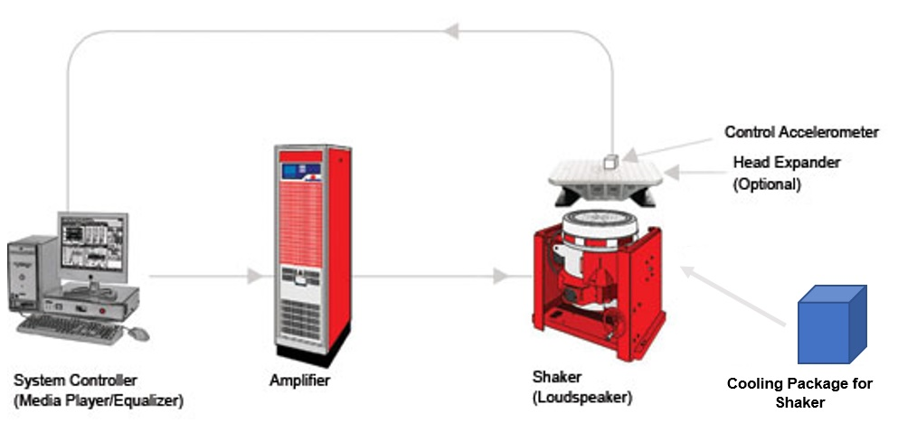
Fig.1: The typical set up of a vibration system [1]

Frequently, as with the nature of live testing, trials over run the schedule and customer deadlines are not met. For some trials, there are penalties to pay for such occurrences, which in turn negatively impact company profit and business reputation (customer satisfaction).

THE BASIC PROCESS
- System Operational Flow Chart

Critical Path Analysis (CPA) provides an ideal starting point for identifying where essential and non-essential, value and non-value adding activities are occurring and where changes need to be made with regards to streamlining the process to eliminate risks, waste, and save time. The flowchart (Appendix A), is a form of CPA, highlighting stages at which problems occur, causing wasted time and delay. At first glance, better planning and scheduling of staff and resources, combined with time risk management could foresee and solve these issues before they develop.

Notable improvements include:

- Customer providing correct test specification in the beginning
- Having TI ready before trial commences
- Staff competencies at writing TI accurately using data from customer Instrumentation plan / Qualification plan
- Ensuring instrumentation is available before trial commences
- Scheduling facilities, equipment in advance
- Completing set ups on time
- Fixtures organised & labelled up
- Log book of common test faults / procedures

RESEARCH & DESIGN

Quality Function Deployment (QFD)
QFD diagrams (aka House of Quality) aid design of products or services with awareness of customer values. A QFD listens to the voice of the customer, identifying the best approach to providing the most satisfying service of what customers expect and value. QFD also evaluates the impacts of making changes to technical characteristics and specifications used in production of deliverables and determines where priorities lay during product or process development. The input configuration of a process can be tweaked to optimise production performance and provide a more satisfactory output by amending the scale or amount of something or by increasing or decreasing the levels of certain elements.
According to Yoji Akao, in the History and Definition of Quality Function Deployment, QFD
‘is a method for developing a design quality aimed at satisfying the consumer and then translating the consumer's demand into design targets and major quality assurance points to be used throughout the production phase.’ [2]
It is evident that, from the QFD performed on the process (Appendix B), there are strong relationships between what the customer wants (Demanded Quality) and the way the service can be delivered (Quality Characteristics). It is vital for the workplace culture to remain positive and where possible be improved perhaps through advanced leadership training for Team Leaders. Planning and Scheduling needs to be maintained or even improved to enable deadlines to be met and allow other characteristics to be fulfilled. Having as many staff fully trained competent and capable could have a huge impact on getting tasks completed efficiently and accurately, providing an overall satisfactory service.
As an organisation, QinetiQ could try to rearrange resources and schedules to positively affect how well they deliver customer requirements and test services.
Prioritising the availability of facilities and resources, (Planning and Scheduling) has a substantial relational impact on the remaining functions of the process. Ultimately it effects the most important aspect valued by the customer, of completing the entire trial and producing a full set of data, to deadline and in a professional safe manner. The ability to deliver a high-quality service and data within the time frame and according to the customer specification, builds good relationships with clients. Calculating a minimal Project Timeframe has a strong effect on how much budget is put by for each trial, potentially how rushed or slowly the service can be carried out and how likely expected deadlines are to be met. This can affect the quality of final results, consequently customer satisfaction. When under pressure, mistakes are more likely to be made and staff health and safety put at risk.
Sufficiently trained and competent staff are required to maintain the accuracy of the delivered service and data. With as many staff as possible being capable to run equipment, interpret and record data accurately, the test centre can run efficiently and without failure.
The workplace culture has a strong effect on nearly every aspect of the service. The behaviour of QinetiQ staff and the way in which they conduct themselves has an influence on the amount of time and care put into trial work and determines how safe, accurate and quickly a test can be conducted.
Setting the targets defined in the QFD diagram will improve achievement of the satisfactory delivery of trials data. Hitting or even lowering project timeframes and project budgets will keep turnaround times short and service costs low, meaning the relationships towards customer requirements will not be strained.
Aspects that require improvements are listed in Table 1 (Appendix B), with reasons for necessity and the impact they would have once completed.

Failure Mode and Effects Analysis (FMEA)
FMEA is a qualitative and systematic tool used to anticipate what could go wrong with a product or process and why failure occurs. It identifies and ranks the priorities in which to make to changes to a system, depending on the consequential impact individual failures have on the outcome of the service or product.
FMEA calculates a Risk Priority Number (RPN) based on the multiplication of the ratings of severity of impact of the failure, likelihood of occurrence and likelihood it can be detected. (Severity; low number = low impact, Occurrence; low number = not likely to occur, Detection; low number = very likely to be detected)

RPN = severity x occurrence x detection [3]

Using the flowchart (Appendix A) an FMEA was created (Appendix D). All process steps were listed alongside eventualities of the potential ways the process functions can fail. A second FMEA (Appendix E), prioritized functions for which they should be developed and improved, in descending RPN. This provided a starting point for highlighting where corrective action needs to be focused first. Ideally all problems need to be fixed but the biggest, most severe, common and undetectable issues are usually attended to first, depending on resources, health and safety issues and industry standards etc. Severity classifications determine which failures have the most severe damaging effect to equipment and injury to staff according to their Class (Table 2).
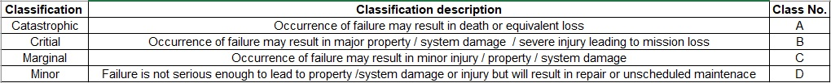
Table 2.

The FMEA reflects that the most influential failure of customer value (frustration), is the delay in production of data plots. Ultimately, this relies on completing all previous stages in the process, every stage of the process has a domino effect on the next.
Resource demands and test requirements need to be predicted further in advance of the intended start date, e.g. making sure test rig is suitable for the test item and checking the test spec for accuracy. Both issues have potential to cause damage to test items, delays and cost implications for projects, resulting in very unhappy customers. Huge amount of time is wasted due to conditioning failure which impacts deadline pushbacks. When conditioning units fail, it can add 2 days to a trial due to investigation work and reconditioning durations. More frequent maintenance and gas refilling of the conditioning units would aid their reliability.
A method commonly used for prioritisation of improvements is the Pareto rule. It suggests;
Typically, 80 percent of issues are caused by 20 percent of the potential problems. As a rule of thumb, teams can focus their attention initially on the failures with the top 20 percent of the highest RPN scores [4].
Good practice would be to address the top three reasons for failure first; test item not fitting rig, instrumentation not available and incorrect test spec instructions in the TI. A standardised TI procedure would aid compiling the document.
Overall, it would be a good idea to first improve the process by which rigs are designed for testing and to ensure that there is always enough instrumentation made available and calibrated ready for use. This could be achieved by encouraging the rig designer to visit the test items, take pictures and measurements to create more accurate designs. A team leader in the Tech Department would encourage direction and positive workforce culture, hopefully improving the calibration and availability of test equipment.
Root Cause Analysis (RCA)
To get a better understanding of why waste and delay occurs during trial delivery a Root Cause Analysis (RCA) can be carried out to investigate details and define the underlying issues regarding the problems. This involves identifying;
- What happened
- How it occurred and why it took place
- What we can do to prevent reoccurrence

Root cause is defined by J Rooney and L. Vanden Heuvel, in Definition, Root Cause Analysis For Beginners [4]:

1. Root causes are specific underlying causes.
2. Root causes are those that can reasonably be identified.
3. Root causes are those management has control to fix.
4. Root causes are those for which effective recommendations for preventing recurrences can be generated.

According to M. Doggett in his paper Root Cause Analysis: A Framework for Tool Selection;

‘Beneath every problem is a cause for that problem. In order to solve a problem, one must identify the cause of the problem and take steps to eliminate the cause. If the root cause of a problem is not identified, then one is merely addressing the symptoms and the problem will continue to exist.’ [5]

This suggests the underlying, root cause of a problem must be addressed to solve systematic or functional problems, commonly a result of human error, latent (organisational) or physical issues.
Many tools and techniques are available for RCA, all of which aim to identify true causes of failure. It is however, important to avoid cognitive biases such as cognitive laziness and overconfidence when performing an RCA. This ensures we don’t just rely on the first obvious reason for a problem but seek further into the process and allow evidence or data to conclude the truth. No assumptions are made and fresh relevant information is considered rather than relying on the first available accounts that perhaps only confirms pre-existing forethoughts of the causes.
A fishbone diagram (aka Cause and Effect Diagram) [6] developed by Kaoru Ishikawa (first published in his 1990 book Introduction to Quality Control) is a good way to dissect and trace underlying issues and reach the root of the cause by identifying and organising the potential causes. The underlying problem can be found by tracing through the causes, and then using the 5 Whys [7] subsequent questioning technique to identify the sub causes that lead to the Primary cause.

A Fishbone diagram was created (Appendix F) to identify root causes customer dissatisfaction. This further proved that the major underlying issue of delay is mainly due to availability of facilities and resources. Insufficient planning, organisation, staff–project balance levels, maintenance and a lack of management in the Tech Service department are all contributors. It is critical for the early stages of organisation and planning to be achieved successfully, which may even improve morale due to lower levels of pressure on trial staff to hit difficult targets. Other issues include; having sufficient instrumentation on reflection of the number of projects running at one time, inadequately trained personnel and poor workplace culture.

It may be wise to firstly cure the severe issues that have the biggest influence of delay and safety to the test but the workplace culture as with any business, is having a strong impact on production rate. Overall there are short, medium and long term transformational changes which could be implemented. Some interventions may have immediate impact but other more underlying issues such as organisational cultural changes would take longer to implement through advanced leadership.

Lean Thinking
To improve efficiency of a procedure, value and non-value adding processes and waste, aka Muda, needs to be systematically identified and eliminated. Lean can be used to identify unnecessary steps within a process so that every process adds value for the customer. Any activity that consumes time, resources or space and doesn’t add any value to a product or service is Muda.
For this process, the main value is the capability to provide accurate test data on time, by the deadline as specified by the customer, at the agreed service price.
The five principles of lean thinking are [8]:
- Define the Value (from customer perspective) (Provide accurate data on time)
- Working in value streams (Provision of Trial Instruction, Physical item testing, Plotting data without interruptions)
- Maximise the process flow and pull (Before trial finishes, prepare for the next)
- Empower the people in the company (Strengthen workplace culture)
- The pursuit of perfection (Complete all activities to deadline)

The main improvements of non-value adding steps within the process are:

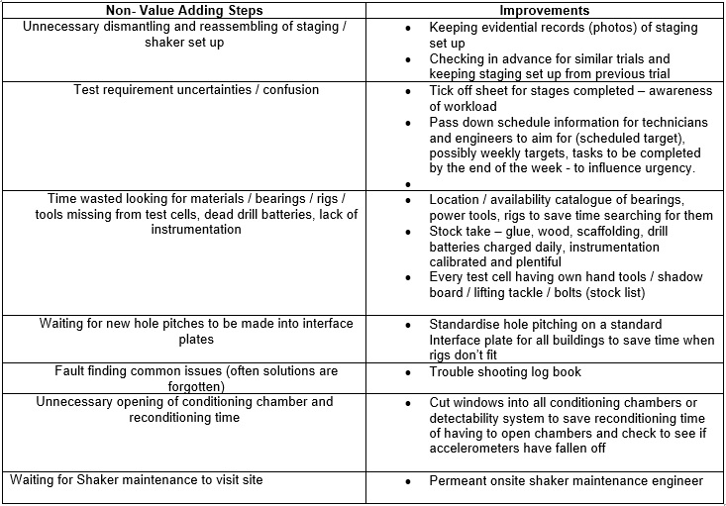
Having considered the avoidable and unavoidable Muda within trial delivery using the Flow Chart (Appendix A), the following steps could be maintained or implemented (Table 3);

EVALUATION
Failing to meet trial deadlines, can result in very dissatisfied customers and impacts company reputation. Consequently, the Project Engineer in charge of overseeing activities, applies pressure onto the operational team to complete the tasks quicker. This impacts the accuracy of work completed. Carelessness can result in mistakes being made and even more delays. It is important that targets are frequently reviewed throughout trials to deliver data on time. Time is money, mistakes and delays cost businesses working time (man power), materials, energy, fuel and power that could be spent elsewhere. Scheduling improvements could have an impact on resource availability and provide sufficient time to enable trials to be conducted more quickly and safely around overall. In the long run, it would benefit ETC if everyone was trained in their role to the highest competency and capability levels possible. Non- project related budgets would be better spent on training existing staff rather than on recruiting new employees (extra wages).
Customer satisfaction is a result of successful trial delivery. This can only happen if resources are available, maintained and in safe working order.
Leadership needs to excel, employees need to be directed and remain content. According to E. Schein, in the book Organisational Culture and Leadership, ‘cultures begin with leaders who impose their own values and assumptions on a group [9]’ and leadership is what ‘Creates and changes cultures, while management and administration act within a culture…the unique talent of leaders is their ability to understand and work with culture; and that it is an ultimate act of leadership to destroy culture when it is viewed as dysfunctional [10].”
At present QinetiQ is attempting to strengthen the organisation of its workforce and leadership. Transform is underway to restructure and streamline the organisation at all levels, with a lean thinking approach to remove unnecessary management, recruitment and wasted processes. The first year focused on creating the right organisation and having the right people in the right places for optimal delivery and to help drive growth. The final year is focused on embedding and maturing new ways of working, rebranding and implementing new systems and processes that support our people. Increasingly employees are required to be interchangeable and be multidiscipline (cross-trained) across all areas of the business. Teams of common skills sets will aid the flow of workload by increasing awareness and availability. There does however need to be an improvement of clarification on the impact of Transform, especially regarding consequential roles of employment, which has caused frustration and confusion among employees. It has not been without its niggles, as acknowledged on QinetiQ’s internal news page by CEO Steve Wadey when he accounted for miscommunication within the organisation during Transform and that QinetiQ has started to
“make improvements to our communication, accelerated the reorganisation by three months and included local slides to highlight local successes from last year and set out objectives for the coming year.’ [11]
Here, Wadey is owning up to slight failure of the company’s ability to provide everyone with crucial information when and where it should have been provided, and promising to improve the communication across the business (regular updates bulletins). Wadey is using a method closely inspired by the so called black box thinking as described by Matthew Syed in his book Black Box Thinking: Marginal Gain and the Secrets of High Performance. In the book Syed explores how different companies confront failure and take ownership of failure, revealing the best techniques that can be used to learn from interrogating errors to reverse their fortunes to achieve success and the dangers of failing to learn from mistakes. The term refers to the data recorder box carried on board aircraft that if found can be examined after accidents for retrieval of useful information into why the accident happened. It enables future training and protocols to minimise the chance of the same error happening again. Black box thinking relates to the owning up of failures, learning from mistakes and making use of historical records with the gain of providing a better service or product.
Syed sums up the required mindset for success by suggesting ‘that failure is a part of life and learning, and that the desire to avoid it leads to stagnation [12].’
Good communication is key to keeping everyone in the bigger picture and enabling Transform to move ahead smoothly with a strong culture. There is currently a live programme in place to support cultural change. The QinetiQ Visible Active Leadership (QVAL) training programme is aiming to actively strengthen the workplace culture by supporting leaders with advanced leadership training. This builds on the capabilities and competencies of its leaders and managers and enhances their skills to lead by example, instil common values and beliefs of the company vision, promote a positive future and make others feel empowered.

CONCLUSION AND RECOMENDATIONS
The problems that occur at Trial delivery level are usually a combination of physical (practical), sometimes human and often organisational (latency).
From analysing and evaluating the process using the engineering tools it has proven that there is room for maintaining and improving the service.
Immediate long-term corrective action could include:
- Complete roll-out of Advanced Team Leadership training
- Advanced training for staff in the Planning Department
- Advanced software training for Technicians and Engineers
- Training and consistency (photos) for trial set up (staging and shakers)
- Regular maintenance of facilities
- Team Leader Technical Services Department
- Process function failure detection solution in the form of paper-trail check list
- Maintain a good communication during transform

A task ticketing system (Appendix G) could be used to chronologically issue paper check cards, one after the other on completion and sign-off of the previous, in arrangement of events in their order of occurrence that they are expected to be carried out. Before the trial is to commence, the PE could collaboratively work with the planning team to identify and detail the specific processes that need to proceed one another and when, depending on availability of staff and equipment. Details could then be input onto a check sheet (Appendix H) including start date and predicted completion date, which in turn could then be issued to the trial Engineer. This could start the audited systematic paper chain, beginning by releasing the first ticket for raising the trial log book.

Methodically organising and consecutively structuring as many of the test activities as possible, could help maintain and support the current positive output. It could also act as an improvement plan to diminish any niggles and improve risk management, ensuring trials can proceed as safely and efficiently as possible. This would enable the PE to approve of the Engineers actions and confirm completion and target rate of the trial. It would provide the PE and Engineer a chance to give each other frequent structured feedback as to the progress of the trial. Coloured tickets for the current process due for completion (signed and dated upon completion) would enable a PE to quickly and clearly identify which level the trial is at, simply by seeing in the folder which tickets are missing and unsigned. The next process ticket would not be issued before the current process has been completed. This may enable better planning for time scales and facilities, providing more accurate predictions for customers in terms of dates for meeting deadlines and complying with safe working practices.
Further development could include using a Poka-yoke [13] approach to error proofing the system. By introducing an automated device such as RFID tagging for certain steps perhaps in the process regarding the access to and use of the vibration controller, it may be possible to eliminate human operational errors. Overall, the tools used in the report have proven useful, just like Albert Einstein famously said
“We can’t solve problems by using the same kind of thinking we used when we created them.”
This is always a good reminder for a starting point when solving complex issues, to try and think outside the box and use appropriate tools to figure out the truth.
REFERENCES
[1] Evaluationengineering.com, LDS Test and Measurement, Evaluation engineering , S. Dhillon, ‘The role of Vibration Testing In Product Integrity,’ June 2007, [Online], Available from: https://www.evaluationengineering.com/the-role-of-vibration-testing-in-product-integrity Accessed 05/01/18.
[2] Christian N. Madu, ‘History and Definition of Quality Function Deployment, House Of Quality in a Minute, Quality Function Deployment,’ 2nd Edition, Chi Publishers, Chapter 1, pg. 1, 2006
[3] Isixsigma.com, George Forrest, ‘Quick Guide to Failure Mode and Effects Analysis, Finding Failure Modes, Setting Priorities,’ [Online] Available: https://www.isixsigma.com/tools-templates/fmea/quick-guide-failure-mode-and-effects-analysis/ [Accessed 01/01/18]
[4] Env.nm.gov, James J Rooney & Lee N. Vanden Heuvel, ‘Definition, Root Cause Analysis For Beginners, Quality Basics,’ [Online] Available: https://www.env.nm.gov/aqb/Proposed_Regs/Part_7_Excess_Emissions/NMED_Exhibit_18-Root_Cause_Analysis_for_Beginners.pdf [Accessed 16/01/18]
[5] Researchgate.net, M. Doggett, Humboldt State University, ASQ, 2005, ‘Introduction, A Framework for Tool Selection,’ 2005, pg. 1 [Online] Available: https://www.researchgate.net/publication/42831418_Root_Cause_Analysis_A_Framework_for_Tool_Selection [Accessed: 16/01/18]
[6] Isixsigma.com, Six Sigma Tools & Templates, Cause & Effect, ‘The Cause and Effect (a.k.a Fishbone) Diagram,’ [Online] Available: https://www.isixsigma.com/tools-templates/cause-effect/cause-and-effect-aka-fishbone-diagram/ [Accessed 17/01/18]
[7] Isixsigma.com, Six Sigma Tools & templates, 5 Whys, ‘Determine the Root Cause: 5 Whys,’ [Online], Available: https://www.isixsigma.com/tools-templates/cause-effect/determine-root-cause-5-whys/ [Accessed 03/01/18]
[8 Lean.org, Lean Enterprise Institute, ‘Principles of Lean, What is Lean? Principles,’ [Online], Available: https://www.lean.org/WhatsLean/Principles.cfm [Accessed 15/01/18]
[9] Edgar H. Schein, ‘Culture and Leadership, Part One, Organisational Culture and Leadership Defined,’ Third Edition, CA, USA, Jossey-Bass, 2004, pg. 2
[10] Edgar H. Schein, ‘Culture and Leadership, The concept of organisational culture: Why bother?’ Organisational Culture and Leadership, Third Edition, CA, USA, Jossey-Bass, 2004, pg. 11
[11] Roadshows: your opportunity to give us feedback, Latest blog from Steve Wadey, CEO, 02 May 2017, [only available to QINETIQ employees via online intranet Nucleus], see Appendix H below for an extract from the article.
[12] M. Syed, ‘Coda: The Big Picture, Part 6: Creating a Growth Culture, Black Box Thinking: The Surprising Truth About,’ John Murray (Publishers), 2015, pg. 306
[13] asq.org , ‘When to use Mistake-Proofing,’ Mistake-proofing, Learn About Quality, Process Analysis Tools [Online] Available: http://asq.org/learn-about-quality/process-analysis-tools/overview/mistake-proofing.html [Accessed: 14/01/18]

BIBLIOGRAPHY
- Desolutions.com , ‘Choosing a Vibration Test Lab Part 1,’ Part - 1 Defining your project and Obtaining a Quote, DES, Delserro Engineering Solutions, [Online] 05/08/15, Available: http://www.desolutions.com/blog/2015/08/choosing-a-vibration-test-lab/ Accessed 02/01/18.

- Desolutions.com, ‘Choosing a Vibration Test Lab Part 2,’ Part 2 -Selecting a Lab and Performing your Test, DES, 24/09/15 [Online], Available: http://www.desolutions.com/blog/2015/09/choosing-a-vibration-test-lab-2/ Accessed 02/01/18.

- Fme.aegean.gr, ‘Quality Function Deployment,’ Product Brief Development Tools, Creative Industries Research Institute, AUT University, pg. 1-11 [Online PDF] Available: http://www.fme.aegean.gr/sites/default/files/cn/quality_function_deployment.pdf Accessed 15/01/18.

- Ipwea.org, ‘Failure Mode Analysis and How It Impacts Your Strategy,’ Helen Ramsey, National Asset Manager Utility Services, Downer, Auckland, [Online], Available: https://www.ipwea.org/HigherLogic/System/DownloadDocumentFile.ashx?DocumentFileKey=0c377bc1-b827-c83b-93d9-cb6197d84d42 [Accessed: 12/01/18]

- Kalsher.com, ‘Unit 3, The Design of Every Day Things, Part 5: Human error or bad design,’ Michael J. Kalsher [Online], Available: www.kalsher.com/HF/PresentationFiles/Donald%20Norman_Part%205_RED.ppt [Accessed 02/01/18]

- Env.nm.gov, ‘Root Cause Analysis For Beginners, Quality Basics,’ James J Rooney & Lee N. Vanden Heuvel, [Online] Available: https://www.env.nm.gov/aqb/Proposed_Regs/Part_7_Excess_Emissions/NMED_Exhibit_18-Root_Cause_Analysis_for_Beginners.pdf [Accessed 16/01/18]

- Tfzr.uns.ac.rs, ‘Effective Root Cause Analysis and Corrective Action Process,’ Journal of engineering management and competitiveness (JEMC), Branislav TOMIĆ 1, Vesna SPASOJEVIĆ BRKIĆ 2, Vol. 1, No. ½, 2011, pg.16-21 [Online] Available: http://www.tfzr.uns.ac.rs/jemc/files/V1N1-22011-04.pdf [Accessed 17/01/18]

- M. Syed Black Box Thinking: The Surprising Truth About, 2015, John Murray (Publishers), London, UK,

- E H. Schein, Culture and Leadership, Third Edition, 2004 Jossey-Bass, CA, USA

APPENDIX A
The overall process can be outlined by the following flow chart which breaks it down into the main sequential stages:

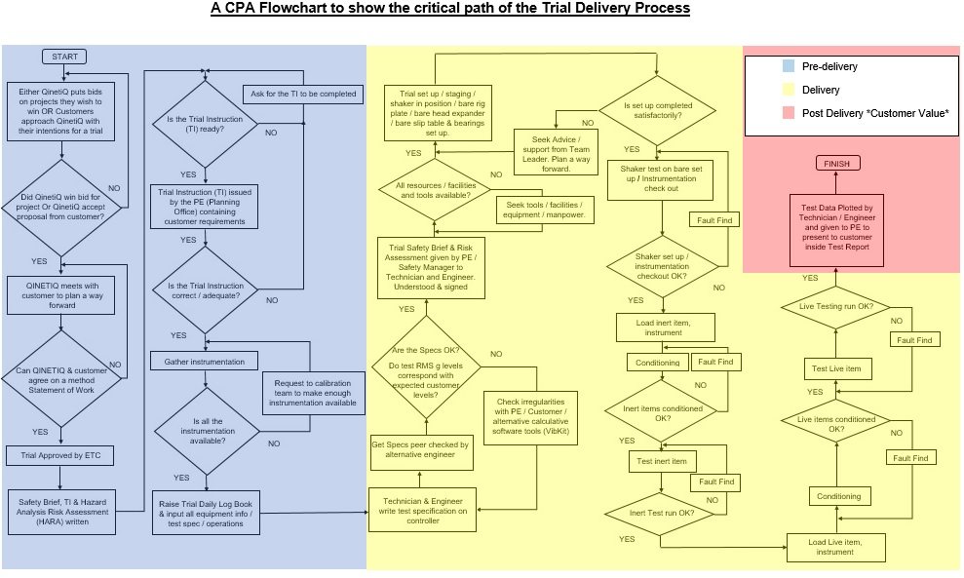
APPENDIX B Suggested improvements as a result of carrying out a QFD on the process

SUGGESTED IMPROVEMENT? | WHY NECESSARY? | IMPACT ON THE WHOLE PROCESS?
Investment of Instrumentation  & Vibration Shakers | Purchasing more equipment, means more will be available for use at once (Increased Availability). Increasingly at present, with more trial work arriving simultaneously, there becomes a shortage of equipment (All being used at once). Time is not wasted waiting around for equipment. When equipment breaks down, there’s spare equipment for backup and so trials can continue without any hold ups. Many trials can be run simultaneously. | Trial delivery work is not held up by shortage of equipment and has a better chance of being completed to schedule enabling production of data plots by deadline.
Increase the range of reusable materials and equipment | Lowers project spending (less materials / tools purchasing required), decreases necessary Project Budgets. Increases efficiency of delivery and reduces unnecessary spending (less often over time). | Lowers project cost. Potentially lower Service cost and keep Charge costs low for customers. Customers feel that are getting a better value for money
Frequency of Calibration Checks  (Calibrated immediately before a trial starts) | So that equipment doesn’t run out half way through a trial and needs be substituted. Although calibration only lasts 6 months, certifying the equipment is accurate and fit for purpose just before a trial, maximises the length of time it can be used before it needs to be calibrated again. | Trials completed to schedule without hold ups of having to swap instrumentation or other equipment over for in CAL date equipment. Test data measured in time to meet completion deadline.
Project Budgets to cater for free collection and delivery service for test assets | Broadening the service provided takes the stress / effort required by the customer to get items to site (Major security / permission and logistical issues with passing through security onto the island of Foulness) | Something less for the customer to have to deal with. Encourage more customers to use the ETC site. Quicker turnaround time for trial.
Project Budgets to cater for free customer visit hospitality | Encourage customer visits to the remote island of Foulness | This would help deal with any site location or logistical issues customers face. Settle any confusion over uncertainties and enable customer to appreciate the scale of trials and therefore effort / timeframe lengths.

Table 1

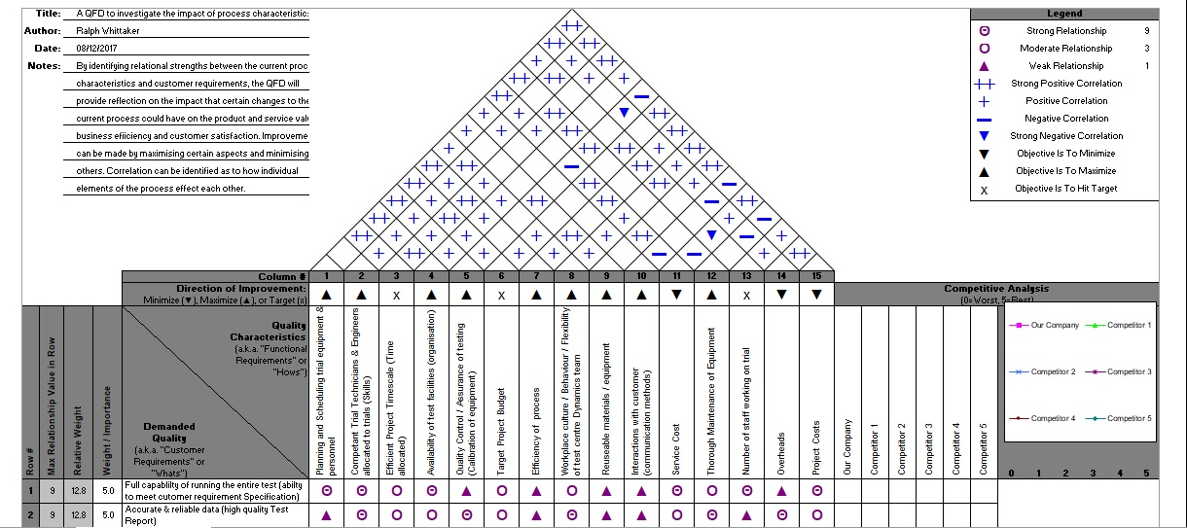
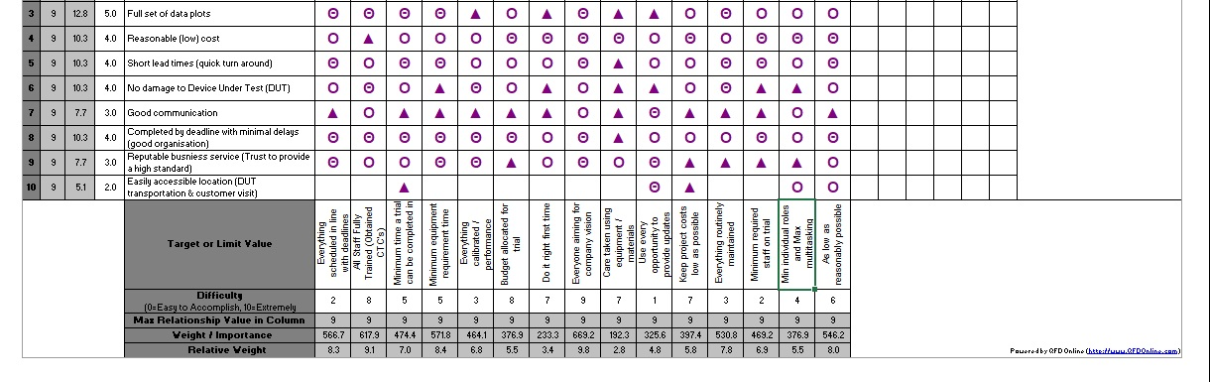
APPENDIX C QFD of Trial Delivery Process
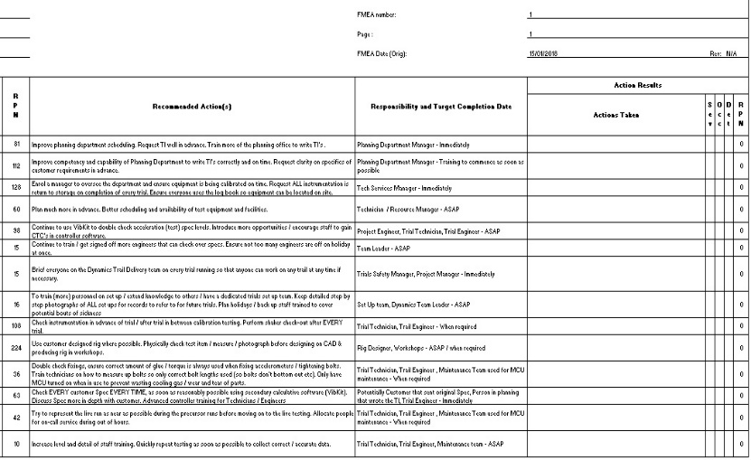
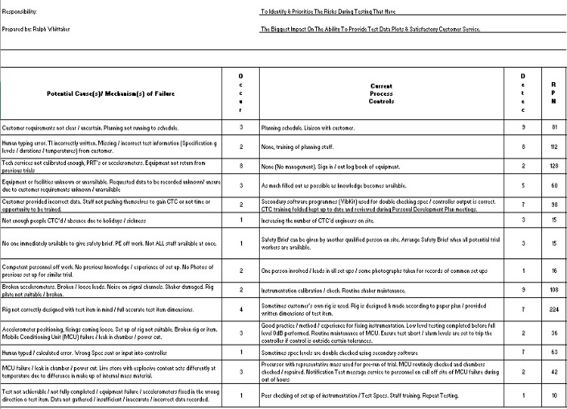
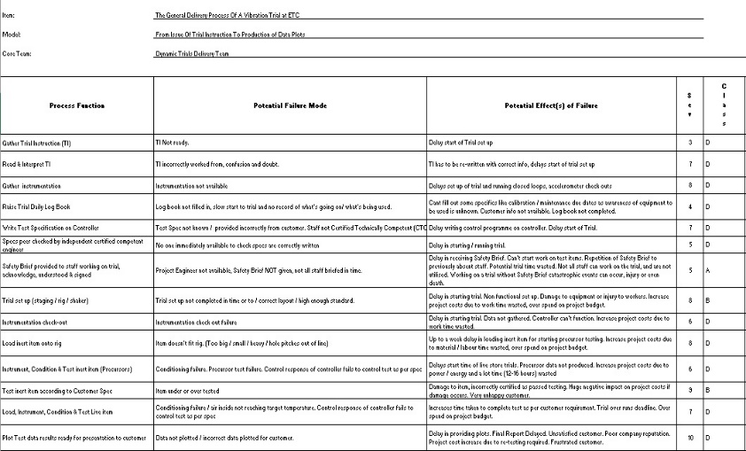
APPENDIX D Original FMEA of Dynamic Trial Delivery Process

APPENDIX E Rearranged / Complete FMEA of Dynamic Trial Delivery Process
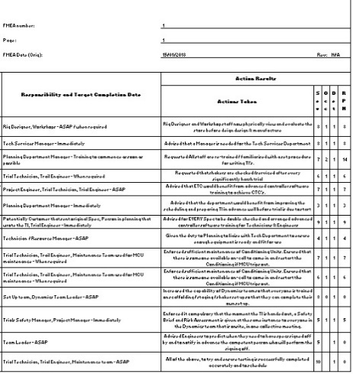
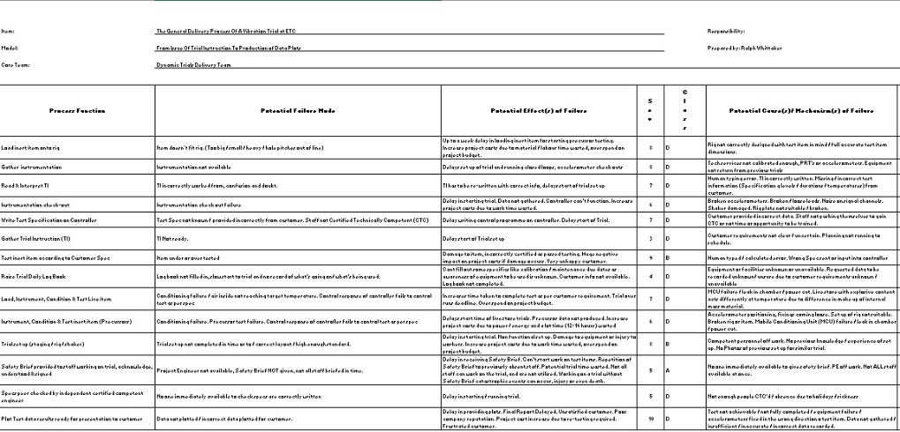
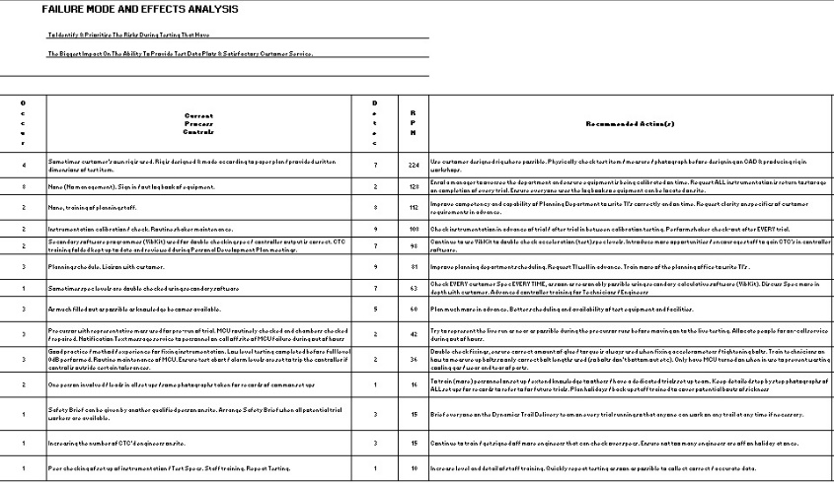
APPENDIX F
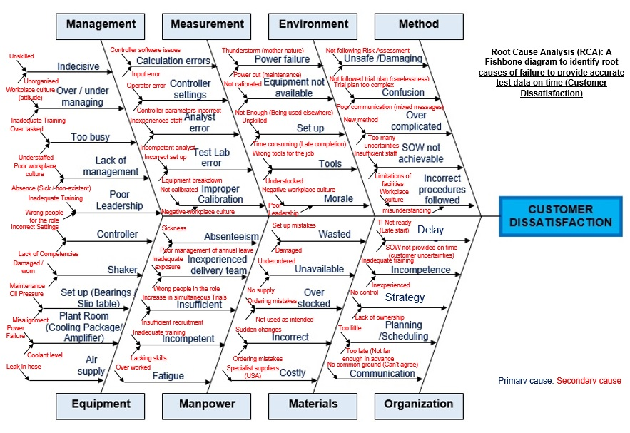
APPENDIX G Potential Check Card Design that could be used to sign off sequential stages of trail
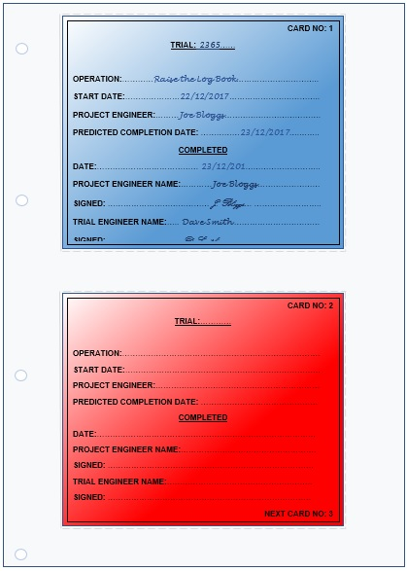
APPENDIX H Task Check Sheet
Below is an example of the possible solutions for keeping a log of Trial work progress:
TASK / PROCESS | Planned Date | Completion Date | PE Name | Signed | Engineer Name | Signed
Engagement with
Project Engineer
Issue of TI
Approval of
Timescale
Safety Brief
Risk Assessment
Raise Log Book
Gather
Instrumentation
Write Specification
Staging / Shaker
Set Up
Precursor Testing
Live Testing
Data Plots

APPENDIX I Blog from QINETIQ CEO, Steve Wadey

Roadshows: your opportunity to give us feedback
Latest blog from Steve Wadey, CEO
02 May 2017

During the roadshows we discussed the progress we made in the first year of our new vision and strategy. Thank you for a great year. We have made great progress and are in a strong place to deliver year two of our plan. As a result of the feedback we received from the roadshows in October we started to make improvements to our communication, accelerated the reorganisation by three months and included local slides to highlight local successes from last year and set out objectives for the coming year. I believe that it is critical that each and every one of us understands how we can contribute to growing QINETIQ and making it an even greater place to work.

