
Women’s Leadership in Football
Implementation Plan

January 13, 2023
University of Wales Trinity Saint David

Alicja Moga 1909156
Contemporary Themes in Leadership and Management
MA Leadership

Summary

The football industry is one of the most popular and lucrative sports worldwide. Despite this, there is a significant underrepresentation of women in executive roles in the industry. In response to the findings presented in the first assignment, this paper aims to provide an action plan to improve the number of women in executive roles in the football industry by identifying the limitations that women face to attain them. The plan involves a multifaceted approach that includes leadership development programs, increasing access to education and training, and cultural change initiatives.

Table of Contents

Summary 1
Table of Figures 3
1. Implementation Plan 4
1.1 Introduction 4
2. Rationale 7
2.1 Aims and Objectives 8
2.2 Action Plan 8
2.2.1 Time Plan 11
Appendix 1 11
2.2.2 Risk Management and Strategies 11
3. Recommendations 13
4. Conclusion 14
References 15
Appendix 17
Appendix 1 17

Table of Figures

Figure 1 - Gender Makeup of Men’s Club Football in the 2017/2018 Season 4
Figure 2 - Number of Women Board Members and Number of Clubs Without a Woman on Their Board per Season in Men’s Club Football 1987/1988 to 2017/2018 4

Implementation Plan

Introduction

Football began in the 19th century and was considered unsuitable for women. Women’s football was accepted in the 1970s by the National Football Association. Since then, it emerged globally (Pfister, 2015). Thanks to legislative interventions and programs at the national level, girls and women had been encouraged to be physically active. Women’s Olympics in 2012 hit a record number of female participants. However, this number does not match the proportion of women in leadership roles within the sports industry. Although women have many more opportunities, men still dominate in the industry (Laura J.Burton, 2017). The football industry needs improvement in gender diversity. Despite the increasing presence of women in the UK, leadership roles remain strongly masculine (Beth Fielding-Lloyd, 2011). People would favour men’s leadership as their traits are considered more effective (Jean Lau Cin, 2007). In 2016 only two of the 209 Presidents of the Member associations of FIFA were women. In 2018 FIFA initiated a strategy for the growth of women’s football and increased financial support (Learn, 2023).
In Norway and Germany, the entrance of females in decision-making started earlier. Both countries have a similar structure of the sport. However, in Norway, women account for a much higher percentage of decision-makers in both society and football. In the German sports system, men dominate in the most powerful leadership positions (Anna-Maria Strittmatter, 2017). Although the Scandinavian countries have the biggest number of female players, only Sweden’s teams have the most media attention.
According to recent findings, despite women's significant participation as workers in football, men continue to dominate the highest positions in men's club football. Figure 1 shows that women make up more than 25% of all men’s club football workers, but this proportion decreases as they climb the organisational ladder. In the 2017/2018 football season, women accounted for only 14% of workers in the top pay quartile, 8% of board members, and a mere 6% of chief executive officers (CEOs), who hold the most senior managerial position in an organisation.
Figure: 1
Progress on gender equality in the boardroom, which is the highest decision-making body, has been slow within men's club football, as shown by historical data in Figure 2. Although there is no data on the racial and ethnic composition of football leadership, a previous study revealed that less than 1% of European football leaders are visible minority women, indicating that Black women are severely underrepresented in football leadership and are practically excluded from it (Amee Bryan, 2021).
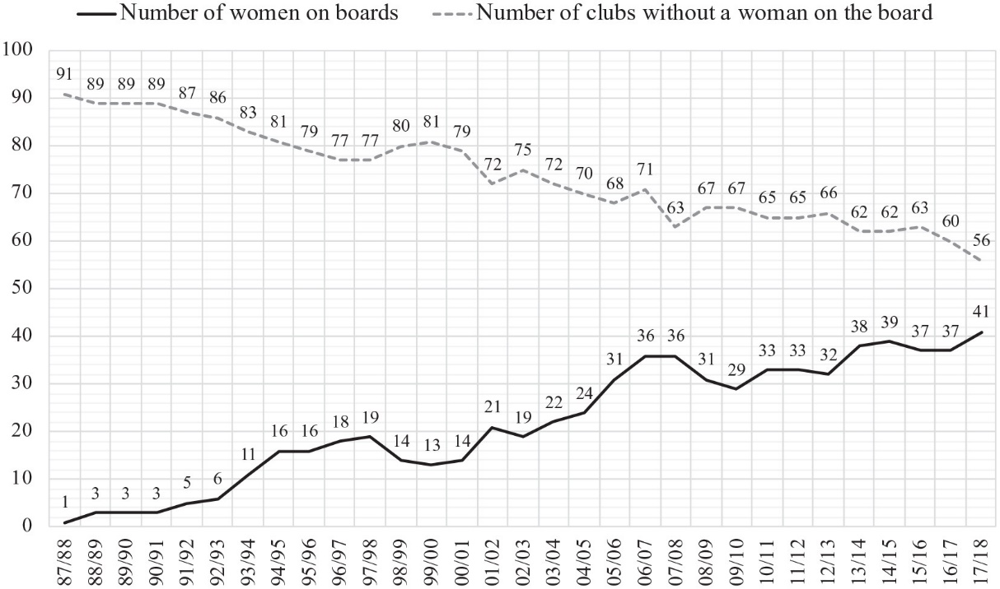
Figure: 2
Although women’s situation is changing, football associations should use a game as a tool to encourage diversity and show its benefits (Pfister, 2015). Football values, rules, and norms are based on masculine culture, and women may feel trapped as a minority. Like many other industries, it relies heavily on networking, which can make it difficult for women to break into executive roles (Curran, 2021). Another barrier for women identified in the first assignment was power and education. Women often face barriers to accessing education and training that are necessary for executive roles. Football associations can influence the strategic use of discourses about women in football by using their status. According to a study by the Women in Football Organisation, women occupy less than 30% of senior leadership roles, which was the target set up by The Football Leadership Diversity Code (Football, 2021).

Rationale

This paper's rationale is focused on women's position in the football industry.
In football history, the national football associations have prohibited women from playing for around 50 years. At the same time, men’s games developed rapidly. From the 1970s onwards women were allowed but not encouraged to play. National associations did not pay much attention to improving and developing the game. Today’s women’s football is provided with more support, but the football industry still needs to improve equality, diversity, and inclusion in clubs (Alfred Archer, 2019). The underrepresentation of women in executive roles in the football industry is not only social injustice but also a business issue. Football associations should look at the issues and provide solutions that will allow them to improve their governance (Department for Digital, 2021).
The partnership between the sectoral stakeholders and the UK Government can develop the concept of women’s empowerment. The main aim is to support women aspiring to become sports leaders in the football governing bodies.

2.1 Aims and Objectives

- To develop a solid foundation for women that will give them more opportunities to attain leadership positions in the football industry.
- To bring more diversity in a change-making position in the football industry
- To promote motivation, training, and skills development for all.

2.2 Action Plan

A mind map was used to create an action plan to visualise how to increase women’s representation in the football industry. The link is attached below:
Mind Map
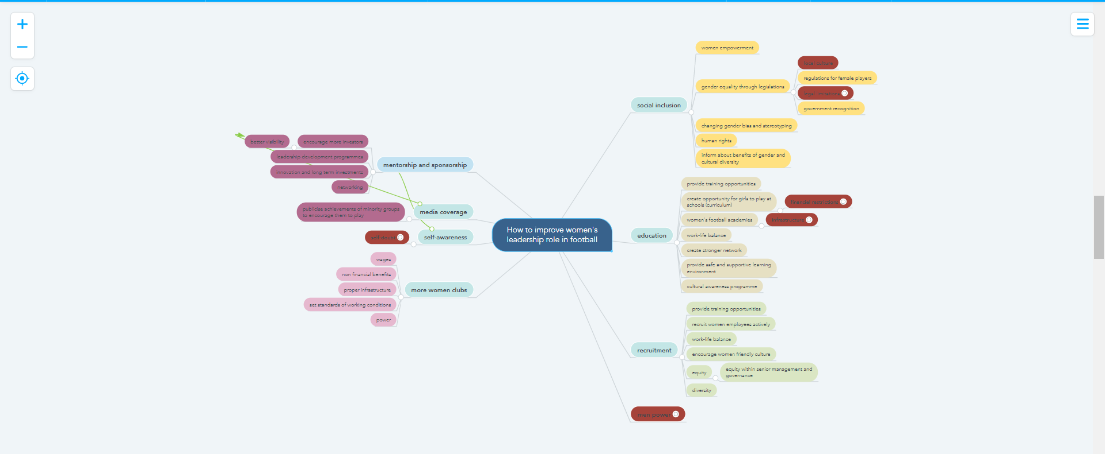

- Implement inclusive hiring practices:
Football clubs should implement diversity and inclusion initiatives that aim to increase the representation of women in executive roles. These initiatives should include strategies for reducing gender bias in hiring and promotion practices, as well as creating a more inclusive workplace culture. This can be achieved through the following strategies:
- Partnering with organisations that promote gender diversity in leadership, such as Women in Football.
- Ensuring job advertisements are gender-neutral and avoid using language that may deter women from applying. Job adverts attract a different type of candidates. According to one study, specific types of words are more likely to attract female or male candidates (CIPD, 2015).
- Actively recruiting women for leadership positions and offering mentorship and sponsorship programs to support their career growth.
- Leadership Development Programs
According to recent research, participants of leadership programs gain knowledge of self, improve in business, and are more aware of cultural differences (Alice M. Black, 2009).
Leadership development programs can play a significant role in preparing women for executive roles in the football industry. Such programs should be designed to address the specific challenges and barriers that women face in the industry. This can be achieved through the following strategies:
- Developing leadership training programs that provide women with the skills and knowledge required to succeed in executive roles.
- Providing networking opportunities and mentorship programs that connect women with successful female leaders in the industry.
- Offering career coaching and support to help women navigate the unique challenges they may face in the industry.
- Cultural Change Initiatives
The Fair Game report highlighted the importance of board diversity in effective decision-making and the financial prosperity of organisations (Cripps, 2022). Creating a culture that supports gender diversity and inclusion is critical for increasing the number of women in executive roles in the football industry. This can be achieved through the following strategies:
- Establishing a code of conduct that promotes diversity and inclusion within the organisation.
- Providing unconscious bias training to all employees, particularly those involved in the recruitment and selection process.
- Creating a supportive work environment that offers flexible work arrangements and family-friendly policies to support women in balancing work and family responsibilities.

2.2.1 Time Plan
The implementation of the action plan will involve a series of activities that need to be completed within a specific timeframe. The Gantt chart below outlines the key activities, their duration, and the timeline for completion.

Appendix 1

2.2.2 Risk Management and Strategies

Implementing the above action plan requires a strategic approach that considers potential risks and challenges. The strategy includes the involvement of all stakeholders, including football clubs, governing bodies, and industry associations. The key risks and challenges include:
1. Resistance to Change: One risk for women entering the football industry is resistance from the male-dominated culture. It's important to establish women's rights and support their well-being, as they may feel isolated. To address this, the industry must change its sexist and discriminatory culture by involving male executives and promoting diversity and inclusivity.
- Lack of Commitment: Another significant risk is a lack of commitment from the football industry to implement the program. The solution is to develop a business case that demonstrates the benefits of having more women in executive roles, such as a brand image.
- Limited Access to Opportunities: Another challenge is limited access to opportunities for women in the football industry. The solution is to create a platform that provides equal opportunities for both men and women in executive roles, such as leadership development programs, mentoring programs, and networking opportunities.
- Lack of Diversity in the Recruitment Process: The recruitment process in the football industry is often biased towards men, resulting in a lack of diversity in executive roles. The solution is to implement blind recruitment processes and gender-neutral job descriptions to eliminate biases in the recruitment process (Mocanu, 15).
- Limited Support: Women in executive roles often face challenges and limited support, which can result in low retention rates. The solution is to provide ongoing support through coaching and mentoring programs, which can help women navigate challenges and develop their careers (Farrer&Co, 2019).

Recommendations

- Funding - Research has shown that financial and cultural considerations are mostly limiting the aspirations of professional players to apply for coaching qualifications. Individuals with no experience in coaching or being coached had difficulty attaining the coach position (Dr Steven Bradbury, 2017). That is why the football industry should provide scholarships, sponsorships, and other forms of financial assistance to increase access to education and training programs that prepare women for executive roles.
- Education – Football clubs should provide training and education opportunities for women that are necessary for executive positions. These opportunities can include leadership training, business courses, and other relevant training programs.
- Diversity – Football clubs, governing bodies, and industry associations should develop a culture of diversity and inclusivity within the football industry to encourage more women to pursue executive roles.
- Media – Media organisations should actively seek out and highlight successful women leaders in the football industry. They should promote positive representation of women in all areas of the sport. Media can also partner with women-led organisations in the football industry to promote women’s leadership (Sport, 2018).

Conclusion

Increasing the number of women in executive roles in the football industry is essential for creating a more diverse and inclusive workplace that leverages the talents and experiences of all individuals, regardless of gender. The proposed implementation plan provides a roadmap for achieving this goal, including affirmative action policies, increasing representation in leadership roles, mentorship opportunities, and access to education and training programs. This plan's implementation requires all stakeholders' involvement, sustained effort, and regular monitoring and evaluation to ensure its success.

References
- Alfred Archer, M. P., 2019. Equal play, equal pay’: moral grounds for equal pay in football. Journal of the Philosophy of Sport , 46(3), pp. 416-436.
- Alice M. Black, G. W. E., 2009. Measuring the Outcomes of Leadership Development Programs. Journal of Leadership &, 16(2), pp. 184-196.
- Amee Bryan, S. P. A. J. R.-W., 2021. On the Periphery Examining Women’s Exclusion From Core Leadership Roles in the “Extremely Gendered” Organisations. Gender & Society, 35(6), pp. 940-970.
- Anna-Maria Strittmatter, B. S., 2017. Managing football organizations: a man’s world? Comparing women in decision-making positions in Germany and Norway and their international influence: a contextual approach. Soccer & Society, 18(1), pp. 81-101.
- Annelies Knoppers, D. d. H. L. N. N. L., 2021. Elite women coaches negotiating and resisting power in football. Gender, Work and Organisation, 29(3), pp. 880-896.
- Beth Fielding-Lloyd, L. M., 2011. I don't think I can catch it’: women, confidence and responsibility in football coach education. Soccer & Society, 12(3), pp. 345-364.
- CIPD, 2015. A head for hiring:, London: CIPD.
- Cripps, A., 2022. New Research Reveals Women Make Up Just 11.1% of Board Members at Premier League Clubs. [Online]
Available at: https://versus.uk.com/2022/03/new-research-reveals-women-make-just-11-1-board-members-premier-league-clubs/
[Accessed 12 January 2023].
- Curran, A., 2021. Durham study finds women sidelined for leadership roles in sport. [Online]
Available at: https://www.palatinate.org.uk/durham-study-finds-women-side-lined-for-leadership-roles-in-sport/
[Accessed 10 April 2023].
- Department for Digital, C. M. &. S., 2021. Fan-Led Review of Football Governance: securing the game’s Future, London: gov.uk.
- Dr Steven Bradbury, D. J. V. S. P. M., 2017. Cracking the glass ceiling?, Loughborough: School of Sport, Exercise and Health Sciences.
- Europe, W., 2022. WOMEN’S FOOTBALL: RIDING THE WAVE TOWARDS SPORTS LEADERSHIP. [Online]
Available at: https://worldfootballsummit.com/womens-football-sports-industry-leadership/
[Accessed 4 January 2023].
- Farrer&Co, 2019. Professional sports clubs bottom of the league on female representation: 53% have no women on their board. [Online]
Available at: https://www.paperturn-view.com/uk/briannawilson/farrer-co-women-in-sport?pid=NzA70913&v=1.1
[Accessed 12 January 2023].
- Fifpro, 2022. Raising our game - women's football report , Hoofddorp: Fifpro.
- Football, W. i., 2021. Written evidence submitted by Women in Football. [Online]
Available at: https://committees.parliament.uk/writtenevidence/117550/pdf/
[Accessed 12 January 2023].
- Jean Lau Cin, B. L., 2007. Women and Leadership- Transforming Vision and Diverse Voices. 1st ed. Oxford: Blackwell Publishing Ltd.
- Kelsey Richards, C. L. J. O., 2022. ‘We need a whole range of different views’: exploring the lived experiences of women leaders in Australian rules football. Sport in Society , 25(10), pp. 1940-1956.
- Laura J.Burton, S. L., 2017. Women in Sport Leadership. New York: Routledge Taylor&Francis Group.
- Learn, F., 2023. Women’s Football: Key Information and Statistics. [Online]
Available at: https://www.futurelearn.com/info/courses/football/0/steps/6325
[Accessed 12 January 2023].
- Mocanu, T., 15. Designing Gender Equity: [Online]
Available at: https://tatianamocanu.github.io/jm/mocanu_jmp_hiring.pdf
[Accessed 23 April 2023].
- Pfister, G., 2015. Assessing the Sociology of Sport. International Review for the Sociology of Sport , pp. 563-569.
- Society, G. &., 2021. On the Periphery – Women in Football Leadership. [Online]
Available at: https://gendersociety.wordpress.com/2021/10/16/on-the-periphery-women-in-football-leadership/
[Accessed 12 January 2023].
- Sport, W. i., 2018. Where-are-all-the-Women, s.l.: Women in Sport.
- Trust, F., 2022. BE. FOOTBALL SCHOOLS PROGRAMME | DEVELOPING LIFE SKILLS AND LEADERSHIP THROUGH FOOTBALL. [Online]
Available at: https://www.fawtrust.cymru/get-inspired/news/be-football-schools/
[Accessed 4 January 2023].
- UEFA, 2019. Women's football- Football Development. [Online]
Available at: https://www.uefa.com/insideuefa/football-development/womens-football/
[Accessed 12 January 2023].

Appendix

Appendix 1

