

Assessment 1 – Reading Task Template
PART 1: Upload your photo of your A3 in-class notes here:

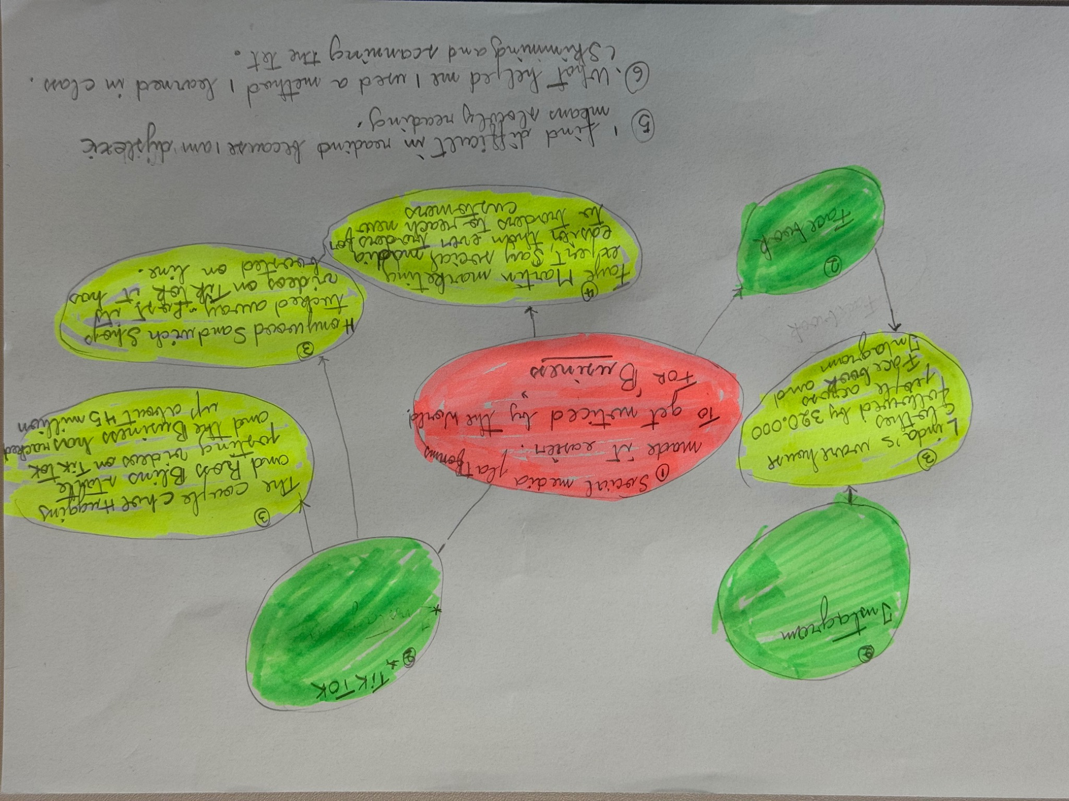

PART 2:
- Answer every question below in 1-3 full sentences.
- Use your own words. Do not use generative AI to answer these questions.
- Include a specific detail from the text when asked.
REMINDER
- The main idea is the overall message of the whole text.
- A key point helps to explain the main idea.
- A specific detail or example from the text shows that the key point is true.

- What is the main idea of the whole text?
The main idea of the text is social media advertising.

- What is one key point that supports the main idea, and which specific example from the text shows this?
One key point that support the main idea is a customer travelled 3 hours
Ex: ‘customers travelled three hours for our chicken burger’

- What is a different key point that supports the main idea, and which specific example from the text shows this?
a different key point that supports the main idea is a bisuness going viral in tiktok. Ex; ‘the business has racked up about 45 million views”

- Which part of the text do you think is most important, and why?
The most important on text is “social media platforms such as tiktok and instagram have it easier than ever ti get niticed by the world.”

Reflection:
- What did you find difficult in this task (including in-class components), and why was it difficult?
I find difficult the reading and writing in PC because I am dyslexic .

- What helped you with this difficulty, and how did it help you?
By practising.

