

Study Skills for Electronics

Name: Iolo Williams

Student No: 2508067

L4- Study Skills

ACDA4021

Electrical and Electronic Degree Apprenticeship

TABLE OF CONTENTS
LIST OF FIGURES 3
LIST OF TABLES 4
SECTION 1: PRESENTATION SKILLS 5
1.1: A BRIEF OVERVIEW OF MYSELF 5
1.2: MY PRESENTATION 5
1.3: KEY POINTS 8
1.4: ASPECTS THE PRESENTER COULD IMPROVE ON 8
1.5: WHAT WENT WELL DURING THE PRESENTATION 9
SECTION 2: PERSONAL RESEARCH ON REQUIRED SKILL SETS 10
2.1: SKILLS REQUIRED FOR SUCCESSFUL LEARNING IN A HIGHER EDUCATION ENVIRONMENT 10
2.2: TRANSFERABLE SKILLS SOUGHT AFTER BY EMPLOYERS 10
SECTION 3: SELF-EVALUATION AND ACTION PLANNING 11
3.1: SELF-EVALUATION 11
3.2: SMART LONG AND SHORT-TERM GOALS 15
SECTION 4: APPLICATION 16
4.1: LOOKING AFTER YOUR DATA 16
4.1.1: RANSOMWARE 16
4.2: TIME MANAGEMENT AND SELF-ORGANISATION 17
SECTION 5: CONCLUSION & EVALUATION 18
SECTION 6: REFERENCES 19
SECTION 7: APPENDICES 20
APPENDICES: TABLE OF FIGURES 20
APPENDIX A: POWER POINT SLIDES 21
APPENDIX B: PEER FEEDBACK ON PRESENTATION 25
APPENDIX C: SOME OF MY ANSWERS TO MYERS-BRIGGS TEST [4] [5] 26
APPENDIX D: RESEARCH FOR RANSOMWERE AND MY SAVING LOCATIONS 30
D.1: RESEARCH POINTS [10] 30
D.2: THE THREE DIFFERENT LOCATIONS USED TO SAVE THIS ASSIGNMENT 31

LIST OF FIGURES
Figure 1: Cover page. 5
Figure 2: An introduction to where I grew up and what I like about it. 6
Figure 3: A slide showing a few interesting facts about myself. 6
Figure 4: What I enjoy doing in my spare time this one being rugby. 7
Figure 5: Results of Myers-Briggs test [5] 11
Figure 6: Learning style. 13
Figure 7: Learning style chart. 13
Figure 8: Learning style distribution 14
Figure 9: Intelligence style. 14
Figure 10: Style of learning and intelligence. 14

LIST OF TABLES
Table 1: The apprentice's SMART goals for the foreseeable future. 15
Table 2: Typical week in the apprentice's life 17
Table 3: The apprentice's PDP 17

SECTION 1: PRESENTATION SKILLS

1.1: A BRIEF OVERVIEW OF MYSELF
My name is Iolo Williams. I'm currently living in Pembrokeshire and working alongside my degree as an Electrical, Controls and Instrumentation engineer. In my spare time, I enjoy playing sports like rugby, going wakeboarding and exploring the countryside.

1.2: MY PRESENTATION
As part of this section, we were challenged to create a 5-minute presentation on ourselves to “Break the ice” between our classmates. Before we began this, we were given a guest lecture where we were advised on some useful tips and tricks for a triumphant presentation in front of our peers.
Below are four screenshots from my PowerPoint presentation listed in figures 1,2,3, and 4.
See Appendix A for the full presentation.
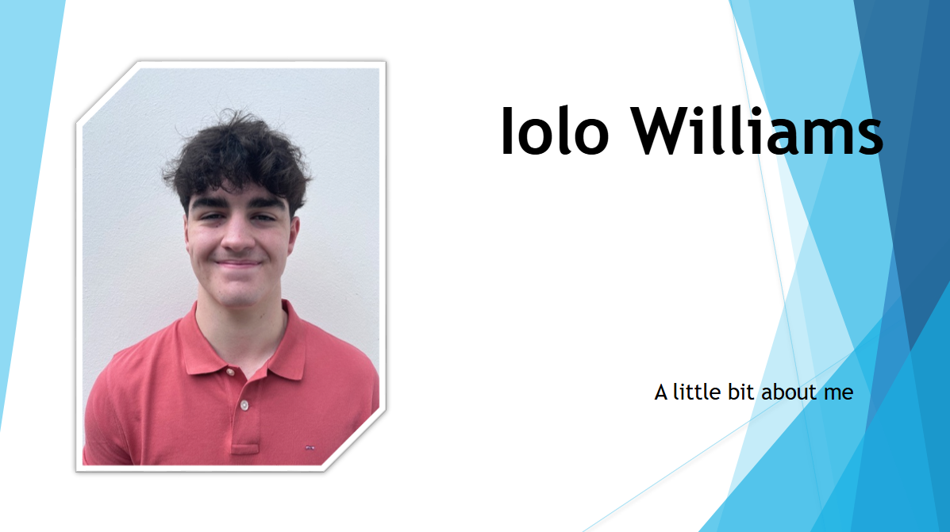
Figure 1: Cover page.

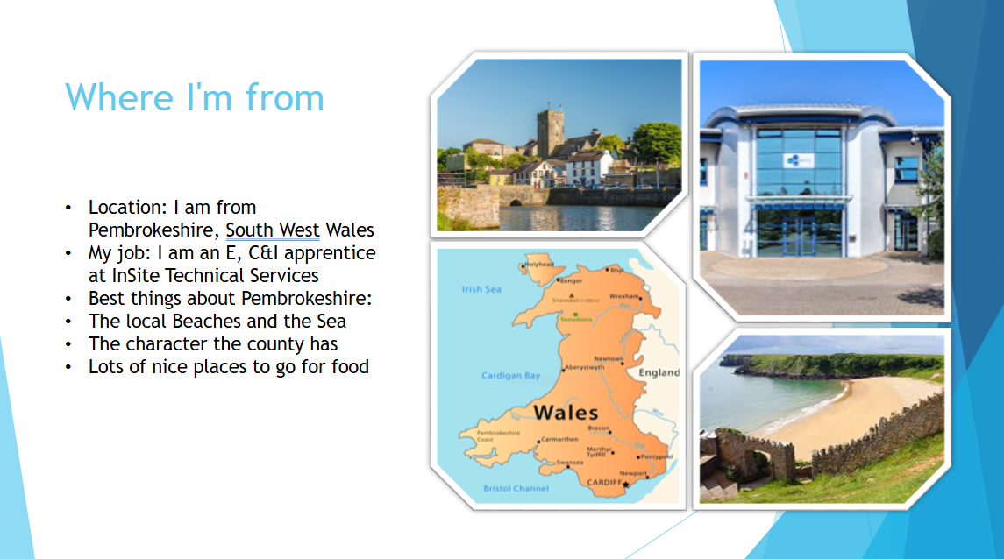
Figure 2: An introduction to where I grew up and what I like about it.
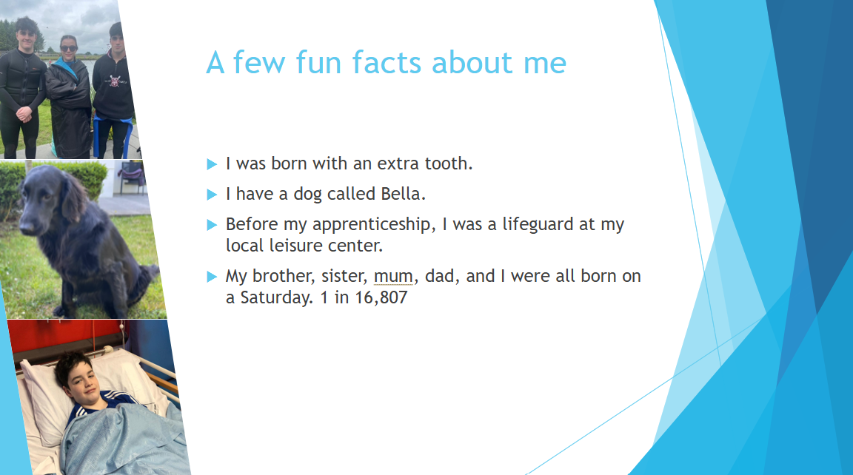
Figure 3: A slide showing a few interesting facts about myself.
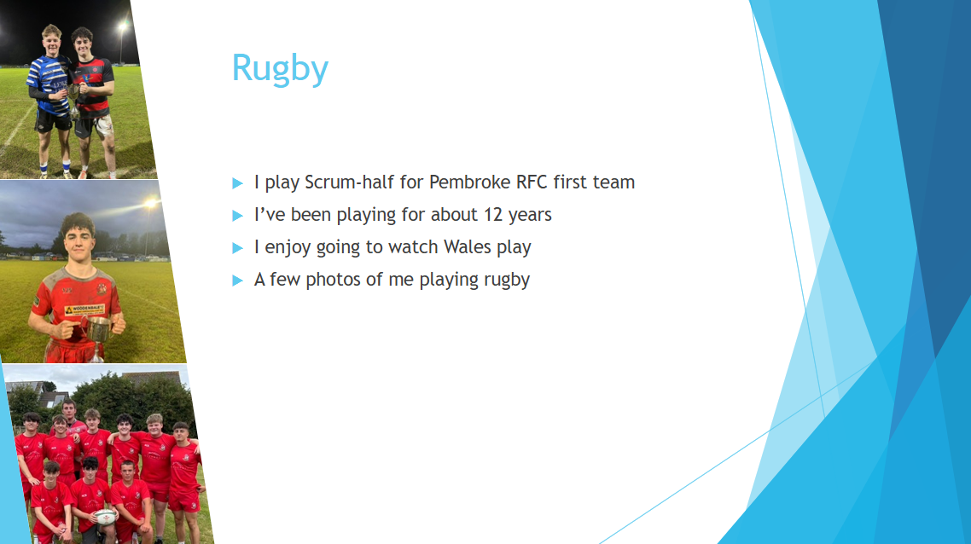
Figure 4: What I enjoy doing in my spare time this one being rugby.

1.3: KEY POINTS
Over the last few months, studying and researching for this module, the three key points about delivering a successful presentation that I have discovered are:
- Effective preparation
This can help with all aspects of your presentation, and in the student’s eyes, is the most important piece of the puzzle; preventing rambling and giving you somewhere to fall back to if you are unsure where to go next and, lastly, gives you a strong idea of your timings.
- Audience engagement (talking to your audience, not at them)
When you talk to your audience and involve them in your presentation, it will allow them to retain more of the information you tell them. For example, making eye contact and having a clear and confident voice are both great ways of including your audience in your presentation without getting them to stand up with you.
- Tailoring your presentation to your audience
For instance, if you are presenting to a large group of school children, you would adjust your presentation by perhaps shortening the time, as children have shorter attention spans, and making the content a lot simpler instead of much more complex if it were your boss.

1.4: ASPECTS THE PRESENTER COULD IMPROVE ON
After gaining feedback from his group and some self-reflection, the most important areas for the presenter to improve on are:
- Speed of presentation
The presenter rushed through his slides and didn’t convey enough information. This can be improved by settling your nerves prior to speaking. But overall, the speaker put this down to a lack of experience in presenting.
- Eye contact
The group suggested the speaker wasn’t specifically making eye contact, but he was still talking to the audience and looking at them.
Feedback notes from the group are shown in Appendix B.

1.5: WHAT WENT WELL DURING THE PRESENTATION
The positive feedback received is as follows:
- A visually appealing PowerPoint
It was referred to the presenter that his slides were easy to follow, well structured, and contained a good proportion of photos and text alike.
- Good body language
During the presentation, the presenter used hand gestures as he was talking, which helped to convey his emotion and made it easier for the listener to focus on the presentation.
Feedback notes are also shown in Appendix B.

SECTION 2: PERSONAL RESEARCH ON REQUIRED SKILL SETS

2.1: SKILLS REQUIRED FOR SUCCESSFUL LEARNING IN A HIGHER EDUCATION ENVIRONMENT
As shown in [1], [2], [3], and Interpersonal research done by the apprentice to broaden their knowledge by talking to family members, friends who have studied and are studying in a higher education environment. The apprentice concluded that the most beneficial skills for higher education are.
- Critical thinking
Critical thinking is the art of making clear, reasoned judgements based on interpreting, understanding, applying and synthesising evidence gathered from observation, reading and experimentation. [1]
- Note-taking
After researching, being proficient at note-taking is a necessity for success. Being able to note down in real time and have a robust system in place to allow you to revise your notes can be the difference when working to accomplish top grades on your degree.
- Communication
“The activity or process of expressing ideas and feelings or of giving people information.” This is a vital skill for group projects and presentations, which contribute to a strong proportion of your degree, making communication a skill that is highly desired among university students. [2]

2.2: TRANSFERABLE SKILLS SOUGHT AFTER BY EMPLOYERS
Transferable skills are defined as “Skills used in one job or career that can also be used in another”. [3]
- Analytical thinking
- Empathy and active listening
- Curiosity
- Attention to detail
- Creativity
Being proficient in these skills and others alike can really benefit a young student's career.

SECTION 3: SELF-EVALUATION AND ACTION PLANNING

3.1: SELF-EVALUATION
Throughout this section, the learner will carry out exercises to discover their strengths and weaknesses, personality type and discover different careers which are suitable for them. He will do this by conducting research, considering previous self-reflection, and then comparing this with online test results obtained.
Firstly, the Myers-Briggs Type Indicator test was performed. This test is used to gain insight into how individuals view the world. Moreover, it is used to identify strengths and weaknesses possessed by an individual.
The test results in 16 different personality types being either introversion/extraversion, Sensing/Intuition, Thinking/Feeling and Judging/Perceiving. Each different category combination aligns with a multitude of different personality types.
The student’s answers to the Myers-Briggs test can be found in Appendix C
Figure 5 below shows the results from the Myers-Briggs test [4].
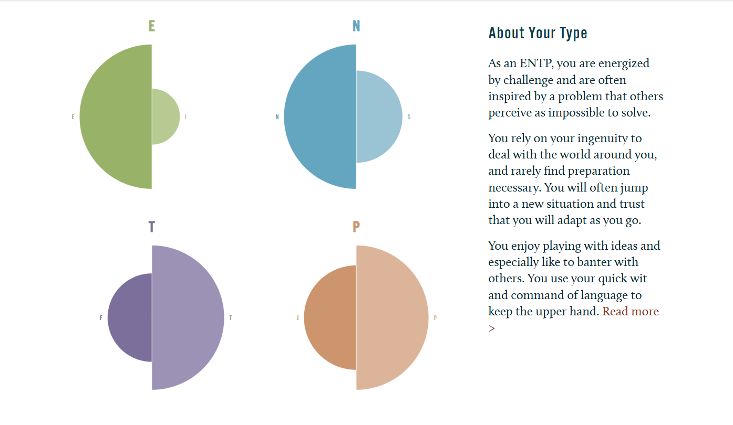
Figure 5: Results of Myers-Briggs test [5]

As the results of Figure 5 show, the learner is a ENTP (Extraversion, Intuitive, Thinking, and Perceiving). The ENTP personality type is often described as “The Visionary” This means they are energised by working with others, are creative thinkers, and are comfortable with fast-paced change. This combination of traits makes ENTP people “Quick-witted, confident, and charming, they are visionaries with infectious enthusiasm. ENTPs trust their instincts, are not bound by convention, and are rarely judgmental; however, they can be impatient and impractical.” [5]
ENTPs are often described as friendly and charming people, curious about the world and are always looking to understand how things work. A drawback of the ENTP personality type is that they often focus on the big picture, unfortunately, sometimes missing out on minor details. This can make them seem unreliable in a workplace setting, as they may not always follow through with their ideas.
Listed below are the common strengths and weaknesses of an ENTP [6]
Strengths
- Quick thinkers
- Good brainstormers
- Charismatic
- Knowledgeable
Weaknesses
- Argumentative
- Insensitive
- Difficulty focusing
- Intolerance
ENTP Career options include [7]
- Engineer
- Financial analyst
- Lawyer
- Software developer
ENTP Careers to avoid
- Dentist
- Receptionist
- Preschool teacher
- Airline Pilot

My learning style [8]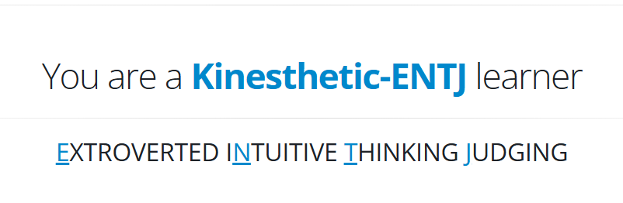
Figure 6: Learning style.
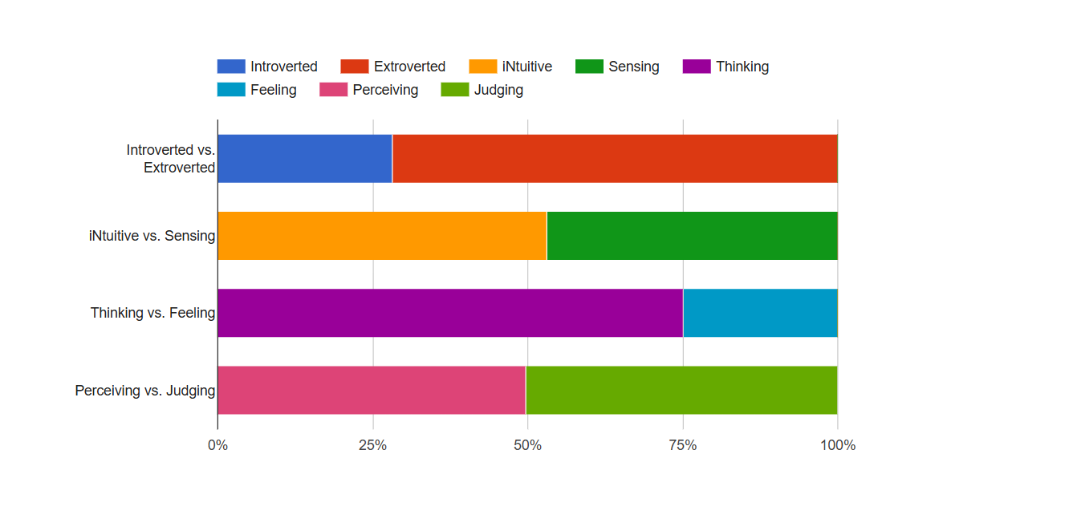
Figure 7: Learning style chart.
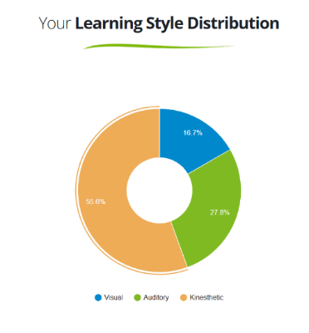
As we can see from the results of the quiz, the student's personality type is very similar to the previous result, the only difference being judging instead of perceiving; however, as we can see from the chart, the perceiving vs. judging has a 50/50 split, so this difference in results does not concern the learner.
Figure 8: Learning style distribution

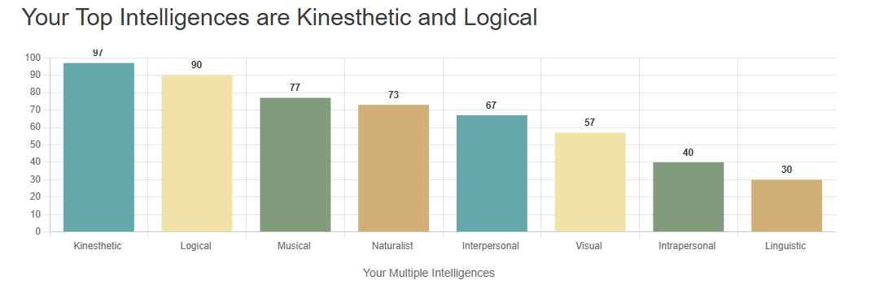
Figure 9: Intelligence style.
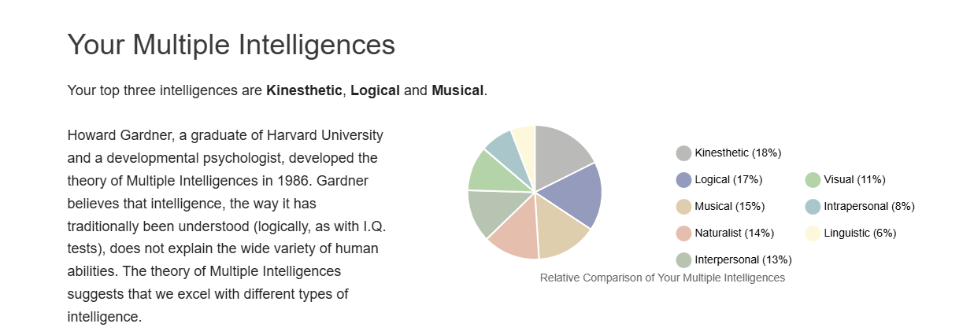
Figure 10: Style of learning and intelligence.
The results show that the student is a kinaesthetic learner, meaning they learn best when they get involved and experience what they're studying. The learner said, “I feel all these results coincide with each other because being able to hear, see, and play around with, when possible, can greatly support the amount of information retained from a lecture.”
After reviewing the research, the learner believes that the results presented by his tests and research align with his personal thoughts and feelings about his personality, learning style and future career. For example, in the strengths and weaknesses section, the learner feels, and after speaking with his friends who agree, he does possess such characteristics, showing the accuracy of the test [8].

3.2: SMART LONG AND SHORT-TERM GOALS
Personally, the student's 4 main SMART goals would be to improve his sleep, his reading and rugby ability and lastly cut down on weekly expenses to allow for more savings.
Table 1: The apprentice's SMART goals for the foreseeable future.
S  (SPECIFIC) | M  (MEASUREABLE) | A  (ATTAINABLE) | R  (RELEVANT) | T  (TIMEBOUND)
Maintain a healthy sleep schedule by getting regular amounts of sleep at similar times. | Progress will be measured by tracking the amount of sleep each night using a smart watch. | This goal is very attainable; it may be difficult at first, but it will be well worth it overall. | Strong sleep habits improve your overall health and mental well-being being hence allowing the student to study more effectively. | This routine will be followed for 6 months to see improvement in that time.
Progress in my reading ability. | This will be measured by using a diary to track the amount of reading completed each session. | The student will set aside 20 minutes before bed to complete the reading. | Reading before bed will be a useful way to wind down and relax before bed. | The learner is aiming to finish a book every 1-2 months.
Improve rugby ability. | Log match statistics in a diary, for example, tries scored, passes completed, and tackles made. | Train 5 times a week with 3 gym sessions and two on-field team sessions. | This will make the apprentice stronger and fitter, giving them a more active and healthier lifestyle. | Aiming to have seen improvement by September 2026.
Limit the amount of money spent weekly to allow me to save more. | Track weekly spending using a banking app. | This will be done by reducing the number of needless trips for lunch and instead bringing a packed lunch. | More money will be saved, so therefore allow the apprentice to go on another holiday, etc. | 5 weeks to see the average money saved per week, and after a year of reduced spending, enough could be saved for a holiday.

SECTION 4: APPLICATION

4.1: LOOKING AFTER YOUR DATA
To ensure the safety of this entire document, the student used a backup strategy that obeyed the “in three different places rule.” Those places being on the student's UWTSD OneDrive, the employer’s system, and lastly a USB stick [9]. This is a robust system to use due to the number of different locations used.
Why backing up your data is useful.
- If your file is saved directly to the laptop, it may become damaged, and you’ll have to start again
- If you have a new device, you can copy your information over to it
- A virus or type of ransomware may affect your file
- You accidentally delete your data

4.1.1: RANSOMWARE
Research into protection against and my method I used for protecting against ransomware can be found in Appendix D
Ransomware is a three-step process by a hacker where they first gain access to your files or network and plant malicious software. Secondly, the malware is activated, which can lock devices and or cause the data across the network to become encrypted, blocking your access. Lastly, the person who hacked you will then try to ransom your work to gain payment from the affected person in exchange for access to your originally encrypted data. [10]
If the learner were to be targeted with ransomware, the method of storage using the “in three different places rule” the data is stored in many different places and has multiple backups across all storage sites, thus making his work well defended against any malpractice.

4.2: TIME MANAGEMENT AND SELF-ORGANISATION
 | MONDAY | TUESDAY | WEDNESDAY | THURSDAY | FRIDAY | SATURDAY | SUNDAY
MORNING | LECTURES | WORK | WORK | WORK | WORK | RELAX | GYM
LUNCH | 1-2 PM | 12-12:30 PM | 12-12:30 PM | 12-12:30 PM | 12-12:30 PM | RUGBY GAME | 12-1 PM
AFTERNOON | LECTURES | UNI WORK | WORK | UNI WORK | EARLY FINISH | SOCIALISE | UNI WORK
DINNER | 6-7 PM | 6-7 PM | 6-7 PM | 6-7 PM | 6-7 PM | 6-7 PM | 6-7 PM
EVENING | RELAX | RUGBY TRAINING | GYM | RUGBY TRAINING | GYM | SOCIALISE | RELAX
Table 2: Typical week in the apprentice's life
As we can see from this table of a typical week in the apprentice’s life, there is a strong balance between work, university, and socialising, which is majorly important to success in his university career.
Table 3: The apprentice's PDP
What do I want/need to learn or develop?  (Specific & Relevant) | What will I do to achieve this?  (Specific) | What resources or support will I need?  (Achievable) | What will my success criteria be?  (Measurable) | Target dates for review and completion  (Timebound)
Complete his degree in Electrical & Electronic Engineering with a First-class degree. | Learn from lecturers and classmates, complete coursework in good time and revise well for exams. | Use the lecturer's knowledge and extended reading to allow himself to complete my degree to the highest standard. | Receive results and have a First-class degree. | By the Summer of July 2029.
The student wants to become a Chartered Engineer. | This will be done alongside the student's career by completing CPD and logging it on the IET website. | To complete this objective, the aim is to complete his CPD every month, finishing training courses, etc. | Become a chartered engineer. | By 2035.
Buy a new car. | Save up £300 a month to afford a deposit on a £16000 VW Golf. | Use the Salary from the student's apprenticeship to save this money in the time frame stated. | Placed a deposit on the car and have it parked on the student's driveway. | By November 2026.
Improve AutoCAD skills. | Enrol in a course and learn from my peers to gain as much experience as possible. | Use his peers in work to iron out any errors and a training course to teach the details. | Will be able to complete my work to a higher standard and quickly, improving his performance at work. | Review after 5 Weeks and aim to have largely improved by 10 Weeks.

SECTION 5: CONCLUSION & EVALUATION
To conclude, during the study of each individual topic on this assignment, the following areas have tremendously stood out to the apprentice. Firstly, during the presentation skills section, he gained a newfound confidence in public speaking. The factors that contributed to this are as follows.
- The research he conducted allowed him to perform his presentation as best as he could
- The positive feedback gained from peers
- And getting over the first hurdle of nervousness, and just getting up and doing his presentation
Following on, in the self-evaluation and action planning segment of this paper, the apprentice found it particularly useful to discover his learning style, personality type and suggested careers. Luckily, an engineer was a recommended career, so he is on the right career path.
For the student to further his knowledge in this field, he will continue his research at [11] for a more in-depth look into his future prospects. Moreover, researching how to improve the ability to study was highlighted to the apprentice after discovering the fact that there are multiple learning styles, so to improve his knowledge of his own, he will begin his research at [12] and continue on from there.

SECTION 6: REFERENCES
- R. Needleman, “What Are The 6 Essential Skills For University Students?,” UniAdmissions: The Oxbridge Experts, Jun. 30, 2021. https://www.uniadmissions.co.uk/application-guides/6-essential-skills-for-university-students/
- Oxford University Press, “communication noun - Definition, pictures, pronunciation and usage notes | Oxford Advanced American Dictionary at OxfordLearnersDictionaries.com,” Oxfordlearnersdictionaries.com, 2019. https://www.oxfordlearnersdictionaries.com/definition/american_english/communication
- “What employers look for,” Cardiff University , 2021. https://sites.cardiff.ac.uk/studentfuturesplus/skills-and-attributes/what-employers-look-for/
- Truity, “The TypeFinder Personality Test,” Truity, 2019. https://www.truity.com/test/type-finder-personality-test-new
- “ENTP | True You Journal,” www.truity.com. https://www.truity.com/blog/personality-type/entp
- “Debater Personality: Strengths & Weaknesses,” 16Personalities, Aug. 2013. https://www.16personalities.com/entp-strengths-and-weaknesses
- “The Best Careers for ENTP Personality Types | True You Journal,” www.truity.com. https://www.truity.com/blog/personality-type/entp/careers#type-details
- www.learningstylequiz.com, “I am a Kinesthetic-ENTJ learner | Language Learning Style Quiz | Live Lingua,” Learningstylequiz.com, 2020. https://learningstylequiz.com/quiz/results/Kinesthetic-ENTJ/1926807 (accessed Nov. 25, 2025).
- National Cyber Security Centre, “Always Back up Your Most Important Data,” www.ncsc.gov.uk, 2021. https://www.ncsc.gov.uk/collection/top-tips-for-staying-secure-online/always-back-up-your-most-important-data
- National Cyber Security Centre, “A Guide to Ransomware,” www.ncsc.gov.uk, 2025. https://www.ncsc.gov.uk/ransomware/home
- “Career» BlossomUp,” BlossomUp, Nov. 12, 2025. https://blossomup.co/lp/career/?utm_medium=cpc&utm_source=google&utm_campaign=22208639649&gad_source=1&gad_campaignid=23192881878&gbraid=0AAAAAoP3mdBvRCJ1UEEDyMLHLbNea_36Y&gclid=EAIaIQobChMI4renm7q_kQMVMRoGAB3q4hywEAAYASAAEgK-qfD_BwE (accessed Dec. 15, 2025).
- Show Me Images, “Getting to know tactile/kinaesthetic learners | ShowMe Images,” www.showmeimages.com. https://www.showmeimages.com/news/tactile_learner.html

SECTION 7: APPENDICES

APPENDICES: TABLE OF FIGURES
Figure_Apx 1: Cover page. 21
Figure_Apx 2: Where I’m from. 21
Figure_Apx 3: What I do outside work. 22
Figure_Apx 4: Rugby outside of work. 22
Figure_Apx 5: Wakeboarding outside of work. 23
Figure_Apx 6: Skiing and darts 23
Figure_Apx 7: Fun facts 24
Figure_Apx 8: Slide to say thank you. 24
Figure_Apx 9: Myers-Briggs Questions set 1 26
Figure_Apx 10: Myers-Briggs Questions set 2. 27
Figure_Apx 11: Myers-Briggs Questions set 3. 28
Figure_Apx 12: Myers-Briggs Questions set 4. 29
Figure_Apx 13: Research on what a ransom does. 30
Figure_Apx 14: What to do if affected by ransomware. 30
Figure_Apx 15: Reasons to back up the device. 31
Figure_Apx 16: Work saved on USB stick 31
Figure_Apx 17: Saved onto work OneDrive 31
Figure_Apx 18: Saved on UWTSD OneDrive 32

APPENDIX A: POWER POINT SLIDES
Figure_Apx 1: Cover page.
Figure_Apx 2: Where I’m from.
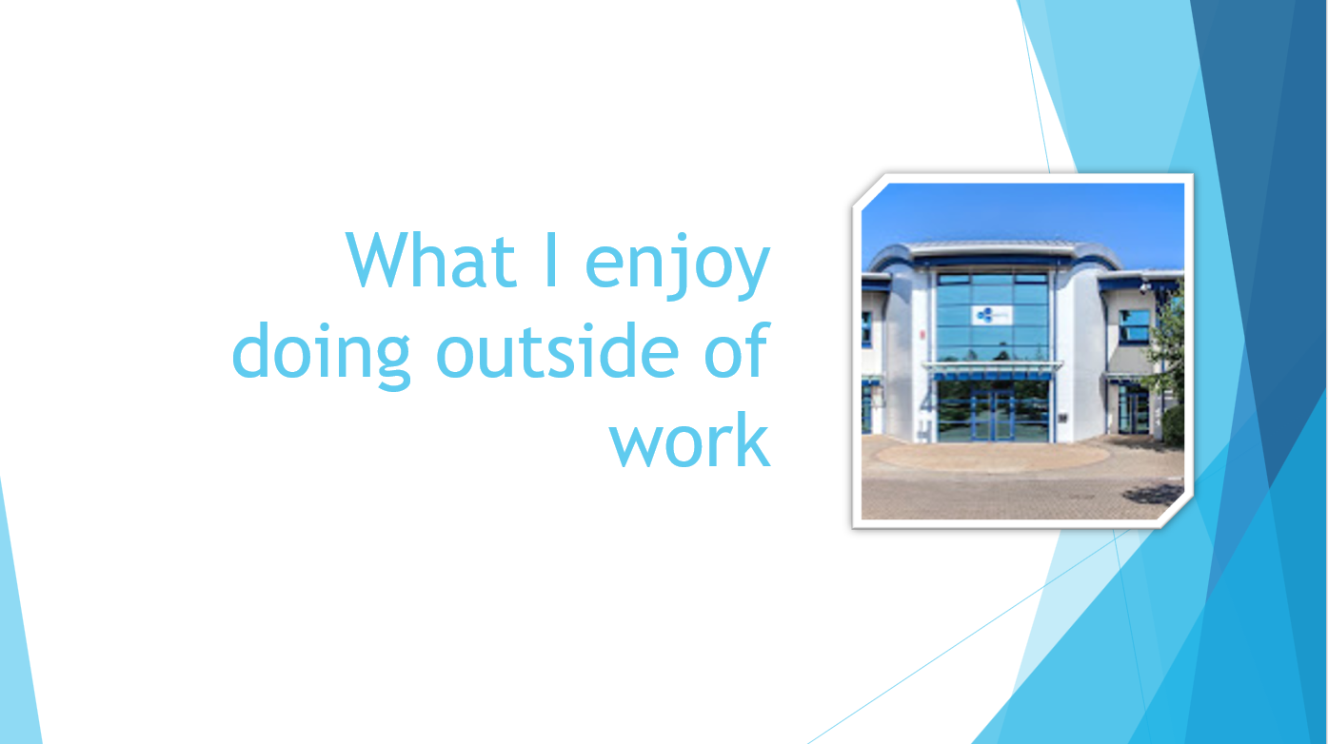
Figure_Apx 3: What I do outside work.
Figure_Apx 4: Rugby outside of work.
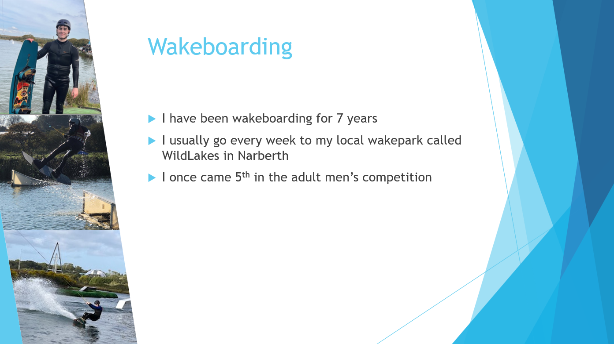
Figure_Apx 5: Wakeboarding outside of work.
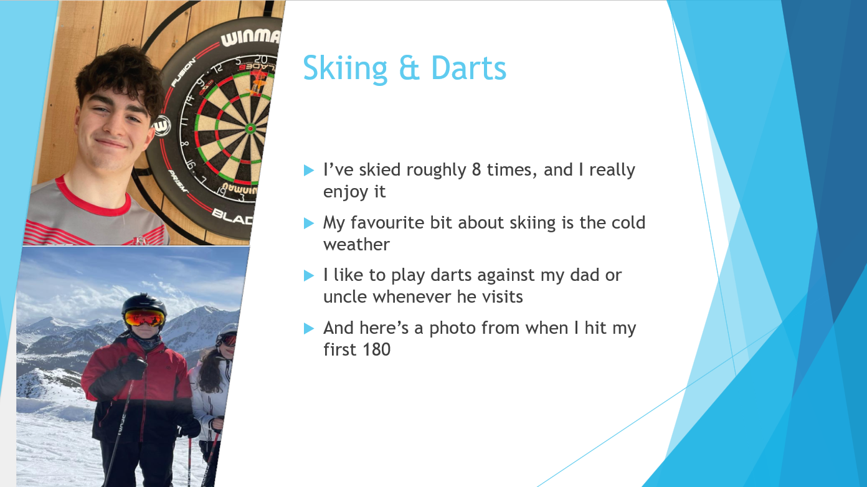
Figure_Apx 6: Skiing and darts
Figure_Apx 7: Fun facts
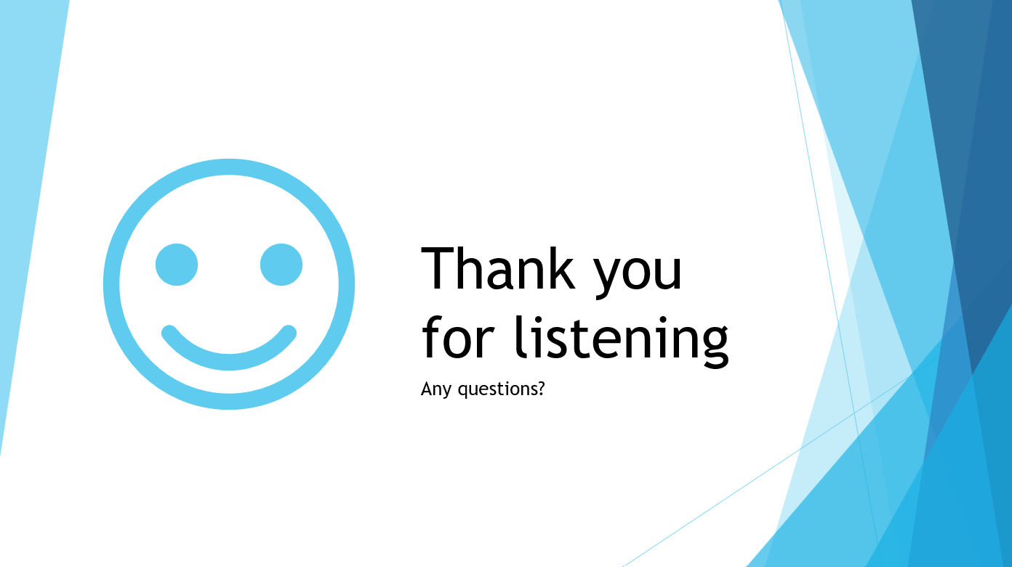
Figure_Apx 8: Slide to say thank you.

APPENDIX B: PEER FEEDBACK ON PRESENTATION
Leon said that “I could improve my speed of presentation; in his opinion, the presenter rushed through his slides when he should’ve given himself more time to get the information across and to relax to make himself come across more relaxed and professional.”
As a positive, he described the PowerPoint as “Visually appealing” saying that there was a plentiful amount of information for each slide, not too much, not too little, while also being straightforwardly followed and using inclusive colours, hence making the text easily visible.
Ben said that over the course of the presentation, the presenter had a specific weakness of making eye contact with each and every listener, while they still looked at the audience and didn’t stare at their feet, etc, they weren't making eye contact.
He also mentioned that the presenter had good body language and that they used hand gestures really well to convey their emotion, which made a positive impact on the listeners.

APPENDIX C: SOME OF MY ANSWERS TO MYERS-BRIGGS TEST [4] [5]
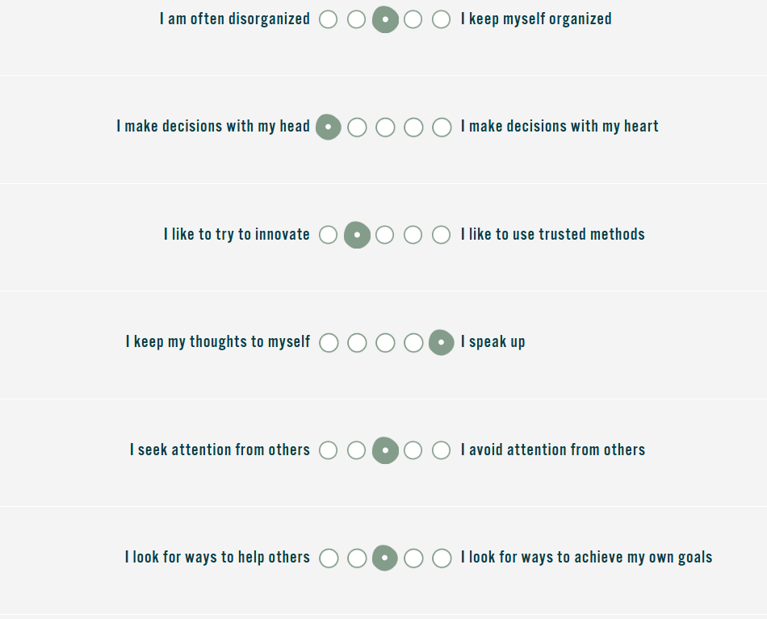
Figure_Apx 9: Myers-Briggs Questions set 1
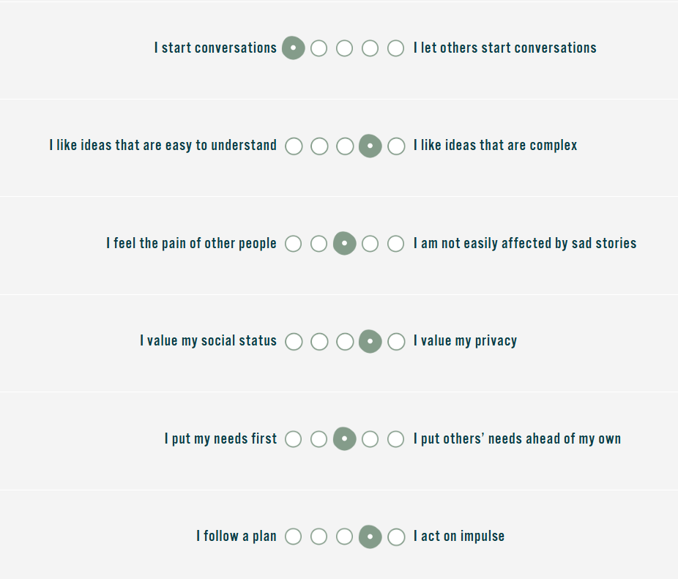
Figure_Apx 10: Myers-Briggs Questions set 2.
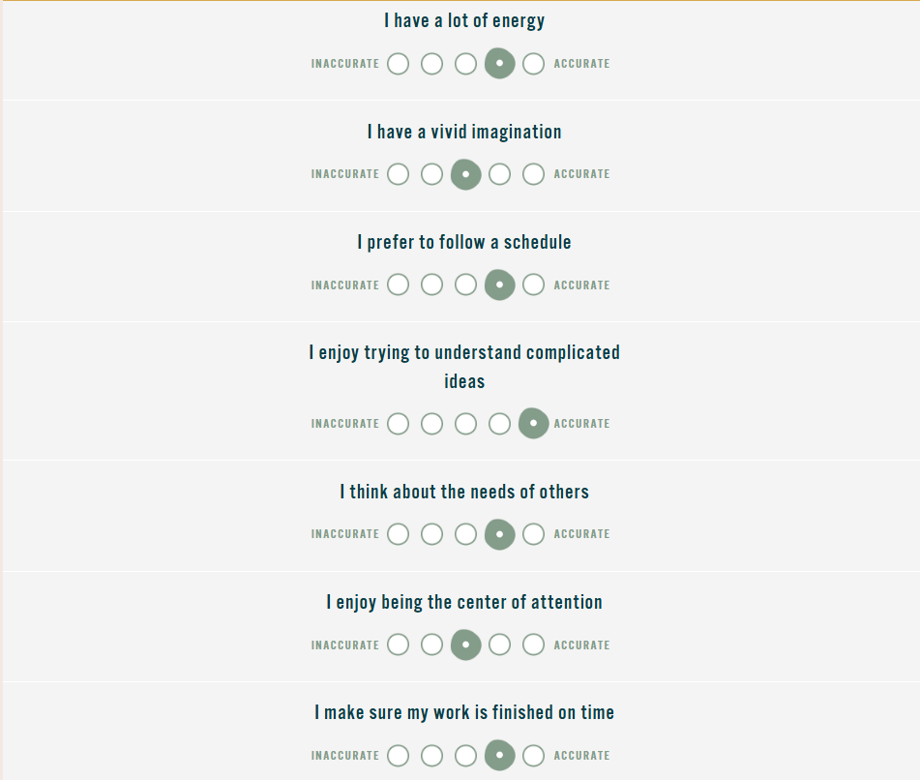
Figure_Apx 11: Myers-Briggs Questions set 3.
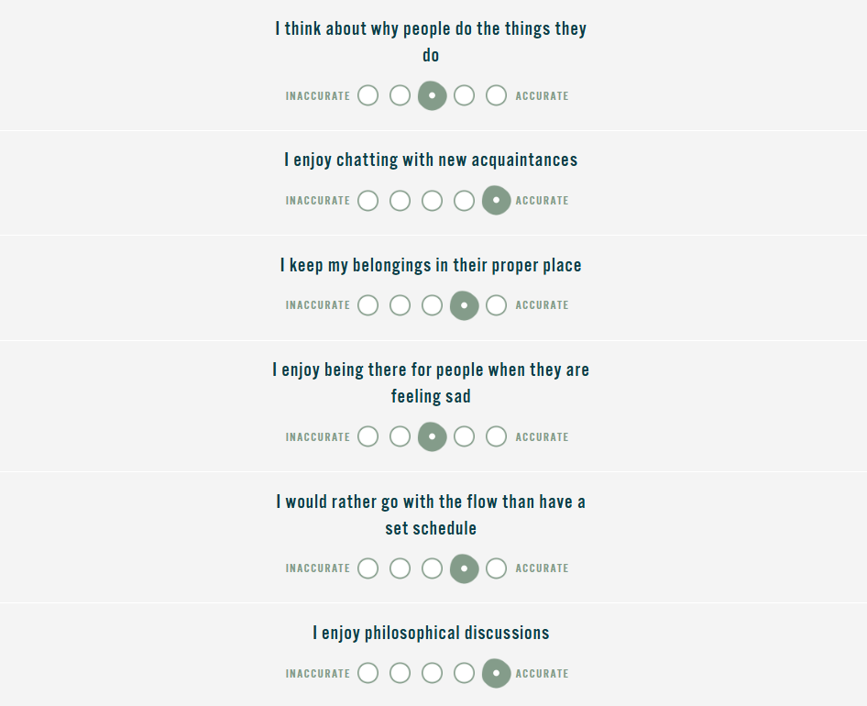
Figure_Apx 12: Myers-Briggs Questions set 4.

APPENDIX D: RESEARCH FOR RANSOMWERE AND MY SAVING LOCATIONS

D.1: RESEARCH POINTS [10]
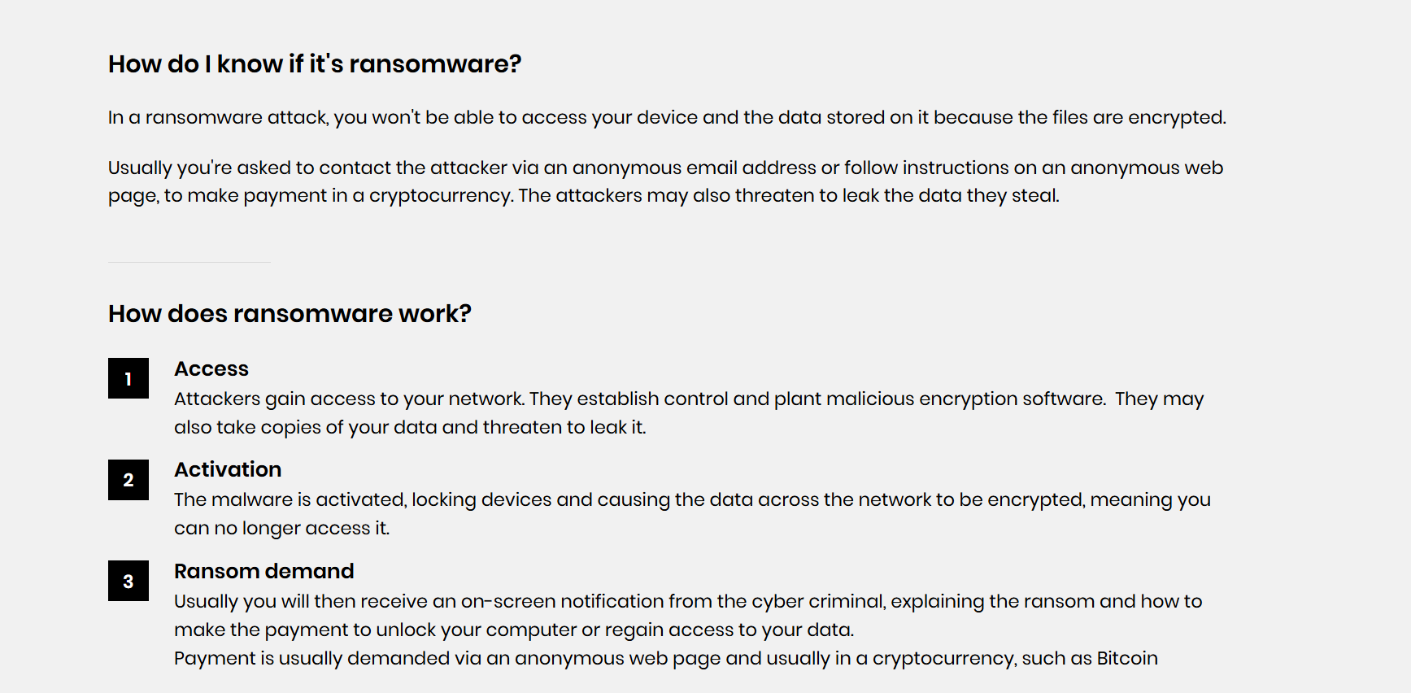
Figure_Apx 13: Research on what a ransom does.
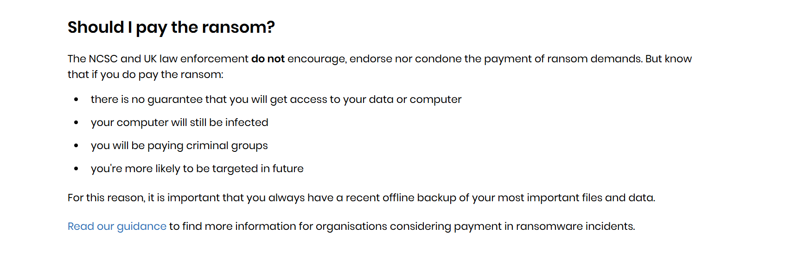
Figure_Apx 14: What to do if affected by ransomware.
[10]
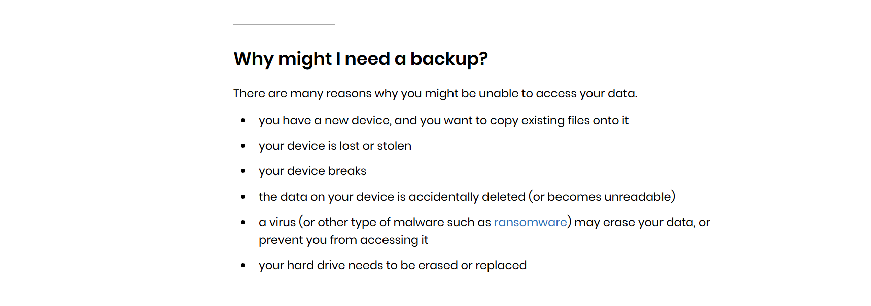
Figure_Apx 15: Reasons to back up the device.
[9]

D.2: THE THREE DIFFERENT LOCATIONS USED TO SAVE THIS ASSIGNMENT

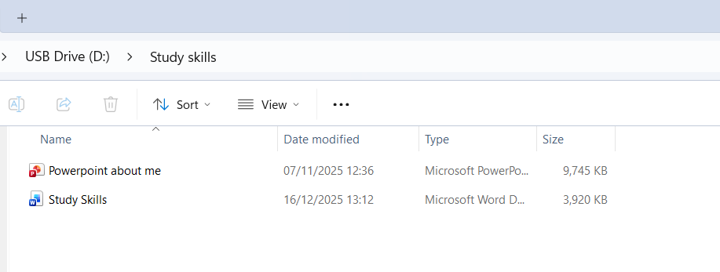
Figure_Apx 16: Work saved on USB stick
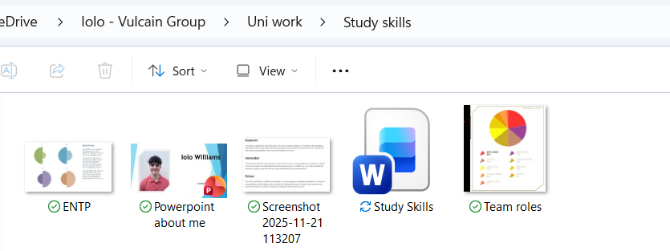
Figure_Apx 17: Saved onto work OneDrive
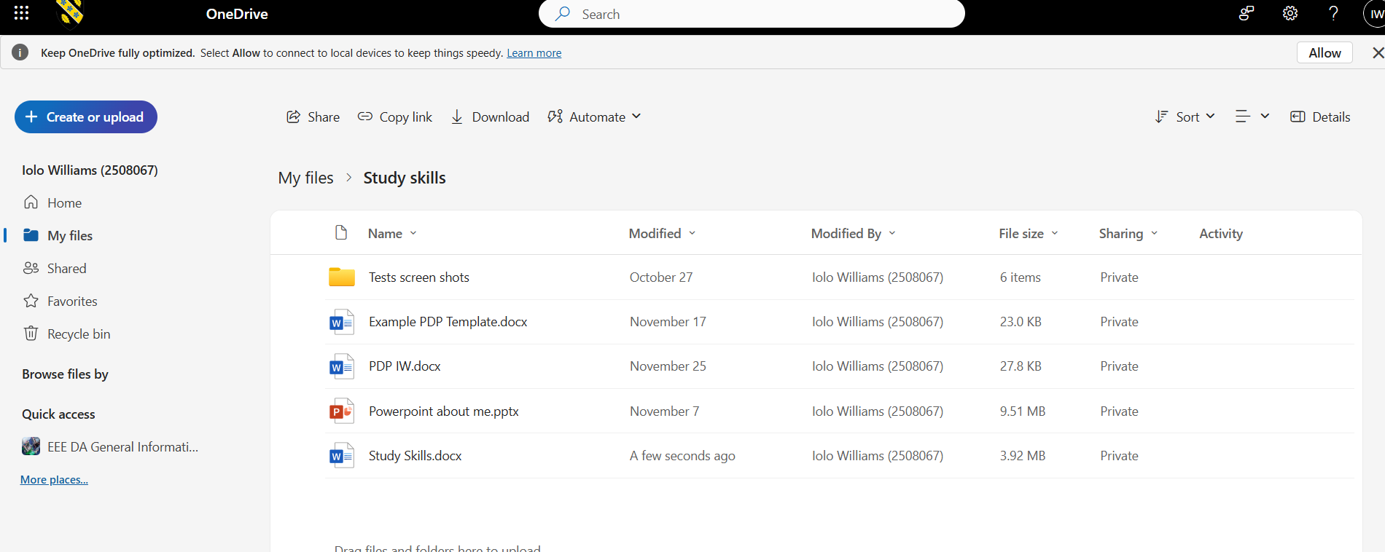
Figure_Apx 18: Saved on UWTSD OneDrive

