BMSW4006

Managing Enterprise in the 21st Century
Lecturer: Mohammad Rahman

University of Wales Trinity Saint David

1 Alina Cocirlea 2123036 Company Overview
2 Cezar Stroescu 2123047 Market Research
3 Alexandra Cozma 2125169 Marketing and Promotion
4 Mihai Cozma 2125171 Operations and Management
5 Andreea Simion 2120568 Financials

Table of Contents

Company Overview 4
Company Profile of Coffee Shots 4
Management and Personnel of Coffee Shots 4
Mission of Coffee Shots 4
Vision of Coffee Shots 5
Aim and Objectives of Coffee Shots 5
Product & Services of Coffee Shots 5
Coffee Shots Location 9
Unique Selling Propositions of Coffee Shots 9
Use of Technology in Coffee Shots 10
Growth and Expansion of Coffee Shots 10
Market Research 11
Industry Analysis 11
Target Market 11
Competitors 12
Government Regulations 12
Customer Profile 12
Business Analysis - PESTLE 13
Business Analysis - SWOT 14
Porter’s Five Forces Analysis 15
Marketing and Promotion 17
7Ps of Marketing 17
Market and Sales Strategies 19
Promotional Campaigns 19
Key Performance Indicators 21
Operations and Management 23
Product Procurement and Distribution 23
Product Plan 23
Legal Structure 24
Personnel of Coffee Shots 25
Organisational Structure 25
Management Orientation of Coffee Shots 25
Executive Board and Decision Making 26
Organisational Culture 26
Human Resource Management 26
Use of HR for CRM 27
Stakeholder Analysis 27
Financials of Coffee Shots 28
Souring Funds 28
Total Initial Cost 29
Net Profit of Coffee Shots 30
Cash Flow Statements 31
Price Point Calculations 32
Pricing Strategy 33
Legal and Compliance Issues 33
Gantt Chart 34
Conclusion 35
References 36
Presentation Slides 39

ALINA COCIRLEA (2123036) Company Overview

Company Profile of Coffee Shots
There are different types of businesses and each of them requires different types of mechanisms in the business (Formichelli et al., 2019). In this case, the business that is being set up is that of a coffee shop. The name of the company of the coffee shop will be Coffee Shots and it will be a chain store which will initially start with a single store in the United Kingdom. The location of the shop will be in London as it is a very busy area and it will help to attract the customers. The coffee industry has been exponentially growing in the past decade and the lifestyle and habits of people have also helped to facilitate the process of selling coffee in modern civilization (Formichelli et al., 2019). So, with that in mind, the company is set up as a coffee shop business that will be managed by a group of partners.

Figure: Logo of Coffee Shots (Source: Author)

Management and Personnel of Coffee Shots
The management and personnel of the coffee shop are very essential for maintaining the business activities and this will be divided into five sectors (Jones, 2020). The five partners of the business will divide the activities among themselves and will include a General Manager, a Marketing Manager, a Financial Manager, an Operations Manager and a Customer Relationship Manager. The management of the company will oversee all the activities of the business and ensure that Coffee Shots become a successful business in the long run (Sutherland, 2009).

Mission of Coffee Shots
The mission of the company is the short-term goal that the company needs to achieve and in the case of Coffee Shots, the mission of the business is to create a customer base which is loyal to it and also make the business profitable in the process.

Vision of Coffee Shots
The vision of the business is the long-term goal that the company wants to achieve and in the case of Coffee Shots, the company's vision is to be one of the largest coffee shop chains in the United Kingdom. The business activities of the coffee shop have to be maintained in keeping the mission and vision of the company in mind.

Aim and Objectives of Coffee Shots
The aims and objectives of the organization are those that define its activities and Coffee Shots is a new business that will operate in a very saturated market (Robinson, 2017). Some of the aims and activities of the company include -
- To set up the coffee shop in the designated location in London.
- To decorate the shop with a proper ambience for the customers to be attracted to.
- To prepare all the assortments and products required for the shop to cater to the customers.
- To create a small group of loyal customers at the initial stage for word of the mouth marketing.
- To get the initial sunk cost as soon as possible.
- To ensure top quality products and services to the customers to keep up the reputation.

Product & Services of Coffee Shots
The products and services offered by the coffee shop are very essential as it is the main aspect that will attract customers to the business. Being a coffee shop, Coffee Shots will not only serve coffee but also different types of snacks and brunch items to the customers. Being located in London, the snacks and food items that will be offered to the customers will mostly be based on the cuisine of England as it would be more popular than the other products. The service quality of the shop will be maintained to ensure that the customers remain satisfied with the environment and behavior of the employees at the shop. Being a coffee shop the delivery will be quite fast as the product will be prepared to some extent so that the customers can be served early and can get the authentic taste of coffee. The shop will have waiters to serve the coffee to the customers and they will be specially trained for customer relationship and engagement so that the customers remain happy with the services.
The snack items will include various types of assortments of sweet products and savory products as well. A list of the major food items that will be catered to the customers at Coffee Shots is discussed below:
Coffee: The coffee items will be the major attractions of the shop at Coffee Shots as it is a coffee shop and will have different assortments of coffee for all types of consumers. There will be twelve major types of coffee which will be offered to the customers. This includes the espresso, macchiato, cappuccino, latte, Mocha, Con Panma, affogato, flat white, americano, Irish coffee, iced latte and frappe. All these types of coffee will be served to the customers at all times of the day.
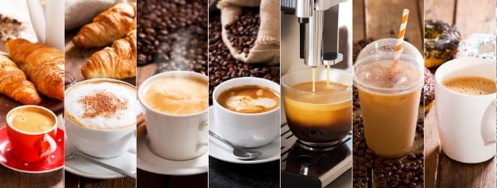
Figure: Various types of coffee (Unsplash, 2022)
Assortment of bread: The English people like to have bread and butter in the morning, and it will be served at the coffee shop to meet their demand. There will be different types of bread which will increase customer service and give some more choices to choose from.

Figure: Assortments of bread (Unsplash, 2022)
Brunch: Fish and chips are one of the common combinations that are very common to the English people and they love to have it as one of their brunch items and it will be provided in the coffee shop as a part of the savoury items. The savoury items will be of limited capacity as Coffee Shots will mainly focus on serving the customers with the authentic taste of coffee.
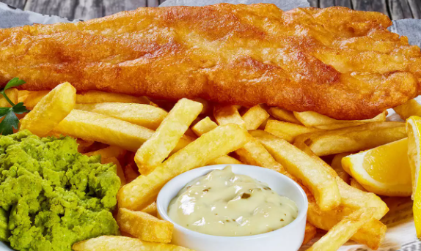
Figure: Bruch item (Unsplash, 2022)
Biscuits: Coffee Shots will also have a very diverse assortment of biscuits of different types so that the customers can have them along with their coffee. Having biscuits is one of the traditions for the British people and it will serve according to the demographics. Chocolate chips cookies and other types of butter and bakery cookies will be available at Coffee Shots.
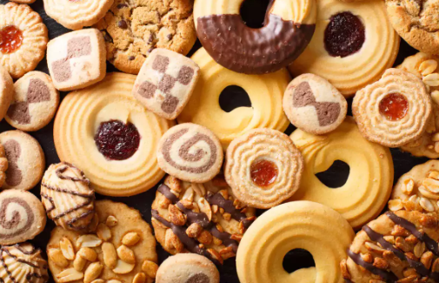
Figure: Assortments of biscuits (Unsplash, 2022)
Pastry: Coffee Shots will provide different types of pastry items to the customers to go along with their coffee. The pastry items will include croissants and cupcakes. The pastry items will be prepared by the baker who will be hired to produce the items.

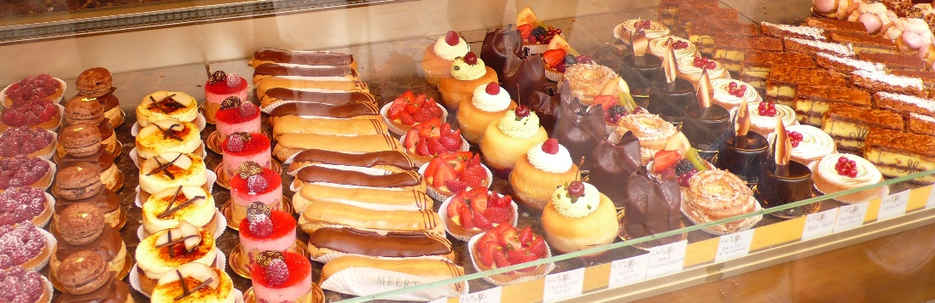
Figure: Assortments of pastry (Unsplash, 2022)
Chocolate items: Coffee shots will also have a separate segment for selling chocolate bars and these are the type of products that will be in packets and sold like a retail store. The chocolate will be mainly procured from third parties and will be sold as separate items in the coffee shop.
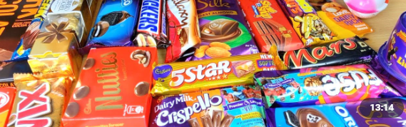
Figure: Assortments of chocolates (Unsplash, 2022)
Cake: Cakes will be another important part of the coffee shop. This will attract a separate base of customers who will come to the shop to have the cakes and also the coffee in the process. Having a good assortment of cakes will increase the overall value of the business and attract more customers and make them loyal to it.

Figure: Assortments of cakes (Unsplash, 2022)
Savoury items: There will be some savoury items are the coffee shop as well so that the customers can change their taste buds from all sweet to something savoury as well and it will increase the acceptance rate of the shop to the customers due to its variety of products.

Coffee Shots Location
The location of the company is selected based on the research on coffee consumption in the United Kingdom. It can be observed that in the busy city of London the consumption of coffee is much higher than that of other cities. It is because most of the national and multinational companies have their offices situated in London and the professionals consume coffee to start their day as it has been part of the lifestyle of many people nowadays (Jones, 2020). This location selection is also affected by the demographics of the target market of Coffee Shots (Jones, 2020). So, the place where the coffee shop will be situated is selected to be Borough Market as it is a busy place and will help to increase the number of sales of coffee.

Unique Selling Propositions of Coffee Shots
The unique selling propositions are the qualities of the business that makes it different from the competitors and it helps the business to gather more clients in the process (Jones, 2020). There is a huge number of coffee shops all around London and so the market is very situated to compete against the large companies. So, the target market will be fixed in such a way that Coffee Shots can cater to the customers properly. The unique selling proposition of officials will help the customers to identify the business and differentiate it from the other competitors (Formichelli et al., 2019). Some of the unique selling propositions of Coffee Shots are mentioned below:
- The coffee will be procured from abroad and it will ensure that the quality of the coffee is exceptional.
- The shop will provide customised coffee for the clients according to their personal preferences.
- The coffee shop will also offer vegan alternatives to the customers for healthy consumption.
- Coffee Shots will provide delicious sweet treats as well which can be purchased by the customers.
- The service of the coffee shop will be top-notch as the baristas will be experienced and they would offer very fast service (Jones, 2020).
- Coffee shops will provide a customer loyalty program for the regular customers which will be exciting for them.
- The pricing of the coffee will be value-based which will help to attract customers in these days of economic recession.
- The ambience and atmosphere of Coffee Shots will be welcoming so that the people can spend time and enjoy the coffee.
- The shop of Coffee Shots will be eco-friendly and will offer ethical products produced through an ethical process and the utensils and packaging will also be sustainable and eco-friendly.
- Coffee Shots will also take part in community development by volunteering for different activities for the development of the community surrounding the coffee shop as a part of its corporate social responsibility (Bowen and Bowen, 2015).

Use of Technology in Coffee Shots
The use of technology is very essential at present times as businesses are adopting different types of machines and software to facilitate the process of providing service and reduce the overall cost of business. Some of the technology that can be adopted by Coffee Shots during the process of business operations include-
- An application will be developed in which the customers can order their coffee sitting at the shop and they will be provided with their order (Borosky, 2019).
- Customer Experience Data Collection technology will be utilised to improve the customer experience of the consumers of coffee at Coffee Shots.
- An advanced point of sale system will be utilised to ensure that the ordering process of the customers is very easy.
- A digital inventory system will be utilised in Coffee Shots to ensure that the management of inventory is properly done and the products and raw materials required for providing the services are readily available.
- Technology will also be used in the marketing activities of Coffee Shots as it will gather customer data and show them the promotional campaigns based on their demographics.

Growth and Expansion of Coffee Shots
The growth and expansion of Coffee Shots will initially follow the plans of creating a loyal customer base and setting up a coffee shop chain around the different locations in London. The target for expansion will initially be five years as creating a loyal customer base in the saturated market will be quite difficult for the new entrant Coffee Shots (Ballagh, 2021). With the expansion target in mind, the profit from the initial years of the coffee shop will be reinvested in the company for development and expansion. This will ensure the long-term sustainability of the business and the growth of the coffee shop chain.

CEZAR STROESCU (2123047) Market Research

Industry Analysis
The industry of coffee consumption in the United Kingdom has been growing as over 95 million cups of coffee at drunk in the United Kingdom every day according to the British Coffee Association. The lifestyle of the people has been changing and it has been affecting the rise in coffee consumption during the morning and work hours as well. The independent coffee shops of the United Kingdom are continuing to grow as the industry is worth more than 10 billion pounds now and is also growing by 7.9% (Cardoso, 2021). Although the coffee chains are growing at an exponential rate, the independent coffee shops are also not lagging as they have a selected base of customers that they want to serve and this makes the industry very look pretty for the new entrants of a coffee shop (IBISWorld, 2022). So as the industry suggestions are showing positive feedback for Coffee Shots, the business will try to implement marketing tactics to get the right base of customers and cater to them.
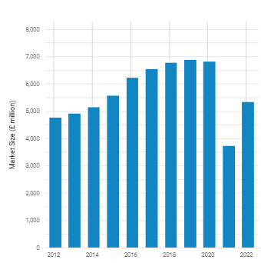
Figure: Market size of cafes & coffee shops in the UK (IBISWorld, 2022)

Target Market
The target market of the coffee shop in the case of Coffee Shots will be the people who are professionals or the young professionals who work every they and start their days with a cup of coffee. Young professionals are the major targets of Coffee Shots as they would be able to spend more in the shop and also have different types of needs will be the target for Coffee Shots to fulfil. So the target market based on the demographics and geographic area will be the young professionals situated in London (Jones, 2020).

Competitors
Some of the major competitors of Coffee Shots will be the major brands that operate which include Starbucks and Costa Coffee. Some of the other local branches should also be competitors of Coffee Shots to operate in that busy area and have to fight for keeping their position intact. The highest portion of independent shops in London consists of coffee outlets and these independent stores serve more than 11 million cups of coffee each week according to an Allegra report (Cardoso, 2021). So there is a mass market opportunity for an independent coffee shop like Coffee Shots to operate and get good revenue. The competition in the coffee industry of the United Kingdom and especially in London is very saturated and it would be quite tough for Coffee Shots as a new entrant to get the market share required to get good revenue (Bowen and Bowen, 2015).

Government Regulations
For starting and conducting a business regarding coffee, Coffee Shots will have to ensure some rules and regulations that have been enacted by the government (Bowen and Bowen, 2015). This includes the food business registration that will help to get the licence of providing food to the customers. Some of the other aspects of rules and regulations that Coffee Shots has to ensure regarding regulations include the maintenance of hygiene during the production process and serving of food, the licence regarding the purchase of coffee and bringing it, the health and safety measures of the coffee shop, the inspection and quality control of the products and services of the coffee shop, maintenance of the HACCP regulations etc. (Borosky, 2019). Coffee Shots might lose its licence if these aspects are not maintained during the operational activities of the business.

Customer Profile
The customer profile will be prepared for the company so that the main target customers can be identified easily and can be catered to. The customers can be mainly defined based on their demographic, geographic and psychographic aspects. These aspects are mentioned below:
Demographic segmentation: According to the demographic segmentation the target customers will be those who have a medium to high-class income rate and are mainly executives of companies at age of 20 to 35. These are the people who are young professionals and their lifestyles match the target of the company. These kinds of people have a lifestyle that they want to uphold and maintaining it is one of their priorities starting the day by having a cup of coffee and another type of snack.
Geographic segmentation: According to the geographic segmentation, the maximum of the target customers will be in London and mainly based on the Borough Market where the shop will be situated. It will help the coffee shop to cater to the customers that are mostly near to them and target them to show different offline marketing activities.
Psychographic segmentation: Psychographic segmentation of the people of the target market will be mainly divided based on their attention and behavioural activations. The target group of people feel better when they have a cup of coffee in the morning and also during work hours so that it can keep them energized. These kinds of people are the main target group for coffee Shots as it wants to sell its coffee to the right target markets.

Business Analysis - PESTLE
Understanding the microenvironment before starting a business is very essential. It is because the business and the internal decisions are mainly influenced by the outside environment (Perera, 2018). The PESTLE analysis can be utilized in this case to understand the different aspects of the business environment and this can be utilized to assess the external situation of Coffee Shots. Show the PESTLE analysis of the business mentioned below:
Political: The political aspect includes the situation of the government and the regulations of the country that the company must follow while operating. The political situation of the United Kingdom is quite stable and it helps to facilitate the starting of new businesses. The government also support the starting of new business as it makes the economy more active and shows the political situation is in favor of Coffee Shots (Robinson, 2017).
Economic: The economic aspects of the United Kingdom that would affect the coffee shop of Coffee Shots will include the recession or the economic downfall of the country as the spending amount of people might decrease. This will impact the spending of pocket money for the people for the sake of coffee and will move to more essential products. Brexit is another aspect that will affect the shop as the transportation and other important goods will incur more costs than before and it will affect the situation of the business. The inflation in the country also has an impact on it as it decreases the value of money and might cause issues regarding the pricing of products in Coffee Shots.
Social: The social aspect is mainly favourable for the coffee shop as starting the day by drinking coffee is one of the social norms nowadays for the target market of Coffee Shots and they try to maintain a lifestyle by drinking coffee and it will be affected by it (Robinson, 2017). Drinking coffee is also socially acceptable for executives as it is known to energize them and make them more focused on their work. The social aspect of the target market for Coffee Shots includes the middle and upper-class people of the community.
Technological: The technological aspect that would impact the business of Coffee Shots included the use of different types of digital tools for marketing and also taking orders from the customer. The orders can be automated so that it can decrease the overall cost of employees and also the customers can choose what they like and it will be automated. Automation can be used in a coffee shop for faster ordering and getting the orders at the right time. Technology will also impact inventory management as digital inventory management will be used in coffee shops to maintain the inventory of goods and products.
Legal: The legal aspects of the Coffee Shots mainly include the maintenance of the regulations of the legislature like the employee rights and the regulations regarding health and hygiene maintenance of the shop. Getting the company license and the license to produce different types of coffee and food will also be under this aspect (Robinson, 2017). These legal aspects will impact how the company runs the human resource and operations of Coffee Shots.
Environmental: The environmental aspect of Coffee Shots would mainly include the use of ethical business practices and also using different types of biodegradable packaging for the products that would be sold in the shop. There has been a shift in consumer behaviour during the pandemic and it has resulted in them being ethical and almost 51% of the customers in the United Kingdom have moved to more ethical products than before. Coffee Shots has to ensure sustainable measures in its operations to be active as a good coffee shop among the customers.
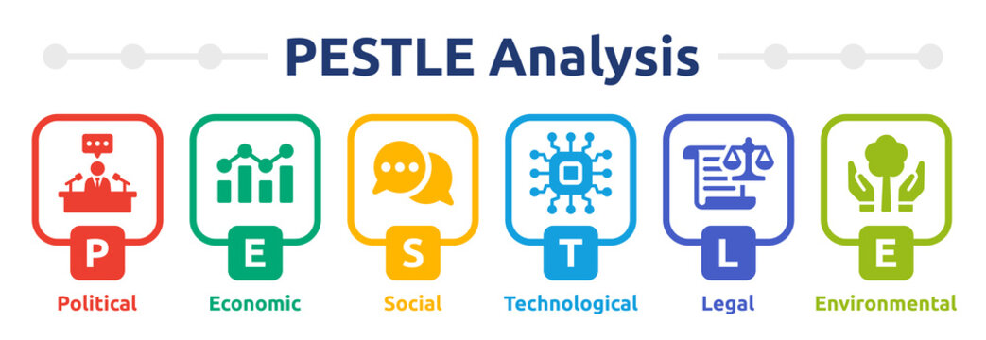
Figure: PESTLE Analysis (Perera, 2018)

Business Analysis - SWOT
The internal business of Coffee Shots can be analyzed by using the SWOT analysis which identifies the strengths, weaknesses, opportunities and threats of the business (Reynolds, 2015). SWOT analysis for Coffee Shots is mentioned below:
Strength: The coffee will be procured from abroad and it will ensure high quality of products. The shop will provide a customized coffee list for the customers to choose from. The coffee will also offer alternative products as the coffee shop will not only have a coffee but a very large variety of snacks for the people to purchase and enjoy themselves. Coffee Shots will focus on customer service to create brand loyalty for the customers to ensure that the highest quality of customer relationships is maintained (Robinson, 2017).
Weakness: The weakness of Coffee Shots is that the business is very new compared to the other established businesses. So it will be very tough for the company to initially get a large customer base and get a profit. It is one of the major weaknesses that the company has to be aware of (Robinson, 2017).
Opportunities: The opportunities for Coffee Shots include the growing customer base of coffee and the increase in the industry growth. As the demand for coffee is increasing exponentially, independent coffee shops will be able to operate more freely and cater to a large customer base.
Threats: Some of the major threats of Coffee Shots include the increasing price of commodities and coffee all around the world, the hike in payment and wages of employees, and the marketing of the established co0ffee chains that might take away the loyal customers etc (Robinson, 2017).
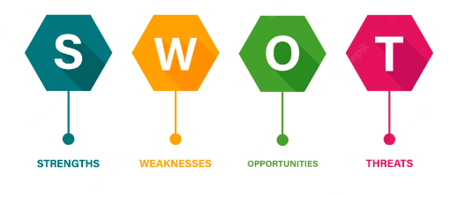
Figure: SWOT Analysis (Reynolds, 2015)

Porter’s Five Forces Analysis
Porter's Five Forces analysis will be utilized to understand the different forces that are operating in the industry and which might affect the business of Coffee Shots (Blokdyk, 2018). Porter's Five Forces analysis of Coffee Shots is mentioned below:
The threat of new entrants: The threat of new entrants for Coffee Shots is relatively moderate as it requires a lot of business planning and human resource to maintain a coffee shop and so in this economic aspect the threats of new entrants will be moderate.
Bargaining power of buyers: The bargaining power of buyers in the case of Coffee Shots is relatively low as most of the prices of the products are fixed and the people are accustomed to the fixed-priced products in coffee shops (Blokdyk, 2018). So the price-sensitive target market is not the right target market for Coffee Shots and that is why the demographic has been chosen in that way.
The threat of substitute products: The threat of substitute products in the coffee industry is relatively high for Coffee Shots as it is a new entrant and there are a lot of established brands in the industry. So customers might move to other competitor products if the quality of Coffee Shots is not maintained.
Bargaining power of suppliers: The bargaining power of suppliers, in this case, is relatively higher as the products of Coffee Shots have to be bought from different suppliers from abroad and around the country as well (Robinson, 2017).
Rivalry among existing competitors: The rivalry among existing competitors in the coffee industry is very high as the established brands are always marketing their products and trying to get more market share by giving different offers and marketing campaigns.

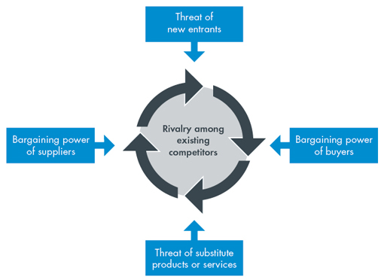
Figure: Porter’s Five Forces Analysis (Blokdyk, 2018)

ALEXANDRA COZMA (2125169) Marketing and Promotion

7Ps of Marketing
The 7Ps of marketing include the product, price, promotion, place, people, process and physical evidence (Armstrong et al., 2018). These together can be called the marketing mix and it can be utilized for Coffee Shots to understand the marketing activities of the company and how the business will be conducted in terms of different aspects. The 7Ps of the marketing mix for Coffee Shots are mentioned below:
Product: The product of Coffee Shots mainly consists of the coffee products and the snacks that will be offered to the customers. The products consist of the 12 different types of coffee and the various types of snacks that will be accompanying the coffee in the shops of Coffee Shots. The company has to ensure top-quality coffee and the other sides to ensure that the customers come back so that they can purchase and word of the mouth marketing is achieved (Ballagh, 2021). The products of Coffee Shots will be showcased on the banners and the leaflets along with the menu cards of the shop.
Price: The pricing strategy that will be followed for Coffee Shots will mainly be value-based pricing. The average price for coffee drinks will be 2.5 pounds. The strategy behind the pricing of the coffee will be mainly based on the demographics as the main target group of Coffee Shots are the executives and young professionals and they have higher incomes than normal or average (Kotler, 2011). They would want good quality coffee and for that, they are willing to pay more than the average amount of price in normal cafes.
Promotion: Promotion is one of the major aspects of starting a new business and in the case of a saturated market of coffee shops, the promotion will play a very great role in bringing in the customers to Coffee Shots. Successful marketing strategy for coffee shops will include the marketing mix along with advertising, direct marketing and in-shop promotional activities like discounts and customer relationship management (Johnson, 2020). All these aspects are necessary for a good promotional campaign so that the coffee shop can run by having a good number of loyal customers to cater to.
Place: The customer should be aware of where and how the products are displayed and sold by the coffee shop. Maintaining transparency with the customers can help to bring in more customers as they will be able to know how the distribution of the coffee shop is maintained by the company and it will ensure that ethical business is conducted by coffee shops. Then the customers will be more attracted to the shop if they know the source of the ingredients and how they are distributed (Cinar, 2021). The distribution of the coffee will be mainly from the shop that will be situated in London.
People: People consists of the human resource that will be used in coffee shops and its shop (Kotler, 2011). It may improve the management of the company and the people who are working under the company. The baristas and the waiters in this case will have a great role in maintaining customer service and the customer relationship as they will have direct contact with the customers in the coffee shop. The waiters and the baristas of Coffee Shots will be properly trained before hiring so that they can maintain the standard that will be maintained at the shop.
Process: The process includes the delivery of the product or service to the customers which is designed for maximum efficiency and reliability. In the case of Coffee Shots, the brand will be environmentally focused and will look for alternatives to products that are harmful to the environment (Schobert, 2021). The supply chain of coffee and the other snacks that will be served to the customers in Coffee Shots will be sourced from different outlets all around the world and they will be available at the disposal of the customers at a reasonable price.
Physical evidence: Physical evidence is the aspect that the brand exists and the purchase of the customers that take place. In the case of coffee shops, the example of physical evidence would be the physical store and the logo of the company that will be recognizable to the customers. The digital receipts and the newsletters of the invoices that will be utilized by the shop will be also an example of physical evidence of its existence (Schobert, 2021). The crops that are used in the coffee shop are a very essential aspect in this case as they will be branded to match the ambience and brand value along with the use of sustainable measures to recycle them. The social media pages and digital website will also be part of the physical evidence in this case.
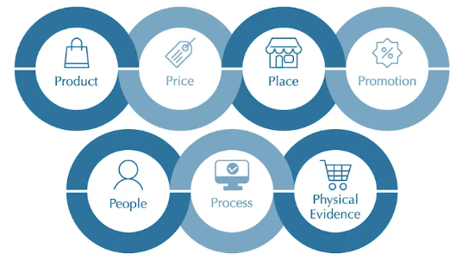
Figure: 7Ps of Marketing

Market and Sales Strategies
Marketing strategy can be termed as the overall plan of reaching the customers and potential customers and turning them into regular customers of the product or service (Kotler, 2011). The marketing and sales strategies for Coffee Shots would mainly develop around the competitors and the capability of Coffee Shots to maintain the marketing activities. The marketing strategies for Coffee Shots are discussed below:
Market segmentation and target marketing: The target market of the Coffee Shots coffee shop will be selected based on the segmentation and as it has been already been discussed that the target group for the coffee shop will be the young professionals and executives who want to start their day by drinking a cup of coffee and have snacks along with it (Stillwagon, 2021).
Promotion strategy: Different types of promotional strategies will be utilized to buy Coffee Shots and some of them include social media and internet promotion, offline promotion, word of mouth promotion, customer relationship management promotion etc. (Sigalit, 2019). Different channels will be utilised for the promotional campaigns and activities for Coffee Shots and it will be according to the budget of the company. At the initial stage of the business, the promotion is very essential as it would help the customers to know about the shop and it will bring in more return customers if the quality of the production is maintained along with giving special discounts to them.
Sales strategies: The ultimate goal of the business is to make a profit and the increase wealth of the shareholders. So it is very essential to increase the number of sales of coffee and other items to create the revenue required for gaining profit. The sales strategies will include some sales campaigns and offer with discounts so that the customers will be more motivated to buy products from Coffee Shots (Stillwagon, 2021). By creating a positive relationship between the customers and the company, the sales of the coffee shops can be increased by many folds and also a loyal customer base will be gained in the process.

Promotional Campaigns
Promotional campaigns for starting a new business is very essential as they would initially introduce the coffee shop to the customers. Different promotional channels will be used to promote Coffee Shots to the target customers. Some of the promotional channels that will be utilised for the company are discussed below:
Use of flyers: The right use of flyers can bring in more customers for Coffee Shots if the leaflets and flyers are given to the right customer base as they move into the city (Ballagh, 2021). The flyers are a cost-effective and traditional way of marketing that can bring in customers to the coffee shop.
Incentives: Different types of incentives and discounts can be offered to the customers if they visit the shop at a definite time during the initial stages of the Coffee Shots so that the customer base can be grown exponentially in a short amount of time (Armstrong et al., 2018).
Loyalty card: Loyalty cards can be used by Coffee Shots so that they can give customers a way to come in for return purchases and offer them free coffee after a certain amount of purchases (Schobert, 2021). It will create a connection between the customer and the company and will ensure a loyal customer base.
Promotional banners: Promotional banners can be used by the marketing team of Coffee Shots so that the customers can be attracted and they can be used at the inauguration of the shop so that a large mass of people can see the opening and also know about Coffee Shots (Cinar, 2021).
Word of the mouth marketing: Word of the mouth marketing can be utilised if the company can ensure proper quality products and services to the customers of Coffee Shots and it would depend on the baristas and the behaviour of the waiters at the coffee shop as well (Sermons, 2021).
Social media campaigns: The use of social media campaigns is the most effective way of promotional activity at the present times as most people are now online and the target demographics can be easily found in different social media that can be utilised by Coffee Shots to get the target customers coming into the shop (Mascroft, 2021).
Branding the coffee shop: Brands always have an extra value to the customers and making Coffee Shots a brand that can be resonated with the customers would increase the number of customers in the shop and help them to get the promotion required for running a sustainable business (Johnson, 2020).


Figure: Demo promotional campaigns (Source: Author)

Key Performance Indicators
Key performance indicators of a business are the critical indicators of the performance of the marketing campaigns that are being conducted by the company. Now, these are mainly based on analysis and analytics of the campaigns that are conducted and the business activities as well. Some of the key performance indicators that will be utilised for measuring the business performance of Coffee Shots are discussed below:
Revenue growth: The revenue growth of the company will be measured to understand how it is performing against the competitors and the spending of the company in terms of marketing. The revenue growth will be measured after the initial six months of running the business.
Profit margin: Profit margin is another key performance indicator that shows how much profit the company is gaining from the spending the company and the costs that are incurred. It shows the per dollar profit of the company based on its spending. The profit margin of Cofee Shots will be lower than the competitors as it will look to attract more customers.
Client retention rate: Client retention rate is another very useful tool that can be used to understand the business performance of Coffee Shots as the client retention rate shows how many customers are returning for purchasing in the shop again and it shows the return rate of the customers and the creation of loyal customer base. The client retention rate will be measured digitally by using unique codes.
Customer satisfaction: Satisfaction is another very important metric that can be utilised to understand how the performance of the shop is according to the industry as it shows how much the customers of Coffee Shots are satisfied with the services offered by the shop. Customer surveys will be conducted when customers come to order and after they get their services to understand how they feel about the shop.
Revenue per client: Revenue per client is another metric that can be used to understand how much percentage of the share of the wallet is Coffee Shots getting from its customers. It will help to understand the basket size of purchases of customers and price the products accordingly.
Net profit: Net profit is a very useful tool to understand if the company is making any sort of profit by conducting the business or not and it will be implemented in terms of Coffee Shots. The net profit will be important as the business is about making a profit and if the business is facing a loss, then proper actions have to be implemented by the management.

MIHAI COZMA (2125171) Operations and Management

Product Procurement and Distribution
A supply chain is a representation of the complex series of procedures needed to deliver a product to a customer. The supply chain for coffee is a complicated system. No matter how big or small the coffee distribution network is, each link must be a good addition to the chain since each link is accountable and equally crucial in getting peoples favorite caffeinated drink from the field to the consumers' tables (Ballagh, 2021). The general process of the procurement and distribution of coffee for Coffee Shots is mentioned below:
- The growers harvest the coffee.
- As the farm is not also a processor, the coffee is next transferred to a processing facility, where the beans are hulled and either dry- or wet-processed, depending on the method appropriate for that particular farmer and coffee; this process is sometimes referred to as milling.
- Beans are sent by exporters to suppliers, brokers, roasters, and retailers after they have been expertly shelled to produce green coffee beans.
- Then, beans are roasted to the appropriate level of brightness or blackness. Then coffee is supplied at the coffee shop.
The supply chain for the snack items at Coffee Shots would mostly be brought from third-party companies as they will handle all the supply chain activities regarding those and the end product will be sold at Coffee Shots and which will reduce the overall costs of the shop and also reduce management hassle for the team (Cinar, 2021). The snack and side items will be brought from a bakery and the shelf will be updated every morning before opening the shop. One part-time chef will be hired to produce some of the special items in small quantities to maintain the uniqueness of Coffee Shots.

Product Plan
The product plan will help Coffee Shots to have a distinct idea about the servings and will also ensure quality management of the shops and services. Coffee lovers are well-versed in the various varieties of coffee, and Coffee Shots will help them learn how to distinguish between them so they can select their preferred cup from the available choices (Mascroft, 2021). From extremely strong coffee to the sweet affogato, there is coffee to suit every taste. The list mentioned below would be the product plan for Coffee Shots which will be followed by the baristas.
Type | Espresso shots | Steamed Milk | Milk Foam | Other Flavors | Serving size
Espresso | 1 | x | x | x | 1 oz/ 30 ml
Macchiato | 1 | x | a thin layer | x | 1.5 oz/ 45 ml
Cappuccino | 1 | 4 parts | 1 part | x | 5 oz /150 ml
Latte | 1 | 6 parts | 1 part | x | 8 oz/ 240 ml
Mocha | 1 | 2 parts | 1 part | 1 part chocolate | 5 oz/ 150 ml
Con Panna | 1 | x | 1 part whipped cream | x | 2 oz/ 60 ml
Affogato | 1 | x | x | 1 scoop vanilla ice cream | under 5 oz/ 150 ml
Flat White | 1 | 4 parts | x | x | 5 oz/ 150 ml
Americano | 1 | x | x | 4 parts hot water | 5 oz/ 150 ml
Irish Coffee | 2 | x | top with fresh cream | 1 part whiskey | 5 oz/ 150 ml
Iced Latte | cold brew | 6 parts cold milk | top with whipped cream | add ice as desired | 10 oz/ 300 ml (ice included)
Frappe | instant coffee | 5 parts cold milk or ice cream | top with whipped cream | add ice as desired | 10 oz/ 300 ml (ice included)
Table: Product Plan for Coffee Shots (Source: Author)

Legal Structure
Private sector businesses are usually constructed in different ways to provide tax benefits to the owners and the others involved within the business and some of the most common types of organizational structures include sole proprietorship, partnership, corporations etc. In the case of Coffee Shots, the legal structure would be that of partnership as there would be five partners of the business who will be involved in conducting the business and also taking liability and profit from it. The shareholders and directors of the company would regulate their relationship with Coffee Shots and each other. The exit strategy for any of the partners would be to sell their share at the right amount to any other client who is compatible with the business (Stokes et al., 2016). The company will not go into the public trading or stock market as the scale of the company is very small and it is just initiating its business.

Personnel of Coffee Shots
The business's five partners are the general manager, a marketing manager, a financial manager, an operations manager, and a customer relationship manager - who will split up the tasks among themselves. They will be the initial stakeholders and shareholders of the company and then the stakeholders would be expanded after the set of the whole business. There will be the inclusion of other personnel for the position of barista and waiter in the coffee shop and they will be termed as employees.

Organisational Structure
Small businesses like Coffee Shots cannot maintain bureaucracy at a high level and so it is much better for the organisation if a flat structure is maintained and it would help the company to operate much faster and also in a lenient way (Venugopal, 2013). In the case of Coffee Shots, the organisational structure will be flat organisational structure as the partners will be in the same position and the other employees would be under their supervision. Maintaining a flat organisational structure will help Coffee Shots to get any decision at a very fast rate and also reduce the lead time for customers to get any of the services. The general manager of the organisation will be at the top and then there will be four other positions that will be the position of marketing, finance, operations and customer management. These positions will be filled up by the other four partners and together they will form the board of directors of Coffee Shots. The flat organisational structure will give the managers the proper power to implement any sort of change in the shop so that they can increase the overall profitability of Coffee Shots (Stokes et al., 2016).

Management Orientation of Coffee Shots
The way through which managers fulfil their roles can be termed management style or orientation and there are different types of external and internal factors that impact the management style of an organisation. In the case of Coffee Shots, the management style that will be mainly followed is the transformational management style where the innovation in the shop is increased, employees are more adaptable to change or disruptions and creative thinking along with problem-solving aspects are encouraged in the organisation. One of the drawbacks of this management style is that if the implementation of this style is not properly done then there might be burnout of employees as they might lose consistency to do better for the shop. Transformational leadership and management style will help coffee shops to be adaptable to the changing environment of the industry and take necessary decisions required for the sustainability of business (Stokes et al., 2016).

Executive Board and Decision Making
The executive board will be formed of the five partners of the coffee shop and the decisions that will be taken by them will be mainly based on exchanging information, reviewing different types of data along with ideas and reviewing alternatives etc. (Rajagopal, 2013). All these aspects ensure that the proper decisions are taken according to the change in the coffee industry and Coffee Shots can adapt to those changes (Venugopal, 2013).

Organisational Culture
One of the distinct characteristics of any organisation is the organisational culture that has to be followed by a company and its employees which makes it widely different from the other companies in the market. The culture is the main concept of the values, customs, traditions and behavioural aspects of the employees in the organisation (Ulrich and Brockbank, 2014). Being a coffee shop, Coffee Shots needs to have a good organisational culture so that the employees have a good reputation among the customers and they can have a good culture. The warm and friendly ambience in the coffee shop is one of the aspects of the cultural distinction of the firm. So, the culture of the shop will be one of the key factors to being successful in the business as a coffee shop as it has to sell not the coffee or the other food items, but the experience of purchasing and spending time at the shop.
The relationship-driven approach will be utilised to buy Coffee Shots to support the employees and the other stakeholders of the shop so that they exhibit a friendly bond with each other (Lashley, 2012). This aspect of the shop might be extended to the customers as well as they emphasise the relationship to build a custom report. So, the warm and friendly customer relationship-driven approach will be the right cultural aspect for Coffee Shots to follow.

Human Resource Management
The human resource management in Coffee Shots will be maintained by the general manager and the customer relationship manager as they will oversee the hiring of the waiters and the barristers of the shop. Maintaining the human resource would be a very critical aspect of the coffee shop as the supervision of the shop is not always possible for the general manager and the customer relationship has to be properly maintained by the working employees (Lashley, 2012). The human resource of Coffee Shots will mostly include two baristas who will work part-time at different shifts and four waiters among which two will be full-time and two of the waiters will be on a part-time basis.
So in preparing the human resource for Coffee Shots, they will be initially trained for two weeks regarding the development of customer relationships and teach them the approach of value creation for the customer so that loyal customers can be created within a short amount of time for Coffee Shots (Dessler, 2015). Thus the management of human resources would be very critical for Coffee Shots to maintain in the long run.

Use of HR for CRM
Human resource management will also be utilised for customer relationship management in Coffee Shots. In the service industry, the employees are in contact with the customers and they are the ones whom the customers will evaluate for assessing the service of Coffee Shots' customer relationship management (Dessler, 2016). CRM is a tool that can be used for automating sales and marketing to existing customers or potential ones and the employees of Coffee Shots will be the vital points of contact with these customers. They will be present at the point of sale and so they are the ones who would most influence the purchase of Coffee Shots (Ulrich and Brockbank, 2014).

Stakeholder Analysis
The stakeholders are the ones who are influenced by the different internal and external decisions of a company and in this case, some of the stakeholders of Coffee Shots include the employees of the shop, the customers, the suppliers of the raw materials and products, the environment, the partners of the shop and the government (Kimmich et al., 2012). A stakeholder analysis of Coffee Shots is discussed below:
Employees: The employees of Coffee Shots will be privatised as it is a part of the corporate social responsibility to ensure the betterment of the employees.
Customers: Customers are the driving force of the coffee shop and maintaining their proper interest is very essential for the shop as they are the ones who will help the shop to produce revenue.
Suppliers: Coffee Shots have to maintain a good relationship with the suppliers of coffee and also the snacks provided at the shop to get their shipments in time.
Environment: Coffee Shots have to be aware of the environment and the impact it has on them to be aware of any negative effects it might occur.
Partners: The partners in this case of Coffee Shots are the five owners of the company and they will work together to ensure the development and growth of Coffee Shots.
Government: Coffee Shots have to maintain a good relationship with the government regulatory bodies so that the shop can properly conduct its business.

ANDREEA SIMION (2120568) Financials of Coffee Shots

Souring Funds
Coffee Shots
FUNDING
 | PARTICULARS | AMOUNT(£) | PERCENTAGE | SOURCE
 | EQUITY FINANCING | 57500 | 50% | PERSONAL FUNDING
 | DEBT FINANCING | 57500 | 50% | BANK LOAN
 |  | 115000
 |  |  |  |  | INTEREST RATE | 8%
Table: Sourcing funds for Coffee Shots
Funding is very essential for any business and in the case of Coffee Shots, the funding will be mainly gathered from two sources. The initial source will be the equity financing of the partners and the second source will be the debt financing from the bank. In the case of equity financing, personal funding will be gathered from all five partners and they will contribute equally to the business. In the case of a bank loan of 57500 pounds will be taken at an interest rate of 8% and this money will be utilised for setting up the shop and other necessities of the business. The bank loan will be repaid in one year and the funding from personal sources will be incurred as sunk cost for the business. The total amount of funding required would be 115000, 50% of it will come from the financing of personal sources and the other 50% will be a bank loan. This will help the business to operate and also does not give any stake to any of the other lenders of money (Tracy and Tracy, 2011). It will ensure that the state of the business is at the hands of the five partners and they are the main decision-makers of the business.

Total Initial Cost
Coffee Shots Cost
No | ITEM | AMOUNT(£)
1 | Initial Rent | 4000
2 | Kitchen Equipment | 47000
3 | Table, Furniture, Tableware | 56000
4 | Business Licensing And Permits | 1150
5 | Renovating The Space | 4000
6 | Insurance And Safety Deposit | 700
7 | Signage And Advertising | 1500
8 | Miscellaneous | 500
 | Total | £ 114850
Table: Total initial cost calculation
The total initial cost of setting up the shop for Coffee Shots that will be incurred will be termed the sunk cost and this will be the initial spending by the business (Tracy and Tracy, 2011). The total spending of the business at the initial stage will be £114850. This total amount will be spent in eight different categories which include the initial rent for the shop which is £4000, kitchen equipment will be bought for forty-seven thousand pounds. Table furniture and table along with decoration will be brought for £56000, the licences and permits for the business will be bought for £1150, renovating the space will also cost Coffee Shots four thousand pounds, the insurance and safety deposit for the business will incur £700 cost, the signage and advertising will cost £1500 and miscellaneous expenses will be £500. This initial cost will be spent on the equity financing and the debt financing of the business.

Net Profit of Coffee Shots
SALES |  |  | YEAR 1 | YEAR 2 | YEAR 2
CUSTOMER (Total person) |  |  | 65000 | 67500 | 70000
SPLIT INTO
 | (%)
RESIDENTS | 25 |  | 16250 | 16875 | 17500
TOURISTS | 50 |  | 32500 | 33750 | 35000
LOCAL VISITOR | 15 |  | 9750 | 10125 | 10500
STUDENT | 5 |  | 3250 | 3375 | 3500
LOCAL BUSINESS | 5 |  | 3250 | 3375 | 3500
AVERAGE REVENUE PER CUSTOMER |  |  | 20.5 | 21.5 | 20.5
SALES PER YEAR |  |  | 1332500 | 1451250 | 1435000
(-)COST OF SALES |  |  | 30% | 29% | 28.50%
 |  |  | 399750 | 420862.5 | 408975
Gross profit |  |  | 932750 | 1030388 | 1026025
OPERATING EXPENSES
Rent Payments |  |  | 35000 | 35000 | 35000
Employee Salaries |  |  | 28500 | 29000 | 30000
Marketing and Advertising |  |  | 4000 | 4000 | 4000
Paper cost |  |  | 15000 | 17000 | 20000
Discounts and coupons |  |  | 3000 | 3500 | 4000
Uniforms |  |  | 1000 | 1200 | 15000
Cleaning/Laundry |  |  | 5000 | 6000 | 5500
Entertainment fee |  |  | 1000 | 500 | 700
License fee |  |  | 1400 | 1500 | 1800
Insurance |  |  | 20000 | 20000 | 20000
Office expense |  |  | 2000 | 2000 | 2000
Utilities |  |  | 25000 | 25000 | 28000
Miscellaneous Expenses |  |  | 10000 | 15000 | 17000
Total |  |  | 150900 | 159700 | 183000
NON OPERATING COST |  |  | 130000 | 125000 | 112000
Net profit |  |  | 651850 | 745687.5 | 731025
Table: Net profit of Coffee shots
The net profit of Coffee Shots will be estimated based on different aspects and the number of sales and customers. According to the table mentioned above the total net profit estimated to be in the first year is £651850, the total estimated net profit to be in the second year is £745687 and the total profit estimated to be in the third year of conducting business is £731025. It can be observed that there has been a slight decrease in the overall net profit for the business and it is due to the expansion and increase of staffs in the coffee business in the third year which is being estimated at the moment. The main customers of the coffee shop are mentioned on the table as well which includes the residents, the tourists, the local visitors, the student and the local businesses. Overall they will be the main customers who will bring in the revenue for the business.

Cash Flow Statements
Tables: Cash flow statements for Coffee Shots
The cash flow statement for Coffee Shots can be observed in the table mentioned above. Here the cash flow of the business has been shown for twelve months. The inflow of cash and the outflow of cash have been mentioned separately. The cash inflow will mostly be from the sales of the products in the shop and some of the financing from the partners and the bank loans. In the case of cash outflow, there are a lot of sectors which will regularly incur costs. The balance between the inflow and the outflow of cash has to be maintained by Coffee Shots to be active in the business.

Price Point Calculations
Type | Cost | Price | Profit
Espresso | 3 | 5 | 2
Macchiato | 4 | 6 | 2
Cappuccino | 3.5 | 5 | 1.5
Latte | 4 | 7 | 3
Mocha | 4 | 8 | 4
Con Panna | 5 | 7 | 2
Affogato | 5.5 | 8 | 2.5
Flat White | 3.5 | 5 | 1.5
Americano | 3 | 5 | 2
Irish Coffee | 4 | 8 | 4
Iced Latte | 4 | 8 | 4
Frappe | 2.5 | 4 | 1.5
Table: Price points of Coffee Shots coffee
Setting the price points of the coffee in Coffee Shots is very essential a the customers will be affected by it and it is the main source of cash inflow for the business. Coffee Shots will offer twelve different types of coffee. The price of the Espresso will be £5 and the profit from it will be £2, the price of the Macchiato will be £6 and the profit from it will be £2, the price of the Cappuccino will be £5 and the profit from it will be £1.5, the price of the Latte will be £7 and the profit from it will be £3, the price of the Mocha will be £8 and the profit from it will be £4, the price of the Con Panna will be £7 and the profit from it will be £2, the price of the Affogato will be £8 and the profit from it will be £2.5, the price of the Flat White will be £5 and the profit from it will be £1.5, the price of the Americano will be £5 and the profit from it will be £2, the price of the Irish Coffee will be £8 and the profit from it will be £4, the price of the Iced Latte will be £8 and the profit from it will be £4 and the price of the Iced Latte will be £4 and the profit from it will be £1.5.

Pricing Strategy
The pricing strategy is very essential for the business as it will attract customers and determine how the business will perform in most cases. The pricing strategy that will mostly be followed is value-based pricing as it is the most reasonable pricing strategy that is based on value creation and how much the customers are willing to pay for the service that they get (Abrams, 2019). This is different from the sales or production concept where the price depends on the production cost. Depending on the demographics of the customers, the pricing strategy for Coffee Shots is value-based pricing which will attract the customers based on the value that they get for the services offered by Coffee Shots. As the pricing is usually the estimated value before starting the business, the prices might change to some extent after conducting the business for a couple of months or the trial run. It will help the business to understand the market and price accordingly (Barrow et al., 2012).

Legal and Compliance Issues
The legal and compliance issues are mainly about the rules and policies that need to be followed in setting up the business according to the legislature and the set of rules by the government and local authorities (Ekanem, 2017). It is very essential to comply with all the legal issues of the business so that the business does not face any sort of fine or penalties. Proper certification and documentation of the business are necessary and some of the aspects that are included in the legal and compliance issues of Coffee Shots are mentioned below:
Food Safety and Hygiene Regulation: According to the Food Safety and Hygiene Regulation Act of 2013, fresh and healthy food have to be supplied to the customers and the authenticity of the raw materials have to be maintained by the business. Coffee Shots will work to provide the best raw materials for providing the food to the customers and maintain a good reputation.
Employee safety: Employee safety has to be maintained in the workplace and according to the Health and Safety at Work Act 1974, the business has to be aware of the activities that the employees take part in and they have to ensure that they are safe along with taking precautionary measures to take control of any sort of damage or accident (Finch, 2013).
Employee rights: Coffee Shots have to be aware of the employee rights that the baristas and the waiters have while working in the shop. Human resource management also has to maintain the Equality Act 2010 where any sort of racism and discrimination will not be tolerated in the business (Chavez, 2019).

Gantt Chart
Figure: Gantt Chart for the plan
The Gantt chart shows the different milestones and development of the business plan and the time required for conducting each of those milestones. The Gantt chart also shows the category and the progress report of the activities that need to be implemented for conducting the business and also preparing the business plans. The Gantt chart can provide a systematic list of all the activities required to be conducted and the partners can divide the activities among each of them to complete all the tasks in time so that the business can be set up without any hassle (Jackman, 2021).

Conclusion
The business plan for Coffee Shots covers all the aspects of operational, marketing and financial issues along with the other aspects that need to be covered within a business plan. The strength of the business plan is that it has an elaborate description of all the activities that need to be undertaken for conducting and setting up the business for Coffee Shots. The weakness of the business plan is that it is prepared in a short amount of time and needs to be evaluated through market research and implemented in the market. The proper evaluation of the business plan cannot be done without its implementation and so the business the effectiveness of the business plan can be understood by its market performance. The Gantt chart is prepared for maintaining a flow in preparing the business plan for Coffee Shots and all the activities related to it. In some cases, the completion date does not match with the target days and it is because of the issues that the partners faced in some decision making and gathering proper research on the market. The contingency plans for any sort of missed targets would be to revert to the previous position and continue the work according to the timeline so that any of the tasks are not left out and each of them is completed fully. In that case, the timeline would be improvised to match the activities of the business plan. So, the business plan can be followed to implement the business processes and activities of Coffee Shots and make it a successful business.

References
Abrams, R. (2019) Successful Business Plan: Secrets & Strategies. 7th edn. Planning Shop.
Armstrong, G. et al. (2018) Principles of marketing.
Ballagh, G. (2021) Opening A cafe by simple steps: Tips and guides for starting A coffee shop business: Opening A cafe with no experience. Independently Published.
Barrow, C., Barrow, P. and Brown, R. (2012) The Business Plan Workbook. 7th edn. London: Kogan Page.
Blokdyk, G. (2018) Porter’s five forces analysis: A complete guide. North Charleston, SC, USA: Createspace Independent Publishing Platform.
Borosky, P. (2019) Write a coffee shop business plan in ten steps: Business plan sample and template included. Independently Published.
Bowen, A. J. and Bowen, C. E. (2015) The daily grind: How to open & run a coffee shop that makes money. North Charleston, SC, USA: Createspace Independent Publishing Platform.
Cardoso, M. (2021) Coffee shop industry UK: overview, stats & trends, Hubl App. Available at: https://www.hublapp.co.uk/post/coffee-shop-industry-uk-overview-stats-trends (Accessed: 6 August 2022).
Chavez, M. (2019) Business plan pro: The secrets to writing A successful business plan that is guaranteed to win investors!: (elite blackhat business strategies). Independently Published.
Cinar, K. (2021) Opening A coffee shop: How to open A cafe- A step by step guide: Open A coffee shop and bakery. Independently Published.
Dessler, G. (2015) Fundamentals of human resource management. 4th edn. Upper Saddle River, NJ, USA: Pearson.
Ekanem, I. (2017) Writing a Business Plan: A Practical Guide. London: Routledge. doi: 10.4324/9781315465814.
Finch, B. (2013) How to write a business plan. 4th edn. London: Kogan Page.
Formichelli, L., Villaneuva, M. and OverDrive (2019) Starting & running a coffee shop : brew success with proven strategies for every aspect of your espresso startup.
Grit, R. (2019) Making a Business Plan. 2nd edn. London: Routledge.
IBISWorld (2022) Ibisworld.com. Available at: https://www.ibisworld.com/united-kingdom/market-size/cafes-coffee-shops/ (Accessed: 6 August 2022).
Jackman, H. (2021) Create your business plan for the digital age guide to an effective business plan. Transnational Press London.
Johnson, A. (2020) How to start A coffee shop in 2020: How to turn your passion into A profitable business in 2020 step by step. Independently Published.
Jones, D. (2020) Coffee shop business for starters: Step by step guide to starting A profitable coffee shop business. Independently Published.
Kimmich, C., Janetschek, H. and Meyer-Ohlendorf, L. (2012) Methods for stakeholder analysis. Europaischer Hochschulverlag.
Kotler, P. (2011) Marketing insights from A to Z: 80 Concepts every manager needs to know. Nashville, TN, USA: John Wiley & Sons.
Lashley, C. (2012) Empowerment: HR strategies for service excellence. London: Routledge.
Mascroft, A. (2021) Starting your coffee shop business: Step by step guides for entrepreneurs: Financial planning for coffee shop owners. Independently Published.
Perera, R. (2018) The Pestle Analysis. North Charleston, SC, USA: Createspace Independent Publishing Platform.
Rajagopal (2013) Marketing decision making and the management of pricing: Successful business tools. Hershey, PA, USA: Business Science Reference.
Reynolds, M. D. (2015) The Swot Analysis. Createspace.
Robinson, R. (2017) Coffee shop business smart Startup: How to start, run & grow a trendy coffee house on a budget. North Charleston, SC, USA: Createspace Independent Publishing Platform.
Schobert, D. (2021) How to start A coffee shop A practical guide to opening and running A successful independent coffee shop: Starting A coffee shop business plan. Independently Published.
Sermons, C. (2021) Making money with coffee shop business opening: The complete guide to run A coffee shop: Tips for making your coffee shop business successful. Independently Published.
Sigalit, H. (2019) Coffee shop business: 7 Easy steps to open A profitable coffee shop. Independently Published.
Stillwagon, B. (2021) Opening A small coffee shop: How to start A successful coffee shop: Coffee shop business ideas. Independently Published.
Stokes, P. et al. (eds) (2016) Organizational Management: Approaches and Solutions. London: Kogan Page.
Sutherland, J. (2009) Start and run a sandwich and coffee shop. London: How to Content.
Tracy, T. C. and Tracy, J. A. (2011) Small business financial management kit for dummies. For Dummies.
Ulrich, D. and Brockbank, W. (2014) The HR Value Proposition. Harvard Business School Press.
Unsplash (2022) Beautiful free images & pictures, Unsplash.com. Available at: https://unsplash.com/ (Accessed: 6 August 2022).
Venugopal, P. (2013) Marketing management: A decision-making approach. New Delhi, India: SAGE

Presentation Slides




