

Computer Architecture and Operating Systems
Module Name: Computer Architecture and Operating Systems
Module Code: ACCA40022
Student Name: Carolina Capatina
Student ID: 2509818

Submission date:3/3/2026

Contents
Introduction 4
Key functions of general Operating Systems 4
Task Management: 4
Application/Program Management: 4
File/Directory Management: 5
Device Management: 5
Security Management: 6
Use of Windows OS CLI commands 7
Example 1: 7
Example 2: 7
Example 3: 8
Example 4: 8
Example 5: 8
Example 6: 9
Example 7: 9
Example 8: 10
Example 9: 10
Example 10: 11
Use of Linux OS CLI commands 11
Example 1: 11
Example 2: 12
Example 3: 12
Example 4: 13
Example 5: 13
Example 6: 14
Example 7: 14
Example 8: 15
Example 9: 15
Example 10: 16
Use of Windows OS scripts 16
Example 1: 16
Example 2: 17
Use of Linux OS scripts 18
Example 1: 18
Example 2: 19
Conclusion 20
References 20
Appendices 21

Introduction
This coursework explains the function of the operating system and explains how they help a computer operate in an easier and more efficient way. The report contains how operating systems manage hardware, software, files, devices, and security and provides a clear understanding. It also shows how users interact with the system through CLI commands and OS script. These will be described in the following chapters: the key functions of the general operating system, task management, application/program management, file/directory management, device management, security management, as well as CLI commands and scripts for Windows OS and CLI commands and scripts for Linux OS.

Key functions of general Operating Systems
Operating System (OS) software which connect user and computer hardware. Provides efficient and convenient use for the user who is programming it control all computer resources and other [1].
Functions of an Operating System:
- Task Management
- Application/Program Management
- File/Directory Management
- Device Management
- Security Management [2]

Task Management:
Task Manager is a component that shows you the tasks, processes, and performance of your computer. You can view the memory in use, available system resources, and stop unresponsive programs [3]. Task manager can be open by pressing Ctrl+Alt +Del. It has processes tab which shows al windows processes running on the computer. Performance tab shows the computer system resources and how much is used. App history tab shows the overall history of each of the window’s apps. Startup tab presents each program that start and it’s a problem on the load time. Users tab shows all the users. Detail tab has detail of the processes running. And Services tab shows the Windows Services.
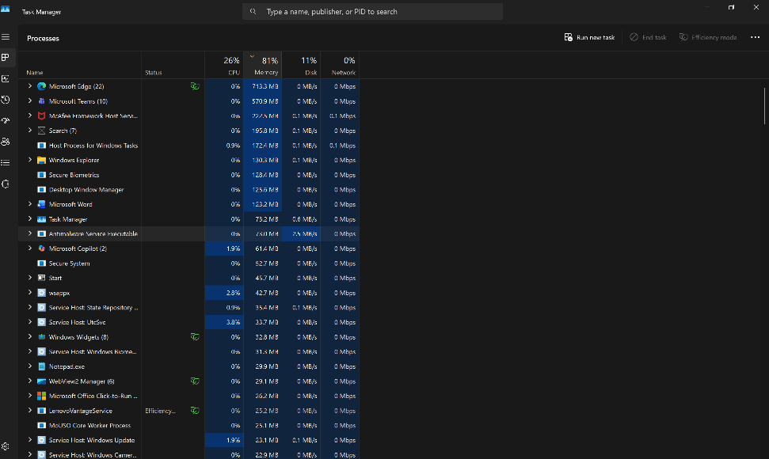
Figure 1: Task Manager

Application/Program Management:
Application management encompasses software maintenance, from installation and updates to patching and delivering high-performance, feature-rich applications to users. This includes installation, operation, maintenance, support, and optimization of applications. It updates software, fixes bugs, and helps maintain application security and compatibility with new technologies, as well as promotes its organization. When an application becomes useless or outdated, it is replaced with a new one [4].
Program management is the creation of executable programs that can run on a computer. The main goal is to convert a program into an executable file that the computer can load into memory and run. This file is often called object code. This is why it is an essential component of an operating system.
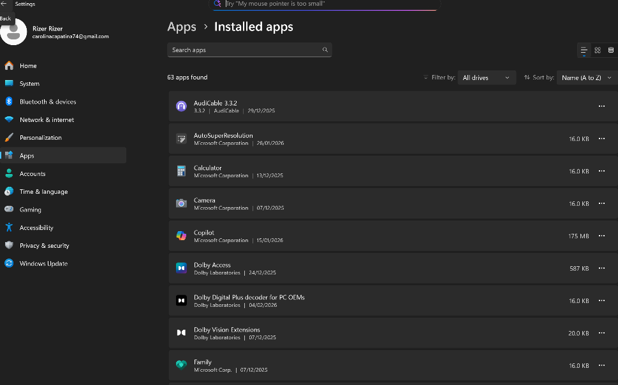

File/Directory Management:
Write about in File/Directory Management windows. Use 1 reference minimum (100 words)
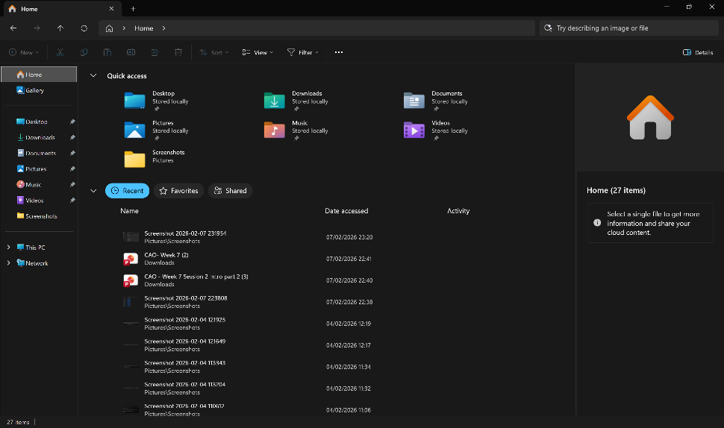
Figure 2: Description

Figure 3: Description

Device Management:
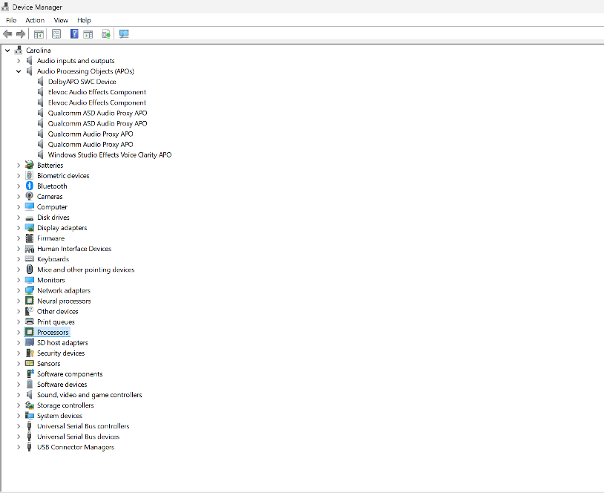
Device management in an operating system is responsible for controlling and monitoring all physical and virtual devices connected to a computer. The system allocates input and output devices to different processes based on their priority and need. When necessary, it can also reassign these devices either for a short time or on a permanent basis. The function of this is monitors the status of each device, such as storage units, printers, and other peripheral devices. It monitors all devices, and the program responsible for performing this function is called the input-output controller. It applies preset rules and makes decisions about which process receives the device when, and for how long. It allocates and releases the device efficiently [5].

Figure 4: Description

Security Management:
Mechanisms that ensure the security and protection of a computer system both internally and externally are implemented by the operating system's security management function. The system has to different levels for securing which are internal security and external security. Internal security refers to the protection of activities of one process from the activities of another process. It is considered as system protection, which also ensures the reliability of a computer system. External security is necessary when a computer system is either on a network or connected to the Internet. It is a mechanism which protecting the data and programs stored in a computer system, as well as various resources of a computer system, from unauthorized access [6].
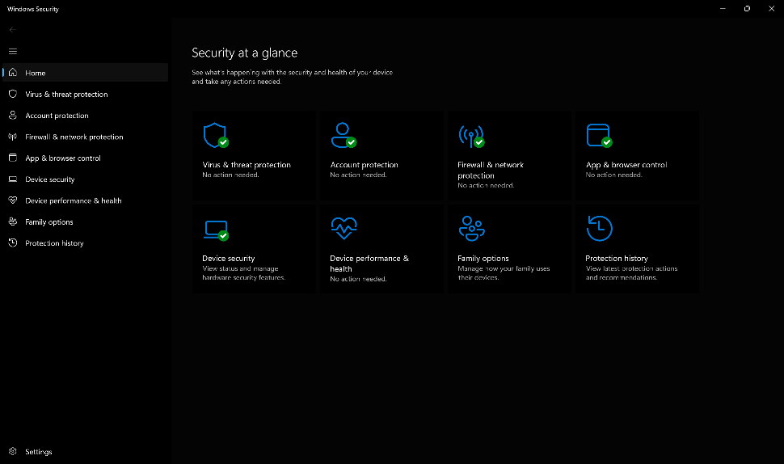
Figure 5: Description

Use of Windows OS CLI commands
PowerShell and Command Prompt are part of the Windows CLI. They can run commands, manage files, examine networks, automate tasks, and troubleshoot the system [7]. These commands provide a direct way to manage the operating system through text-based instructions[8].

Example 1:
Command dir is the most common command which is used to display a list of files and folders in a directory with their attributes such as time , date and else.
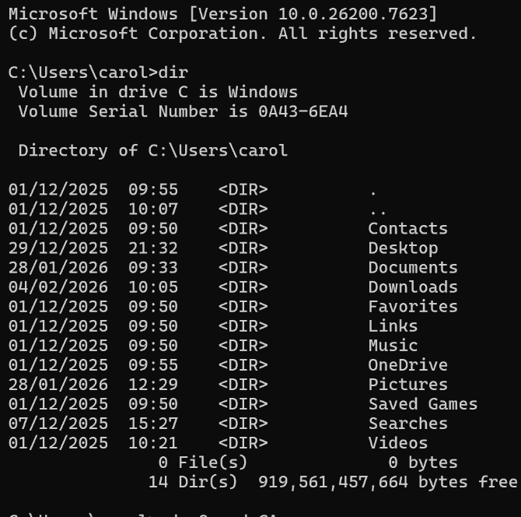
Figure 6: Description

Example 2:
Command del is used to delete one or more files in Command Prompt its need to write command del space file name but after deleting it can be retrieved.
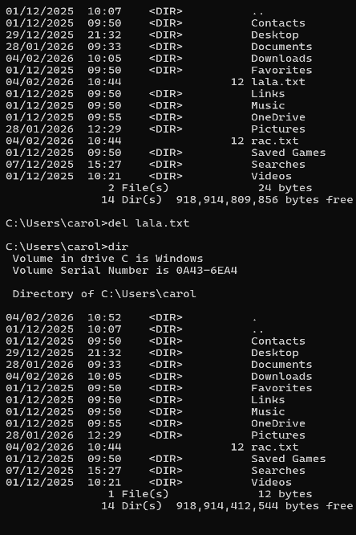
Figure 7: Description

Example 3:
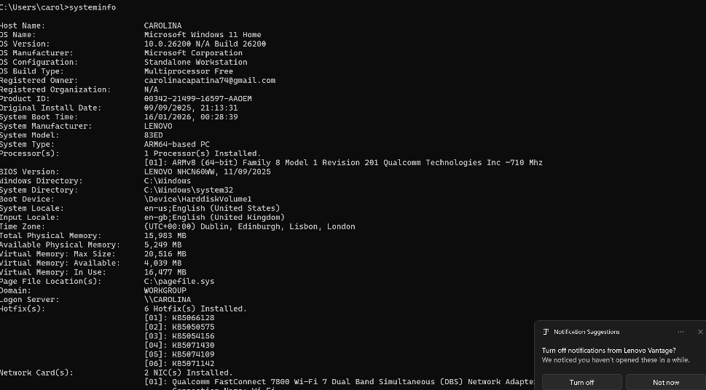
The command systeminfo is displaying a list of system information which including the operative system name, version, manufacture, memory detail and more. In Command Prompt type systeminfo and press ENTER.
Figure 8: Description

Example 4:
Command echo is typing in a file which is chosen a text that is written by the user and save the text in file. In Command Prompt: echo text > file name

Figure 9: Description

Example 5:
Command type displays the text of the file which you chosen, this command does not allow you to edit or add some new text. In Command Prompt: type file name.
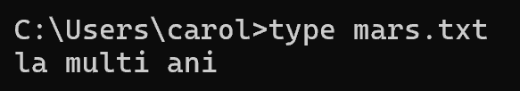
Figure 10: Description

Example 6:
Command rename is used to give to file which have a name a new one or allow user to specify the location and name of the file. rename old,file,name new,file,name .

Figure 11: Description

Example 7:
Command copy duplicate information form first file and transfer it in second file. With this command you can copy multiple files at once and rename them. In Command Prompt: copy <source> <destination>.
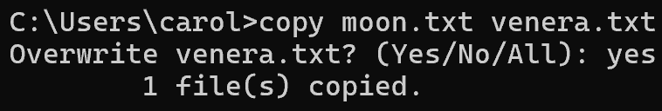
Figure 12: Description

Example 8:
Command ping check if a device has connection with network and measures the round-trip time from your computer to the target device. It's often used to troubleshoot network problems and identify slow connections.
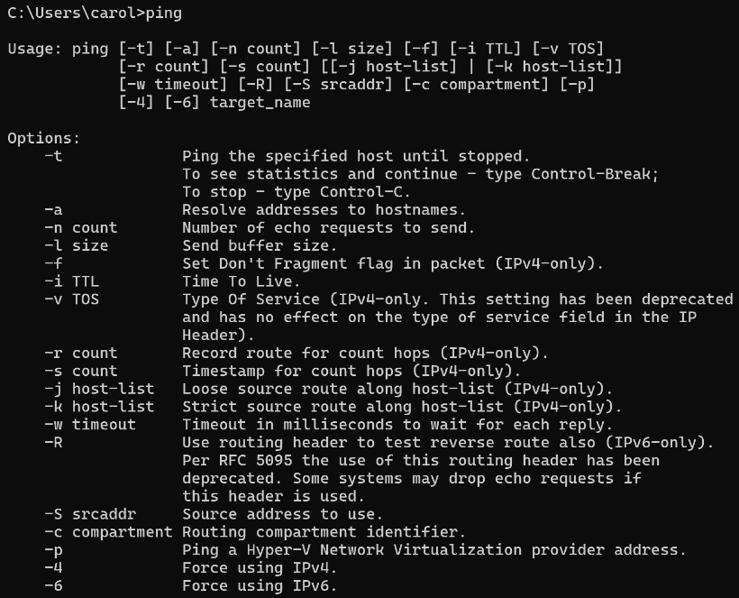
Figure 13: Description

Example 9:
Command tasklist is used to display a list of currently running processes on computer . It shows the process ID number of each running task, the name of executable program.
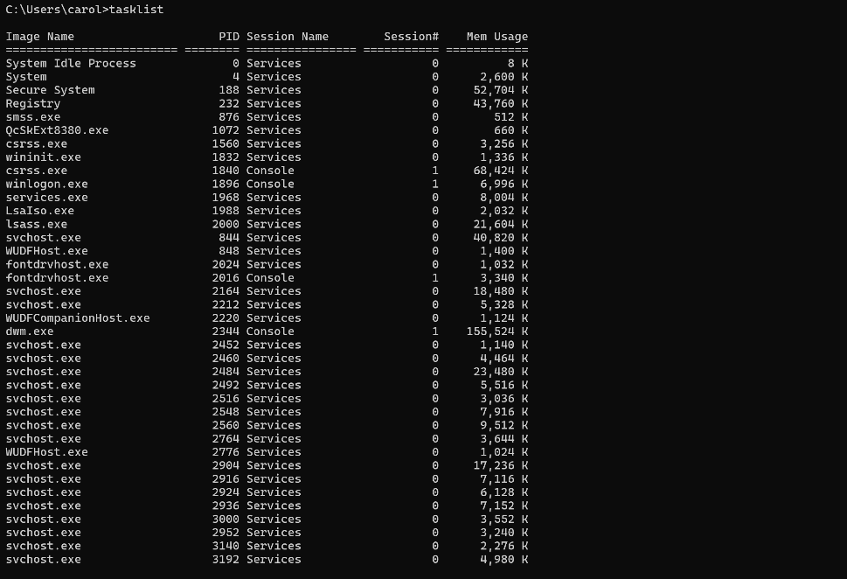
Figure 14: Description

Example 10:
Command ver is a simple utility in Windows that displays the current version of the operating system installed on your machine. In Command Prompt: ver.

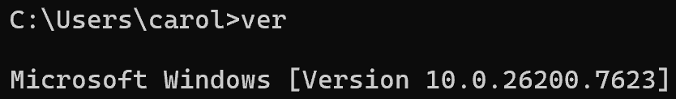
Figure 15: Description

Use of Linux OS CLI commands
The command line terminal in Linux is the most powerful component of the operating system, which holds a large number of available commands [8]. Linux commands are used for quick system management, powerful automation, efficient resource management, and remote system administration [9].

Example 1:
The ls command can be given the name of a directory for example Documents as an argument. The resulting output is a list of files contained with the Documents directory.
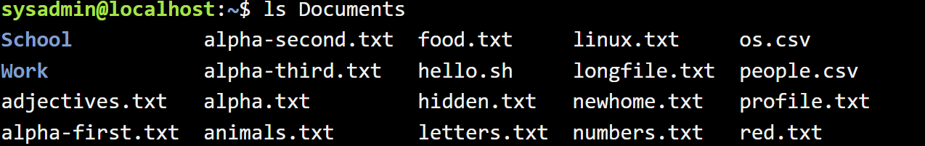
Figure 16: Description

Example 2:
The su command allows you to temporarily act as a different user. It does this by creating a new shell. After executing the su command, a password will be required.
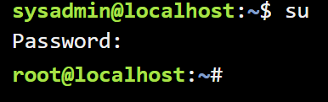
Figure 17: Description

Example 3:
To logout and return to the previous account, use the exit command. And you will be moved to the previous IP.
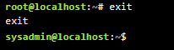
Figure 18: Description

Example 4:
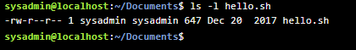

Figure 19: Description

Example 5:
The command free -m is used to display the total amount of free and used physical and swap memory system. Output includes total, used, free, shared, buffer and cache memory.
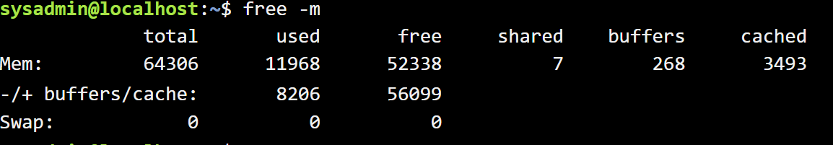
Figure 20: Description

Example 6:
Command whoami is a simple utility that print effective username of the current user session. This command is especially useful when working on shared systems or after switching users.
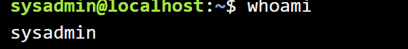
Figure 21: Description

Example 7:
The cat >file is used to create a new file and write content into it directly from the terminal. After the text is written to save and exit need to press Ctrl+D.
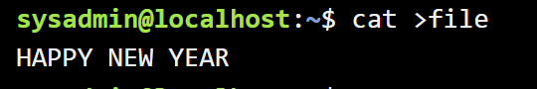
Figure 22: Description

Example 8:
The command cat file without > will show the text which was written in the file in this case HAPPY NEW YEAR.
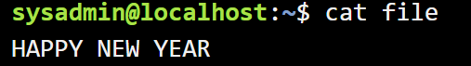
Figure 23: Description

Example 9:
Command sudo fdisk -l where sudo give the permission -l is a list and fdisk display the partition table for all disks connected to system and give the names, size, and type of partitions.
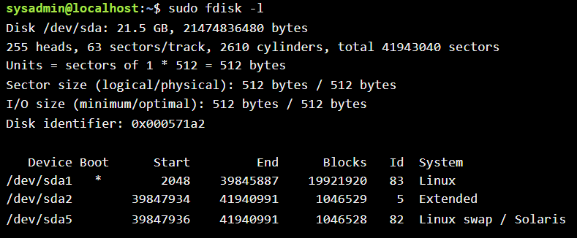
Figure 24: Description

Example 10:
Command top is a powerful tool for monitoring system performance and managing processes. This command opens an interactive display showing system metrics and a list of processes sorted by CPU.
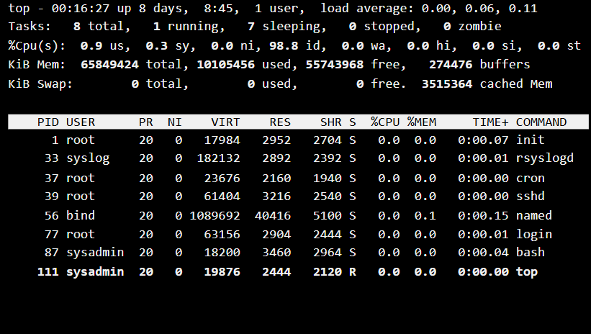
Figure 25: Description

Use of Windows OS scripts
A text file saved with the .bat file extension is a simple batch file. It can be written one using Notepad or other processors [10]. In a Batch script you can create a script that helps ease work by automating these sequences of commands, making work in the shell simpler and more productive [11].

Example 1:
The program underneath is a simple age checker for voting eligibility.
First line is stating with command @echo off which is used to hide the commands, so only the message will appear on the screen. The second line command set for creates or changes a variable, /p to asks the user to type something age is the name of variable and the text is a message shown on the screen. Next line will compare the value entered if age is 18 or more, the script will show to the user that is eligible to vote. In case that is less 18 it will show that is note eligible to vote. The command pause keeps the window open and shows Press any key to continue. This script will properly work only with the number in case of later it will show an error. In output script is asking for ages and show the right message.
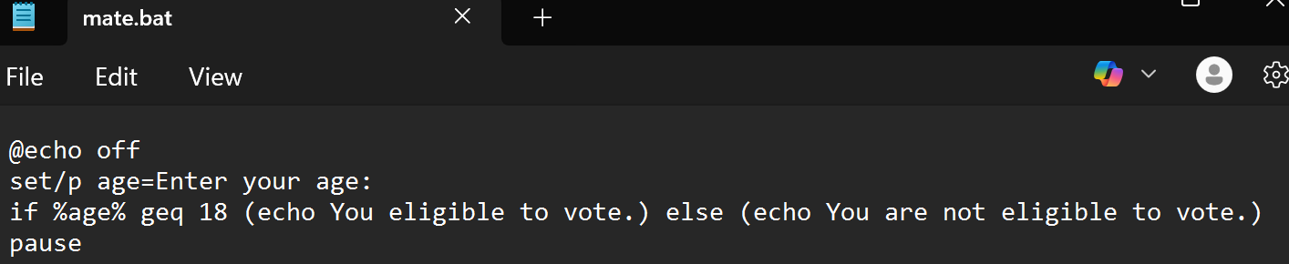
Figure 26: Description
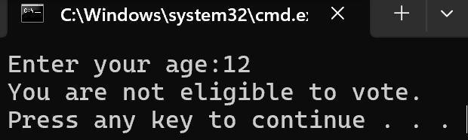
Figure 27: D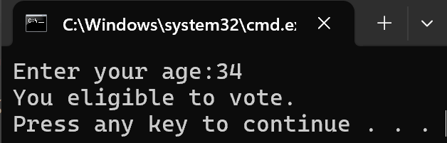escription

Example 2:
In this script is a simple addition program in firs line command @echo off hides the futures commands so the screen looks clear. After this line is enter a command which is asking the user to enter the first number the third line is command which ask for second number these numbers are saved as num1 and num2 because these are the variable for the command set /p. Next line first set for variable which create or change /a tells to windows to do arithmetic and sum is a variable where the answer will be stored, num1+num2 adds the values of num1 and num2. And echo Sum: %sum% show the result on screen. At final pause which keeps the window open. Output show to put first number 5 and second number 90 the program calculates and show the Sum: 95.
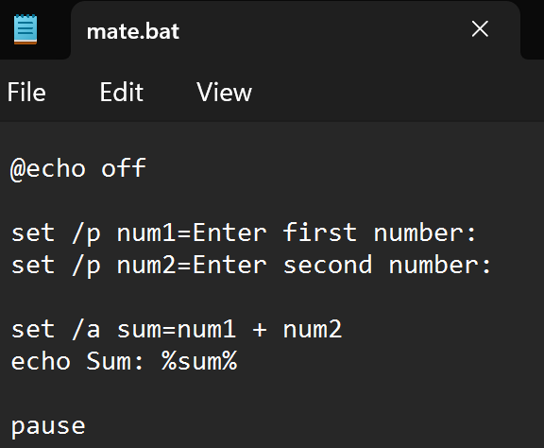
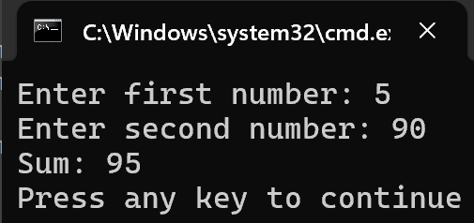

Use of Linux OS scripts
Shell scripting is an important part of process automation in Linux [12]. Instead of executing commands one by one in the terminal, a Bash script allows you to execute them in one step. Writing a sequence of commands to a file and running them together for automatic task execution is the process of creating Bash scripts [13].

Example 1:
This script is starting with command echo off which hides the commands from the screen. Next tow lines are asking for numbers, first in the line is set and this create or change a variable. Second command is /p tells the program to wait the user to type something number1 and number2 are variables, the text is a message shown on the screen. Lines three and four are written to do a calculation where /a means arithmetic. After this to line are two more-line, echo for shows on the screen text is a message and the %total% also %difference% are value stored in the variable total or difference. At the end pause keeps the window open.

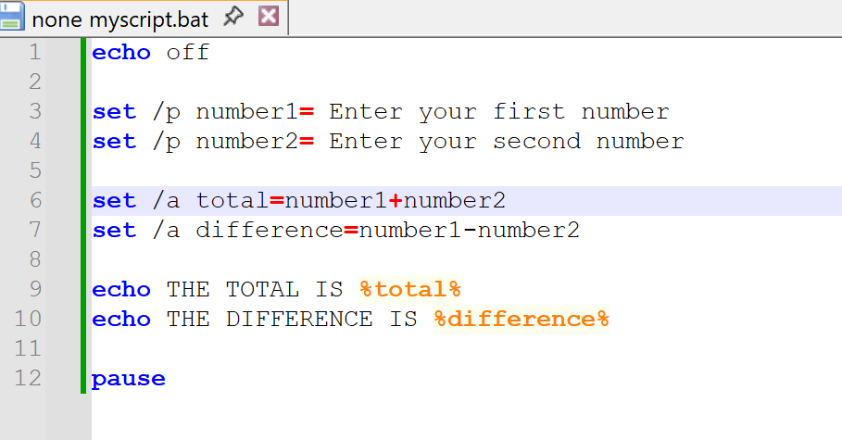
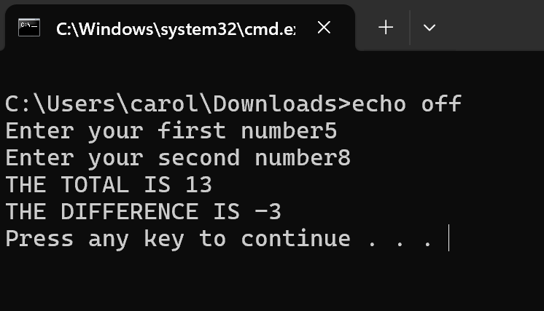

Example 2:
Evry script for not showing the command and only the output is using @echo off. Second line is used set /p age where age a variable and after this a text which is display on the screen. Next one first is if a condition %age% the value entered by the user geq is greater than or equal to in our case 18. First message appears if the age is 18 or more second one will appear in case if age is below 18. into these two messages is a command else that says what to do is if the condition is false in our script )else ( means if that is not true do the next part. And to keep window open at the end put pause. In the output where is asking for age user put 12 this is not greater than or equal to 18 and the program shows that the user is not eligible to vote.

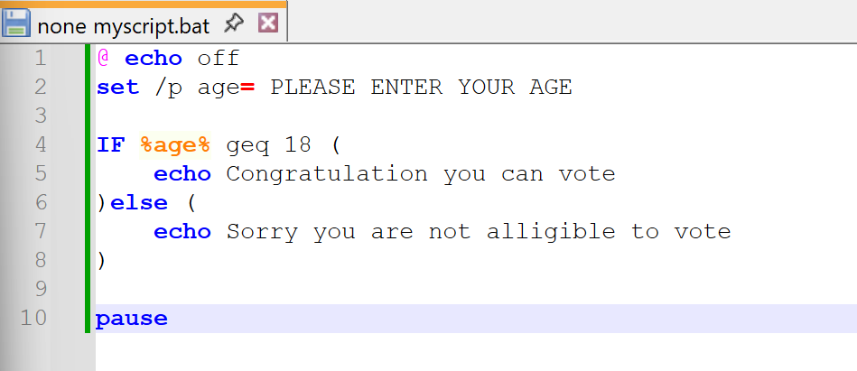
Figure 32: Description
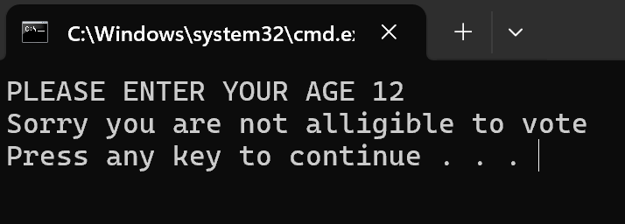
Figure 33: Description

Conclusion
This report covers the basic principles of operating system functionality, including task management, application management, file management, device management, and security management. It also demonstrates how using CLI commands/scripts in Windows and Linux allows users to efficiently manage system control. Overall, these functions provide the user with an understanding of how operating systems ensure resource management, performance optimisation, and safe computer usage.

References
[1] GeeksforGeeks, “Functions of Operating System,” GeeksforGeeks, Dec. 11, 2018. https://www.geeksforgeeks.org/operating-systems/functions-of-operating-system/
[2] BBC Bitesize, “Functions of operating systems - Computer systems - AQA - GCSE Computer Science Revision - AQA - BBC Bitesize,” BBC Bitesize, Mar. 19, 2019. https://www.bbc.co.uk/bitesize/guides/zkkkw6f/revision/6
[3] Computer Hope, “What is Task Manager?,” Computerhope.com, Dec. 23, 2025. https://www.computerhope.com/jargon/t/taskmana.htm (accessed Feb. 23, 2026).
[4] IBM, “Application Management,” Ibm.com, Mar. 05, 2024. https://www.ibm.com/think/topics/application-management
[5] GeeksforGeeks, “Device Management in Operating System,” GeeksforGeeks, Jul. 23, 2023. https://www.geeksforgeeks.org/operating-systems/device-management-in-operating-system/
[6] Includehelp, “Device and Security Management in Operating System,” Includehelp.com, 2018. https://www.includehelp.com/operating-systems/device-and-security-management.aspx
[7]
R. Harwood, “Windows commands,” Microsoft.com, Jul. 29, 2025. https://learn.microsoft.com/en-us/windows-server/administration/windows-commands/windows-commands
[8] GeeksforGeeks, “OS Commands on Windows,” GeeksforGeeks, Feb. 11, 2026. https://www.geeksforgeeks.org/computer-science-fundamentals/os-commands-on-windows/ (accessed Mar. 26, 2026).
[9] GeeksforGeeks, “Linux Commands Cheat Sheet,” GeeksforGeeks, Jul. 14, 2023. https://www.geeksforgeeks.org/linux-unix/linux-commands-cheat-sheet/

[10] C. Hoffman, “How to Write a Batch Script on Windows,” How-To Geek, Jul. 05, 2017. https://www.howtogeek.com/263177/how-to-write-a-batch-script-on-windows/
[11] Tutorials point, “Batch Script Tutorial - Tutorials point,” Tutorialspoint.com, 2019. https://www.tutorialspoint.com/batch_script/index.htm
[12] Z. Hira, “Shell Scripting for Beginners – How to Write Bash Scripts in Linux,” freeCodeCamp.org, Mar. 31, 2022. https://www.freecodecamp.org/news/shell-scripting-crash-course-how-to-write-bash-scripts-in-linux/
[13] GeeksforGeeks, “Bash Scripting Introduction to Bash and Bash Scripting,” GeeksforGeeks, Apr. 19, 2022. https://www.geeksforgeeks.org/linux-unix/bash-scripting-introduction-to-bash-and-bash-scripting/

Appendices
Online Course name: Linux Unhatched
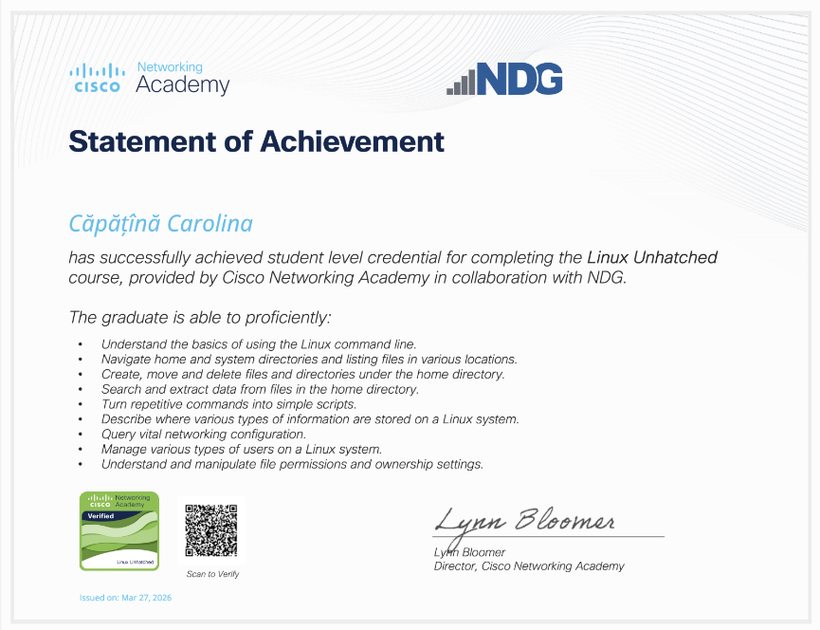
Figure 34: Certificate of completion

