Introduction to Python

The print() function

print()

The print function in Python is simple. The syntax is:

print("")

and any text to be printed should be within quotes (these can be single '' or double "" – I usually use double)

Python will put in an automatic linebreak by default:

print("Hello ")
print("How are you")

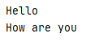

You can stop the automatic linebreak by using an end parameter

print("Hello",end='')

print("Hello", end='')
print("How are you")

You can print out with more than one set of quotes if you like:
print("I like tea", "and my favourite is Yorkshire")

You can also use a separator (sep). This will put the separator between each of the text in quotes:
print("A", "B", "C", sep='-')
This will print out as follows:
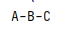

Using Comments

Use # (# followed by a space) to add comments to your programme:

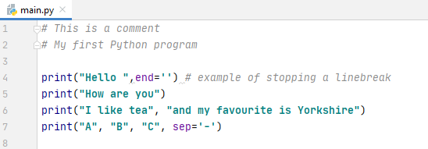

You can also use """ to start and finish a multi-line comment.

For example:

"""This
is a
multi-line
comment"""

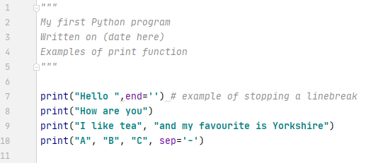

Variables

Variables are used to store values in a program. These might be whole numbers (integers), decimal numbers or letters.

These are:

Integers - int
Decimals – float
Letters – string (str)

Some programming languages insist on us declaring the type of our variable upfront, so the programme can allocate memory for it. This is known as strongly-typed.

In Python, however, this is not required – in fact there is not a command for declaring a variable in Python. Instead, Python infers the type – but there are also ways that we can help to specify it (this will be explained below)

First, we will use some variables, and then we will talk about typing.

Choosing a suitable variable name

There are some rules associated with choosing variable names.

1. A variable name must start with a letter or the underscore _ character
(eg myName)

2. A variable name cannot start with a number
(so myNumber1 is OK, but not 1myNumber)

3. A variable name can only contain alpha-numeric characters and underscore (A-Z, a-z, 0-9, and _ )
We cannot use special characters such as ?!-$%^

4. Variable names are case-sensitive
(ie myname, myName and MYNAME are not the same)

Self-describing variable names
I would add to the above rules that a variable name should be self-describing:

For example, carPrice=2300 make it quite easy to understand what the purpose of the variable is, a=2300 does not. This is especially important when you haven't worked on a program for a while – it may be difficult to recall what a refers to.

Let's set up some variables as an example:

For example:

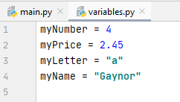

If there are letters in the contents of the variable, put " " or ' ' around the contents as shown above.

Camel Casing
You have seen above that I have chosen variable names such as myName, myNumber, carPrice

You may have wondered why they have a random capital letter in the middle of them. This is known as camel casing, which is a programming convention.

Camel casing is not a rule - but many programmers, not just in Python, but in many other languages, use camel casing to make their variables easier to read.

For example, myname is quite short and fairly easy to read, but myName makes it more readable without resorting to using underscore (although my_name or my_Name are also OK!)

When variable names become longer, camel casing can help with readability:

myfirstname -> myFirstName
mymiddlename -> myMiddleName
mysurname -> mySurname

There are no hard and fast rules here. If you don't like camel casing, you don't have to use it, but bear in mind that other programmers who may maintain your program in the future may prefer it!

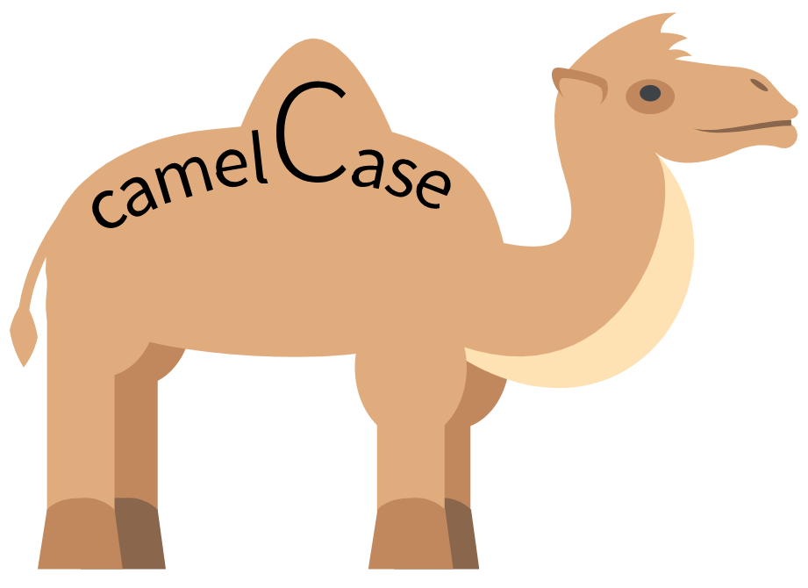

We can print variables on the screen using the print() function

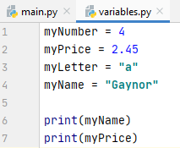

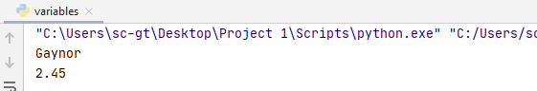

Python variable types
To find out the type that has been inferred by Python, we can print it out by using type().

print(type(myNumber))
print(type(myName))

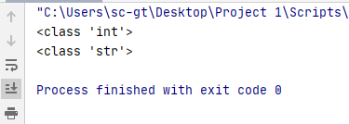

However, you can also specify the type, rather than rely on Python inferring (because sometimes Python might get it wrong) This is known as casting.

Casting
For example, I might intend myNumber to be of float type. So I can specify the type:

myNumber=float(4)

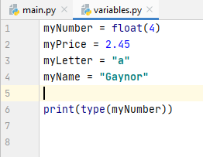
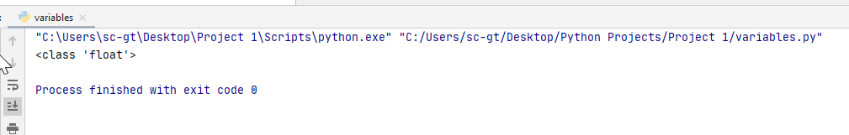

I can only do this within reason. For example, I can't make myName = "Gaynor" into an int type!

Also, if I specify myPrice above into as an int type :

myPrice=int(2.45)

Python will truncate the value – so only the whole number 2 is left. This may be what I want, but not necessarily!

Python is more forgiving than other languages about mixing types. If I add an int and a float together in Python for example, Python will quietly change the result to a float

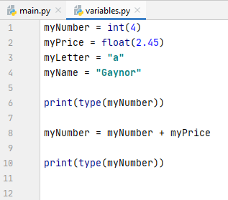

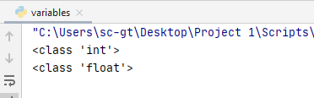
type has changed to float

