
Student name: | PETAR ARTYUHOV | Student ID number: | 2123090
Programme: | BA Business Management
Module: | Community Engagement
Module code: | LCBB4002 | Contribution to Overall Module  Assessment (%): | 50%
Lecturer: | Dr. Olu Adegbite | Internal Verifier: | Dr Eric Osei
Assignment Title: | Community Engagement Assignment 1 – Essay | Word count (or equivalent): | 2000
Submission deadline: | 09/07/22 – 3pm | Return date of provisional marks & written feedback: | TB
Submission method: | All written assessments, where practical and possible, must be submitted via Turnitin unless otherwise instructed by the Lecturer. (Please DO NOT put this assessment specification into Turnitin or it will match many similarities with other students’ submissions.)  Alternative submission method (if applicable):  Late submission of the assessment will result in a late penalty mark. Penalties for late submission: Up to one week late, the maximum mark of 40%. Over one week late, 0%. Only the Extenuating Circumstances Panel may approve a change to submission dates.
Academic honesty  / referencing: | Academic honesty is required. In the main body of your submission, you must give credit to authors on whose research and ideas your work is based. Append to your submission a reference list that indicates the books, articles, etc. that you have used, cited or quoted to complete this assessment.

Table of Contents
Introduction 3
Discussion & analysis of the organisation 3
Outline how Fujitsu has been using both its human and material resources to better improve lives in the community. 3
Identify key themes upon which Fujitsu carry out its community engagement activities 4
Identify its service users and what services they require from the Fujitsu 6
Explain the importance of the community engagement role in Fujitsu’s business 7
As regards, Fujitsu's staff, explain the skills and knowledge needed to successfully carry out community engagement activities 8
How can they acquire the identified skills? 9
Conclusion 10
References 11

Introduction
Sönnichsen and Clement (2020) have exhibited that community engagement is interrelated with understanding the effects of connection of organisations by shifting from individuals towards a collective audience. The study is based on understanding the social values and their repercussions on the organisation and their effects on business operations and reputation. Moreover, the community engagement strategies by the organisation Fujitsu is described in this study which is an Information and communications technology company, and its headquarter is based in Kawasaki, Kanagawa, Japan. The organisation is majorly involved with community engagement activities across the world, which also contributed to the development of underdeveloped groups across the UK. The organisation mostly focuses on some of the key areas which include majorly 9 factors based on community action strategy. The organisation is able to handle 127 entries submitted by a wide range of Fujitsu Group companies based on six excellence awards based on a lean Consulting Creation methodology in a caring process (Fujitsu, 2022b).

Discussion & analysis of the organisation

Outline how Fujitsu has been using both its human and material resources to better improve lives in the community.
In order to provide a great service to the industry, the company is based on effective social development based on a high level of engagement. The organisation is using digital strategies, university research, STEM systems, youth employment, volunteering and charities. Based on these action strategies the organisation for the improvement of business operations. Based on these strategies the organisation is able to handle sustainable manufacturing, a healthy lifestyle, a trusted society, and Hybrid IT technologies.
Digital inclusion
This strategy includes both the machines and their learners through the processes of effective digital drivers based on collaboration. Key drivers of the organisation for digital transformation are employee engagement and productivity, talent acquisition, innovation and growth. Based on these strategies the organisation is able to retain talents based on diverse populations which maintains effective growth of ideas and innovativeness among the teammates.

Figure 1: Digital transformation strategy of Fujitsu
(Source: Fujitsu, 2022c)
This includes a total of 16 events which includes a focus on digital inclusions based on the strategies of Integrated Experiences, Future Ready, Silos and Industrialisation. This system includes updating legacy systems, improvement of customer experience, trailing & a set of business models and establishing the new environment. This inclusion is done based on the DX framework which is based on explicit knowledge of existing stakeholders.
Youth employment
The organisation has done a youth employment program on Prince’s trust in which an analysis of 45 CVs with the development of Interview skills based on a 12 weeks program is done which helps to improve their existing skills and knowledge for creating strategies for recruitment. The organisation has a total number of 150,000 employees in 100 countries from different diverse cultures. They prioritise their diversity and inclusive nature for business operations which is done based on their “Promotion Framework for Diversity, Equity and Inclusion”. During this 12-week program, the organisation has provided training for the development of CV and interview skills based on the different needs of diverse cultural employees and different underrepresented backgrounds. Based on these strategies it has been identified that 25 out of 100 people in the Junior Talent program of the organisation belong from underrepresented backgrounds.

Identify key themes upon which Fujitsu carry out its community engagement activities
Integration of responsible business tracker for effective engagement
Moreira and de França (2019) have stated that a business tracker is one of the key methods for monitoring an individual based on a specific metric which creates a robust benchmark for the engagement of the individual. Based on the scores of the tracker, organisations are able to handle better policies and practices on the organisation based on the improvement of their skills. The organisation is currently operating in 154 countries and has made an investment of $1.6 billion for its research and development activities which provides best-in-class solutions for decision making. Based on the tracking method, the organisation is able to handle effective communication with their employees about their needs and encourage them toward work. Kalogiannidis and Papaevangelou (2020) have demonstrated that interaction with the employees helps to understand their mainstream growth opportunities and abilities, based on these organisations being able to handle effective outcomes and performances. The tracking and improvement of skills are done based on the strategies of “Connect”, this helps to determine the vision with the members for better improvement. Based on this system the organisation is able to educate individuals based on their knowledge and ideas by enhancing and practising purpose-driven management.
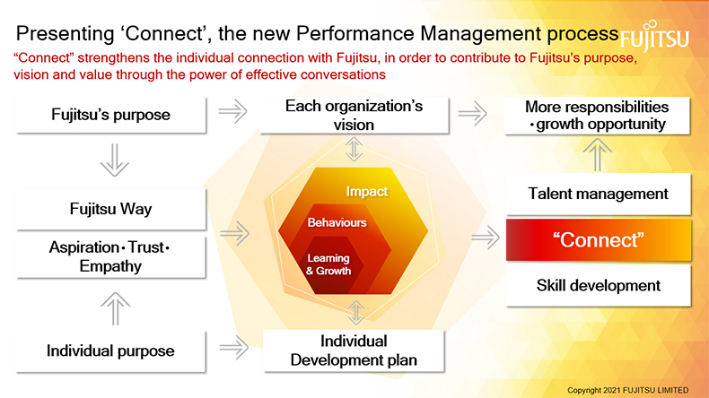
Figure 2: The connect framework of Fujitsu
(Source: Fujitsu, 2022c)
Adoption of a business class framework
This is known as a government-endorsed program which helps to integrate a systematic framework into the organisation based on the support of young people during recruitment. Based on the application of the business class framework the organisation is able to handle the social disadvantages of youth which are the most common factors among them, this is done based on partnership with different schools for purposeful training. Based on the belief in the development of business skills for maintaining a fair and sustainable society across 100 countries where they are serving. This program helps to develop four business values for maintaining responsibilities with association with 5 business pillars.
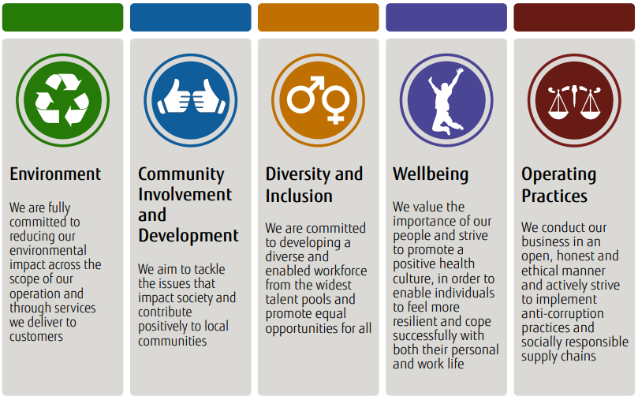
Figure 3: The role of a business class framework for responsible education
(Source: Fujitsu, 2022c)
Based on the business class framework the organisation is able to create a vision towards the creation of a connected society with the partnership with Business in the Community (BITC) by balancing great initiatives (Bitc, 2022). Based on the strategy the organisation participated in supporting schools of 3.7 Million people among them 30% belong to the UK. Based on this partnership the organisation is able to reach 3025 young people through their 268 Fujitsu employees as a volunteer which donated a total of 1352.5 hours for their business educational training.
Development of different charity partnerships for better social engagement
The organisation has an effective strategy for their charity partnership which is decided by employee voting processes. The employees of Fujitsu vote every 2 years for the selection of charity partners which is done by focusing on the charity needs and technological expertise of the company. In the year 2018, the employees of the organisation selected Autistica as their charity partner which contributes to their social development from the year 2019 to the current year. Based on their partnership process the organisation is able to maintain effective social benefits which are able to serve 700,000 autistic people across the UK through different artistic research based on technology as well as investment in research (Fujitsu, 2022).

Identify its service users and what services they require from the Fujitsu
Fujitsu mainly provides end-user services based on innovative solutions which help to make them more proactive to meet sustainable goals in different regions. The organisation majorly works with different trusts, public institutions, government institutions, healthcare industries, financial services and manufacturers. The organisation is mostly based on delivering a single blended service which includes Virtual Workplace, Classic Client Services, Mobile Workplace, security and scalability. Based on these processes the organisation is able to serve different organisation growth needs and helps to make them more proactive by integrating different technologies.
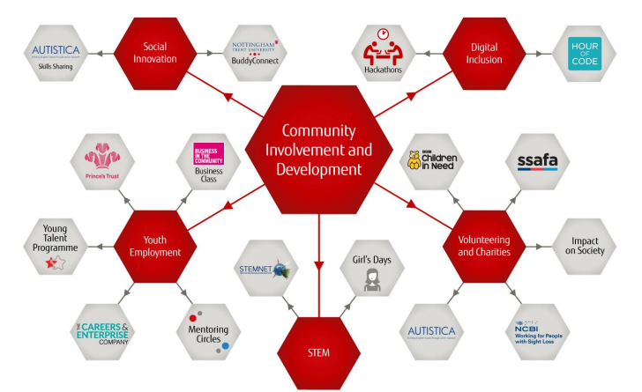
Figure 4: Community map of Fujitsu
(Source: Fujitsu, 2022c)
The organisation is based on the services of Multi-cloud, Application services, Business services, digital workplace services, Cyber security services, and network communication services. Based on these services the organisation is able to handle social innovations, charities, digital inclusions and STEM operations.

Explain the importance of the community engagement role in Fujitsu’s business
Community engagement for organisations is necessary as this helps to ensure better decision-making based on seeking out aspirations based on different social values. Based on this, organisations are able to serve as invaluable platforms for the promotion of their products and services. Based on this Fujitsu is able to make sustainable decisions based on the needs and interests of different participants who are involved with the operations. Based on community engagement, the organisation is able to meet the needs of millions of people from the UK and Ireland every day. The organisation majorly prioritises the engagement of the community stakeholders with different people from diverse cultural groups which helps to ensure long-term sustainability for the organisation. The organisation mostly operates based on the support of the local community and charitable activities across the UK and Ireland which helps to ensure company and locally initiated programmes through volunteering and highly scalable technologies.
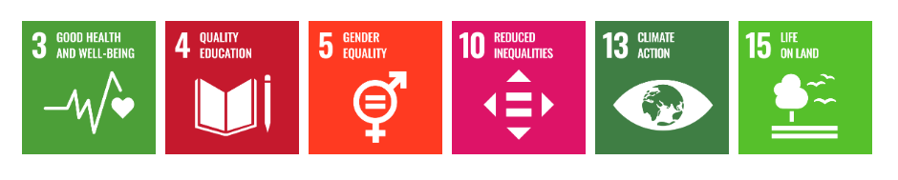
Figure 5: Key areas of focus for community engagement by Fujitsu
(Source: Fujitsu, 2022c)
In order to meet the social working objective, the organisation makes partnerships with Impact on Society (IOS) groups from different regions which help to ensure funding and local volunteering activities. The organisation have done different skill development activities to support their volunteering activities based on this they are able to engage their volunteers in professional environments. Based on this, organisations are able to develop collaborative models of care, which helps to create a holistic view of health and wellbeing (De Weger et al. 2018). Based on the effective development of skills among the volunteers, the organisation has developed their internal portals for effective skills support of the individual.

As regards, Fujitsu's staff, explain the skills and knowledge needed to successfully carry out community engagement activities
Effective interpersonal skills play an effective role in the management of community engagement activities by different staff that helps to manifest better engagement with each other. Based on these skills the individuals are able to understand the role of multiple dimensions and disciplines while they are engaging with different communities. Hatala et al. (2017) have mentioned that the most important skills that are needed for effective community engagement are listening skills, responding skills, conflict resolution, membership support and connection facilitation. Based on these skills the volunteers are able to form a positive relationship with the social groups, which helps to make understanding strategies for engagement, negotiation, and participatory knowledge production. Along with the above-mentioned skills, volunteers of Fujitsu have to be effective in the skills of communication, emotional intelligence, leadership, organisation and spiritually-informed attitudes while they are serving different communities.

How can they acquire the identified skills?
The organisation provides different types of training for the promotion of community engagement skills through different types of virtual and technical training processes. Based on the training the organisation is able to handle professional development among the volunteers which help to create better expertise, skills and knowledge about engaging with people which is known as the “Volunteer Activity Support System ''. Depending on this skills development activity the organisation is able to handle different needs for effective community engagement based on a Global Wisdom Program (GWP) and Global Organisational Leadership Development Program (GOLD). Based on this intervention the organisation developed Fujitsu University in 2002 which helps to maintain a systematic educational program based on social connection needs.
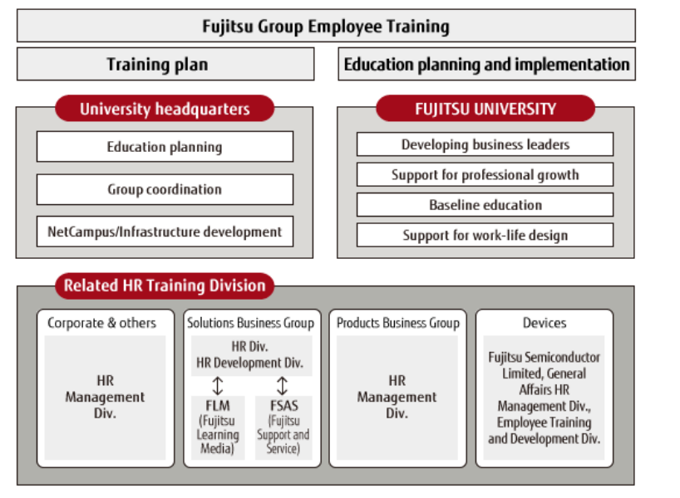
Figure 6: Training framework for employees of Fujitsu
(Source: Fujitsu, 2022c)

Conclusion
The above study demonstrated the application of different community engagement that is done by the organisation Fuistshu which is one of the telecommunication technology companies of Japan. The organisation has done major social works towards the development of the culture and values of different people with leadership programs for better education of underrated social groups. Based on these engagement strategies the organisation is able to create a greater reputation among different people. The organisation mostly did their social engagement by a partnership with different social groups or NGOs. the current partner for social engagement by the organisation is Autistica, which serves to reduce the issues of autism among the UK people.

References
Bitc, 2022. “Make responsible business your business” [Online] Available at: <https://www.bitc.org.uk/>
De Weger, E., Van Vooren, N., Luijkx, K.G., Baan, C.A. and Drewes, H.W., 2018. Achieving successful community engagement: a rapid realist review. BMC health services research, 18(1), pp.1-18.
Fujitsu, 2022a. “Fujitsu and Autistica” [Online] Available at: <https://www.fujitsu.com/uk/about/local/corporate-responsibility/charity-partner/#:~:text=In%20October%202018%2C%20Fujitsu%20colleagues,partnership%20into%202021%20and%202022>
Fujitsu, 2022b. “Transforming Our Corporate Culture” [Online] Available at: <https://www.fujitsu.com/global/about/csr/transformation/>
Fujitsu, 2022c. “Community Investment and Development 2017” [Online] Available at: <https://www.fujitsu.com/uk/Images/Fujitsu-UKI-Community-Plan-2017.pdf>
Hatala, A.R., Erickson, L., Isbister-Bear, O., Calvez, S., Bird-Naytowhow, K., Pearl, T., Wahpasiw, O., Engler-Stringer, R. and Downe, P., 2017. The interpersonal skills of community-engaged scholarship: Insights from collaborators working at the University of Saskatchewan’s Community Engagement Office. Journal of Community Engagement and Scholarship, 10(1), p.6.
Kalogiannidis, S. and Papaevangelou, O., 2020. Impact of Business Communication on the Performance of Adult Trainees. International Journal of Academic Research in Progressive Education and Development, 9(3), pp.213-222.
Moreira, C. and de França, B., 2019. Towards a healthier collaboration at the business-development interface. In CIbSE (pp. 86-99).
Sönnichsen, S.D. and Clement, J., 2020. Review of green and sustainable public procurement: Towards circular public procurement. Journal of cleaner production, 245, p.118901.

