Royal Free London NHS Foundation Trust

ASSESSMENT 1: COMMUNITY ENGAGEMENT
Student Name:Moisiu Maria-Alexandra
Student id:1921355

Table of Contents
Introduction 3
Analysis of the project 3
Relationship with the stakeholders 3
Different eras of the organization 4
Different use of social media platforms by the organization 6
Training and development need to deal with Socio-Cultural issue 7
Reasons for providing training on multiculturalism issue 8
Conclusion 9
Recommendations 9
Reference List 10

Introduction
Community engagement programs have great importance for any kind of social service or even for any kind of business. Social services are given to provide support to community people of that place. A community is a specific geographic area, where every person who lives around that area or works in that place is a member of the community and all of them should get the social service that is provided by the organization. Community engagement is really important for health care organizations. It provides benefits to both healthcare and society. It helps the health care organization to identify common health issues within the area, it creates strong relationships with the community (Dureyet al., 2016). On the other hand, it helps to establish more communication for the community people with the health organization. In this report a world-class healthcare organization, Royal Free London NHS Foundation Trust has been selected to analyze the community engagement and its benefit to the organization. There is some area to make continuous communication with the community, those will be also discussed in the report. The report will also reveal the relationship with its stakeholders and how they manage the social media platform to make continuous connections. The report also identifies the required training for their employees to make strong engagement with local people. Finally, the report will end with some valuable recommendations to improve their community engagement to get a competitive advantage in the industry.

Analysis of the project

Relationship with the stakeholders
Royal Free London is one of the best medical service providers in London with some world-class medical facilities. They considered that patients are their most important stakeholders. They do a lot to provide safety to their patients. A great job has been done by the team of Royal Free London to defend the COVID-19 pandemic. A huge number of patients are recovered by them. They are providing a lot of services to their patients before covid and after covid situations. Due to the pandemic situation they had to close some of their emergency care services to avoid face to face to meetings. Still, they find some new way to meet their patients and try their best to give solutions. The director of the organization introduced a video-based system call attend anywhere system. This is a video-based consultation and they wanted to keep their caregivers safe. Also, they wanted to give support. Despite the pandemic situation, they keep opening their young and child emergency care services. Apart from this, they have done very good things for their health workers to boost their energy, they clipped more than 750 numbers of greeting messages which come from the local community. Apart from this, they always take care of their employees, they give best facilities to their employees to keep engaging them with people. They also maintain a very positive relationship with all of their partners and other stakeholders. Recently, they have received a finding of £9 million from one of their partners and they invest that amount to replace 3 MRI machines to increase the scanning capacity as they feel patients are their most valuable stakeholders.
At present Royal Free Trust is working with two more hospitals which are Chase Farm and Barnet hospital. They have almost 1.6 million patients and more than 10,000 active employees. Therefore, it is very important to make a continuous engagement with them. Social media platforms are the best option to stay connected always with them and this trust also does that. They are on Facebook, YouTube, Twitter, and Instagram. They also have an instant WhatsApp facility. They have updated all of their information regarding their notifications, greetings, information of changes in their official website.

Different eras of the organization
Royal Free Trust is one of the oldest hospitals in the city of London. The hospital was first introduced in the 18th century. At that time the hospital worked with a different name. The hospital was introduced in 1828. At that time this was introduced as a free health care sector for those people who did not afford treatment. The news of the hospital efforts reached the queen of England and in 1837 the hospital got the name of Royal which was a cent percent justice for them. At that time the hospital was working to defend against another dangerous disease that is cholera. This was an era and for many years there were no such good hospitals in London like Royal which provided support to poor people (Carriganet al., 2021). The community engagement program is not new for them, rather they are doing this since the end of the 18th century. They were the only which provided medical training to the women free of cost and later it was introduced as Royal Free Hospital School of Medicine. After a long time, Royal Free moved to its current place in 1970.
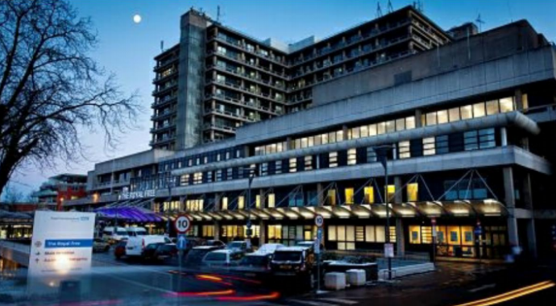
Figure 1: Royal Free London NHS Foundation Trust
(Source: (Carriganet al., 2021).)
Royal Free never forgot to work for the community and when the government of the UK introduced the NHS and Community Care Act 1990, then Royal Free Hospital came and it was the first hospital that started to work as NHS Trust. In 2012, this hospital got authorization from the NHS as a trust and was renamed to Royal Free London NHS Foundation Trust. The community engagement becomes easier from then and after two years they have partnered with two other Royal healthcare organizations which are Barnet hospital and Chase Farm hospital. At present they have more than 1.6 million patients and more than 10,000 employees. This shows how they evolve into community engagement at different times and how it increases with time.
There are different skills required for those people who want to work in a Royal Free organization. This is a healthcare organization and all the common knowledge and skills are required to work here. The most important skill is communication skills (Zhang et al., 2020). Without communication skills, the care workers can't identify the issue of the patient, the body language of the care worker is all needed to be appropriate. Apart from this, empathy is required to handle tough situations for the patients. Excellent team working skill is required to discuss one patient's issue, to get advice from others (Adhikariet al., 2016). Another thing required is time management, there will be multiple tasks but it needs to separate the tasks according to priority.

Different use of social media platforms by the organization
Social media platforms in today's world are the best option for community engagement as more than 50 million people are using Facebook in the United Kingdom (Dessart,2017). Therefore, to reach local and national people, to send the information regarding the hospital, to stay connected always with the people of the community, Facebook, Instagram, Twitter, YouTube, etc. are the best options nowadays. The organization has a Facebook page with the same name of organization and it is liked by more than 12,000 people.
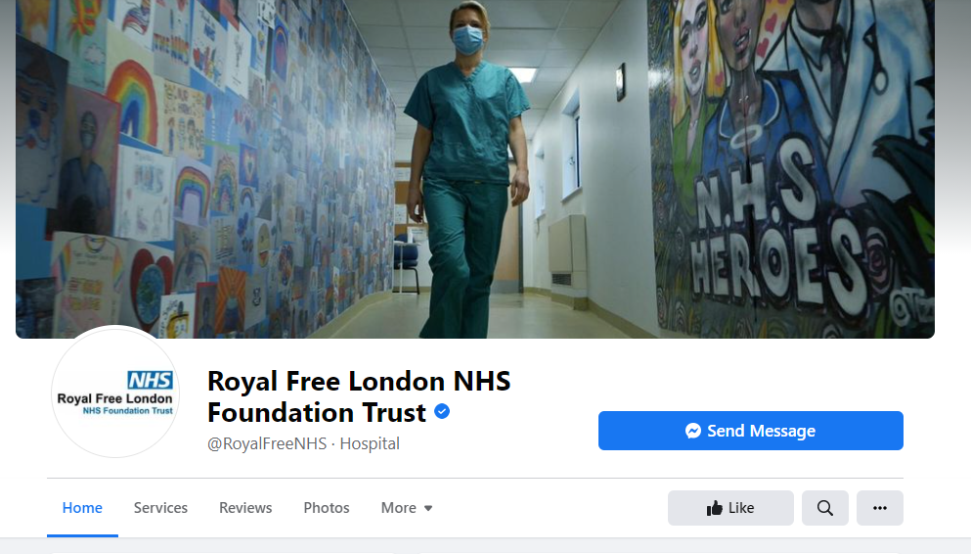
Figure 2: Royal Free London NHS Foundation Trust Facebook page
(Source: facebook.com,2021)
They have posted all important notifications, job hiring notifications, service changes, or increase information on their Facebook wall. Apart from this, video engagement has also equal importance and the organization is also active on the YouTube platform.
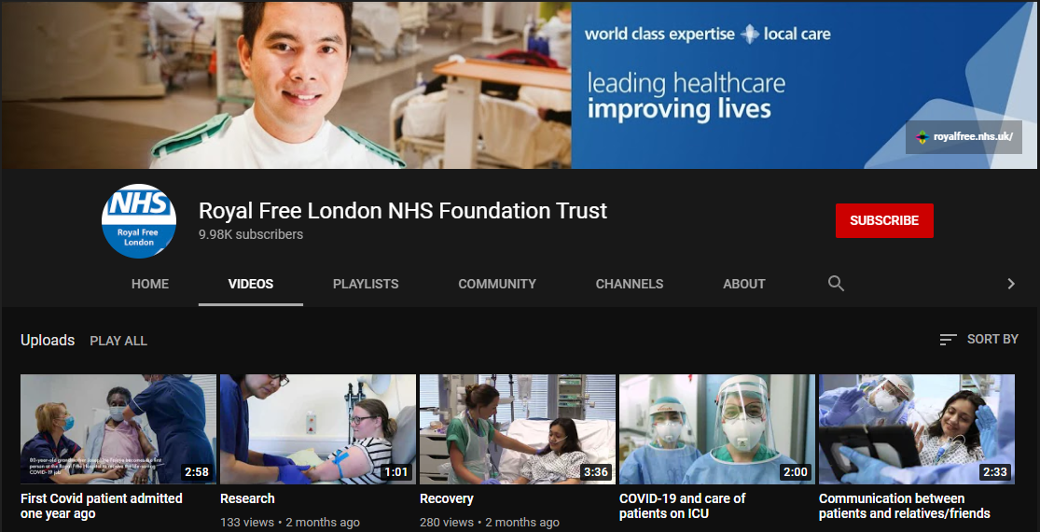\
Figure 3: Royal Free London NHS Foundation Trust YouTube page
(Source: youtube.com,2021)
They have almost 10,000 active subscribers. Apart from this, they have a separate Instagram page and a Twitter handle with their official name. They have almost 8,000 twitter follower at present.

Training and development need to deal with Socio-Cultural issue
In the UK, there is a huge social and cultural diversity according to their geographic region. Those people have different communication approaches, different cultural diversity. However, all of them are human and their health issues are also the same as others. Still, the socio-culture difference can hamper the treatment of poor people due to miss communication or any other interruption (Paudelet al., 2018). This situation needs to be handled and for this, some specific training and development program is required for the employees.
Importance of cultural diversity
All the employees need to understand the cultural diversity in the UK. They have to understand the socio-culture pattern of the community and need to respect cultural diversity. Health worker's cultures may be different from the patient's culture (Kiselevet al., 2020). It also may happen that health workers or workers may refuse to give treatment to such people who belong to lower caste, these issues need to be handled and should provide training.
Common diversity
The London-based hospital hired a lot of employees from different nationalities and different cultures. It should not happen that due to different cultural backgrounds one employee gets paid differently or gets extra or fewer services compared to other employees.
Employee relation
This is another important thing that needs separate training. The organization is hiring different nationalities of employees around the world. Now in this service sector, team working has great importance. So at first, the organization should provide training on employee relations so that they should not raise any issues or should not refuse work with another employee only due to different cultures.

Reasons for providing training on multiculturalism issue
There are some definite reasons for providing multiculturalism training to the employees. A healthcare profession is a sensitive place. Here all people should be treated the same. All the patients should get the best chance to recover from their health issues. The training is important because the organization does not want any of their patients to get unrecovered only due to cultural differences. Inna the healthcare sector different cultures employees are there as well as different background people admitted as patients. Cooperation is needed from both sides, and strong communication is required to build a relationship (Ashcroft and Bevir,2018). Especially for the employees who provide care support. They should not refuse any patient due to their cultural background or lower caste. For example, in Royal Free Hospital, there has one Muslim religious doctor who has been joined recently in the hospital, it may happen the colleges of the health worker refused to work with him or her only due to his or her religion (Kirmayer,2019). There is another issue that is the white and black native issue. All the employees need to work with calm, no one should harm one's religion, no one should hurt another by the color of the body. Some external factors may impact this situation. Political influence should be strictly banned, there should be no political influence come to rile employees to such things. The geographic location also impacts multiculturalism, one may come from a poor geographic area where people are less cultured, and due to these other employees may not give priority.

Conclusion
The report is mainly prepared to address the importance of community management. The Royal Free London NHS Foundation Trust has been chosen to perform the study. There is a detailed analysis of stakeholders' relationship with the organization and how the organization keeps engaged with them that is also discussed. Apart from this, there has been a detailed analysis done on the use of social media platforms by the organization to stay connected with the community. Moreover, there is a discussion on the knowledge and skill required to be an employee of the organization. Then there is also an evaluation done on different eras of the organization. Finally, the report ends with a multiculturalism issue and specific training to deal with this situation.

Recommendations
In this section, there will be some recommendations to improve community engagement to get back the competitive advantage in the sector.
The organization can involve or organize various events related to health issues or awareness programs to engage more people in the community.
They can organize free health checkups or provide medical camps in rural areas to meet more people once a month. This will help them to identify community-based health issues and also they can get funding for this.
Social media is a good platform to engage with people and the organization is also present on all popular social media platforms. However, they are slightly irregular and as a result despite having more than 15 million Facebook users in London, they have only 12,000 Facebook likes. They can provide interesting tips or advice regarding any health issue.
The same thing applies to YouTube. They have to be regular, they can give interesting videos on some health issues or ways to prevent some common issues daily to get more subscribers.

Reference List
- Adhikari, B., James, N., Newby, G., Von Seidlein, L., White, N.J., Day, N.P., Dondorp, A.M., Pell, C. and Cheah, P.Y., 2016. Community engagement and population coverage in mass anti-malarial administrations: a systematic literature review. Malaria journal, 15(1), pp.1-21.
- Ashcroft, R.T. and Bevir, M., 2018. Multiculturalism in contemporary Britain: policy, law and theory.
- Bright, F.A., Kayes, N.M., Worrall, L. and McPherson, K.M., 2015. A conceptual review of engagement in healthcare and rehabilitation. Disability and rehabilitation, 37(8), pp.643-654.
- Carrigan, R., Cakebread, S., Schofield, L., Henawi, N. and Wilson, J., 2021. 27 Evaluating the role of the royal free london NHS foundation trust palliative care teams during the Covid-19 pandemic.
- Dessart, L., 2017. Social media engagement: a model of antecedents and relational outcomes. Journal of Marketing Management, 33(5-6), pp.375-399.
- Durey, A., McEvoy, S., Swift-Otero, V., Taylor, K., Katzenellenbogen, J. and Bessarab, D., 2016. Improving healthcare for Aboriginal Australians through effective engagement between community and health services. BMC Health Services Research, 16(1), pp.1-13.
- Hvalič-Touzery, S., Hopia, H., Sihvonen, S., Diwan, S., Sen, S. and Skela-Savič, B., 2017. Perspectives on enhancing international practical training of students in health and social care study programs—A qualitative descriptive case study. Nurse education today, 48, pp.40-47.
- Kirmayer, L.J., 2019. The politics of diversity: Pluralism, multiculturalism and mental health.
- Kiselev, N., Pfaltz, M., Haas, F., Schick, M., Kappen, M., Sijbrandij, M., De Graaff, A.M., Bird, M., Hansen, P., Ventevogel, P. and Fuhr, D.C., 2020. Structural and socio-cultural barriers to accessing mental healthcare among Syrian refugees and asylum seekers in Switzerland. European journal of psychotraumatology, 11(1), p.1717825.
- Paudel, M., Javanparast, S., Dasvarma, G. and Newman, L., 2018. Religio-cultural factors contributing to perinatal mortality and morbidity in mountain villages of Nepal: Implications for future healthcare provision. PloS one, 13(3), p.e0194328.
- World Health Organization, 2020. Risk communication and community engagement readiness and response to coronavirus disease (COVID-19): interim guidance, 19 March 2020 (No. WHO/2019-nCoV/RCCE/2020.2). World Health Organization.
- Zhang, M., Zhou, M., Tang, F., Wang, Y., Nie, H., Zhang, L. and You, G., 2020. Knowledge, attitude, and practice regarding COVID-19 among healthcare workers in Henan, China. Journal of Hospital Infection, 105(2), pp.183-187.

