University of Wales Trinity Saint David

Wales Institute of Science & Art



Engine Performance Characteristics

Motorsport Technology/ACHA4012

Ella Chaves

1802962

25/03/2022

Table of Contents
1 Introduction 2
2 Testing Equipment & Methods 3
3 Matlab Review 4
4 Conclusion 5
5 References 6

Introduction

The following technical report will discuss the use and potential benefits of engine dynamometer testing. The aims of this investigation were to take data produced from a D16 1.6 VTEC Honda Engine to calculate the following values:
- Torque
- Power
- Corrected Power
- Area of bore
- Break mean effective pressure (BMEP)
- Specific Fuel Consumption (SFC)
- Thermal Efficiency
The Turkish Journal of Computer and Mathematics Education state that, development in engines mainly include designing, prototyping, testing and manufacturing. Testing is an important element in the development of an engine as it allows you to confirm the product is designed correctly and validate the product has been designed for the correct application. (Shraddha Vinod Khadilka et al., 2021)

Testing Equipment & Methods

When using an engine dynamometer to test the D16 engine, specific testing equipment was used. The D16 1.6 VTEC Honda engine is a 4-cylinder engine connected to the Eddy Current Dynamometer which is connected via a driveshaft bolted to the crankshaft which is self-contained on a rig. The sensor recorder monitors feed the computers, and the basic functions are controlled via sensor modules and the main control units. Both engine and dyno have coolant temperature sensors while the engine also has a fuel flow meter and a lambda sensor, and the dyno also has a speed sensor. The Eddy Current dyno is limited to 10,000 RPM and has a max load of 230 kilowatts, when in use the engine RPM matches the RPM of the dyno. The Dynamometers inner core spins freely from the crankshaft whereas the outer casing is fed by current that produces an electromagnetic field which puts a load on the engine that tries to slow it down, the outer casing is restricted from turning by a strain gauge that sends a signal between 0 and 10 volts to the computer system within the control cell. Calibration arms of equal length are placed on both sides of the dyno, the radius of the dyno, measured from the centre of the dyno to the end of the calibration arms, is multiplied by the force measured through the strain gauge to give the calculation of engine torque. When increasing the electromagnetic force from the control room to put load on the engine to try and slow down the engine, the speed (RPM) and power (N) is reduced. As load is reduced, power and speed increase until max power is reached. The load can be set to maintain a constant speed and power which enables the user to monitor other sensors at specific values.(UWTSD WISA Workshops, 2020)

MATLAB Review
Looking at the results gained from MATLAB, the graphs produced show some important performance characteristics of the engine.
Firstly, the SFC heat map against load and engine speed
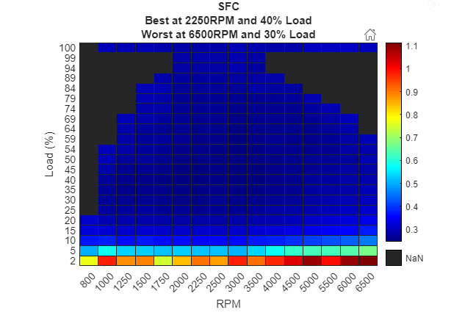
- Figure 1 shows how the fuel consumption is affected when the load is increased, and the engine speed rises. The heat map shows, the load applied to the engine along with RPM. Specific fuel consumption is shown on the right-hand side of the graph, it ranges from 0.3-1.1 lbs of measured fuel burned per hour. It is presented that the best fuel consumption is at 2250 RPM and 40% Load and the worst fuel consumption is at 6500 RPM and 30% Load. Specific fuel consumption increases with load because the flow rate of the fuel increases to meet the higher intake of air.
Figure 1: SFC heat map

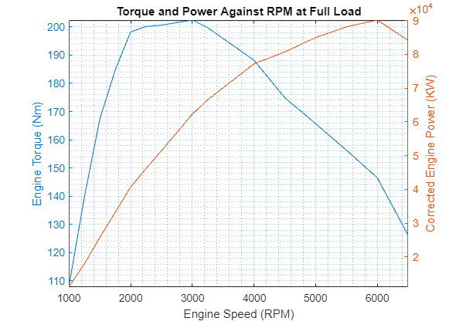
Secondly is the Torque and power against engine speed at full load.
Figure 2: Torque and Power against RPM at full load
The graph in figure 2 was produced by calculating the engine torque (Nm) and engine power (KW). The graph shows that the torque is produced much more rapidly than the power at full load with max torque being produced at 3000 RPM and then dropping in a linear fashion until the test comes to an end whereas the power increases at a slower rate and only reaches max at 6000 RPM and then begins to drop just before the end of the test at 6500 RPM. The torque decreases with engine speed due to the volumetric efficiency being surpassed, as the speed of the piston is too high for the fuel to burn completely. (Don Sherman, 2016)

The next set of data to be discussed is thermal efficiency and BMEP at full load.
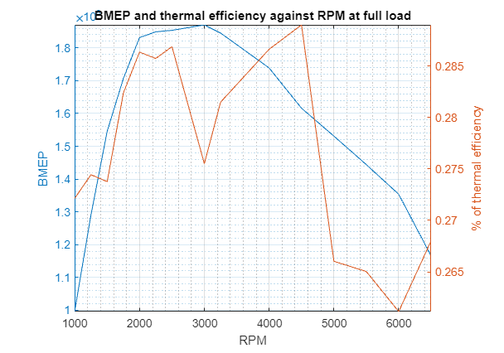
The brake mean effective pressure is based on the engine bore, stroke and number of cylinders and is measured against the speed of the engine. The brake mean effective pressure is a way of calculating torque per litre.(Brian Silvestro, 2020)
Figure 3: BMEP and thermal efficiency against RPM at full load
The thermal efficiency is the percentage of heat energy that is transformed into work. The brake mean effective pressure rapidly increased up to 2000 RPM, remains steady until 3000 RPM and then begins to drop. An interesting note is that the thermal efficiency increases with a positive correlation with the BMEP up until 2000 RPM where it drops by 3000 RPM, increases again and drops rapidly by 5000 RPM. It can be noted that the efficiency of the torque goes up and decreases in a linear fashion, however the thermal efficiency seems to have a sporadic fashion.

Lastly, the 3D graph of the cylinder pressure across all RPM and crank angles is also to be discussed.
Figure 4: Pressure v RPM & Crank Angle
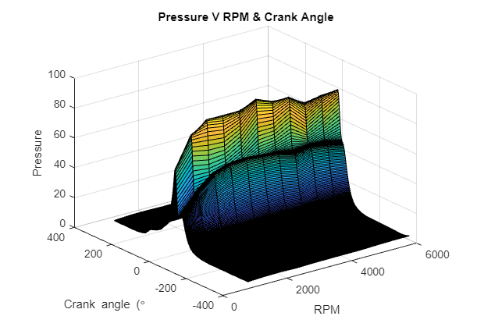
Figure 4 shows the differences of values found in the different engine operating strokes.
Throughout the compression and the combustion strokes, the cylinder pressure remains within the region of 60 – 80 Pa as the RPM’s rise to 6000. However, during the intake stroke is where the pressure begins to build up to around 20 Pa and is depressurised during the exhaust stroke. (Britannica, n.d.)

Conclusion
To conclude, data was collected from a D16 1.6 VTEC Honda engine. After running the collected data through MATLAB and using formula for calculations, it is found that the load applied to the engine along with RPM enabled to give the values of the best and worst fuel consumptions, provided information on max torque and power at full load and made it clearer to see why the torque decreased with engine speed. Showed the correlation between the BMEP and thermal efficiency in the engine and provided data of the cylinder pressure within each stroke of the engine at certain RPM.

References
Brian Silvestro. (2020). Here’s Why the Mustang’s 5.0-Liter V-8 Is More Impressive Than Ferrari’s V-12. Roadandtrack.Com.
Britannica. (n.d.). Four stroke cycle . Engineering.
Don Sherman. (2016). Horsepower vs. Torque: What’s the difference? Car and Driver .
Shraddha Vinod Khadilka, Haripriya H Kulkarni, & Vritika Gupta. (2021). Engine Testing In Dyno Close Loop Simulation Environment. Turkish Journal of Computer and Mathematics Education, 2021-01-01, Vol.12 (12), p.3507-3515.
UWTSD WISA Workshops. (2020). Engine Dynamometer Overview .

