

Mental Disorders and Psychopathology BMHP6006 – LON
Assessment 1 - Supporting Paper
Student name: Tea shchepanovich
student id: 2026173
Lecturer: Bianca Sanfilippo

Table of Contents
Presentation Slides 2
Definition of the selected mental disorder 6
Classification within the ICD – 10 6
Prevalence of ocd disorder 6
Causes of Ocd 6
Symptoms of ocd 6
Diagnosis of ocd 6
Historical overview and treatments 6
Current available treatments in the UK 6
Issues in provision, professional support or policy about the selected mental health issue 6
Principles of care when working with people with ocd (NICE) 6
Conclusion and Recommendations 6
Useful organisations/websites: 6

Presentation Slides

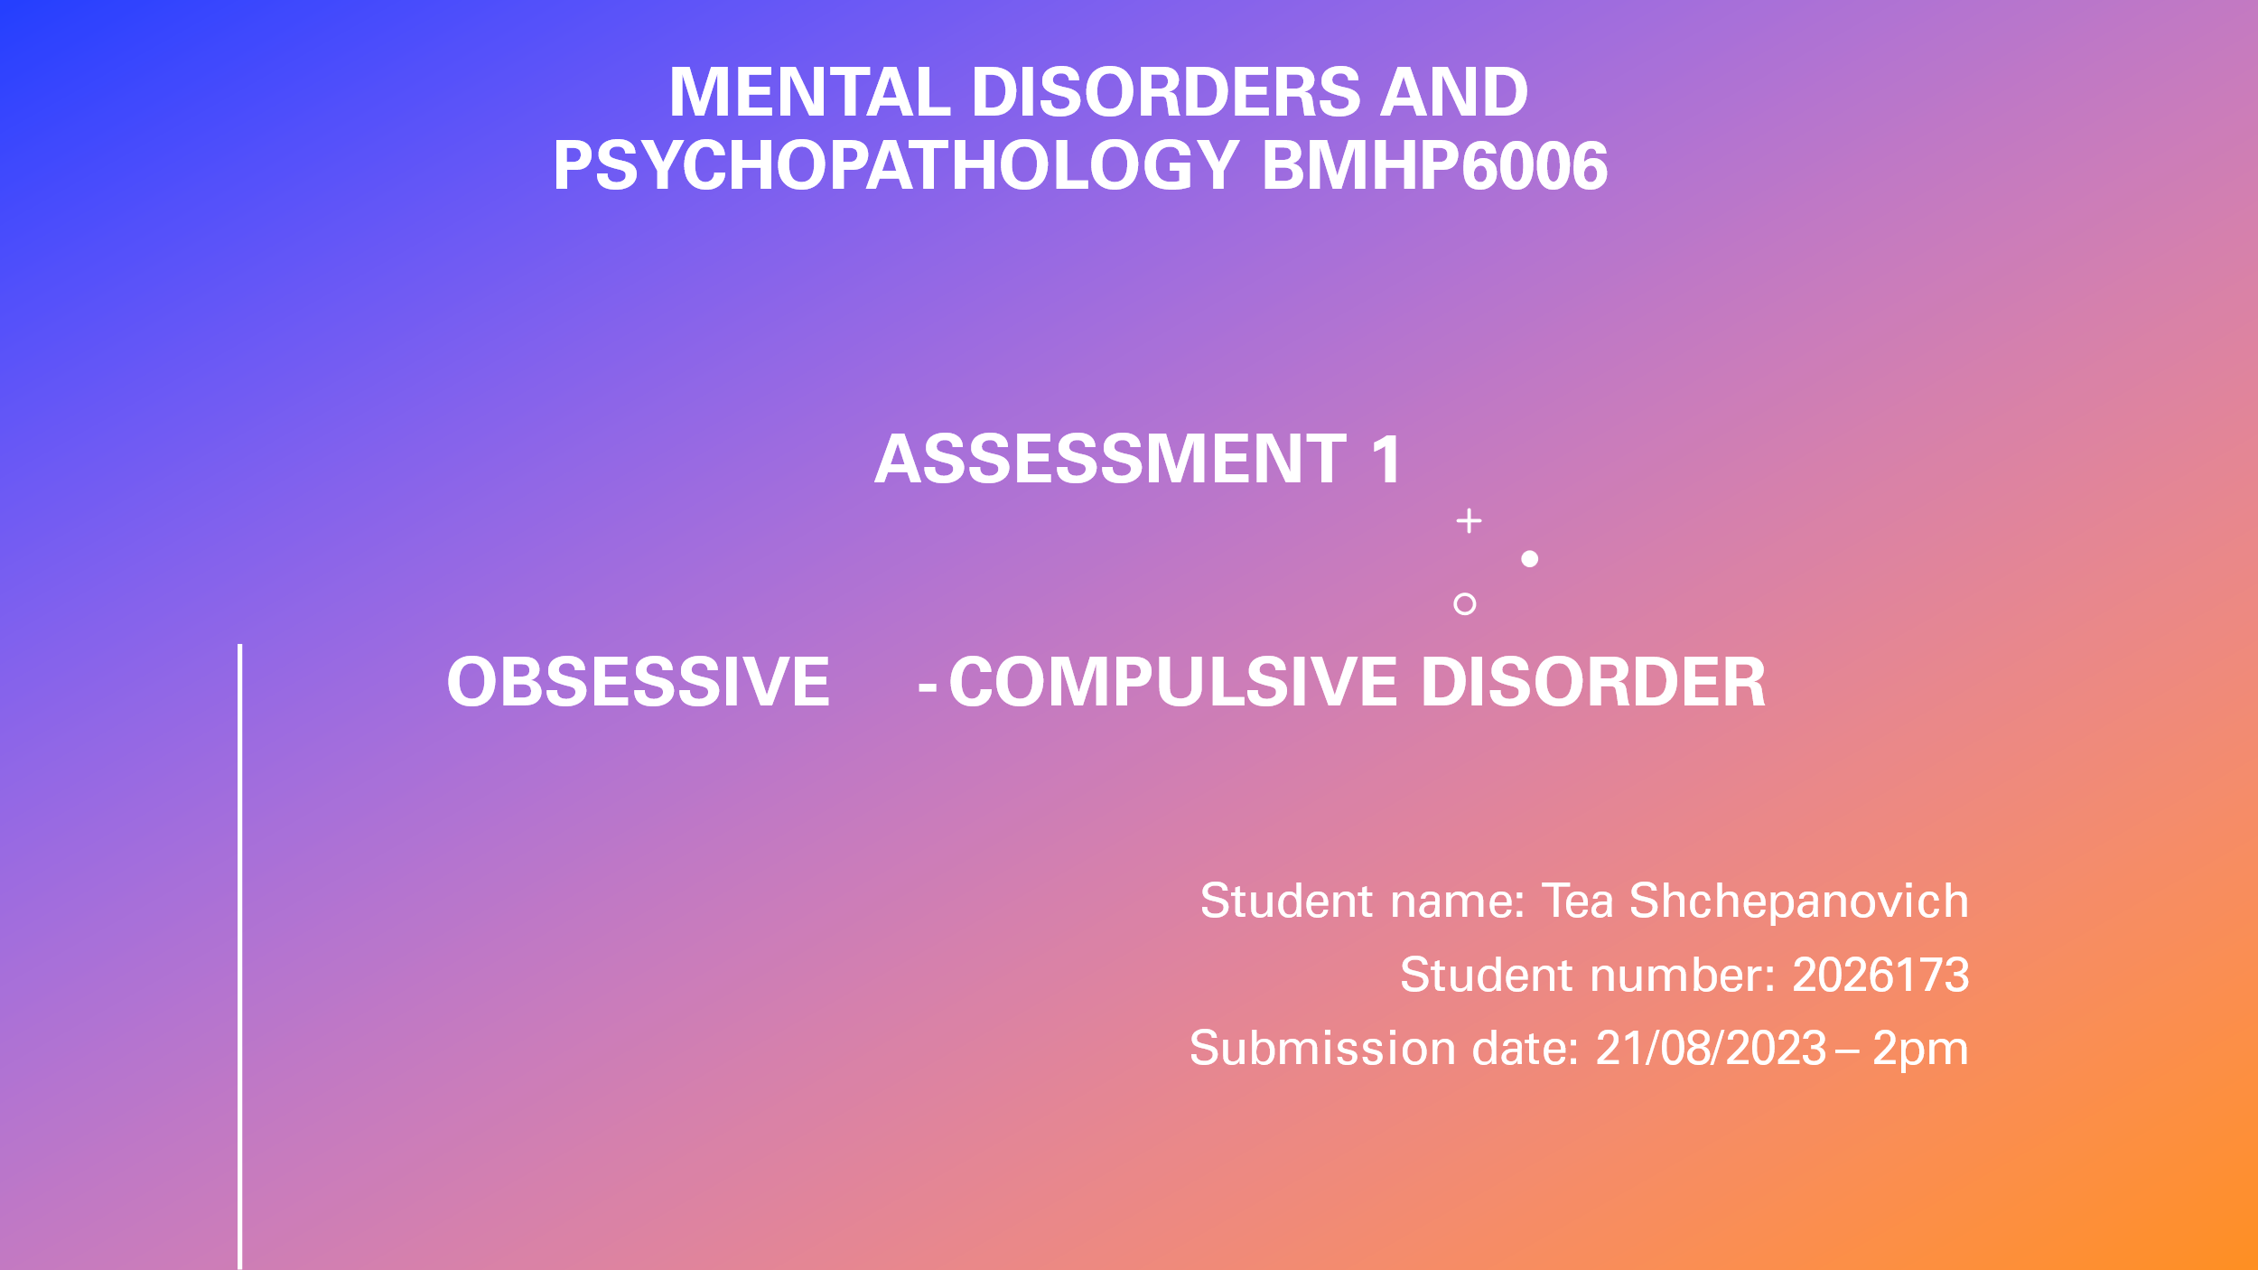

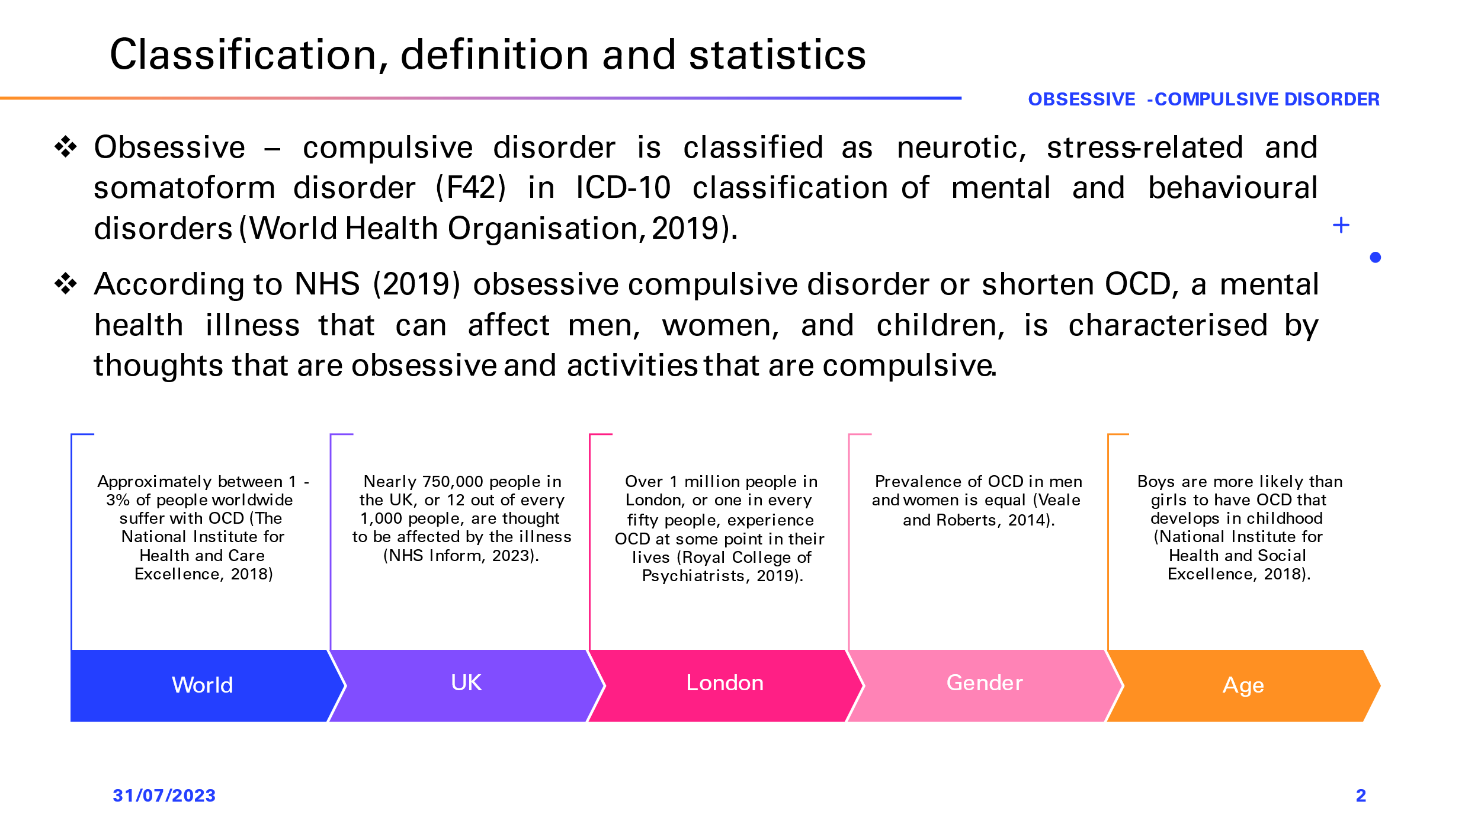
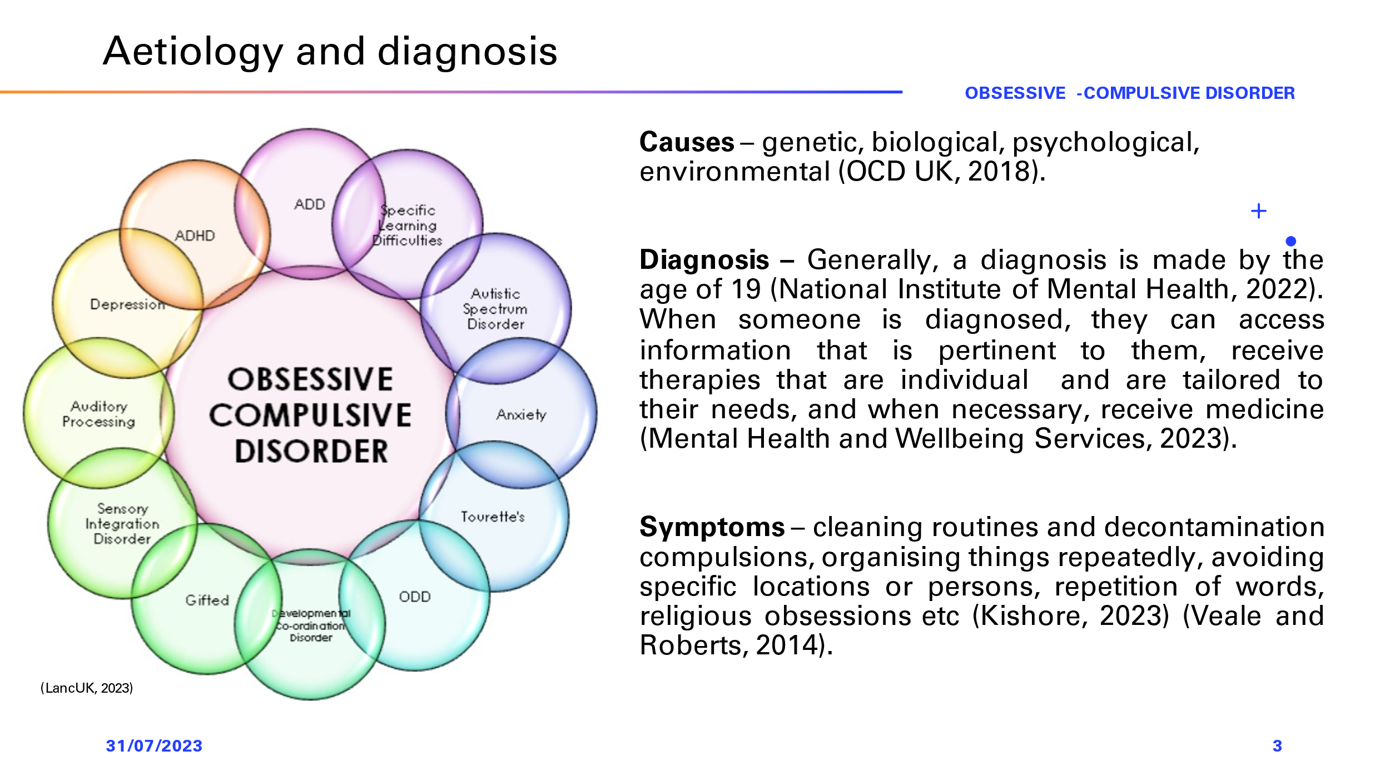

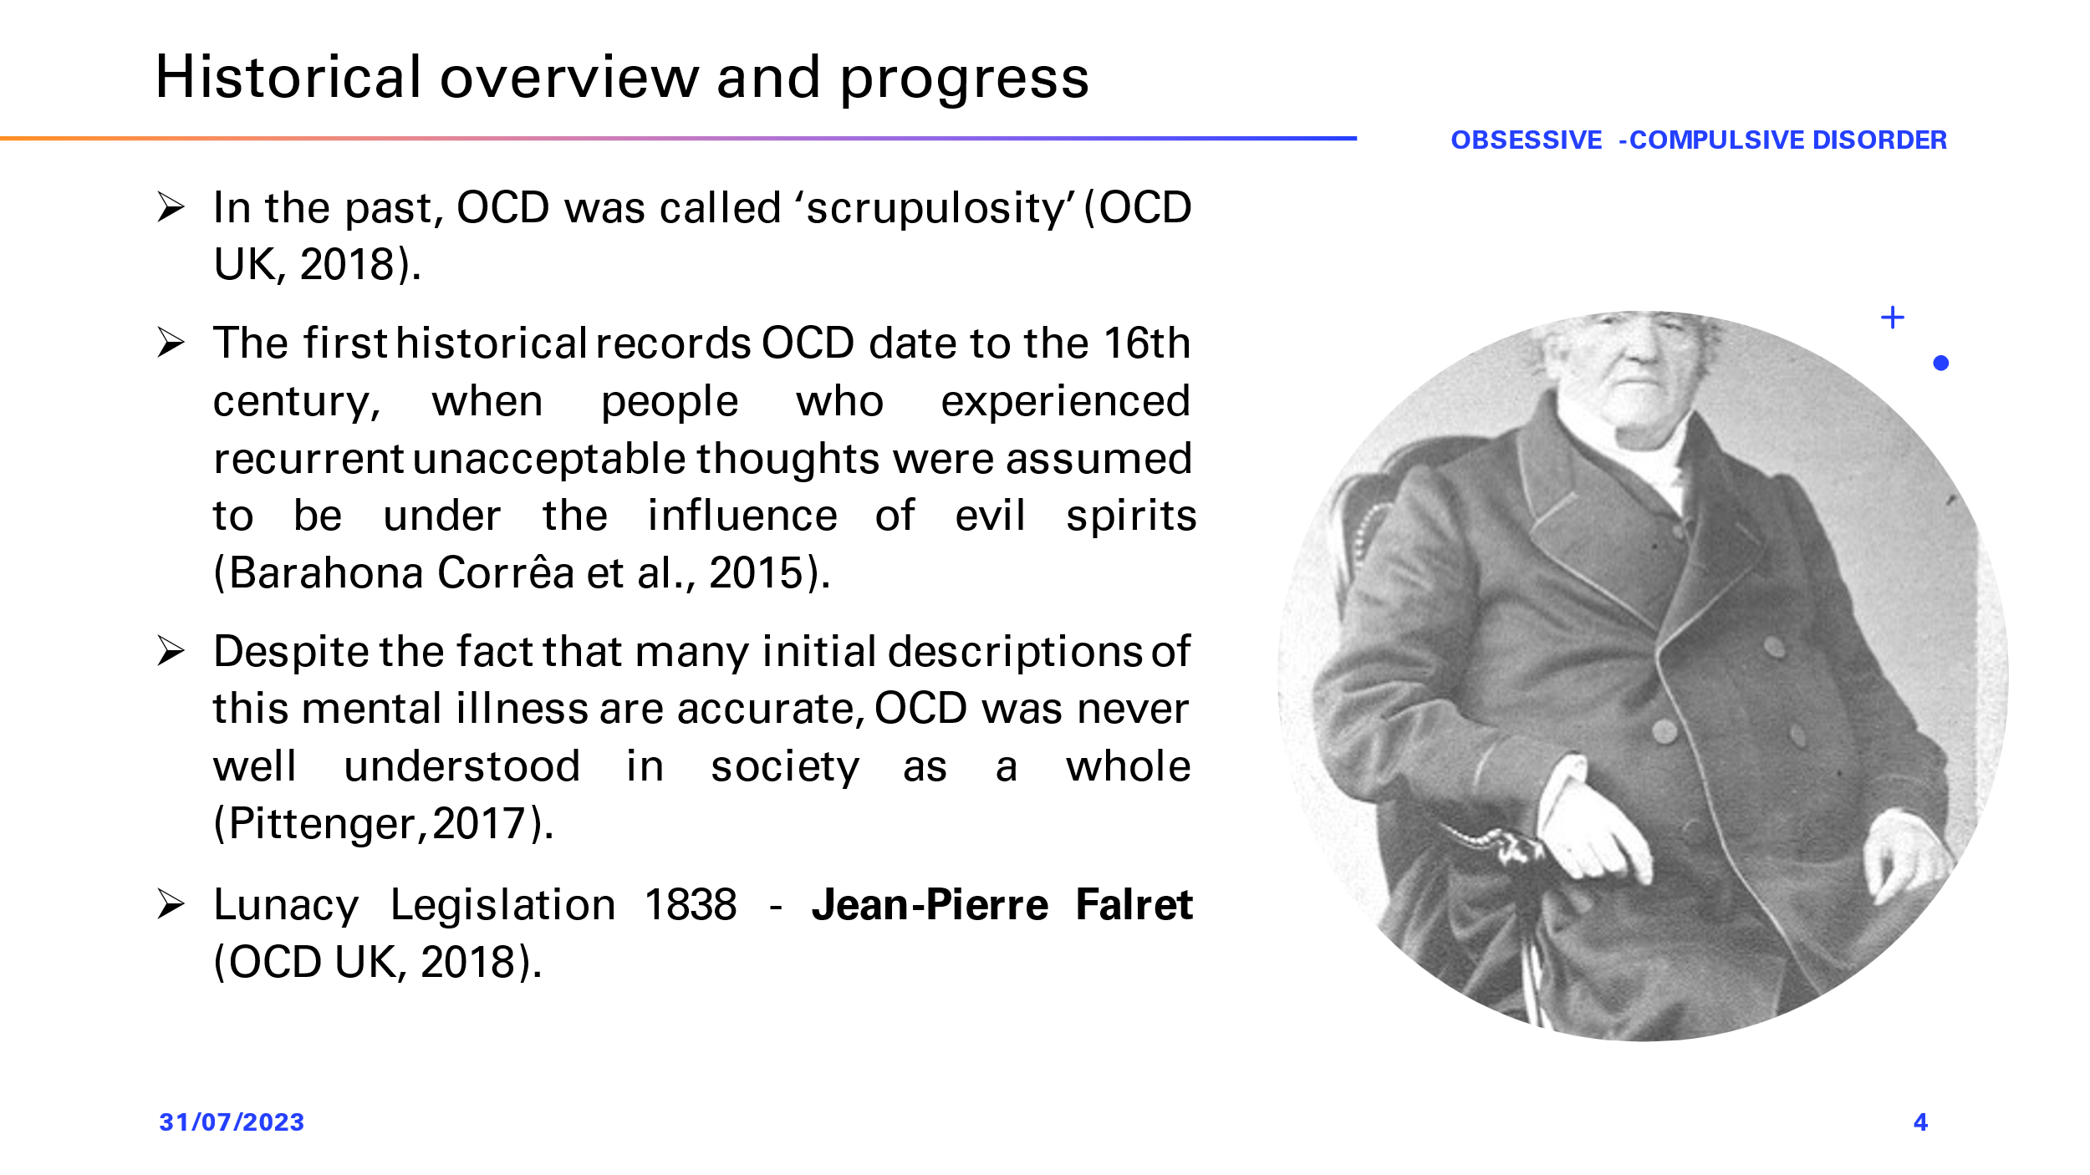
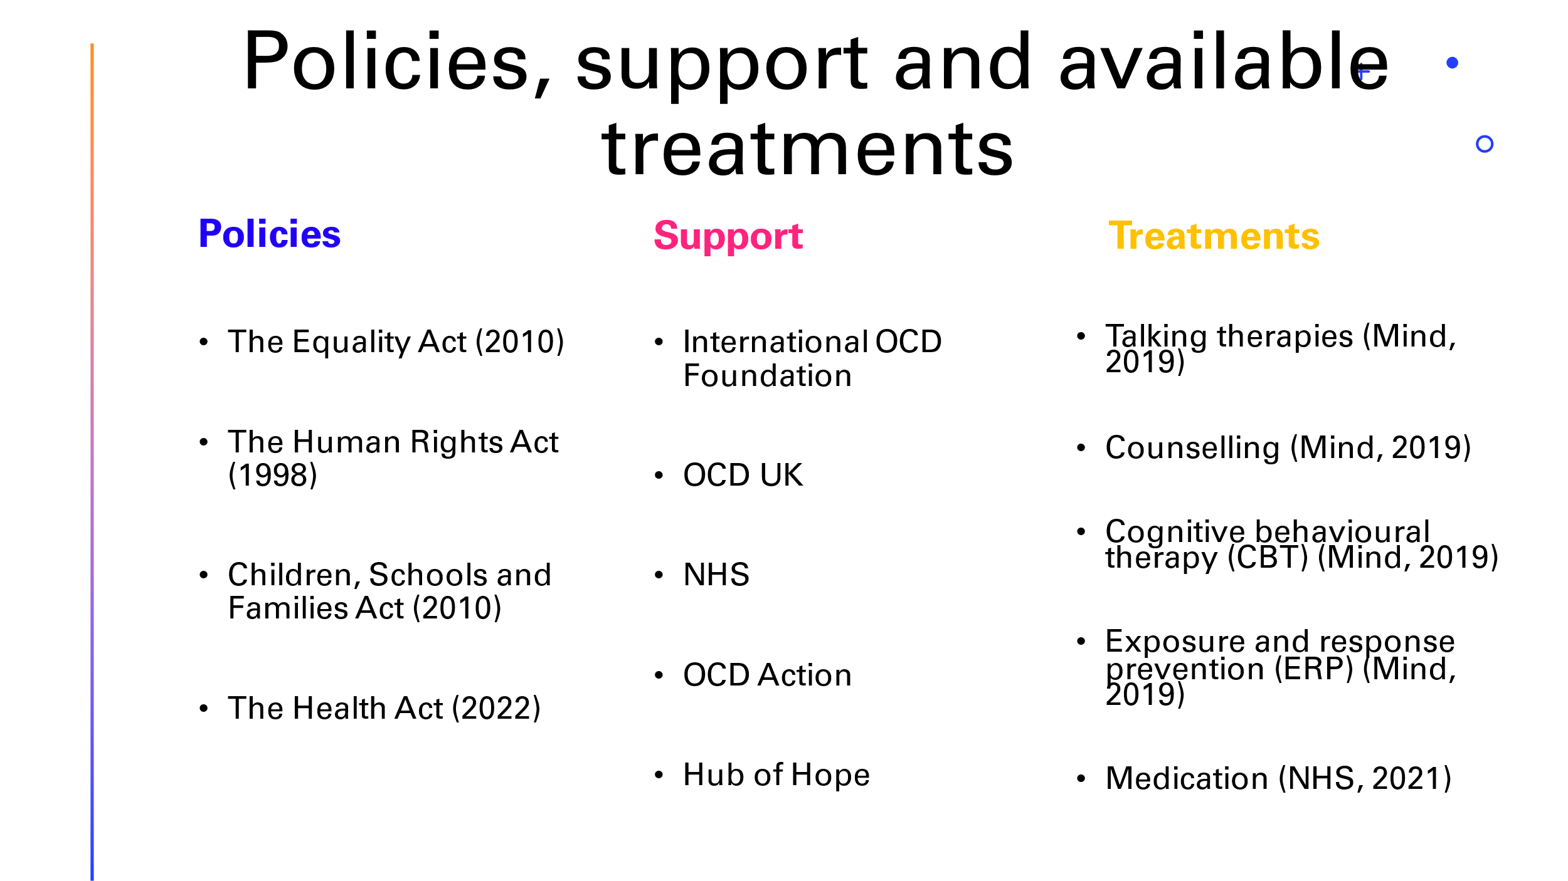


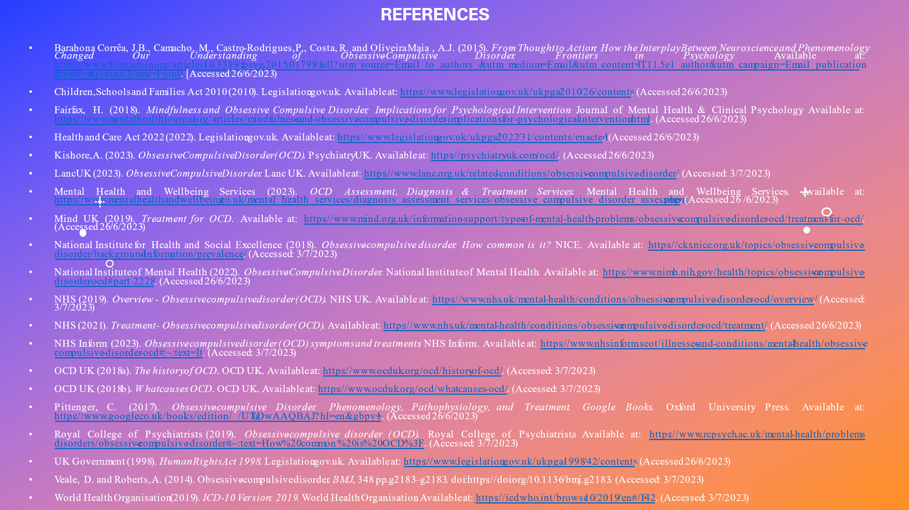



Definition of the selected mental disorder

Classification within the ICD – 10

Prevalence of ocd disorder

Causes of Ocd

Symptoms of ocd

Diagnosis of ocd

Historical overview and treatments

Current available treatments in the UK
Analyse the positives and negatives of treatments available for this mental health disorder

Issues in provision, professional support or policy about the selected mental health issue

Principles of care when working with people with ocd (NICE)

Conclusion and Recommendations

Useful organisations/websites:

