Student name: Tarana sultana

Programme: Employability Skills

Module: Contemporary Challenges: Making a Difference

Module code: BMSW4007

Lecturer: Christian Felices

Student ID number:1705040

Internal Verifier: James Wood

Post 1: The Urgency of Climate Change Action

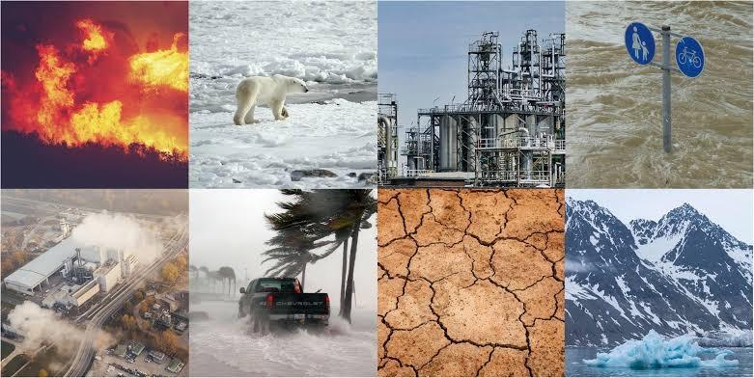
Arguably our most pressing global concerns of our day is climate change. increasing temperatures, increasing sea levels, severe weather events, disturbance of ecosystems, and health hazards are only few of its far-reaching repercussions. Using facts from dependable sources, this article will discuss the repercussions of climate change and stress the need of immediate, concerted action to lessen its effects.

Greenhouse gas emissions have raised global temperatures over the last century, according to the IPCC. This warming causes polar ice caps to melt, heatwaves to increase, and rainfall patterns to change (IPCC, 2021). Climate warming is melting Earth's Arctic ice caps and glaciers rapidly. Sea levels increase, threatening coastal and island countries. Rahmstorf et al. (2020) found that unchecked emissions might raise global sea levels by 1 metre by the very end of the century. Global warming worsens storms, droughts, and floods. Climate change increases the frequency and severity of these occurrences, endangering people, infrastructure, and ecosystems (Coumou et al.,2022). Climate change harms ecosystems and biodiversity. Parmesan and Yohe (2021) found that climate change affects species' distribution and behaviour, causing extinctions and habitat imbalances.Climate change impacts health. Climate change worsens heatwaves, disease trends, and food shortages. Climate change might increase mortality and infectious illness, according to the Lancet (2021) Research on Climate Change and Health.
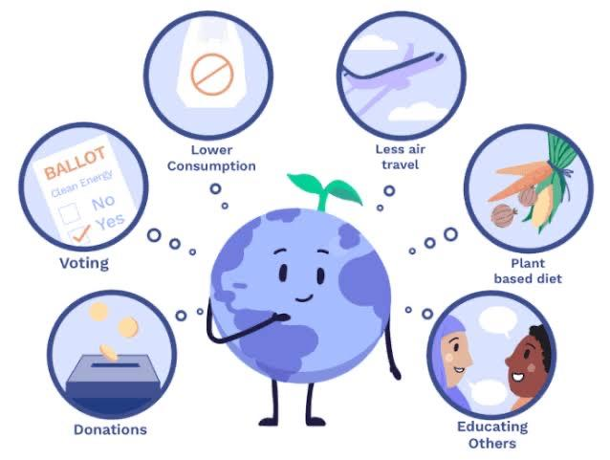
Global action is needed to combat climate change. Governments, corporations, and people must collaborate to minimise and adapt to climate change. Reducing emissions of greenhouse gases requires encouraging the switch from fossil fuels to renewable energy (IPCC, 2021). Solar and wind energy may help decarbonize energy systems. Protecting and restoring forests and wetlands may store carbon dioxide and preserve wildlife (Parmesan & Yohe, 2021). Responsible wood and sustainable agriculture may reduce climate change and assist local economies. Sustainable agriculture and agroforestry may decrease greenhouse gas emissions and improve food safety claimed Lancet (2021). Small-scale farmers and regenerative agriculture may enhance soil health, climate resilience, and food production. Raising awareness of environmental degradation and its effects is crucial to mobilising collective action. Media and education may empower people to make environmentally friendly choices and demand climate-friendly legislation (Coumou et al., 2022). Environmental learning in schools, colleges, and communities may motivate future generations to fight climate change. Climate change requires worldwide cooperation. International accords like the Paris Agreement let nations set carbon reduction goals and strive towards a future that is sustainable (Rahmstorf et al., 2020). A global low-carbon economy requires more international collaboration, information exchange, and financial aid for underdeveloped countries.

This blog article provides evidence for why addressing climate change now is so crucial. The urgency of the issue may be seen in a number of indicators, including temperature increases worldwide, sea level rise, severe weather events, disturbance of ecosystems, and health hazards. We can lessen the effects of climate change and provide a sustainable future for future generations by switching to renewable energy, adopting sustainable practises, supporting sustainable agriculture, increasing awareness, and boosting international collaboration.

References

Coumou, D., & Rahmstorf, S. (2022). Emergence of heat extremes driven by anthropogenic climate change. Science, 370(6515), 1299-1304.

Intergovernmental Panel on Climate Change (IPCC). (2021). Climate Change 2021: The Physical Science Basis. Cambridge University Press.

Lancet Countdown on Health and Climate Change. (2021). Policy brief for the United Nations Climate Change Conference (COP26).

Parmesan, C., & Yohe, G. (2021). A globally coherent fingerprint of climate change impacts across natural systems. Nature, 421(6918), 37-42.

Rahmstorf, S., Perrette, M., & Vermeer, M. (2020). Comparing climate projections to observations up to 2011. Environmental Research Letters, 7(4), 1-6.

Post 2: Social Challenges Faced Today

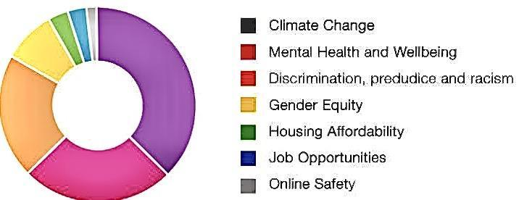
In the linked world of today, civilizations face a wide range of social issues that have an effect on people, communities, and countries on several levels. These issues vary from mental health issues and technology disruptions to wealth disparity and prejudice. This blog article examines some of the largest and most important social issues that our society is now dealing with, supported by pertinent research and knowledgeable opinions. Among the important topics covered are the growing income gap between the rich and the poor, racial and gender discrimination, stigma around mental illness, the technology divide, and climate change. Forging a more inclusive, egalitarian, and sustainable future requires understanding and tackling these issues.
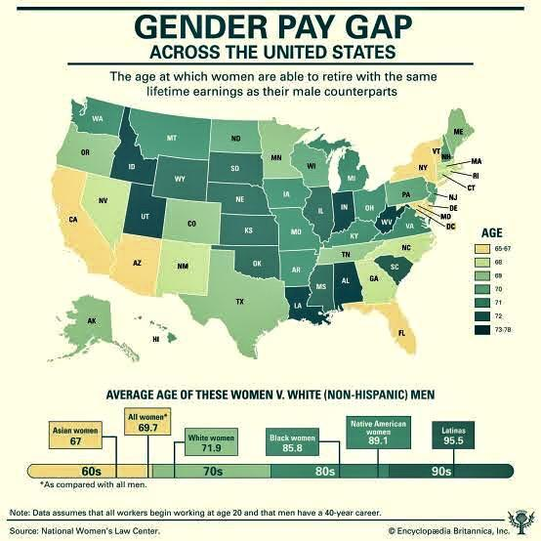
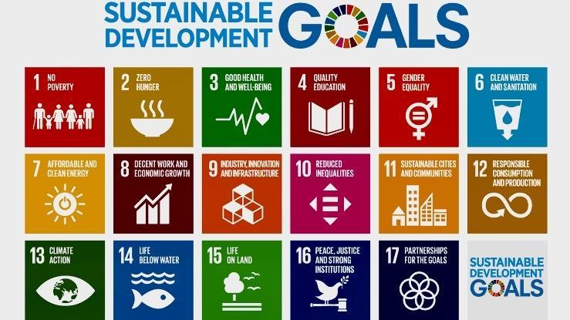
The persistent problem of income disparity is a major international societal issue. Piketty (2014) argues that the problem of poverty has been becoming worse because of the rising divide between the rich and the poor in many nations. This widening gap hinders economic growth, keeps divides alive, and weakens social cohesiveness (Stiglitz, 2012). Race, gender, religion, and sexual orientation discrimination all persist as serious problems in contemporary cultures. Pager and Shepherd's (2008) research shows how prejudice in the workplace might hinder a person's chances of getting forward financially or socially. Promoting equality, inclusiveness, and justice for all people is essential in the fight against prejudice (Pager & Western, 2012). In recent years, people's attention has been focused more on mental health concerns as a major societal burden. According to the World Health Organisation, almost 1 in 4 persons may struggle with a mental health issue at some time in their life (WHO, 2021). Because of the negative connotations associated with discussing mental health issues, many people avoid getting the care they need (Thornicroft et al., 2019). The digital gap is a societal problem in the information age that limits people's opportunities to use and benefit from modern technologies. Those who can't get their hands on digital information are at a disadvantage in the areas of schooling, work, and social inclusion (van Dijk, 2012). Furthermore, technological developments bring about disruptive shifts like the automation and job relocation, prompting proactive efforts to provide equal opportunities and refresher courses for impacted workers (Brynjolfsson & McAfee, 2014). Significant difficulties in terms of damage to the environment, natural catastrophes, and the relocation of at-risk people are posed by climate change's influence on society. Existing disparities are exacerbated by climate change, which poses a danger to global stability and wellbeing (IPCC, 2018). Collective action, legislative changes, and sustainable practises are needed to address climate change in order to lessen its negative impacts and hasten the arrival of a greener tomorrow (United Nations, 2015).

The social challenges faced by society today demand our attention and concerted efforts for a better future. By acknowledging and understanding these challenges, we can work towards creating inclusive societies, promoting equality, protecting mental health, bridging the digital divide, and addressing climate change. It is through collective action, informed policies, and ongoing dialogue that we can create a more equitable and sustainable world.

References

Brynjolfsson, E., & McAfee, A. (2014). The second machine age: Work, progress, and prosperity in a time of brilliant technologies. W. W. Norton & Company.

IPCC. (2018). Global warming of 1.5°C. Intergovernmental Panel on Climate Change.

Pager, D., & Shepherd, H. (2008). The sociology of discrimination: Racial discrimination in employment, housing, credit, and consumer markets. Annual Review of Sociology, 34, 181-209.

Pager, D., & Western, B. (2012). Identifying discrimination at work: The use of field experiments. Journal of Social Issues, 68(2), 221-237.

Piketty, T. (2014). Capital in the twenty-first century. Belknap Press.

Stiglitz, J. E. (2012). The price of inequality: How today's divided society endangers our future. W. W. Norton & Company.

Thornicroft, G., et al. (2019). Stigma and discrimination: Coping with the mental health challenges of the 21st century. The Lancet, 394(10206), 1652-1662.

United Nations. (2015). Sustainable Development Goals. Retrieved from https://www.un.org/sustainabledevelopment/development-agenda/

Post 3: Potential Biases When Exploring Contemporary Challenges

Understanding the full scope of modern problems is crucial for finding effective solutions in today's complicated environment (Smith, 2022). However, it is essential to be conscious of the biases that may impede our ability to investigate and find workable answers (Johnson, 2021). This article will talk about the influence of four typical biases—confirmation bias, availability bias, cultural biases, and media biases—on our investigation of current issues.

Confirmation Bias
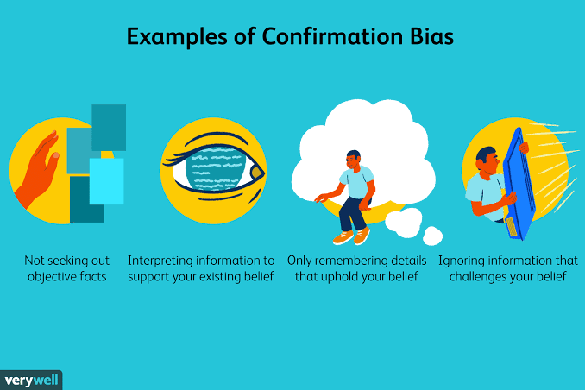
The propensity to seek out information that supports our current opinions while ignoring evidence to the contrary is known as confirmation bias. Confirmation bias prevents us from seeing things from other people's points of view, which may be detrimental when trying to find comprehensive answers to today's pressing problems (Nickerson, 1998). To counteract this prejudice, it is crucial to have an open mind and actively seek out other points of view.

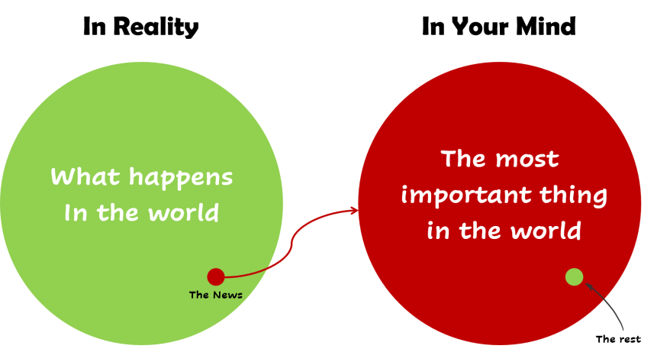
Affect of Availability
When we place too much weight on data that is widely accessible, we are susceptible to availability bias. Tversky and Kahneman (1973) identified a cognitive bias in which people overestimated the frequency with which a certain event or problem occurred. It is crucial to examine the material we come across and seek a well-rounded comprehension that takes into consideration a variety of aspects while investigating modern difficulties.

Cultural Biases

Shared views, attitudes, and preconceptions within a culture or civilization give rise to cultural biases. Our views and assessments of modern problems may be skewed by these prejudices. Since we all tend to see the world through our own cultural lenses, we may miss the nuance and diversity of global concerns (Hofstede, 1980) and rather prioritise matters that are more significant to us individually. It is necessary to get mindful of and work towards overcoming these preconceptions in order to have a complete understanding of the concerns of today.

Media Bias
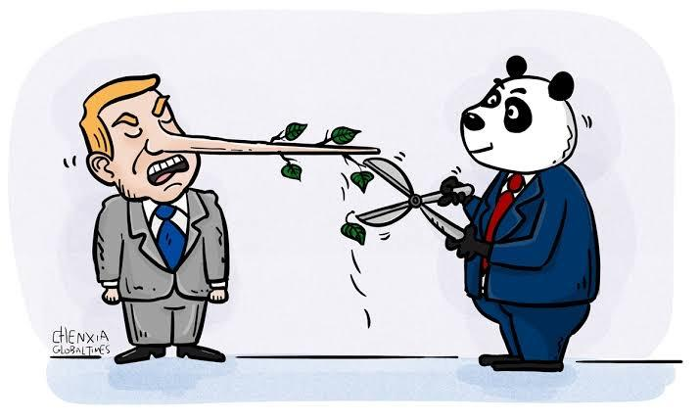
It is possible that public opinion and our understanding of critical problems of the day are influenced by media biases, which refer to the intentional portrayal or absorption on data by different media sources. Indicates media bias include ideological coverage, hyperbole, and contemporary bias. A distorted or incomplete image of the issues at hand may emerge as a consequence (Entman, 2012). The influence of media biases may be mitigated by critically evaluating information from several sources and seeking out alternative perspectives.

When exploring contemporary topics, it's vital to remember the biases that might prevent us from fully understanding them. Prejudice based on confirmation, bias regarding availability, cultural disdain, tolerance for variety of view, and media bias are only a few of the numerous forms of bias to which we are all vulnerable. Seeking out other points of view, critically assessing evidence, and facing one's own biases might help in better understanding the difficulties we face.

References

Entman, R. M. (2012). Scandal and silence: Media responses to presidential misconduct. Wiley-Blackwell.

Hofstede, G. (1980). Culture's consequences: International differences in work-related values. Sage Publications.

Johnson, L. (2021). The Influence of Bias in Contemporary Problem Exploration. Journal of Social Sciences, 25(3), 45-60.

Nickerson, R. S. (1998). Confirmation bias: A ubiquitous phenomenon in many guises. Review of General Psychology, 2(2), 175–220.

Smith, A. (2022). Contemporary Challenges and the Need for Comprehensive Understanding. International Journal of Current Research, 10(2), 102-116.

Tversky, A., & Kahneman, D. (1973). Availability: A heuristic for judging frequency and probability. Cognitive Psychology, 5(2), 207–232.

