Trinity Saint David University of Wales
Usability Engineering 2 (ACCA6017)

Author: | Tutor:
Chris Hampton | Prof. Nik Whitehead
2116517@student.uwstd.ac.uk | nicola.whitehead@uwtsd.ac.uk

10/01/2025

Contents
Table of Figures 2
1. Introduction 3
2. Storyboard Prototype 3
3. Prototype Feedback 6
4. Data Collection 7
5. Design Analysis 7
Conclusion 9
References 9
Appendices 10
Game Menus 10
Game Play 12
Feedback Survey 14
Feedback Survey Answers 16

Table of Figures
Figure 1 - Main screen 3
Figure 2 - Enter name 3
Figure 3 - Brightness and Volume Toggle 4
Figure 4 - Updated Features 4
Figure 5 - Game play buttons 5
Figure 6 - Player Score 5
Figure 7 - Game scorecard 5
Figure 8 - Zombie Deadline 5
Figure 9 - Zombie Winner 6
Figure 10 – Code 8
Figure 11 - Input Code 8
Figure 12 - Zombie image 9
Figure 13 - Background 9

Introduction
This report focuses on transforming wireframes into full-colour storyboards for a UWTSD-themed Zombie Dice game. A comprehensive overview of usability, feedback and enhancing user experience is discussed considering the design evolution and testing to ensure a robust and user-friendly interface, whilst evaluating future developments and improvements.
A feedback collection process will also be undertaken to elicit positive and negative feedback for the storyboards to gain an understanding of how real-life users will navigate the interface and the emotional feedback that is achieved from the game.
To improve future iterations and a discussion on the types of data would be collection if a working version of the game were to be built and released. Explorations of how this data can be used to influence further development will be included.

Storyboard Prototype
The storyboards have been developed into a full-colour prototype derived from the wireframes shown in Appendices – Game Menus, Game Play. To ensure the user enjoys a high level of usability and user experience, certain features have been implemented to make the game a success.
The initial main screen gives the user a simple and easy to follow screen. As shown below, the user can enter their name and press play or toggle through the menus using the menu icon in the top right of the screen.
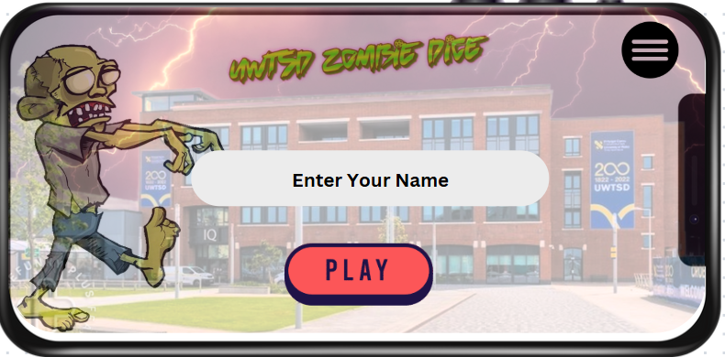
Figure 1 - Main screen
To ensure the player inputs their name, validation on the name box will be undertaken. If the player decides to hit play without inputting a name, the name placeholder will ‘shake’ and highlight the text in red to ensure the user knows what step is needed to take.

Figure 2 - Enter name
Within each screen the user will have the option to return to the previous screen  or go into the ‘Settings’ menu .
The ‘Settings’ menu allows the user to toggle the brightness/contrast of the screen to suit their needs using a slider for easier usability.

Figure 3 - Brightness and Volume Toggle
The volume control can also be toggled in the same way as the brightness. For a fully developed working interface certain sounds and background music will be used to elicit reactions from the user. Collins explores the role of sound and music in video games. She delves into how sound and music enhance the gaming experience, create emotional responses, and contribute to the overall immersion of the player [1].
Some features have changed from the wireframes to the storyboards. For example, the wireframe for the ‘Enter Code’ screen had the option to play individually – this has been omitted from the full-colour storyboard.
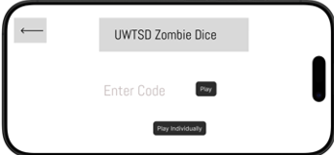

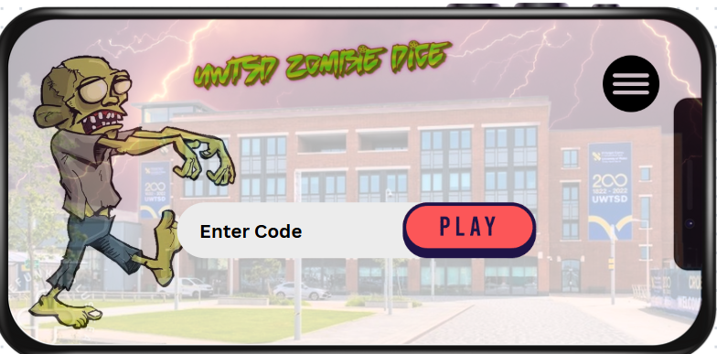
Figure 4 - Updated Features
The rationale behind this was to encourage group play within the university setting. Campbell et. al. suggests that friendship within education is more complex than some theories suggest but balancing academic approaches can be improved with socially cooperative relationships [2]. For many students, attending university can be a challenging time to begin with. By utilising a non-educational UWTSD-themed game can encourage relationships and peer groups for students.
The premise of the game is to roll 13 ‘Passes’ before the other players without getting 3 ‘Deadlines’. Each player rolls three dice and evaluates their next turn based on the outputs. To continue with the theme each dice face contains a different symbol representing the game play.
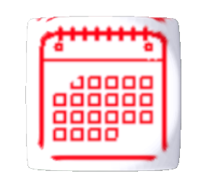 | 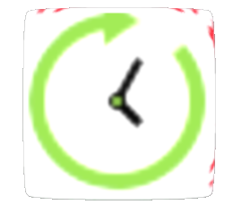 | 
The calendar Icon represents a ‘Deadline’ | The ‘Extra Time’ icon represents to the player that they can roll another dice. | The ‘Pass’ icon represents a score for the player.

The example of the game play, referred to in Appendices – Game Play, shows a turn of a player.

Figure 5 - Game play buttons
The player is given three buttons to play the game. The green ‘Roll Again’ is used to indicate that the player intends to roll the dice. The red ‘End Turn’ button indicates that the player no longer wishes to continue their turn and move on to the next player. The idea for the red and green colours was to represent a Stop/Go traffic light feel to the game. Yamin recommends that least effective button colour is blue when used with a moving background, and that orange is the most effective [3]. Although, orange buttons haven’t been used within the storyboard, neither has blue, thus reducing the likelihood of having ineffective buttons.
For effective game play – a current score is displayed for each player on the right side of the screen.
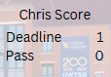
Figure 6 - Player Score
By having this update on the players go will allow the player to monitor their ‘risk’ to continue or stop.
On the left side of the screen, is a drop-down score card of all the players within the game. By having the game scores as a drop-down reduces the amount on screen ‘real estate’ that is taken up by this extra data. By having a game scorecard can create some strategy into the game whereby a player might want to continue or stop depending on other players scores.
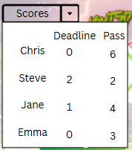
Figure 7 - Game scorecard
Once a player has hit three deadlines, they are out of the game. To increase the emotional response from the player a visual of a zombie will let the player know that they have hit three deadlines.
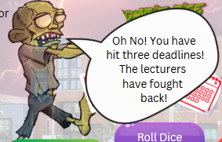
Figure 8 - Zombie Deadline
However, if a player was to win and hit 13 passes the Zombie character will let the user know.
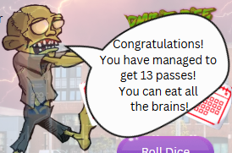
Figure 9 - Zombie Winner
The slight changes from the feedback from the wireframes and full-colour storyboards utilising a UWTSD theme can encourage players to return to playing the game. The ease at which a game can be played using a joining code can allow players to play with different groups of people quickly and intuitively.

Prototype Feedback
The gain appropriate feedback from the full-colour storyboards – a short survey was introduced to gain some qualitative and quantitative feedback on usability and experience. This is used to identify areas for improvement and clarification on certain aspects of the game.
The survey, as shown in Appendices – Feedback Survey, asks 10 questions – five around usability and five regarding user experience. The survey was sent to a varied range of potential users asking to review the storyboards and given a brief description of what the game entails and general overview of the interface.
From the responses, six in total, the potential users aligned to some aspects of the personas created and discussed in the previous assignment. For example, there were some responses who were part-time and full-time students who game for various durations, and non-students who perhaps don’t game that often. By having the varied user demographic can ensure that the feedback is reliable and mixed instead of targeting a demographic that may yield the same results.
The results from Appendices – Feedback Survey Answers show a varied distribution of answers. Although the feedback was generally positive for the usability questions, there was some negatives for intuition and understanding the game. The positives from some users around navigation and how easy it would be to initiate the game play shows how the general idea of the game is to start quickly and be able to join a game with few inputs.
From a user experience point of view, there was a high positivity for the theme and how it was on brand for the UWTSD-Theme. The consensus was that sound and haptics would enhance the experience for the user, but also to be able to control the sounds within the game would be beneficial.
To understand the user needs for the interface further feedback can be performed. Not only through surveys but through observation. A usability test where a user is observed to conduct certain actions can be implemented. The results of these tests can then be used to understand the constraints faced by the potential users.
To use the data collected from the feedback, these need to be turned into actionable insights. By capturing and categorising the feedback into usability, design, and emotional response can help identify common themes and adjust based on the responses. By using method such as MoSCoW analysis to prioritise the issues raised to create meaningful actions plan to address and usability and user experience issues.

Data Collection
Data collection is a useful process for any user interaction interface. This will allow for continuous improvement to ensure success for the application. Both usability and user experience can be collecting depending on what processes have been implemented. Generally, the data gathered and analysed from a usability perspective can derive assumptions of user experience.
Some data that can be collected include frequency and duration of a user’s sessions. By understanding when and how long a user interacts with the interface can provide insights into the user’s behaviour. This data can be captured automatically with timestamps. This will allow the developers to understand the peak times in which the game is played.
By collecting user actions, the data can highlight certain choices of the player. In the instance of UWTSD-Themed Zombie Dice, it can be understood the decisions made by the player, such a continue or stop when rolling the dice. This will show how risk adverse the players are to the game.
Implementing such features as achievements earned and highest scores etc. can evaluate the game’s learning curve and difficulty based on how quickly progress is achieved.
Collecting navigation data can also help the developer to understand the way in which a player navigates the interface. This will show the user’s behaviour but also any difficulties when navigating the game.
Most of these can be achieved through automatic analytic tools. It is important to ensure that the data is anonymised to protect the privacy of the users.
Wood et. al. [4] recommends certain methods to extract user behaviour and emotional response from a video game. This can be achieved through interactions in the interface to gather the user’s satisfaction level. By having a periodic pop up that is easy to fill out with a click of a button allows valuable information to be collected but minimise any intrusive actions for the players. This data can be collected straight from the interface.
Another way to capture emotional responses could be through focus-groups and interviews. Although this may not gather as many responses the data can be of more value and can capture more pertinent points that the game developers want to understand.
Automatic and direct data collection both have advantages and limitations but combining both methods will allow the developer to gain a comprehensive understanding of what the user experiences when interacting with the interface to achieve a more user-friendly game. With automatic data collection, this data can be collected in a greater quantity and provide objective data analysis to how the interface performs. Whereas direct data collection will provide a more emotive viewpoint of the application.

Design Analysis
When designing any interface, a balance needs to be struck between usability and user experience. By understanding the difference between the two allows develops to create for satisfactory interface. Usability consists of such aspects like, how quickly can a user learn to use the interface, how quickly can the tasks be performed, how familiar will the functions be for the user to remember.
Usability is a component of user experience design. While usability focuses on the functional aspects of a product, user experience design takes a broader view, aiming to create a more meaningful experience for users.
From a purely usability perspective some design aspects could be:
- Simplified Navigation – Each menu would have a minimalist approach with clear and concise labels.
- Minimal Design – a clean interface that would not overwhelm the user. Only essential elements would be displayed.
- Functional Layout – Priorities over efficiency and clarity with actions laid out in a logical orientated manner.
A major usability function of the UWTSD-Themed is to join a game with a code.
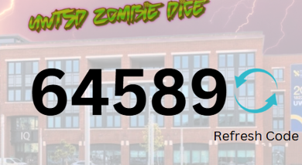
Figure 10 – Code

Figure 11 - Input Code
For a user to be able to join a game relatively easy without having to register any personal details or email address allows for quick game play and sharing with other players. One aspect taken from the Nielson Norman Groups website (10 Usability Heuristics for User Interface Design) is to provide shortcuts and allow users to tailor frequent actions [5].
It is often difficult to balance a usability issue with user experience issue. The simplicity of creating a usable function but also keeping the user engaged can often cause conflicts. An article in the Interaction Design Foundation (IDF) emphasizes the importance of understanding the emotions to determine the functionality when designing the interaction. Rather than focusing on immediate experiences is it important to focus on memorable events to ensure the user will return to interact with the interface again [6].
For a more user experience aspect over a usability aspect was the decision to use a ‘Zombie’ graphic to deliver a winner or loser of the game. Although, from a pure usability point of view a simple pop-up box to flag the result of the game would suffice; to elicit emotion from the user a visual graphic of the zombie theme can influence the user to have a better user experience from the game.
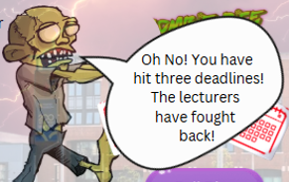
Figure 12 - Zombie image

According to an article published by The Encyclopaedia of Human-Computer Interaction (HCI), named Emotion and Website Design. The author states emotion is crucial in interpreting experiences and so a more user experience approach needs to be considered over a usability approach [7].
To enhance the user’s experience a common themed background has been used throughout the game. By utilising an image of the university’s building with a zombie themed sky will show familiarity for the user especially when attending the site.
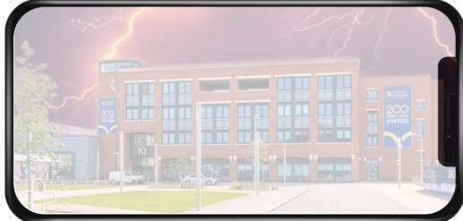
Figure 13 - Background

Conclusion
By developing the UWTSD-Themed Zombie dice game has highlighted the importance of balancing both usability and user experience to create a user-friendly interface. Transitioning the wireframes to full-colour storyboards using feedback to refine and influence the design and addressing the usability challenges while enhancing the emotional engagement of the game.
Conflicts between usability and user experience were resolved to ensure the final product was functional and enjoyable. By involving potential users in the design process provided valuable actionable insights to improve the overall interface.
By ensuring that quantitative and qualitative response data is collected a comprehensive understanding of user behaviour has been defined, enabling better decision making for future iterations of the interface.
This report and the UWTSD-themed Zombie Dice game highlights the importance of a user-centric approach to combine both usability and user experience to make a game that is easy to use but also enjoyable to play and will ensure a user returns to engage further with the interface.

References

[1] | K. Collins, Playing with sound: a theory of interacting with sound and music in video games, MIT press, 2013.
[2] | S. M. Campbell, M. J. Zimmer-Gembeck and A. Duffy, “Friends and education: Identity patterns across domains and associations with emotion dysregulation and identity disturbance,” Journal of youth and adolescence, vol. 48, pp. 703--716, 2019.
[3] | P. A. Yamin, J. Park, H. K. Kim and M. Hussain, “Effects of button colour and background on augmented reality interfaces,” Behaviour & Information Technology, vol. 43, pp. 663--676, 2024.
[4] | R. T. Wood, M. D. Griffiths and V. Eatough, “Online data collection from video game players: Methodological issues,” CyberPsychology & Behavior, pp. 511--518, 2004.
[5] | J. Nielsen, “10 Usability Heuristics for User Interface Design,” Nielson Norman Group, [Online]. Available: https://www.nngroup.com/articles/ten-usability-heuristics/. [Accessed 01 2025].
[6] | M. Hassenzahl, “User Experience and Experience Design,” Interaction Design Foundation, [Online]. Available: https://www.interaction-design.org/literature/book/the-encyclopedia-of-human-computer-interaction-2nd-ed/user-experience-and-experience-design. [Accessed 01 2025].
[7] | D. Cyr, “Emotion and website design,” Interaction Design Foundation, [Online]. Available: https://www.interaction-design.org/literature/book/the-encyclopedia-of-human-computer-interaction-2nd-ed/emotion-and-website-design. [Accessed 01 2025].

Appendices

Game Menus
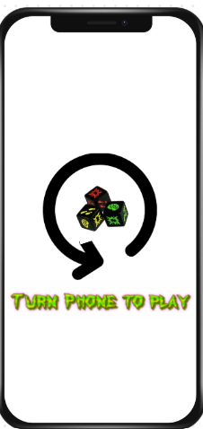
To ensure that the game is played in the correct orientation, a prompt is given to the user to rotate their device to start playing the game.

The initial game play screen shows a name placeholder where the user can enter their name. The user can hit play or toggle through the menus with the menu icon in the top right-hand corner.

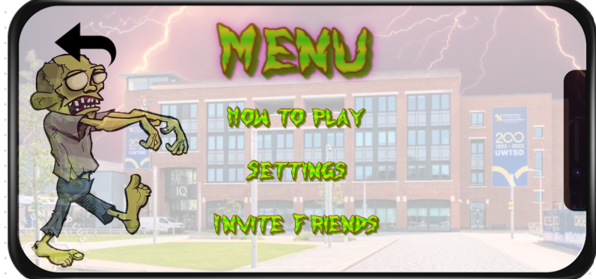
The menu screen allows the user to explore the menus such as ‘How to play’, ‘Settings’, and ‘Invite Friends’. There is also a back option in the top right where a user can return to the previous screen.

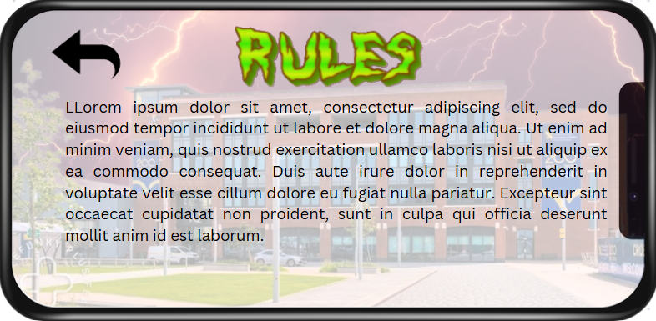
The ‘How to Play’ screen displays the rules of the game that the user can read to understand the game play.

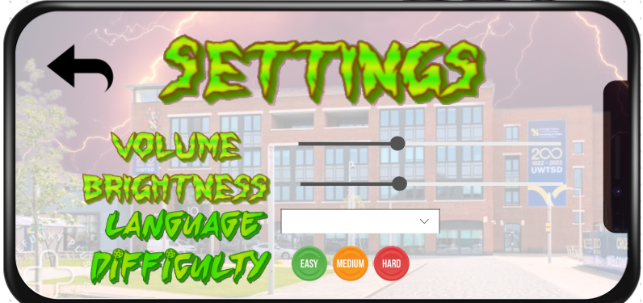
The settings menu will allow the user to toggle the volume and contrast controls depending on their needs. The Language dropdown box will enable the user to select an appropriate language they desire. The user can toggle the difficulty level within the settings menu too.

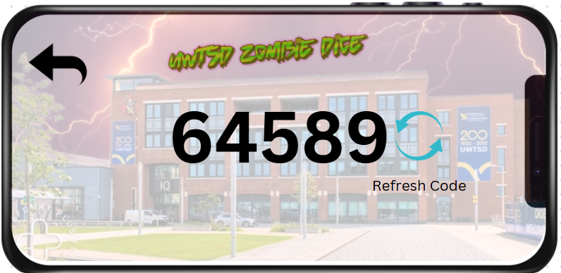
To allow a user to play with friends a code generator is used when they select the ‘Invite Friends’ option. This code can be sent to various friends to join in with game play.

Game Play

User enters code to begin a game session.

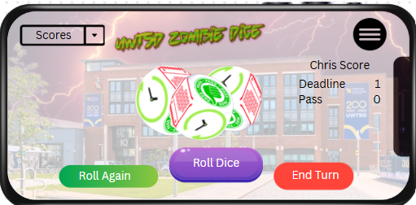
Game play screen allows user to roll the dice for their turn or end their turn for the next player.

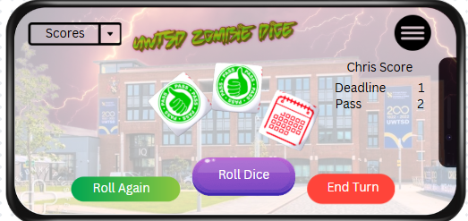
The player has rolled the dice and has rolled 2 passes and one deadline for this turn. The scorecard is updated on the right side of the screen.

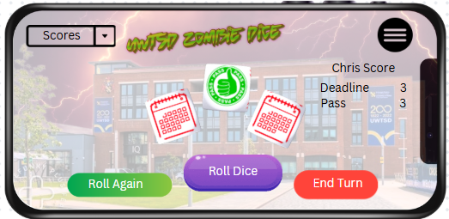
The player has continued to roll the dice to get more passes. Unfortunately, the player has accumulated three deadlines. This has ended the players turn and they are out of the game.

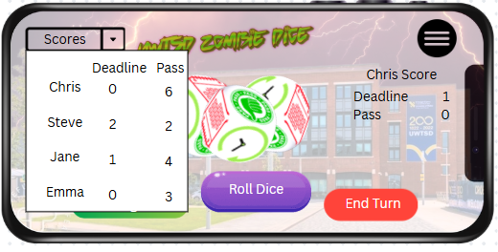
The player can check the scores at any time through game play. By toggling the score card, the user will be presented with a dropdown box showing the current scores of the players.

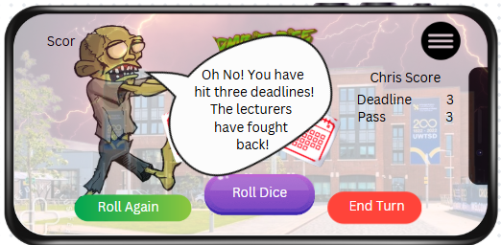
The zombie character moves into view on the screen and gives the player feedback to their game loss.

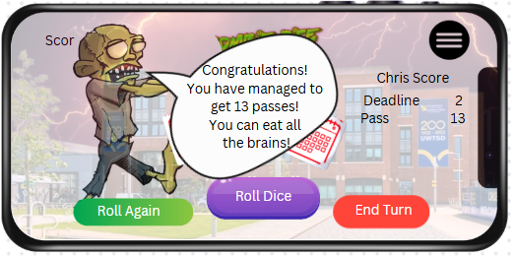
If a player has achieved 13 passes within their game play, they have won the game. The zombie character re-appears to let the player know they have won.

Feedback Survey

Usability:
- Was the game easy to understand?
  - Yes, very easy
  - Yes, easy
  - Neutral
  - No, difficult
  - No, very Difficult
- Was the navigation intuitive within the game?
  - Very Intuitive
  - Intuitive
  - Neutral
  - Not Intuitive
  - Very Not Intuitive
- How quickly were you able to learn the game rules and controls?
  - Very Quickly
  - Quickly
  - Neutral
  - Slowly
  - Very Slowly
- How helpful were the in-game tutorials or help sections?
  - Very Helpful
  - Helpful
  - Neutral
  - Not Helpful
  - Very Not Helpful
- Any other comments regarding the usability of the game?
User Experience:
- How much did you enjoy playing the UWTSD-Themed zombie dice game?
  - Loved It
  - Liked It
  - Neutral
  - Disliked It
  - Hated It
- Was the overall design and graphics appealing?
  - Very Appealing
  - Appealing
  - Neutral
  - Unappealing
  - Very Unappealing
- Would sound effects and music enhance your gaming experience?
  - Greatly Enhanced
  - Enhanced
  - Neutral
  - Detracted
  - Greatly Detracted
- How immersive was the gameplay experience for you?
  - Very Immersive
  - Immersive
  - Neutral
  - Not Immersive
  - Very Not Immersive
- Any other comments regarding the user experience of the game?

Feedback Survey Answers

Question | Answers
1 | Very Easy | Easy | Neutral | Difficult | Very Difficult
1 |  | ||| | || | |
2 | Very Intuitive | Intuitive | Neutral | Not Intuitive | Very Not Intuitive
2 | || | ||| |  | |
3 | Very Quickly | Quickly | Neutral | Slowly | Very Slowly
3 |  | ||| | | | ||
4 | Very Helpful | Helpful | Neutral | Not Helpful | Very Not Helpful
4 | || | ||| | |
5 | - Rules difficult to understand at first.  - Navigation was intuitive and easy to follow.  - Easy Navigation.  - Controls seemed easy to understand and quick to start play  - No option to end game  - Maybe a sound control within the game screen  - Help icon
6 | Loved It | Liked It | Neutral | Disliked it | Hated It
6 | ||| | || | |
7 | Very Appealing | Appealing | Neutral | Unappealing | Very Unappealing
7 | || | || | | | |
8 | Greatly Enhanced | Enhanced | Neutral | Detracted | Very Detracted
8 | |||| | ||
9 | Very Immersive | Immersive | Neutral | Not Immersive | Very Not Immersive
9 |  | || | ||| | |
10 | - Enjoyed the theme and familiarity with the background.  - Graphics are good overall.  - Sound would enhance the game play.  - Gameplay was ok, but maybe increase gameplay time with other features.

