Student Name: Nakum Kamlesh
Student ID: 2503810
Module Code: LCHS7000
Module Title: Social Epidemiology and Public Health Development
Assignment Title: “Disability and Health Inequalities in the UK and an Epidemiological Analysis of Depression among Disabled Adults in Birmingham”
Lecturer’s Name: Mr. Mohammad Aliyu

Table of Contents
Task 1 - Social Epidemiological Analysis 3
Introduction 3
Contextual Background and Underlying Factors 3
Higher rates of depression and anxiety 4
Higher rates of long-term physical illness and multimorbidity 4
Avoidable mortality among people with learning disabilities 5
Poverty and additional disability costs 5
Employment exclusion and lower income 5
Accessible housing, transport and digital barriers 6
National Response to Reduce Health Inequalities 6
Organisation Supporting Disabled People - Scope UK 7
Conclusion 7
Task 2 - Epidemiological Analysis 8
Introduction 8
Public Health Measures 8
Determinants or Risk Factors 9
Epidemiological Identification and At-Risk Population 9
Monitoring and Surveillance Systems 10
Public Health Impact and Consequences 10
Intervention Design and Evaluation 10
Strengths and Weaknesses of the Epidemiological Approach 11
References 13

Task 1 - Social Epidemiological Analysis

Introduction
Disabled people are a very diverse group, including those with physical, sensory, intellectual, developmental, mental-health and long-term health impairments. In public health, disability should not only be considered as a medical impairment, because the social model of disability illustrates how inaccessible environments, stigma and health and social-care services disadvantage people. Health inequality is a sharing of disadvantage, health and opportunity which is unjust and avoidable across social groups. So, people with disability are vulnerable to health inequalities because impairment may combine with poverty, inaccessible living environments, insecurity in the workplace, lack of transport infrastructure, lack of digital infrastructure and discrimination over a lifetime. The World Health Organization estimates 16% of the world population - or 1.3 billion people have significant disability, which means disability inclusion is important for public health, not a niche issue (World Health Organization, 2022).
In the UK, rates of disability have risen significantly and are highly age- and socioeconomic-class stratified. In 2023/24, some 12% of children, 24% of adults of working age and 45% adults of State Pension age reported disability, while nearly two thirds of adults aged 85 or over had a disability (House of Commons Library, 2025). These patterns highlight the need for disability and health inequalities to be considered using social epidemiology approaches: risk is not equally distributed across the population, and health is determined by social factors as well as medical need.

Contextual Background and Underlying Factors
Figure 1 below shows the prevalence of disability by age group in the UK and highlights the growing population need for inclusive health, housing and social-care responses.
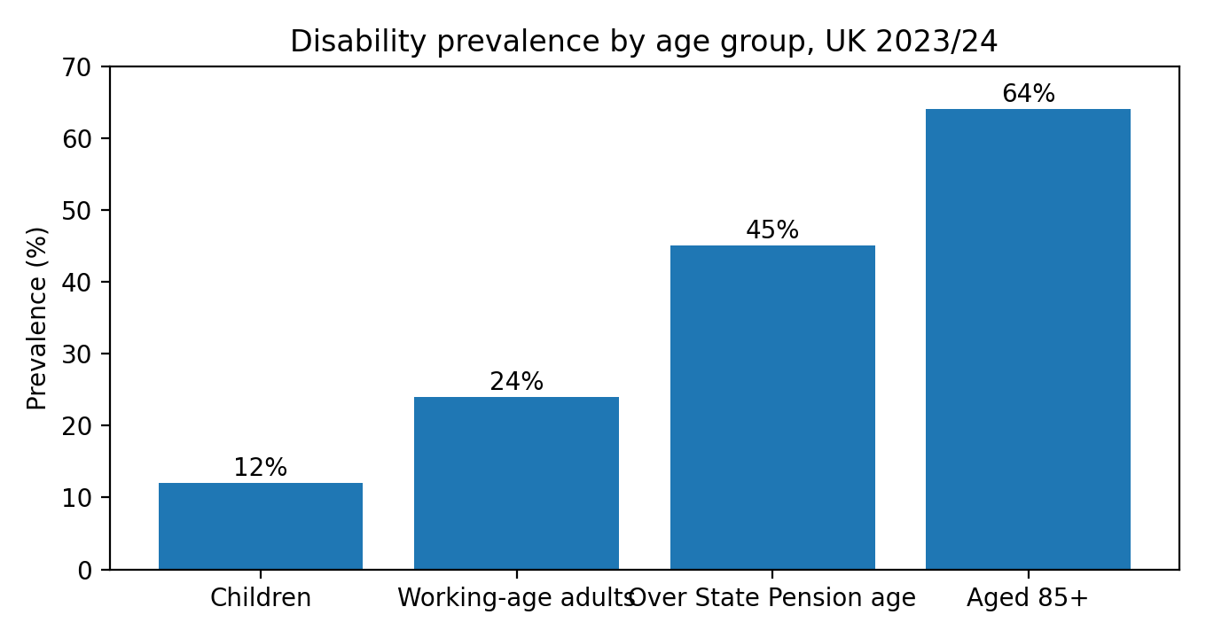
Figure 1: Disability prevalence by age group, UK 2023/24.
Source: House of Commons Library (2025).

Higher rates of depression and anxiety
Disparities in mental ill-health are a major disease-related inequality experienced by people with disabilities. Disability can lead to an increased risk of chronic pain, isolation, poverty and poor experiences with health services and, in turn, mental ill-health can exacerbate functional impairment. A recent overview of reviews showed people with disabilities have worse health across a wide range of outcomes, including mental-health outcomes, than people without disabilities (Smythe et al., 2025). The disparity is because risk is generated by both impairment-based needs and social factors, including being excluded from the workforce, having limited social engagement and lacking access to psychological interventions. The response should include accessible psychological talking therapies, reasonable adjustments to mental-health care, screening in primary care and peer support in the community.

Higher rates of long-term physical illness and multimorbidity
Long-term physical illness and multimorbidity are common among people with disabilities. According to the WHO, people with disabilities have higher rates of diabetes, obesity, asthma, oral disease and stroke due to social and health-system discrimination (World Health Organization, 2022). This is compounded in the UK by late-appointments, lack of communication support and prevention services. A public-health response is to ensure mainstream prevention is available, such as accessible NHS Health Checks, invitations to screening, longer GP consultations if needed and disability-sensitive chronic-disease care.

Avoidable mortality among people with learning disabilities
Avoidable deaths are a serious measure of disability health inequalities. There are well-documented inequalities in health and employment faced by people with a learning disability and people with autism, and parliamentary evidence has shown they have shorter lives and more avoidable deaths than peers (Women and Equalities Committee, 2024). This is caused by diagnostic overshadowing (assuming symptoms are due to disability) and failure to make reasonable adjustments when diagnosing and treating. Mandatory learning-disability registers, annual health checks and reviews of mortality (LeDeR) are crucial but need to be better embedded in services.

Poverty and additional disability costs
Poverty is a significant social issue for people with disability, as disability increases the cost of transport, heating, personal care, equipment and special diets. The Joseph Rowntree Foundation states that higher poverty rates among people with disabilities are due to lower employment rates and that people with mental-health disorders and multiple disabilities are particularly disadvantaged (Joseph Rowntree Foundation, 2026). Health is undermined by poverty, which restricts access to healthy foods, warm homes and social activities. Solutions include adequate disability benefits, local advice, energy assistance and social prescribing that focuses on material as well as behavioural factors.

Employment exclusion and lower income
Another social determinant is employment exclusion. In July to September 2024, the disability employment rate was 54.4% against 81.9% for non-disabled people, with a disability employment gap of 27.5% points (House of Commons Library, 2024). The gap is not due to lack of motivation; it is due to employer discrimination, inaccessible recruitment processes, lack of flexible work, poor health services in workplaces and many other barriers faced by people with mental-health conditions and multiple impairments. So reasonable adjustments in the workplace, supported employment and equal opportunities in recruitment, as well as more effective enforcement of equality duties, are public-health interventions given that income and decent work are determinants of health.
Figure 2 illustrates the size of the disability employment gap and its relationship to income, mental health and social participation.
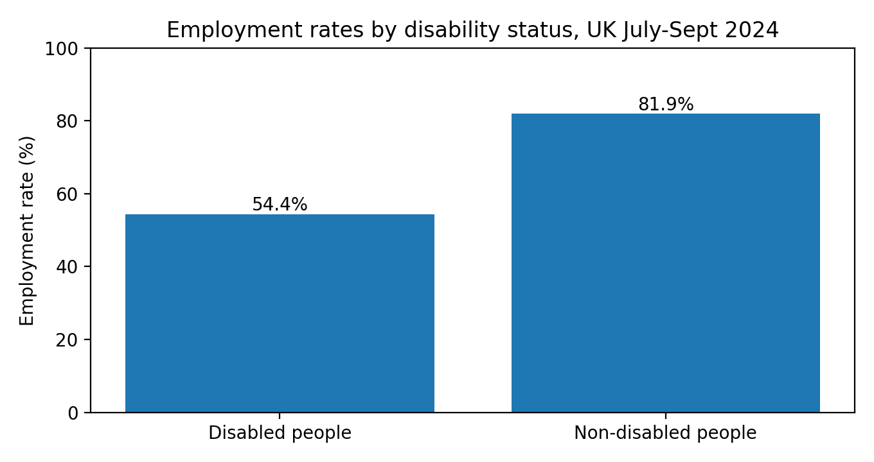
Figure 2: Employment rates by disability status, UK July-Sept 2024.
Source: House of Commons Library (2024).

Accessible housing, transport and digital barriers
Accessible housing, transport and digital systems are important for health. People with disabilities may be more likely to live in damp housing, be overcrowded, have inadequate housing adaptations and have poor access to public transport, which can result in social isolation, falls, respiratory disease and missed appointments. The UK disability evidence base reveals that participation barriers mediate inequalities in self-reported health, anxiety, satisfaction with life and happiness (Emerson et al., 2022). Local action includes boosting accessible housing provision, adaptations, accessible transport, and ensuring non-digital back-ups for any digital NHS services.

National Response to Reduce Health Inequalities
At a national level, the Equality Act 2010 requires public authorities and service providers to make reasonable adjustments and the NHS has increasingly placed disability inequality within the context of health inequality initiatives. Core20PLUS5 is significant as it asks integrated care systems to prioritise the most disadvantaged 20% of the population, locally identified inclusion populations and five clinical areas (NHS England, 2024). Disability may be captured within the Core20 and the PLUS groups, particularly if you are poor, from an ethnic minority, homeless or have a mental illness. But, the approach will only work if local systems gather data and engage with disabled people in service design.
A second national response is the roll-out of annual health checks, learning-disability registers and death reviews for people with learning disabilities. These are designed to identify unmet need and preventable deaths. The issue is that checks can be a one-and-done approach if they do not result in accessible referrals, continuity of care and accountability for reasonable adjustments. A rights-based approach therefore asks for outcome measures, rather than measures of activity (Rotenberg et al., 2024).

Organisation Supporting Disabled People - Scope UK
Scope is a UK charity that promotes disability equality, striving to ensure equal rights and fairness for people with disabilities. Its broader public-health contribution is not just to individuals but also to challenging stigma, campaigning for accessible services, offering information about employment and welfare, and raising awareness of the additional costs of disability. Scope provides advice to disabled people on benefits, employment, social care, and independent living, and influences the national policy debate on disability equality (Scope, 2026). Scope's work has public-health impacts through raising public awareness and advocate by highlighting the social determinants of disability. It does good work because the systems that often affect disabled people can be disjointed, but charity support cannot substitute for statutory obligation to provide accessible health care, an adequate income and accessible living conditions.

Conclusion
Health and disability inequalities in the UK are the outcome of interactions between impairment, social exclusion and resource inequalities. People with disabilities are more likely to suffer from mental illness, chronic disease and preventable death, and poor health outcomes are compounded by poverty, discrimination in the workplace and an inaccessible built environment. Government strategies and charities like Scope play a vital role, but evidence shows that more needs to be done on reasonable adjustments, access to prevention, housing, income protection and monitoring. A social epidemiological approach is necessary because it recognises disability inequality as a structural, public-health problem, not an individual issue.

Task 2 - Epidemiological Analysis

Introduction
This report now examines depression in disabled adults in Birmingham as a public-health issue. Depression is a frequent mental illness characterised by low mood, loss of interest, tiredness, poor sleep and disability. Depression has social, cultural and health impacts on disabled adults, as it can hinder autonomy, exacerbate pain, undermine engagement in health care and lead to suicide. Depression is also stigmatised, and disabled adults can experience double stigma if their mental distress is seen as a natural consequence of disability, rather than a health condition that can be treated.
The impact is significant globally and nationally. The World Health Organization (WHO) recognises mental health is a leading cause of disability globally, and disability is in turn associated with poorer health and functioning (World Health Organization, 2022). In England, Birmingham is a suitable target community given it is a large metropolitan local authority with high levels of deprivation, ethnic diversity and health inequalities. The target population is adults (18 and over) with disabilities in Birmingham, with a focus on people from deprived wards, people with learning disabilities, people with physical disabilities and people with multiple long-term conditions.

Public Health Measures
Public-health interventions should be implemented through the 3 Ps such as prevention, protection and promotion. Prevention is avoiding risks before depression occurs. For Birmingham, this includes affordable social prescribing, connection to community support, inclusive physical-activity groups and welfare guidance for adults with disabilities. Prevention needs to be proportionate universalism all disabled adults should be included, but the most intensive support should go to adults who are poor, isolated or have multiple conditions (Marmot et al., 2020).
Protection is the prevention of escalation of depression. Primary care should use accessible screening, longer consultations, communication aids and periodic reviews for at-risk disabled people. NHS Talking Therapies should offer reasonable adjustments, such as accessible premises, remote services, interpreters, easy-read materials and longer or shorter sessions. The evidence on disability-inclusive health systems suggests mainstream services need to expect, accept and include disabled people, not provide accessible services as a "nice to have" (Rotenberg et al., 2024).
Promotion is enhancing mental health and decreasing stigma Local government, NHS partners and voluntary organisations can spread the message that depression in disabled people can be prevented and treated. Campaigns should be co-developed with disabled people and not blame individuals. This is because lifestyle-focused health promotion messages can be exclusionary if they fail to consider transport, poverty, pain and inaccessible environments.

Determinants or Risk Factors
Biological, behavioural, psychosocial and structural factors contribute to the risk of depression among adults with disability. Biological factors include pain, fatigue, sleep impairment and multiburden. Behavioural factors include low physical activity, but low physical activity should be seen in the context of physical inactivity, not failure because disabled people may have limited access to leisure facilities and unsafe transportation. Psychosocial factors include loneliness, discrimination, employment loss and loss of independence.
Structural determinants are particularly important. Poverty exposes people to cold living conditions, hunger and debt, and exclusion from employment decreases income and social status. The disability employment gap suggests that disabled people face inequity in access to good work (House of Commons Library 2024). Inequality in education, housing and transport may also be risk factors. These factors demonstrate that depression in disabled adults is not only a clinical, but also a social epidemiologically driven problem influenced by social inequalities.

Epidemiological Identification and At-Risk Population
Epidemiological case-identification should involve routine quantitative data and community needs assessments. Primary-care registers, the Quality and Outcomes Framework, NHS Talking Therapies, the Mental Health Services Data Set and local public-health profiles can detect diagnosed depression, service engagement and outcomes. But routine data may underestimate the number of disabled adults because of variable recording of their disability status, and because some disabled adults may not access care, either due to stigma or a poor experience of previous care.
So a health needs assessment should map Birmingham adults by disability status, age, sex, ethnicity, deprivation, housing tenure and employment status. It should examine at-risk groups, such as single disabled adults, adults with learning disabilities, adults on the autistic spectrum, adults with sensory impairment and adults with multiple chronic conditions. Qualitative input is necessary because epidemiological rates do not explain service non-use. A mixed-methods approach is justified by research demonstrating participation barriers explain a substantial proportion of disparities in wellbeing among people with disability (Emerson et al., 2022).

Monitoring and Surveillance Systems
Surveillance should use several surveillance systems. First, primary-care data can monitor the coding of depression, antidepressant prescriptions and annual assessments for adults with disability. Second, NHS Talking Therapies data can track referrals, waiting times, completion, and recovery rates by disability status. Third, OHID Fingertips and local Joint Strategic Needs Assessment indicators can track broader factors including deprivation, work, housing and subjective health. Fourth, the voluntary sector data from Scope, local disabled people's organisations and Healthwatch Birmingham can detect barriers to access not captured by routine data sources.
Equality indicators should be monitored. These include the proportion of adults with disabilities screened for depression, time from referral to treatment, intensity of therapy, recovery, patient-reported accessibility and complaints about reasonable adjustments. The data should be discussed quarterly by the integrated care board and local authority public-health team. The main caveat is that disability categories may not be standard across data sources, making comparisons tricky.

Public Health Impact and Consequences
The immediate consequences of depression include impaired quality of life, daily functioning, sleep and increased primary care use. Among adults with disabilities, depression also leads to a lack of confidence to attend appointments, take medication or participate in rehabilitation. Long-term impacts include joblessness, social exclusion, loss of physical health, risk of accessing crisis services and higher mortality. The WHO notes health inequities associated with disability are expensive at an individual, health sector and societal level (World Health Organization, 2022).
Epidemiology can quantify this by estimating differences in prevalence, incidence, service utilisation and outcomes. It can also inform service allocation by directing services to lower wards or populations with unmet service needs. However, epidemiological approaches shouldn't categorise people with disability as risks. The principle of inclusion means disabled adults should participate in defining the outcomes that are most meaningful to them, such as independence, social connection and dignity (Kamenov et al., 2023).

Intervention Design and Evaluation
The intervention is a 12-month Birmingham Disability-Inclusive Mental Health Programme. It will help alleviate untreated depression and promote wellbeing for adults with disabilities. It will be offered in GP surgeries, community centres, organisations for people with disabilities and digitally accessible options. This includes active depression screening, housing advice, adapted National Health Service (NHS) Talking Therapies, peer support, accessible physical activity and health-professional training regarding reasonable adjustments.
Intervention name | Birmingham Disability-Inclusive Mental Health Programme
Target population | Adults aged 18+ with disabilities in Birmingham, focusing on high-deprivation wards and multiple conditions
Theory base | Social model of disability, social determinants of health and proportionate universalism
Core activities | Accessible screening for depression, adapted Talking Therapies, peer support, welfare advice and accessible activity referral
Key stakeholders | Birmingham City Council, NHS Birmingham and Solihull Integrated Care Board (ICB), GPs, Scope, Healthwatch and disabled people's organisations
Duration | 12 months at quarterly intervals
Evaluation indicators | Referral rates, waiting times, completion of therapy, improvement, quality of life and patient satisfaction with accessibility
Process, outcome and equity evaluation should be used to assess the intervention. Process evaluation would examine whether services were delivered as intended and whether reasonable adjustments had been made. Outcome evaluation would assess the difference in baseline and follow-up depression scores, recovery, quality of life and health service use. Equality evaluation would assess whether there were changes for the most disadvantaged people with disability, as well as those who could access services. This is crucial because universal services can inadvertently increase inequalities if there is greater participation among those better able to access services.

Strengths and Weaknesses of the Epidemiological Approach
The key advantage of the epidemiological approach is that it enables inequalities to be measured. It can tell us who, where and if interventions are beneficial. It enables comparisons between adults with and without disability and across impairment groups. Second, local epidemiology informs commissioning by relating mental-health outcomes to deprivation, employment and housing.
The weaknesses are also important. Routine data can underestimate depression in adults with disability due to under diagnosis, diagnostic overshadowing and variable recording of disability. Data may also find associations but not causation. To start with, depression and unemployment may mutually reinforce each other. Quintly, epidemiology can overlook lived experience without combining with qualitative research and co-production. So, the best approach should combine statistical and participatory needs assessment and feedback from disabled people.
Finally, depression in Birmingham's adult population with disability is a significant public-health problem because it is a convergence of mental health, disability, poverty, access and social exclusion. Prevention, protection and promotion, with local surveillance and service co-design, are essential for management. Our intervention offers a blueprint for addressing inequalities, but it requires long-term investment, disability data and disabled people's involvement.

References
Banks, J., Karjalainen, H. and Waters, T. (2024) Inequalities in disability. Oxford Open Economics, 3(Supplement_1), pp.i529-i548. DOI: 10.1093/ooec/odad091. Available at: https://doi.org/10.1093/ooec/odad091
Davy, C., Harfield, S., McArthur, A., Munn, Z. and Brown, A. (2022) Access to primary health care services for people with disabilities: a systematic review. BMC Health Services Research. Available at: https://bmchealthservres.biomedcentral.com/
Emerson, E., Fortune, N., Llewellyn, G. and Stancliffe, R. (2022) Disability-related inequalities in health and well-being are mediated by barriers to participation faced by people with disability. Social Science & Medicine, 315, 115498. DOI: 10.1016/j.socscimed.2022.115498. Available at: https://doi.org/10.1016/j.socscimed.2022.115498
Friedman, C. (2024) Equity, inclusion and health systems for disabled people. Disability and Health Journal. Available at: https://www.sciencedirect.com/journal/disability-and-health-journal
House of Commons Library (2024) Disability statistics. Available at: https://researchbriefings.files.parliament.uk/documents/CDP-2024-0173/Disability-statistics.pdf
House of Commons Library (2025) UK disability statistics: prevalence and life experiences. Available at: https://commonslibrary.parliament.uk/research-briefings/cbp-9602/
Joseph Rowntree Foundation (2026) UK poverty statistics: disability. Available at: https://www.jrf.org.uk/uk-poverty-statistics/disability
Kamenov, K., Mikkelsen, B., Chatterji, S. and Cieza, A. (2023) Health equity for persons with disabilities: a global scoping review on barriers and interventions in healthcare. International Journal for Equity in Health, 22, 236. DOI: 10.1186/s12939-023-02035-w. Available at: https://doi.org/10.1186/s12939-023-02035-w
Krahn, G.L., Walker, D.K. and Correa-De-Araujo, R. (2022) Advancing health equity and reducing health disparities for people with disabilities. Health Affairs, 41(10), pp.1379-1386. DOI: 10.1377/hlthaff.2022.00499. Available at: https://doi.org/10.1377/hlthaff.2022.00499
Marmot, M., Allen, J., Boyce, T., Goldblatt, P. and Morrison, J. (2020) Health Equity in England: The Marmot Review 10 Years On. London: Institute of Health Equity. Available at: https://www.health.org.uk/reports-and-analysis/reports/health-equity-in-england-the-marmot-review-10-years-on
Mitra, S. (2022) Disability, health and human development. Basingstoke: Palgrave Macmillan. Available at: https://link.springer.com/
NHS England (2024) Core20PLUS5 - an approach to reducing healthcare inequalities. Available at: https://www.england.nhs.uk/about/equality/equality-hub/national-healthcare-inequalities-improvement-programme/core20plus5/
Public Health England/OHID (2023) Health Inequalities Dashboard: statistical commentary. London: Office for Health Improvement and Disparities. Available at: https://www.gov.uk/government/statistics/health-inequalities-dashboard-march-2023-data-update
Rimmer, J.H., Chen, M.D. and Hsieh, K. (2023) A conceptual model for identifying, preventing and managing secondary conditions in people with disabilities. Disability and Health Journal, 16(2), 101392. Available at: https://www.sciencedirect.com/journal/disability-and-health-journal/vol/16/issue/2
Rotenberg, S., Kuper, H., Barrett, D., et al. (2024) Building disability-inclusive health systems. The Lancet Public Health, 9(4), pp.e278-e289. DOI: 10.1016/S2468-2667(24)00042-2. Available at: https://doi.org/10.1016/S2468-2667(24)00042-2
Scope (2026) Scope: disability equality charity. Available at: https://www.scope.org.uk/
Shakespeare, T., Ndagire, F. and Seketi, Q.E. (2023) Triple jeopardy: disabled people and the COVID-19 pandemic. The Lancet, public health commentary. Available at: https://www.thelancet.com/
Smythe, T., Rotenberg, S., Moyo-Chilufya, M., Wilbur, J. and Kuper, H. (2025) Health inequalities among people with disabilities: an umbrella review and evidence synthesis. EClinicalMedicine, 86, 103675. DOI: 10.1016/j.eclinm.2025.103675. Available at: https://doi.org/10.1016/j.eclinm.2025.103675
Women and Equalities Committee (2024) Inequalities in healthcare and employment for people with a learning disability and autistic people. Sixth Report of Session 2023-24. London: UK Parliament. Available at: https://publications.parliament.uk/pa/cm5804/cmselect/cmwomeq/134/report.html
World Health Organization (2022) Global report on health equity for persons with disabilities. Geneva: WHO. ISBN: 9789240063600. Available at: https://www.who.int/publications/i/item/9789240063600

