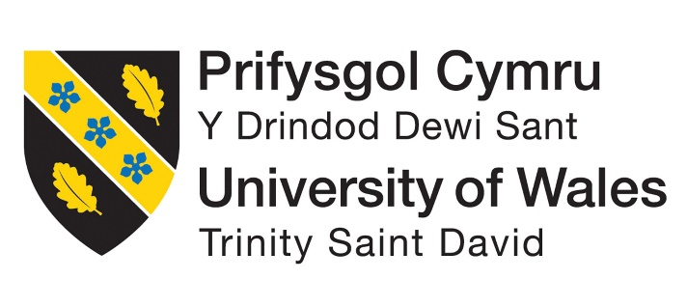

Student name: Vilma Dias Rodrigues
Student ID:2336478
Module Code: BMHP5015
Module Title: Changemakers: Building Your Personal Brand for Sustainable Employment

Table of Contents
Introduction 3
Analysis of Employability Skills 3
Employability Skills Required for a Respiratory Nurse 3
Main Skills Required 4
NHS 6Cs Framework 5
Digital and Professional Skills 5
Summary of Skills 6
Evaluation of My Own Skills 6
Personal Brand and Professional Identity 8
Action Plan and Career Development 9
Conclusion 10
References 11

Introduction
In this report, the job role of a Respiratory Nurse in the UK healthcare system is presented. In addition, it is completely related to the National Health Service (NHS). I have chosen this position, as it satisfies my personal interest in helping people with breathing conditions like asthma and chronic obstructive pulmonary disease (COPD). Also, respiratory nurses are considered to have main roles in supporting patients with long-term and serious conditions and refining their life quality (NHS, 2023).
The role of respiratory nurses includes providing patient-based care, education for new hires, and clinical support. These people often work in multidisciplinary teams. The job requires strong communication and teamwork abilities and makes this role challenging and very rewarding (Royal College of Nursing, 2022).
The report will inspect the main employability skills needed for this role and present an evaluation of my current skills aligned with these requirements. Moreover, I will analyse how I can improve my personal brand and professional identity for ensuring sustainable employment. Lastly, the report will provide an action plan and timeline to support my future career growth as a Respiratory Nurse (Skills for Care, 2023).

Analysis of Employability Skills

Employability Skills Required for a Respiratory Nurse
The Respiratory Nurse role requires a strong combination of interpersonal, clinical, and professional skills. According to the NHS (2023), nurses should guarantee and provide efficient, safe, and patient-oriented care. In addition, they are obliged to work in multidisciplinary teams (NHS, 2023). So, possessing technical knowledge and soft skills is considered crucial for this role.
I work in a hospital and one day I saw a patient who tends to get breathing difficulties after cleaning her room. They have a history of asthma but doesn’t use their inhaler regularly. This person experiences tightness in their chest and some difficulty in speaking. The treatment they received from the doctor was high-flow oxygen, nebulised bronchodilators and oral corticosteroids. After observation this person was discharged with advice on trigger avoidance.
Screenshot 1 shows a job advertisement about the role of Respiratory Specialist Nurse at Shropshire Community Health NHS Trust. In addition, the job requires proficient clinical knowledge, teamwork abilities, and support of patients with respiratory conditions in hospital and community environments (NHS Jobs, 2026).

Screenshot 1 NHS Job Advertisement – Respiratory Nurse (NHS Jobs, 2026)
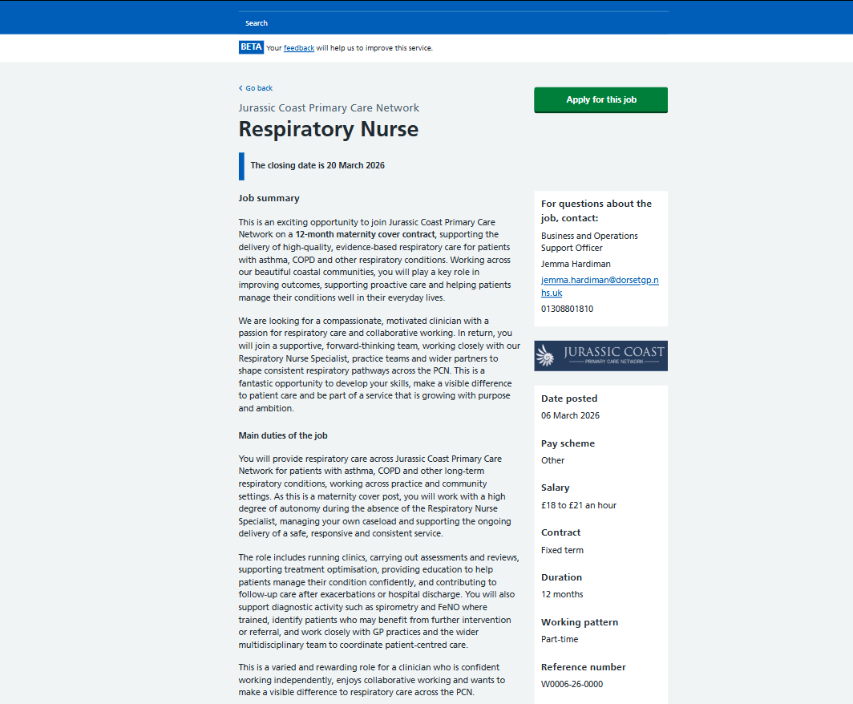

Main Skills Required
As a mandatory skill for this job role is communication. In addition, respiratory nurses should explain complex medical information to patients in a viable and easy way. Also, they are required to provide emotional support to the patients. So, this is very important for patients experiencing breathing problems and who may feel nervous and stressed. Moreover, efficient communication helps nurses to provide better patient results and satisfaction (Kourkouta and Papathanasiou, 2014). As seen in Screenshot 1, the role requires very strong communication skills and patient support (NHS Jobs, 2026).
Teamwork is another important skill for this job role. Nurses often work with different professionals like doctors, physiotherapists, and other healthcare specialists. In this way, they deliver coordinated care as a team. In respiratory care, this is extremely important, because patients demand support from various professionals. Teamwork guarantees safe and efficient patient care (Royal College of Nursing, 2022).
Moreover, clinical ability is also very important. Respiratory nurses should know how to deal with different conditions like asthma and COPD and apply medical equipment right. This indicates the essence of professional knowledge and constant learning (NMC, 2018). In addition, the job advertisement in Screenshot 1 focuses on the need for essential clinical skills and exclusive patient monitoring (NHS Jobs, 2026).

NHS 6Cs Framework
There are six main values in the NHS, known as the 6Cs. These include care, compassion, competence, communication, courage, and commitment, and they help nurses manage well their professional practice (NHS England, 2015). The values are very important in respiratory nursing, characterised by patients that often experience frustration because of breathing problems. In addition, care and compassion aid nurses in offering emotional support and motivation for patients. Also, it improves patient comfort and trust. Communication is also important for analysing and explaining different treatment programmes, medications’ schedules, and self-management strategies in a perfect and easy way. Competence guarantees that nurses provide safe and efficient clinical care, especially when viewing respiratory conditions. Moreover, courage and commitment help nurses make the best decisions and keep high-quality care.
The 6Cs show that nursing demands technical knowledge, strong emotional intelligence, and ethical responsibility, especially when working with vulnerable patients in complex healthcare settings.

Digital and Professional Skills
Digital skills are also mandatory for modern healthcare. In addition, nurses use electronic health records and medical systems to monitor patients and keep data records. Digital proficiency is considered very important in health and social care settings (Skills for Care, 2023).
Also, nurses should show professional behaviour, such as responsibility, time management, and loyalty to ethical principles. That is why the NMC (2018), has created a Code that obliges nurses to prioritise patients with complex conditions, practise their work efficiently, and maintain safety settings.

Summary of Skills
To conclude, the Respiratory Nurse role demands a combination of the following:
- Communication skills
- Teamwork
- Clinical knowledge
- Emotional intelligence
- Digital competence
- Professional values
So, these skills are very important for providing perfect services and fulfilling the expectations of the NHS healthcare companies.

Evaluation of My Own Skills
I used a SWOT analysis to evaluate my suitability for the Respiratory Nurse role. In Screenshot 2, I have provided a complete SWOT to show my positives and negatives for applying for this job position. This framework helped me recognise my strengths, weaknesses, opportunities, and threats in alignment with the requirements of the job. In addition, self-assessment is very important for professional growth. It helps individuals see their abilities and areas for improvement when applying for a specific job (Bulman, C. and Schutz, S., 2020).
Screenshot 2 Personal SWOT Analysis for Respiratory Nurse Role
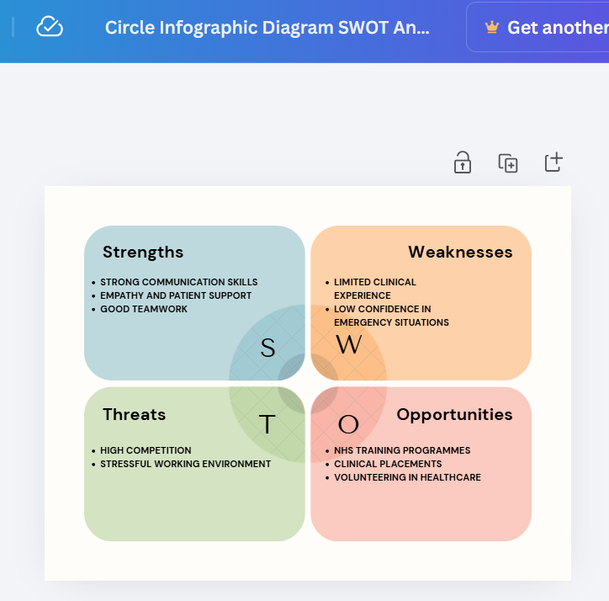
Communication is one of my strongest strengths. For example, I am able to express my ideas openly and really support other people when they face difficulties in understanding information. In respiratory nursing settings, this is crucial because patients can feel much stressed because of problems with their breathing. Therefore, they will need reassurance by the professional that is responsible for them. Efficient communication helps nursing staff reach better patient results and satisfaction. I also possess strong compassion, helping me understand patients’ emotions and assure emotional support. Moreover, I can work with different teams and collaborate efficiently with other co-workers. In healthcare environments, teamwork is important because it guarantees well-managed and safe patient care (Royal College of Nursing, 2022).
Despite the strengths, I also saw some weaknesses. For example, I do not have enough clinical experience, particularly in respiratory health care. So, in real-life situations I cannot feel completely confident when facing difficult patients’ conditions or applying specialised medical equipment. Moreover, I have low confidence in emergency situations, which happen very often in healthcare environments. The NMC (2018) state that nurses should be confident and capable of providing good care in their clinical expertise. In this way, they guarantee patient safety. So, I must definitely work on these main areas for improvement.
Many opportunities are also provided so I can follow my career development. For instance, I can gain practical experience through clinical substitutions, voluntary participations, and training programmes by the NHS. Constant professional growth is important in healthcare environments because it helps professionals maintain knowledge and improve practice (Skills for Care, 2023). So, these opportunities will aid me in improving my technical and professional skills.
On the other hand, threats are also issues that I need to consider. The high competitiveness of the healthcare sector is represented by other candidates with more professional experience than me. Moreover, the role of a Respiratory Nurse can be emotionally stressful and physically demanding. This can cause frustration and burnout when not managed well. In healthcare settings, burnout is a common problem that can impact performance and wellbeing (West et al., 2020).
In Screenshot 2, it is obvious that I possess strong interpersonal skills. However, I have to improve my clinical knowledge and practical experience. Overall, my self-evaluation shows that I possess a good foundation as a respiratory nurse. Definitely, I should constantly improve my skills, as I want to follow a career as a respiratory nurse.

Personal Brand and Professional Identity
Creating a strong personal brand is essential for gaining good employment, especially in the healthcare industry. In addition, the personal brand represents the individual’s skills, values, and professional identity and impacts how they are seen by the employers (McNally and Speak, 2020). Choosing to follow a career as a Respiratory Nurse, I must know that it is important to present a professional image that shows abilities, compassion, and responsibility.
In addition, my personal brand is formed on being a caring, consistent, and motivated individual. I am also dedicated to supporting patients with problematic respiratory conditions. Also, I intend to show serious communication skills, compassion, and eagerness to learn more and improve. These qualities are related to the NHS values and the 6Cs framework. Both frameworks focus on care, empathy, and commitment in nursing practices (NHS England, 2019).
The professional identity is improved by gaining higher education, practical experience, and continuous professional development (CPD). Moreover, the NMC (2018) state that nurses should adhere to professional requirements, focus on patient care, and maintain safety and efficiency. So, I will obey these principles and increase my clinical knowledge by enrolling in training programs and gaining real-life experience.
Moreover, digital presence is very essential in creating a personal brand. Most healthcare professionals should use digital platforms like LinkedIn to present their abilities, professional qualifications, and career goals so employers can be more interested (Foster et al., 2019). The professional online profile can increase visibility and help individuals look for more career opportunities.
So, creating a strong personal brand will aid me in being a more competitive applicant in the healthcare environment. Also, it will help me reach my goal of becoming a confident and capable Respiratory Nurse who offers exclusive patient-based care.

Action Plan and Career Development
So, to achieve my future goal to become a Respiratory Nurse, I have created an action plan completely related to SMART goals. Moreover, SMART goals improve individuals’ structure of their career objectives and help them maintain professional development (Bjerke and Renger, 2017).
For short-term goals, I will improve my clinical knowledge by finishing relevant courses and reading about respiratory conditions like asthma and COPD. Moreover, I will apply for volunteering opportunities in healthcare organisations in the following six months. In this way, I will gain more practical experience. This will provide me with more confidence and essential clinical skills.
For medium-term goals, I will finish my nursing qualification and enrol in clinical job placements. In this way, I will use theoretical knowledge in real-life situations and improve my professional competence. According to NMC (2018), real-life experience is very important for providing safe and efficient nursing work.
In the long term, I will secure a position as a Respiratory Nurse in the NHS. Moreover, I will continue my professional development by enrolling in specialised training programs. CPD is very crucial in healthcare sector to retain high requirements of care (Skills for Care, 2023).
With this action plan I will achieve my career goals because it is well-structured and focus-oriented.

Conclusion
To conclude, this report has analysed the main requirements for becoming a Respiratory Nurse in the NHS. It described the main employability skills required for this role, such as communication, teamwork, and clinical competence, related to the 6Cs framework of the NHS. Also, the report evaluated my current competences by presenting a SWOT analysis, showing strengths like empathy and communication and weaknesses like lacking clinical experience and low confidence. Moreover, the report focused on the importance of creating a strong personal brand and professional identity. It focused on the need for continuous learning and relevance to professional requirements. Lastly, the report finished with a structured action plan so I will support my career progression. Higher education, practical experience, and long-term development were structurally stated in order to prove that I follow specific guidelines. In general, this report shows that possessing a strong foundation, I must continuously develop in order to achieve my goal of becoming a professional and confident Respiratory Nurse.

References
Bjerke, M.B. and Renger, R. (2017) ‘Being smart about writing SMART objectives’, Evaluation and Program Planning, 61, pp. 125–127.
Bulman, C. and Schutz, S. (2020) Reflective practice in nursing. 6th edn. Oxford: Wiley-Blackwell.
Foster, K., Fethney, J., McKenzie, H., Fisher, M., Harkness, E. and Kozlowski, D. (2019) ‘Emotional intelligence increases over time: A longitudinal study of Australian pre-registration nursing students’, Nurse Education Today, 76, pp. 64–69.
McNally, D. and Speak, K.D. (2020) Be your own brand: Achieve more of what you want by being more of who you are. 3rd edn. San Francisco: Berrett-Koehler.
NHS (2023) Careers in nursing. Available at: https://www.healthcareers.nhs.uk (Accessed: 19 March 2026).
NHS England (2015) Compassion in practice: Nursing, midwifery and care staff – our vision and strategy. Available at: https://www.england.nhs.uk (Accessed: 19 March 2026).
NHS England (2019) The NHS Long Term Plan. Available at: https://www.longtermplan.nhs.uk (Accessed: 19 March 2026).
NHS Jobs (2026) Respiratory Specialist Nurse vacancy. Available at: https://www.jobs.nhs.uk/candidate/jobadvert/C9825-26-0081 (Accessed: 19 March 2026).
Nursing and Midwifery Council (NMC) (2018) The Code: Professional standards of practice and behaviour for nurses, midwives and nursing associates. London: NMC.
Royal College of Nursing (2022) Workforce standards for nursing. Available at: https://www.rcn.org.uk (Accessed: 19 March 2026).
Skills for Care (2023) Workforce development strategy. Available at: https://www.skillsforcare.org.uk (Accessed: 19 March 2026).
West, C.P., Dyrbye, L.N. and Shanafelt, T.D. (2020) ‘Physician burnout: contributors, consequences and solutions’, Journal of Internal Medicine, 283(6), pp. 516–529.

