Sarah Carr
Student ID - 2107448
Globally Responsible business (Bmsp6001)
Assignment One

Table of Contents
Introduction 2
Business Ethics 2
Corporate Social Responsibility 2
Triple Bottom Line 2
The Arguments 3
Position for coerced business social responsibility 3
Argument 1 – Public Image 3
Argument 2 – Ethics 3
Argument 3 – Sustainability 4
Position against coerced business social responsibility 5
Argument 1 – Stakeholder Theory 5
Argument 2 – Cost 5
Conclusion 6
Bibliography 6

Introduction
This report will show my interpretation of John Mackey’s quotation, ‘Business social responsibility should not be coerced; it is a voluntary decision that the entrepreneurial leadership of every company must make on its own’. I will draw upon my understanding and further research of business ethics, corporate social responsibility, and relevant theory, as well as presenting arguments for and against, provide examples of good and unfavourable business practices, before discussing and drawing a conclusion form my research.

Business Ethics
Business ethics are the moral principles, policies and values that control the way a company, organisation or individual engages in business activity (Twin, 2024). In many cases it can be seen as a code of conduct set out by an organisation where they outline their policies and or practices for their stakeholders, employees, customers, and community, with regards to controversial subjects such as discrimination and social responsibility.

Corporate Social Responsibility
Corporate social responsibility (CSR) is the concept that businesses and organisations have a responsibility to the community that exists around them. Businesses need to act socially responsible in a way that will have a positive impact on the world. They do this by organising a list of goals that they hope to achieve and then creating initiatives or strategies to achieve these goals. Many businesses and organisations communicate their efforts through their advertising, stakeholder reports and by working with non-profit organisations (Stobierski T. , 2021).

Triple Bottom Line
The triple bottom line was first outlined by John Elkington in 1999, he argued that ‘in order for companies to effectively manage and measure their true economic value, they should set out three bottom lines’ (Elkington, 1999). Businesses and organisations are now realising that the impact of using sustainable practices to help combat the world’s climate issues as well as creating organisational success. One way they measure this is by using the triple bottom line concept. The triple bottom line is a concept that many businesses use to measure their social and environmental impact in addition to their financial performance unlike previous years where they solely measured profit or the ‘standard’ bottom line. The triple bottom line consists of 3P’s profit, people, and the planet.
A businesses financial performance is something they all share, whether they use a triple bottom line or not. However, when they measure their profit using this concept businesses are using the idea that profits will help the community as a whole rather than going into the pockets of their CEO or shareholders. Companies think about how their actions impact all the people involved with their business, from shareholders to suppliers, everyone is considered. Many businesses are now taking steps to reduce or try to eliminate their carbon footprint. They do this by reducing their pollution, introducing new practices for reducing waste, recycling, and offsetting their carbon footprint through green initiatives such as partnerships with environmental charities or tree planting programmes.

The Arguments
The World Business Council defines corporate social responsibility as “the continuing commitment by business to behave ethically and contribute to economic development while improving the quality of life of the workforce and their families as well as the local community and society at large” (Varma, 2011).

Position for coerced business social responsibility

Argument 1 – Public Image
Many businesses are now increasing their focus on becoming socially responsible, this can be done by becoming more sustainable, improving working conditions, or championing a cause. They do this to look attractive to their customers and shareholders which in turn would give the company a positive public image and help to build their brand.
Businesses that are socially responsible are becoming increasingly more attractive to consumers, shareholders, and employees, which once again will greatly improve their bottom line. Social responsibility is an effective tool that can be used in employee recruitment. Employees who are looking to change the world are attracted to organisations big or small that are showing the achieve substantial results and in turn boost morale and increase productivity (Murphy, 2024).
Research conducted by Harvard Business School shows that ‘93% of employees believe companies must lead with a purpose, and a further 88% believe that it is no longer acceptable for companies to make money at the expense of society at large’ (Stobierski T. , 2021)

Argument 2 – Ethics
Businesses and organisations are already involved in the social side of the world, so it is only right that they do what is ethically correct to keep that world a safe and serves the interests of the business. Businesses should consider their decisions carefully and reflect on that process regularly, are we making these decisions entirely on self-interest or for what is best for our community.

In 2015, the United States Environmental Protection Agency announced that Volkswagen had violated the clean air act when they knowingly installed illegal software in their diesel vehicles to cheat the emissions tests. Before the scandal Volkswagen was one for the main players in the automotive industry, after their profits fell by nearly 20% at the beginning of 2016 (Kollewe, 2016). The company was incentivized to sell as many cars as possible but when they were unable to make their engines more environmentally friendly and reduce their emissions, they created a piece of software that would fake the results in a testing environment. Volkswagen then began to market their new diesel vehicles as ‘clean diesel’, when in truth they were anything but clean. Once they were found out the trust that they had built with their customers over the years fell almost instantly.

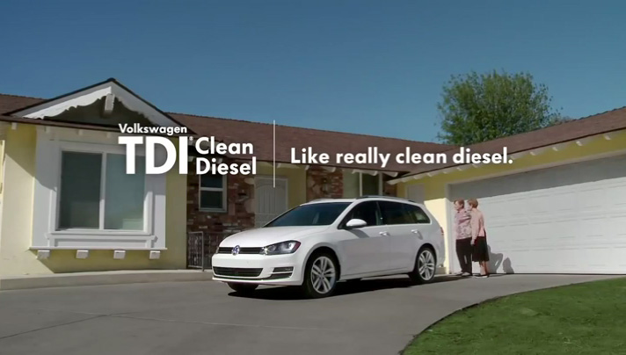
Volkswagen Advertising Campaign - (Volecker, 2016)

Argument 3 – Sustainability
Patagonia is a retailer known for their upscale outdoor clothing, as well as their environmental and sustainable efforts. The company is well known for asking its customers to think twice about being their products. In 2011 the led with a marketing strategy “Don’t buy this jacket”, which told consumers the cost to the environment to manufacture one of their best-selling jackets, and instead asked them to purchase a used or second hand Patagonia product instead. In spite of this campaign their sales continued to grow. Consumers can see that Patagonia not only talk about environmental issues they also do something about it.

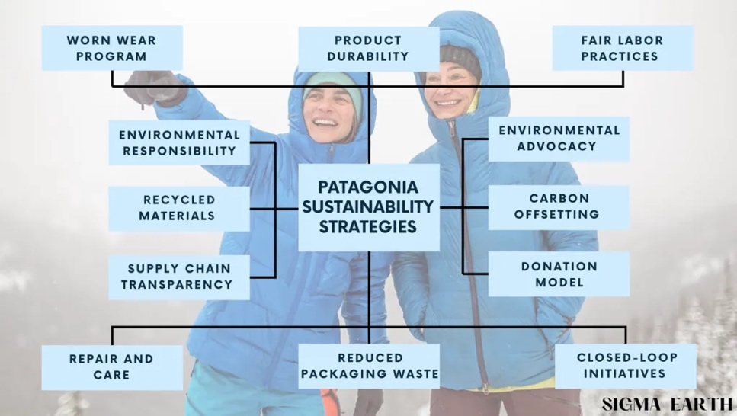
Patagonia’s Sustainability Strategies - (Greenfield, 2023)

Patagonia’s commitment to social responsibility is an incredible example to other businesses that from creating a product, to supply chain and their environmental advocacy, they are becoming a leader in sustainability and promoting fair labour.

Position against coerced business social responsibility

Argument 1 – Stakeholder Theory
Stakeholder theory is a business ethics theory that concerns the issues of how business should behave with regards to their moral purposes and responsibilities. A supporter and writer on this theory is Milton Friedman, his theory states that ‘businesses are merely arrangements by which one group of people, the stakeholders, advance capital to another group, the managers, to be used to realize specified ends and for which the stockholders receive an ownership interest in the venture’ (Mertens, 2013).

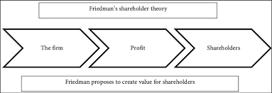
Friedman’s Shareholder Theory - (Narbel & Muff, 2017)

Argument 2 – Cost
The benefit of social responsibility is clear, but at what cost to business. Large organisations can afford to allocate funds from their budgets unlike smaller business’s or start-ups. The costs that arise from social responsibility can be a long term constraint, such as training sessions, memberships or CSR professionals and there are also the upfront costs on new technologies, programmes or infrastructure that will be needed by business to implement their new strategies. While these investments should pay out in the near future, businesses will lose that money that could be used on product development, employees and growing the business to create a greater profit.

It is not only the monetary value, but that also has an effect. The time and effort that goes into the planning, executing, and sustaining new initiatives can be very costly on employees. While employees are working on these new strategies it can take them away from their regular role, causing issues in other departments and possibly costing more in the long term. Finally, every business is accountable to their stakeholders. What if a stakeholder is resistant to the way the company is trying to go. Many may see business in a similar way to Milton Freidman, and the prioritise profit over everything. It will be difficult to change their opinion on that especially if they have been very successful in the past.

Conclusion
This report has demonstrated arguments for and against business social responsibility, drawing upon people, ethical arguments, current theory, and examples from businesses out there today. Where I can understand and somewhat agree with the stakeholder theory, business is created and operated to make money, in today’s climate business is so much more than that. Consumers care greatly about what they spend their money on. They are always asking questions, who made this? Why? What materials where used? Is it recyclable? In today’s market it’s not just a case of buying a product. People what to know more about the product, and the company behind it. Many people see companies such as Patagonia, who have expensive products, but they are built to last and are willing to spend the money on them because of the good that company does with their money. The old thinking of make cheap and make a lot doesn’t seem to be what the people want. Consumer trends are changing. It’s not all about the item, in a way it’s about what the item represents.
Following my research, I disagree with John Mackey’s statement. Business should feel the need to be socially responsible, it shouldn’t be a choice. Many businesses have proved that you can be successful and make lots of money as well as looking out for the environment, local communities, and your employees.

Bibliography
Boyles, M. (2023, July 27). What are business ethics and why are they important? Retrieved March 12, 2024, from Harvard Business School: https://online.hbs.edu/blog/post/business-ethics
Elkington, J. (1999). Cannibals with forks: the triple bottom line of 21st century business. Oxford: Capstone.
Greenfield, D. E. (2023, December 8). Patagonia Sustanability: What Strategy Makes Them Sustainable? Retrieved March 20, 2024, from Sigmaearth: https://sigmaearth.com/patagonia-sustainability-what-strategy-makes-them-sustainable/
Gulati, N. (2021, March 18). Ethics and important of ethics in organisation. Retrieved March 12, 2024, from Linkedin: https://www.linkedin.com/pulse/ethics-importance-organisation-nishant-gulati/
HBS Online. (2023, July). What is the triple bottom line? Retrieved March 12, 2024, from Youtube: https://www.youtube.com/watch?v=1-Ct_53XKYY
Kollewe, J. (2016, May 31). VW profits down 20% after diesel emissions scandal. Retrieved March 18, 2024, from The Guardian: https://www.theguardian.com/business/2016/may/31/vw-volkswagen-profits-down-20-diesel-emissions-scandal#:~:text=Volkswagen's%20profit%20tumbled%20nearly%2020,€4bn%20a%20year%20earlier.
Mertens, K. M. (2013, November 15). Milton Friedman & Social Responsibility - An Ethical Defense of the Stockholder Theory. The University of Oslo. Retrieved from Core: https://core.ac.uk/download/pdf/30893731.pdf
Mind Tools. (2024). The Triple Bottom Line. Retrieved March 12, 2024, from Mind Tools: https://www.mindtools.com/awbh8iv/the-triple-bottom-line
Murphy, C. (2024, January 27). Why Social Responsibility Matters To Businesses. Retrieved March 18, 2024, from Investopia: https://www.investopedia.com/ask/answers/041015/why-social-responsibility-important-business.asp#citation-7 (
Narbel , F., & Muff, K. (2017). Should the Evolution of Stakeholder Theory Be Discontinued Given its Limitations? Theoretical Economics Letters .
Patagonia. (2024). Were in business to save our home planet. Retrieved March 20, 2024, from Patagonia: https://eu.patagonia.com/gb/en/activism/
Stobierski, T. (2021, June 15). 15 eye-Opening Corporate Social Responsibility Statistics. Retrieved March 18, 2024, from Harvard Business School: https://online.hbs.edu/blog/post/corporate-social-responsibility-statistics
Stobierski, T. (2021, April 8). What is corporate social responsibility? 4 types. Retrieved March 12, 2024, from Harvard Business School: https://online.hbs.edu/blog/post/types-of-corporate-social-responsibility
Twin, A. (2024, January 25). What is business ethics? Definition, principles and importance. Retrieved March 12, 2024, from Investopedia: http://www.investopedia.com/terms/b/business-ethics.asp
Varma, S. (2011, February 18). Coercive Social Responsibility. Retrieved March 14, 2024, from The Economic Times: https://economictimes.indiatimes.com/coercive-social-responsibility/articleshow/7518928.cms?from=mdr
Volecker, J. (2016, September 26). VW Dieselgate one year later:what have we learned about diesel cars. Retrieved March 20, 2024, from Green Car Reports: https://www.greencarreports.com/news/1106208_vw-dieselgate-one-year-later-what-have-we-learned-about-diesel-cars

