Data Handling and Business Intelligence

Student Name: Elena Butescu
Student Id: 2132844
Module Code: LCBB5000

Table of Contents
Introduction 3
Part 1 4
A) Discussion and analysis of the GreenMed_Healthcare_2023 data set 4
B) Charts and Graphs for GreenMed_Datasets 13
C) Correlation of processing times of Hadoop and Tableau 18
Part 2 24
A) Discussing the benefits and drawbacks of using Excel and SPSS using relevant real-life examples 24
B) Illustrating the significance of data governance with examples 26
Conclusion 28
References 29

Introduction
Data handling is referred to as gathering a wide range of data along with presenting the data in various forms. Business intelligence is considered the concept of developing and changing the world which can be classified as a set of methodologies as well as concepts for the purpose of developing business decision-making by using various facts. The below context will focus on various key aspects of the data and information of GreenMed Innovations. It will also include the estimation as well as analysis of mean processing time, median processing time as well as standard deviation processing time. Through the help of Excel, different types of graphs will also be highlighted in the below context. The correlation between Tableau as well as Hadoop processing time along with a scatter diagram for these two variables will be presented here. Apart from that, the below context will elucidate the benefits as well as drawbacks of using Excel and SPSS along with the worth of data governance.

Part 1

A) Discussion and analysis of the GreenMed_Healthcare_2023 data set
1) Description of mean processing time
Date | Hadoop_ProcessingTime
2023-01-01 | 1.387743717
2023-01-02 | 0.622392972
2023-01-03 | 2.300683893
2023-01-04 | 4.944243526
2023-01-05 | 2.279136541
2023-01-06 | 4.523819201
2023-01-07 | 3.575640033
2023-01-08 | 1.514816235
2023-01-09 | 1.895300612
2023-01-10 | 4.807012942
2023-01-11 | 4.927338279
2023-01-12 | 3.397961367
2023-01-13 | 0.770182579
2023-01-14 | 3.637991514
2023-01-15 | 0.950857082
2023-01-16 | 3.080417426
2023-01-17 | 3.223703272
2023-01-18 | 3.716017942
2023-01-19 | 2.037100732
2023-01-20 | 3.252764619
2023-01-21 | 2.039289337
2023-01-22 | 0.953912485
2023-01-23 | 4.3937956
2023-01-24 | 2.444977017
2023-01-25 | 2.729322362
2023-01-26 | 3.921550057
2023-01-27 | 3.404929851
2023-01-28 | 2.808024322
2023-01-29 | 4.537031731
2023-01-30 | 1.736193155
2023-01-31 | 0.764005115
2023-02-01 | 3.79521728
2023-02-02 | 4.063221191
2023-02-03 | 2.502246994
2023-02-04 | 0.911063835
2023-02-05 | 3.414140105
2023-02-06 | 2.604745198
2023-02-07 | 2.049604649
2023-02-08 | 1.333757784
2023-02-09 | 3.948237974
2023-02-10 | 2.669162256
2023-02-11 | 2.626075387
2023-02-12 | 3.667332165
2023-02-13 | 1.855814121
2023-02-14 | 2.564629313
2023-02-15 | 3.550821403
2023-02-16 | 1.313885248
2023-02-17 | 2.828479729
2023-02-18 | 4.514282888
2023-02-19 | 2.053587363

Show the formula for deriving Mean processing time for Handoop
Mean | =AVERAGE(B2:B51)

Result
Mean | 2.776889208

Analysis: The above segment has displayed the estimation regarding mean process time in the context of Hadoop. The above-mentioned formula has been used in Excel to determine the value. After the accurate implementation of the formula, the outcome of mean processing time has been detected as 2.776889208.
2) Deriving Median processing time using Spark
Date | Spark_ProcessingTime
2023-01-01 | 2.018439586
2023-01-02 | 0.922405085
2023-01-03 | 1.843993792
2023-01-04 | 3.347538857
2023-01-05 | 2.751179647
2023-01-06 | 2.227753681
2023-01-07 | 2.075419386
2023-01-08 | 1.132140738
2023-01-09 | 4.343354286
2023-01-10 | 2.916452552
2023-01-11 | 4.700144448
2023-01-12 | 3.196762076
2023-01-13 | 4.452992802
2023-01-14 | 3.212374842
2023-01-15 | 2.595985277
2023-01-16 | 1.126103617
2023-01-17 | 4.267841685
2023-01-18 | 4.9228482
2023-01-19 | 1.306268253
2023-01-20 | 2.660683078
2023-01-21 | 2.556471354
2023-01-22 | 4.86353788
2023-01-23 | 1.196902516
2023-01-24 | 3.820568086
2023-01-25 | 2.719321349
2023-01-26 | 0.873575367
2023-01-27 | 3.439638086
2023-01-28 | 2.460317202
2023-01-29 | 4.815070854
2023-01-30 | 3.39646924
2023-01-31 | 1.438974688
2023-02-01 | 4.281543451
2023-02-02 | 2.775317498
2023-02-03 | 2.742641084
2023-02-04 | 1.429528002
2023-02-05 | 3.94990848
2023-02-06 | 4.723229025
2023-02-07 | 3.98798444
2023-02-08 | 4.619631651
2023-02-09 | 0.683939604
2023-02-10 | 2.315944767
2023-02-11 | 4.979141288
2023-02-12 | 0.842809752
2023-02-13 | 4.671415142
2023-02-14 | 2.61953666
2023-02-15 | 1.875394101
2023-02-16 | 4.783154875
2023-02-17 | 3.555519681
2023-02-18 | 1.519074409
2023-02-19 | 2.653700027

The formula for calculating median processing time using Spark
Median | =MEDIAN(C2:C51)

Result
Median | 2.746910366

Analysis: The above section represents the estimation of median processing time by using Spark from the given data set. The above formula has been used accurately to determine the value of median processing time. Hence, after the utilisation of the formula, the value of this specific aspect has been determined as 2.746910366.
3) Evaluating the date on which R have the highest processing time
Date | R_ProcessingTime
2023-01-01 | 2.486711251
2023-01-02 | 1.864462073
2023-01-03 | 3.380302383
2023-01-04 | 2.260015242
2023-01-05 | 2.606585689
2023-01-06 | 0.970952967
2023-01-07 | 3.7068075
2023-01-08 | 3.113446463
2023-01-09 | 1.266335404
2023-01-10 | 1.86153227
2023-01-11 | 0.773426996
2023-01-12 | 3.483490293
2023-01-13 | 3.723886626
2023-01-14 | 2.658995854
2023-01-15 | 0.664337124
2023-01-16 | 4.867451715
2023-01-17 | 1.679950459
2023-01-18 | 0.884489138
2023-01-19 | 3.469964391
2023-01-20 | 0.694753427
2023-01-21 | 4.329950606
2023-01-22 | 1.842460594
2023-01-23 | 1.853700876
2023-01-24 | 4.649545312
2023-01-25 | 3.928365906
2023-01-26 | 2.538976395
2023-01-27 | 1.239423593
2023-01-28 | 4.675297667
2023-01-29 | 3.504590969
2023-01-30 | 1.414875532
2023-01-31 | 2.335005604
2023-02-01 | 0.829101268
2023-02-02 | 2.724856752
2023-02-03 | 2.890685794
2023-02-04 | 3.342667063
2023-02-05 | 2.846727762
2023-02-06 | 2.606046778
2023-02-07 | 4.118590599
2023-02-08 | 4.597597229
2023-02-09 | 1.246977744
2023-02-10 | 0.718829831
2023-02-11 | 3.340388971
2023-02-12 | 4.759139529
2023-02-13 | 2.353115235
2023-02-14 | 4.502792389
2023-02-15 | 2.889771361
2023-02-16 | 2.970652496
2023-02-17 | 3.725938394
2023-02-18 | 4.774301852
2023-02-19 | 3.77094467

The formula for calculating R for the highest processing time
Max |  |  | =MAX(D2:D51)

Result
Max |  |  | 4.867451715

Analysis: The above-mentioned estimation calculates the data in which R has the highest processing time. The function of =MAX has been used to determine the date on which R has the largest processing time. The accurate implementation of the formula depicts that 16th January 2023 is determined as the date on which R has the largest processing time.
4) Calculate the standard deviation for Python processing time
Date | Python_ProcessingTime
2023-01-01 | 3.985149864
2023-01-02 | 1.144563869
2023-01-03 | 0.569147403
2023-01-04 | 2.559038687
2023-01-05 | 2.787323247
2023-01-06 | 3.721955966
2023-01-07 | 2.701854875
2023-01-08 | 1.183454925
2023-01-09 | 4.756181143
2023-01-10 | 4.019016007
2023-01-11 | 1.490738489
2023-01-12 | 2.208611507
2023-01-13 | 3.485053842
2023-01-14 | 1.930687526
2023-01-15 | 1.273347813
2023-01-16 | 3.020010626
2023-01-17 | 0.788496475
2023-01-18 | 0.986186108
2023-01-19 | 1.271200836
2023-01-20 | 0.720062375
2023-01-21 | 2.609130946
2023-01-22 | 2.754569064
2023-01-23 | 0.963348428
2023-01-24 | 4.114667215
2023-01-25 | 3.701173926
2023-01-26 | 1.112482338
2023-01-27 | 4.790219612
2023-01-28 | 0.642849604
2023-01-29 | 4.343311999
2023-01-30 | 3.594482803
2023-01-31 | 2.897187544
2023-02-01 | 1.605838244
2023-02-02 | 1.796358531
2023-02-03 | 1.246618179
2023-02-04 | 2.187414732
2023-02-05 | 4.208801329
2023-02-06 | 4.489703831
2023-02-07 | 3.940497257
2023-02-08 | 0.634702641
2023-02-09 | 4.329643677
2023-02-10 | 2.35742097
2023-02-11 | 0.816642737
2023-02-12 | 3.647336131
2023-02-13 | 2.447917262
2023-02-14 | 4.26857589
2023-02-15 | 3.505292662
2023-02-16 | 2.20664139
2023-02-17 | 3.333267521
2023-02-18 | 2.36775158
2023-02-19 | 3.143125189

Evaluating standard deviation for Python Time
Standard Deviation |  |  |  | =STDEV(E2:E51)

Result
Standard Deviation |  |  |  | 1.297205735

Analysis: Standard deviation is regarded as the statistical aspect that comes into play as the measurement of process variability. For instance, if an individual is measuring the time it takes for the purpose of assembling a product, it indicates a higher standard deviation. STDEV(E2:E51) has been used to determine the standard deviation for Python time and the outcome has been detected as 1.297205735.
5) Lowest average processing time across the dataset
Average | =AVERAGE(B2:B51) | =AVERAGE(C2:C51) | =AVERAGE(D2:D51) | =AVERAGE(E2:E51) | =AVERAGE(F2:F51)

Minimum | =MIN(B56:F56)

Evaluating the Lowest average processing time
Average | 2.776889208 | 2.932218849 | 2.754784321 | 2.573181096 | 2.830278628

Minimum | 2.573181096

Analysis: The above section has displayed the estimation regarding the least average processing time in the given data set. =MIN (B56:F56) has been utilised for the purpose of estimating the least average processing time in the data set and the value has been determined as 2.573181096.
6) Interpret the difference between processing times across different tools or platforms
The processing times across different types of platforms and tools can change significantly on the basis of various factors like specifications, hardware, task complexity as well as algorithms used.
Local Machine vs Cloud services: Processing time relies on the CPU, RAM and other key resources of an individual’s machine while operating tasks on the individual’s computer. Processing time for local machines can be quicker for various small-scale tasks as well as may be restricted by hardware. On the other hand, cloud platforms provide various scalable resources. Data transfer and set-up of data may need time and after the configuration of the data, cloud services can track and control large-scale operations effectively (Pacheco et al., 2023).
Programming languages: Different types of compiled languages such as C, C++ and others gather to machine code which leads to quicker implementation. Additionally, the development time might be lengthy as a result of strict composition as well as manual memory management. On the other hand, different types of interpreted languages such as JavaScript, Python and others are comparatively easier to write as well as repair but might have sluggish implementation as a result of interpretation. The utilisation of JIT as well as Libraries compilation can help to address this.
Web Browsers: Google Chrome is known for its efficient as well as speed memory management as well as it loads web pages rapidly. On the other hand, Firefox represents customisation as well as privacy but may be slower than Chrome (Li et al., 2021). In addition to that, Edge is considered the browser of Microsoft which provides a proper balance between compatibility as well as speed.
Deep learning frameworks: TensorFlow is recognised for its performance as well as flexibility and it is naturally utilised for neural network training. This specific framework influences GPU acceleration for quicker training times. On the other hand, PyTorch is reputed for research as it offers dynamic calculation graphs. It is suitable in terms of its usage but might be sluggish than TensorFlow.

B) Charts and Graphs for GreenMed_Datasets

Figure: Clustered column chart for Hadoop Processing Time
Source: Self-Created
Analysis: The above section highlights a clustered column chart for Hadoop Processing time. Hadoop is regarded as an open-source software which is utilised for the purpose of processing as well as storing a huge amount of data in a distributed computing atmosphere (Benfeldt et al., 2020). It can be seen from the above chart that the Hadoop Processing time for a certain time period has been highlighted in the above graphical representation. According to the above chart, it can be argued that the Hadoop Processing time for 1st January 2023 was 0.622392972. This specific rate has been varied over the time period. On 4th January 2023, the outcome of Hadoop Processing time was 4.944243526 which is considered the highest in the above chart.

Figure: Clustered Chart for Spark Processing time
Source: Self-Created
Analysis: The above section showcases a graphical representation of Spark Processing time for a specific time period. Spark is regarded as an influential as well as fault-tolerant stream processing engine which enables individuals to streamline estimations. It can be seen from the above-clustered chart that the Spark_ProcessingTime on 1st January 2023 was 1.843993792 and this specific rate has fluctuated over the time period. The above chart also indicates that the highest value of Spark_ProcessingTime was 4.979141288 on 11th February 2023.

Figure: Clustered diagram for R processing time
Source: Self-Created
Analysis: The above diagram is prepared to showcase the R processing time for a certain time period. With the help of Excel, the above-clustered diagram for R processing time has been prepared. This procedure is flexible and simple as one can measure the time needed by a large amount of code by estimating the comparison between end times as well as start times. It can be seen from the above chart that, R processing time on 16th January 2023 was 4.867451715 which was regarded as the largest in the data set. In addition to that, the least amount of R processing time in the above chart was 0.664337124 and this specific rate has been varied over the time period as well.

Figure: Clustered Diagram for Python Processing Time
Source: Self-Created
Analysis: The above graphical representation has been prepared for the purpose of highlighting Python processing time for a particular time period. However, Python is a widely utilised programming language which is known for its readability, extensive applications as well as simplicity. According to the above-clustered chart, it can be seen that the outcome of Python processing time on 1st January 2023 was 3.985149864. In addition to that, this particular rate has varied over the time period and the highest time needed for Python Processing was 4.790219612 on 27th January, 2023 whereas the least time taken for Python Processing was 0.569147403 on 3rd January, 2023.

Figure: Clustered Diagram for Tableau Processing Time
Source: Self-Created
Analysis: The above-mentioned graph is prepared for the purpose of showcasing the processing time needed in the context of Tableau. According to the above-clustered chart, the time taken for tableau processing was 2.268954172 on 1st January 2023. Due to various reasons, this specific rate has been changed over the time periods. In addition to that, the above graph indicates that the highest amount of time taken for Tableau processing was 4.937233846 on 17th February 2023 whereas the least time needed for Tableau Processing was 0.753179032 on 19th January 2023.

C) Correlation of processing times of Hadoop and Tableau
C1. Deriving the correlation of processing time for Hadoop and Tableau while evaluating both the data set in a separate sheet
Hadoop_ProcessingTime | Tableau_ProcessingTime
1.387743717 | 2.268954172
0.622392972 | 2.526112873
2.300683893 | 1.155477907
4.944243526 | 2.835981413
2.279136541 | 0.792572374
4.523819201 | 3.139061087
3.575640033 | 3.180341847
1.514816235 | 3.849111181
1.895300612 | 3.008397357
4.807012942 | 2.988376574
4.927338279 | 3.885722467
3.397961367 | 4.249781731
0.770182579 | 2.261280718
3.637991514 | 3.157966776
0.950857082 | 1.163643086
3.080417426 | 3.428034728
3.223703272 | 1.865037735
3.716017942 | 2.686984912
2.037100732 | 0.753179032
3.252764619 | 4.109410879
2.039289337 | 2.39599436
0.953912485 | 2.162512609
4.3937956 | 4.594127717
2.444977017 | 2.820620856
2.729322362 | 2.684360487
3.921550057 | 0.751327156
3.404929851 | 4.438055466
2.808024322 | 3.997448747
4.537031731 | 1.89294452
1.736193155 | 3.224935038
0.764005115 | 1.625230842
3.79521728 | 3.069005528
4.063221191 | 0.75289038
2.502246994 | 2.986093184
0.911063835 | 3.907416115
3.414140105 | 0.88977815
2.604745198 | 2.823251653
2.049604649 | 2.71960955
1.333757784 | 2.363791084
3.948237974 | 1.94305886
2.669162256 | 3.781475405
2.626075387 | 2.012176666
3.667332165 | 3.68213064
1.855814121 | 4.471773435
2.564629313 | 3.106261276
3.550821403 | 4.586836548
1.313885248 | 1.896407216
2.828479729 | 4.937233846
4.514282888 | 3.499080888
2.053587363 | 4.192674307

Step 2: Correlation will be calculated by the data analysis tool configured in the excel
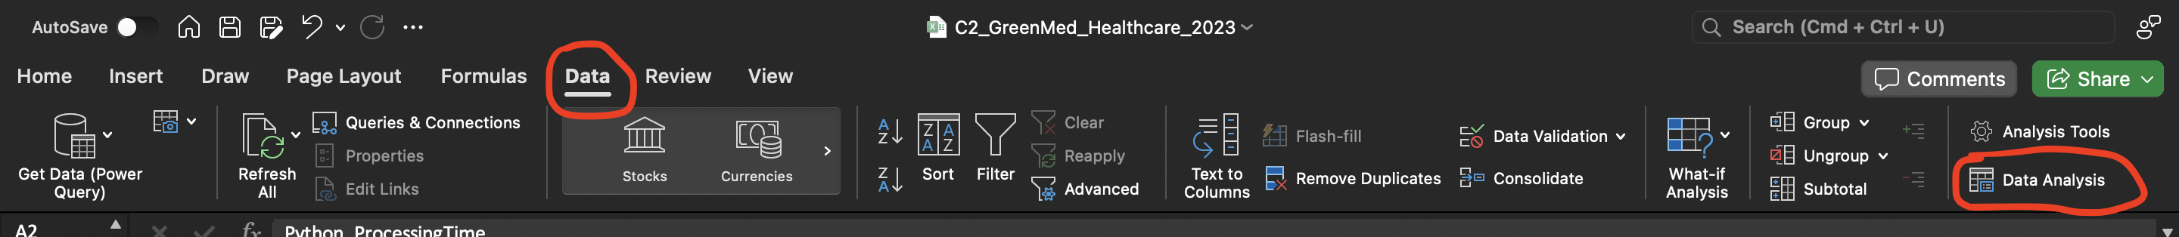
Step 3: Clicking on the Data analysis to derive a dialogue box with a correlation
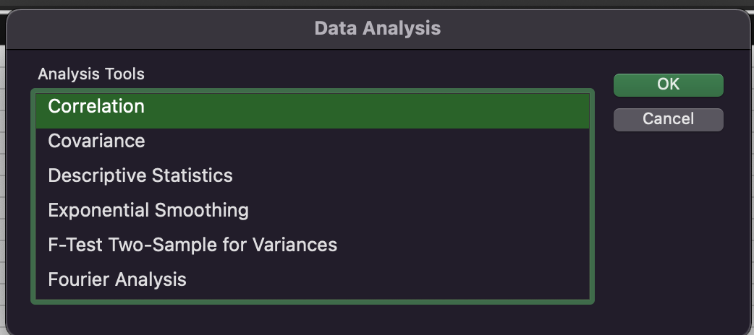
Step 4: Another Dialogue will be open to evaluating proper value and fill up the remaining details
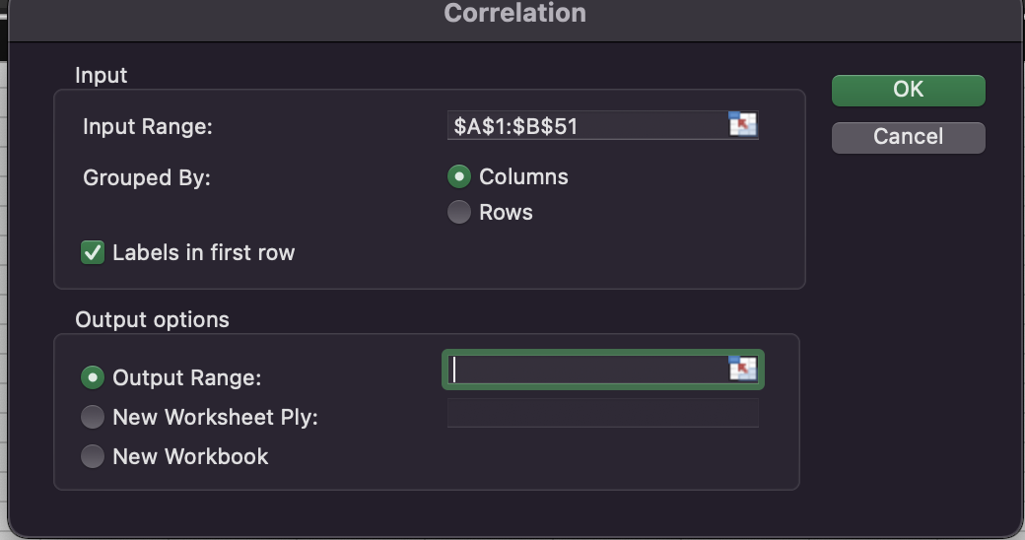
Step 5: Select input Range
$A$3: $B$52 This is the input range for calculating the correlation
Step 6: Clicking on labels in the first row and put output range for computing correlation
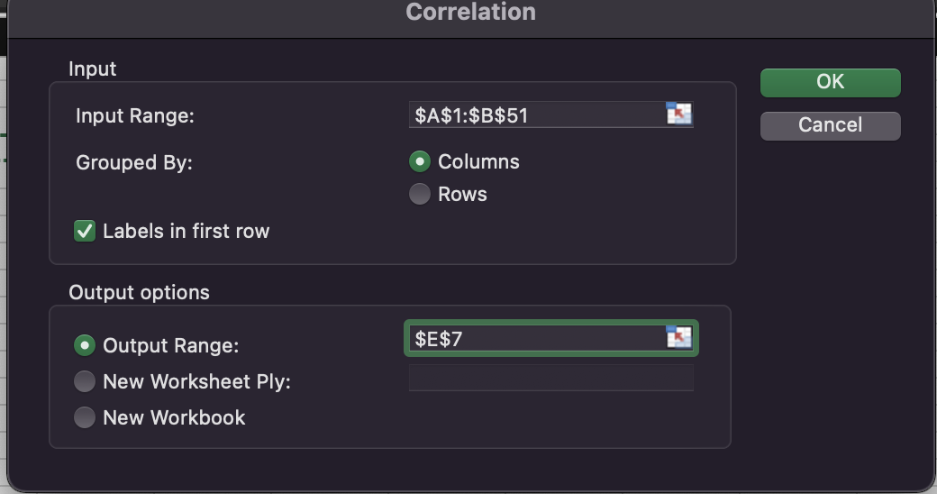
$E$7 is the output range for calculating the correlation value
Step 7: Computed correlation table from the data set
 | Hadoop_ProcessingTime | Tableau_ProcessingTime
Hadoop_ProcessingTime | 1
Tableau_ProcessingTime | 0.17783816 | 1

Step 8: Developing Correlation data by adjusting the decimal place
 | Hadoop_ProcessingTime | Tableau_ProcessingTime
Hadoop_ProcessingTime | 1 | 0.18
Tableau_ProcessingTime | 0.18 | 1

r = 0.18 [Answer]
Analysis: The correlation between Tableau as well as Hadoop depends on their complementary roles in handling as well as examining data while dealing with a large volume of data. However, it can be seen from the above estimation that the correlation between Hadoop as well as Tableau has been detected in the form of r. The correlation will be estimated through the configured data analysis tool in Excel. After that, click on the Data analysis for deriving a dialogue box with correlation. However, different steps to estimate the correlation have been presented in the above chapter. In addition to that, it can be seen from the above section that different steps to determine the correlation between Hadoop and Tableau have been presented here. By using the accurate input and formula, the value of r has been detected as 0.18.
C2. Scatter plot diagram for evaluating Hadoop processing time and Tableau processing time

Figure: Hadoop and Tableau Processing Time
Source: Self-created
Analysis: The above-mentioned scatter diagram is prepared to showcase the scatterplot of two variables Hadoop Processing time as well as Tableau Processing time. The above chart also indicates the relationship between these two variables. However, each point on the plot resembles one observation in the data set. Moreover, each point is also placed on the basis of its values for the purpose of differentiating two variables.

Part 2

A) Discussing the benefits and drawbacks of using Excel and SPSS using relevant real-life examples
1. SPSS (Statistical Percentage for Social Science)
Benefits
Statistical analysis: SPSS is introduced for the purpose of statistical analysis which makes it powerful for various huge tasks such as regression analysis, data mining as well as hypothesis testing (Bryant, 2021). For instance, the researchers of psychology may utilise SPSS for the purpose of examining the data gathered from the survey to determine correlations between several variables.
Data management: SPSS has attributes for data management such as data transformation, manipulation as well as cleaning. It is generally useful while negotiating with large kind of data sets. For instance, a market researcher may also utilise SPSS for the purpose of cleaning as well as organising consumer data before directing analysis.
Drawbacks
Steep learning curve: The implementation and utilisation of SPSS is difficult for beginners as it needs effort as well as time to understand and master its numerous functionalities. The users of SPSS basically need effective training as well as widespread study to use its full potential efficiently (Lindquist and Sulewski, 2020).
Limited visualisation opportunities: SPSS delivers some basic or normal visualisation tools but it lacks the developed features and customisation options which is found in visualisation tools such as Tableau.
2. Excel
Benefits
Marcos and templates: One of the key benefits of Excel is that this has macros as well as templates. However, Macros enable users to automate repetitive tasks for the purpose of saving time while templates are prearranged files with procurator data for easy utilisation. Some of the key examples involve budgeting spreadsheets to create budgets for a company, vacation planning spreadsheets with tabs for days, months and note sections for activities, packing lists and travel plans (Rangkuti and Harahap, 2020).
Security and control: One of the key benefits of utilising Excel is that users have more control over the information and data. For instance, each file can be protected via password as well as only unlocked with a password which indicates it is more difficult for strangers to access without authority or accidentally unlocking the spreadsheet which contains necessary and sensitive information (Sadriddinovich, 2023).
Drawbacks
Data and growth: One of the key issues with Excel is that this is not able to handle more than 1000 rows without decelerating to crawling. It also enforces limitations on the size of the file but there are various ways for this. The key aspect is not to surrender if an individual finds himself in one of these conditions. Instead of looking at the tools accessible in Excel and using them efficiently to get their intended effect.
Difficult to learn: Another drawback of Excel is that it is tough to learn due to its various features like functions, keyboard shortcuts as well as formulas (Sadriddinovich, 2023). In addition to that, this drawback may be improved with Excel tutorials to begin quickly with daily practice and an effective learning procedure.
Calculation errors: One of the limitations of Excel is that there are numerous errors in estimations. For example, when operating with percentages and fractions, the decimal point can be misdirected and it could result in an error in the screen. It is tough for those who do not understand and know what needs to be done to address the problem.

B) Illustrating the significance of data governance with examples
Data governance is denoted as the procedure of managing as well as controlling the usability, integrity, security as well as availability of the data in the commercial context. It is based on the policies as well as internal standards that control data utilisation. Efficient data government make sure that the data is trustworthy and consistent along with does not get misrepresented. It is significantly crucial as business entities experience increasing data privacy rules and depend more on data analytics for the purpose of optimising operations as well as driving commercial decision-making (Anlesinya and Dadzie, 2023). However, the worth or importance of data governance along with its examples has been reflected in the below context.
Data quality enhancement: Inconsistent as well as inaccurate data can result in defective business operational decisions. However, data governance sets up standards for consistency, completeness as well as data accuracy. For example, a retail firm may execute rules to make sure that descriptions as well as names of the products are consistent around all databases as well as systems (Pallant, 2020).
Cost reduction: Poor data management practices can also lead to an increase in unnecessary expenses. Data governance assists in streamlining data procedures, reducing redundancy as well as eliminating data errors (Plotkin, 2020). Business entities can save huge resources by reducing duplicate efforts as well as optimising storage.
Access control and security: Any kind of unauthorised access to necessary or crucial data generates security risks. However, data governance illustrates user roles, permissions as well as access policies. For instance, a healthcare business may restrict authority to patient details to authorised medical workers only.
Compliance and risk management: Business entities can experience legal issues due to non-compliance with regulations such as HIPAA as well as GDPR. However, data governance guarantees compliance with various data privacy regulations and rules (Pallant, 2020). Business entities can track extraction, maintain audits as well as validate compliance during regulatory audits.
Developed decision-making: Data governance also guarantees that decision-makers have the authority to reliable as well as high-quality data for informed and effective decision-making. For example, the implementation of data quality monitoring can help business entities achieve confidence in the correctness of their sales data which can result in efficient strategic decisions (Sadriddinovich, 2023). Along with this, data governance also fosters a sense of data stewardship as well as accountability within the business. Data stewards basically observe the execution of data awareness policies that guarantee data assets are controlled as well as managed efficiently.

Conclusion
The above context has explained several key aspects associated with understanding various key data analytical tools like Spark, Python, Tableau, and Python. The accurate utilisation of Excel has helped the individual to estimate the mean processing time, date of the highest processing, median processing time as well as standard deviation processing time. It can be concluded from the above discussion that the outcome of mean processing while using Hadoop, median processing time while using Spark, as well as the standard deviation for processing time while using Python are 2.776889208, 2.746910366, and 1.297205735 respectively. Different types of steps have also been included here to display the correlation between Hadoop as well as Tableau processing times. Different key benefits of using Excel include Marcos and templates, useful in making presentations, security and control and some key drawbacks of using Excel include data and growth, difficult to learn as well as calculation errors. The above context also concludes that some of the significance of data governance includes data quality enhancement, cost reduction, access control and security as well as compliance and risk management.

References
Anlesinya, A. and Dadzie, S.A., (2023). Technology and the Conduct of Bibliometric Literature Reviews in Management: The Software Tools, Benefits, and Challenges. In Advancing Methodologies of Conducting Literature Review in Management Domain (pp. 57-78). Emerald Publishing Limited.
Benfeldt, O., Persson, J.S. and Madsen, S., (2020). Data governance as a collective action problem. Information Systems Frontiers, 22, pp.299-313.
Bryant, L.A., (2021). Statistical skills for the workplace: A practical approach to teaching methods with Excel. The Palgrave Handbook of Political Research Pedagogy, pp.289-300.
Li, H.L., Pang, Y.H. and Liu, B., (2021). BioSeq-BLM: a platform for analyzing DNA, RNA and protein sequences based on biological language models. Nucleic acids research, 49(22), pp.e129-e129.
Lindquist, J.M. and Sulewski, C.A., (2020). Microsoft Excel: The Universal Tool of Analysis. In Handbook of Military and Defense Operations Research (pp. 19-54). Chapman and Hall/CRC.
Pacheco, M., Oliva, G., Rajbahadur, G.K. and Hassan, A., (2023). Is my transaction done yet? an empirical study of transaction processing times in the ethereum blockchain platform. ACM Transactions on Software Engineering and Methodology, 32(3), pp.1-46.
Pallant, J., (2020). SPSS survival manual: A step by step guide to data analysis using IBM SPSS. Routledge.
Plotkin, D., (2020). Data stewardship: An actionable guide to effective data management and data governance. Academic press.
Rangkuti, K. and Harahap, M., (2020). Development Of Business Analysis Learning Model Using The Microsoft Excel Application. JASc (Journal of Agribusiness Sciences), 3(2), pp.77-84.
Sadriddinovich, J.T., (2023). Capabilities of SPSS Software in High Volume Data Processing Testing. American Journal of Public Diplomacy and International Studies (2993-2157), 1(9), pp.82-86.

