UNIVERSITY OF WALES
TRINITY SAINT DAVID

Topic: Patients have been diagnosed with diabetes
(Case Study 1)

Student: Hazra Bibi:
Student number: 2420438

Programme: Skills for the Workplace Health and Social Care

Module: Introduction to Physiology BMHP5023

Lecture: Dr Gillian Weaver

28/06/25

Contents
1. Introduction 3
2. How Blood sugar levels are maintained at a safe and effective level for the body's needs 4
3. How Oxygen and Glucose produce energy through cell metabolism 5
4. Recording and tracking blood sugar levels how Type 2 diabetes can be safely managing their condition 7
5. Evidence-based recommendations 8
6. Conclusion 10
References: 11

1. Introduction
Due to its rising incidence and consequences, type 2 diabetes mellitus (T2DM) is a serious public health issue. The body becomes insulin-resistant or unable to generate enough insulin to sustain normal blood glucose levels. Long-term hyperglycaemia damages blood arteries, neurones, and key organs, increasing the risk of cardiovascular disease, renal disease, vision impairment, and lower limb issues. To manage diabetes effectively, one must understand the physiological processes that control blood glucose and sustain cellular function as well as the proper medical therapy.
Maintaining blood glucose homeostasis is crucial to the body's energy needs, as this essay explains. Insulin and glucagon use homeostatic feedback mechanisms to keep blood glucose levels safe. The subject then turns to how glucose and oxygen make ATP during cellular metabolism, which powers the body. Type 2 diabetics should record and monitor blood glucose levels to assist self-management and evidence-based clinical decision-making. The last section offers evidence-based lifestyle changes to improve glycaemic management, prevent long-term problems, and improve quality of life. These conversations cover the physiological fundamentals of Type 2 diabetes care and emphasise the need of patient education, constant monitoring, and good lifestyle strategies for long-term health.

2. How Blood sugar levels are maintained at a safe and effective level for the body's needs
Maintaining a suitable physiological range of blood glucose ensures a constant energy supply and prevents hypoglycaemia and hyperglycaemia. The brain, which runs almost entirely on glucose, needs glucose as its main energy source. Thus, the human body possesses an effective homeostatic system that monitors and adjusts blood glucose levels to metabolic demand. This regulation is mostly achieved by the coordinated actions of the pancreatic hormone’s insulin and glucagon, which keep blood glucose levels within a narrow range despite changes in food intake, physical activity, and fasting.
After eating carbs, digestive enzymes transform complex carbohydrates into glucose, which raises blood glucose levels. In reaction, pancreatic beta cells produce insulin, enabling glucose to enter muscle, adipose, and liver cells where it is either used to create ATP via cellular respiration or stored as glycogen for future energy needs. Insulin also inhibits hepatic glucose synthesis, avoiding excessive glucose release. Fasting or extended physical exercise lowers blood glucose, which causes pancreatic alpha cells to produce glucagon and accelerate liver glycogen breakdown (glycogenolysis) and glucose production (gluconeogenesis). These parallel hormonal responses provide a negative feedback system that normalises blood glucose levels and stabilises metabolism (International Diabetes Federation, 2022; NICE, 2026).
In Type 2 diabetes, this delicate mechanism is interrupted. Insulin resistance and increasing pancreatic beta-cell failure limit insulin production in the syndrome. Hyperglycaemia persists because glucose stays in the circulation instead of being delivered into cells. Hyperglycaemia damages endothelium and raises the risk of microvascular problems including retinopathy, nephropathy, and neuropathy and macrovascular consequences like cardiovascular disease and stroke if left untreated. Maintaining good glycaemic control is one of the key goals of diabetes therapy to slow disease progression and enhance health (American Diabetes Association, 2024; NICE, 2026).
NICE offers evidence-based blood glucose and HbA1c objectives to help clinicians make decisions and track glycaemic control. Table 1 shows UK clinical practice's suggested objectives.

Table 1. Recommended blood glucose and HbA1c targets for adults according to NICE guidance
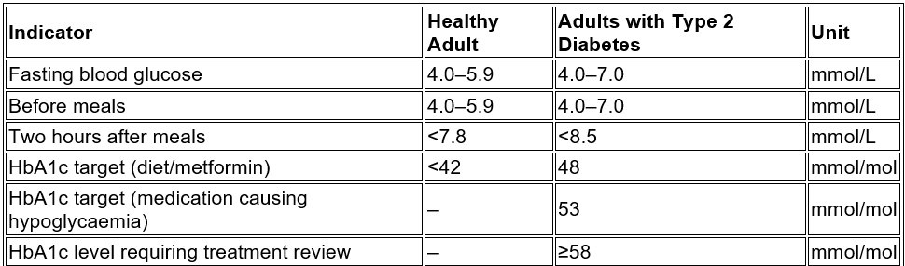
(
Source: NICE, 2026)

As shown in Table 1, glycaemic management goes beyond maintaining normal blood glucose levels to achieve personalised treatment objectives that decrease long-term consequences. To balance glucose management with the danger of hypoglycaemia, people with T2DM are allowed a slightly broader therapeutic range for fasting blood glucose than healthy adults. In addition, HbA1c measures average blood glucose over three months, making it the gold standard for diabetes monitoring. To maintain glucose homeostasis, NICE advises frequent monitoring, lifestyle changes, and pharmaceutical therapy when HbA1c reaches 58 mmol/mol. In the next part, we describe how cells use glucose during cell metabolism by understanding these physiological systems.

3. How Oxygen and Glucose produce energy through cell metabolism
After maintaining blood glucose within physiological limits, the next step is knowing how cells turn glucose into energy. Biochemical mechanisms in cell metabolism convert nutrients into ATP, the body's energy currency. Glucose is the main fuel, while oxygen is the oxidiser that releases energy effectively via aerobic respiration. This activity, mostly in mitochondria, supports physiological processes including muscular contraction, neuronal transmission, protein synthesis, and active transport across cell membranes (OpenStax, 2023; Hall and Hall, 2021).
Through specialised glucose transporters, glucose enters the cell and undergoes glycolysis in the cytoplasm, creating two pyruvate molecules and a little quantity of ATP. Pyruvate enters mitochondria and performs the Krebs cycle and electron transport chain when oxygen is adequate. Oxygen is the last electron acceptor, allowing oxidative phosphorylation to effectively generate 30–32 ATP molecules from one glucose molecule. Natural byproducts like water and carbon dioxide are eliminated by respiration and circulation. Aerobic respiration is the most efficient energy generation method, ensuring that body tissues get enough ATP to operate normally (National Center for Biotechnology Information, 2023; OpenStax, 2023).
Cells transition to anaerobic respiration during severe exercise or poor tissue perfusion when oxygen availability is low. This metabolises glucose without oxygen, creating just 2 ATP molecules per glucose molecule and lactic acid. This route produces short-term energy but is less effective than aerobic metabolism and cannot maintain physiological activity. Hyperglycaemia may compromise microvascular circulation and oxygen supply to tissues in Type 2 diabetics, affecting cellular metabolism and wound healing. These physiological alterations emphasise the need of glycaemic management and oxygen delivery for energy generation and tissue function (British Heart Foundation, 2023; Hall and Hall, 2021).
Table 2 contrasts the two main metabolic routes that generate ATP in human cells to show how glucose, oxygen, and energy production relate.

Table 2. Comparison of aerobic and anaerobic respiration in cellular energy production
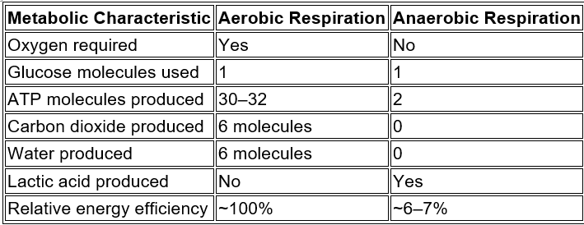
(Sources: Hall and Hall, 2021; OpenStax, 2023)

The Table 2 comparison shows that oxygen is essential for cellular energy generation. Aerobic respiration generates 15 times more ATP than anaerobic respiration from one glucose molecule, highlighting the importance of oxygen delivery through an effective cardiovascular and respiratory system for normal physiological activity. Accumulating lactic acid during anaerobic metabolism causes muscular exhaustion and lowers physical performance, whereas aerobic metabolism provides more energy with fewer metabolic effects. Thus, maintaining proper blood glucose levels and oxygen supply helps cells make ATP effectively, improving health and decreasing Type 2 diabetes metabolic consequences. This insight offers the physiological foundation for assessing the clinical effects of disruptive glucose control and diabetes treatment in the next section.

4. Recording and tracking blood sugar levels how Type 2 diabetes can be safely managing their condition
To manage Type 2 diabetes mellitus (T2DM), one must understand how blood glucose is controlled and metabolised and monitor blood glucose levels to evaluate therapy. Tracking blood sugar gives doctors and patients objective data on glycaemic management, allowing them to spot aberrant glucose variations before they become dangerous. Regular monitoring lets people see how lifestyle, nutrition, exercise, medicine, and sickness affect blood glucose throughout the day. Personalised diabetes care relies on blood glucose monitoring to assist decision-making and improve long-term clinical outcomes (NICE, 2026; American Diabetes Association, 2024).
CGM devices, finger-prick capillary blood glucose testing, and laboratory HbA1c determination are all options for blood glucose monitoring. While finger-prick testing offers rapid blood glucose concentrations, HbA1c is the most accurate measure of long-term glycaemic management since it shows the average blood glucose level over the last two to three months. Recent CGM technology allows people to monitor glucose trends, diagnose hyperglycaemia and hypoglycaemia, and get warnings when glucose levels go outside the prescribed range. These technology advances enable medication modifications before symptoms become clinically relevant, improving diabetes self-management (Diabetes UK, 2024; NIDDK, 2023).
Regular blood glucose recording inspires patient self-care and helps doctors create personalised treatment programs. Clinicians may modify medication doses, offer dietary changes, and assess lifestyle treatments by analysing glucose fluctuation patterns. A consistently high fasting blood glucose may indicate poor overnight glycaemic management, whereas recurrent postprandial increases may indicate excessive carbohydrate consumption or insufficient treatment. Maintenance of glucose records helps patients understand the relationship between daily behaviours and glucose responses, improving treatment adherence and reducing diabetes complications (International Diabetes Federation, 2022; Diabetes UK, 2024).
Clinical recommendations propose keeping blood glucose and HbA1c within evidence-based goal limits for diabetes management. In Table 3, typical monitoring markers and clinical objectives for Type 2 diabetes adults are included.

Table 3. Recommended blood glucose monitoring indicators for adults with Type 2 diabetes
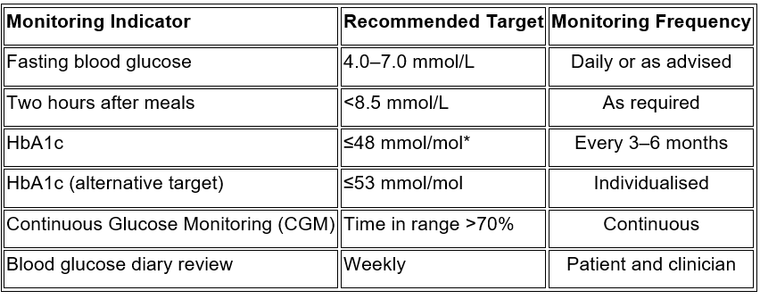
(Sources: 2026; Diabetes UK, 2024; American Diabetes Association, 2024)

Target for many individuals treated with lifestyle change or metformin depending on circumstances.
As shown in Table 3, optimal diabetes care requires regular blood glucose monitoring, long-term HbA1c evaluation, and, where necessary, continuous glucose monitoring. Daily glucose readings allow prompt treatment choices, whereas HbA1c gives a longer-term assessment of glycaemic management. These aims improve cardiovascular, renal, and neurological health and prevent hyperglycaemia, hypoglycaemia, and diabetic complications. Systematic blood glucose monitoring and interpretation allow patients and healthcare providers to make evidence-based therapeutic choices that enhance safety, treatment efficacy, and quality of life. This focus on patient-centered monitoring naturally leads to evaluating how healthcare professionals may help Type 2 diabetics via education, evaluation, and multidisciplinary treatment.

5. Evidence-based recommendations
Along with frequent blood glucose monitoring, Type 2 diabetes mellitus (T2DM) care involves sustained lifestyle changes to address the root reasons of poor glycaemic control. Although medication is important for many people, diet, physical activity, and smoking cessation can improve insulin sensitivity, lower blood glucose, and reduce diabetes complications. Instead of short-term therapies that may not endure, healthcare providers should urge patients to make realistic and sustainable lifestyle changes (NICE, 2026).
One of the best diets is one rich in whole grains, vegetables, fruit, lean protein, and healthy unsaturated fats and low in processed carbohydrates and saturated fats. Regular mealtimes and portion management may further minimise blood glucose spikes. At least 150 minutes of moderate intensity exercise each week helps persons with T2DM control weight, glucose absorption by skeletal muscles, and insulin sensitivity. Stopping smoking is also important since it accelerates cardiovascular disease, lowers blood circulation, and increases diabetes problems. Weight management, stress management, alcohol reduction, and sleep enhance metabolic regulation and general health. For optimal adherence and long-term success, these guidelines should be adjusted to each patient's health, preferences, and objectives. With lifestyle changes, frequent monitoring, and proper medication care, T2DM patients may improve their glycaemic control, complications, and quality of life. The conclusion discusses this report's primary conclusions using these evidence-based suggestions.

6. Conclusion
This study shows that regular blood glucose levels are essential for health and Type 2 diabetes prevention. Insulin and glucagon work together to control glucose homeostasis, keeping blood glucose within a safe physiological range despite changes in food and energy demand. Chronic hyperglycaemia increases the risk of significant microvascular and macrovascular consequences when insulin resistance and decreased insulin production disrupt this regulating system.
The paper also explored how glucose and oxygen combine to make ATP, showing that aerobic respiration in the mitochondria provides the most energy for proper cellular activity. Insufficient oxygen lowers ATP generation, showing the strong link between glucose management, oxygen delivery, and metabolic health. Healthcare providers need to understand these physiological processes to explain diabetes treatment to patients and promote evidence-based clinical practice.
According to the research, finger-prick testing, continuous glucose monitoring, and HbA1c measurement are crucial for blood glucose monitoring. Patients and healthcare providers may assess treatment efficacy, recognise aberrant glucose patterns, and alter medication, food, and exercise with regular monitoring. The patient-centered approach promotes self-management and reduces unnecessary diabetic complications.
Finally, long-term diabetes care requires evidence-based lifestyle therapies such a balanced diet, frequent exercise, healthy weight control, and smoking cessation. With frequent blood glucose monitoring and pharmaceutical therapy, these approaches increase insulin sensitivity, glycaemic management, and quality of life. The integrated management of Type 2 diabetes requires physiological understanding, continuous monitoring, and sustainable lifestyle modification to reduce complications and improve long-term health outcomes.

References:

American Diabetes Association (2024) Standards of Care in Diabetes-2024. Diabetes Care, 47(Suppl. 1). Available at: https://diabetesjournals.org/care/issue/47/Supplement_1 (Accessed: 25/06/2026).

British Heart Foundation (2023) How oxygen is transported around the body. Available at: https://www.bhf.org.uk/informationsupport/heart-matters-magazine/medical/how-your-heart-works (Accessed: 25/06/2026).

Diabetes UK (2024) Managing your blood glucose levels. Available at: https://www.diabetes.org.uk/about-diabetes/managing-your-diabetes (Accessed: 26/06/2026).

Hall, J.E. and Hall, M.E. (2021) Guyton and Hall Textbook of Medical Physiology. 15th edn. Philadelphia: Elsevier. Available at: https://www.elsevier.com/books/guyton-and-hall-textbook-of-medical-physiology/9780323790052 (Accessed: 26/06/2026).

International Diabetes Federation (2022) IDF Diabetes Atlas. 10th edn. Brussels: International Diabetes Federation. Available at: https://diabetesatlas.org (Accessed: 25/06/2026).

National Center for Biotechnology Information (2023) Cellular Respiration. In: StatPearls. Treasure Island, FL: StatPearls Publishing. Available at: https://www.ncbi.nlm.nih.gov/books/NBK553175/ (Accessed: 24/06/2026).

National Institute for Health and Care Excellence (2026) Blood glucose management. Available at: https://www.nice.org.uk/guidance/ng28/chapter/Blood-glucose-management (Accessed: 24/06/2026).

National Institute for Health and Care Excellence (2026) Type 2 diabetes in adults: management (NG28). Available at: https://www.nice.org.uk/guidance/ng28 (Accessed: 26/06/2026).

National Institute for Health and Care Excellence (2026) Type 2 diabetes in adults: management (NG28). Available at: https://www.nice.org.uk/guidance/ng28 (Accessed: 25/06/2026).

National Institute of Diabetes and Digestive and Kidney Diseases (2023) Managing Diabetes. Available at: https://www.niddk.nih.gov/health-information/diabetes/overview/managing-diabetes (Accessed: 25/06/2026).

OpenStax (2023) Biology 2e: Cellular Respiration. Available at: https://openstax.org/books/biology-2e/pages/7-2-glycolysis (Accessed: 24/06/2026).

World Health Organization (2023) Diabetes: Key facts. Available at: https://www.who.int/news-room/fact-sheets/detail/diabetes (Accessed: 25/06/2026).

