Pathway Project 1
Lecturer:Mr Ze Zook
1604693
annmarie francis
[Year]
Contents
0
Introduction 2
Delegation 2
Interpersonal Communication 3
Listening skills 3
Problem Solving 3
Verbal communication 3
Nonverbal communication 4
Negotiation 4
Assertiveness 4
Networking 4
Knowledge 6
Problem Solving 10
Conclusion 11
References 12

Introduction
In my essay, I will reflect on how we as a team collaborated to deliver our presentation to Lecturers and The group. Our subject was Sustainability Environment and Globalisation in the tourism and hotel sector. Working in our chosen group of four we were required to present a ten-minute presentation with needed research knowledge and findings; we also had to display problem-solving skills in comparative global settings. There will also be a learning log Documenting our interaction as a group and to show off all of our employability skills.

Delegation
Surround yourself with the most exceptional individuals there is, assign abilities, and don't hinder by way of the policy you are sure upon is being carried out. (Quote, 2017)
Time Delegation was very challenging at times. Between us four ladies we had twelve children, Jobs and life responsibility. Our first meetings where after class every Monday afternoon this would give me one hour before I pick up my children from school. We made sure every session was detailed and progressive everyone always came prepared.
We set up a mini schedule to meet every lesson for at least one hour after class on Mondays which we all kept too. The Team all decided on the business the Premier Inn where we all collectively were going to research all aspects of our presentation. We had a strategy in how we built our slides, everyone brought their research to the table, and we collectively chose what we all thought was the best of the study to construct each slide.
Delegation model indicates progression a leader transfers various duties to other team members to implement the vision succeeding at the highest result. (Anon., ) By this term, Melonie was our leader, but we all became leaders through the way we jelled together.
Decision making and being assertive became a joint venture, our leader was very open to us stepping up and leading ourselves, but we were always required to report everything back to her. Melonie believed in her team.

Interpersonal Communication
Active communication more than swapping Knowledge. You can Identify feelings and values on the evidence. As well as evidently communicate the message. Listening systems that gain the full sense of the essence articulated this helps both parties to comprehend and identify. (Helpguide.org, 2017)
The communication I believe was the critical factor in us being able to merge our ideas and execute our presentation. There was never a time we didn’t disagree especially Melonie Nelson and me( I've known Melonie for twenty-five years), but we always agreed in the end due to the other two level-headed ladies whos contributions where diplomatic and fare.
Melonie was the team leader in this project and a great one at that. We all collectively came together and gave ideas and built our presentation without being directed; it was almost as if we all had the team leader role.
As a team, we worked jointly researching and sharing Ideas which felt natural and organic; it was effortless to express how we felt about each other's findings and so became very easy to produce the slides and the quality of work that went into the presentation. Feeling relaxed and confident amongst my peers gave me confidence in my work which I haven't had before.
Interpersonal communication is a trade of knowledge amongst two people. The interpersonal discussion is part of the study. Communication skills are progressed and can be enhanced or improved with increased education and practice. (Anon., )
Here are some of the communication skills that were displayed by the team.
- Listening skills
- Problem-solving
- Verbal Communication
- Nonverbal Communication
- Negotiation
- Assertiveness
- Decision Making

Listening skills
The ability to accurately receive and interpret messages in the communication process.

Problem Solving
Defining the problem, generating alternatives ideas, implementing solutions.

Verbal communication
The ability to communicate through words with a correct tone and manner

Nonverbal communication
facial expressions, body language, and hand gestures.

Negotiation
Having the skill to deliberate and reach an agreement professionally.

Assertiveness
Being able to articulate thoughts in an honest, clear-cut and accurate way.

Decision making
Evaluate, make effective decisions, achieve short and long-term goals.

Networking
“You don’t build the business – you build people – and then people build business” (partnership, 2017)
Being a parent with five Children and a job I believe prepared me for this presentation. I have to be disciplined and organized and no what indeed was essential and this reflected in the group work. Communication skills were vital and united us as a group in ways that surpassed us all.
The team started off with a WhatsApp group which we named Project Pathway; we exchanged everything on this app from work to timekeeping to group meetings this was the most efficient way to communicate and update each other.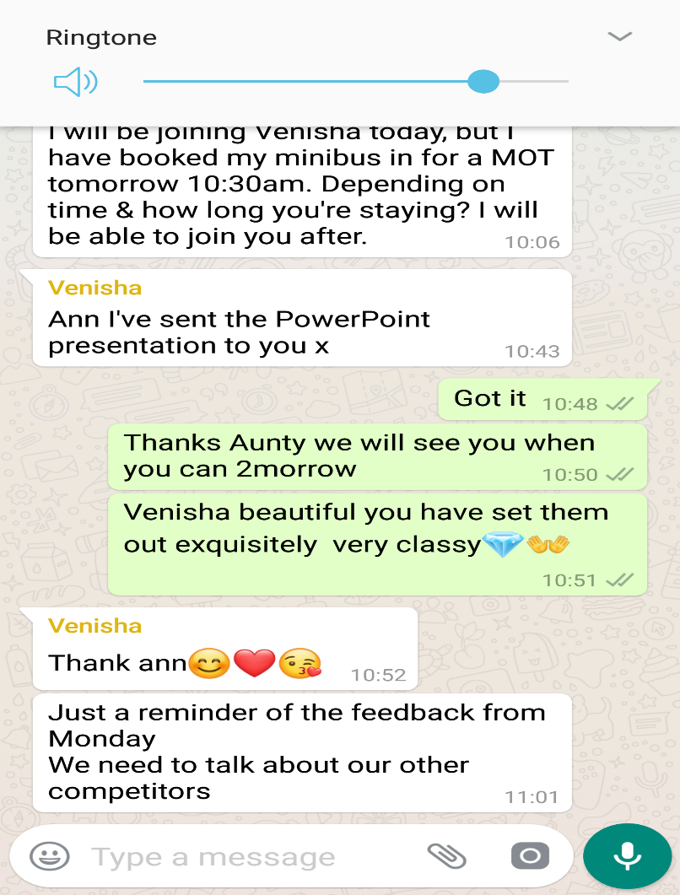
We also used other resources such as Skype. We would hold business meetings in synchronized times mostly after nine when all children have gone to bed. We catch up on where each other was with their research and slides. We often enjoyed the Skype meetings because this is a time where we call it mummy time (usually that’s lonely no communication glad the kids have gone to bed)
PowerPoint Microsoft outlook is where we shared and prepared our slides for this presentation. With this app, we all could edit at any time. Sometimes there would be two to three of us adding and deleting the work.
Smart technology covers a distinct field of analysis from difficult devices applying optoelectronics and methods of censoring structural reliability to research into molecularly original materials. Smart technology is still primary that promises substantial advantages in a wide range of business sectors. (Margaret R, 2017)
The use of laptops and desktop computers where our primary materials for preparing our work. Phones and tablets were also used to communicate and schedule meetings.

Knowledge
According to learning styles, (online.com, 2017) Everyone has a Combination of learning style. At times one may find that they have a leading form of learning, With less use of the other methods. Others may see that they use different ways in different circumstances. There is no right mix.
The teams learning styles where evident, we did kolbs teaching styles model in a previous assignment so we could identify each other's teaching techniques. Venisha was Reflector and pragmatist (Very focused and calming assertive when the need is)myself was reflector(Analytical and Observant and listening to my surroundings, but I am also an Activist (Enthusiastic learner who learns by doing.) Team leader Melonie learning method is a pragmatist(An efficient person who looks for the quickest way to solve the problem), Aunty Jean is an Activist ( An activist likes to do, be the first one to jump in and try). As a team, all our methods merge beautifully.
According to (Rumson, 2015) Honey and Mumford learning styles were improved by Peter Honey and Alan Mumford in 1986. Their creation is motivated from and built upon Kolb’s learning model (Leaver, 2005). They also produced their Learning Styles Survey.
Premier Inn Sustainability Environment and Globalisation in the tourism and hotel chain is the name of our presentation. Melonie bought the idea of us doing a hotel chain which we all agreed on and chose Premier Inn. We all went away and researched Premier Inn separately. There was a method in which we set up our slides and emerged the work together. Answering all the question that asked on the presentation worksheet. We Organise all of our Knowledge that we gathered into the right order. So we had a total of four slides each to produce.

I also used a swot analysis to arrange information gathered from the group presentation and reflective experience.
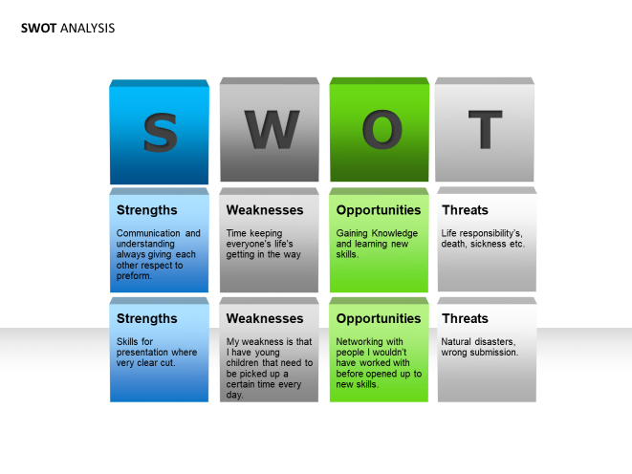

So that we could have some primary first-hand data, we decided to take a visit to our local Premier Inn and ask some questions about the services they offered. Premier Inn is such a clean and professional environment the staff first hand where very informative and welcoming.
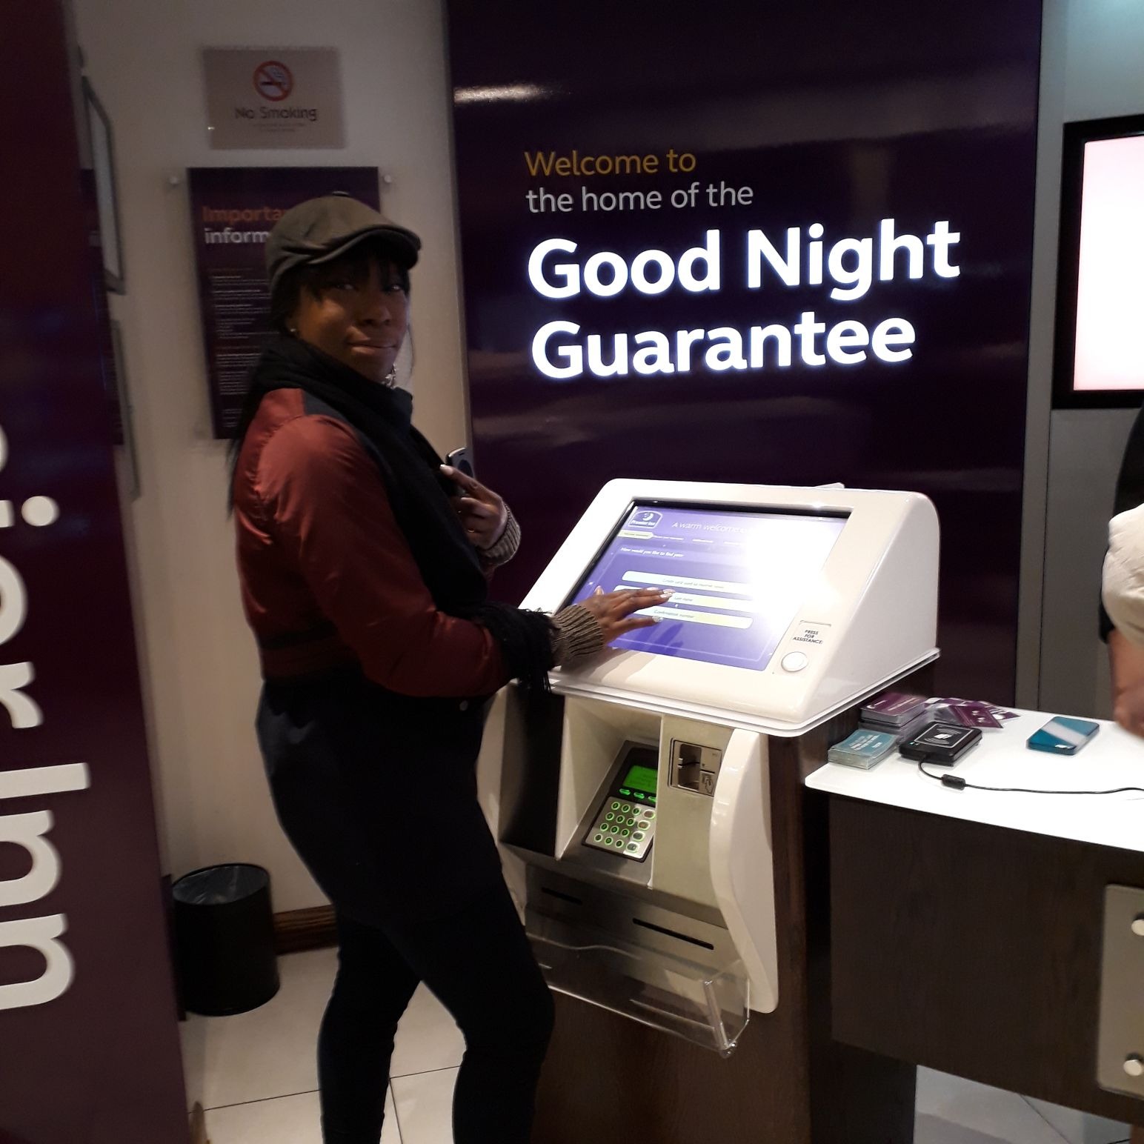
Onsite we met a Customer Service employee named Mohamed he worked at the front desk. Mohamed was very informative about everything premiere Inn.
Melonie had prepared a list of questions we wanted to ask. Example; how much does it cost for you to add a person to your room at last notice. How much is the breakfast etc.? Mohamed showed us around the building we got to see the restaurant where they do the prize-winning breakfast and lunches. We also got to see their new Checking in the machine for those who just want to check themselves in hassle-free quickly.
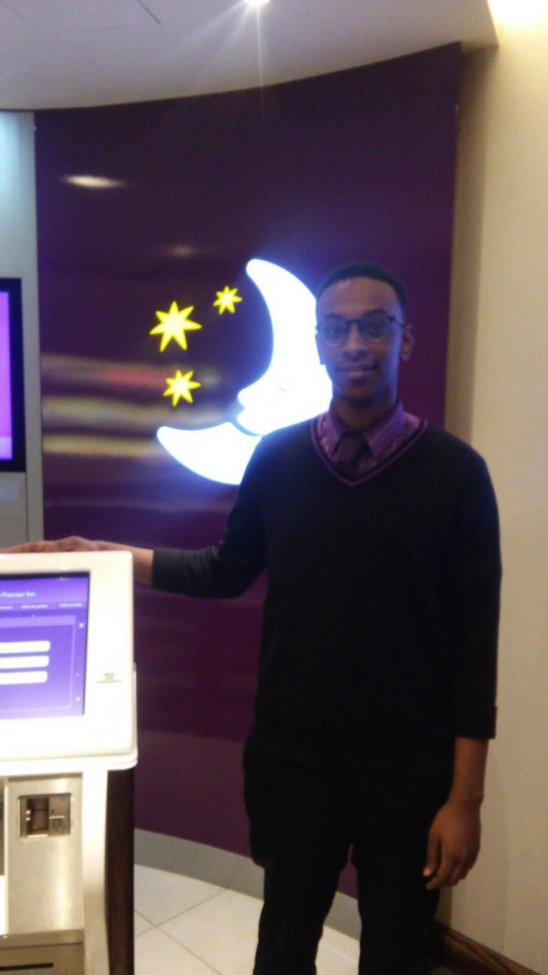
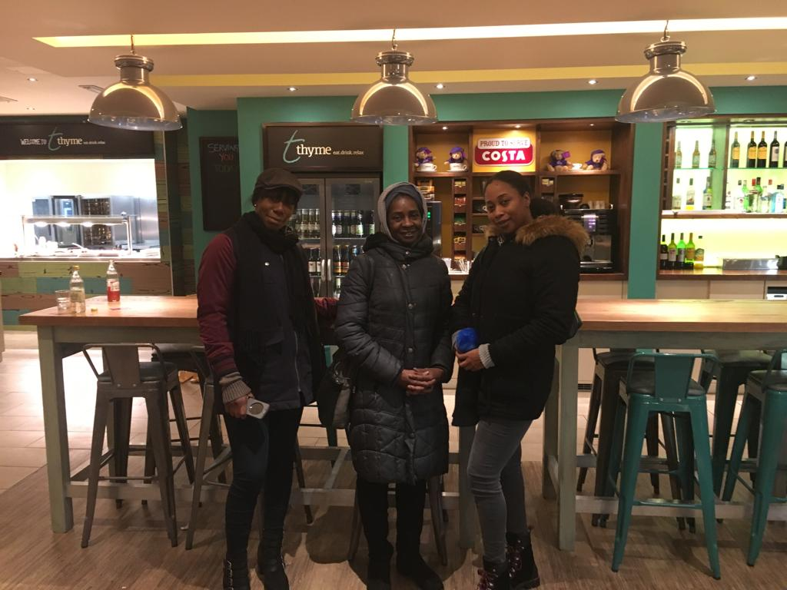
There was a question asked by the worksheet., What is an Effective Global citizen? According to Oxfam, (Oxfam, 2017), a global citizen is somebody who is mindful of and values the world - and their status in it. Global citizens take an official view of the public eye and work with others to make the world more equal, fair and sustainable.
Learning about global citizen has been very inspiring, there are many leaders and global motivational figures in the public eye who are amazing global citizens. Nelson Mandella is an excellent example of a worldwide Citizen, a man that spent his life doing good for others. Nelson Mandela jailed for twenty-seven years; he served time for standing up for his human rights abuses committed to apartheid government against his people black South Africans. Nelson Mandela is stated to have said “What counts in life is not the mere fact that we have lived. It is what difference we have made to the lives of others” (Loftus, 2017)“

Problem Solving
According to (University, 2013)Logical and detailed theory services help you to evaluate the issue and to make decisions. A consistent and methodical approach is, best in some circumstances.
There where many times in this group that we had to use alternative skills and abilities to solve many problems that we came up against, for example: Finding alternative solutions to Meeting up in University, Schedules changing last minute. The group also experienced death twice. Venicha grandfather passed away on the fifteenth of November at the beginning of the term, to Melonie on the day of our presentation she got the sad news that her Uncle her Mums brother had died. On the morning of the performance, I got into Leadership mode and prepared everyone's notes and delegated Melonie's parts of the presentation to others. We all also let Melonie no that we supported her and if she didn’t want to read, her just being there and us helping her would be good for her. Melonie showed up and gave an excellent performance in the presentation.

Conclusion
This reflective essay has shown how my team and I have worked together in an academic environment to produce a knowledge filled presentation on Sustainability Environment and Globalisation in the tourism and hotel sector. I have displayed the way we have communicated and used interpersonal skills throughout the assignment.
The Delegation and leadership in this paper showed and explained through Knowledge. Networking and smart technology also were exhibited and illustrated in this assignment. The Knowledge and the way it received in this research for the essay, and also shows the way the education organized.
The implementation of Problem-solving skills and how we tackled this in our group, represented in the essay. Doing this presentation and assignment has been life-changing for me. I have had many lessons in strength and understanding reflecting. As a team, we worked so well together and merged in such a natural way. I lost a son December 2015 and used University as an escape from my feelings. Having the lost we had as a group made me open up in a way I never knew I could and brought us in the team closer together. Being able to perform even when everything around you goes wrong showed strong, ambitious Individuals I am now proud to call my friends.

References
Anon., Delegation Theory. [Online]
Available at: http://en.wikipedia.org/wiki/Delegation_Theory
[Accessed 6 12 2017].
Anon., . Interpersonal communication. [Online]
Available at: http://en.wikipedia.org/wiki/Interpersonal_communication
[Accessed 23 12 2017].
Helpguide.org, 2017. Effective communication. [Online]
Available at: https://www.helpguide.org/articles/relationships-communication/effective-communication.htm
[Accessed Wednessday December 2017].
Loftus, M., 2017. World bicycle relief. [Online]
Available at: https://worldbicyclerelief.org/en/nelson-mandela-day/?gclid=EAIaIQobChMI16vwxJ2i2AIVb7XtCh2PBAaGEAAYASAAEgKMW_D_BwE#
[Accessed Sunday December 2017].
Margaret R, S., 2017. Science Direct. [Online]
Available at: http://www.sciencedirect.com/science/article/pii/016649729596613X
[Accessed Thursday, December 2017].
online.com, l.-. s., 2017. [Online]
Available at: https://www.learning-styles-online.com/overview/
[Accessed Saturday December 2017].
Oxfam, 2017. oxfam. [Online]
Available at: https://www.oxfam.org.uk/education/who-we-are/what-is-global-citizenship
[Accessed Saturday, December 2017].
Partnership, w. a. r., 2017. zig zigular. [Online]
Available at: http://wrpartnership.com/you-dont-build-a-business-you-build-people-and-then-people-build-your-business/
[Accessed Wednesday December 2017].
Quote, B., 2017. Brainy Quote Ronald Reagan. [Online]
Available at: https://www.brainyquote.com/authors/ronald_reagan
[Accessed Wednesday December 2017].
Rumson, R., 2015. E-Learning network. [Online]
Available at: https://resources.eln.io/honey-and-mumford-learning-styles/
[Accessed Saturday December 2017].
University, T. U. E., 2013. University of Kent. [Online]
Available at: https://www.kent.ac.uk/careers/sk/problem-solving-skills.htm
[Accessed Thursday December 2017].

Appendix
learning log

Questions |  | Answers | Questions |  | Answers | Questions | Answers
1.How did we work together? |  | Today was our first meeting my team are cool down to earth | 5.Did you meet often? |  | First meeting | 9. How well did I do? | Well I bought my ideas, and they were received
2. who did what? |  | Formed group TL,MEL, Ann,Venish. Jean. | 6. did you use skype |  | .no | 10. What have I gained from this activity? | A wider outlook
3. What went wrong? | Nothing at this time |  | 7. did the skype work well? |  |  | 11. What could I have done differently? | nothing
4.what went well? | We all got on well |  | 8. Did we have technical problems online? |  |  | 12. what could I have improved. | Talking up as soon as we got together

Questions |  | Answers | Questions |  | Answers | Questions | Answers
1.How did we work together? |  | Well lots of ideas | 5.Did you meet often? |  | Seconf meeting | 9. How well did I do? | Well I was able to be vocal from get go
2. who did what? |  | We divided up the work | 6. did you use skype |  | no | 10. What have I gained from this activity? | Im developing new friedships
3. What went wrong? | Being late trains delay |  | 7. did the skype work well? |  |  | 11. What could I have done differently? | Had more time to come together
4.what went well? | A lot of research brought forward |  | 8. Did we have technical problems online? |  |  | What could I have improved? | nothing

Questions |  | Answers | Questions |  | Answers | Questions | Answers
1.How did we work together? |  | well | 5.Did you meet often? |  | yes | 9. How well did I do? | I did well I had patients
2. who did what? |  | Sustainable and global citizen debate | 6. did you use skype |  | yes | 10. What have I gained from this activity? | I got knowledge of skype
3. What went wrong? | internet |  | 7. did the skype work well? | Not really it took about an hour to get up and to run |  | 11. What could I have done differently? | Had a lot more time for skype meeting
4.what went well? | We had a meeting without actually meeting |  | 8. Did we have technical problems online? | Yes connection was always breaking down |  | What could I have improved? | The communcation with everyone

