
BA (Hons) International Hotel Management
Module Name: Hotel Placement Research Project
Module Code: BMIH6008
Research Title: Enhancing Food and Beverage Service Efficiency at Premier Inn Dunstable South A5: Challenges and Opportunities

Student Name: Syed Jahangir Bakth
Student ID: 2026520
Supervisor Name: Dr. Ernest Balutie Wavei

AI Declaration
I confirm that I have not used any AI tools in the research and creation of this assignment. I confirm that I have not presented any AI-generated materials as my own work. I confirm I have copies of my drafts, notes, and other resources I used, which I may be asked to provide in evidence
Abstract
This study investigated Premier Inn Dunstable South A5's food and beverage, operational performance, customer satisfaction, and improvement targets. Service quality, operational difficulties, and efficiency improvements were investigated utilising qualitative and secondary data. This analysis found that service speed, menu choices, and staff efficiency affect customer satisfaction. The study revealed that outdated technology, staff training gaps, and menu optimisation concerns limit food and beverage service. Mobile ordering, self-service kiosks, and automated inventory systems save money. Staff training in customer contact, food safety, and cross-role competencies would boost customer satisfaction.
This study also indicated that menu optimisation based on customer preferences and seasonal trends could enhance profits and satisfaction. Nutritional options and changeable pricing may attract customers. Customer retention and long-term partnerships would improve with digital feedback and loyalty programs. Waste control, energy-efficient cooking, and local sourcing save money and the environment. Safety and hygiene are essential for guest trust, especially considering health concerns. Technology, staff training, menu optimisation, sustainability, and customer involvement are advised. These ideas may help Premier Inn Dunstable South A5 boost operational efficiency, customer satisfaction, and profits in a competitive hospitality business.

Table of Contents
Abstract 2
Introduction 5
Research Background 5
Aims, objectives and Questions 5
Case Study Overview 6
Key Topic: Food and Beverage 7
Literature Review 8
Importance of food and beverage operation 8
Operational Challenges in Food and Beverage Service Efficiency 8
Customer Satisfaction and Food and Beverage Service Efficiency 9
Strategies to Improve Food and Beverage Service Efficiency 10
Research Gap 10
Summary 11
Methods 12
Case study methodological approach 12
Netnography 13
Case Study Hotel 16
Descriptive information 16
SWOT Analysis 17
PEST Analysis 19
Competitor Analysis (Price vs Quality) 21
Reflective Account 22
Discussion 24
Customer Satisfaction and Food and Beverage Services 24
Food and Beverage Service Strategies Impacting Customer Satisfaction 25
Operational Challenges Affecting Efficiency 27
Strategies to Enhance Food and Beverage Service Efficiency 28
Implications of the Study 29
Limitations of the Study 30
Valuable Areas Critical to the Placement Hotel Operation 30
Conclusion and Recommendations 32
Conclusion 32
Recommendations and Practical Strategies 33
References 36

Introduction
Research Background
Hotel food and beverage service efficiency affects customer satisfaction. According to Mordor Intelligence (2024), 40% of hotel revenue comes from food and drink. Premier Inn Dunstable South A5 serves food and drinks like other hotels. Workforce, supply chain, and environmental constraints may impair service efficiency. According to Hotelsmag.com (2023), 32% of hotel customers were satisfied with slow food service, highlighting the need for operational efficiency. These problems affect Premier Inn Dunstable South A5, a business and leisure hotel. Food quality and quickness are the hotel's competitive advantages, affecting client loyalty and repeat business. Food and service drew 68% of hotel customers back (Xeinadin.com, 2024). Food and beverage service efficiency at Premier Inn Dunstable South A5 will be evaluated for people, training, and supply chain management. The study will also examine how these factors affect customer satisfaction and suggest methods to improve service for all.
Aims, objectives and Questions.
Aim
- The research aims to analyse food and beverage service efficiency at Premier Inn Dunstable South A5.
Objectives
- To conduct an extant literature review of food and beverage service efficiency in the hospitality sector.
- To examine customer satisfaction levels related to food and beverage services at Premier Inn Dunstable South A5.
- To identify operational challenges affecting food and beverage service efficiency at Premier Inn Dunstable South A5.
- To make recommendations for improving food and beverage service operations at Premier Inn Dunstable South A5.

Questions
- How do food and beverage service strategies impact customer satisfaction at Premier Inn Dunstable South A5?
- What operational challenges affect the efficiency of food and beverage services at Premier Inn Dunstable South A5?
Case Study Overview
The case study examines Premier Inn Dunstable South A5, a budget-friendly, high-quality hotel. Premier Inn is one of the prominent hotel brands in the UK. The hotel welcomes families, business travellers, and visitors at Watling Street, Caddington, Dunstable, LU6 3QP (Premierinn.com, 2024). Hotels serve varied guest’s meals and drinks. Popular Premier Inn hotels prioritise cuisine, drink, and service. Hotels struggle to provide good service due to increased customer demands and industry competition (Tripadvisor.com, 2025). Thus, this case study investigates service delivery and suggests food and beverage efficiency improvements.
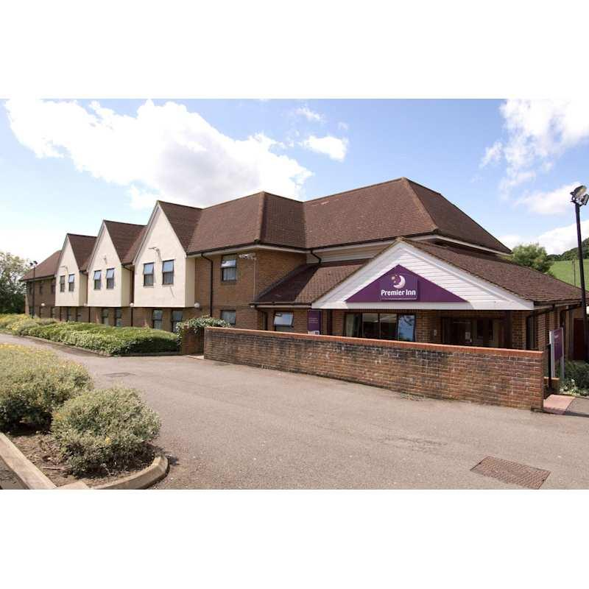
Figure 1: Premier Inn Dunstable South A5
Source: (Premierinn.com, 2024)
Key Topic: Food and Beverage
Hotels' food and beverage service efficiency is studied in this project. Effective service delivers fast, tasty food and drink, making customers happy. Visitors enjoy breakfast, snacks, and drinks at Premier Inn Dunstable South A5. Food and beverage companies will address personnel management, delivery, inventory control, and customer feedback (Nieuwenhuizen, Bursey and Geldenhuys, 2019). The study focusses on process efficiency for customer satisfaction and operations. Hotel food and beverage service staffing, training, and equipment are examined in the study. Customer satisfaction can be harmed by excessive wait times, inaccurate orders, and poor food. The study will address these issues and recommend service enhancements.

Literature Review
Food and beverage service industry efficiency affects UK hospitality's customer happiness and operational efficiency. Efficiency in food and beverage service impacts guest satisfaction and hotel earnings. This literature review will examine UK hospitality food and beverage service efficiency research on operational issues, customer satisfaction, and strategic changes.
Importance of food and beverage operation
Hotel food and beverage operations increase income and satisfaction. According to Bisui, Uniyal and Sharma (2022), hotel meals determine guest satisfaction. The literature examines how UK hotel food and beverage operations effect success. Food and beverage accounts for 30%–40% of full-service hotel revenue. Service quality and efficiency make food and beverage management vital to hotel profitability. Barrows (2016) agreed with Bisui, Uniyal and Sharma (2022) that great food and drink can distinguish hotels in a crowded market and influence guests.
Food and beverage services are an economic stream and part of the guest experience, as per Bohne and Jolliffe (2021). In hotel satisfaction surveys, guests compliment eating. 68% of UK hotel guests return or suggest hotels for food and service. Food and drink drive repeat business. Pereira, Brandao and Costa (2019) proposed hotels use food and drink to keep guests. A well-run meal service company can give guests a special experience. Review and reputation are affected by poor dinner service. Food quality and service are more crucial in evaluations, bookings, and brand loyalty.
Operational Challenges in Food and Beverage Service Efficiency
Staff shortages and insufficient training hurt UK hospitality food and beverage service. Kukanja and Planinc (2020) found that inexperienced staff delayed food service, lowering customer satisfaction. Staff turnover generated inefficiencies, higher costs, and longer wait times. Staff training programs are vital for food and service quality. Gupta and Sharma (2021) claim high staff turnover delays and inefficiencies. Funding new hire recruiting and training hurts operations. UKhospitality.org.uk (2024) claims 20–25% of hospitality staff leave, decreasing service quality. In high seasons, understaffing and turnover reduce service and food and beverage quality.
Supplier management delays and shortages hinder food and beverage service. Large hotels can be slowed by shipping delays and food shortages. Delays in orders may damage customer satisfaction. Assaker (2020) reports menu changes and item shortages at locally sourced restaurants and motels during peak seasons and unexpected events. Limited kitchen space, outdated equipment, staffing, and supply chain issues can limit food and beverage offerings. The British Hospitality Association (BHA) discovered in 2023 that outdated kitchen equipment in many UK hotels slows preparation and raises energy expenses, diminishing service efficiency. To improve meal preparation and efficiency, Okumus (2019) advised kitchen technology and infrastructure upgrades.
Customer Satisfaction and Food and Beverage Service Efficiency
Food and beverage service efficiency impacts customer satisfaction in hospitality. Fast, good meal delivery boosts repeat business. In the competitive UK hotel market, service quality generates client loyalty, thus operational efficiency is key. As per Nazari et al. (2020), in UK hotel customer satisfaction research, food and beverage quality affected client retention. Meal service speed affected 65% of hotel guests' pleasure. Ali et al. (2021) found that food quality and service speed boosted customer satisfaction and online reviews.
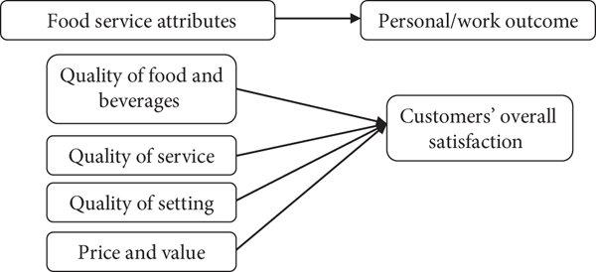
Figure 2: Customer Satisfaction and Food and Beverage
Source: (Gupta and Sharma, 2021)
UK hotel guests demand rapid, easy food and drink. Kim and Chung (2020) found that 57% of hotel clients want faster service without sacrificing quality. Self-ordering kiosks and smartphone apps speed up food and beverage delivery at Premier Inn Dunstable South A5 and other hotels. Bhatt et al. (2022) report that meal ordering and payment systems have improved order speed and accuracy, reducing wait times and improving customer satisfaction. Abdelhamied (2019) said food service needs humans, especially for personalisation, despite technology. Staff should serve guests quickly and cheerfully. 49% of consumers valued food and beverage staff attitude and chose personalised over automated service (Prentice, Lopes and Wang, 2020).
Strategies to Improve Food and Beverage Service Efficiency
UK hotels can enhance food and beverage service efficiency due to operational challenges and consumer expectations. Streamlining requires technology. Service is faster and more accurate with self-ordering and smartphone apps. Digitised ordering reduces human errors, boosting service. Vasilakakis and Sdrali (2022) found that food and beverage service success requires effective staff training. Train staff in food preparation, service, communication, and time management to improve service. Smith (2023) found that well-trained staff were 30% more likely to perform services on time, increasing client experiences. Supply chain management improves operations. Özdemir, Çolak and Shmilli (2018) encouraged hotels to strengthen supplier relationships to avoid supply chain interruptions. Diversifying sources helps hotels handle crises and unexpected demand. Stock tracking and demand forecasts save waste and delays.
Optimise kitchen layout and update cooking equipment to improve service. Wang and Huang (2020) suggested modernising kitchens to speed serving and preparation. The British Hospitality Amicarelli et al. (2021) stated that contemporary kitchen equipment lowered meal preparation times by 25%, boosting service and customer satisfaction. Staffing modifications like peak demand increase food and beverage service. According to Al-Marzouqi and Yahia (2021), data-driven scheduling tools can help hotels forecast peak service times and manage staff to maintain service levels during busy periods.
Research Gap
Few UK hospitality research links hotel food and beverage service efficiency. Most studies on service efficiency and operational concerns do not use Premier Inn Dunstable South A5. Few studies examine ops efficiency and customer satisfaction (Chowdhury et al., 2020). Quantitative research gives trends and numbers but ignores qualitative research's subjective judgements. Food and beverage operations' difficulties and potential are seen by hotel staff, management, and visitors. Premier Inn Dunstable South A5's concerns were understood via customer evaluations, industry research, and similar hotel case studies. Staff training, delivery timeframes, and guest views appraised the hotel's food and beverage service efficiency.
Summary
UK hotels like Premier Inn Dunstable South A5 need efficient food and beverage service. This evaluation found that staffing, supply chain difficulties, and outdated equipment reduce service efficiency. Fast, quality, and personalised service make customers happy, but technology matters more (Ushakov et al., 2020). The literature review found that staff training, kitchen equipment enhancements, and process-simplifying technology can improve food and beverage service. These issues and best practices can help hotels enhance service, customer satisfaction, and competitiveness in the highly competitive UK hospitality business. This study examines Premier Inn Dunstable South A5 operational concerns and customer satisfaction with food and beverage service efficiency. These insights will guide hotel operations and customer happiness.

Methods
Case study methodological approach
The secondary qualitative study used a case study and netnography to evaluate Premier Inn Dunstable South A5's food and beverage service. Operating concerns and customer satisfaction were examined in industry publications, consumer reviews, and university studies. Below are the approaches, pros, cons, and methodology.
Positivism was used as the research philosophy for this study. Positivism trumps subjectivity for quantitative and qualitative investigation of objective events, according to Detterman (2022). Premier Inn's food and beverage service efficiency studies used industry statistics, consumer feedback, and business journals. Positivism enabled methodical, reproducible research and empirical verification. Industry data and quantitative figures may not reveal Premier Inn Dunstable South A5's service issues. Positivism confirmed industry improvements and service efficiency despite its limitations (Saunders, Lewis and Thornhill, 2023).
This study used deductive research to test hypotheses and frameworks. Kruger and Mitchell (2022) claim deductive reasoning enables researchers to test hypotheses and assumptions with data. To assess Premier Inn Dunstable South A5 food and beverage service efficiency, service operations, customer satisfaction, and hotel management theories were investigated. Deductive testing of budget hotel service efficiency assumptions used literature and industry data. These frameworks assessed Premier Inn's service. Secondary data may limit fresh discoveries and flexible research, yet it gives structure. This rigorous strategy may not address real-time hotel operations.
The Premier Inn Dunstable South A5 case study was reviewed. Goddard and Melville (2021) demonstrate theories using cases. The study assessed Premier Inn's budget hotel food and beverage service efficiency, operational effectiveness, and customer satisfaction. Compare case studies to industry norms to find successes and improvements. For operational and market reasons, other hotel brands or locations may disagree with Premier Inn. Despite these limits, the case study recommended Premier Inn's food and beverage service improvements.
Research used academic literature, industry papers, company resources, and customer feedback. Secondary data saves time and money by providing insights (Cahoon, 2023). Premier Inn received quick feedback from TripAdvisor and Google Reviews, while the British Hotel Association and Statista studied UK hospitality food and beverage service trends. Secondary data has limitations but offers insights. Premier Inn Dunstable South A5 may not follow industry trends. Client reviews may reflect personal biases or non-client views. Secondary data allowed multidimensional food and beverage service efficiency analysis.
Thematic analysis analysed qualitative secondary data. Finding, analysing, and presenting qualitative data themes is flexible with thematic analysis (Collis and Hussey, 2021). At Premier Inn Dunstable South A5, this investigation found operational issues, food and beverage efficiency, and customer satisfaction. Thematic analysis works best with qualitative data without categories from complex secondary sources. It identified academic, industrial, and consumer reviews on service wait times, meal quality, staff reaction, and operational bottlenecks. The concept considered consumer feedback and food and beverage service efficiency best practices. Though advantageous, thematic analysis has downsides. The way researchers interpret data can affect results (Veal, 2018). Thematic and quantitative data analysis avoided subjective judgements. Compare qualitative and quantitative data to detect faults and evaluate food and beverage service efficiency.
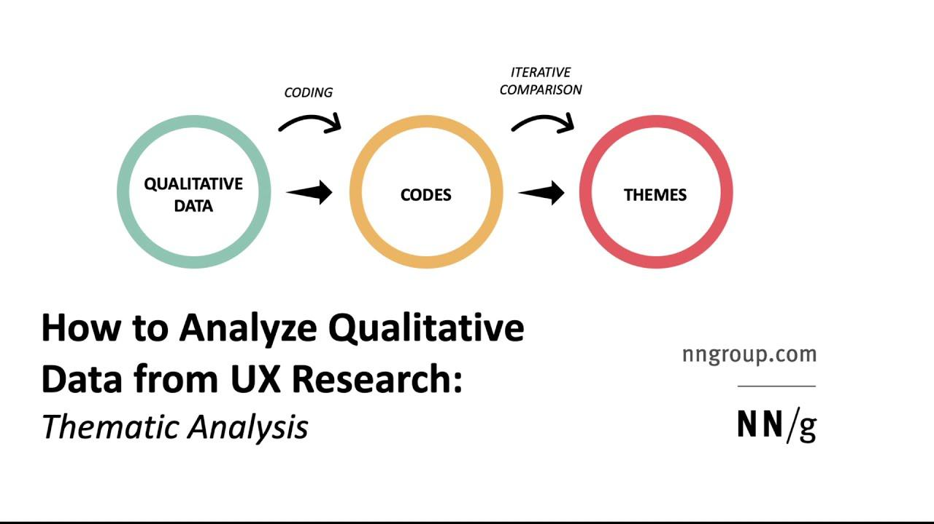
Figure 3: Thematic Analysis
Source: (Cahoon, 2023)
Netnography
Premier Inn Dunstable South A5 guests' food and beverage experiences were studied using netnography, a qualitative survey of internet communities and consumer-generated content. Tripadvisor, Google Reviews, Premier Inn's website, Twitter, and Facebook were examined for online reviews and feedback (Hamid, Azhar and Sujood, 2022). Former guests' internet use showed the hotel's food and beverage services' strengths and weaknesses. These platforms discussed hotel cuisine, beverage, customer satisfaction, and operations. Fast, efficient service was especially popular during meals. The restaurant was clean and the brunch was wonderful. Dinnertime service efficiency issues persisted. Customers noticed meal delivery delays, especially during peak dining periods (Dabas, Sharma and Manaktola, 2021). Delays from understaffing frustrated customers. Meal quality fluctuated on busy evenings, causing inconsistent assessments.
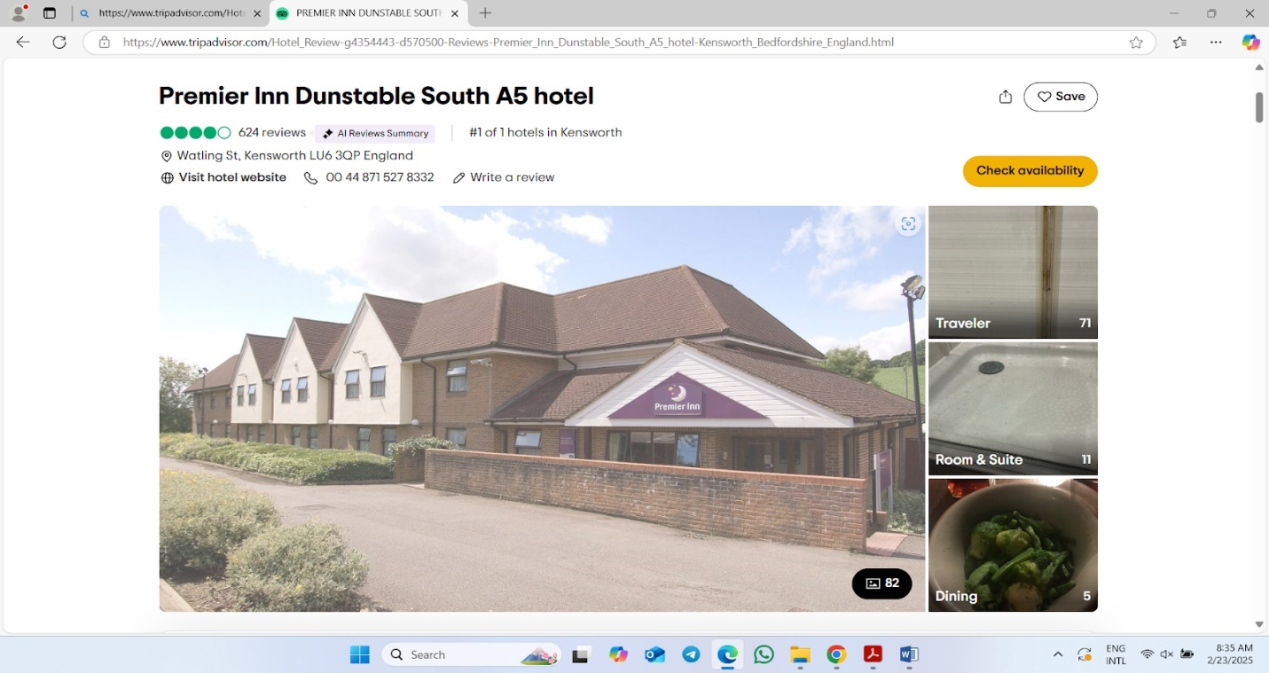
Figure 4: Review
Source: (Tripadvisor.com, 2025)
Social media users appreciated the lodgings' affordability and comfort. Many questioned food service inefficiencies, especially at busy hours. Despite the staff's professionalism and warmth, guests complained about long wait times due to overwork. Although criticised, the hotel was praised for responding to social media complaints and engaging consumers (Sann and Lai, 2020). Dunstable South A5 Premier Inn handled online reviews. The hotel acknowledged guests on Twitter and Facebook after food and beverage delays. The proactive strategy kept a strong reputation and restored client trust after difficulties. Meal service delays and quality issues were repeated in reviews, indicating operational efficiency improvements were needed.
Online consumer reviews found that netnography improves operations. Many reviews suggested reducing wait times and enhancing service to improve meals. Understaffing during busy lunch times caused delays and inconsistent service; the hotel should improve (Gebbels, Pantelidis and Goss-Turner, 2020). Premier Inn understood it needed to increase food and beverage service efficiency to meet rising customer demands after repeated online forum complaints. At Premier Inn Dunstable South A5, Netnography measured food and beverage satisfaction. Service quality and visitor contentment were affected by client choices, operational constraints, and development potential (Ntounis et al., 2021). Room quality and staff attitude were good; however food and beverage service must improve to satisfy customers and compete.

Case Study Hotel
Descriptive information
Premier Inn Dunstable South A5, the UK's largest budget hotel chain, is situated in Watling Street, Caddington Dunstable, LU6 3QP. Whitbread owns Premier Inn. Premier Inn offers business and leisure tourists cheap and comfortable services. Near Premier Inn Dunstable is the A5, which links UK cities.
Turnover and Financial Performance: As part of Whitbread, Premier Inn made £2.6 billion in 2023 (Whitbread.co.uk, 2023). Premier Inn Dunstable South A5 administers 800 UK corporate hotels. Dunstable's network membership may aid its finances. Premier Inn competes in UK hospitality with cheap, good rooms. Strong year-over-year sales growth shows this. Financial stability allows Dunstable South A5 to provide affordable, high-quality service.
Staffing and Employment: Premier Inn Dunstable South A5's workforce reflects its busy location. The hotel employs full- and part-timers. Food, drink, housekeeping, receptionists, and maintenance. Premier Inn Dunstable South A5 employs 20–50 individuals, demand-dependent (Trivago, 2025). Premier Inn's parent business, Whitbread, trains employees. The company promotes careers. Recent reports found that Whitbread employs 40,000 people, including many at UK Premier Inn hotels. A well-trained crew provides good customer service at Dunstable South A5. Hotels need managers, supervisors, and operators. Premier Inn Dunstable South A5 trains personnel in hospitality, food service, and maintenance to impress guests.
Number of Branches and Locations: Around 800 Premier Inn hotels are in popular UK towns, villages, and tourist destinations. Dunstable South A5 is one of several convenient hotels for families, business travellers, and visitors. Premier Inn hotels are near airports, rail stations, and major roads for easy access to activities (Travelweekly.com, 2025). Whipsnade Zoo, a family-friendly destination, and Dunstable Downs, a great outdoor exercise area, both close to Dunstable South A5. Premier Inn has made the UK market more accessible to tourists by extending into urban and rural areas. Dunstable South A5's affordable, dependable, and convenient accommodations boost its brand.
Geographical and Cultural Context: Premier Inn Dunstable South A5 is multicultural and geographically diversified. London commuters may easily reach Dunstable, Bedfordshire, a cheap option (Hurb, 2025). Historic and modern elements blend at Dunstable Priory and landscape. The urban-rural mix includes Dunstable South A5. Although primarily suburban, excellent highways and public services connect it to London, Luton, and Milton Keynes. Rural and city tourists will love it. Culture has grown in Dunstable. Regional residential, business, and recreational areas grow. Premier Inn Dunstable South A5 has affordable rooms for large parties. Local events and attractions are near the motel (Moovitapp.com, 2025). The hotel follows the low-cost, high-quality hospitality trend. Tourists value quality and money, therefore this approach follows suit.
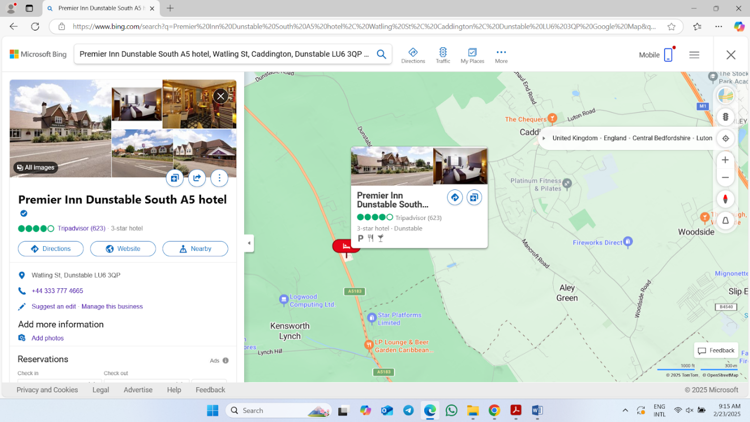
Figure 5: Map
Source: (Google Maps, 2024)
The chain includes Premier Inn Dunstable South A5. Clients admire its A5 location and proximity to urban and rural attractions. Quality, price, and service make Premier Inn great (Cylex, 2024). UK budget hotels' workforce, turnover, and location reflect rising demand for economical, high-quality rooms. Local ties boost Premier Inn Dunstable South A5's reputation.
SWOT Analysis
Premier Inn Dunstable South A5 SWOT analysis shows strengths, weaknesses, opportunities, and threats. The hotel's hospitality and expansion plans are assessed here.
Strengths: Premier Inn Dunstable South A5 links Dunstable to major destinations on the A5. This helps London and Luton drivers. For amusement, motel visitors visit Whipsnade Zoo and Dunstable Downs (Strayhorn, 2021). Reputation UK-trusted Premier Inn Dunstable South A5 hotel. Premier Inn has affordable, clean accommodations and reliable service. The reputation encourages repeat business and loyalty. Price Competitively Accommodation at Premier Inn Dunstable South A5 is inexpensive and high-quality. Business and leisure tourists prefer the hotel's inexpensive rates. This pricing strategy works well in competitive markets where price drives buying (Gursoy, Buttle and Bowie, 2022). Free Wi-Fi, on-site eateries, and a modern, friendly ambience characterise the business and leisure hotel. These solutions satisfy varied customers and boost guest satisfaction.
Weaknesses: Road travellers benefit from the hotel's A5 location, but traffic is bad. Without direct links to major train stations or bus lines, public transport users may have trouble accessing the hotel (Trewhela, 2023). Premier Inn Dunstable South A5 may lack cheap rooms. Its lack of suites and family rooms may hurt it when competing with regional hotels with more amenities. Premier Inn Dunstable South A5, like many budget hotels, may have staff, training, and turnover concerns. Operations concerns might affect service consistency, especially under peak demand. High service standards and less labour availability may impact client satisfaction (George, 2021). While it has free Wi-Fi and eateries, the hotel may lack guest amenities. Premier Inns without gyms, spas, and conference facilities may dissuade luxury and business tourists.
Opportunities: Corporate and international guests visit Premier Inn Dunstable South A5. Business tourists may attend Luton and Milton Keynes events due to inexpensive prices. Dunstable Downs, Whipsnade Zoo, and others may partner with the hotel (Cambridgehotelsuk.com, 2025). Premier Inn customers might get reduced tickets or deals to stay longer. Wishing for green hospitality. This trend may help Premier Inn Dunstable South A5 with energy-efficient lighting, waste reduction, and green facilities. This may attract eco-conscious guests and improve the hotel's reputation (Freeman, 2020). Mobile check-ins, digital room keys, and advanced guest management systems boost customer satisfaction. Changes at Premier Inn Dunstable South A5 may improve operations and please techies.
Threats: Many UK budget and independent hotels compete. Premier Inn Dunstable South A5 competes with Travelodge and Ibis on price and service. This competition may hurt hotel guests' growth and earnings (George, 2022). Tourism and hotel spending may drop in a recession. Budget travellers may avoid non-essentials, cutting hotel revenue. Premier Inn Dunstable South A5 pricing may climb. Seasonal demand may affect Premier Inn Dunstable South A5, like many local motels. Hotel revenues may drop off-peak due to decreased occupancy. Seasonal and business travel may lessen demand year-round. Premier Inn Dunstable South A5 may lose money because of increased labour, utility, and supply costs (Btravel, 2025). Due to increased living costs and inflation, the hotel may struggle to manage operational costs without boosting prices, hurting its market position.
Strengths | Weaknesses
- Strategic location  - Brand reputation  - Competitive pricing  - Wide range of services. | - Dependence on road traffic  - Limited room types  - Operational challenges  - Limited amenities (George, 2021).
Opportunities | Threats
- Expansion of target market, partnerships with local attractions  - Sustainability initiatives  - Technological upgrades. | - Increased competition  - Economic downturn  - Seasonality of demand  - Rising operational costs (Strayhorn, 2021).
Table 1: SWOT Analysis
PEST Analysis
Political, economic, social, and technological examination of Premier Inn Dunstable South A5. External factors may impact hotel growth, operations, and challenges.
Political Factors: UK hotels must follow fire and health regulations. Corporate plans may be affected by waste minimisation and carbon footprint laws. Hospitality workers from EU countries are scarce after Brexit (Cleave, 2019). Premier Inn Dunstable South A5 cannot ignore a tighter job market that makes recruiting harder. Bedfordshire's environmental, infrastructure, and tourist legislation affect hotels. Easily accessible from Dunstable along the M1, however zoning or road-works may hinder guests.
Economic Factors: Economic recessions cut hotel and travel prices. Premier Inn Dunstable South A5 off-peak bookings may drop. Hospitality businesses paid more in 2023 because of UK inflation.
Hospitality costs in the UK rose 5.4% (ONS, 2024). This impacts Premier Inn Dunstable South A5's food, beverage, utility, and labour costs. Economic constraints reduce budget lodging profitability. Premier Inn Dunstable South A5 profited from the 2022 UK tourism revival. However, COVID-19 travel restrictions limited international guests, affecting hotel earnings.
Social Factors: Healthy, eco-friendly solutions are favoured. Premier Inn Dunstable South A5 may need to provide plant-based, organic, and sustainable options to its menu. Family travel is rising in the UK, thus the hotel features family-friendly rooms. Some vacationers take extended business holidays for remote work. Premier Inn Dunstable South A5 benefits from fast Wi-Fi and flexible booking (Law, Smith and Cornelsen, 2022). Post-pandemic cleaning matters. Many hotels have contactless check-ins, superior housekeeping, and in-room sanitisation kits like Premier Inn Dunstable South A5. Maintaining occupancy rates demands client trust in these ways.
Technological Factors: Online Booking Systems: Premier Inn Dunstable South A5's mobile apps and websites use robust digital infrastructure for fast booking. Booking, checking in, and customising services are easier with tech. Innovations in digital and automation Smart rooms, self-service kiosks, and digital check-ins boost hotel productivity and customer satisfaction (Ioannou and Dukes, 2021). Technology may reduce Premier Inn Dunstable South A5 wait times and boost satisfaction. Premier Inn Dunstable South A5 signs up guests on Instagram, Twitter, and Facebook. Positive ratings and marketing on these sites may increase bookings, especially among younger digital natives.
Factor | Details
Political | - Government regulations, post-Brexit labour challenges, and local policies impact operations.
Economic | - Inflation and rising operational costs, economic downturns, and tourism trends affect revenue (Nirino, Miglietta and Salvi, 2019).
Social | - Evolving customer preferences and post-pandemic health concerns.
Technological | - Advanced booking systems, automation, and social media engagement for marketing and customer experience.
Table 2: PEST Analysis
The PEST analysis indicates that external influences affect Premier Inn Dunstable South A5's operations. In a changing hospitality market, the hotel must adapt to political, economic, social, and technical developments to compete and meet tourist expectations.
Competitor Analysis (Price vs Quality)
Premier Inn Dunstable South A5's price and quality compared to Birmingham hotels affect its hospitality sector competitiveness. Ibis Styles Birmingham Centre rooms cost £55–£75 per night, depending on season and room type (Hotels.com, 2025). This mid-range hotel has complimentary Wi-Fi, breakfast, and a 24-hour front desk. Its simplicity and pricing may attract budget travellers. Holiday Inn Birmingham City Centre (£90–£130/night) is another important (Tripadvisor, 2025). Holiday Inn has a restaurant, gym, and conference centre, unlike Premier Inn. Business and leisure tourists get greater luxury and services for more money. Mercure Birmingham City Centre Hotel rates are £85–£120 per night. Mercure's trendy architecture, bar, and food are great. Upscale visitors seeking quality and value visit the city core hotel.
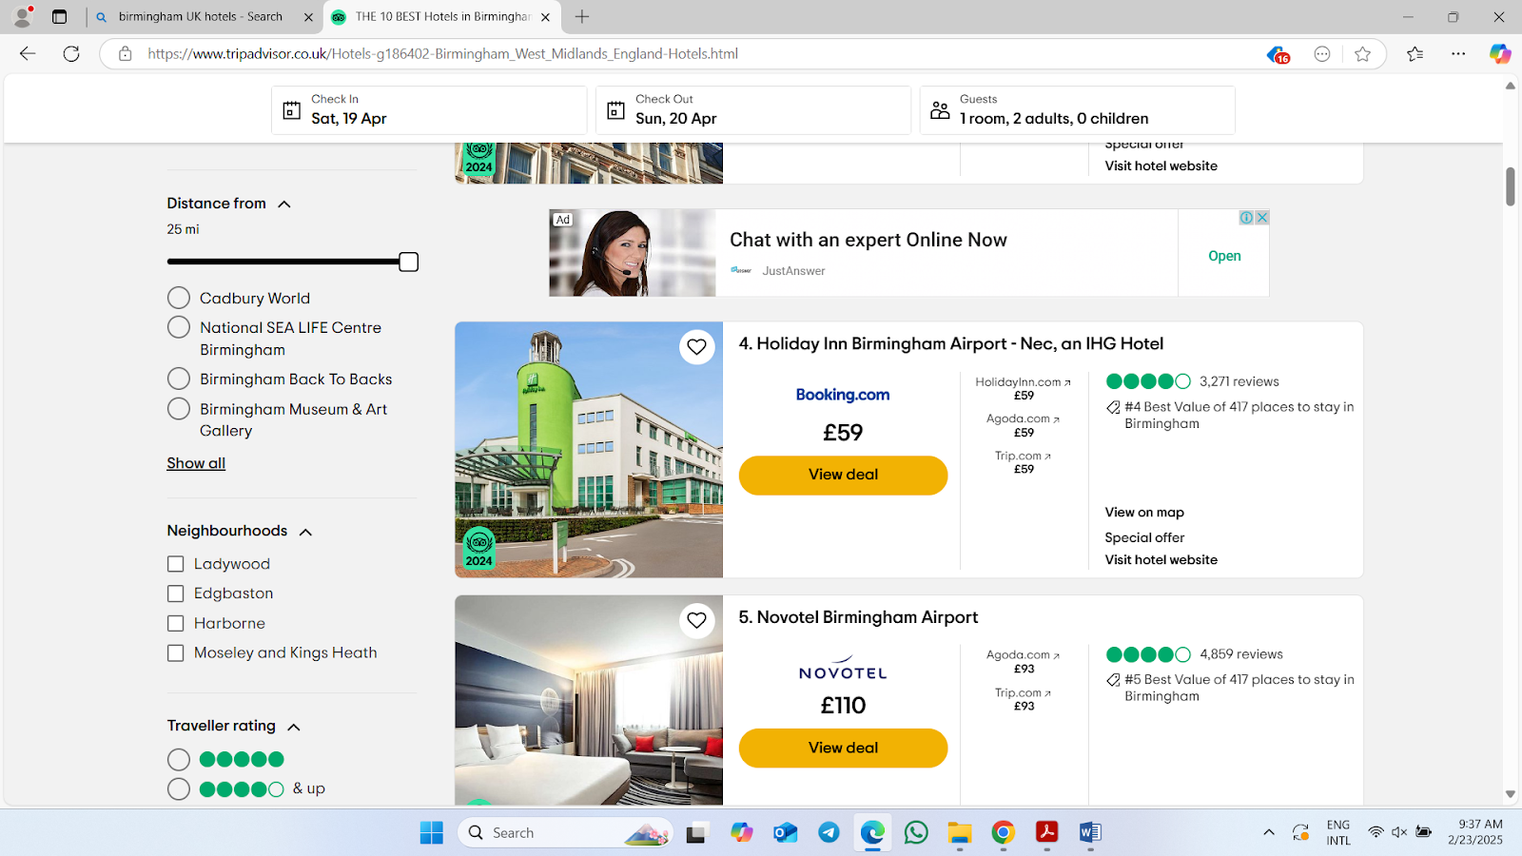
Figure 6: Hotel Price
Source: (Tripadvisor, 2025)
Premier Inn Dunstable South A5 has reasonable rooms from £55–£80 per night, depending on booking time (Muc et al., 2019). Less expensive than Birmingham's Ibis Styles and Holiday Inn. Premier Inn offers clean, comfortable rooms and basic amenities, whereas Holiday Inn and Mercure offer restaurants, gyms, and elegance. Luxury guests may choose these more expensive competitors.
Competitors | Analysis
Premier Inn | Offers clean rooms, basic amenities, and a consistent budget-friendly experience.
Ibis Styles | Provides essential services with a simple, no-frills experience at a comparable price (Hassanien, Dale and Clarke, 2019).
Holiday Inn | Offers additional services like a restaurant and gym, catering to business and leisure guests.
Mercure | A more luxurious option with a higher level of service and more facilities.
Table 3: Competitor Analysis
Premier Inn Dunstable South A5 is cheaper than nearby hotels. Holiday Inn and Mercure offer luxury rooms and services to premium customers. Premier Inn's price advantage is clear for budget tourists, however those seeking higher quality or more amenities may pick other Birmingham hotels.
Reflective Account
At Premier Inn Dunstable South A5, I have observed operational efficiency and customer satisfaction in food and beverage service. This highlighted the hotel's food and beverage pros and disadvantages. Service efficiency depends on staff, my biggest professional discovery. I noticed exhausted staff slowing service and dissatisfying guests during peak hours. Despite staff efforts, breakfast and supper service was often delayed due to high demand. I discovered that food service and personnel hours must coincide for smooth operations. I noticed food quality varies during peak demand (Prosser, Lane and Jones, 2021). I told guests and co-workers about these issues. Some dinner attendees said the dish was overcooked or under-seasoned. Fresh and varied breakfasts were commended. Staff pressure to create and serve food quickly caused these differences. As an operations manager, I recognised that simplifying culinary processes and improving staff collaboration during busy times may help.
Customer feedback enabled guest social media participation. Watching the hotel manage positive and negative feedback taught me the value of timely and empathetic communication. I discovered proactive Twitter and TripAdvisor participation minimises complaints and develops confidence. I learnt how social media affects hospitality customer connections (Patiar et al., 2020). My professional observations at Premier Inn Dunstable South A5 showed food and beverage concerns. Food quality, labour efficiency, and customer communication were my lessons. I learnt hospitality operations from these experiences to boost industry service.

Discussion
Customer Satisfaction and Food and Beverage Services
The research demonstrates that Premier Inn Dunstable South A5's food and beverage offerings considerably impact customer satisfaction. Food quality, service speed, menu variety, and staff professionalism affect customer satisfaction. Hotel food and service might improve. Food quality boosted client satisfaction (Abdullah, Sufi and Kumar, 2022). Busy clients' lunch opinions vary. This validates hospitality research showing meal quality improves client satisfaction. Bad meals ruin guests' delight. Poor food preparation and presentation can hurt a hotel's brand. Efficiency impacts customer satisfaction. Peak-hour delays affect customer happiness. Late meal disappoints guests (Harnjo et al., 2021). Previous research found that restaurant service efficiency boosts customer happiness. Service efficiency cuts wait times and boosts satisfaction. Excellent reviews and repeat visits rise.
Food at Premier Inn Dunstable South A5 improves satisfaction. When busy, the hotel's buffet and self-service speed up meals. The business wants to reduce wait times and offer choices. These technologies boost service but decrease guest customisation (Sudari et al., 2019). Customers feel high-quality dining experiences may be less rewarding without tailored treatment. Food and beverage service needs menu variety. Guests like food. Menu variety improves customer pleasure, study finds. Many Premier Inn Dunstable South A5 guests found meals repetitive or bland. Feedback suggests fresh menu items and creativity may boost customer satisfaction. The friendly personnel pleased most guests (Davras and Caber, 2019). Busy seasons affected staff workload management. It delayed meal service. These issues require front-of-house and kitchen cooperation. The booklet recommends frequent food and beverage service and customer contact training for customer satisfaction.
The study indicated that hotel peak service periods greatly affect customer satisfaction. Research suggests that operations strain during peak hours may lead to longer wait times and lower food quality. During busy periods, Premier Inn Dunstable South A5 struggles to satisfy customers. Service must be maintained at peak times. Adding workers during busy hours or delivering pre-made meals could improve service (Kim and Kim, 2022). The study also found that meal quality, service efficiency, and dining atmosphere affect food and beverage consumer happiness. Diners wanted a calmer, friendly atmosphere to be satisfied. Restaurant atmosphere affects food and service, research suggests. Decorating the dining area at Premier Inn Dunstable South A5 may improve client satisfaction.
This analysis found many factors affecting Premier Inn Dunstable South A5 customer satisfaction. Food quality, service speed, staff professionalism, and menu diversity affect guest happiness. The hotel meets expectations, although peak-time food and service could be better (Ban et al., 2019). Premier Inn Dunstable South A5 may increase customer satisfaction via staff training, peak-hour coordination, and menu variation. This data helps hospitality service efficiency and quality literature.
Food and Beverage Service Strategies Impacting Customer Satisfaction
Premier Inn Dunstable South A5's food and beverage service affects client satisfaction, research finds. Service, food quality, menu diversity, and dining environment greatly affect food and beverage consumer experiences. These criteria and service methods affect hotel reviews and returns.
Service Efficiency: In peak times, Premier Inn Dunstable South A5 serves buffets and self-service. These methods cut wait times and speed up meal delivery. According to research, these methods reduce wait times and improve busy dining experiences. Busy visitors want efficiency, so serve meals swiftly (Nobar and Rostamzadeh, 2018). According to literature, these tactics may not give guests the personalisation they expect. Personalisation makes guests feel special and satisfied. Customers who demand greater customisation may dislike buffets.
Menu Diversity: Menu variety affects consumer satisfaction. Premier Inn Dunstable South A5 caters to all tastes. Various cuisines can enhance hotel meals and satisfy guests. Literature found that a diverse menu boosts customer satisfaction (Candra, Mahaputra and Mahaputra, 2023). Guest reviews improve when dietary restrictions are honoured. Statistics show Premier Inn Dunstable South A5 clients sometimes order seasonal or unique dishes. This supports research proposing fresh menus that reflect food trends and customer preferences.
Food Quality: Consumer satisfaction in the food and beverage industry depends on food quality. Premier Inn Dunstable South A5 guests found that peak-time meals vary but are good. Quicker service at busy times may degrade meal quality by making more food. Research reveals that meal quality can sour a visit. This facility needs good meal service (Goh et al., 2022). At busy times, simplifying kitchen procedures or educating workers can enhance food quality and satisfaction without losing efficiency.
Staff Professionalism: The study emphasises food and beverage service worker professionalism and training. Premier Inn Dunstable South A5 staff were friendly and helpful, improving visitor satisfaction. Research reveals that peak-hour workers may struggle to meet service needs. Delays and errors in food delivery diminish consumer satisfaction (Abu et al., 2024). Literature found that peak-hour service requires personnel expertise, training, and pressure-handling. Improved front-of-house-kitchen coordination and staff training can fix these concerns.
Dining Environment: Food and beverage service perceptions rely on the dining setting. According to research, a clean, pleasant, and appealing workplace boosts customer happiness (Wang and Huang, 2020). Despite its utility, Premier Inn Dunstable South A5's dining room may be better. Decor, lighting, and seating boost consumer happiness, research shows. Well-designed restaurants boost food and repeat business.
Figure 7: Impact of Service Strategies
Source: (Candra, Mahaputra and Mahaputra, 2023)
Operational Challenges Affecting Efficiency
Staffing, supply chain, and operations affect Premier Inn Dunstable South A5's food and drink. Food and beverage service quality and customer satisfaction depend on these issues.
Staffing Shortages: The Premier Inn Dunstable South A5 was understaffed. Peak-hour staffing shortages delayed dinner service, the study revealed. In hospitality, high turnover and difficulty recruiting skilled workers limit service efficiency (Veal, 2018). The literature and research agree that good staff ensures smooth operations. Without skilled staff during high seasons, food delivery times and quality decrease. Customers are unhappy and the hotel's reputation suffers.
Supply Chain Disruptions: Hotel supply chains were problematic. Complex hospitality supply chain stockouts or delivery delays might affect food and beverage offerings. Premier Inn Dunstable South A5 clients experienced peak-demand menu item shortages (Vasilakakis and Sdrali, 2022). Due to supply chain issues, product quality and service delivery varied. A study indicated that high-quality components need superior supply chain management.
Kitchen Layout: Kitchen-dining room layout limits food and beverage options. The undersized kitchen and outdated equipment hampered preparation, the inspection found. The physical environment might help or hurt hospitality operations (Ushakov et al., 2020). An outdated or badly built kitchen can generate congestion, food preparation delays, and delivery issues, lowering customer satisfaction.
Technology Limitations: Food and beverage service technologies were operational concerns. Hotel ordering and staff communication technology improves service (Trewhela, 2023). Premier Inn Dunstable South A5 struggled with manual order-taking and poor technology. Since personnel spent more time entering orders, service times increased. Disconnections between kitchen and front-of-house generated confusion and delays.
Customer feedback and reviews: Customer reviews confirmed service inefficiencies. Late and poor food were regular complaints, especially at peak hours. Similar conclusions were drawn for workforce and supply chain issues (Sudari et al., 2019). Peak-hour guests complained about menu shortages due to supply chain issues.
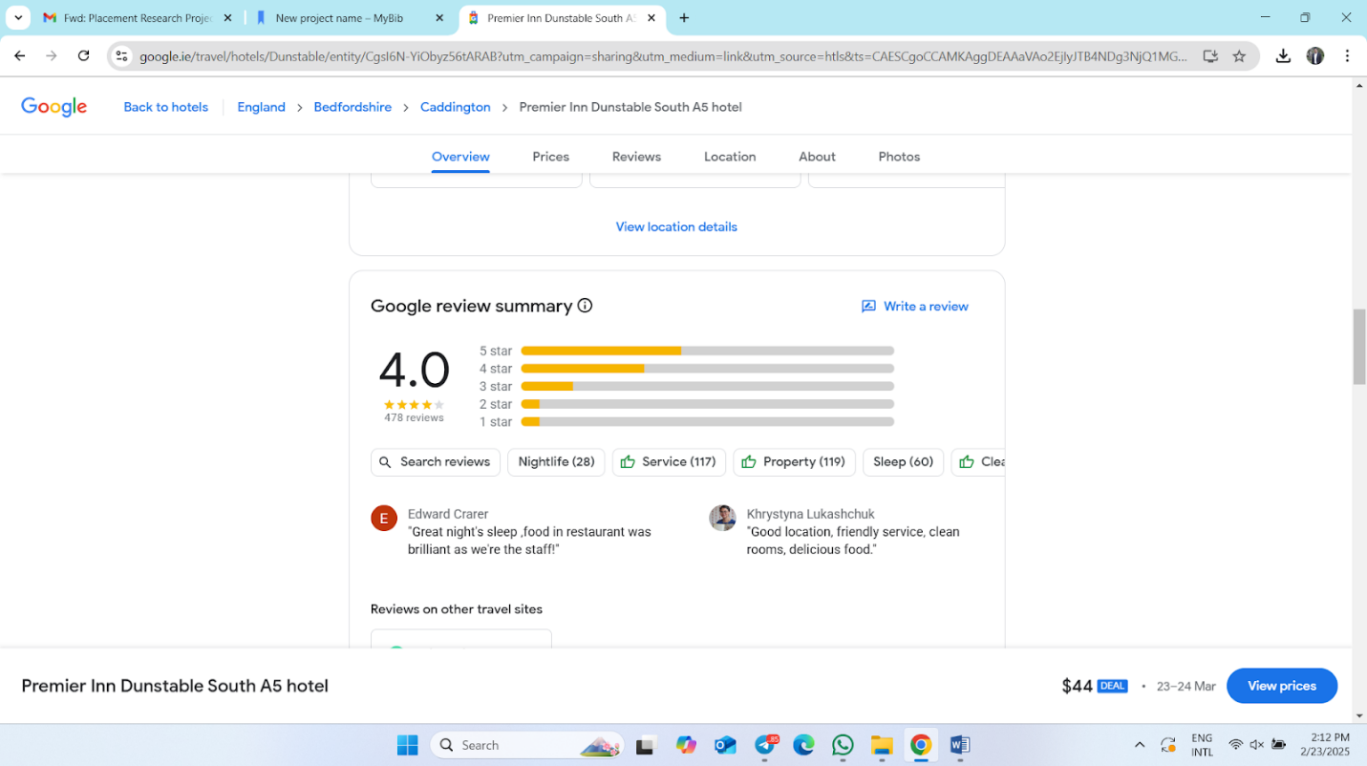
Figure 8: Customer feedback
Source: (Hotels.com, 2025)
Operational concerns hinder Premier Inn Dunstable South A5's food and beverage offering. Staffing shortages, supply chain disruptions, outdated kitchens, and inefficient technology reduce service quality (Strayhorn, 2021). Addressing these issues requires better staff recruitment and retention, supply chain management, culinary facilities, and current technology to ease operations. Service efficiency and hotel guest experience improve customer satisfaction and loyalty.
Strategies to Enhance Food and Beverage Service Efficiency
Research offers Premier Inn Dunstable South A5 food and beverage efficiency improvements. These initiatives follow hospitality best practices and highlight operational adjustments to improve service quality and efficiency.
Staff Training and Development: Staff developmental training was needed. Trained staff can reduce wait times, please consumers, and improve service (Smith, 2023). Regular customer service, food handling, and speed training reduce errors and boost efficiency. Premier Inn Dunstable South A5 staff training may improve food and beverage service and satisfaction.
Technology Adoption: Service efficiency improves with technology. Sann and Lai (2020) found that self-ordering kiosks and mobile app-based ordering systems increase service, remove errors, and speed up ordering. This technology will speed up ordering and give staff real-time updates, reducing wait times and improving food quality.
Supply Chain Management: The study recommends supply chain management improvements. Research suggests supply chain delays may reduce food service efficiency. Improving supplier ties helps Premier Inn Dunstable South A5 minimise stock shortages and food delivery delays (Prosser, Lane and Jones, 2021). Better supplier communication and demand estimates reduce service interruptions and boost reliability. Hotel food waste is reduced with real-time inventory management systems that modify requests.
Kitchen Layout Optimisation: Optimising the kitchen workstation could reduce food preparation time and bottlenecks. Effective kitchen design with clear workstations is advised by Prentice, Lopes and Wang (2020). Premier Inn Dunstable South A5's kitchen is organised for faster cooking and better service.
Menu Simplification: Menu minimalism may improve dinner service. For kitchen efficiency and quick turnover, Pereira, Brandao and Costa (2019) recommend high-demand, easy-to-prepare dishes. Simplifying the menu improves order accuracy, wait times, and kitchen and front-line worker workload. Prioritising popular items improves quality and reduces peak-hour difficulties.
Customer and Staff Feedback: Last, continual improvement incorporates customer and employee input. Patiar et al. (2020) found that client surveys and review systems can highlight development areas. Staff input on operational challenges and solutions may help. Premier Inn Dunstable South A5 changes services based on client input.
Premier Inn Dunstable South A5 needs staff training, technological integration, supply chain optimisation, kitchen layout redesign, and menu simplification to improve food and beverage service. Literature suggests speedier, more efficient services improve hotel performance and customer happiness.
Implications of the Study
The Premier Inn Dunstable South A5's food and beverage services and operational aspects that affect client satisfaction are highlighted. Service, menu variety, pricing, and staff efficiency affect consumer happiness. These issues impact hospitality customer retention, online reputation, and competition (Özdemir, Çolak and Shmilli, 2018). The study concluded that good service boosts consumer loyalty and word-of-mouth. Good food and beverage operations increase repeat business, occupancy, and revenue. Reviews and ratings affect visitors' booking choices, indicating how digital platforms modify customer perceptions. Staff training, workflow optimisation, and technology adoption increase service and reduce delays.
Studies show companies must adjust to market shifts and client expectations. Hotel services can improve with sustainability, gastronomy, and customisation. Local food consumption and waste reduction please customers and improve the company's reputation (Okumus, 2019). Employee engagement and motivation effect workforce management and service success. Staff retention and performance enhancement improve guest experiences by ensuring consistent service and a positive work environment. Career development, competitive pay, and clear protocols reduce employee complaints and increase service. Brand awareness and customer acquisition can be increased via food and beverage differentiation (Ntounis et al., 2021). Business and leisure guests may like the hotel's tailored food and diet. AI-driven analytics and contactless ordering improve client satisfaction. This study focuses on service review and innovation for hospitality competition. Premier Inn Dunstable South A5 can grow by improving operations and customer service.
Limitations of the Study
Secondary qualitative research is scarce. Literature, reviews, and qualitative data limit customer and staff insights. Service and human experiences at Premier Inn Dunstable South A5 are hard to understand without interviews or questionnaires (Saunders, Lewis and Thornhill, 2023). Secondary data biases exist. Results can be affected by subjective appraisals and reports. Sample numbers, research methodology, and context may limit this study's application. Only qualitative analysis is used, making service inefficiency and consumer satisfaction statistically difficult. Setting food and beverage service performance targets or comparing trends is challenging without data. Rapid hospitality business change is another challenge (Kruger and Mitchell, 2022). Literature may miss new service efficiency and customer satisfaction advances due to changing consumer expectations, market trends, and operational approaches. Secondary data may reveal Premier Inn Dunstable South A5's demographics and geography. The constraints suggest primary data collection and quantitative analysis might better measure hotel food and beverage efficiency.
Valuable Areas Critical to the Placement Hotel Operation
Premier Inn Dunstable South A5 needs strategic focus in numerous areas to increase efficiency. For visitors, food and beverage service must be constant, staff trained, and the menu diversified. Service must be effective to reduce wait times and improve visitor experiences. Digital ordering, culinary workflow advancements, and staff optimisation boost service speed and accuracy (Nobar and Rostamzadeh, 2018). Service quality and profitability depend on cost control. Financial stability comes from supplier agreements, waste minimisation, and energy efficiency. Monitoring food cost percentages and inventory turnover enhances food and beverage profits.
Client feedback identifies and fixes service issues. Web evaluations, visitor surveys, and direct feedback highlight service expectations and development areas. Addressing repeated issues builds brand loyalty (Nirino, Miglietta and Salvi, 2019). Competitor benchmarking keeps the business ahead. Strategic market positioning entails assessing Birmingham and Dunstable competitors' pricing, service, and promotions. Businesses succeed by meeting visitor expectations and analysing industry trends. Hospitality requires safety. Audits, food hygiene standards, and staff training decrease hazards and ensure operational integrity. Regulations safeguard guests and brands (Nieuwenhuizen, Bursey and Geldenhuys, 2019). Service quality is highly impacted by employee retention and engagement. Workplace contentment, competitive pay, and career advancement enhance productivity. Guest interactions and service efficiency improve with staff satisfaction and training. These improve hotel efficiency, customer service, and sustainability.

Conclusion and Recommendations
Conclusion
Food and beverage customer satisfaction and operational efficiency at Premier Inn Dunstable South A5 are analysed in this report. Service, menu variety, price, and staff efficiency are key. Customers like consistent meals, fast service, and a friendly atmosphere. Unhappy consumers advise fixing service delays, menu constraints, and meal prep. Operations issues greatly affect service efficiency. Workforce shortages, peak-hour wait periods, and ingredient supply chain issues threaten service. Poor workforce allocation, order processing automation, and staff communication worsen these challenges. Staff management, inventory control, and tech integration boost service. Efficiency in food and beverage service requires technology. Self-service kiosks, smartphone apps, and automated kitchens expedite order processing. Digital solutions increase accuracy, reduce human errors, and track consumer preferences in real-time, personalising eating experiences. Data-driven decisions connect service offers to client expectations, enhancing satisfaction.
Birmingham hospitality competitor analysis focusses on price and service. Affordable, high-quality meal rivals attract and retain customers. Supplier negotiations, trash reduction, and energy-efficient cooking cut costs and improve service. Brand loyalty and repeat visits increase with rewards and promotions. Food and beverage hygiene and safety are improving. Client trust needs hygiene, allergy control, and regulation. Service dependability and efficiency improve with emergency, diet, and food safety training. Meeting these concerns ensures the hotel fulfils industry and operational requirements.
Service improvement comes from client feedback. Management uses online evaluations and satisfaction surveys to establish visitor preferences. Compare services to industry leaders to find gaps and improvements. Competitiveness is increased by data-driven hotel service improvements that meet customer trends. Service excellence requires staff engagement and retention. Performance awards, professional advancement, and planned training inspire employees. Training staff enhances dining and customer relations. Employee well-being and professional development drive exceptional service. The research focusses on strategic service execution, financial management, regulatory compliance, and technology integration. Service quality and efficiency would improve the hotel's market position, customer satisfaction, and sustainability.
Recommendations and Practical Strategies
Following placement findings and insights, these proposals attempt to improve Premier Inn Dunstable South A5's performance and efficiency. Our initiatives include quality, customer satisfaction, cost reduction, labour efficiency, and technology integration. Tips improve guest pleasure, operations, and revenue.
Enhancing Food and Beverage Service Efficiency through Technology Integration: Technology enhances food and beverage operations' accuracy, efficiency, and customer satisfaction (Nazari et al., 2020). Digital technology improves dining experiences, accelerates service, and eliminates errors. Self-service kiosks at restaurant entrances minimise wait times and confusion. Mobile ordering apps handle phone orders during peak demand. Automatic inventory systems track ingredients and supplies in real-time. Reduce food waste and essentials shortages. History-based predictive analytics anticipates demand. Digital screens enable kitchen-waitress communication. Instantly displaying orders improves accuracy (Muc et al., 2019). AI can assess menu preferences, customer behaviour, and seasonal demand. Use this data to alter menus and promotions. Technology integration boosts efficiency, decreases costs, and simplifies guest experiences. Digital technology aids hotel competition.
Workforce Training and Development for Improved Service Standards: Excellent service and client satisfaction demand well-trained workers. Food safety, customer service, and problem-solving training boost guest satisfaction (Law, Smith and Cornelsen, 2022). Food handling, allergen management, and customer service etiquette prepare staff for customers. Staff can fill jobs with multi-role cross-training. Improves efficiency and reduces service disruptions. Performance-based rewards: Recognition and bonuses boost morale. Happy, engaged workers boost customer service. Mentorship Programs New and seasoned employees working together fosters workplace culture adaption, cooperation, and service consistency (Kukanja and Planinc, 2020). Staff should learn active listening, conflict mediation, and problem-solving to satisfy visitors. Developing staff is essential to boost retention, service, and culture.
Optimising Menu Offerings and Pricing Strategies to Attract Diverse Customer Segments: Food and drink dramatically affect customer happiness and revenue. Attractive menus and prices enhance sales and retention (Kim and Kim, 2022). Data-driven menu optimisation identifies successful and failed meals using sales and consumer feedback. Menu changes enhance sales and happiness. Seasonal and local food boosts menu variety, sustainability, and cost while reducing imports. To optimise revenue, menu pricing should vary by demand, time, and season. Offer cheaper prices off-peak to attract customers (Ioannou and Dukes, 2021). Gluten-free, allergen-free, and vegan cuisines boost hotel traffic and customer focus. Offer limited-time meal combos or chef's specials to retain customers. Menu and pricing optimisation enhance restaurant revenue, satisfaction, and competition.
Strengthening Customer Engagement and Feedback Mechanisms: Customer feedback discovers service gaps and improves experience. Structured engagement boosts guest loyalty. QR tags on receipts and table displays provide real-time customer feedback, helping management tackle problems. Guest interaction on Facebook, Instagram, and TripAdvisor builds brand confidence (Hassanien, Dale and Clarke, 2019). Instant responses to customer concerns and reviews increase reputation. Discounts, freebies, and special deals keep customers coming back. Thanking customers and offering discounts by email and SMS builds long-term relationships. Comparing Birmingham hotel client satisfaction to competitors shows growth. Hotel hospitality and brand loyalty improve with customer contact.
Cost Management and Sustainability Initiatives to Enhance Long-Term Profitability: Sustainability and cost control enhance long-term financial and environmental sustainability. Upgrades to energy-efficient kitchen appliances save electricity. Save money using motion sensors and LEDs (Harnjo et al., 2021). Composting and reducing single-use plastics meet environmental standards and promote company image. Local food minimises shipping costs and promotes local companies. Measure food waste and adjust servings to improve sales. Biodegradable takeaway containers, reusable cups, and cutlery improve hotel sustainability. Sustainability saves money and attracts eco-conscious guests, making hotels accountable.
Improving Kitchen and Service Operations for Faster Delivery Times: Kitchen efficiency boosts service and eating. Order and kitchen workflow improvements reduce delays and complaints. Menu planning is easier with pre-made items. Timing software decreases kitchen worker bottlenecks (Hamid, Azhar and Sujood, 2022). Recipe standardisation and quantity control: Standardising portions maintains taste and appearance while reducing food expenditures. Replace order slips with digital screens to improve kitchen-server communication and eliminate errors and delays. Train staff to arrange seats to keep guests moving without delays. Improving kitchen and service operations increases guest satisfaction and revenue.
Enhancing Safety and Hygiene Protocols: Customer safety and regulatory compliance require strict hygiene. Rigid rules assure dining safety. Regular cleanliness checks ensure food safety. Digital menus and contactless payment lessen health risks (Gursoy, Buttle and Bowie, 2022). Staff hygiene training requires hand washing and sanitising for food safety. Strict allergen control protocols Dietary restrictions protected by labelled food and allergy-trained workers. Air filtering enhances dining comfort and air quality. Safeguards boost repeat business.
These recommendations can help Premier Inn Dunstable South A5. Technology, staff training, menu optimisation, and cost control increase customer pleasure and profit (Gupta and Sharma, 2021). Sustainability and customer contact boost hotel competitiveness and accountability. The placement hotel can survive by adapting to industry and client trends.

References

Abdelhamied, H.H.S. (2019). The Impact of Training Activities on Quality of Service, Customer Satisfaction and Behavioral Intention. Journal of Tourism and Hospitality Management, [online] 7(1). doi:https://doi.org/10.15640/jthm.v7n1a14.
Abdullah, O., Sufi, T. and Kumar, S. (2022). Service Quality and its Influence on Customer Satisfaction and Customer Loyalty in the Restaurants of Five-Star Hotels. African Journal of Hospitality, Tourism and Leisure, [online] 11(6), pp.2173–2189. doi:https://doi.org/10.46222/ajhtl.19770720.349.
Abu, M., Md. Aminul Islam, Abdullah Al Masud, Rahman, A., Biswas, S. and Razuan Ahmed Shuvro (2024). The moderating impacts of COVID-19 fear on hotel service quality and tourist satisfaction: Evidence from a developing country. Cogent social sciences, 10(1). doi:https://doi.org/10.1080/23311886.2024.2331079.
Ali, B.J., Gardi, B., Othman, B.J., Ahmed, S.A., Ismael, N.B., Hamza, P.A., Aziz, H.M., Sabir, B.Y., Sorguli, S. and Anwar, G. (2021). Hotel service quality: The impact of service quality on customer satisfaction in hospitality. International Journal of Engineering, Business and Management, [online] 5(3), pp.14–28. doi:https://doi.org/10.22161/ijebm.5.3.2.
Al-Marzouqi, A. and Yahia, I. (2021). Impact of Covid-19 pandemic on food and beverage service performance and behavioral intents: importance of sanitary measures. Journal of Foodservice Business Research, pp.1–24. doi:https://doi.org/10.1080/15378020.2021.1936871.
Amicarelli, V., Aluculesei, A.-C., Lagioia, G., Pamfilie, R. and Bux, C. (2021). How to manage and minimize food waste in the hotel industry: an exploratory research. International Journal of Culture, Tourism and Hospitality Research, 16(1), pp.152–167. doi:https://doi.org/10.1108/ijcthr-01-2021-0019.
Assaker, G. (2020). The effects of hotel green business practices on consumers’ loyalty intentions: an expanded multidimensional service model in the upscale segment. International Journal of Contemporary Hospitality Management, 32(12), pp.3787–3807. doi:https://doi.org/10.1108/ijchm-05-2020-0461.
Ban, H.-J., Choi, H., Choi, E.-K., Lee, S. and Kim, H.-S. (2019). Investigating Key Attributes in Experience and Satisfaction of Hotel Customer Using Online Review Data. Sustainability, 11(23), p.6570. doi:https://doi.org/10.3390/su11236570.
Barrows, C.W. (2016). Introduction to management in the hospitality industry. John Wiley.
Bhatt, S., Dani, R., Deepanshu Girsa, Rashmi Kuksal, Joshi, K. and Gupta, A. (2022). Uses of Social Media and Computer Technologies for Guest Satisfaction and Recommendation Analysis using Machine Learning In Hotels Industries. doi:https://doi.org/10.1109/icccs55188.2022.10079660.
Bisui, Uniyal and Sharma, N. (2022). A systematic review of papers on guest satisfaction practices in food & beverage service department and its impact on customer satisfaction and retention. doi:https://doi.org/10.1063/5.0074818.
Bohne, H. and Jolliffe, L. (2021). Embracing Tea Culture in Hotel Experiences. Journal of Gastronomy and Tourism. doi:https://doi.org/10.3727/216929721x16105303036616.
Btravel (2025). 1 Hotel barato con adaptados-personas-movilidad-reducida en Dunstable | B travel. [online] Btravel.com. Available at: https://www.btravel.com/hoteles/adaptados-personas-movilidad-reducida-dunstable-bedfordshire-inglaterra [Accessed 23 Feb. 2025].
Cahoon, M.C. (2023). Research methodology. 6th ed. Edinburgh: Churchill Livingstone.
Cambridgehotelsuk.com (2025). Premier Inn Dunstable South A5. Cambridgehotelsuk.com. [online] doi:https://doi.org/1031930/1031930521/dunstable-premier-inn-south-a5-picture-1.
Candra, P., Mahaputra, M.R. and Mahaputra, M.R. (2023). Service Quality and Customer Satisfaction Have an Impact on Increasing Hotel Room Occupancy Ratio: Literature Review Study. Greenation International Journal of Tourism and Management, [online] 1(4), pp.400–412. doi:https://doi.org/10.38035/gijtm.v1i4.127.
Chowdhury, Md.T., Sarkar, A., Paul, S.K. and Moktadir, Md.A. (2020). A case study on strategies to deal with the impacts of COVID-19 pandemic in the food and beverage industry. Operations Management Research, [online] 15(1). doi:https://doi.org/10.1007/s12063-020-00166-9.
Cleave, P. (2019). Food as a leisure pursuit, a United Kingdom perspective. Annals of Leisure Research, pp.1–18. doi:https://doi.org/10.1080/11745398.2019.1613669.
Collis, J. and Hussey, R. (2021). Business Research, A Practical Guide for Undergraduate and Post Graduate Students. Bloomsbury Publishing.
Cylex (2024). Best hotels to stay in Dunstable - Cylex Local Search. [online] Cylex-uk.co.uk. Available at: https://dunstable.cylex-uk.co.uk/hotels/ [Accessed 23 Feb. 2025].
Dabas, S., Sharma, S. and Manaktola, K. (2021). Adoption of digital marketing tools in independent businesses: experiences of restaurant entrepreneurs in India and the United Kingdom. Worldwide Hospitality and Tourism Themes, 13(2). doi:https://doi.org/10.1108/whatt-09-2020-0120.
Davras, Ö. and Caber, M. (2019). Analysis of hotel services by their symmetric and asymmetric effects on overall customer satisfaction: A comparison of market segments. International Journal of Hospitality Management, [online] 81, pp.83–93. doi:https://doi.org/10.1016/j.ijhm.2019.03.003.
Detterman, D. (2022). Research Methodology. Norwood, N.J.: Ablex.
Freeman, J. (2020). On Determining the Value of Online Customer Satisfaction Ratings – A Case‐based Appraisal. Data Analysis and Applications 3, pp.195–214. doi:https://doi.org/10.1002/9781119721871.ch10.
Gebbels, M., Pantelidis, I.S. and Goss-Turner, S. (2020). Conceptualising patterns of career commitment: the leaving process in hospitality. International Journal of Contemporary Hospitality Management, 32(1), pp.126–147. doi:https://doi.org/10.1108/ijchm-04-2019-0338.
George, R. (2021). Tourism and Hospitality Marketing Principles. Marketing Tourism and Hospitality, pp.3–31.
George, R. (2022). Tourism and Hospitality Products, Branding, and Pricing. Marketing Tourism and Hospitality, pp.249–283. doi:https://doi.org/10.1007/978-3-030-64111-5_8.
Goddard, W. and Melville, S. (2021). Research Methodology. 2nd ed. Kenwyn, South Africa: Juta & Co., Repr.
Goh, E., Okumus, B., Jie, F., Djajadikerta, H.G. and Lemy, D.M. (2022). Managing food wastage in hotels: discrepancies between injunctive and descriptive norms amongst hotel food and beverage managers. British Food Journal, ahead-of-print(ahead-of-print). doi:https://doi.org/10.1108/bfj-05-2021-0513.
Google Maps (2024). Google Maps. [online] Google Maps. Available at: https://www.google.com/maps/search/Premier+Inn+Dunstable+South++Google+Map/@51.8742787 [Accessed 22 Feb. 2025].
Gupta, K. and Sharma, S. (2021). Kiosks as self-service technology in hotels: opportunities and challenges. Worldwide Hospitality and Tourism Themes, ahead-of-print(ahead-of-print). doi:https://doi.org/10.1108/whatt-10-2020-0125.
Gursoy, Buttle, F. and Bowie, D. (2022). Hospitality Marketing. Taylor & Francis.
Hamid, S., Azhar, M. and Sujood (2022). Behavioral intention to order food and beverage items using e-commerce during COVID-19: an integration of theory of planned behavior (TPB) with trust. British Food Journal, ahead-of-print(ahead-of-print). doi:https://doi.org/10.1108/bfj-03-2021-0338.
Harnjo, E., Rudy, R., Simamora, J., Hutabarat, L.R. and Juliana, J. (2021). IDENTIFYING CUSTOMER BEHAVIOR IN HOSPITALITY TO DELIVER QUALITY SERVICE AND CUSTOMER SATISFACTION. Journal of Industrial Engineering & Management Research, [online] 2(4), pp.107–113. doi:https://doi.org/10.7777/jiemar.v2i4.167.
Hassanien, A., Dale, C. and Clarke, A. (2019). Hospitality business development. London: Routledge.
Hotels.com (2025). The Best Hotels in Birmingham from £45 | Hotels.com. [online] Hotels.com. Available at: https://uk.hotels.com/de554288/hotels-birmingham-united-kingdom/?locale=en_GB&pos=HCOM_UK&siteid=300000005 [Accessed 20 Feb. 2025].
Hotelsmag.com (2023). Survey: F&B revenue falling in U.K. hotels - HOTELSMag.com. [online] HOTELSMag.com. Available at: https://hotelsmag.com/news/survey-fb-revenue-falling-in-u-k-hotels/ [Accessed 23 Feb. 2025].
Hurb (2025). Premier Inn Dunstable South A5. [online] Hurb.com. Available at: https://www.hurb.com/hotels/caddington/premier-inn-dunstable-south-a5-HT-VN3I?locale=pt&srsltid=AfmBOorujf07J0-RcUca3jjO4RM5E7xPZ1Socbtv2mYG_8Txw8qJJ5wH [Accessed 13 Feb. 2025].
Ioannou, G. and Dukes, R. (2021). Anything goes? Exploring the limits of employment law in UK hospitality and catering. Industrial Relations Journal, [online] 52(3), pp.255–269. doi:https://doi.org/10.1111/irj.12329.
Kim, C. and Chung, K. (2020). Measuring Customer Satisfaction and Hotel Efficiency Analysis: An Approach Based on Data Envelopment Analysis. Cornell Hospitality Quarterly, 63(2), p.193896552094491. doi:https://doi.org/10.1177/1938965520944914.
Kim, Y.-J. and Kim, H.-S. (2022). The Impact of Hotel Customer Experience on Customer Satisfaction through Online Reviews. Sustainability, 14(2), p.848.
Kruger, F. and Mitchell, B. (2022). Research methodology. Oxford: Oxford University Press.
Kukanja, M. and Planinc, T. (2020). Toward cost-effective service excellence: Exploring the relationship between managers’ perceptions of quality and the operational efficiency and profitability of restaurants. Quality Management Journal, 27(2), pp.95–105. doi:https://doi.org/10.1080/10686967.2020.1722046.
Law, C., Smith, R. and Cornelsen, L. (2022). Place matters: Out-of-home demand for food and beverages in Great Britain. Food Policy, 107, p.102215. doi:https://doi.org/10.1016/j.foodpol.2021.102215.
Moovitapp.com (2025). How to get to Premier Inn Dunstable South (Premier Inn Dunstable South (A5) Hotel Dunstable) in Central Bedfordshire by bus or train? [online] Moovitapp.com. Available at: https://moovitapp.com/index/en-gb/public_transportation-Premier_Inn_Dunstable_South_Premier_Inn_Dunstable_South_A5_Hotel_Dunstable-London_and_South_East-site_151958017-2122 [Accessed 12 Feb. 2025].
Mordor Intelligence (2024). Hospitality Industry in the United Kingdom - Growth, Trends, and Forecasts (2020 - 2025). [online] www.mordorintelligence.com. Available at: https://www.mordorintelligence.com/industry-reports/hospitality-industry-in-the-united-kingdom [Accessed 23 Feb. 2025].
Muc, M., Jones, A., Roberts, C., Sheen, F., Haynes, A. and Robinson, E. (2019). A bit or a lot on the side? Observational study of the energy content of starters, sides and desserts in major UK restaurant chains. BMJ Open, [online] 9(10). doi:https://doi.org/10.1136/bmjopen-2019-029679.
Nazari, N., Abd Rahman, A., Ab Aziz, Y.B. and Hashim, H. (2020). The effect of customer satisfaction on the performance of the small an medium-sized hotels. Tourism and hospitality management, [online] 26(1), pp.69–96. doi:https://doi.org/10.20867/thm.26.1.5.
Nieuwenhuizen, V., Bursey and Geldenhuys, L.L. (2019). An introduction to hospitality management. Cape Town, South Africa: Edge Learning Media.
Nirino, N., Miglietta, N. and Salvi, A. (2019). The impact of corporate social responsibility on firms’ financial performance, evidence from the food and beverage industry. British Food Journal, 122(1), pp.1–13. doi:https://doi.org/10.1108/bfj-07-2019-0503.
Nobar, H.B.K. and Rostamzadeh, R. (2018). The impact of customer satisfaction, customer experience and customer loyalty on brand power: Empirical evidence from hotel industry. Journal of Business Economics and Management, 19(2), pp.417–430.
Ntounis, N., Parker, C., Skinner, H., Steadman, C. and Warnaby, G. (2021). Tourism and hospitality industry resilience during the covid-19 pandemic: Evidence from england. Current Issues in Tourism, 25(1), pp.1–14. doi:https://doi.org/10.1080/13683500.2021.1883556.
Okumus, B. (2019). How do hotels manage food waste? evidence from hotels in Orlando, Florida. Journal of Hospitality Marketing & Management, 29(3), pp.1–19. doi:https://doi.org/10.1080/19368623.2019.1618775.
ONS (2024). Household Final Consumption Expenditure: Restaurants & hotels: One quarter growth rate %: Chained Volume Measures: Seasonally Adju - Office for National Statistics. [online] www.ons.gov.uk. Available at: https://www.ons.gov.uk/economy/grossdomesticproductgdp/timeseries/kgd5/ukea [Accessed 22 Feb. 2025].
Özdemir, A.İ., Çolak, A. and Shmilli, J. (2018). Business process management in hotels: with a focus on delivering quality guest service. Quality & Quantity, 53(5). doi:https://doi.org/10.1007/s11135-018-0727-4.
Patiar, A., Kensbock, S., Benckendorff, P., Robinson, R., Richardson, S., Wang, Y. and Lee, A. (2020). Hospitality Students’ Acquisition of Knowledge and Skills through a Virtual Field Trip Experience. Journal of Hospitality & Tourism Education, 33(1), pp.14–28. doi:https://doi.org/10.1080/10963758.2020.1726768.
Pereira, F., Brandao, F. and Costa, R. (2019). Role of breakfast in hotel selection: systematic review. International Journal of Culture, Tourism and Hospitality Research. doi:https://doi.org/10.1108/ijcthr-03-2019-0048.
Premierinn.com (2024). Dunstable Hotels | Book Hotels In South Dunstable (A5) | Premier Inn. [online] Premier Inn. Available at: https://www.premierinn.com/gb/en/hotels/england/bedfordshire/dunstable/dunstable-south-a5.html [Accessed 23 Feb. 2025].
Prentice, C., Lopes, S.D. and Wang, X. (2020). The Impact of Artificial Intelligence and Employee Service Quality on Customer Satisfaction and Loyalty. Journal of Hospitality Marketing & Management, [online] 29(7), pp.1–18. Available at: https://www.tandfonline.com/doi/abs/10.1080/19368623.2020.1722304.
Prosser, L., Lane, E. and Jones, R. (2021). Collaboration for innovative routes to market: COVID-19 and the food system. Agricultural Systems, 188, p.103038. doi:https://doi.org/10.1016/j.agsy.2020.103038.
Sann, R. and Lai, P.-C. (2020). Understanding homophily of service failure within the hotel guest cycle: Applying NLP-aspect-based sentiment analysis to the hospitality industry. International Journal of Hospitality Management, 91, p.102678. doi:https://doi.org/10.1016/j.ijhm.2020.102678.
Saunders, M., Lewis, P. and Thornhill, A. (2023). Research Methods for Business Students. 9th ed. United Kingdom : Pearson.
Smith, M. (2023). Six ways to improve food & beverage distribution to hospitality outlets. [online] Descartes.com. Available at: https://routinguk.descartes.com/resources/six-ways-to-improve-food-and-beverage-distribution [Accessed 15 Feb. 2025].
Strayhorn, T. (2021). Investigating the Impact of COVID-19 on Basic Needs Security among Vulnerable College Students: An Exploratory Study. Academia Letters. doi:https://doi.org/10.20935/al1786.
Sudari, S.A., Tarofder, A.K., Khatibi, A. and Tham, J. (2019). Measuring the critical effect of marketing mix on customer loyalty through customer satisfaction in food and beverage products. Management Science Letters, 9(9), pp.1385–1396. doi:https://doi.org/10.5267/j.msl.2019.5.012.
Travelweekly.com (2025). Premier Inn Dunstable South (A5)- First Class Dunstable, England Hotels- GDS Reservation Codes: Travel Weekly. [online] Travelweekly.com. Available at: https://www.travelweekly.com/Hotels/Dunstable-England/Premier-Inn-Dunstable-South-A5-p3963635 [Accessed 21 Feb. 2025].
Trewhela, L. (2023). ‘Too many floors and flaws’: Unanimous objection to new Premier Inn.. Falmouth Packet (Falmouth, England), [online] p.NA-NA. Available at: https://go.gale.com/ps/i.do?p=HRCA&sw=w&issn=&v=2.1&it=r&id=GALE%7CA772281712&sid=googleScholar&linkaccess=abs&userGroupName=anon%7Ec6366454&aty=open-web-entry [Accessed 23 Feb. 2025].
Tripadvisor (2025). Birmingham Hotels and Places to Stay. [online] Tripadvisor. Available at: https://www.tripadvisor.co.uk/Hotels-g186402-Birmingham_West_Midlands_England-Hotels.html [Accessed 20 Feb. 2025].
Tripadvisor.com (2025). Tripadvisor. [online] Tripadvisor. Available at: https://www.tripadvisor.com/Hotel_Review-g4354443-d570500-Reviews-Premier_Inn_Dunstable_South_A5_hotel-Kensworth_Bedfordshire_England.html [Accessed 14 Feb. 2025].
Trivago (2025). Premier Inn Dunstable South A5 hotel. [online] trivago. Available at: https://www.trivago.co.uk/en-GB/oar/premier-inn-dunstable-south-a5-hotel?search=100-2362756 [Accessed 14 Feb. 2025].
UKhospitality.org.uk (2024). Workforce and Skills event 2025 - UKHospitality. [online] UKHospitality. Available at: https://www.ukhospitality.org.uk/event/workforce-skills-event-2025/ [Accessed 15 Feb. 2025].
Ushakov, R.N., KRYUKOVA, E.M., KHETAGUROVA, V.S., MUKHOMOROVA, I.V. and ZELENOV, V.V. (2020). Efficiency of Hotel Management. Training of Specialists in Hotel Industry Field. Journal of Environmental Management and Tourism, 11(2), p.388. doi:https://doi.org/10.14505//jemt.11.2(42).17.
Vasilakakis, K. and Sdrali, D. (2022). Supplier selection criteria in the Greek hotel food and beverage divisions. Journal of Hospitality and Tourism Insights. doi:https://doi.org/10.1108/jhti-07-2021-0169.
Veal, A.J. (2018). Research methods for leisure and tourism. 5th ed. Harlow, United Kingdom Pearson.
Wang, T.-C. and Huang, S.-L. (2020). Benchmarking tourist hotels performance for strategies development. Current Issues in Tourism, pp.1–18. doi:https://doi.org/10.1080/13683500.2020.1718065.
Whitbread.co.uk (2023). FY23 Results Premier Inn UK drives significant profit uplift versus FY22 and FY20 Strength of operating model underpins long-term growth opportunities in UK and Germany Increased dividend plus £300m share buy-back in H1 FY24. [online] Available at: https://cdn.whitbread.co.uk/media/2023/04/Final-FY23-RNS-Final-Combined.pdf [Accessed 20 Feb. 2025].
Xeinadin.com (2024). UK Hospitality Industry 2024: A Financial Guide. [online] Available at: https://xeinadin.com/wp-content/uploads/sites/4/2024/08/UK-Hospitality-Industry-Sector-Report.pdf [Accessed 23 Feb. 2025].

