
Portfolio of written tasks


15 August 2026
Mitsa goncalves
2515320



- Cert HE Business Skills for the Workplace

Name: Employability and Career Development
Module: LCLM4005_LON
Student Name: Mitsa Carla Lima Goncalves
Student ID: 2515320
Assignment Title: Portfolio of written tasks
Lecturer: Sukhpreet Grewal

Table of contents

1. Introduction
2. Task 1: Job Advertisements and Key Skills
2.1 Key Skills and Knowledge
2.2 Comparison of Job Advertisements
3.Task 2: Self-Assessment and SWOT Analysis
3.1 what is Swot
3.2 Personal Strengths and Weaknesses
3.3 Opportunities and Threats
3.4 Evidence of Employability Readiness
4. Task 3: Employment Goals and Personal Development Plan
4.1 Short-Term and Long-Term Goals
4.2 Personal Development Actions
4.3 Timeline and Measuring Progress
5. Conclusion
6. References

1. Introduction

This work addresses my employability skills, personal development, and future professional goals. An analysis of two job postings will be conducted to identify the key skills and knowledge required for the chosen professional field. A SWOT analysis will also be performed to identify my strengths, weaknesses, opportunities, and threats. My professional experience in customer service, management, beauty, and warehousing, along with my studies at UWTSD, will be used as evidence of my preparedness for the job market. Finally, short- and long-term professional goals and a Personal Development Plan will be defined.

2. Task 1: Job Advertisements and Key Skills
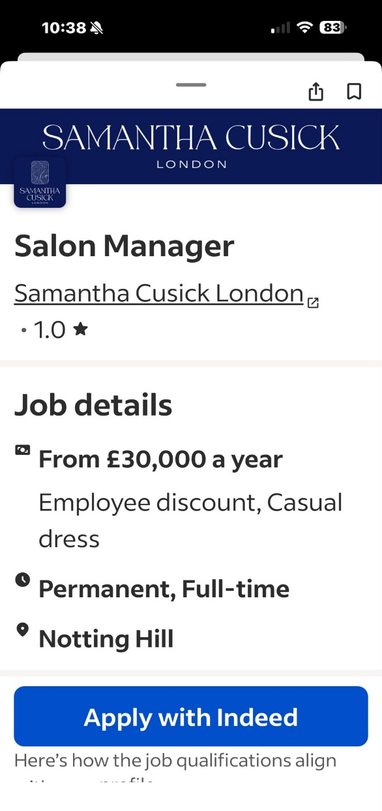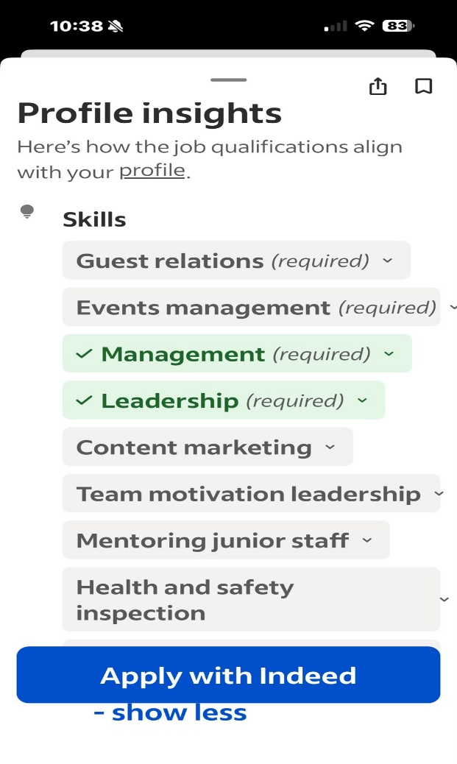

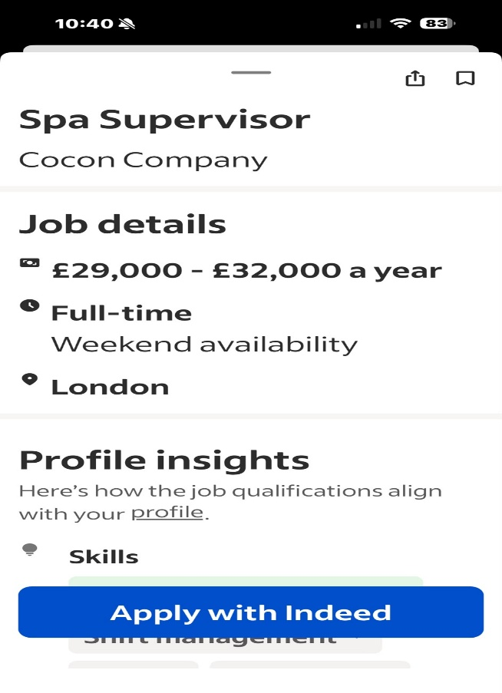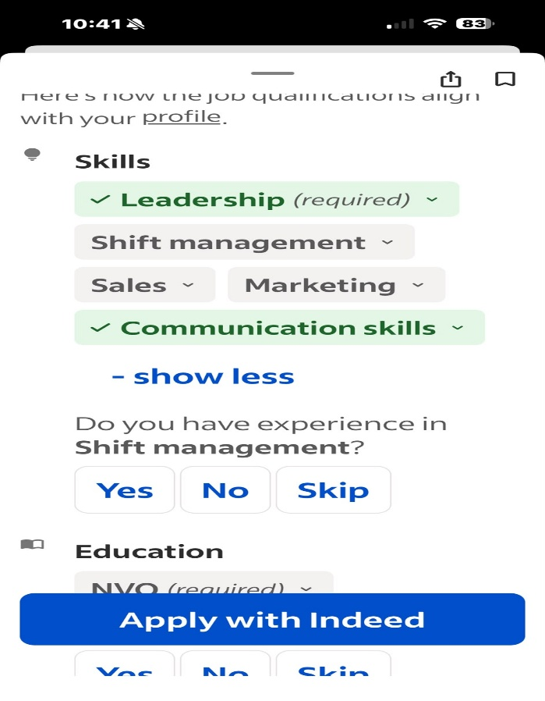

2.1 Key Skills and Knowledge

The two selected job postings are for Spa Supervisor and Salon Manager. Through analysis of the postings, it's possible to identify several important skills and knowledge for working in a management position in the beauty industry.

The main skills identified are leadership, management, communication, customer service, teamwork, employee motivation, organization, and shift management. Knowledge related to sales, marketing, health and safety, and daily operations management is also important.

For the Spa Supervisor role, the ability to lead and motivate the team, maintain good client relationships, supervise employees, and ensure that health and safety standards are met are especially important. For the Salon Manager role, leadership, shift management, sales, marketing, and communication stand out.

These skills are important because a manager needs to be able to organize work, support the team, deal with different types of clients, and solve problems professionally. Furthermore, you need good communication skills to create a positive work environment and ensure that clients receive quality service.

My experience as a Salon Manager allowed me to develop several of these skills, primarily leadership , organization, customer service, and team management. My work as a Nail Technician also helped me develop communication and relationship skills with clients. Currently, my Cert HE Business Skills for the Workplace course at UWTSD is helping me further develop my management and business knowledge

2.2 Comparison of Job Advertisements

Both job postings share several similarities, as both positions are related to the beauty industry and involve managing people and daily operations. Both the Spa Supervisor and Salon Manager roles require leadership, communication, organizational, and customer service skills. Both also involve supporting the team and ensuring clients receive quality service.
However, there are some differences between the two positions. The Spa Supervisor role places more emphasis on client relationships, team motivation, employee monitoring, event management, and health and safety. On the other hand, the Salon Manager role emphasizes shift management, sales and marketing, as well as team leadership.
Overall, both postings show that good leadership is essential for managerial roles, as effective leadership directly influences team motivation and service quality (Goleman, 1998). Similarly, communication is highlighted as a key requirement, reflecting its importance in maintaining positive relationships with clients and ensuring efficient daily operations (TargetJobs, 2012). They also demonstrate that a manager needs to be flexible, organized, and able to work well with clients and employees. These requirements relate to my experience, as I have worked in salon management and customer service, while my current studies are helping me develop the necessary knowledge for future management roles.

3.Task 2: Self-Assessment and SWOT Analysis

3.1 What is a swot?
SWOT analysis is a strategic tool used to assess strengths, weaknesses, opportunities, and threats, offering a structured view that supports informed decisions and professional development planning (MindTools, 2026).

3.2 Personal Strengths and Weaknesses
Based on my professional experience and the skills required in the two job postings reviewed, I believe I possess several strengths that meet the requirements for the Spa Supervisor and Salon Manager roles. My professional experience has allowed me to develop skills primarily in the areas of leadership, customer service, communication, organization, and teamwork.
One of my main strengths is leadership and management ability. During my experience as a salon manager, I was responsible for organizing daily work, managing appointments, supporting the team, and ensuring clients received excellent service. This experience helped me develop responsibility, decision-making skills, and confidence to handle different professional situations.
Another strength is customer service. As a nail technician, I had direct contact with different clients and learned to understand their needs and expectations. I also developed the ability to communicate politely and professionally, maintaining a positive attitude even in more demanding situations. I also believe I am a

responsible, hardworking, organized person capable of working under pressure. My current experience as a warehouse operator at Crosswear also allows me to develop responsibility, organization, customer service, and teamwork.
Despite these strengths, I recognize that I have some areas I need to improve. One of them is confidence in communicating in English, especially in professional situations. Although I can communicate, I want to feel more confident in meetings, presentations, and other work situations. I also want to develop more knowledge of financial management, marketing, sales, and business management. I have practical experience, but I consider it important to complement this experience with academic knowledge.

3.3 Opportunities and Threats
My academic background represents an important opportunity for my professional development. Currently, I am pursuing the Cert HE Business Skills for the Workplace at UWTSD, where I have been developing knowledge and skills through different disciplines.
The Academic Skills discipline has helped me improve how I organize my work, seek information, and present my ideas. Essential Skills has helped me better understand the skills needed for the professional environment. In Effective Teamworking, I learned about the importance of communication, cooperation, respect, and responsibility within a team.
The Problem-Solving discipline has helped me develop a more organized way of analysing problems and seeking solutions. This skill is important for managerial roles because a manager may encounter different challenges daily and needs to make appropriate decisions. Employability and Career Development has also been important for my development, as it has helped me think about my professional goals, my skills, and the areas I need to improve to achieve my goals.
Another opportunity is to continue my studies after the Cert HE. I intend to pursue Levels 5 and 6 of the BA Leadership and Management Skills for the Workplace. This training can help me further develop my leadership and management skills and increase my career advancement opportunities.
At the same time, there are some threats that could hinder my development. Competition in the job market is high, especially for managerial positions. Communicating in English can also be a challenge, especially in professional

environments where you need to speak confidently. Another potential difficulty is balancing work, studies, and personal development. However, I believe these threats can be mitigated through practice, training, organization, and experience.

3.4 Evidence of Employability Readiness

I believe I am prepared to continue developing my career because I have a combination of professional experience, academic background, and a willingness to learn. My experience as a Salon Manager allowed me to develop leadership, organizational, customer service, and teamwork skills. My experience as a Nail Technician helped me develop communication, attention to detail, and the ability to understand clients' needs. Currently, my work at Crosswear allows me to continue developing responsibility, organization, customer service, and the ability to work in a team.

My studies at UWTSD are also important evidence of my preparation for the job market. The subjects Academic Skills, Essential Skills, Effective Teamworking, Problem Solving, and Employability and Career Development helped me develop skills that I can apply both in my professional life and in my personal development. These subjects also helped me better understand my abilities and identify areas where I can continue to improve.

Another important experience was conducting a mock interview. This activity helped me better understand how a job interview works and how I should prepare before a real interview. I learned the importance of knowing my own abilities, organizing my ideas, and answering questions clearly and confidently. I also realized that good preparation could help reduce nervousness and improve how I present my professional experience. The mock interview gave me more confidence and showed me some areas I still need to practice, especially communication in English. 7 good answers to general interview questions

Overall, I believe my professional and academic experience demonstrates good preparation for future job opportunities. I have practical experience, leadership and
customer service skills, and I am developing managerial knowledge through my studies. I also have clear goals to continue my education and improve my skills. I believe that with dedication, practice, and continuous learning, I can overcome my weaknesses, seize available opportunities, and advance to a position of greater responsibility in leadership and management.

4. Task 3: Employment Goals and Personal Development Plan

4.1 Short-Term and Long-Term Goals

My professional goals are related to developing my leadership, management, and communication skills. In the short term, my main objective is to complete the HE Business Skills for the Workplace certificate at UWTSD and improve my confidence in English communication. I also want to develop my knowledge in financial management, marketing, sales, and team management, as these skills are important for the roles of Spa Supervisor and Salon Manager.

In the medium term, I intend to continue my studies for Level 5 and Level 6 of the BA Leadership and Management Skills for the Workplace. I also want to gain more professional experience in roles involving leadership and management.

In the long term, my goal is to achieve a position of greater responsibility in the beauty industry, such as Salon Manager or Spa Supervisor. I want to use my professional experience and the knowledge gained through my studies to lead a team, manage operations, and contribute to the growth of a company

4.2 Personal Development Actions

 | Short-Term Time Frame | Mid-Term Time Frame | Long-Term Time Frame
Section 1 - My Goals | Improve communication in English; complete Cert HE. | Complete Level 5 and begin Level 6; assume supervisory tasks. | Become a Spa Supervisor or Salon Manager
Section 2 - Skills and Knowledge to be  Learned | Professional communication; basic marketing; financial management. | Advanced leadership; team management; business operations. | Strategic management; team development; decision-making.
Section 3 - Next Steps | English workshops; presentation practice; additional study. | Participate in leadership projects; seek feedback; take supplementary courses. | To apply for management positions; to apply academic knowledge at work.

 | Short-Term Time Frame | Mid-Term Time Frame | Long-Term Time Frame
Section 4 - Resources | UWTSD workshops; study time; peer support. | Access to advanced modules; teacher guidance. | Professional experience; continuing education.
Section 5 - Time Schedule | Start date: immediate / End date: 6 months | Start: 6 months / End: 2 years | Start: 2 years / End: 3 years

4.3 Timeline and Measuring Progress

Progress will be tracked through simple, measurable goals. In the short term, I will assess the improvement in my English communication through participation in presentations, feedback from teachers, and increased confidence in professional situations. Completion of the Cert HE will also be an important indicator.

In the medium term, progress will be measured by passing the modules at levels 5 and 6, the ability to take on new responsibilities at work, and the practical application of leadership and management skills. Participation in team projects and positive feedback will demonstrate progress.

In the long term, success will be assessed by obtaining a supervisory or management position in the beauty industry. Leading teams, managing operations, and contributing to company results will show that I have achieved the goals defined in my Personal Development Plan.

5. Conclusion

This portfolio allowed me to reflect on my skills, experiences, and professional goals. Analysing job postings showed that supervisory roles require leadership, communication, organization, and problem-solving skills—areas I have already developed through my experience and studies. Self-assessment and the Personal Development Plan (PDP) helped me identify strengths and areas for improvement, defining concrete actions for my growth. With dedication, continuing education, and professional practice, I believe I am prepared to advance in my career and achieve a position of greater responsibility in the beauty industry.

6. References
- Indeed (2024) Career development plan: Definition, benefits and how to create one. Available at: https://uk.indeed.com/career-advice/career-development/what-is-a-career-plan (Accessed: 15 August 2026).
- TargetJobs (2012) Top 10 skills employers want. Available at: https://targetjobs.co.uk/careers-advice/skills-for-getting-a-job/what-are-top-10-skills-thatll-get-you-job-when-you-graduate (Accessed:15 August 2026)
- Goleman, D. (1998) Working with Emotional Intelligence. New York: Bantam Books. Available at: https://www.amazon.co.uk/Working-Emotional-Intelligence-Daniel-Goleman/dp/0553104624. (Accessed: 16 August 2026)
- MindTools (2026) SWOT Analysis: Discover New Opportunities, Manage and Eliminate Threats. Available at: https://www.mindtools.com/amtbj63/swot-analysis/. (Accessed at: 16 August)

