Name: Mohmed Aarif Idris Patel
Student ID: 2120428
Module Code: BMSW4001

Module Title: Academic And Employability Skills
Lecturer's Name: Sylvia Hoffmann
Assignment Title: ACE Practical Portfolio

Table of Contents
Introduction 3
Chapter-01: Time Management 4
Definition and Theory 4
Elements of Time Management 4
Benefits of Time Management 5
Chapter-02: Organizing 6
Organizing Theories 6
Characteristics of Organizing 6
Chapter-03: Referencing 8
Referencing on Creative work 8
Importance of Referencing 8
Chapter-04: Public Speaking 10
Theory Regarding Public Speaking 10
Importance of Public Speaking for Student 10
Chapter-05: Reflection on the Learning 11
Reflection Model 11
Conclusion 13
References 14

Introduction
Today's students are the future corporate leader who will lead the business sector that impacts the state's economic condition. For a student, soft skills like communication, public speaking, organizing, and managing skills are most important. As a student, I need many soft and technical skills. I have learned some skills that are discussed later on in the report with some appropriate referencing.

Chapter-01: Time Management

Definition and Theory
As the adage goes, "Time and tide wait for no one." To achieve in all parts of life, one must comprehend the value of time. Individuals who waste time are those who have not developed their own individuality.
Time management is the practice of planning and regulating the amount of time spent on a particular activity (Alvarez Sainz, Ferrero and Ugidos, 2019). Effective time management helps an individual to do more in less time, reduces stress, and contributes to job success.
The most successful people are excellent time managers. Managing one's time is all about planning and managing how he or she spends his or her time (Alvarez Sainz, Ferrero and Ugidos, 2019). If he or she gets it right, he or she will be able to operate more efficiently and effectively under time constraints since they will be working smarter rather than harder (CFI, 2021).

Elements of Time Management
Time management is critical not just in corporations but also in our personal lives. Some elements that influence time management activities create the base of a time management procedure for both personal and professional sectors (Juneja, 2019).

Effectively Plan
Prepare a "TO DO" list or "TASK PLAN." Notate the main tasks to be completed in a day and the time assigned to each. Priority work should come first, followed by less important tasks. Finish each duty one by one.

Goals and Object
To do a task on a timely basis, goals and objectives must be set before starting the task. It will help the person to complete the task smoothly and timely.

Deadlines Setting
Deadlines force the person to work faster. It works as a motivation to work on time. How long a task should take and how many days—Mark significant dates against the deadlines in a calendar.

Prioritizing the Tasks
Prioritize projects according to their significance and urgency. Recognize the distinction between critical and urgent jobs.

Benefits of Time Management
The benefit of time management is enormous and cannot be expressed in some words, but some are described below.
Achieving Goal Faster: Managing one's time more effectively increases one's productivity. Focus on one job at a time for a predetermined amount of time instead of getting caught up in multitasking (Nieto, Sora and Ruiz, 2019). As a consequence, one is more likely to succeed in their endeavours since they put up their best effort.
Work Prioritizing: When creating a schedule, prioritize the most urgent tasks first. If you are strong at time management, you can finish your projects before attending a study group. Assignments completed before a study session or study group are an example (Nieto, Sora and Ruiz, 2019).
Reduces Stress: It's easy to become overwhelmed when faced with a huge to-do list and limited time (Nieto, Sora and Ruiz, 2019). In order to get the most important things done first, he has to have good time management skills.
Prevention of Procrastination: Procrastination can result in stress, dissatisfaction, and bad grades. It helps individuals overcome their lethargy, which is a common cause of procrastination. You need to set aside a specific amount of time to get things done.

Chapter-02: Organizing

Organizing Theories
It's the second most important management function in addition to the first, planning, which is responsible for coordinating people's activities as well as arranging resources to assist achieve goals. In order to keep operations running smoothly and effectively, it is necessary to define roles, assign tasks, allocate resources, build a structure that defines duties, responsibilities, and authority, and schedule tasks. Decisions about how to implement the plans must be made.
When it comes to uniting individuals behind a shared mission, an organisation's dynamic process and management action are considered essential.

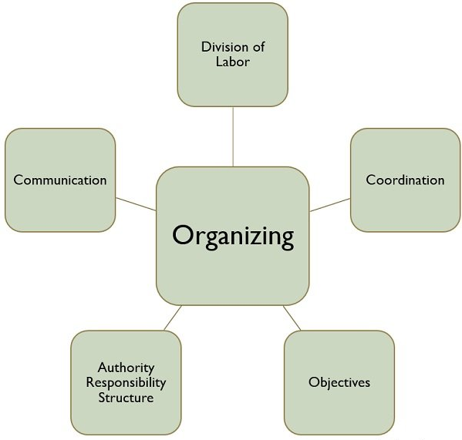
Characteristics of Organizing

Figure: Characteristics of Organizing within the Organisation (Business Jargons, 2022)

Labour Division: The organisation structure is created when the work involved in achieving goals and objectives is separated into activities and functions and assigned to a person or group of individuals. Consider marketing, finance, staff, and production.
Coordination: The next step is to ensure that all of the groups' and individuals' actions are oriented toward the organisation's goals once the roles have been determined and assigned.
Objective: The organisational structure is meaningless unless it serves its mission of achieving the objectives. This is because the structure is framed in such a way that the works are assigned to various goals in such a way that they are unified and coordinated toward the achievement of a common goal or objective.
Responsibility: An organisation's structure is made up of a hierarchy of positions, each having a distinct set of responsibilities and authority delineated.
Communication: An organisation's goal statement, employee training modules, interpersonal interactions between management and employees, and professional communications such as emails are all examples of organisational communication.

Chapter-03: Referencing

Referencing on Creative work
Using citations to back up statements and assertions in assignments is a common practice. Invoking the knowledge of specialists in the field demonstrates an understanding of the subject matter at hand (Brkic, Vucenovic and Ðokic, 2014). It is like sailing by the stars since citations provide a map of the discipline and a method to find one's way around it.
If the references are correct, readers will be able to go back to the original sources of the used material. Keep a list of all the sources used when reading and researching for an assignment in order to ensure appropriate citation (Hamilton, 2016).
More than just one person's thoughts and experiences are needed to write an academic paper. It also incorporates ideas and research from other sources, such as books, journal papers, and websites. It is possible that the author is using these other sources to support their own beliefs or that the author is criticizing, debating, or analysing these other sources (Brkic, Vucenovic and Ðokic, 2014).
The purpose of referencing is to indicate to the reader where ideas from other sources have been incorporated into a project."

Importance of Referencing
Academic writing necessitates the use of citations. An acknowledgement of the contributions of others is an important part of putting your work in perspective and demonstrating its breadth and depth (ScanMarker, 2019). When you use someone else's concept, you should credit them. Some importance of referencing are discussed below:
- It shows the knowledge depth of the research field.
- Prevent plagiarism in the report and assignment.
- Authors get the proper value from their work and research.
- Academic proficiency skills have risen, and theoretical knowledge can accrue while referencing.
- It denotes the proper value of the research work.
- If you make a claim in the original work, one must be able to prove it.
- Using citations in one's writing is a great way to make one's work more appealing to the general audience.

Chapter-04: Public Speaking

Theory Regarding Public Speaking
Public speaking is a talent that many individuals are afraid to learn because they believe they have a natural aversion to it. In public speaking, the act of delivering a speech to an audience is known as oration or oratory. An effort has been made to ensure that the material presented is both educational and entertaining (Spencer, 2021).
There are three components of public speaking. These are:
- Style: Written in such a way that it is beautiful to hear and read, this material has been expertly composed.
- Substance: Central subject for the audience's ideas and aspirations to appeal to and inspire.
- Impact: Changing people's minds, hearts, and opinions. A memorable speech leaves a lasting impression on the listeners.

Importance of Public Speaking for Student
Communication is the backbone of any community. It helps us to make relationships, influence decisions, and encourage change. Public speaking is one of the most crucial and most despised types of communication (Palmer, 2021). In the professional world, public speaking is an important talent to have. The importance of public speaking for the life of a student is very important because the student life is the initial stage of the professional life to lead a better life.

- Improve the way of communication: Public speaking helps the student to improve their communication to develop their network.
- Classroom activities improve: When a student can speak better, the classroom activity may be improved and potentially rise to cut a good result in the test.
- Leadership Quality: Public speaking is also a cause of improving the leadership quality in one's life

Chapter-05: Reflection on the Learning

Reflection Model
Reflection is a term used to describe the process of being aware of one's own thoughts, feelings, and perceptions (Brush, 2019). A model of reflection is a method for analysing and improving one's own and one's environment. From the learning of the module, my learning reflection has been discussed with the help of Kolb's reflective model below.
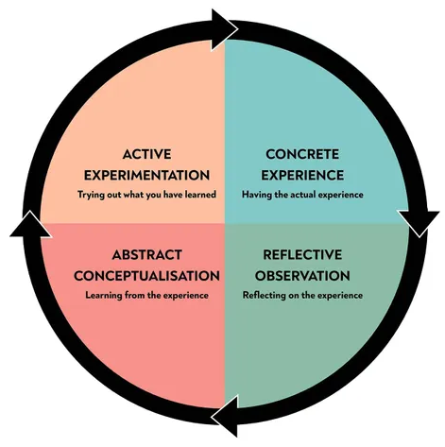

Figure: The Experiential Learning Cycle of Kolb's Reflective Model (McLeod, 2017)

Concrete Experience
Over the course of my learning, I have learned many skills. Some of them are notable in my ways of life, such as time management, organizing, referencing and public speaking. I feel like improving my soft skills that will help me to succeed in my future career.

Reflective Observation
While acquiring this knowledge or skills, I have faced many obstacles that I have no knowledge prior knowledge regarding all the issues. During the session, I learned about the aspects and future implications of all these skills. I was a bit confused and could not cope with my group, but gradually I broke all the inner obstacles and enthusiastically got involved in my group. From the beginning of the session and the recent period, I understood the change within me.

Abstract Conceptualisation
Now I know that only these skills are not enough for me to get better in future. So I need to practice more and more to improve my existing skills and acquire new skills that will add value for me in the future. I focus on my daily task and set a deadline to complete this for time management skills. For organizing, I have started to play a role as a leader in groups that help me to develop my organizing skills. Over this academic session, I have prepared many reports and assignments that require referencing; by this opportunity, I have learned the referencing method. Presentation in academic and non-academic sessions has improved my public speaking skills.

Active Experimentation
Acquiring knowledge is always like a movement. I have already learned some of the soft skills and technical skills. But I need to acquire CV writing, Cover letter writing, Summarising and Academic Writing Skills. My next step is to get more knowledge regarding these skills.

Conclusion
Skills development is the primary task for a student and analysing him or her skills after a period later so that he or she can improve his or her academic and non-academic that help their professional life. If a student can analyse the reflection on their skills on their personal and professional level, they can know the next step for their skills development to fight at the corporate level.

References
Alvarez Sainz, M., Ferrero, A. and Ugidos, A., 2019. Time management: skills to learn and put into practice. Education + Training, 61(5), pp.635-648.
Brkic, S., Vucenovic, M. and Ðokic, Z., 2014. Accurate reference citation and assignment of key words. Archive of Oncology, 10(2), pp.100-101.
Brush, K., 2019. What is a Model of Reflection?. WhatIs.com. [Accessed 10 April 2022].
Business Jargons, B., 2022. What is Organizing? definition, characteristics, process and importance - Business Jargons. Business Jargons. [Accessed 9 April 2022].
CFI, 2021. Time Management: A Brief Guide to Time Management. Corporate Finance Institute. [Accessed 8 April 2022].
Hamilton, J., 2016. Attribution, referencing and commencing HE students as novice academic writers: Giving them more time to 'get it'. Student Success, 7(2), pp.43-49.
Juneja, P., 2019. Time Management - Meaning and its Importance. Managementstudyguide.com. [Accessed 8 April 2022].
McLeod, S., 2017. Kolb's Learning Styles and Experiential Learning Cycle. Simplypsychology.org. [Accessed 10 April 2022].
Nieto, R., Sora, B. and Ruiz, G., 2019. Giving less importance to pain and focusing on achieving objectives. Pain Management, 9(1), pp.45-52.
Palmer, E., 2021. Why to Teach Public Speaking in Your K-12 Classroom. Hmhco.com. [Accessed 10 April 2022].
ScanMarker, 2019. The importance of referencing in your essays. ScanMarker. [Accessed 10 April 2022].
Spencer, L., 2021. What Is Public Speaking? & Why Is It Important? (+ Tips). Business Envato Tuts+. [Accessed 10 April 2022].

