Task 1 – Poster: Hospital Pharmacy Services

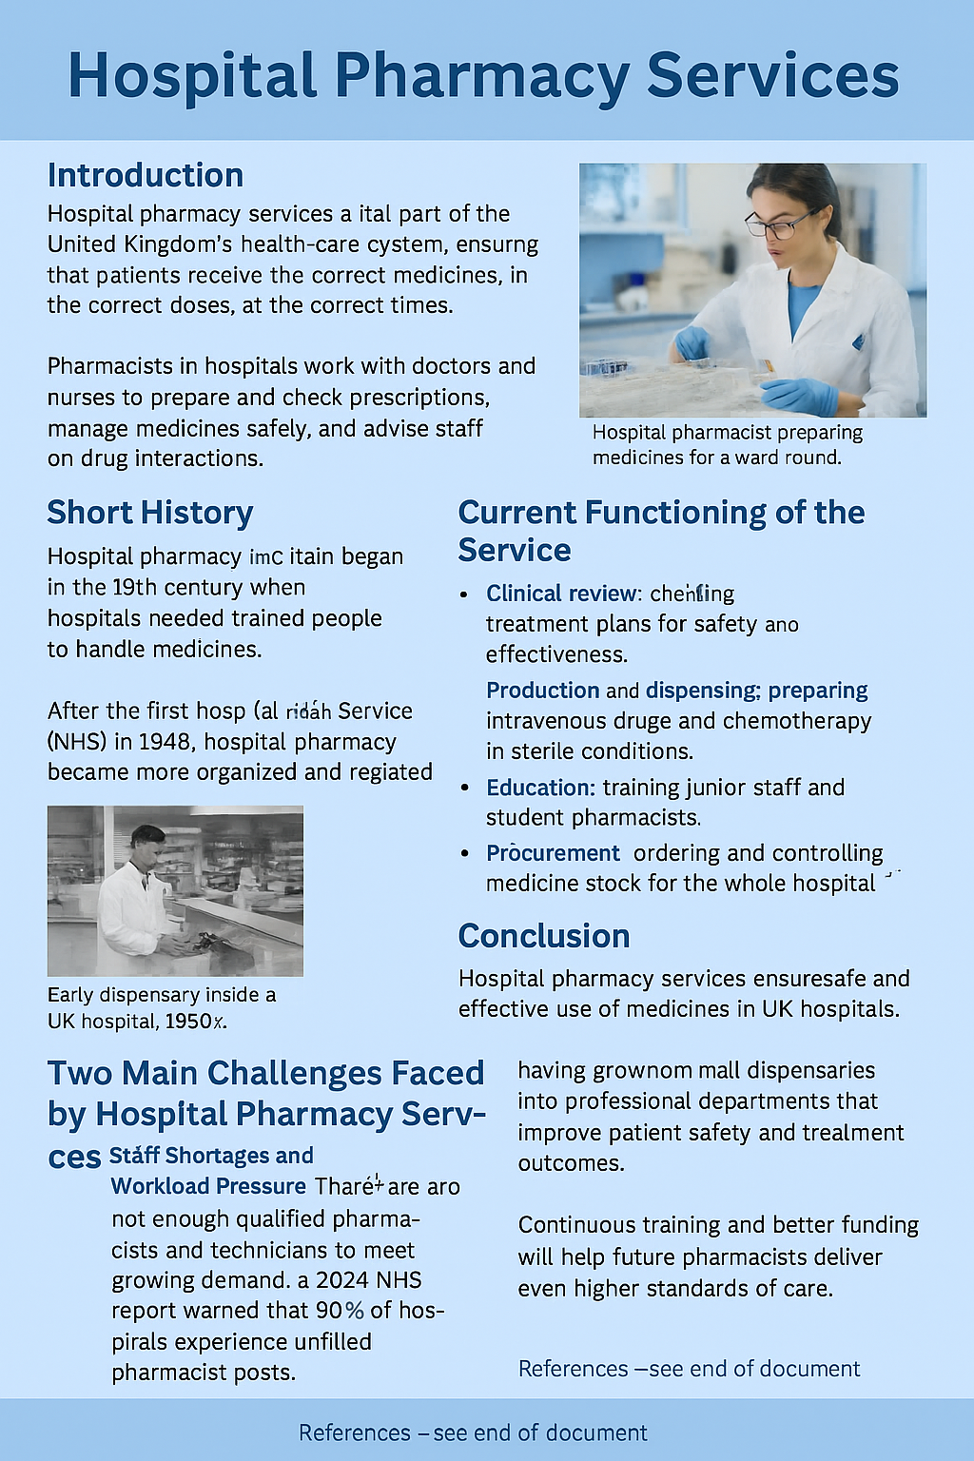

Task 2 – Essay: The Origins and Current Structure of the NHS

Introduction

The National Health Service (NHS) is one of the most important public organisations in the UK. It was founded in 1948 to give free medical care to everyone, based on need rather than the ability to pay. This essay explains the origins of the NHS, its key principles, and how it works today.

Historical Context and Origins

After the Second World War, Britain faced poor public health and widespread poverty. The 1942 Beveridge Report proposed a welfare system to fight the “five giants” – want, disease, ignorance, squalor, and idleness (Beveridge, 1942). Health Minister Aneurin Bevan used this report to design the NHS Act 1946, which created a single national service providing hospital, general-practice, and community care for all citizens.

When the NHS began on 5 July 1948, about 2,700 hospitals were taken into public ownership. The service was funded by taxation and promised to be free at the point of delivery. Its founding principles were:
- It meets the needs of everyone.
- It is free at the point of use.
- It is based on clinical need, not ability to pay (NHS Constitution, 2023).

Current Structure and Functioning

Today, the NHS is divided into four systems: NHS England, NHS Scotland, NHS Wales, and Health and Social Care Northern Ireland. Each has its own government funding and policies.

In England, NHS England oversees Integrated Care Systems (ICSs) that bring together hospitals, GPs, community services, and local authorities to plan health care for their populations (NHS England, 2024).
Services are provided mainly through:
- Primary care: GPs, dentists, opticians, pharmacists.
- Secondary care: specialist hospital treatment.
- Community care: district nurses and home support.

The NHS is funded mostly by general taxation and National Insurance contributions. In 2023 it employed around 1.6 million staff, making it one of the world’s largest employers (Office for National Statistics, 2023).

Current Issues and Reforms

Although the NHS remains highly valued, it faces problems such as long waiting lists, staff shortages, and rising costs of new treatments. COVID-19 made these pressures worse, increasing demand for both physical and mental-health care (Kings Fund, 2024).
Recent reforms focus on digitalisation, integrated care, and preventative public-health programmes to make the service sustainable for the future.

Conclusion

The NHS was born from a belief in fairness and social welfare after the war. Its principles – universality, equality, and free access – still guide it today. While modern challenges such as funding and staffing create pressure, continued reform and innovation can protect this unique system for generations to come.

📚

Reference

Beveridge, W. (1942) Social Insurance and Allied Services. London: HM Stationery Office.
British Pharmaceutical Society (2023) History of Hospital Pharmacy in the UK. Available at: https://www.rpharms.com (Accessed 10 October 2025).
Health Foundation (2024) Medicine costs and NHS budget pressures. London: Health Foundation.
Kings Fund (2024) The NHS at 75: Challenges and Reform. London: Kings Fund.
NHS Constitution (2023) The NHS Constitution for England. London: Department of Health and Social Care.
NHS England (2024) Hospital pharmacy and integrated care guidance. London: NHS England.
NHS Workforce Plan (2024) Addressing Staff Shortages in Hospital Pharmacy. London: NHS England.
Office for National Statistics (2023) UK Health Service Employment Data. Newport: ONS.
Royal Pharmaceutical Society (2023) Role of Hospital Pharmacists in Patient Safety. London: RPS.

